**Documentation**

This document describes headache android application, the main part of this project and how to run it on the server? And then how to install it on your phone.

The project is composed of the following files:

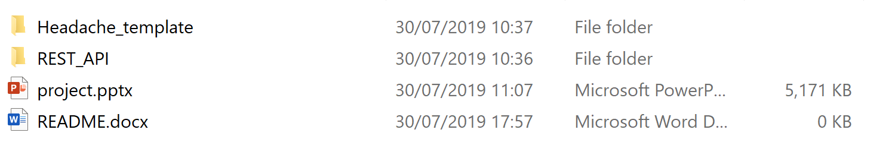

The database and web server ae already created in university server. But if you want to start the project from scratch in other server, this is the steps to follow:

1. **Database Creation:**

First of all we connected to database phpMyAdmin, and we create our database using the file “database_headache.sql” in the path “REST_API\data”.

We copy the content of this file in SQL console, and we execute:

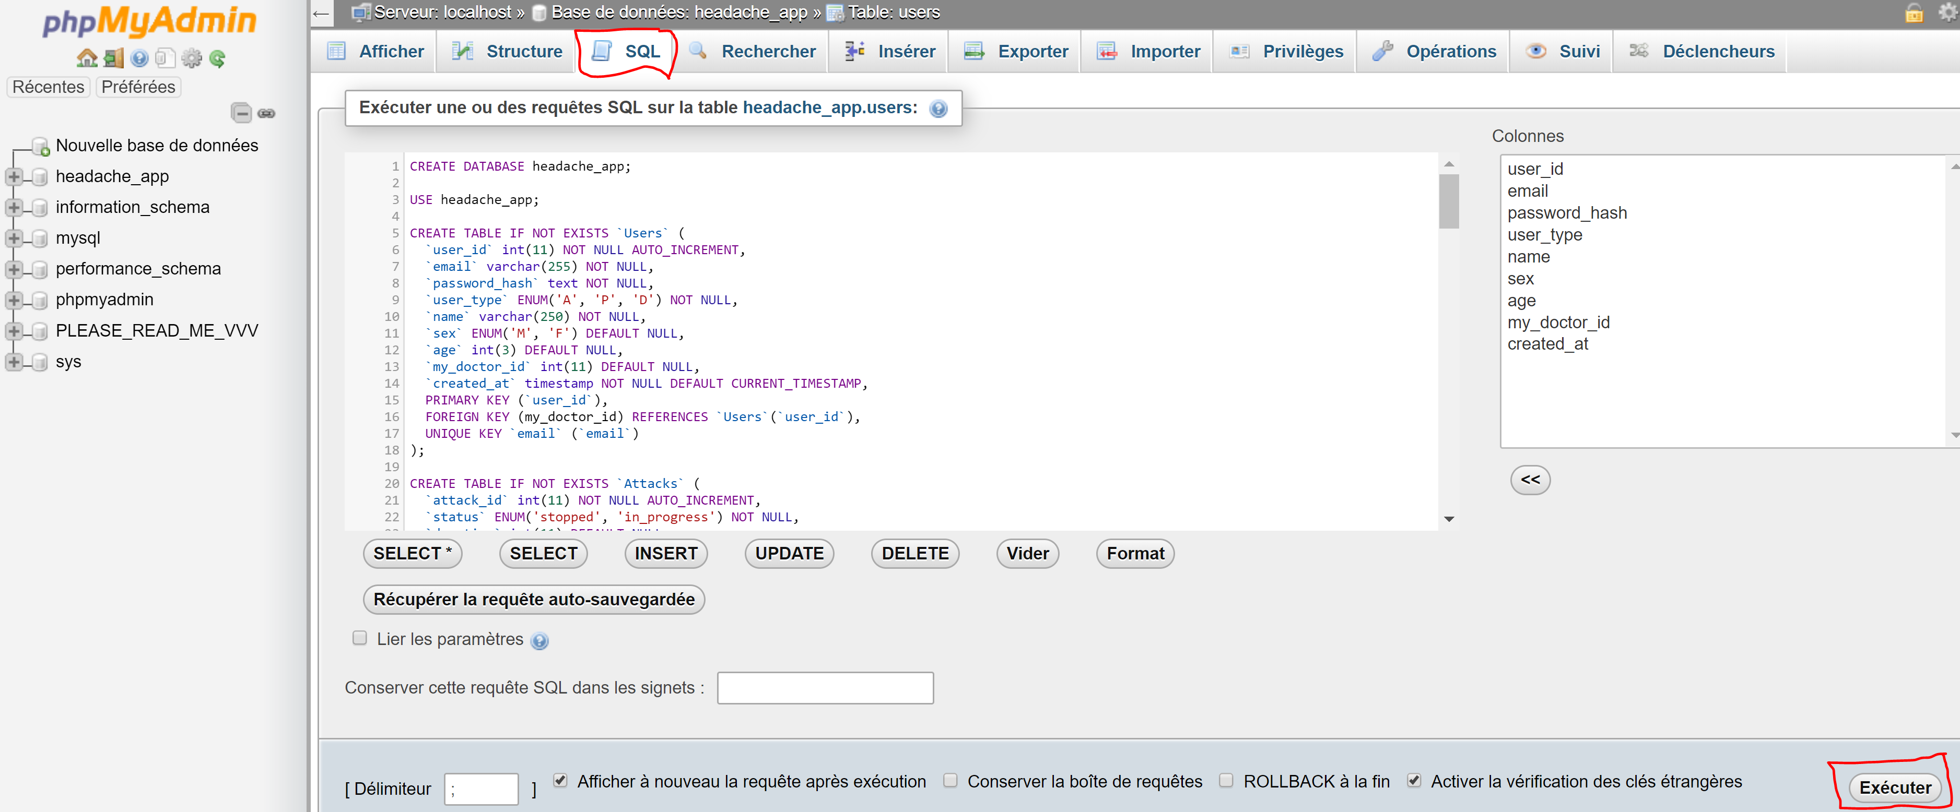

Then we check the creation of our database and its tables:

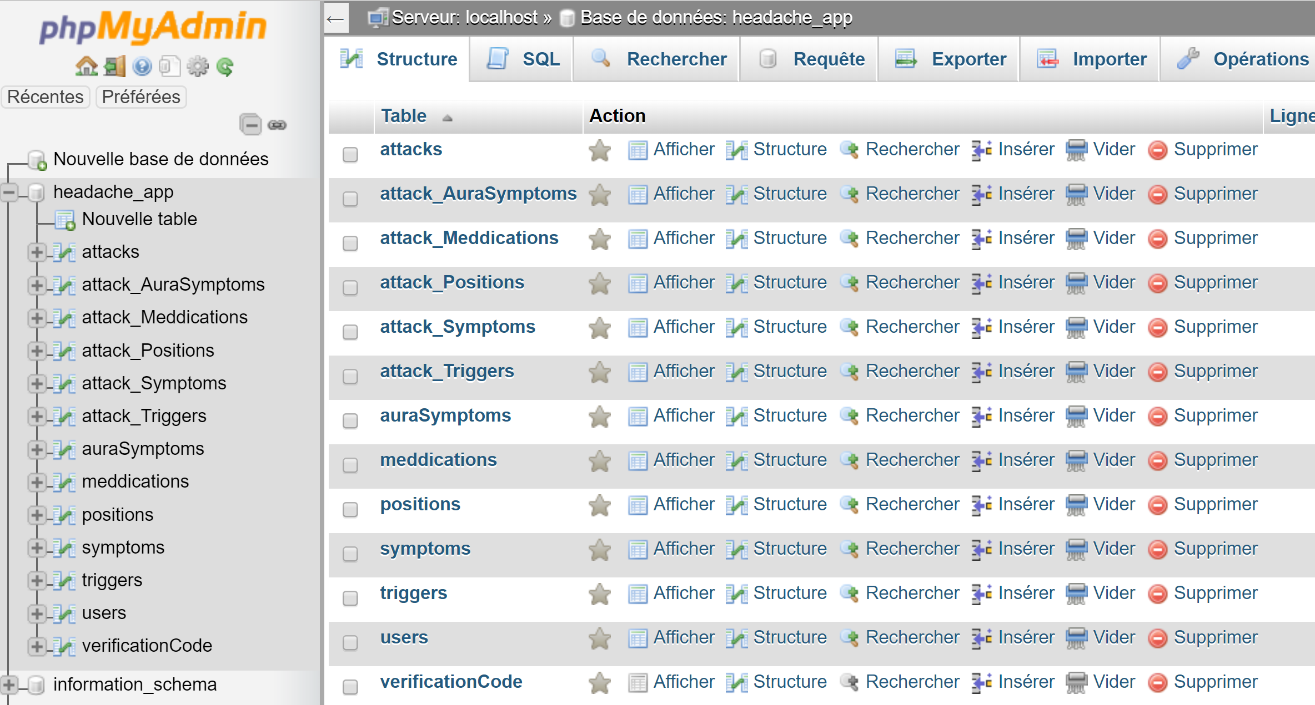

And we should check the content of the following tables also:

* **Medications table:**

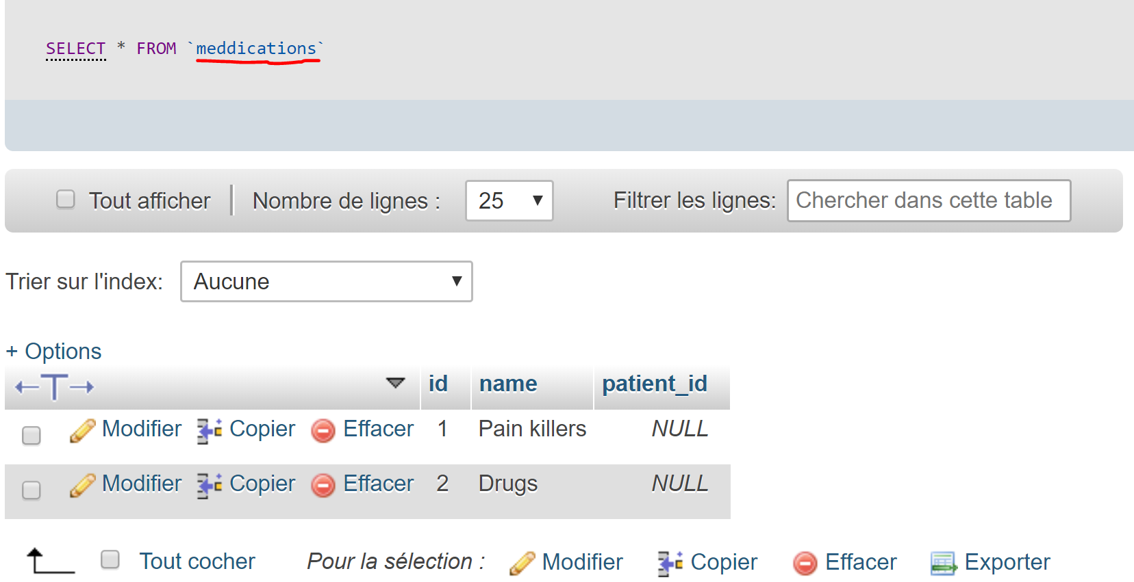

* **Positions table:**

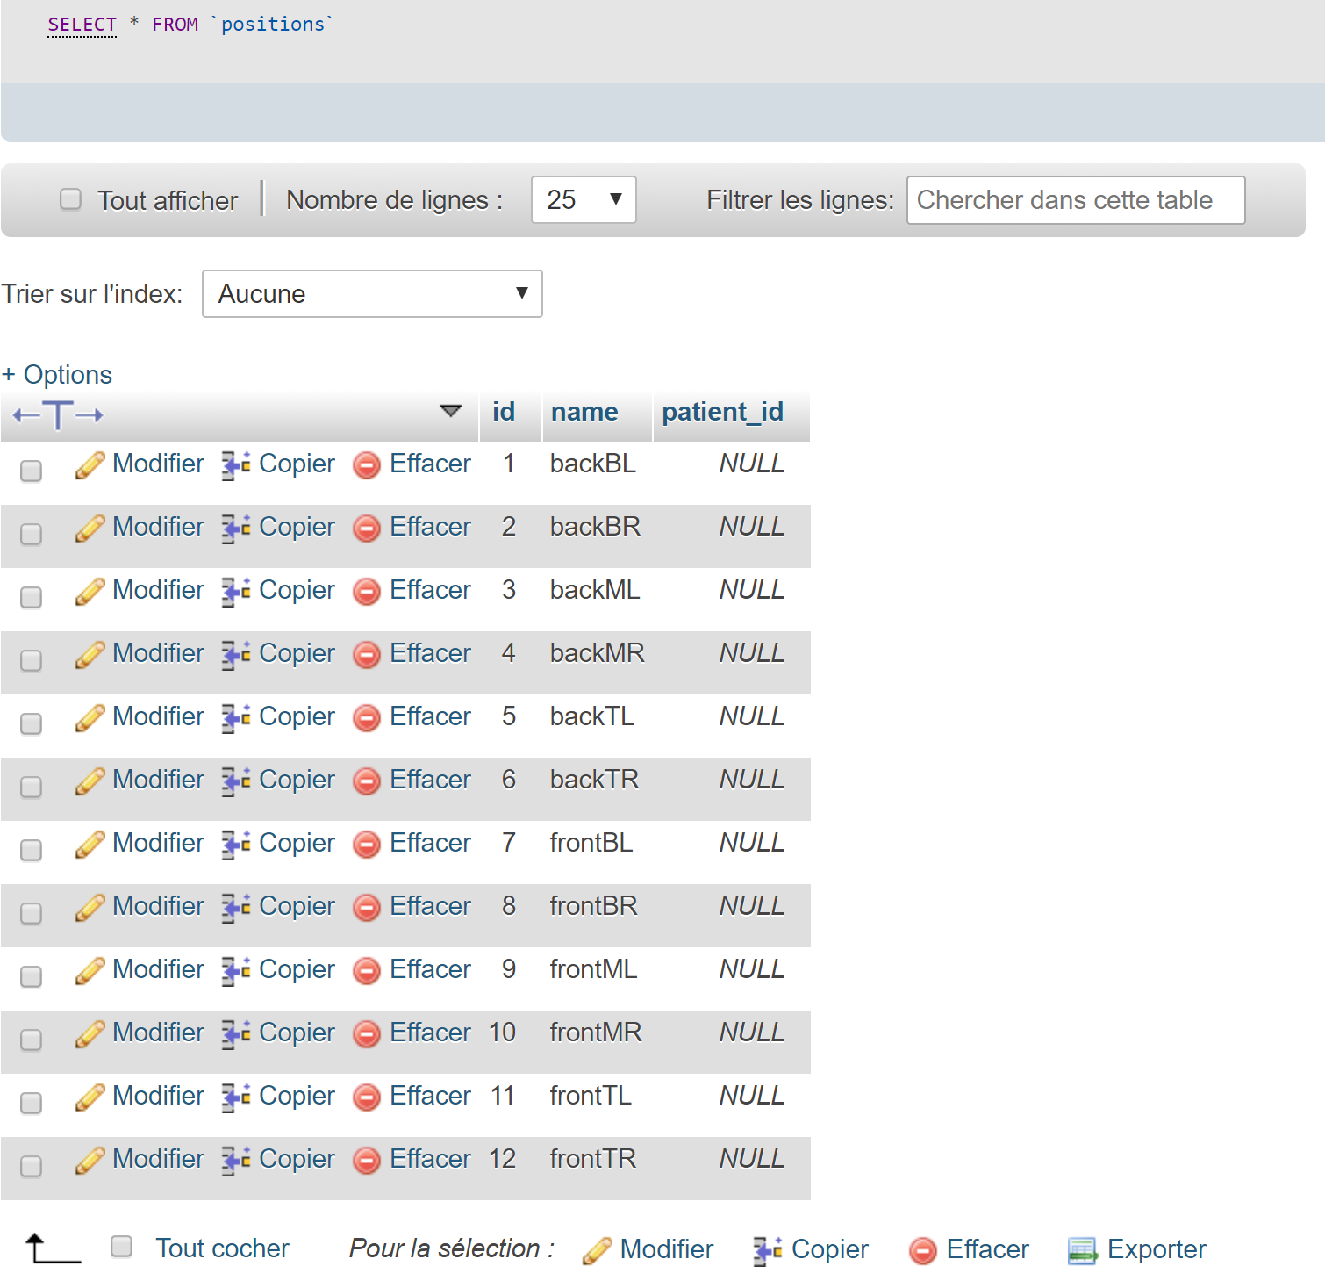

* **Symptoms table:**

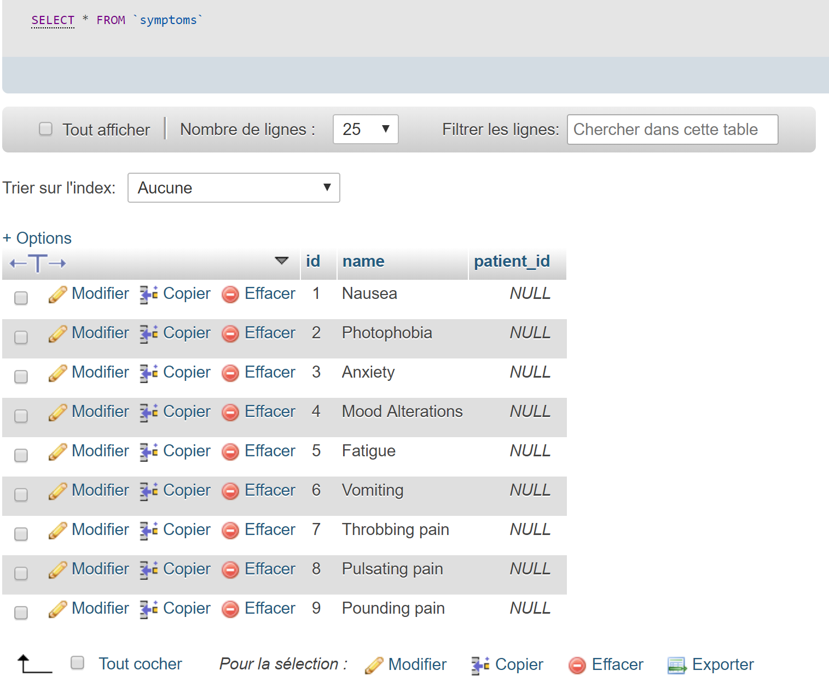

* **Triggers tables:**

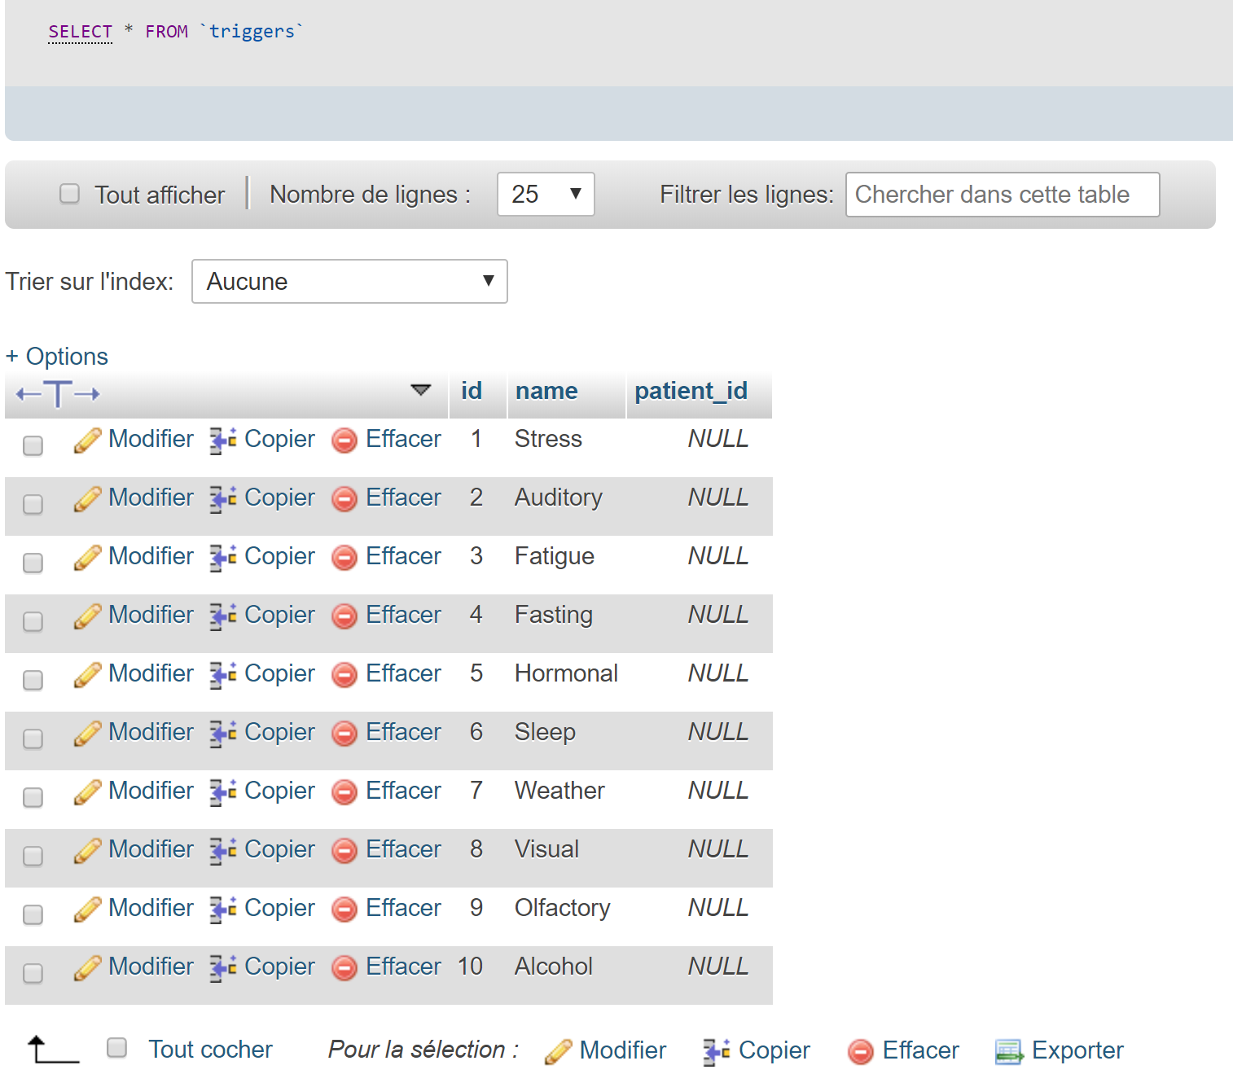

For adding new doctor we should use Advances REST client, because it is not possible with our android application (we should verify the identity of doctor), and of course we can not add the doctor directory to the database because the password should be crypted in web server before stored in database.

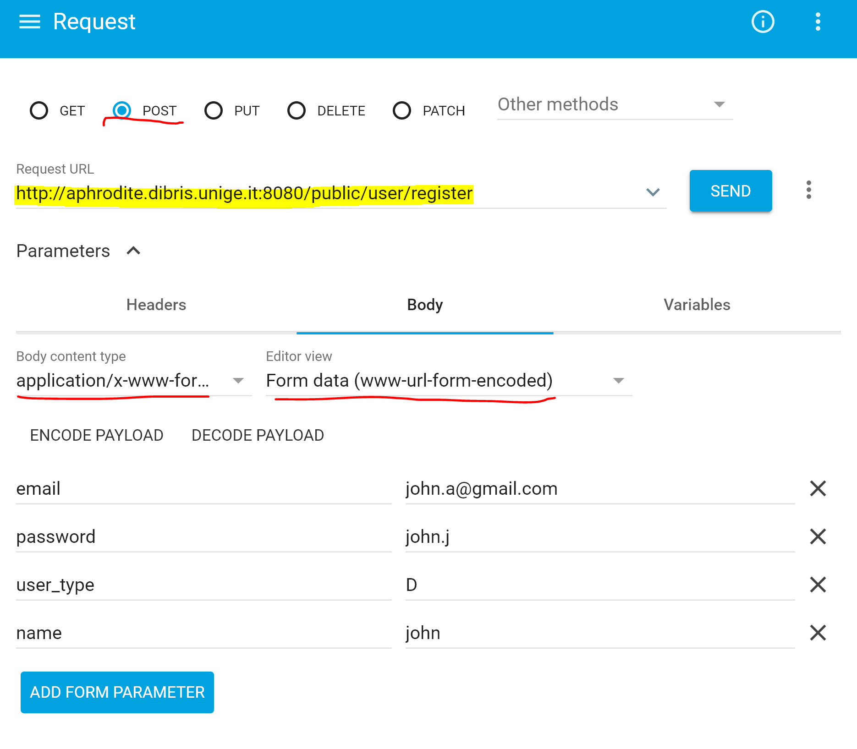

Make sure that you are using post request, and that the body format is application/x-www-form-URL encoded.

1. **Web server/REST API**

Copy the folder of “REST_API” in your server, then execute the following commands:

* cd REST_API
* screen
* php -S 0.0.0.0:8080
* screen -d

That will create a child terminal, which going to lunch php server on screen, so even if you close the terminal, the server still running.

To make sure that the server is running, just execute “ps - aux” and check the existing of the process:

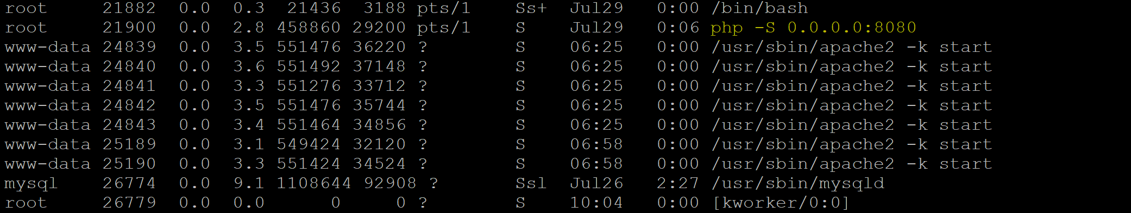

1. **Android application**

Copy the folder of “Headache_template” with android studio and execute the project in your phone.