

Google Analytics Customer Revenue Prediction



Abstract

4 Conclusion………………………………………………………………………………………..13

Creating an automated system for predicting potential future business, finding potential customers based on the various parameters as decided by the machine learning algorithm. The purpose of the document is to explain the High architecture that would be used for developing the Google Store revenue prediction system. We’re challenged to analyze a Google Merchandise Store customer dataset to predict revenue per customer. Google provided Merchandise customer dataset and no of transactions per customer. We will build a predictive model using G-store data set to predict the total revenue per customer that helps in better use of marketing budget and we will also interpret the most impacting element on the total revenue prediction using different models.

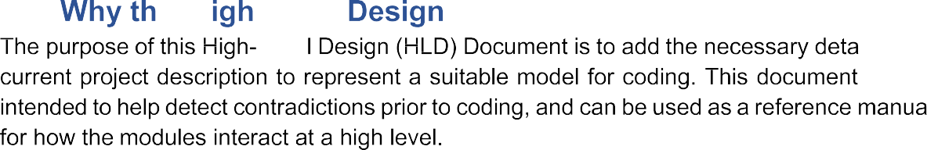

**The HLD Will**



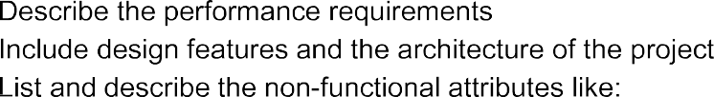

**1.2 Scope**

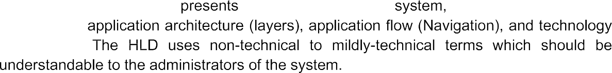

Project : Google Analytics Customer Revenue Prediction System

Technologies : Machine Learning

Domain : Retail

Database : MongoDB

Cloud : Heroku

**2 General Description**

**2.1 Product Perspective**

Create an automated system for predicting potential future business, finding

potential customers based on the various parameters as decided by the machine

learning algorithm.

**2.2 Problem Statement**

Google provided Merchandise customer dataset and no of transactions per customer. We will build a predictive model using G-store data set to predict the total revenue per customer that helps in better use of marketing budget and we will also interpret the most impacting element on the total revenue prediction using different models.

**2.3 Proposed Solution**

The solution proposed here is this prediction system based on some machine

learning algorithms (XGBoost ,LightGBM) can be implemented to perform predictive

analysis for finding the potential customers. After fine tune the model the algorithm

which have the lower Mean Square Error (MSE) will be selected for prediction . So we

have to predict the revenue that is going to be generated by those potential customers

in the near feature. So that marketing teams will invest appropriate money on

promotional strategies to attract potential customers.

**2.4 Data Requirements**

Google provided Merchandise customer dataset. We will build a predictive model

using G-store dataset . The dataset is present in the kaggle . We need to download the

dataset and create a separate databases for training and testing dataset.

**2.5 Tools Used**

** **

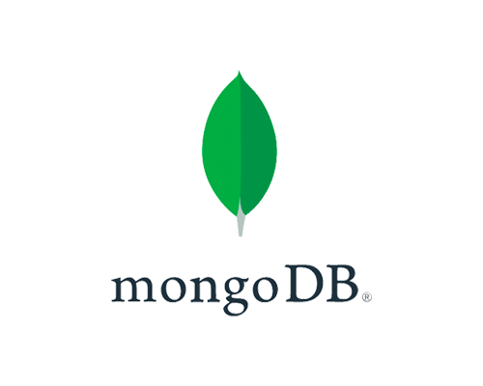

* VS Code used as IDE
* Python Flask used as backend to create API
* HTML , CSS , JAVASCRIPT used in frontend
* SkLearn used for Model building
* MongoDB used as Database for CRUD operation
* GIT used as version control system
* HEROKU cloud used for deployment

**2.6 Constraint**

This Prediction System must be user friendly ,possible and users should not be required to known any of the workings. It should be fully automated.

**3 Design Detail**

**3.1 Work Flow**

**Data Collection**

Database Creation

Data Validation

Testing Database

Training Database

Data Preparation

Prediction

New Data

Evaluation

Model Creation

Data Preparation

**Event Log**

              



\

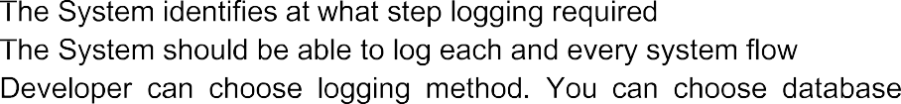

Logging / File



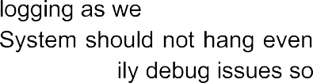

**4 Performance**

In this prediction system , we have used 9 million records to train the model . Ensemble learning algorithm is best suited for making the model , so we have choose the XGBoost and LightGBM model . Performance wise LightGBM model has lower error rate .To enhance the performance ratio model retrain will play a crucial role.

**4.1 Reusability**

The code written and the component used should have the ability the further use with having no problem

**4.2 Application Compatibility**

The different components for this project will b e using Python as interface between them .Each component will have its own task to perform , and it is the job of the python to ensure proper transfer of information.

**4.3 Resource Utilization**

When any task is perform , it will likely use all the processing power available until the function is finished .

**5 Conclusion**

This Google Analyst Customer Revenue Prediction System is basically a predictive model . It will give some continuous data as an output of predictive model , this data will be used to find out the potential customer.