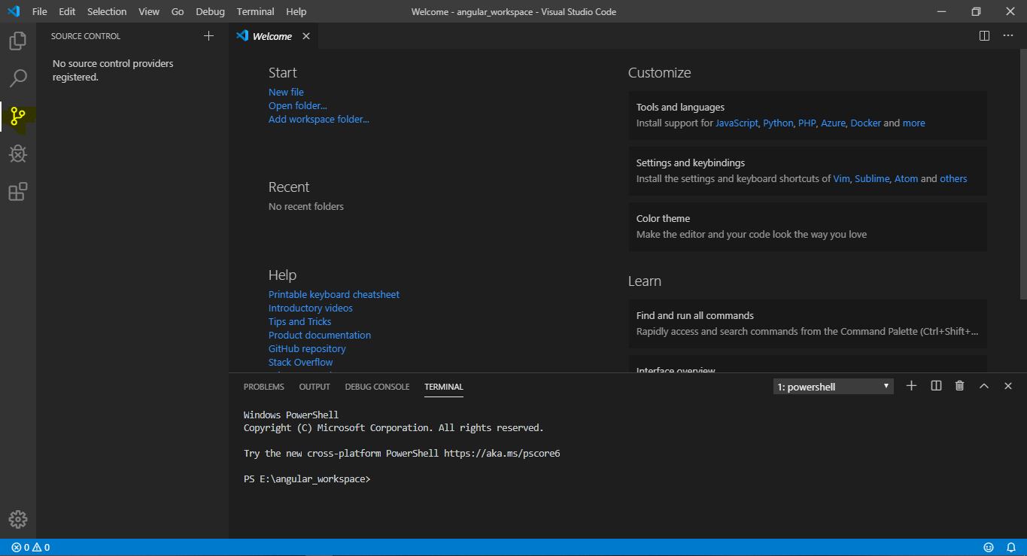

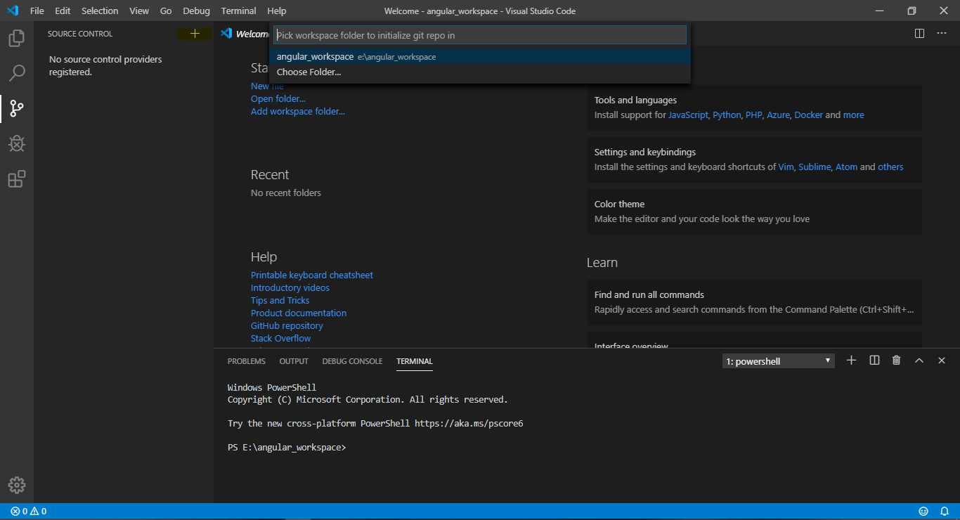

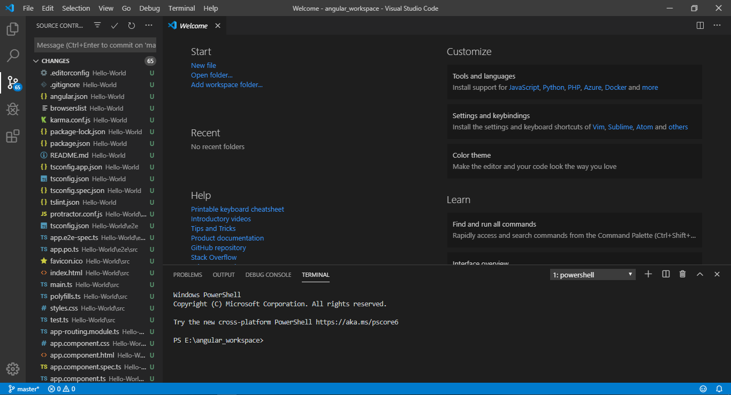

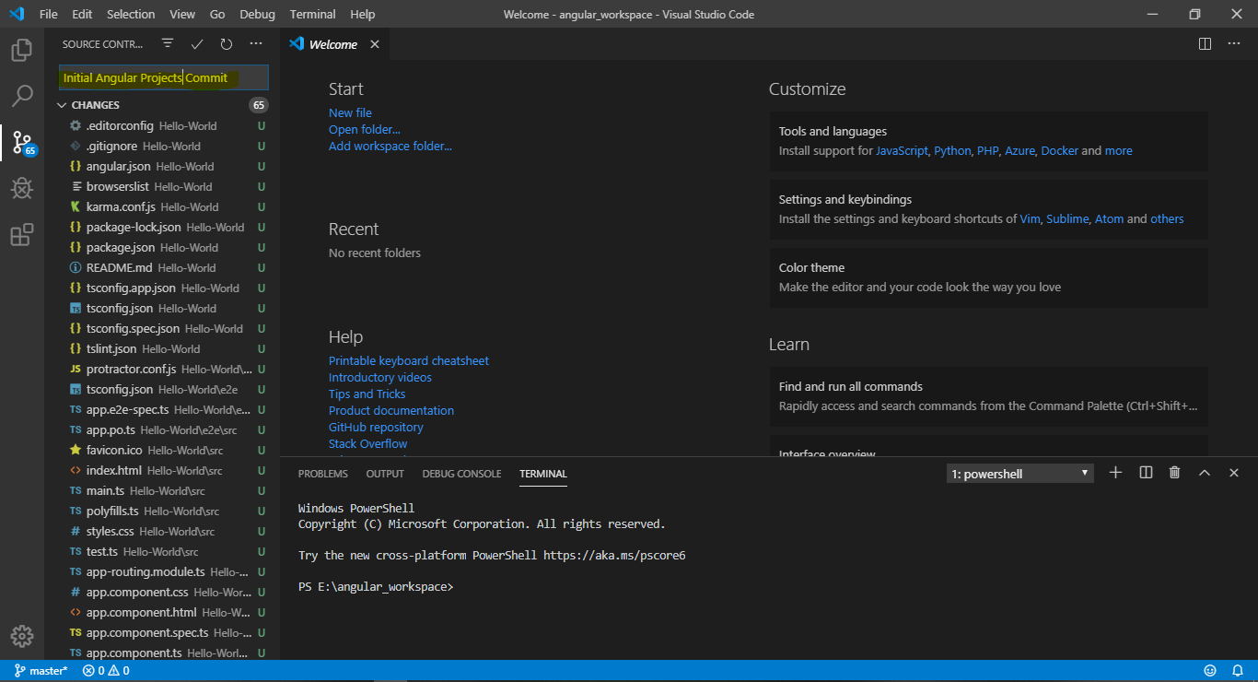

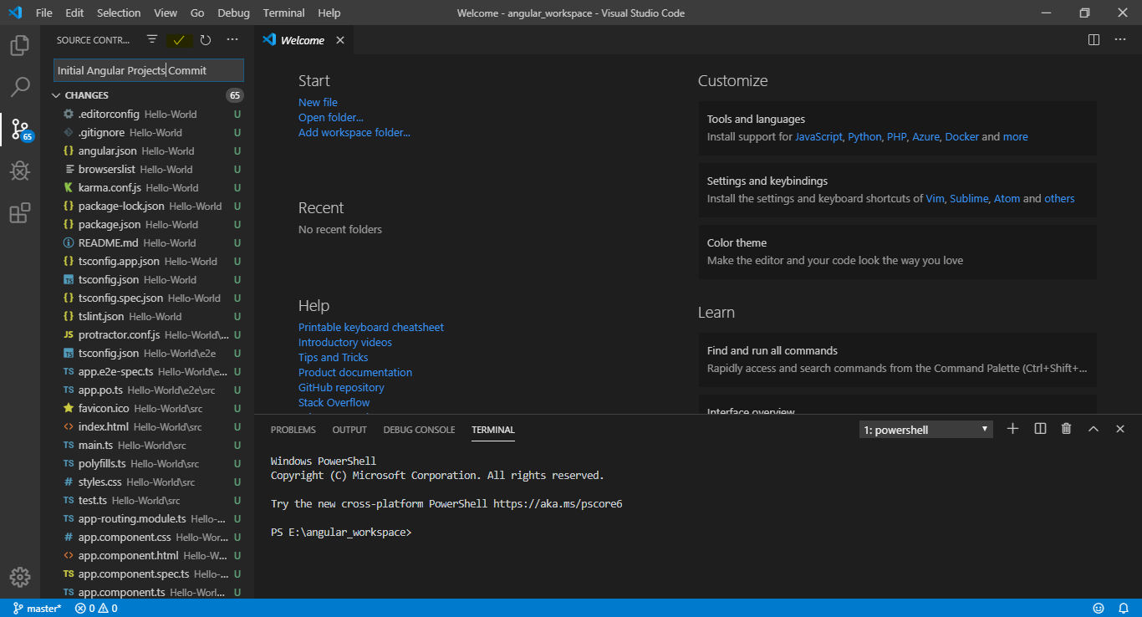

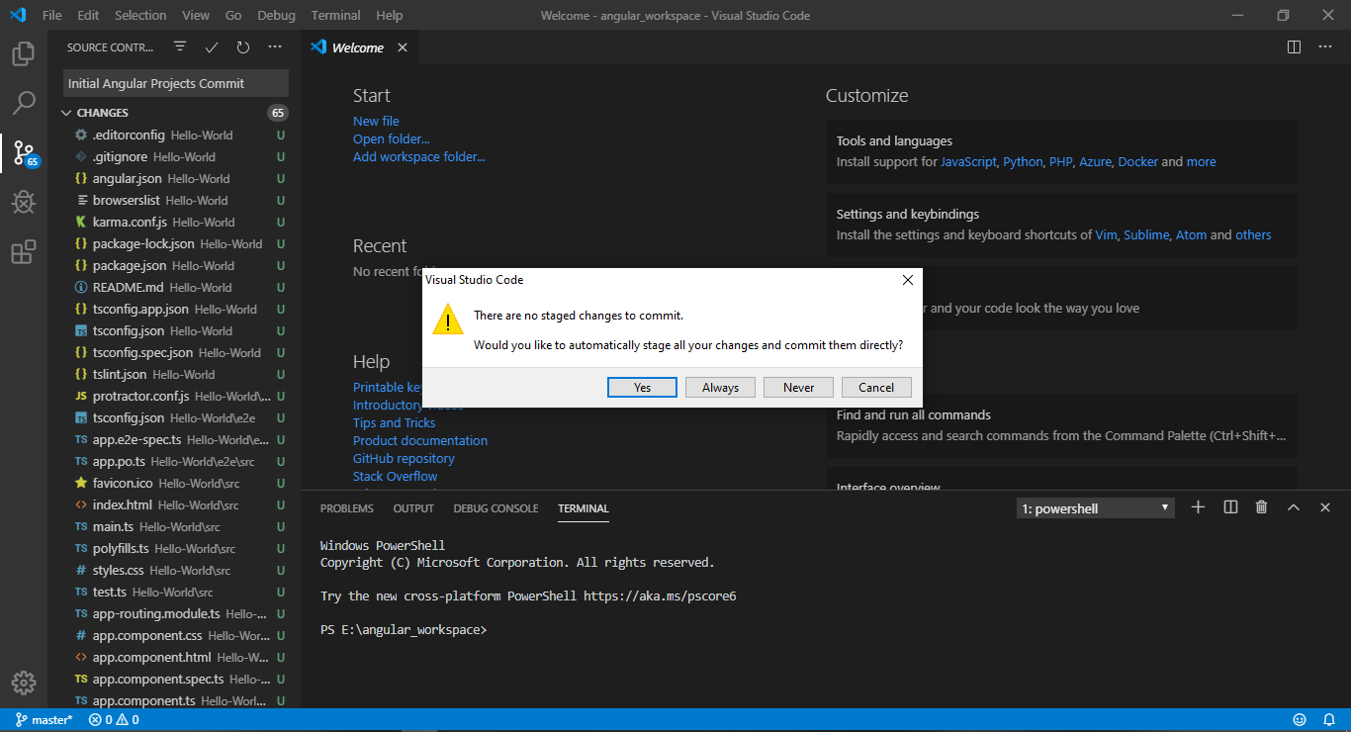

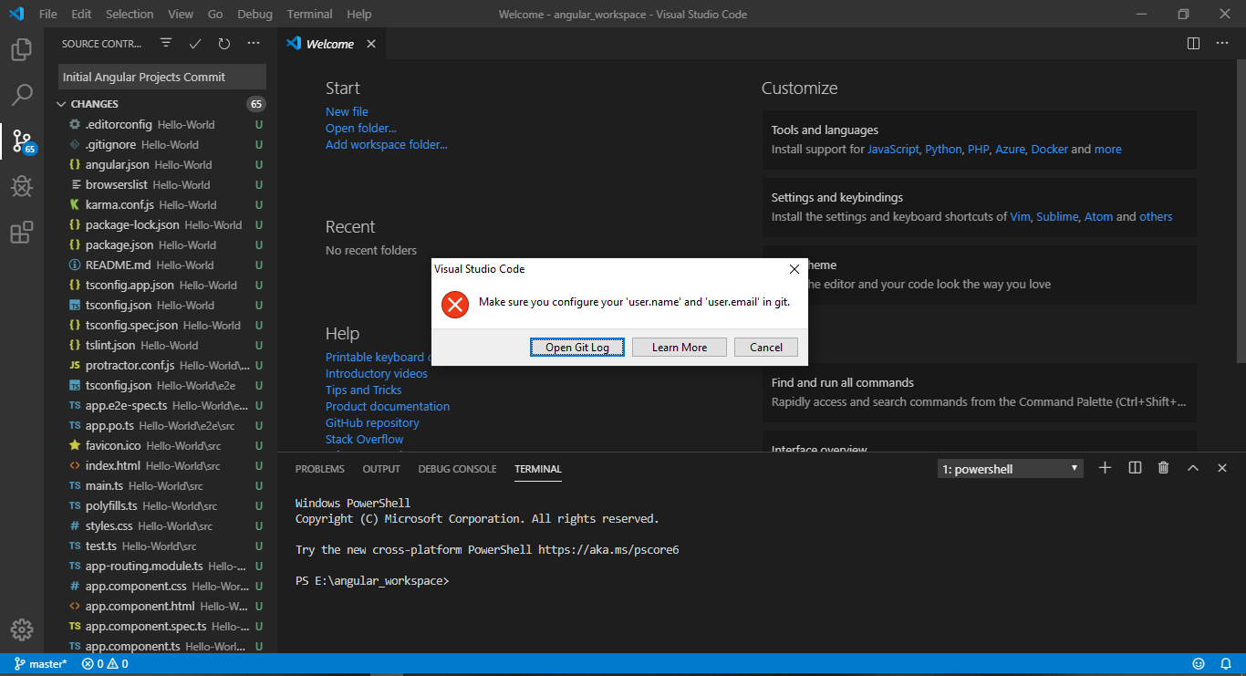

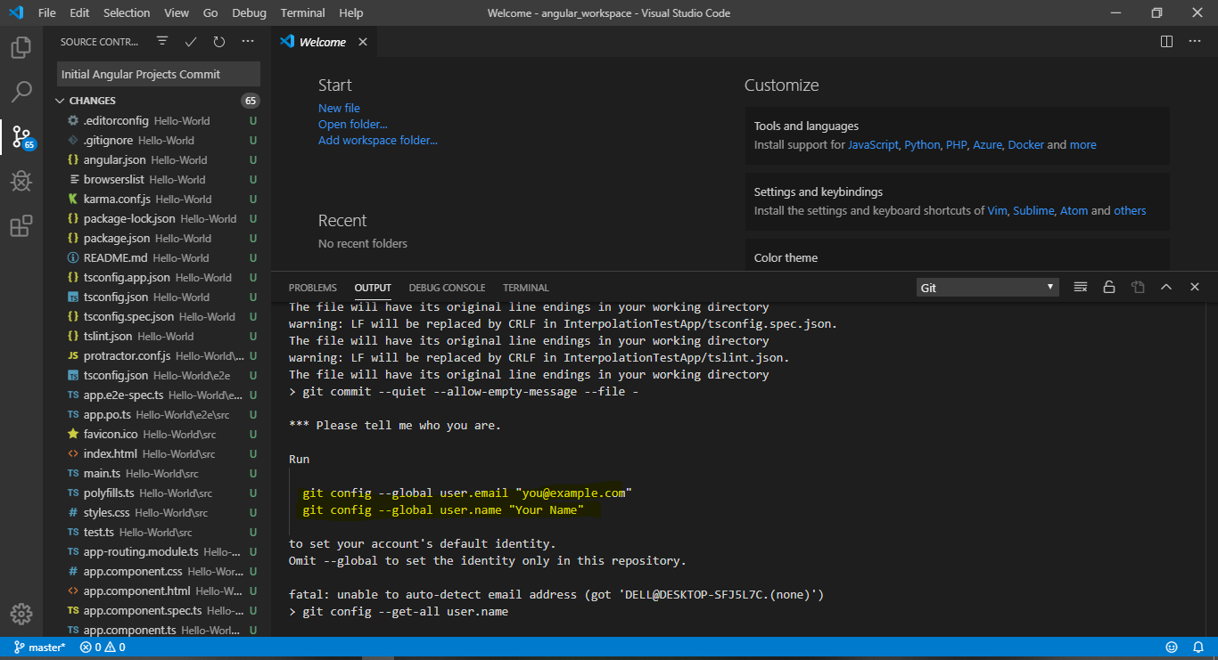

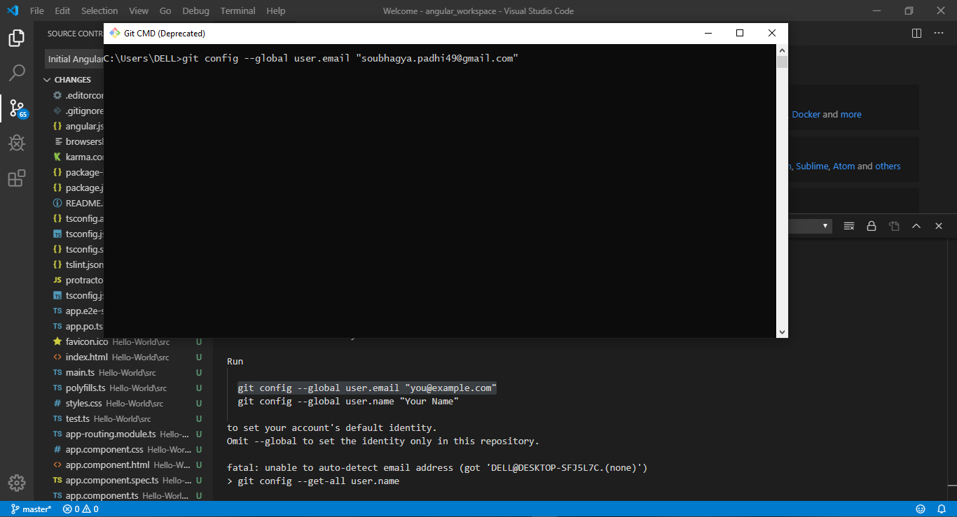

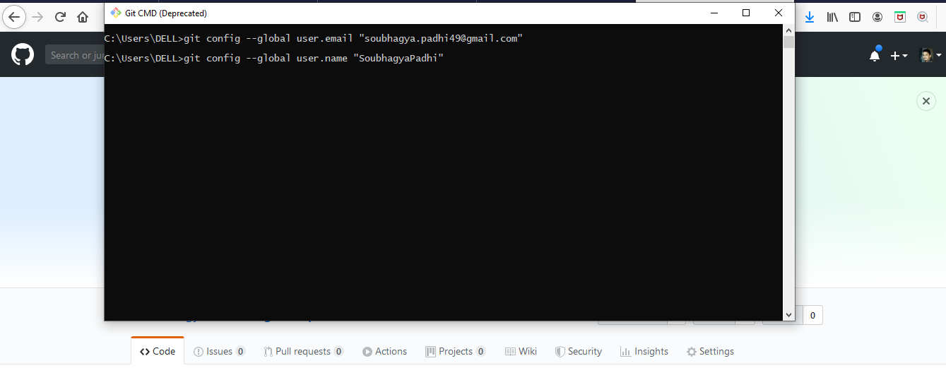

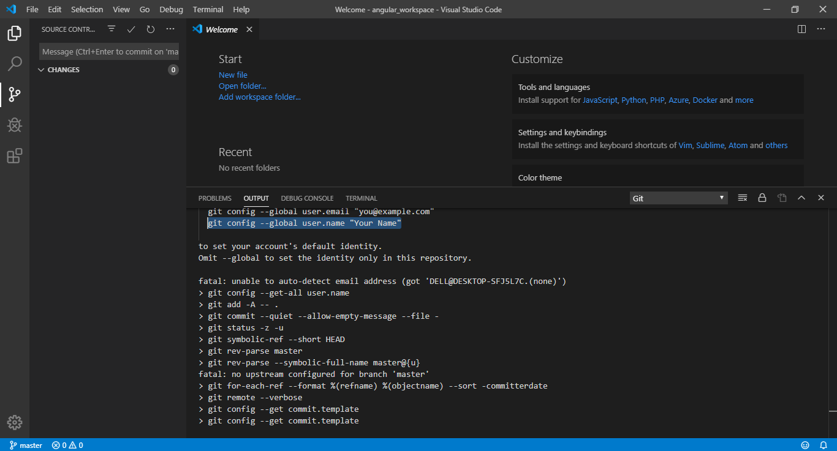

Add Remote Path:-

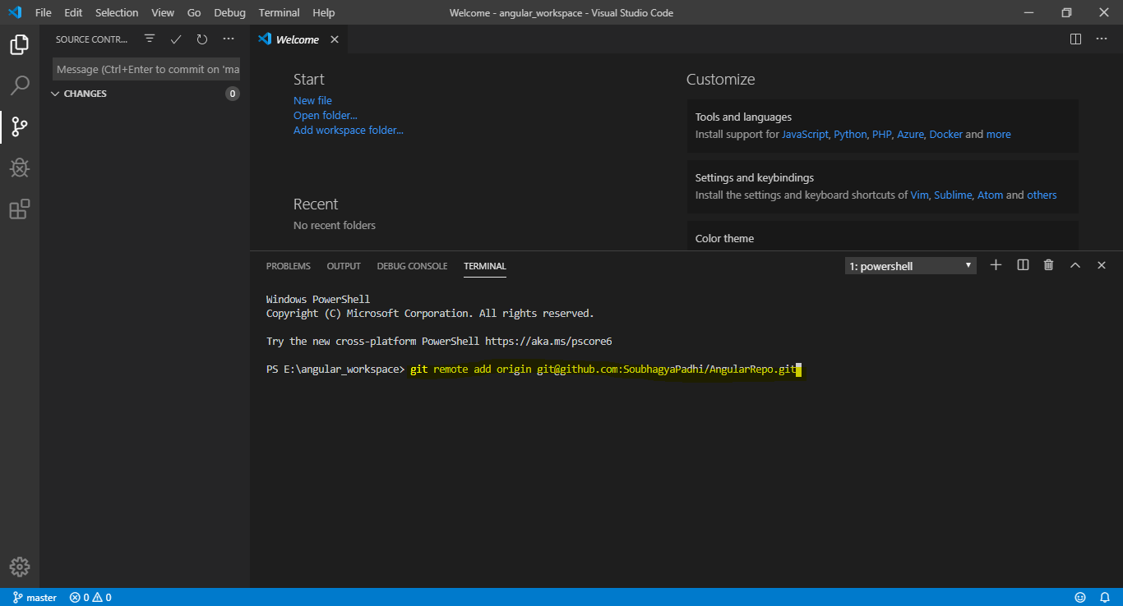

IF we get error as below while pushing the changes to remote master branch:-

**Host key verification failed.**

**Then we need to configure the “SSH Key” for GitBash,steps to be followed as below:-**

1. **Run Command usig GitBash:-**

* **ssh-keygen –t rsa**
* **cat ~/.ssh/id_rsa.pub(** This will print the SSH Key to be used further)**

1. **Then register the SSH key in remote GitHub Repo(GitHub Url).**
2. **Check login working using ssh key,using below command:-**

* **ssh -T** [**git@gitHub.com**](mailto:git@gitHub.com)

1. **It will print user id in cmd terminal as below:-**

$ ssh -T git@gitHub.com

The authenticity of host 'github.com (13.234.176.102)' can't be established.

RSA key fingerprint is SHA256:nThbg6kXUpJWGl7E1IGOCspRomTxdCARLviKw6E5SY8.

Are you sure you want to continue connecting (yes/no/[fingerprint])? yes

Warning: Permanently added 'github.com,13.234.176.102' (RSA) to the list of known hosts.

**Hi SoubhagyaPadhi**! You've successfully authenticated, but GitHub does not provide shell access.

Screenshots:-

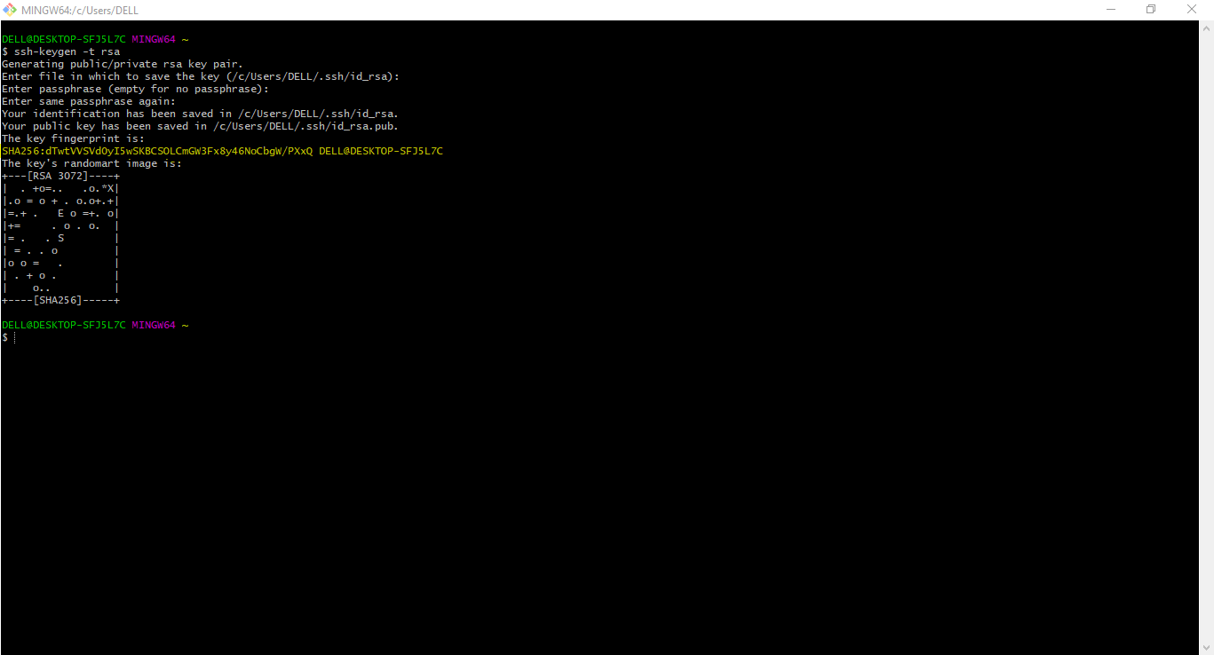

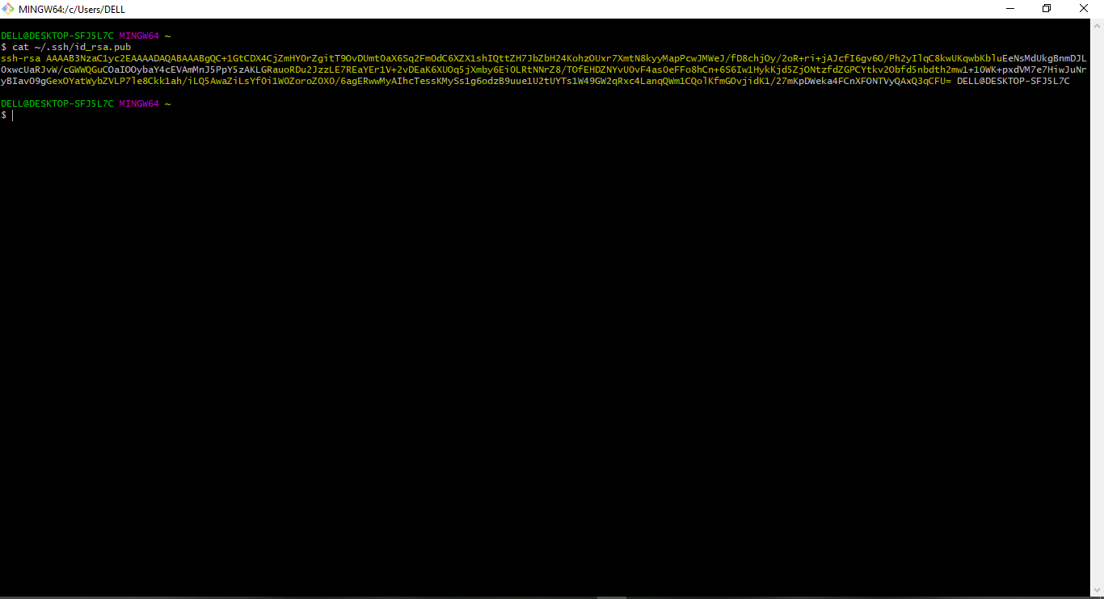

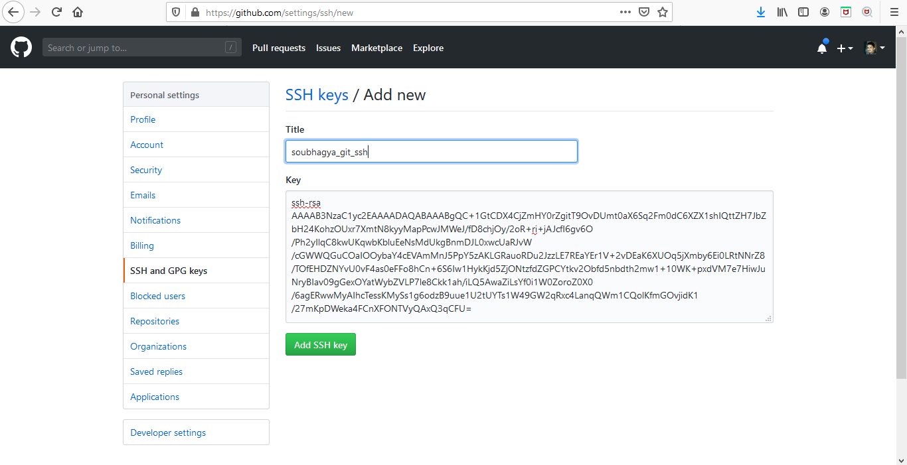

**References**:- <https://www.youtube.com/watch?v=2oihkInZ880>

<https://www.youtube.com/watch?v=dmUxzR0RNkg>

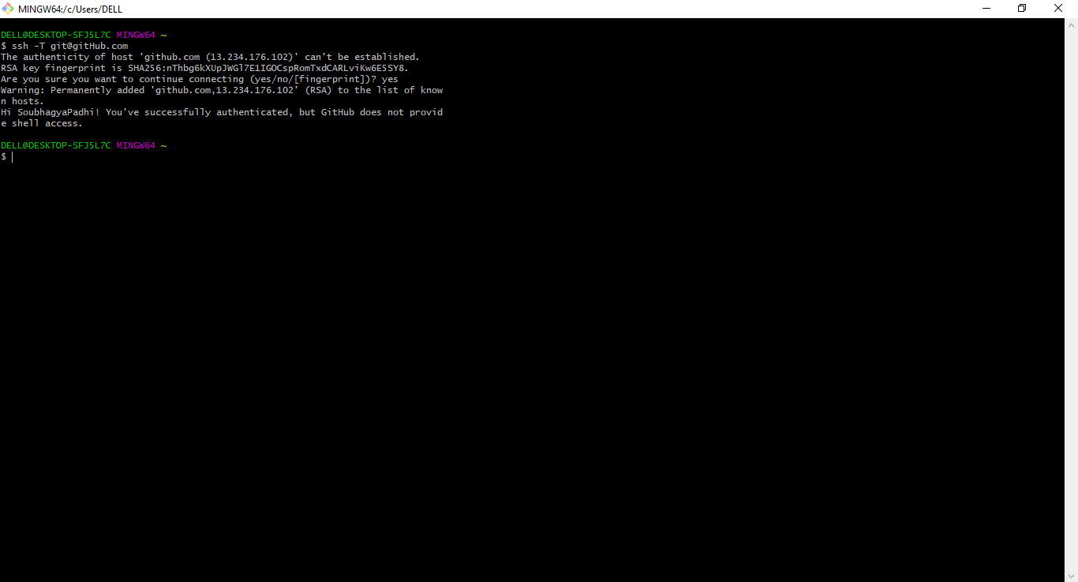

Then run the Git Push from Visual Studio Code:-

