* Document store types ( MongoDB and CouchDB)
* Key-Value store types ( Redis and Volgemort)
* Column store types ( Cassandra)
* Graph store types ( Neo4j and Giraph)

Cassandra Installation And Set Up

Download Data Stax Community Edition using below link-

<https://academy.datastax.com/planet-cassandra/cassandra>

Install it and run the below commands,

C:\Program Files\DataStax-DDC\apache-cassandra\bin

Cassandra.bat and then cqlsh

**Introduction**

-NoSQL DB

-Highly Scalable And distributed

-can handle huge amount of data across many h/ws without a single point of failure

-supports schema free ,handle through simple API, easy replication

-Decentralized Distributed Database System

-Column Oriented DB

-Fault Tolerant,Consistent

-It’s design based on Amazon’s Dynamo DB and data model based on Google’s BigTable

-created By Facebook

-Developed by Avinash Lakshman and Prashant Mallik

-Developed for Facebook’s Inbox feature

-Moved to Apache Incubator in March 2009

**Features**

**-**Highly Scalable

-Rigid Architecture

-Faster Linear Scale Performance

-Fault Tolerant due to Multiple Replication

-Supports all possible data(may be structured/semi-structured/unstructured)

-Easy Data Distribution and Transaction Support

-Fast Writes

**Architecture**

Each node is independent and can perform read/write requests as all are interconnected to each other

Node in cluster act as replicas for a given piece of data thus if some of the nodes present out of date data then Cassandra will serve the request with most recent data and perform read repair to update the correct data in each of the replica.

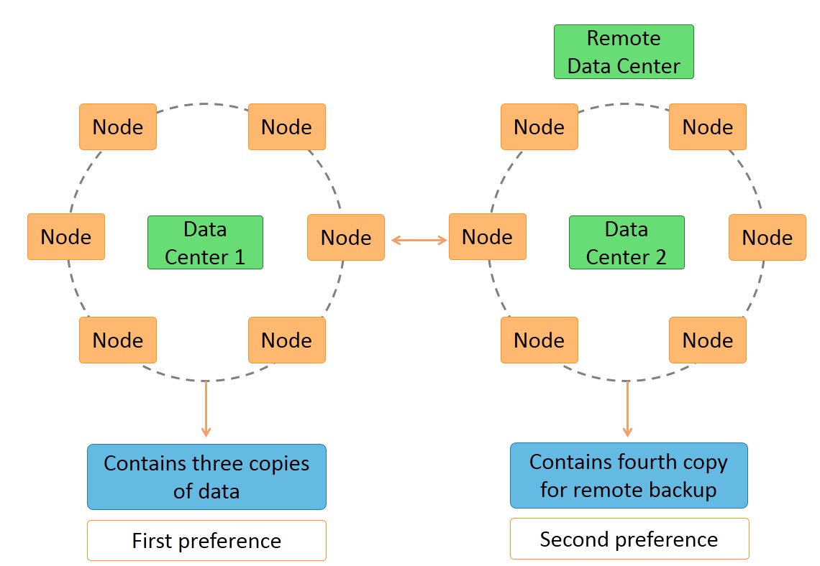

Having a Ring type architecture and designed in such a way that there is no master and no slave nodes.

Similar to HDFS architecture data is replicated across nodes for redundancy

Data is kept in memory and lazily written to disk

Hash values of the keys are used to distribute the data among nodes in cluster

Hashing applied like such as it will give the same value of the keys always gives the same hash value.

(Hash value is a number that can be mapped to each of the key value)

As in ring architecture, each of the nodes is assigned a token value.

It can support multiple data centers as shown in the above image,also data can be replicated across multiple data centers.

We can keep the three copies of data in same data center and store the fourth copy as remote back up in second data center.

As it is having no master/slave dependency,each node will try to serve the request if It has data it will return else it will pass the request to next node in the ring architecture.

Number of replicas can be configurable.

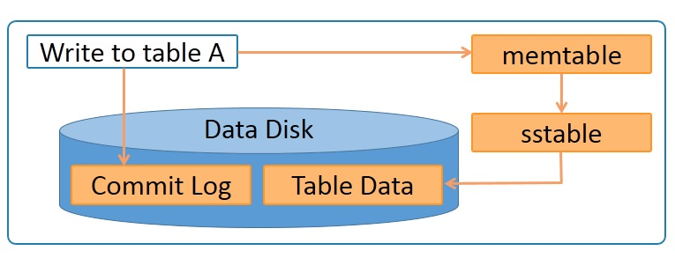

Different Components are,

Node-place where actually the data resides

Data Center-collection of related nodes

Cluster-contains one or more data centers

Commit Log-a crash recovery mechanism using which data can be recovered,every write operation is being written to the commit log

Mem-Table-Memory resident data structure ,after commit log data is written here

SSTable-Placed where the data is parked from the mem-table and It resides in disk file

Stands for Sorted String Table

Bloom Filter-Used as Cache,Algorithms to determine if the element belongs to the set,accesed after every query

Write Request Steps:-

1. Data is written to a commitlog on disk.
2. The data is sent to a responsible node based on the hash value.
3. Nodes write data to an in-memory table called memtable.
4. From the memtable, data is written to an sstable in memory. Sstable stands for Sorted String table. This has a consolidated data of all the updates to the table.
5. From the sstable, data is updated to the actual table.
6. If the responsible node is down, data will be written to another node identified as tempnode. The tempnode will hold the data temporarily till the responsible node comes alive

All writes are automatically partitioned and replicated throughout the cluster. Cassandra periodically consolidates the SSTables, discarding unnecessary data.

Read Request Steps:-

During read request,Cassandra gets the values from mem table and checks the filter to find the SSTable which contains required data,

Direct Request->Digest Request->Read Repair Request

Special Feature-Cassandra Automatic Data Expiration by providing the “**TTL**” value while inserting the data

Cassandra Data Types:-

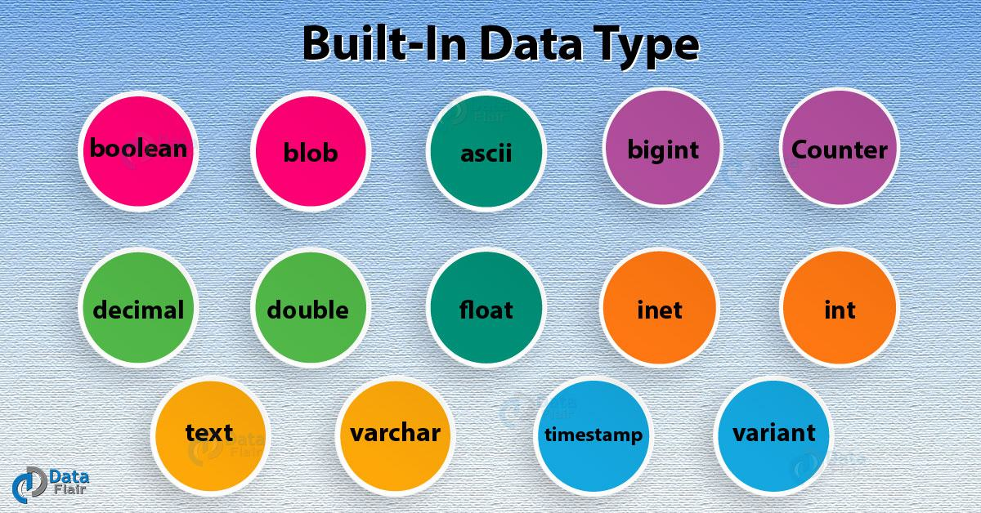

Data Model

