**Stateful Bean Example:-**

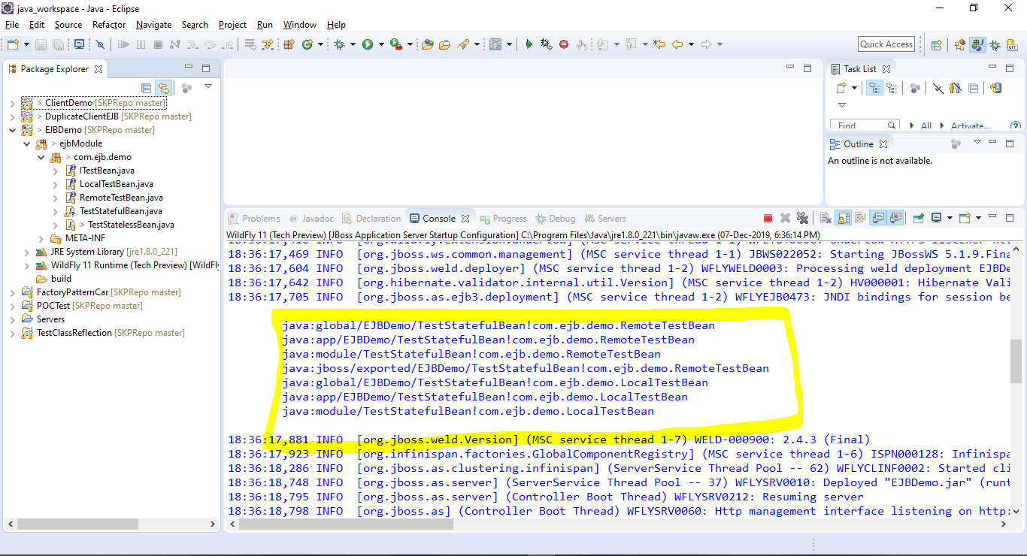

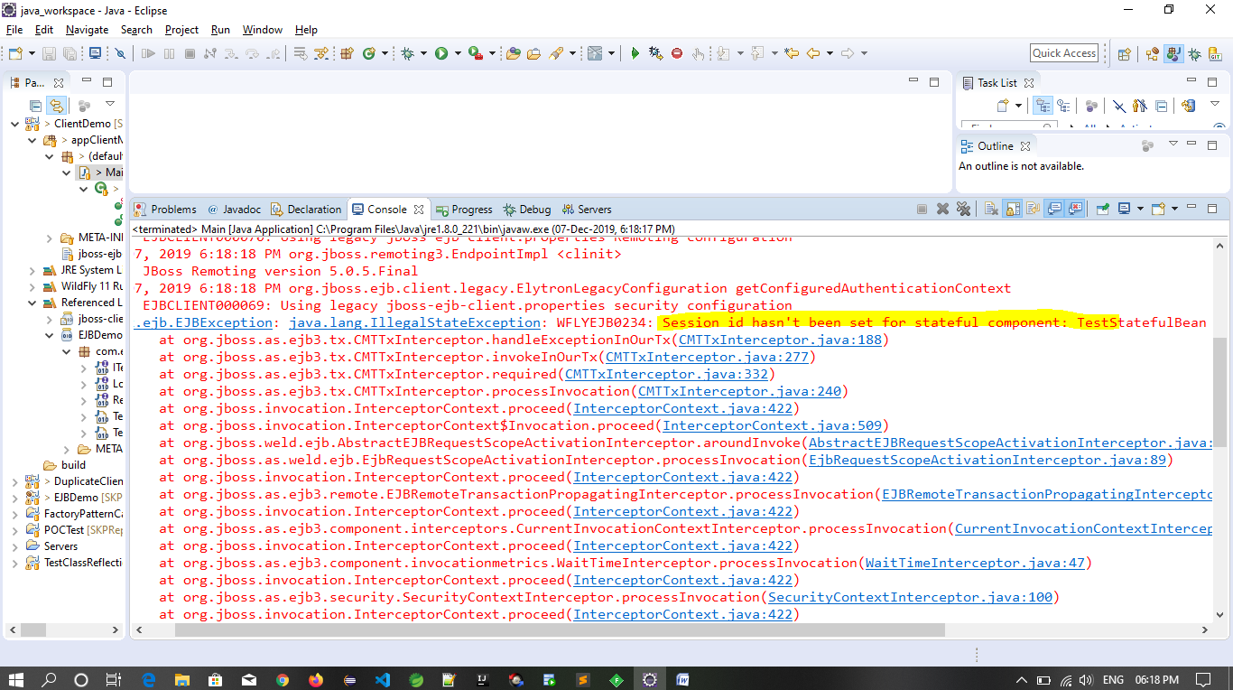

**EJB Exception:-**

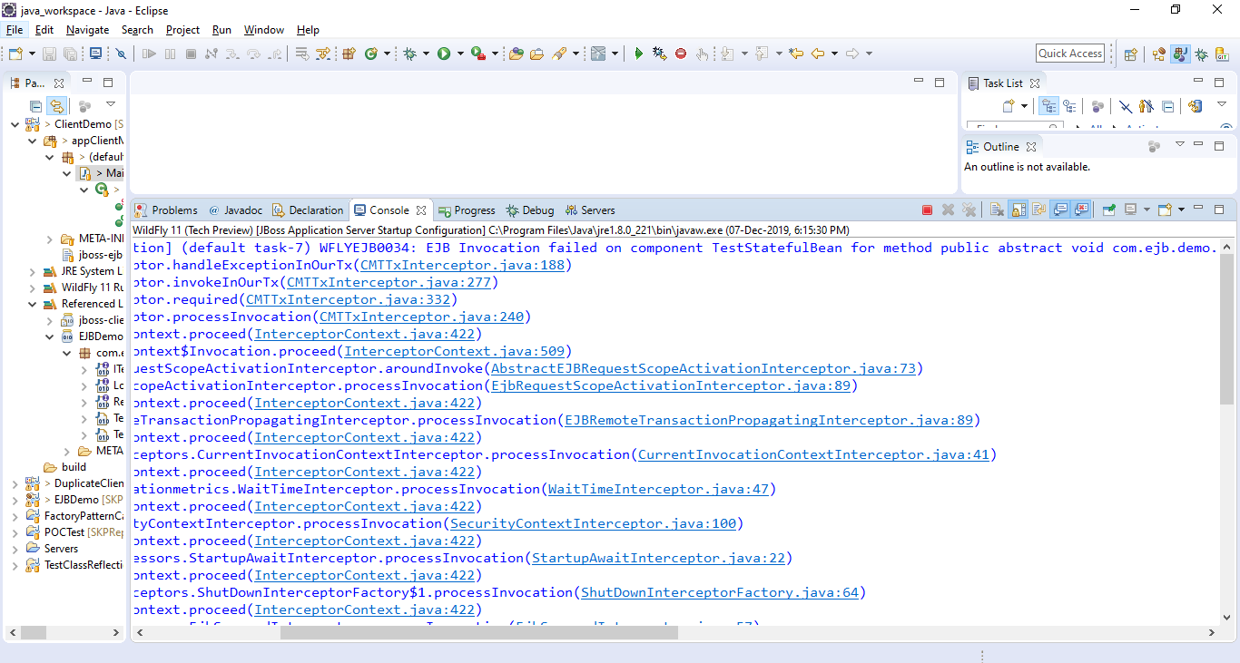

18:18:18,821 ERROR [org.jboss.as.ejb3.invocation] (default task-7) WFLYEJB0034: EJB Invocation failed on component TestStatefulBean for method public abstract void com.ejb.demo.ITestBean.addString(java.lang.String): javax.ejb.EJBException: java.lang.IllegalStateException: WFLYEJB0234: Session id hasn't been set for stateful component: TestStatefulBean

at org.jboss.as.ejb3.tx.CMTTxInterceptor.handleExceptionInOurTx(CMTTxInterceptor.java:188)

at org.jboss.as.ejb3.tx.CMTTxInterceptor.invokeInOurTx(CMTTxInterceptor.java:277)

**Resolution:-**EJB URL to Search for ,

String name = "ejb:/EJBDemo//TestStatefulBean!com.ejb.demo.RemoteTestBean?stateful";

Running From First Client:-

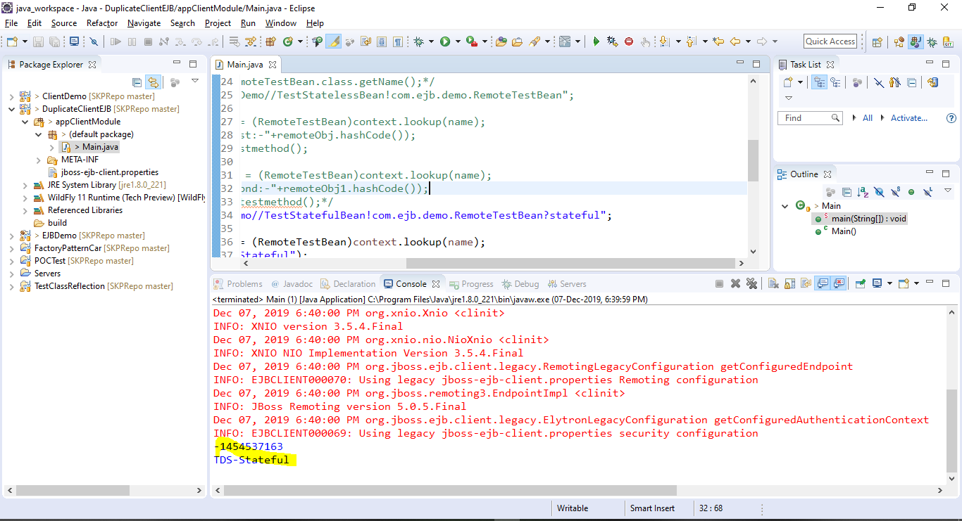

Running From Second Client:-

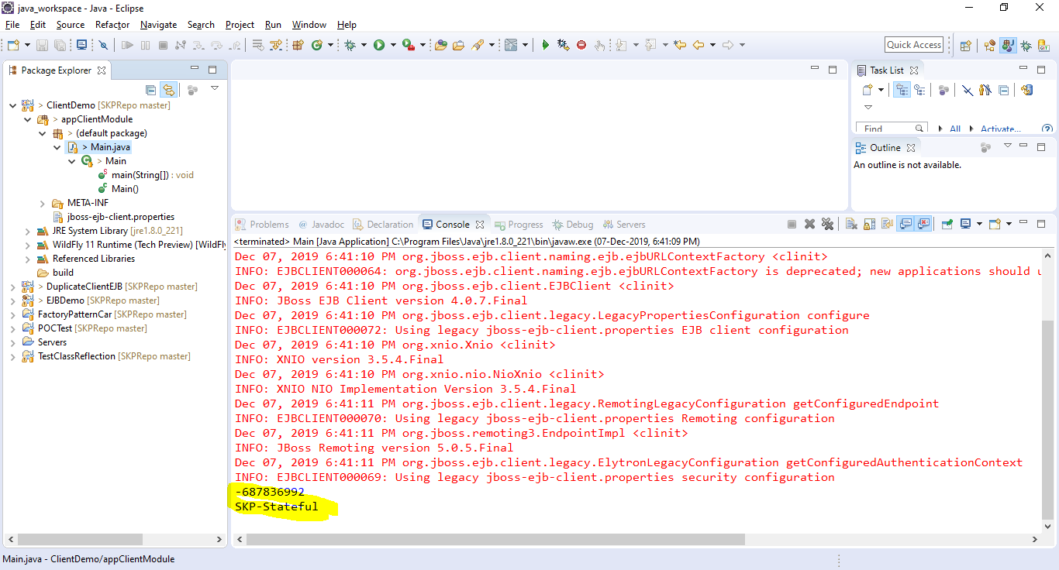

** Instance variable state is stick to per client session in case of Stateful Session bean but in case of Statless Session instance variable state is maintained as per below example(running with different client):-

Running From First Client:-

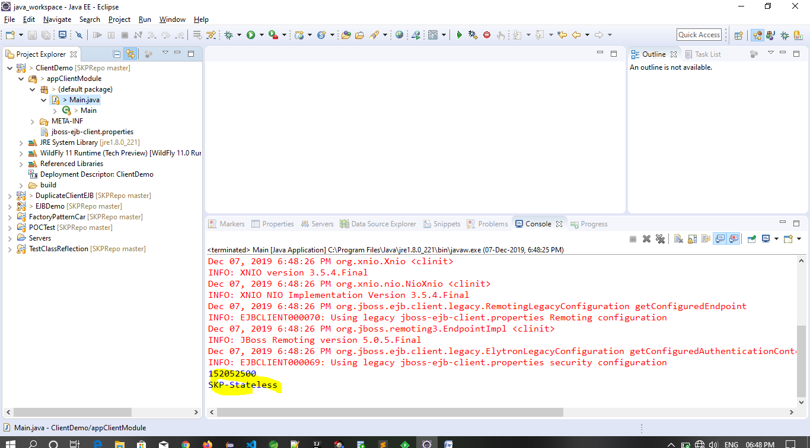

Running From Second Client:-

