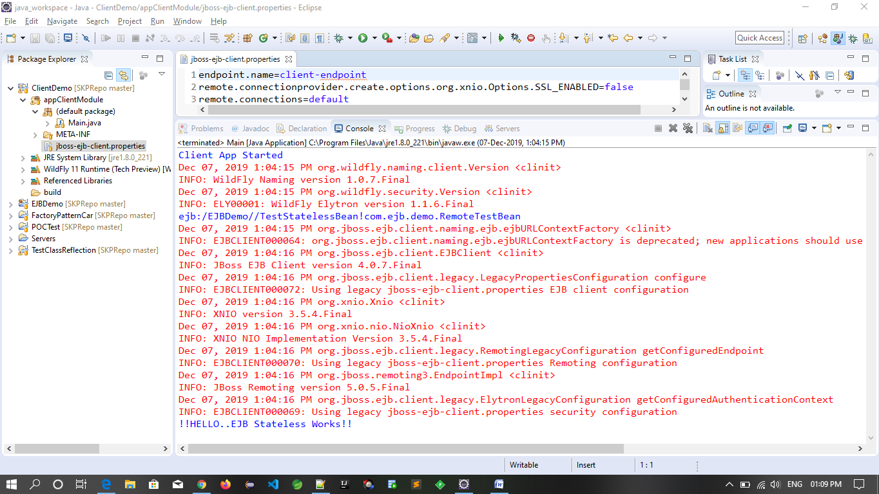

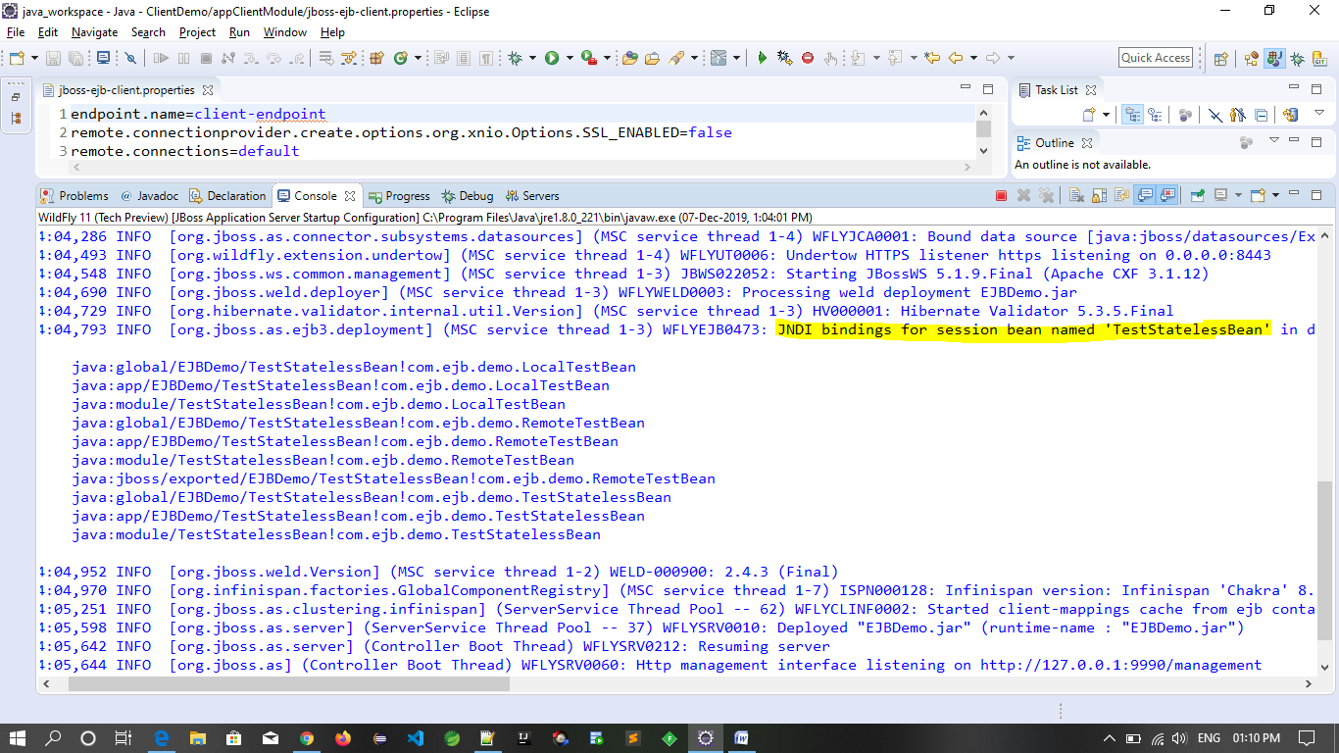

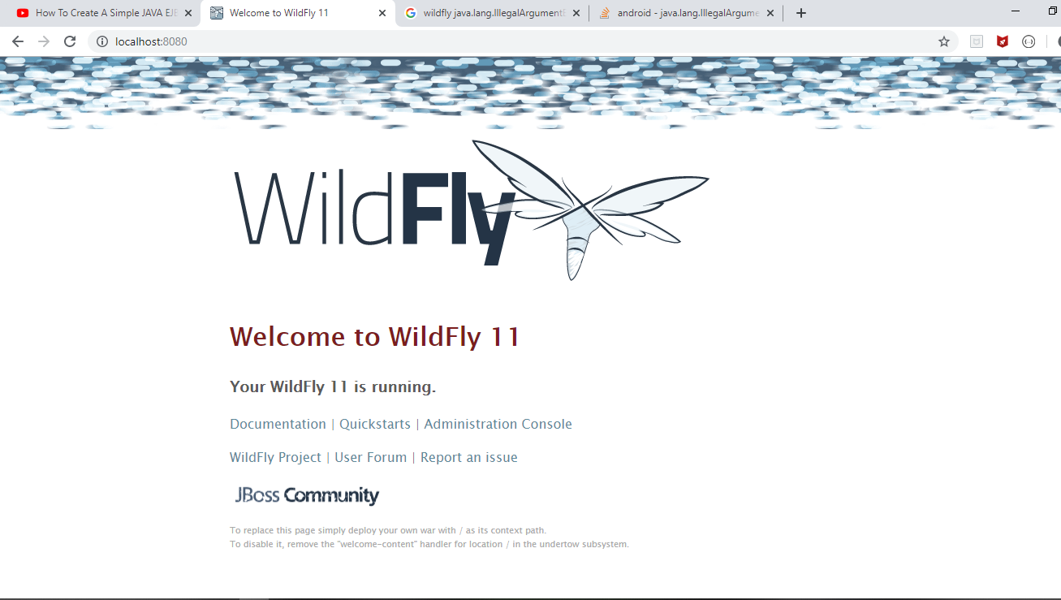

**Jboss-ejb-client.properties:-**

endpoint.name=client-endpoint

remote.connectionprovider.create.options.org.xnio.Options.SSL_ENABLED=false

remote.connections=default

remote.connection.default.host=localhost

remote.connection.default.port=8080

remote.connection.default.connect.options.org.xnio.Options.SASL_POLICY_NOANONYMOUS=false

----------------------

props.put(Context.***INITIAL_CONTEXT_FACTORY***,"org.wildfly.naming.client.WildFlyInitialContextFactory");

props.put(Context.***URL_PKG_PREFIXES***,"org.jboss.ejb.client.naming");

----------------------

String name = "ejb:/EJBDemo//TestStatelessBean!com.ejb.demo.RemoteTestBean";

ejb:/EJBDemo//TestStatelessBean!com.ejb.demo.RemoteTestBean

Dec 07, 2019 1:15:22 PM org.jboss.ejb.client.naming.ejb.ejbURLContextFactory <clinit>

INFO: EJBCLIENT000064: org.jboss.ejb.client.naming.ejb.ejbURLContextFactory is deprecated; new applications should use org.wildfly.naming.client.WildFlyInitialContextFactory instead

Dec 07, 2019 1:15:22 PM org.jboss.ejb.client.EJBClient <clinit>

INFO: JBoss EJB Client version 4.0.7.Final

java.lang.ClassCastException: com.sun.proxy.$Proxy0 cannot be cast to com.ejb.demo.LocalTestBean

at Main.main(Main.java:30)