**JMS P-T-P Messaging using GlassFish Server:-**

**JARS to incude in Sender/Receiver app:-**

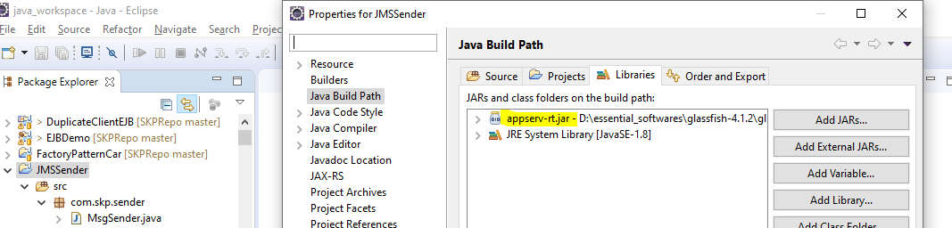

* **JMS Connection Factory:-**

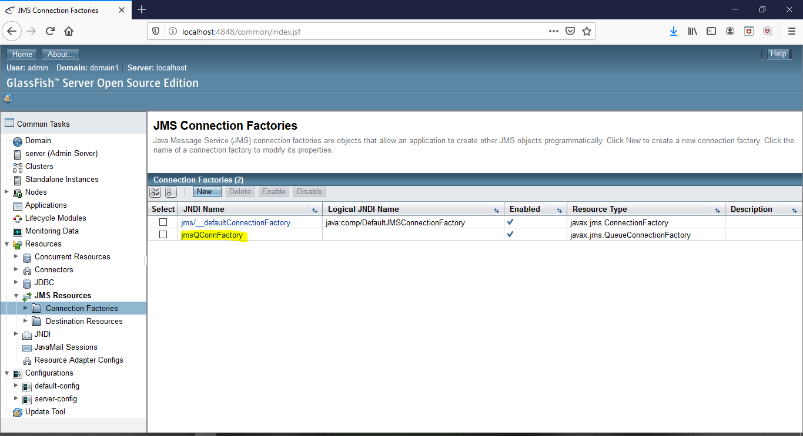

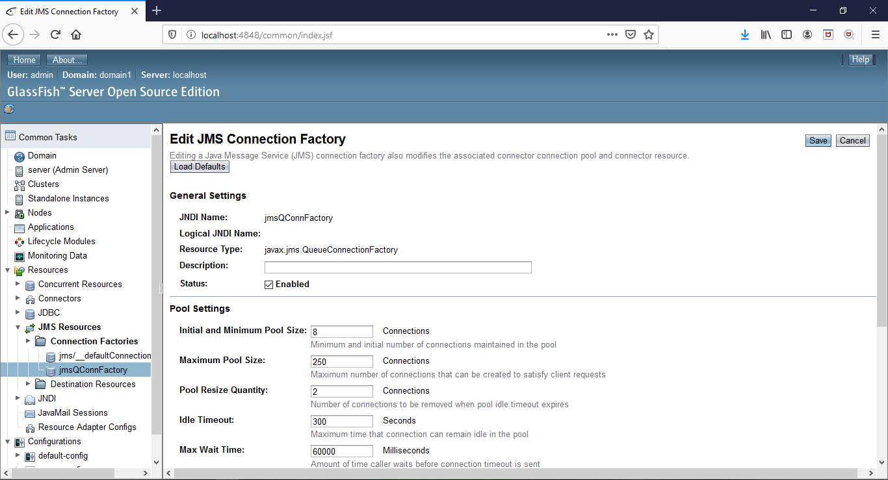

* **JMS Queue Defined in GlassFish Server:-**

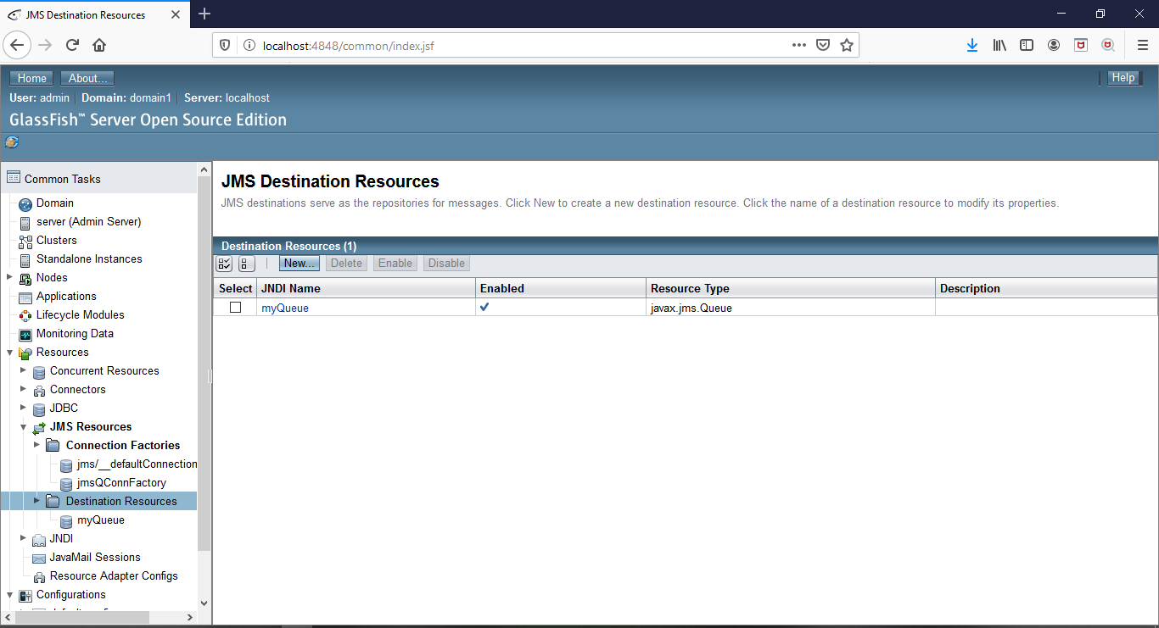

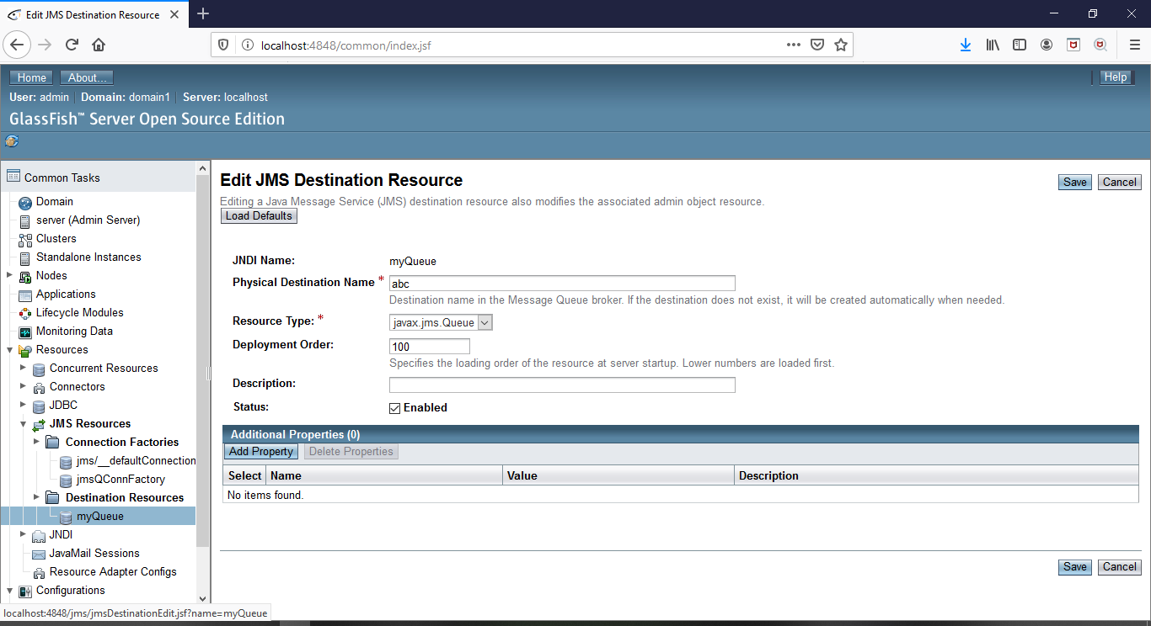

* **JMS Sender:-**

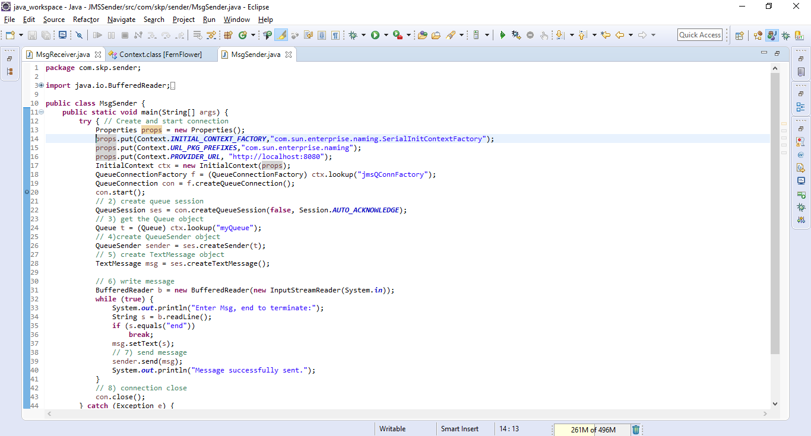

* **JMS Receiver:-**

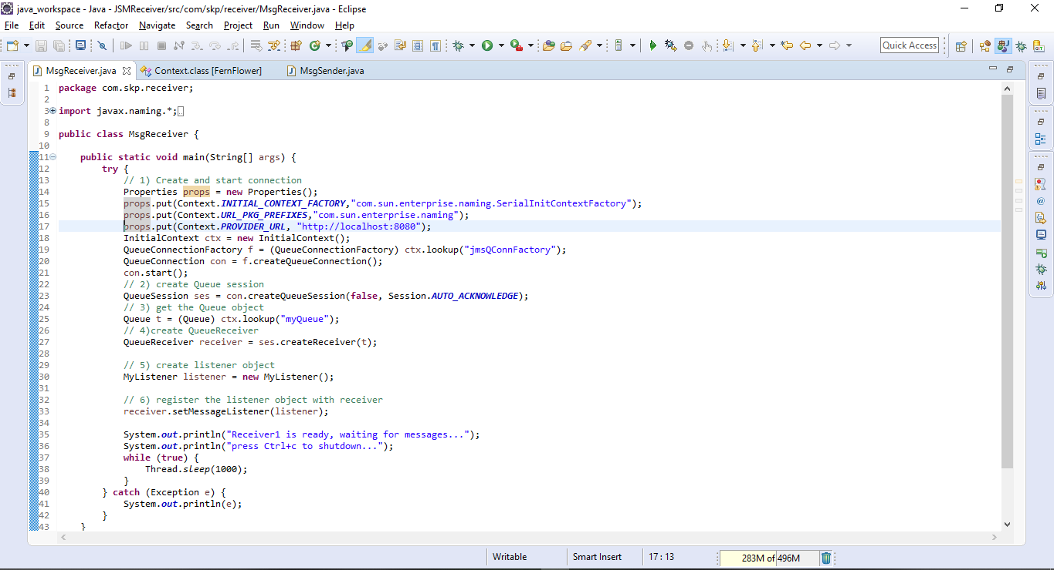

* **JMS Listener:-**

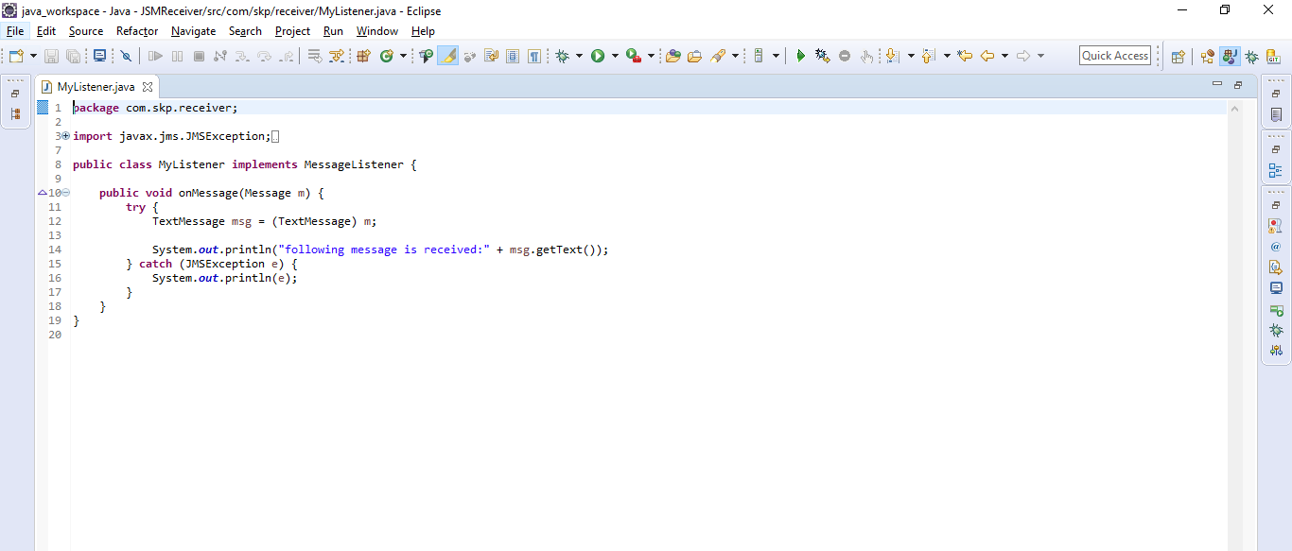

* **Running Message Receiver First and Sender afterwords:-**
* **Sender Logs:-**

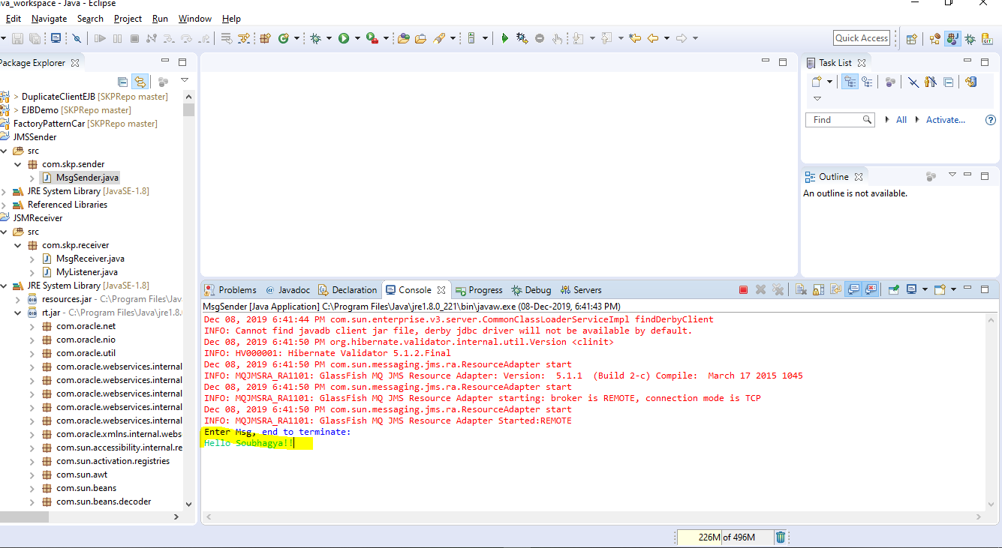

* **Receiver Logs:-**

