**JMS Publisher/Subsriber(Topic) Messaging using GlassFish Server:-**

* **JMS Topic Connection Factory:-**

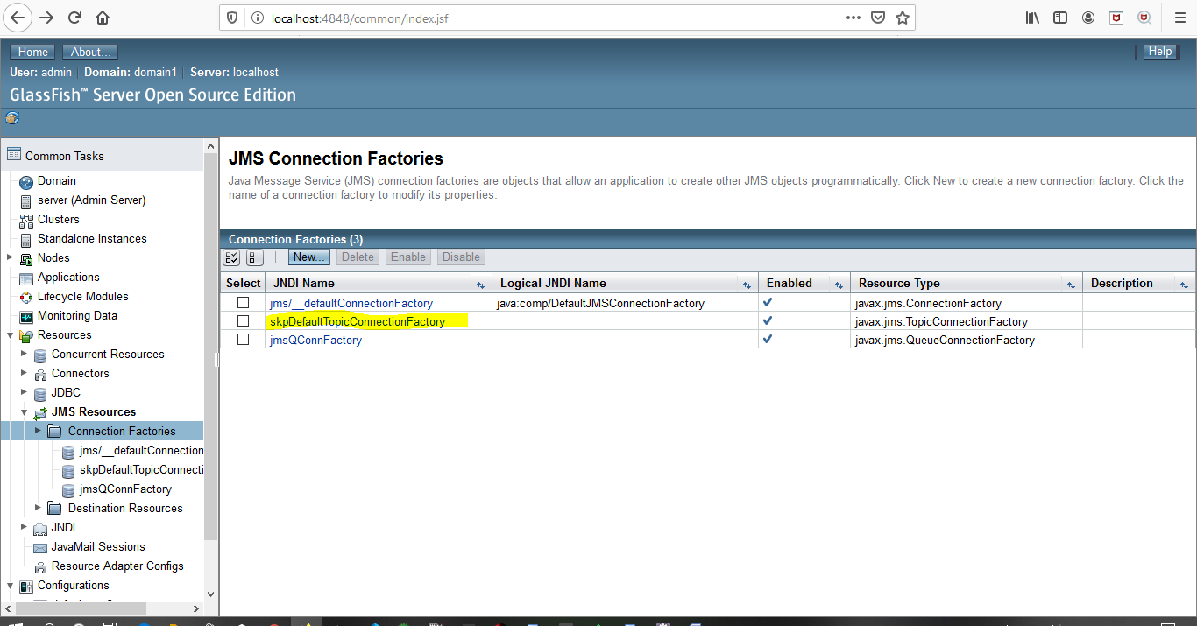

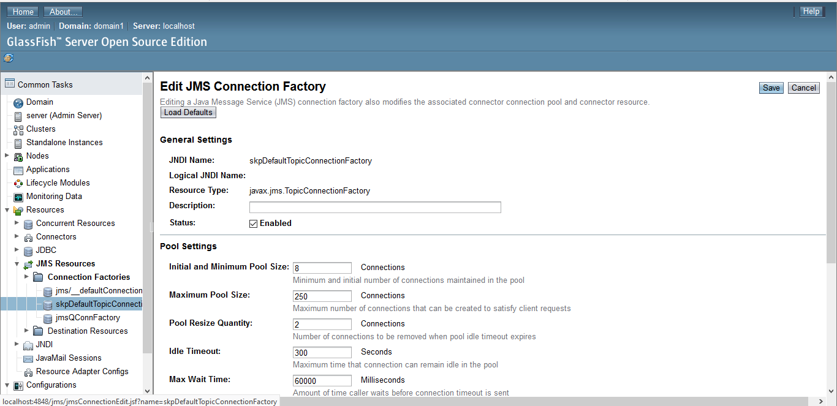

* **New JMS Topic Configuration:-**

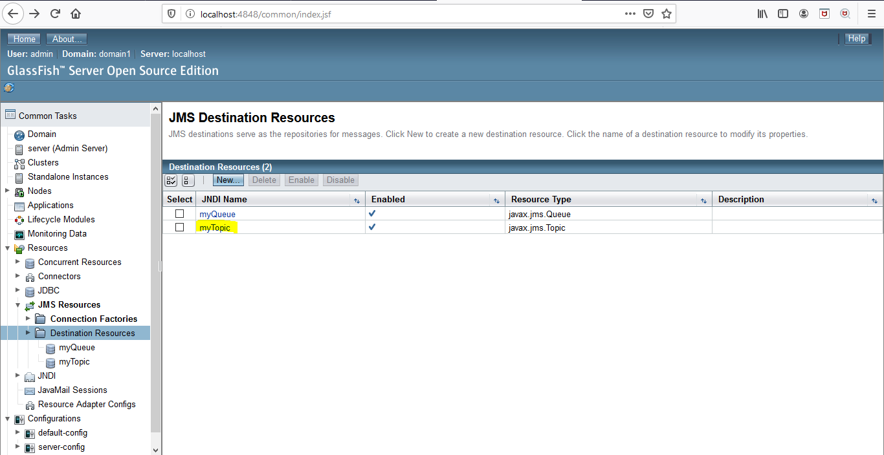

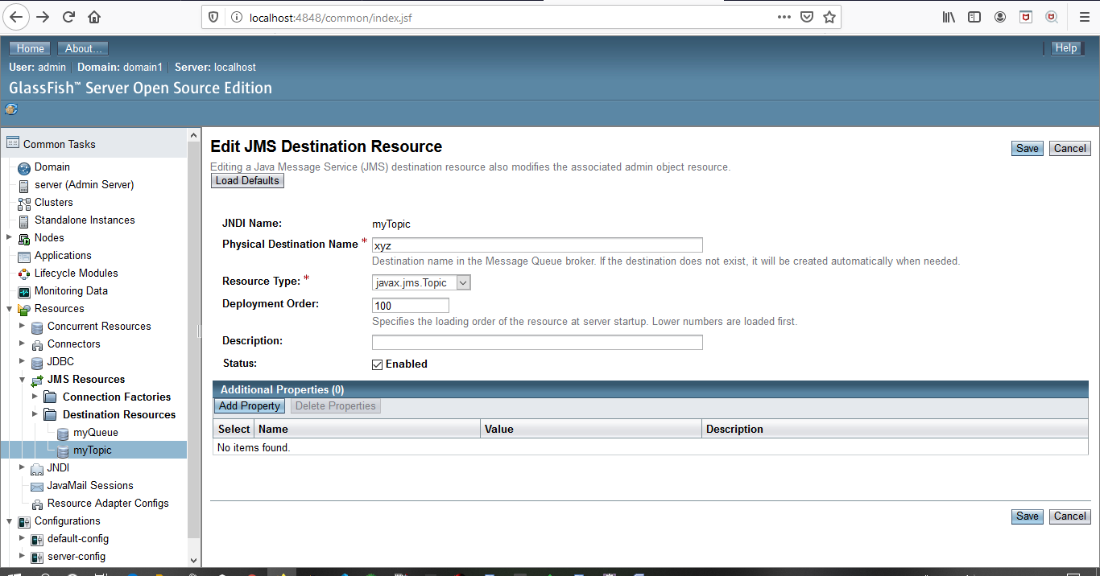

* **Add the below jar to Subsriber/Producer:-**

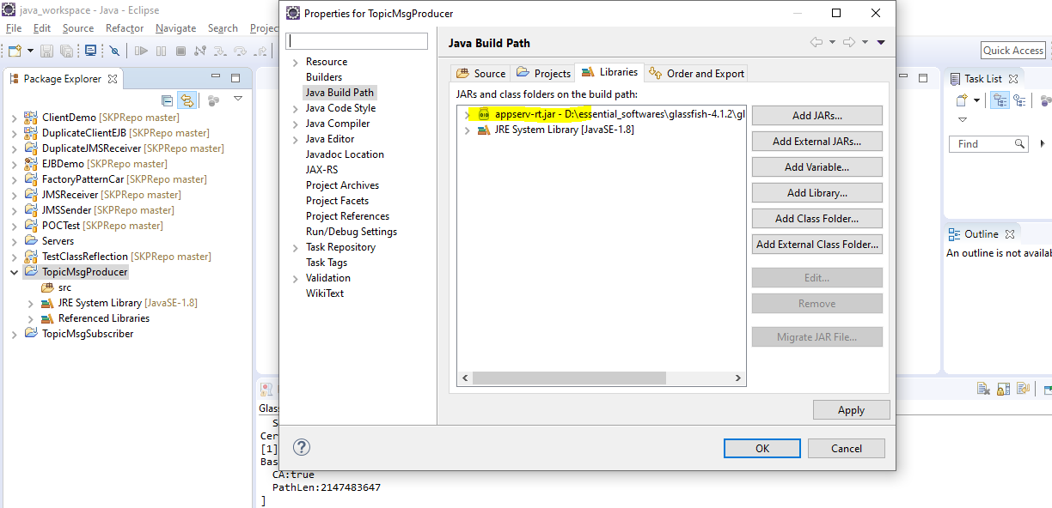

* **TopicMsgPublisher Code:-**

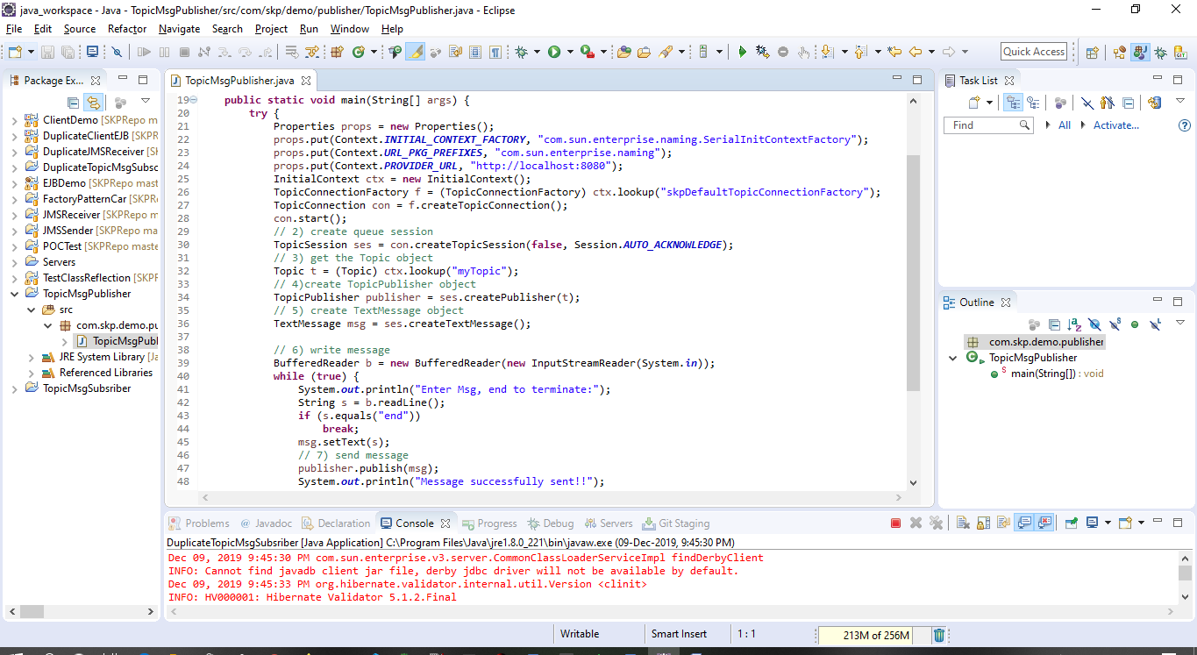

* **TopicMsgSubscriber Code:-**

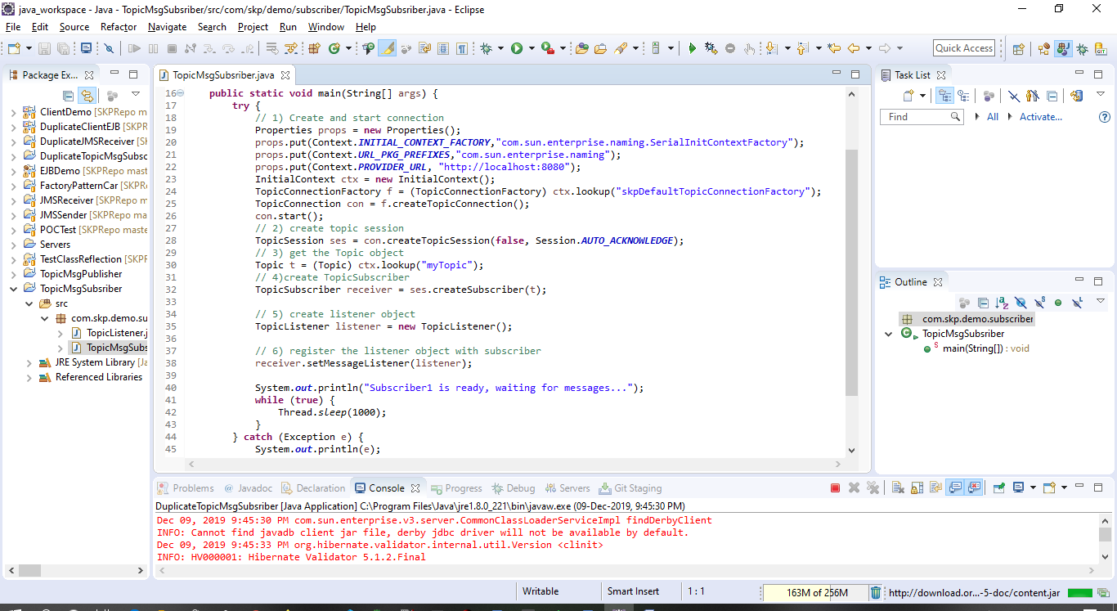

* **TopicMsgListener Code:-**

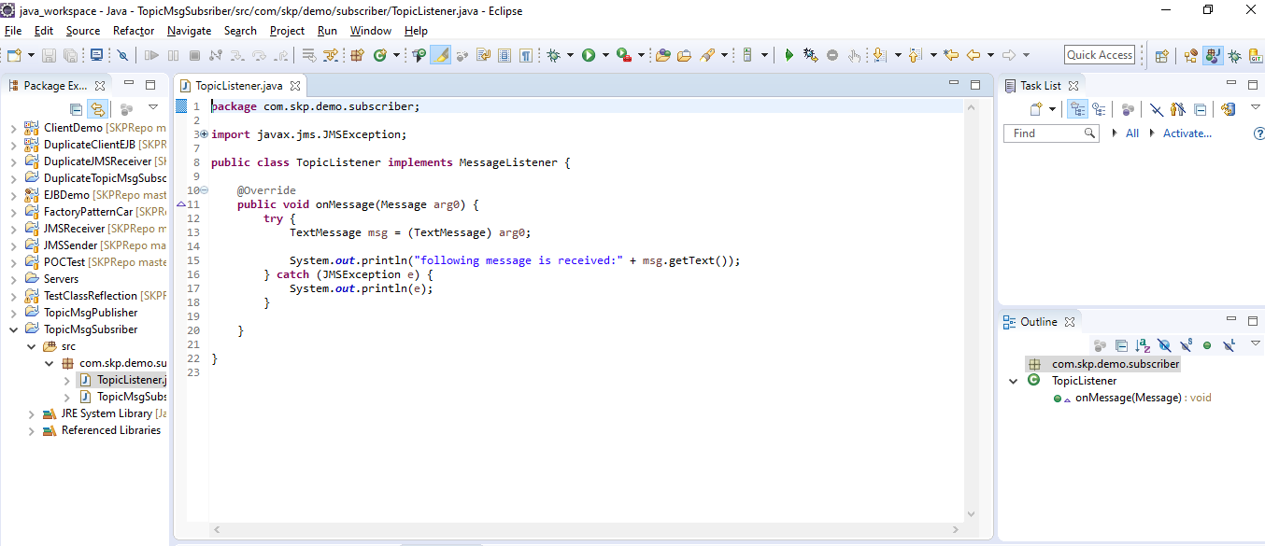

* **Running multiple Message Subsriber:-**

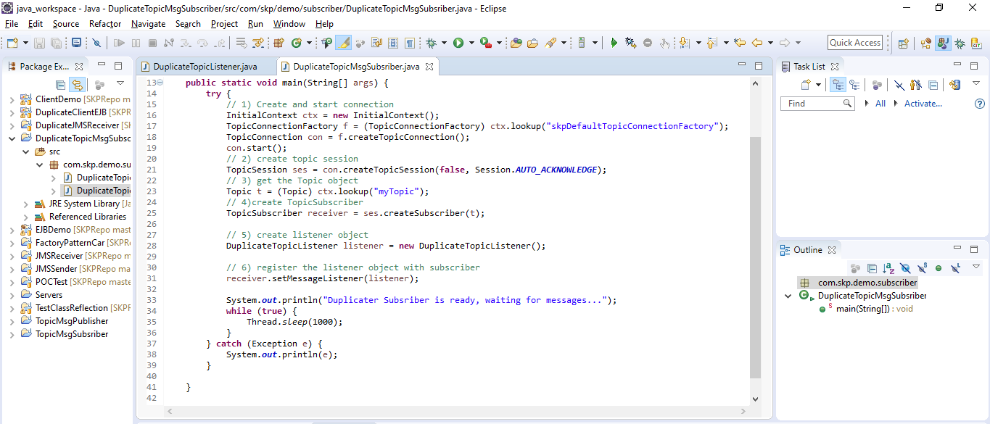

* **Message Producer Logs:-**

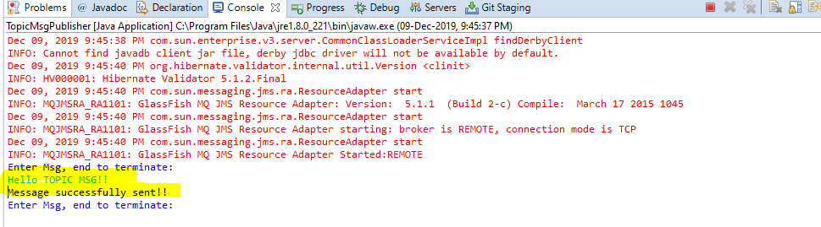

* **First Message Subscriber Logs:-**

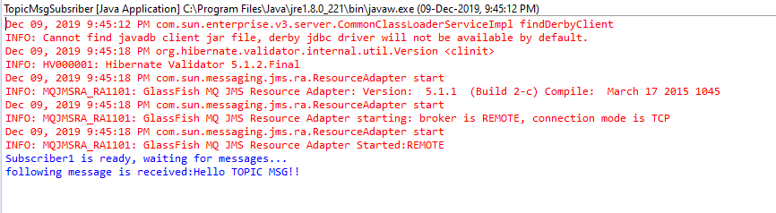

* **Second Message Subscriber Logs(Listening to same message as we are using Topic Config):-**

