***Jenkins –Maven And GitHub Integration***

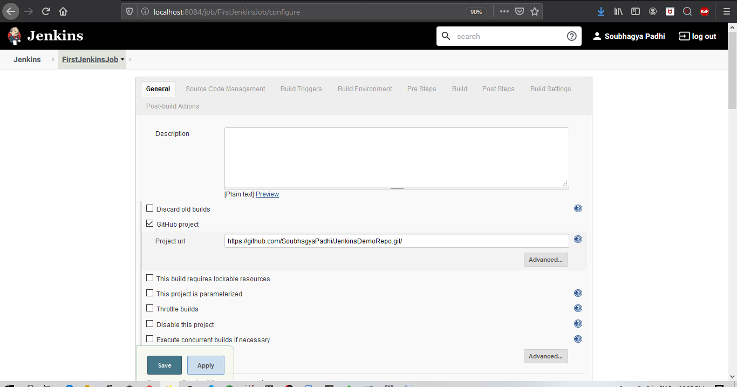

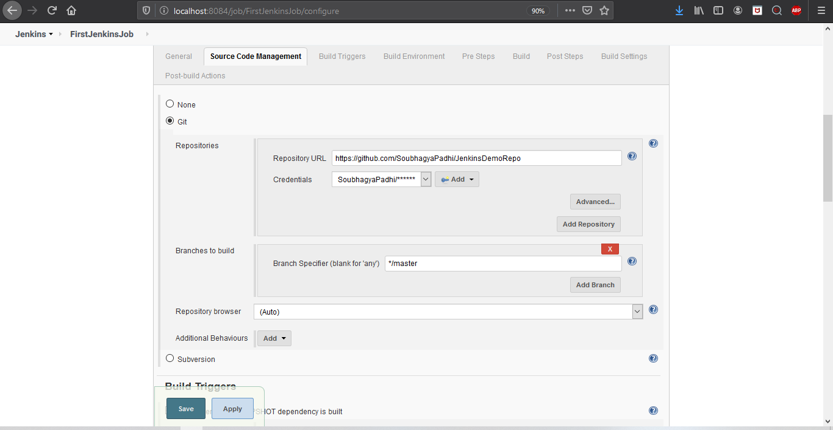

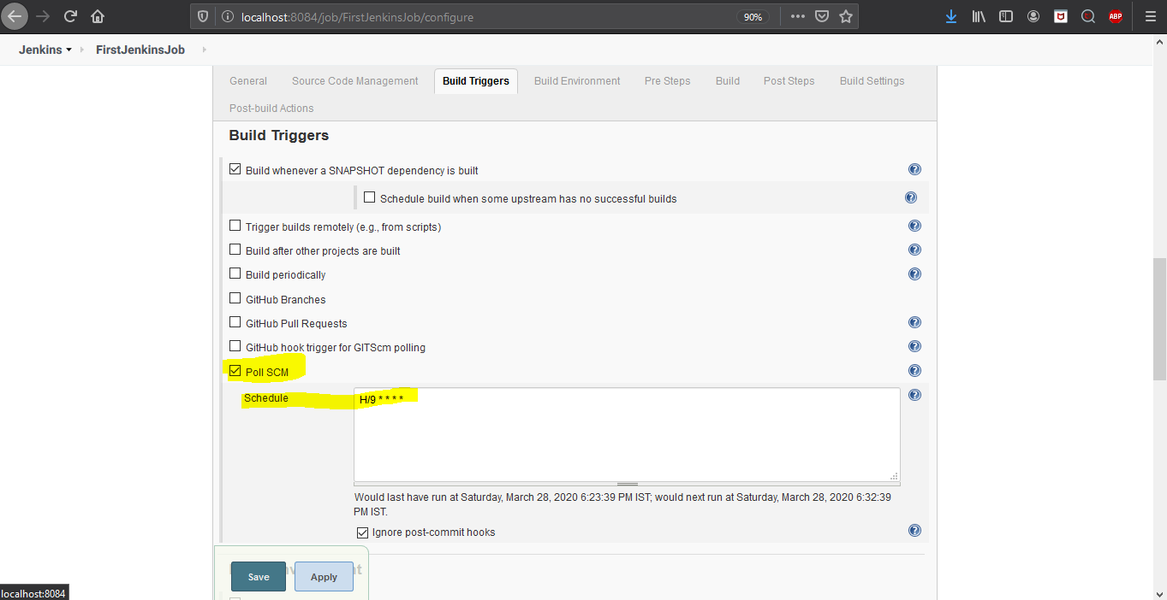

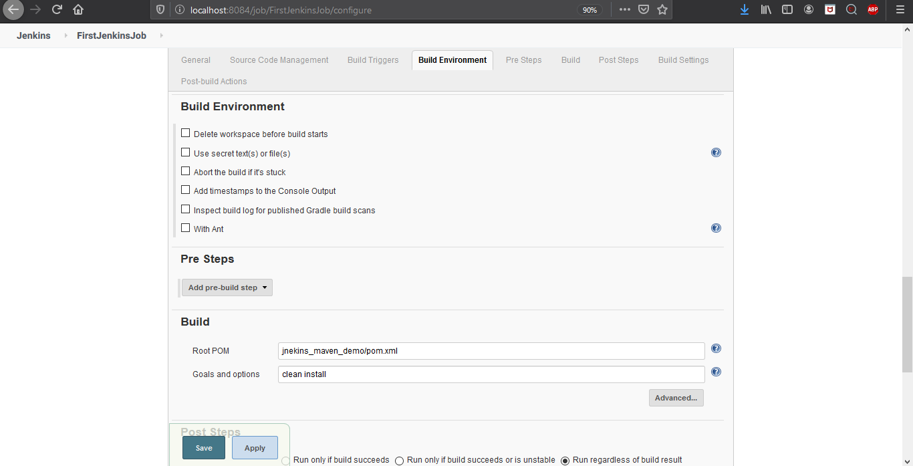

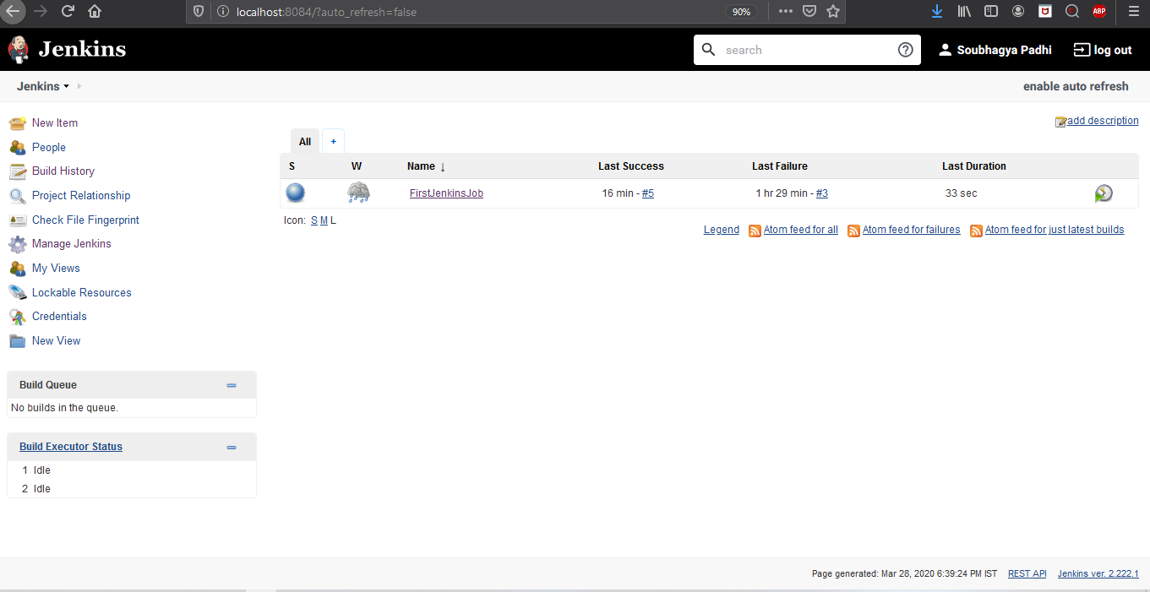

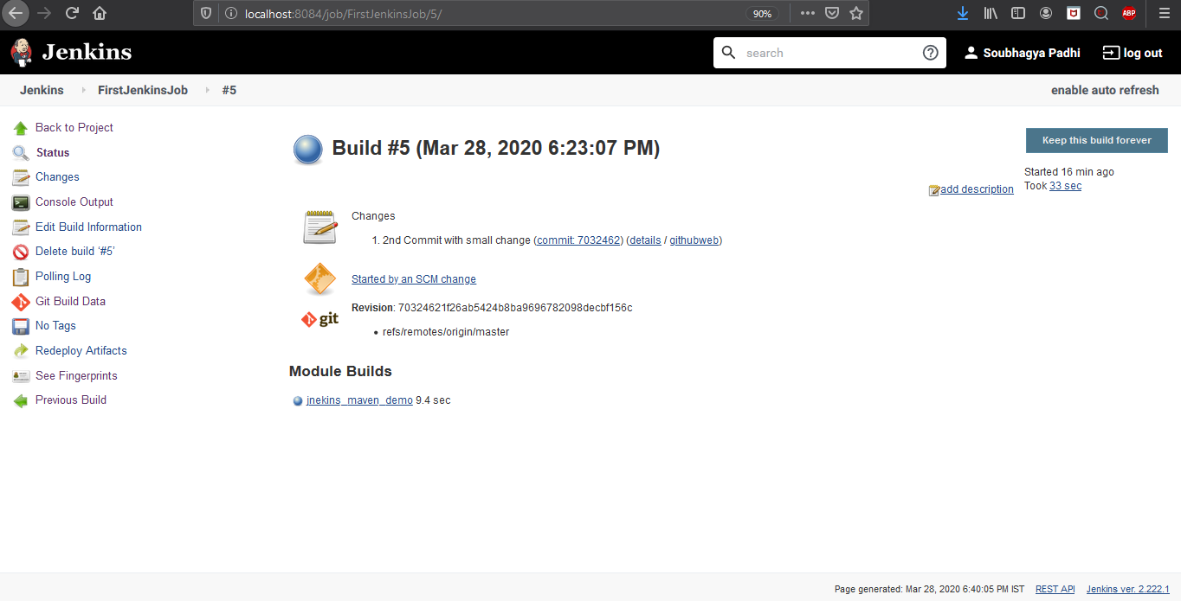

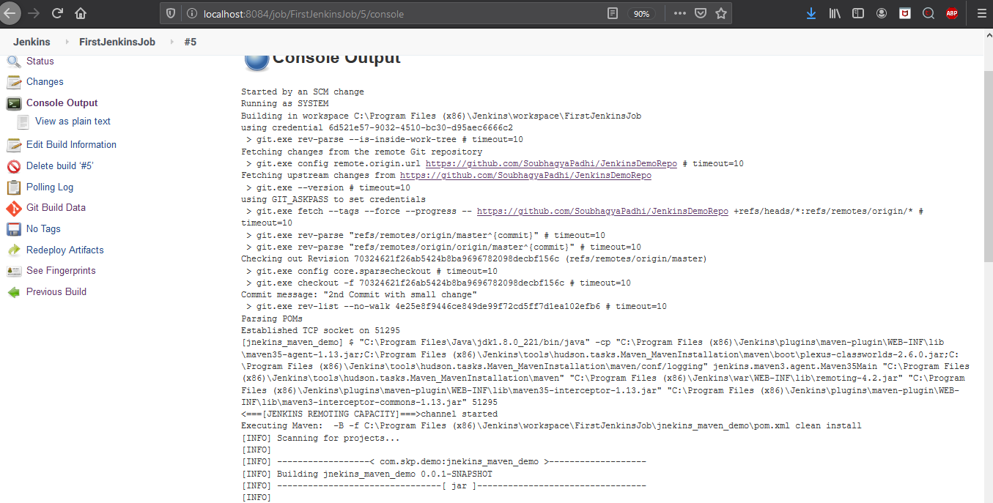

**Polling Log**

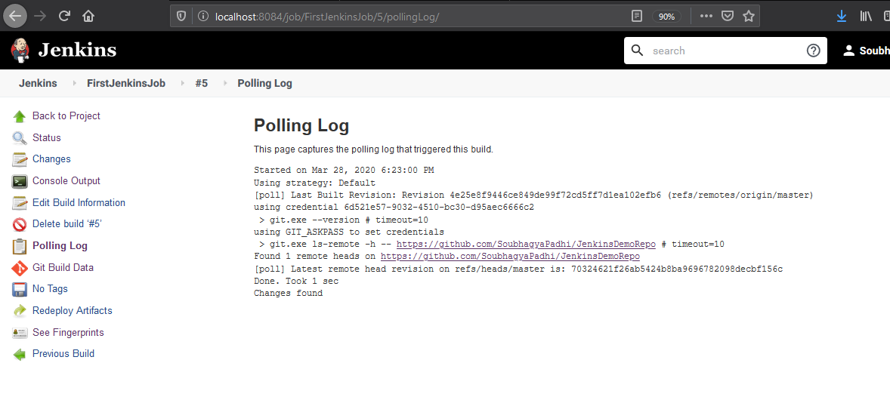

We can also add webhook in git repo but should be with an public ip/url ,can be tweeked using WebRelay app as well with using localhost.

**Plugins needed:-**

Git Plugin

GitHub Plugin

Maven Integration Plugin

GitHub Integration Plugin