**Message Driven Bean Example using Glassfish-4 Server:-**

* **Create a EJB Project and declare a MDB as per below screenshot:-**

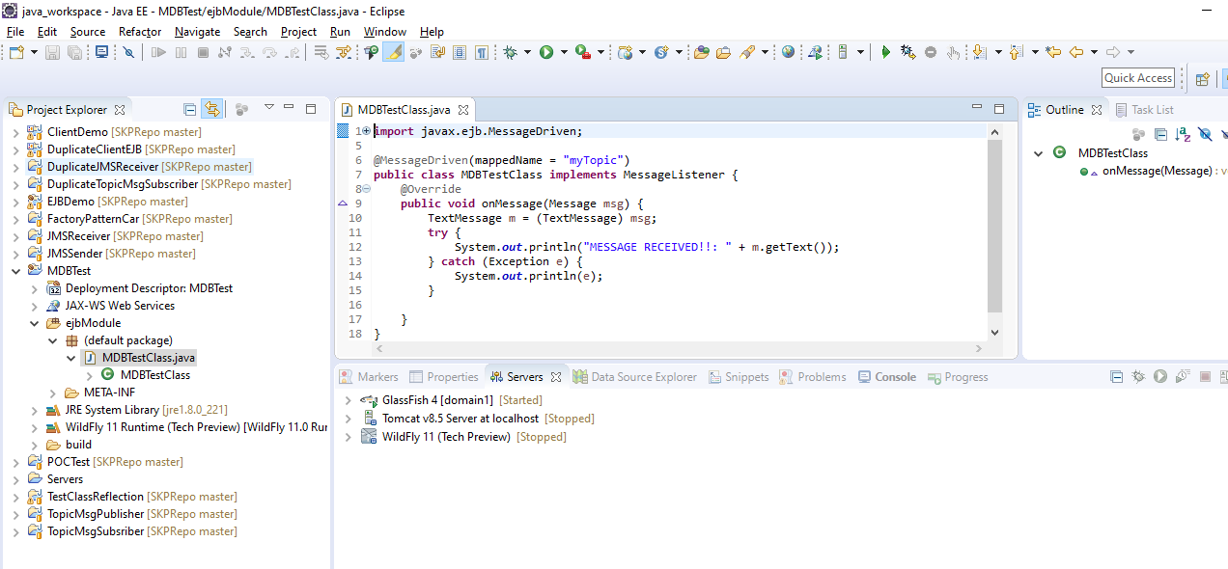

* **Deploy this to GlassFish Server(in Applications module coming under Admin GUI):-**

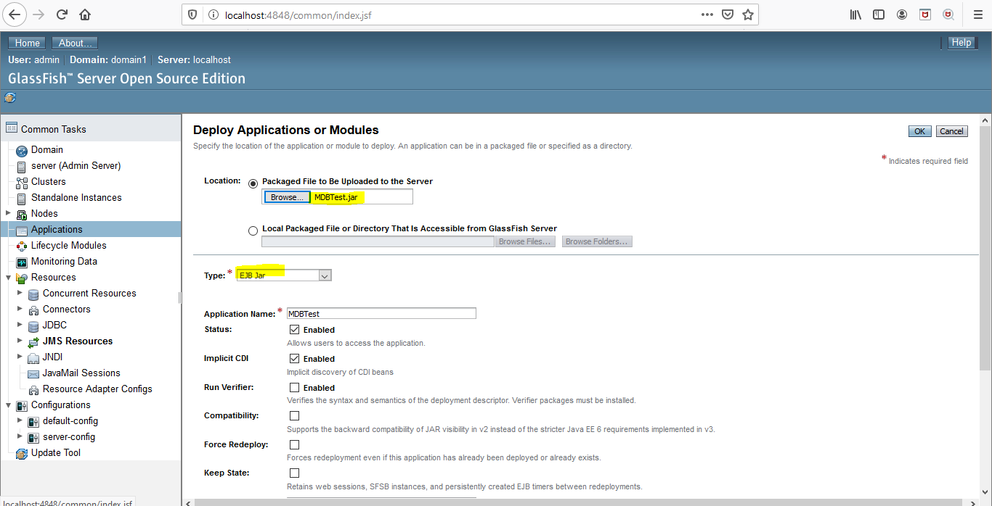

* **Monitor the server logs:-**

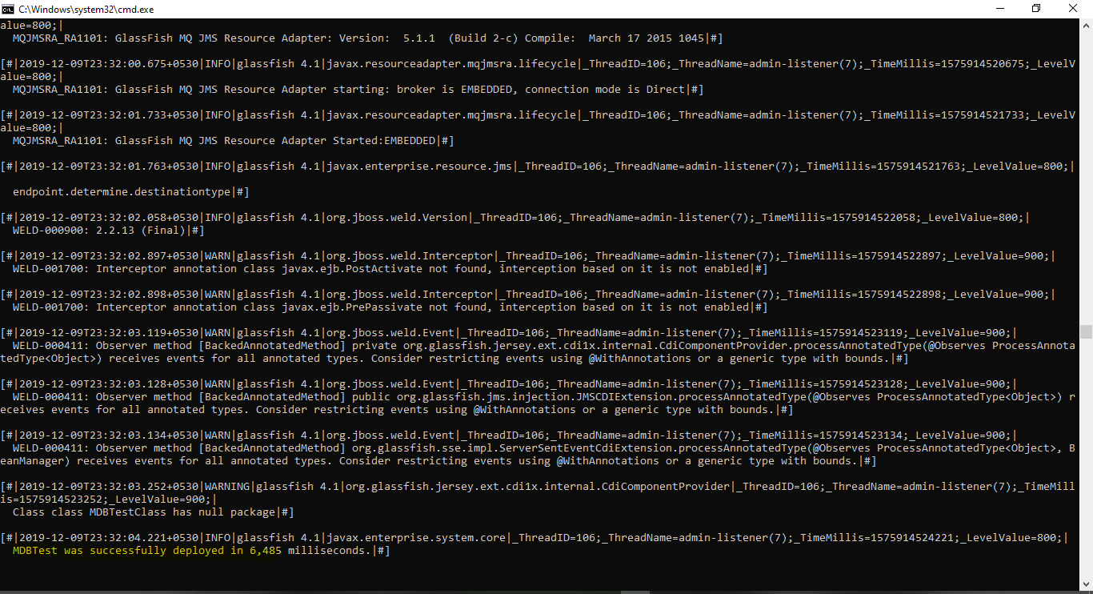

* **Now run a TopicPublisher to send a nessage to running MDB Server:-**

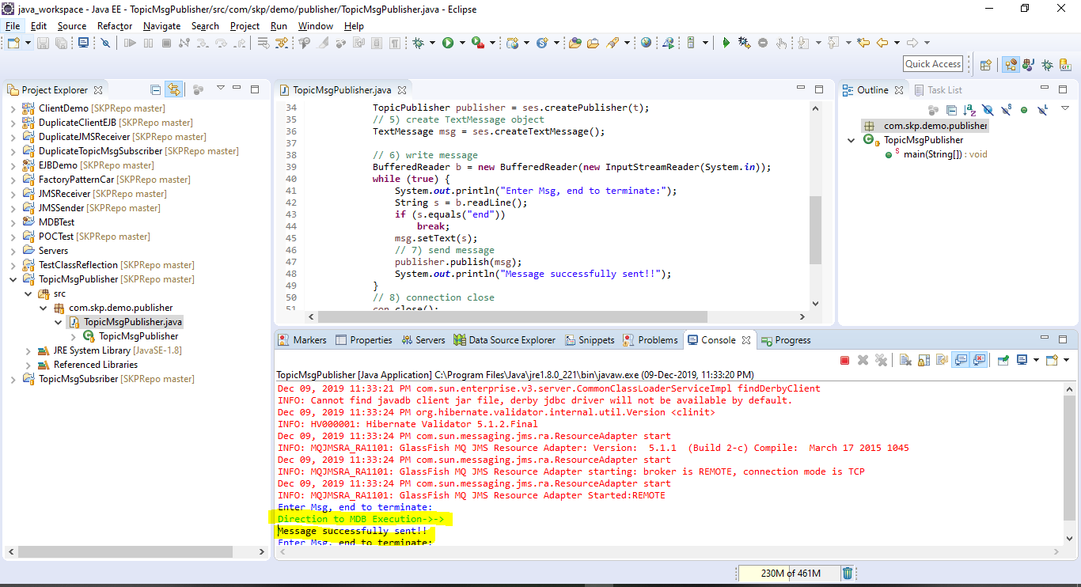

* **Now check the Glassfish MDB Server Logs if it receives the sent message from Publisher as per below screenshot:-**

