Add **<JMS ActiveMQ>** Messaging option to **Wildfly-11.0** Server by using wildfly admin command console with below highlighted command:-

[standalone@localhost:9990 /]/extension=org.wildfly.extension.messaging-activemq:add

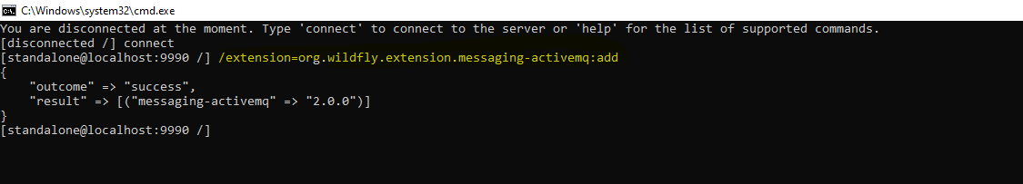

Then copy the below messaging confguration from standalone-full.xml to standalone.xml:-

<subsystem xmlns="urn:jboss:domain:messaging-activemq:2.0">

<server name="default">

<security-setting name="#">

<role name="guest" send="true" consume="true" create-non-durable-queue="true" delete-non-durable-queue="true"/>

</security-setting>

<address-setting name="#" dead-letter-address="jms.queue.DLQ" expiry-address="jms.queue.ExpiryQueue" max-size-bytes="10485760" page-size-bytes="2097152" message-counter-history-day-limit="10"/>

<http-connector name="http-connector" socket-binding="http" endpoint="http-acceptor"/>

<http-connector name="http-connector-throughput" socket-binding="http" endpoint="http-acceptor-throughput">

<param name="batch-delay" value="50"/>

</http-connector>

<in-vm-connector name="in-vm" server-id="0">

<param name="buffer-pooling" value="false"/>

</in-vm-connector>

<http-acceptor name="http-acceptor" http-listener="default"/>

<http-acceptor name="http-acceptor-throughput" http-listener="default">

<param name="batch-delay" value="50"/>

<param name="direct-deliver" value="false"/>

</http-acceptor>

<in-vm-acceptor name="in-vm" server-id="0">

<param name="buffer-pooling" value="false"/>

</in-vm-acceptor>

<jms-queue name="ExpiryQueue" entries="java:/jms/queue/ExpiryQueue"/>

<jms-queue name="DLQ" entries="java:/jms/queue/DLQ"/>

<connection-factory name="InVmConnectionFactory" entries="java:/ConnectionFactory" connectors="in-vm"/>

<connection-factory name="RemoteConnectionFactory" entries="java:jboss/exported/jms/RemoteConnectionFactory" connectors="http-connector"/>

<pooled-connection-factory name="activemq-ra" entries="java:/JmsXA java:jboss/DefaultJMSConnectionFactory" connectors="in-vm" transaction="xa"/>

</server>

</subsystem>

Then start the wildfly server and check the management admin console to verify the newly added sub-system:-

