SQL Order Of Execution:-

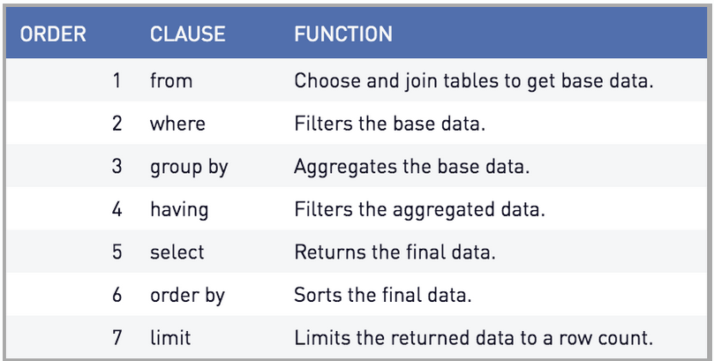

FROM -> CONNECT BY -> WHERE -> GROUP BY -> HAVING -> SELECT -> ORDER BY

FROM clause selects and joins your tables and is the first executed part of a query. This means that in queries with joins, the join is the first thing to happen.

It's a good practice to limit or pre-aggregate tables before potentially large joins, which can otherwise be very memory intensive. However, if you are going to use columns in a way that prevents pre-filtering, the database will have to sort and join both full tables. For example, the following query requires a column from each table and will be forced into a join before any filtering takes place.

