Run the following command to run the main.yaml playbook

ansible-playbook main.yaml

Assuming the The default inventory file already define in ansible.cfg

ansible.cfg

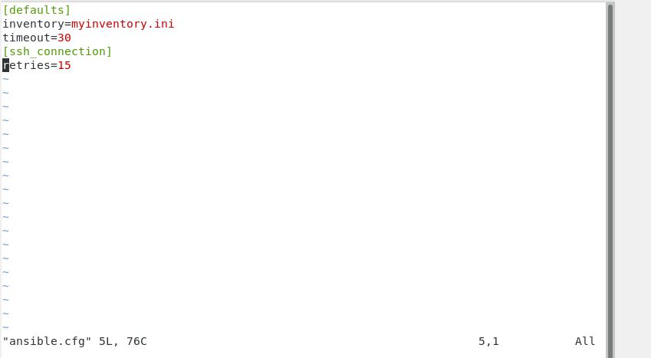

myinventory.ini

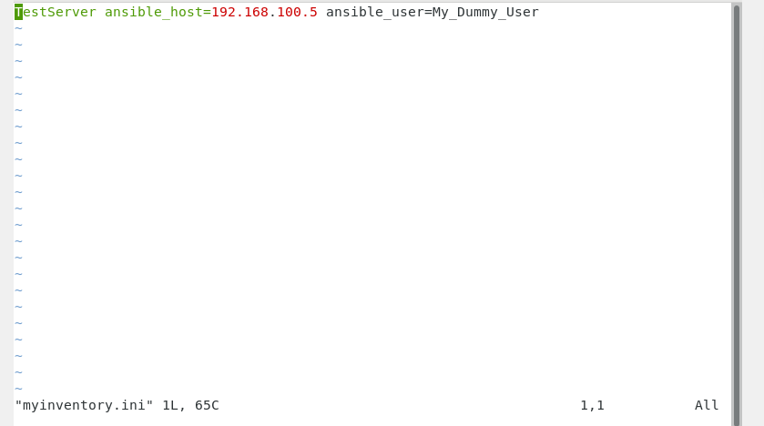

Output

