Problem Statement :

--------------------------------------------------------------------------------------------------------

Write Roles using ansible-galaxy,fill README.md and meta/main.yml

Publish,test and tag the role to Git

Specify roles and install it in roles directory

All roles that are ready to go to production should be tagged with a version,All playbook that are ready for

production should specify which version of each role to use

Tags and changes to identify the version of the playbook to use,store version of the playbok with environment

----------------------------------------------------------------------------------------------------------

Solution:

We have to run following command

ansible-galaxy init Ping_All_Target

explanation:

After executing this command Ping_All_Target role will be created in the current working directory.

Here Ping_All_Target is the name of the role.

The directory Structure for this role will be look like

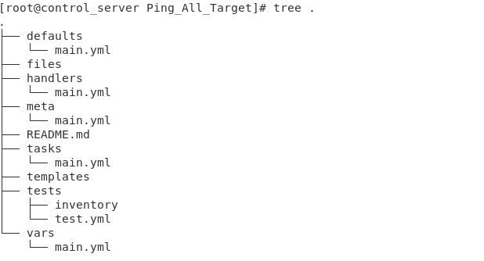

Next We Have Modified README.md file using the following command

vim README.md

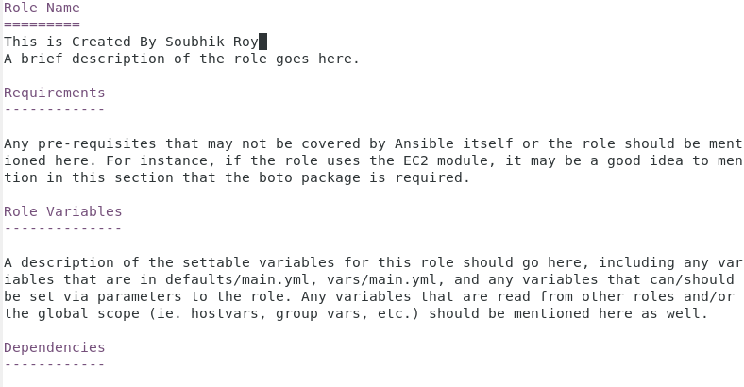

Next We have modified meta/main.yml file using the following command

vim /meta/main.yml

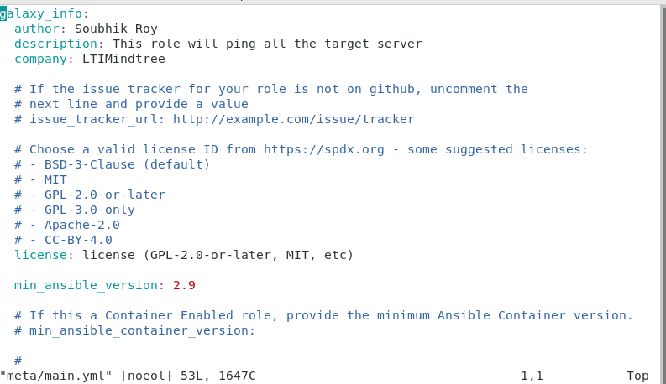

Next we have Modified Defaults/main.yml and tasks/main.yml

In Defaults/main.yml we have added Default Variables to be used for this role and in tasks/main.yml we have added role specific tasks

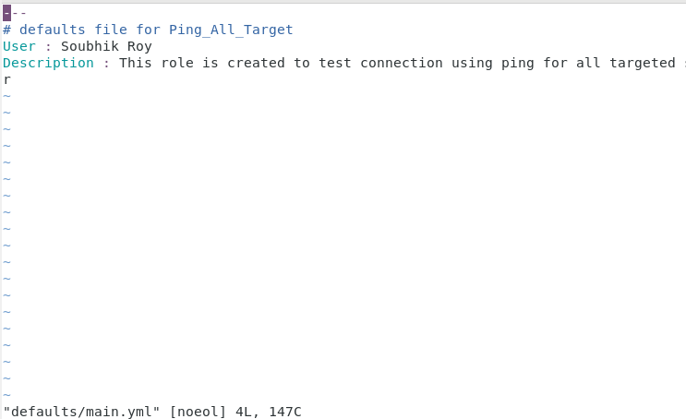

Tasks/main.yml

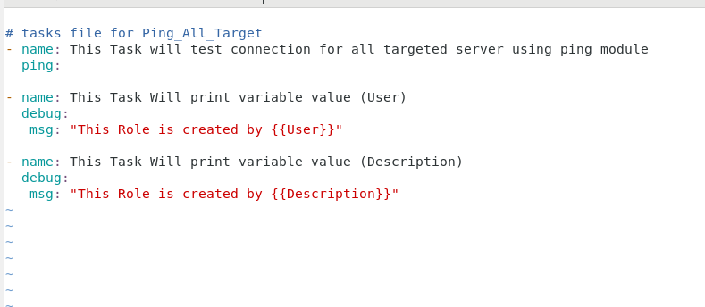

Next For Publishing the role into git we have to follow steps mentioned below

NOTE:- Assuming Git is already Configured

1. git init
2. git add .
3. git commit -m "Initial commit for Ping_All_Target”
4. git tag -a v1.0.0 -m "Release version 1.0.0"
5. git branch -M main
6. git remote add origin <repository_url>
7. git push -u origin main
8. git push origin main –tags

After Performing this steps –

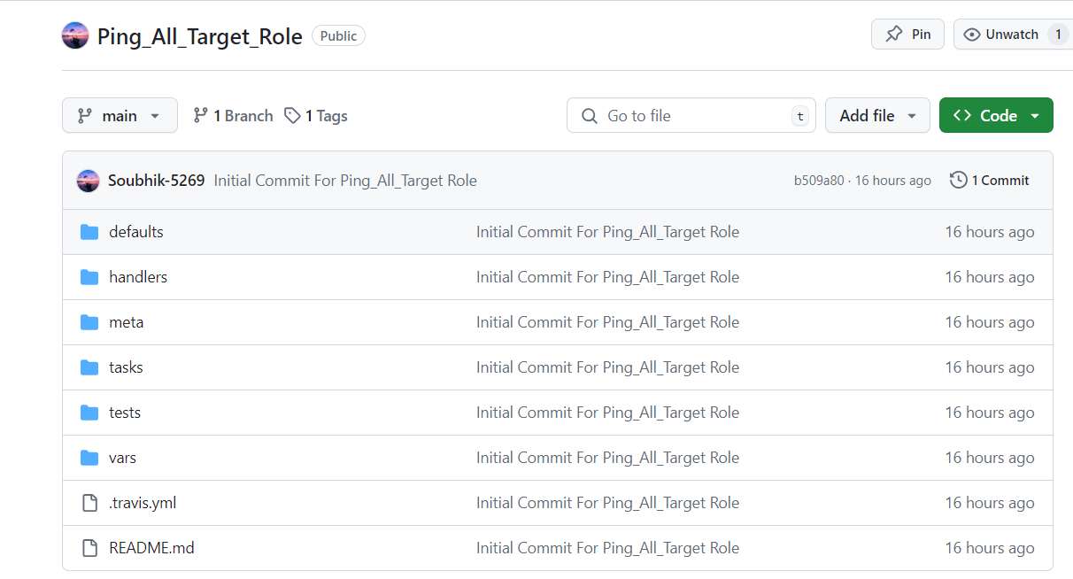

Now Install The Role in roles directory



Now Test The role using ping_all_target.yml file

Ping_all_target.yml

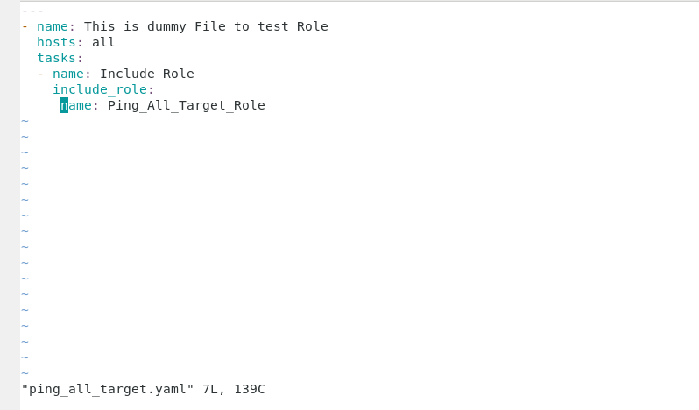

Now run this playbook using the following command

ansible-playbook ping_all_target.yaml

