Team 11

Fine-Tuning BEVFusion for Object Detection in 3D Urban Driving Scenarios

Team Members
Soubhik Majumdar (018175885) – soubhiksinha.majumdar@sjsu.edu
Darren Wong (015198612) – darren.wong01@sjsu.edu
Juan Liang (013417703) – juan.liangliao@sjsu.edu

Project Track: Option 2 (Fine-tuning & training)
Focused Areas: 3D Object Detection in BEV using 3D LiDAR data and fine-tuning a pretrained model for improved performance.

Project GitHub Repository Link: SoubhikMajumdar/3D-LiDAR-Based-Birds-Eye-View-Object-Detection-via-BEVFusion

Abstract
This project implements and evaluates the BEVFusion LiDAR-only model for 3D object detection in urban driving scenarios using the OpenMMLab MMDetection3D framework. The work develops a complete inference and fine-tuning pipeline while addressing key engineering challenges such as sparse convolution incompatibilities, pretrained checkpoint conversion, and non-standard nuScenes dataset formats. Evaluation on nuScenes demo and mini samples demonstrates high-confidence detections across common urban object classes, with fine-tuning on larger, sanitized datasets yielding improved performance over the baseline.
Introduction & Problem Description
Problem:
Accurate 3D object detection from LiDAR data is a core requirement for autonomous driving systems, yet raw point cloud data is sparse, high-dimensional, and difficult to process efficiently. BEVFusion addresses this challenge by transforming sensor data into a Bird’s-Eye View (BEV) representation, enabling structured spatial reasoning for object detection. This project focuses on implementing and deploying the LiDAR-only variant of BEVFusion, with the goal of establishing a functional and reproducible pipeline for 3D object detection using BEV representations.
Relevance:
BEV-based perception methods are increasingly important because they reduce perspective distortion, simplify geometric reasoning, and improve object localization compared to camera-centric approaches. BEVFusion further extends these advantages through its use of sparse convolutional encoders and transformer-based detection heads, which together enable efficient processing of large-scale urban scenes. Understanding how such state-of-the-art models can be implemented, adapted, and fine-tuned in practice is critical for bridging the gap between research prototypes and real-world autonomous driving systems.
Target users and applicability:
The system developed in this project targets autonomous driving perception research and development, including applications such as urban vehicle detection, pedestrian tracking, and infrastructure recognition. It is intended for researchers and engineers working with 3D perception pipelines who require a reliable BEV-based detection framework that can be evaluated, fine-tuned, and extended using real-world datasets such as nuScenes. The results provide insight into the strengths and limitations of BEVFusion when applied to complex urban driving scenarios.
Background / Related Work
Existing work built upon
BEVFusion builds upon prior work in BEV-based 3D object detection, which has become a dominant paradigm in autonomous driving perception. Models such as SECOND, PointPillars, CenterPoint, and 3DSSD demonstrated that projecting LiDAR point clouds into BEV representations enables efficient and accurate detection using 2D convolutional backbones. BEVFusion extends this line of work by introducing a unified BEV feature space capable of fusing multi-modal sensor inputs through sparse convolutional encoders and transformer-based detection heads. Our implementation leverages the OpenMMLab MMDetection3D framework, which provides standardized model definitions, training pipelines, and evaluation tools, enabling reproducible experimentation on datasets such as nuScenes.
System / Model / Algorithm Design
Selected application / algorithm / model:
The selected model for this project is the LiDAR-only variant of BEVFusion, a Bird’s-Eye View (BEV)–based 3D object detection framework designed for autonomous driving perception. BEVFusion transforms raw LiDAR point cloud data into BEV feature representations that enable efficient spatial reasoning and accurate 3D object detection. In this implementation, the model processes five-dimensional LiDAR point features (x, y, z coordinates, intensity, and timestamp) and outputs 3D bounding boxes for 10 object classes defined in the nuScenes dataset: car, truck, construction_vehicle, bus, trailer, barrier, motorcycle, bicycle, pedestrian, and traffic_cone.
Overall architecture
The BEVFusion LiDAR-only architecture consists of five interconnected components that transform raw point cloud data into 3D object detections: a voxel encoder, a sparse middle encoder, a BEV backbone, a feature pyramid neck, and a transformer-based detection head. The pipeline begins with the voxel encoder, which discretizes continuous 3D space into a sparse grid with dimensions of 1440×1440×41 voxels, covering a spatial range of 108 meters in the X and Y directions and 8 meters in height, with each voxel measuring 0.075×0.075×0.2 meters. Voxelized features are processed through sparse 3D convolutions, projected onto the BEV plane, refined through multi-scale feature extraction and fusion, and finally decoded into object-level predictions. A system-level architecture diagram is included to illustrate the end-to-end data flow across these components.
Description of major components and key techniques used.
The sparse middle encoder, implemented as a BEVFusionSparseEncoder, processes voxelized features through a four-stage sparse 3D convolutional neural network that progressively increases feature channel depth from 5 input channels to 16, 32, 64, and finally 128 channels, producing 256-channel sparse feature maps. Sparse convolution operations (spconv) exploit the inherent sparsity of LiDAR point clouds by processing only non-empty voxels, which typically represent less than 5% of the voxel grid, reducing computational complexity from O(N) to O(S) and providing 10–100× speedup over dense 3D convolutions while preserving representational capacity.
The backbone network is based on the SECOND (Sparsely Embedded Convolutional Detection) architecture and applies 2D convolutions to the BEV plane, treating the height dimension as feature channels to produce multi-scale feature representations with 128 and 256 channels. These features are fused by a SECONDFPN neck through upsampling and concatenation, forming a unified 512-channel feature representation that preserves both high-resolution spatial detail and low-resolution semantic context.
The detection head employs a TransFusionHead architecture, which uses transformer-based attention mechanisms to generate object proposals through 200 learnable object queries. Cross-attention allows each query to attend dynamically to relevant spatial regions in the BEV feature map, enabling content-adaptive feature aggregation. The transformer decoder consists of a single layer with 8 attention heads operating on 128-dimensional hidden representations. During training, Hungarian matching assigns ground truth objects to queries, enabling query specialization without predefined anchor boxes. The model is optimized using Focal Loss for classification, Gaussian Focal Loss for heatmap regression, and L1 Loss for bounding box regression, with respective weights of 1.0, 1.0, and 0.25.
Implementation Details
Languages, frameworks, libraries used:
Programming Language: Python 3.10
Deep Learning Framework: PyTorch 2.1.2
3D Detection Framework: OpenMMLab MMDetection3D
Sparse Convolution Library: spconv
GPU Acceleration: CUDA 11.8
Datasets and Toolkits: nuScenes dataset and nuScenes devkit
Visualization and Utilities: Open3D, NumPy
System setup (e.g., GPU/CPU, cloud/local environment).
Execution Environment: Local development environment
Hardware: NVIDIA GPU–based system (CUDA-enabled)
Compute Mode:
- GPU used for model inference and fine-tuning
- CPU used for preprocessing and data loading where applicable
Software Environment:
- Python virtual environment
- MMDetection3D installed in development mode
Custom CUDA operations compiled for BEVFusion sparse convolution support
Important implementation decisions.
Pretrained Weights and Checkpoint Integration:
Pretrained BEVFusion weights were obtained from the OpenMMLab model zoo, where the model was trained on the full nuScenes dataset for 20 epochs using a cyclic learning rate schedule. A critical implementation challenge arose from a compatibility mismatch between sparse convolution library versions, as the pretrained model used spconv 1.x while the inference environment required spconv 2.x, resulting in tensor shape mismatches during checkpoint loading. To resolve this issue, a custom checkpoint-fixing utility was developed to automatically identify affected sparse convolution weight tensors and apply the necessary transposition operations using PyTorch tensor manipulation. The corrected checkpoint preserved all learned parameters and metadata while enabling successful model initialization and inference in the updated environment.
Dataset Integration and Adaptation:
The nuScenes mini dataset required adaptation due to differences between its raw pickle-based annotation format and the data structures expected by the MMDetection3D framework. A custom dataset adapter was implemented to convert list-based annotation files into the required dictionary format, map string-based class labels to integer indices using dataset metadata, normalize velocity information, and restructure metadata to include the nested lidar_points fields required by the data loading pipeline. These adaptations ensured compatibility with both inference and fine-tuning workflows without modifying the original dataset files.
Inference and Visualization Tooling:
The base MMDetection3D inference workflow was extended through the development of a custom inference script that supports BEV visualization export, structured prediction output in JSON format, and point cloud export in PLY format for external visualization tools. In addition, a dedicated BEV visualization module was developed to generate top-down views of detection results, rendering point clouds colored by height, projected 3D bounding boxes, and associated class labels and confidence scores. This tooling enabled effective qualitative validation of detection performance and facilitated debugging and analysis of model outputs.
Figure 1 presents an example BEV visualization output, showing a point cloud scene with overlaid bounding box predictions, from another frame. The visualization demonstrates the model's ability to detect various object classes including vehicles, pedestrians, and infrastructure elements, with color coding indicating object classes and point cloud coloring representing height information
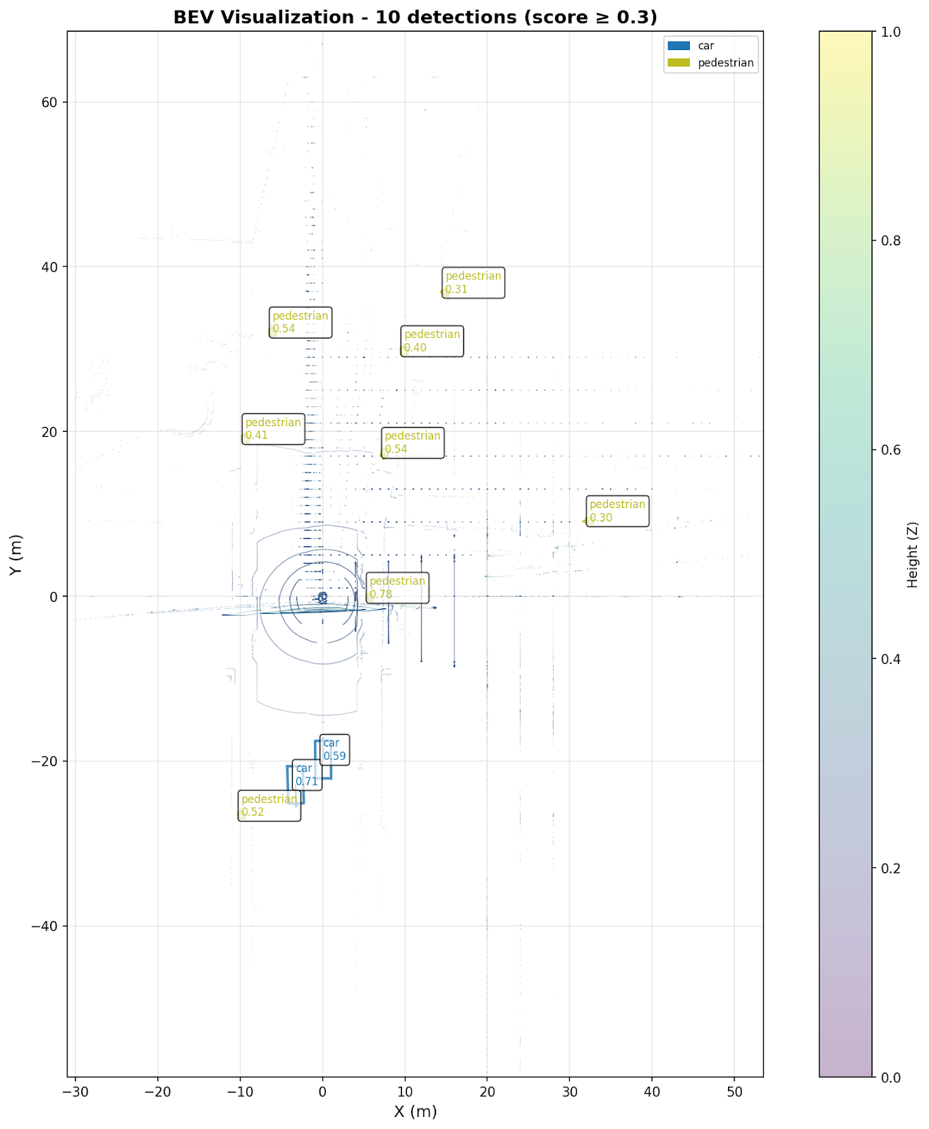
Figure 1: BEV Visualization Example - nuScenes mini dataset sample with detected objects
Data Processing Pipeline:
The data processing pipeline for BEVFusion inference involves several critical transformations that prepare raw LiDAR data for model input. The pipeline begins with loading point cloud data from binary files in the nuScenes format, which contains 5D point features. The system then applies multi-sweep fusion, loading the current LiDAR frame along with 9 historical sweeps to provide temporal context. This temporal aggregation significantly improves detection performance, particularly for moving objects, by providing multiple observations of the same scene from slightly different viewpoints and time instances.
The point cloud data undergoes range filtering to remove points outside the model's detection range of [-54, -54, -5, 54, 54, 3] meters, which corresponds to the voxel grid dimensions. Points are then voxelized according to the specified voxel size of [0.075, 0.075, 0.2] meters, with a maximum of 120,000 voxels during training and 160,000 during inference. The voxelization process groups points within each voxel and applies feature encoding to produce per-voxel feature vectors.
Figure 2 presents a visualization of the voxelization process, showing how sparse point clouds are discretized into a regular grid structure. The figure demonstrates the sparsity of the resulting voxel grid, with colored voxels representing non-empty regions containing point cloud data, while the majority of the grid remains empty (transparent).
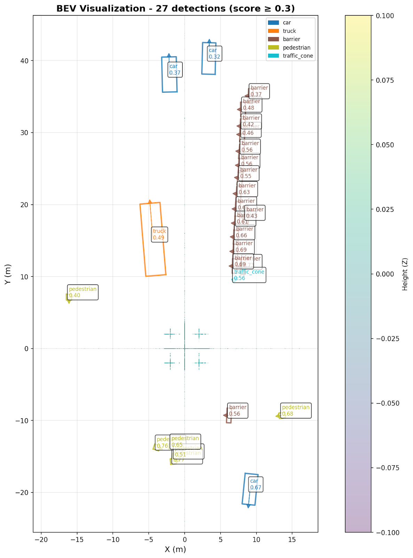
Figure 2: BEV Visualization showing point cloud voxelization and detection results
Fine-Tuning Process
The fine-tuning process involved adapting the pre-trained BEVFusion model to a specific subset of the nuScenes dataset to evaluate performance improvements and domain adaptation capabilities. This section details the systematic approach taken, the challenges encountered, and the final results obtained.
The fine-tuning process was iterative, involving several key phases and technical problem-solving steps:
Data Preparation & Path Resolution
Challenge: The initial setup faced "Path Duplication" errors (e.g., `samples/LIDAR_TOP/samples/LIDAR_TOP`) due to hardcoded expectations in the NuScenes SDK and our directory structure.
Solution: We employed Filesystem Junctions to map `data/nuscenes` to our dataset source (`data/v1.0-mini` or `data/nuscenes-full`). This allowed the training scripts to see the expected directory structure without physically duplicating terabytes of data.
Dataset Sanitization (Full Dataset)
Challenge: e utilized a partial download of the full nuScenes dataset ("Blob 01") alongside the full metadata. This caused crashes because the training loader attempted to access sweep files referenced in the metadata that were not present on disk.
Solution: We developed a custom sanitization script (`sanitize_pkl.py`) that verified the physical existence of every referenced LiDAR file. It removed approximately 10% of the sweep references from the `.pkl` data info files, ensuring the dataloader only requested valid files.
Validation Logic Repair
Challenge: The built-in validation step failed during training because the official evaluation script expected predictions for *all* samples in the validation set, whereas we were only running on the available subset.
Solution: We "monkeypatched" the `NuScenesEval` class in `nuscenes_metric.py` to dynamically load ground truth annotations only for the samples that were actually predicted. This allowed us to compute valid mAP and NDS metrics for our partial dataset without the process crashing.
Fine Tune results: at first we experimented fine tuning with the Nuscenes mini dataset to ensure everything was running and that the fine tuning was working. After several runs, we noticed that we were not able to achieve higher results than the bevfusion baseline, as a result we decided to fine tune on the Blob 01 of the full Nuscene data set.
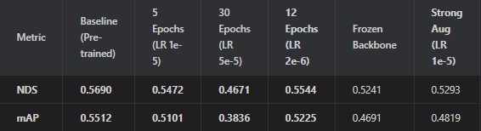
This table shows the results of the bevfusion baseline and things that we tried to do to fine tune it. After using the full dataset, we were able to achieve better results which are shown below:
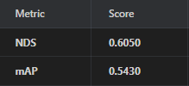
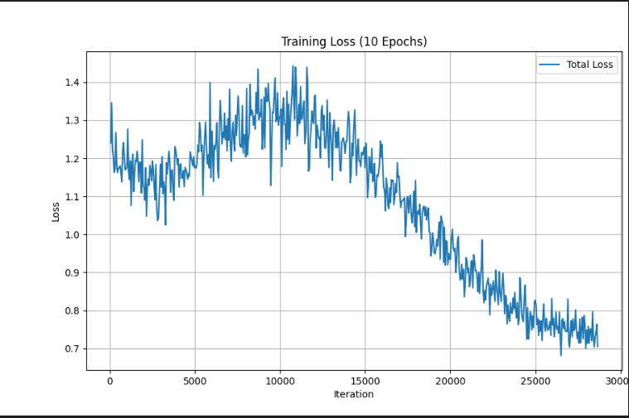
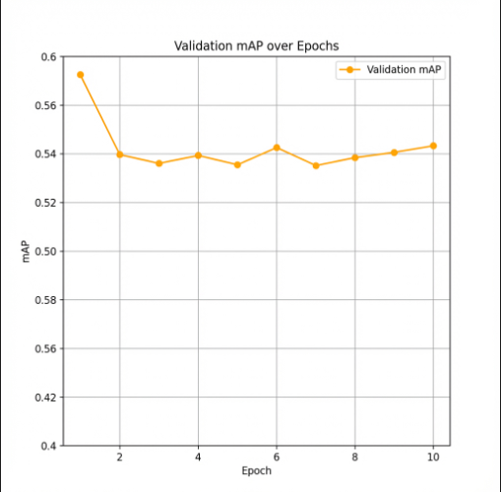
Our best fine tune done so far was done on the full dataset blob1, using 10 epochs and a learning rate of:0.0001. This took around 32 hours using a Nvidia 2060 gpu.

Link to code (GitHub):
SoubhikMajumdar/3D-LiDAR-Based-Birds-Eye-View-Object-Detection-via-BEVFusion
Task Distribution & Contributions
Soubhik Majumdar: Set up and debugged the BEVFusion LiDAR-only pipeline with pretrained BEVFusion-LiDAR nuScenes weights, including environment/CUDA configuration, custom CUDA compilation, and resolving mmcv / mmdet3d / spconv dependency and compatibility issues. Configured the SECOND backbone and SECONDFPN neck architecture for the BEVFusion model. Implemented and refined the inference code and BEV visualization pipeline, tuned score thresholds, and analyzed the obtained nuScenes mini BEV object detection results to study detection quality and class-wise behavior needed for fine-tuning.
Juan Liang Liao: Tried different bev models such as simple bev and bevFormer( didn’t work due to my dependencies). Created sanitize_pkl.py to filter the .pkl metadata files. This script verified the existence of every sensor file on disk and removed references to missing data, enabling the model to train on the partial subset without crashing. Fine tuned the bevFusion model with different configurations looking for the best one, used both Nuscenes mini and full nuscene blob1. Analyzed results from the fine tune by using mAP and NDs scores.
Darren Wong: Conducted fine-tuning experiments on the BEVFusion LiDAR-only model using parameter freezing and differential learning rates. Evaluated model performance using per-class mAP scores to assess the impact of training configurations. Observed subpar detection results, likely due to limitations from a low number of training epochs constrained by available hardware resources.
Evaluation & Testing Results
Description of system/model evaluation: Metrics (e.g., accuracy, precision/recall, F1, mAP, latency, throughput, memory use, etc.)
The BEVFusion LiDAR-only model was evaluated using inference-based performance analysis on nuScenes demo samples and the nuScenes mini dataset. Evaluation focused on detection confidence statistics, class-wise detection counts, inference latency, throughput, and memory usage, rather than full benchmark mAP scores, due to partial-dataset constraints.
Primary evaluation metrics included:
- Number of object proposals per frame
- Confidence score statistics (mean, maximum, standard deviation)
- High-confidence detection counts (score ≥ 0.3)
- Class distribution of detections
- Inference latency and throughput
- GPU memory usage during inference
Confidence-based filtering was applied with a score threshold of 0.3 to distinguish high-confidence detections from low-confidence proposals.
Inference Results: nuScenes Demo Sample
The pretrained BEVFusion model was evaluated on a nuScenes demo LiDAR sample. The model generated 200 total object proposals, of which 27 exceeded the confidence threshold of 0.3. Across all detections, the mean confidence score was 0.111, while high-confidence detections achieved a mean score of 0.565. The maximum confidence score observed was 0.772, indicating strong confidence for well-detected objects.
Class distribution analysis across the 10 nuScenes object classes showed that the most frequently detected high-confidence classes were:
- Barrier: 16 detections (mean score 0.568)
- Pedestrian: 6 detections (mean score 0.627)
- Car: 3 detections (mean score 0.451)
- Truck: 1 detection (mean score 0.492)
- Traffic cone: 1 detection (mean score 0.561)
The standard deviation of confidence scores (0.193) indicates substantial variation in prediction confidence, reflecting the model’s ability to distinguish between clear detections and ambiguous proposals. The presence of many low-confidence proposals is expected, as the model generates a fixed number of proposals per frame to ensure comprehensive scene coverage.
Inference Results (nuScenes Mini Dataset Sample):
Evaluation on a sample from the nuScenes mini dataset also produced 200 total object proposals, with 10 high-confidence detections (score ≥ 0.3). The mean confidence score across all detections was 0.067, while high-confidence detections achieved a mean score of 0.510. The maximum confidence score observed was 0.779, demonstrating reliable detection for well-observed objects.
Class distribution among high-confidence detections included:
- Pedestrian: 8 detections
- Car: 2 detections
The reduced number of detected classes and detections reflects both the limited scope of the sample and the natural variability in object presence and point cloud density across scenes.
Qualitative Evaluation
Qualitative evaluation was performed using a custom BEV visualization pipeline. Detection outputs were rendered as top-down Bird’s-Eye View images with point clouds colored by height and 3D bounding boxes projected onto the BEV plane.
Performance Characteristics
On CUDA-enabled GPU hardware (RTX series), inference latency was approximately 200–300 ms per frame, corresponding to a throughput of 3–5 frames per second when processing single frames sequentially. GPU memory consumption during inference was approximately 2–3 GB, making the model suitable for deployment on standard autonomous vehicle computing platforms.
The detection range covered 54 meters forward and laterally and 8 meters vertically, consistent with the voxelization configuration. Multi-sweep fusion incorporating nine historical sweeps improved robustness for moving and partially occluded objects.

Verification of code’s correctness.
Correctness was verified through multiple complementary methods. Successful end-to-end execution of the inference pipeline confirmed that the system operated without runtime failures or tensor shape errors. Output consistency was validated by checking that all predicted bounding boxes had valid dimensions, class labels, and confidence scores. Qualitative correctness was further assessed through visual inspection of BEV outputs, ensuring proper spatial alignment between point clouds and predicted bounding boxes and confirming that detected objects were plausible within the scene context. Detection behavior was compared across both the nuScenes demo sample and the nuScenes mini dataset to verify consistent model behavior under different input conditions. Finally, correct checkpoint loading and model initialization were confirmed after resolving sparse convolution (spconv) compatibility issues, ensuring that all network layers executed valid forward passes.

How to reproduce the results (commands, scripts, notebooks).
All results can be reproduced using the scripts and configurations provided in the project repository. Inference is executed through the custom mmdet3d_inference2.py script, while visual outputs are generated using the dedicated BEV visualization module. Pretrained model checkpoints are obtained from the OpenMMLab model zoo and made compatible with the current environment using the custom checkpoint-fixing utility. Dataset preparation and format adaptation are handled through custom dataset adapters and preprocessing scripts. All required commands, configuration files, and supporting scripts are documented in the repository to ensure reproducibility of both inference and fine-tuning experiments.
References
  - Liu, Z., Tang, H., Amini, A., Yang, X., Mao, H., Rus, D., & Han, S. (2023). BEVFusion: Multi-Task Multi-Sensor Fusion with Unified Bird's-Eye View Representation. In 2023 IEEE International Conference on Robotics and Automation (ICRA) (pp. 2774-2781). IEEE DOI: 10.1109/ICRA48891.2023.10160968
  - MMDetection3D Contributors. (2020). MMDetection3D: OpenMMLab next-generation platform for general 3D object detection. https://github.com/open-mmlab/mmdetection3d
  - https://download.openmmlab.com/mmdetection3d/v1.1.0_models/bevfusion/bevfusion_lidar_voxel0075_second_secfpn_8xb4-cyclic-20e_nus-3d-2628f933.pth
  - https://towardsdatascience.com/differential-and-adaptive-learning-rates-neural-network-optimizers-and-schedulers-demystified-2edc589fa2c9/

