CR 1: jp-m_app

|  |  |  |  |  |
| --- | --- | --- | --- | --- |
| 1 | Include an edit function for product variant on backend | Backend | Product variant | Yes |

Action:

Change Order:

Click on Change Order to change order column 🡪 Save to apply new order

Load product by order.

Edit function:

Click on Edit button to edit : title , Carat, Diamond cut, setting 🡪 Click on Save button to apply change.

Click on image: open dialog to change images. (image change immediately after finish on upload image dialog)

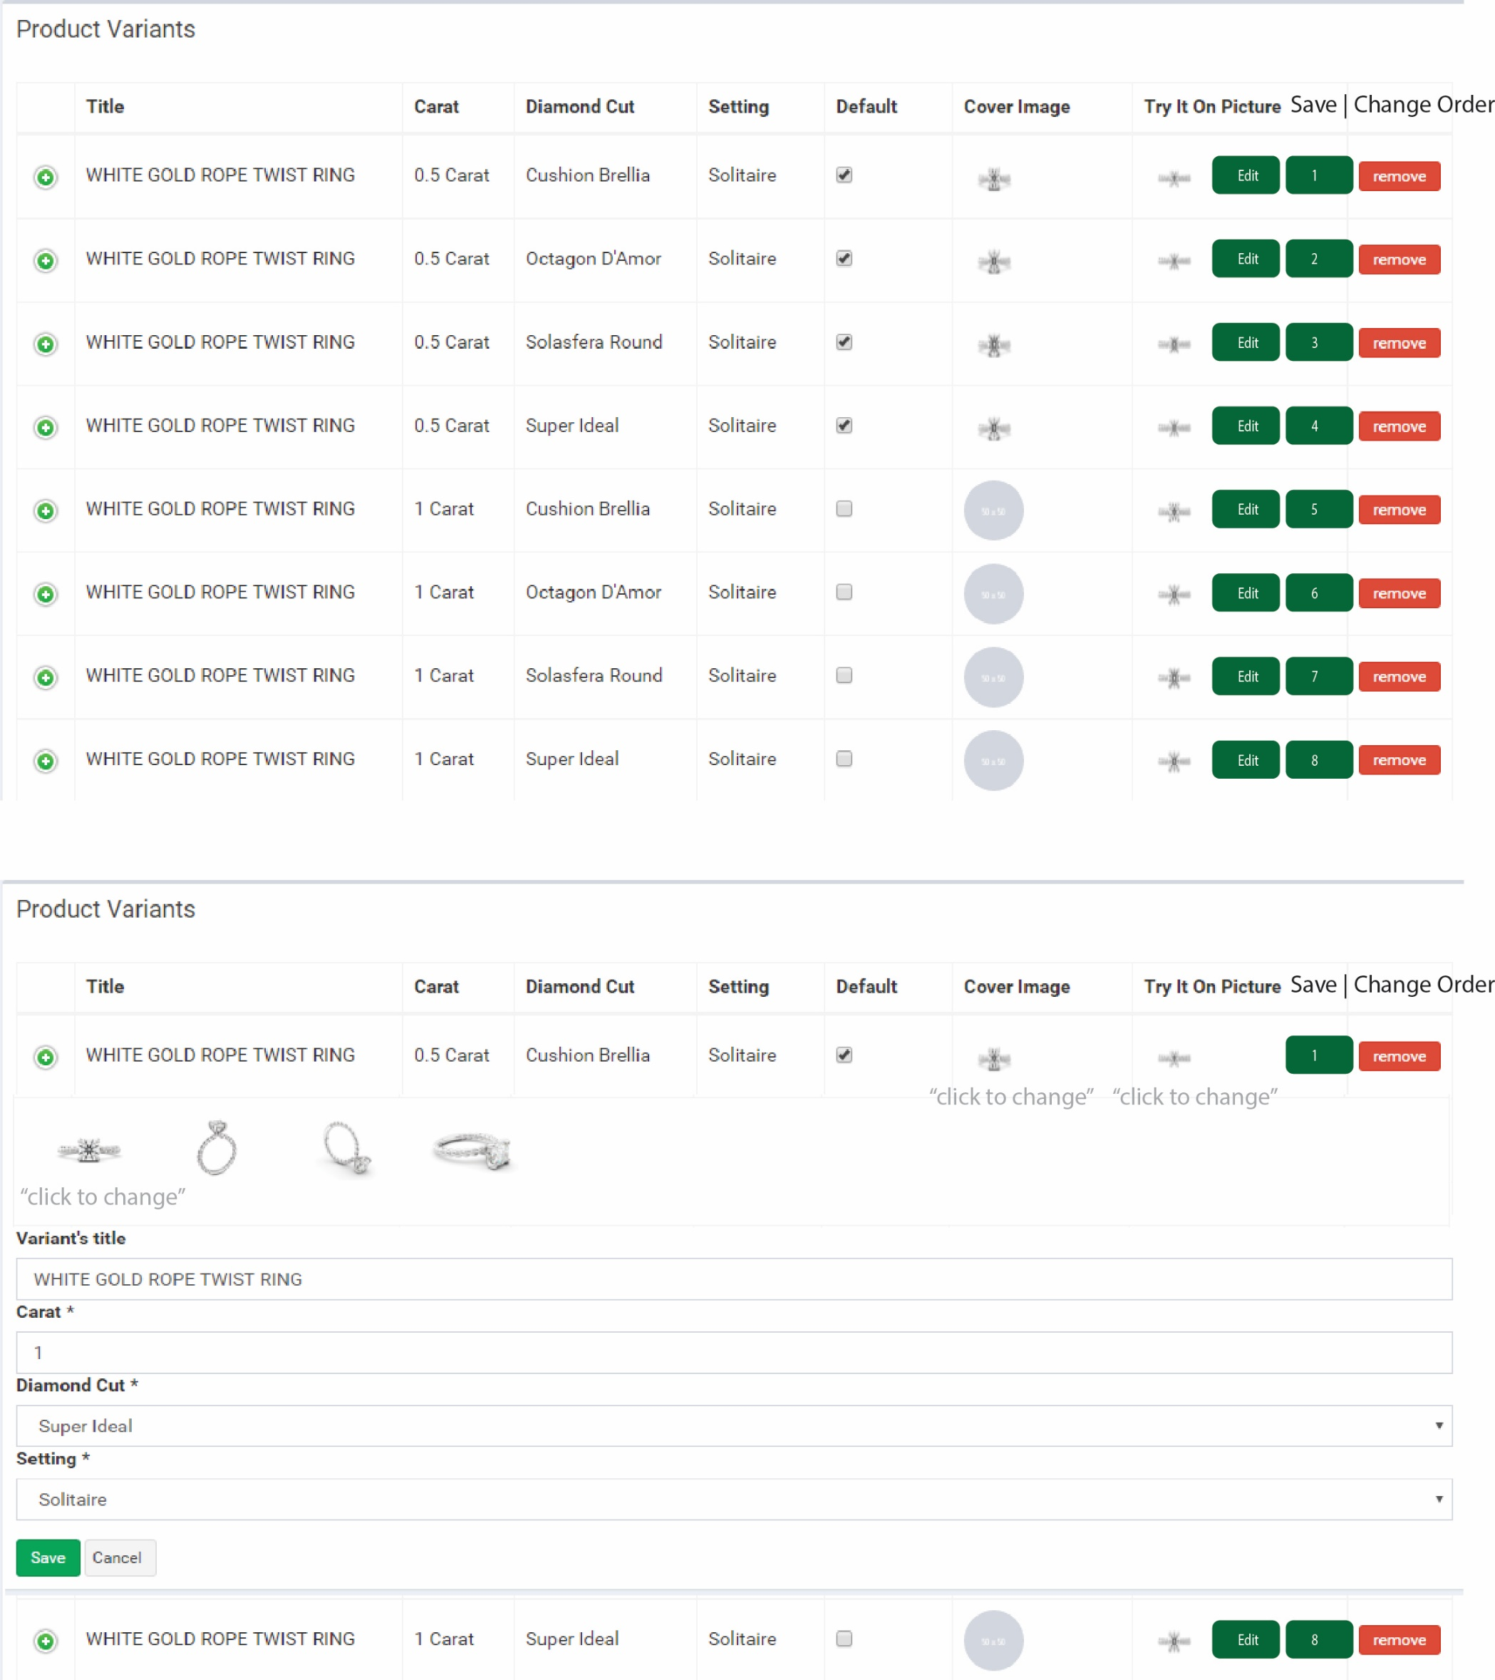

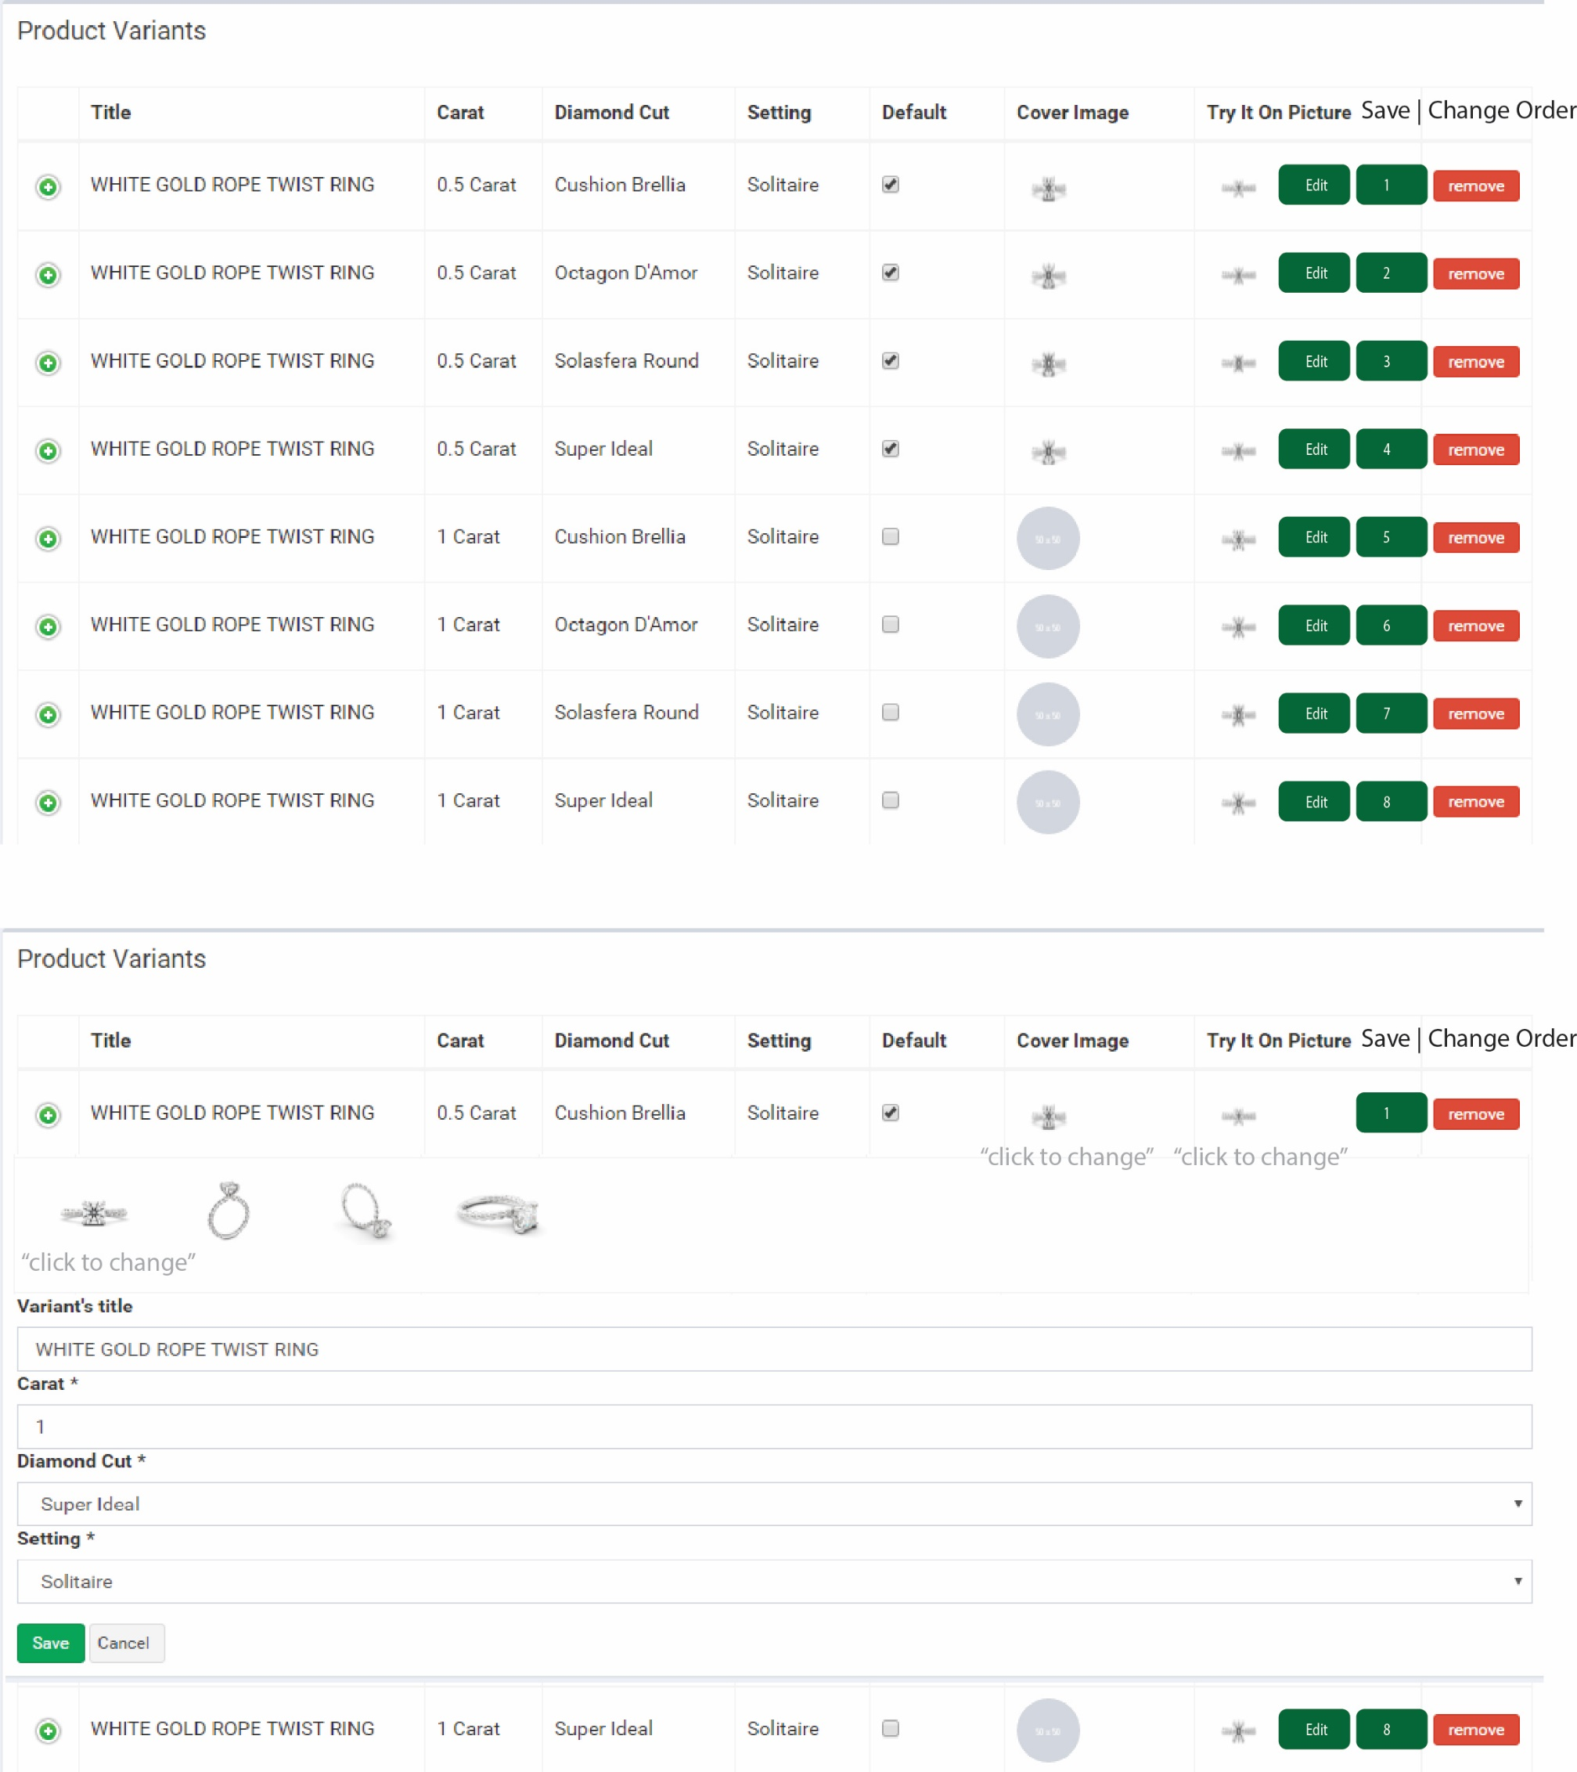

|  |  |
| --- | --- |
| 2 | Fix sharing links to show preview instead of URL |

Friendly url can show directly on app: Whatapp, Skype, Viber, … should be a html link: mean the image of save/ sharing ring should be show in a mini site as: <http://m-app.jannpaul.com/superidealcut-rosegold-solitaire.html>

and this page contain page title: Super Ideal Cut in Solitaire Rose Gold + images + images description + metadata + …

App will priority show the image.

Sample:

<http://www.lazada.vn/ao-khoac-family-shop-kn21-xam-301931.html>

in Viber/ Skype:

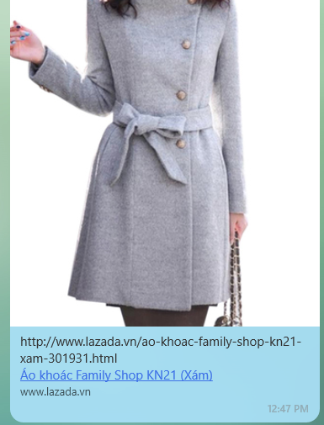 

|  |  |  |  |
| --- | --- | --- | --- |
| 3 | Update diamond images on main page | Mobile App | Main page (Diamond) |

Change images of diamond on Choose your diamond:

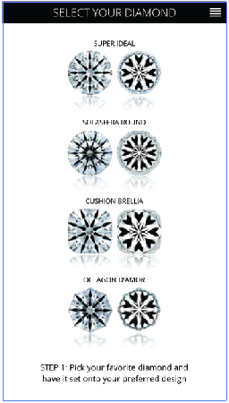

|  |  |  |
| --- | --- | --- |
| 4. Include a function to select order of product display on backend | Backend | Product variant |

(Included in 1)

5. Change CHOOSE YOUR SETTING PAGE 2 to CHOOSE COLOR:

This change need restructure of DB. First, on front end:

Method 1: use OS control: Swipe Up / Down to change Metal (Color or ring); still keep Swipe left / right to view other images : this solution no need to add more screen, all control of button keep as currently.

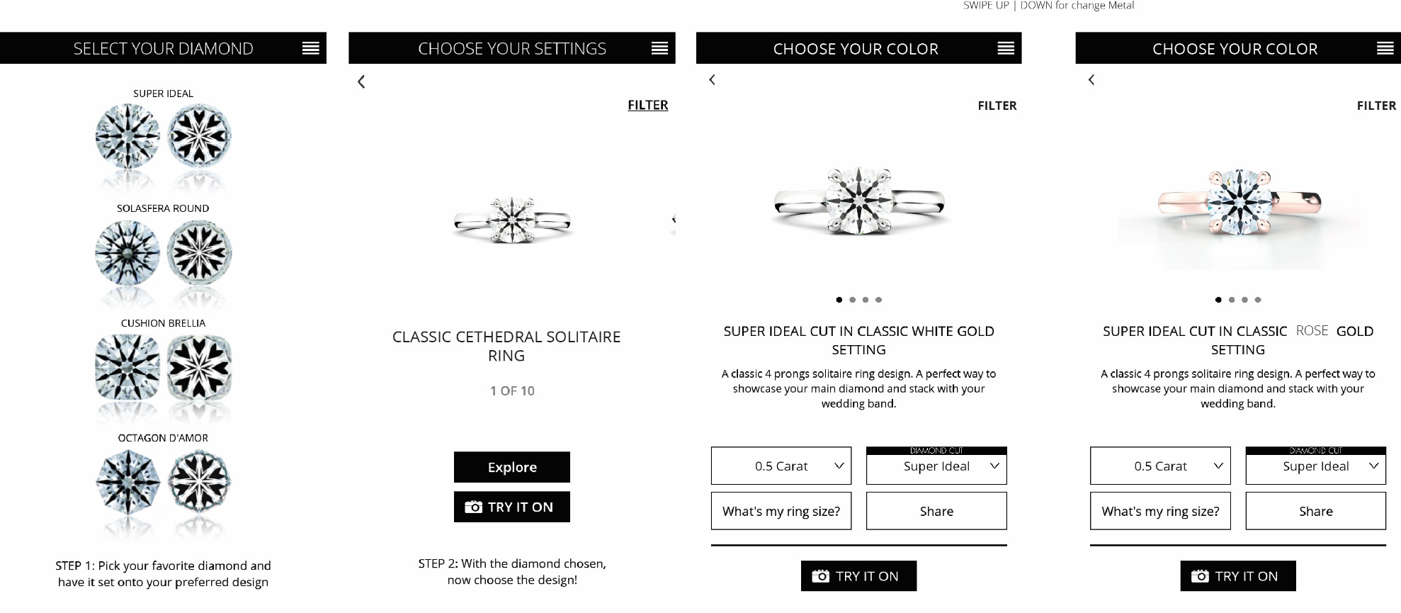

Method 2: Add 1 screen

Step 1: rename CHOOSE YOUR SETTING page 2 🡪 CHOOSE YOUR COLOR : action swipe left / right to change metal (color)

Step 2: add 1 screen for action select Ring (explore).

