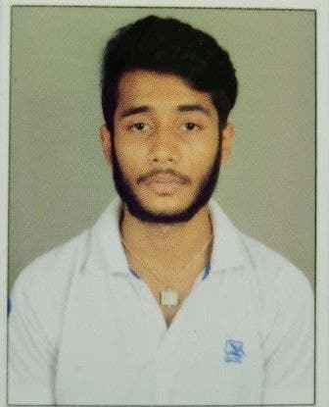CURRICULUM VITAE

|  |  |
| --- | --- |
| **SOUDIP PRAMANIK** | ***Permanent Address***  66,G.N. Mukherjee Road  PO – Bansberia, PS – Magra, Dist – Hooghly, Pin – 712502, West Bengal |
| Related image **: +91 9038816347** |
| **Image result for message box sign :** [**soudippramanikk@gmail.com**](mailto:soudippramanikk@gmail.com) |

|  |
| --- |
| **CAREER OBJECTIVE** |
| To be a part of organization where I could be able to prove myself worthy by implementing by skills and  efficiency towards the growth of the organization. |

|  |  |  |  |
| --- | --- | --- | --- |
| **ACADEMIC QUALIFICATION** | | | |
| ***Name of the Exam*** | ***Board/Council/University Name*** | ***Year of Passing*** | ***Obtained*** |
| ***Madhyamik*** | West Bengal Board of Secondary  Education | 2019 | 68.67% |
| ***Higher Secondary*** | West Bengal Council of Higher  Secondary Education | 2021 | 70.04% |
| ***B.Sc IT (Cyber Security)*** | Maulana Abul Kalam Azad University of Technology | Present |  |

|  |
| --- |
| **COMPUTER PROFICIENCY** |
| * Basic computer knowledge. * Programming Language (C,HTML,Python,CSS,Java Script) * MS Word, MS Excel, MS Powerpoint |

|  |  |  |
| --- | --- | --- |
| **PERSONAL DETAILS** | | |
| ***Date of Birth*** | : | 07-05-2003 |
| ***Father’s Name*** | : | Samiran Pramanik |
| ***Mother’s name*** | : | Suchandra Pramanik |
| ***Gender*** | : | Male |
| ***Nationality*** | : | Indian |
| ***Religion*** | : | Hinduism |
| ***Social Category*** | : | SC |
| ***Marital Status*** | : | Unmarried |
| ***Hobby*** | : | Playing Outdoor Game |
| ***Languages Known*** | : | Bengali, English & Hindi |

|  |  |
| --- | --- |
| **STRENGTHS** | |
| * “Never Say Die” Attitude | * Hard Working Ability |
| * Ability to work in any working environment | * Quick Learner |

|  |
| --- |
| **DECLARATION** |
| * All the information provided above is true to the best of my knowledge and belief, |

Date :

Place : Bansberia, Hooghly ………………………………

Signature