**HARDWARE SHOP MANAGEMENT SYSTEM**

**Use Case Diagram**

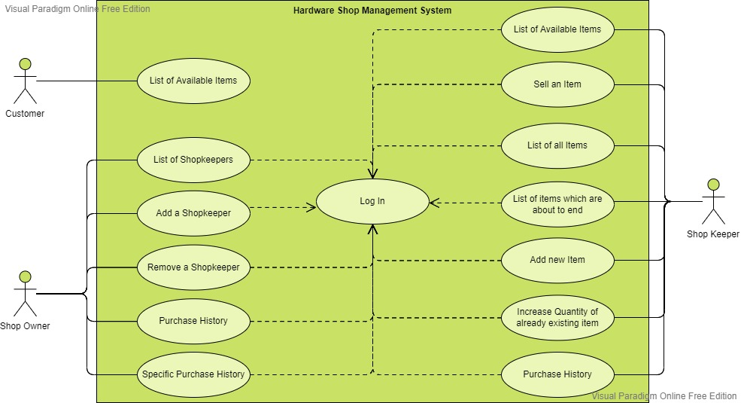

**UML Diagram**

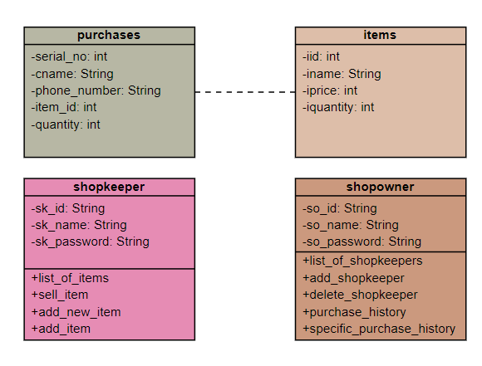

**OR Mapping**

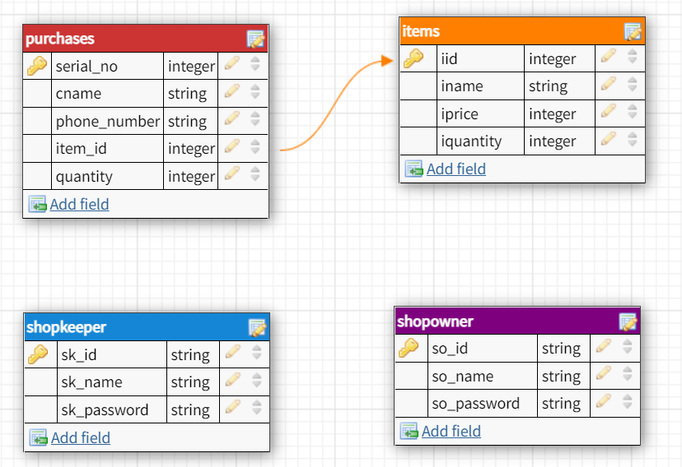

**Output Screenshots**

* Main Menu

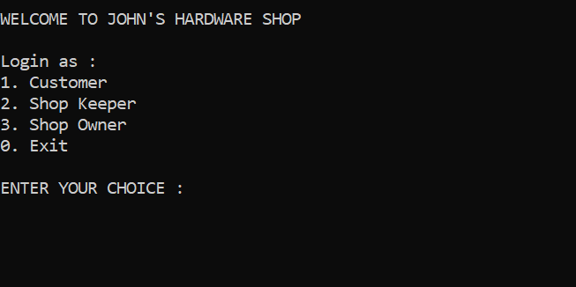

* Customer Menu

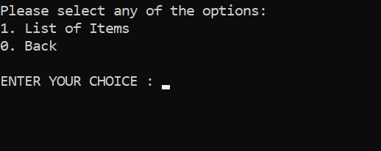

* List of available items for purchase

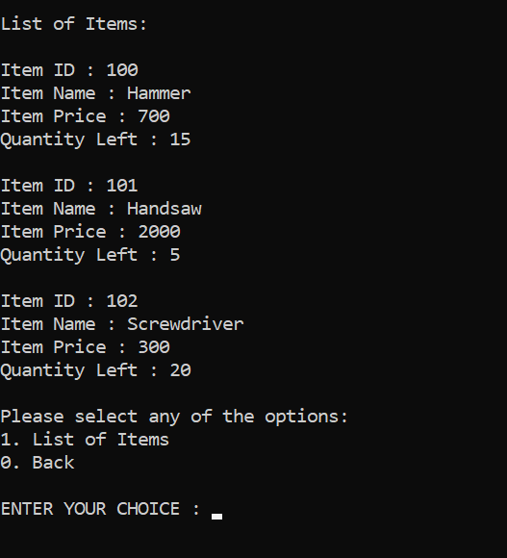

* Shopkeeper Login

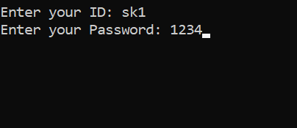

* Shopkeeper Menu

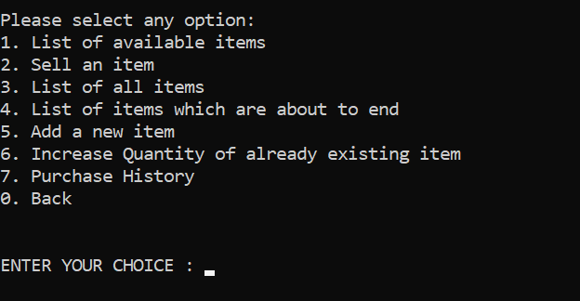

* Selling an item

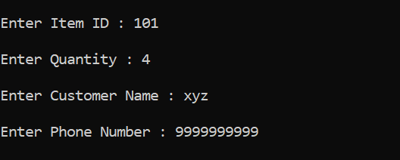

* Successful update of records

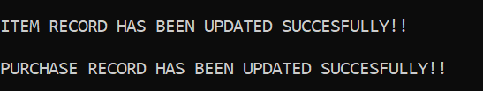

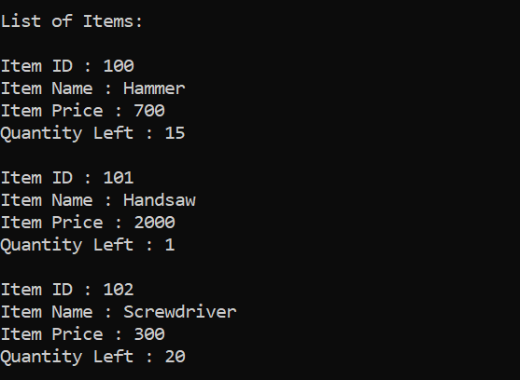

* List of items which are about to end (Less than 3)

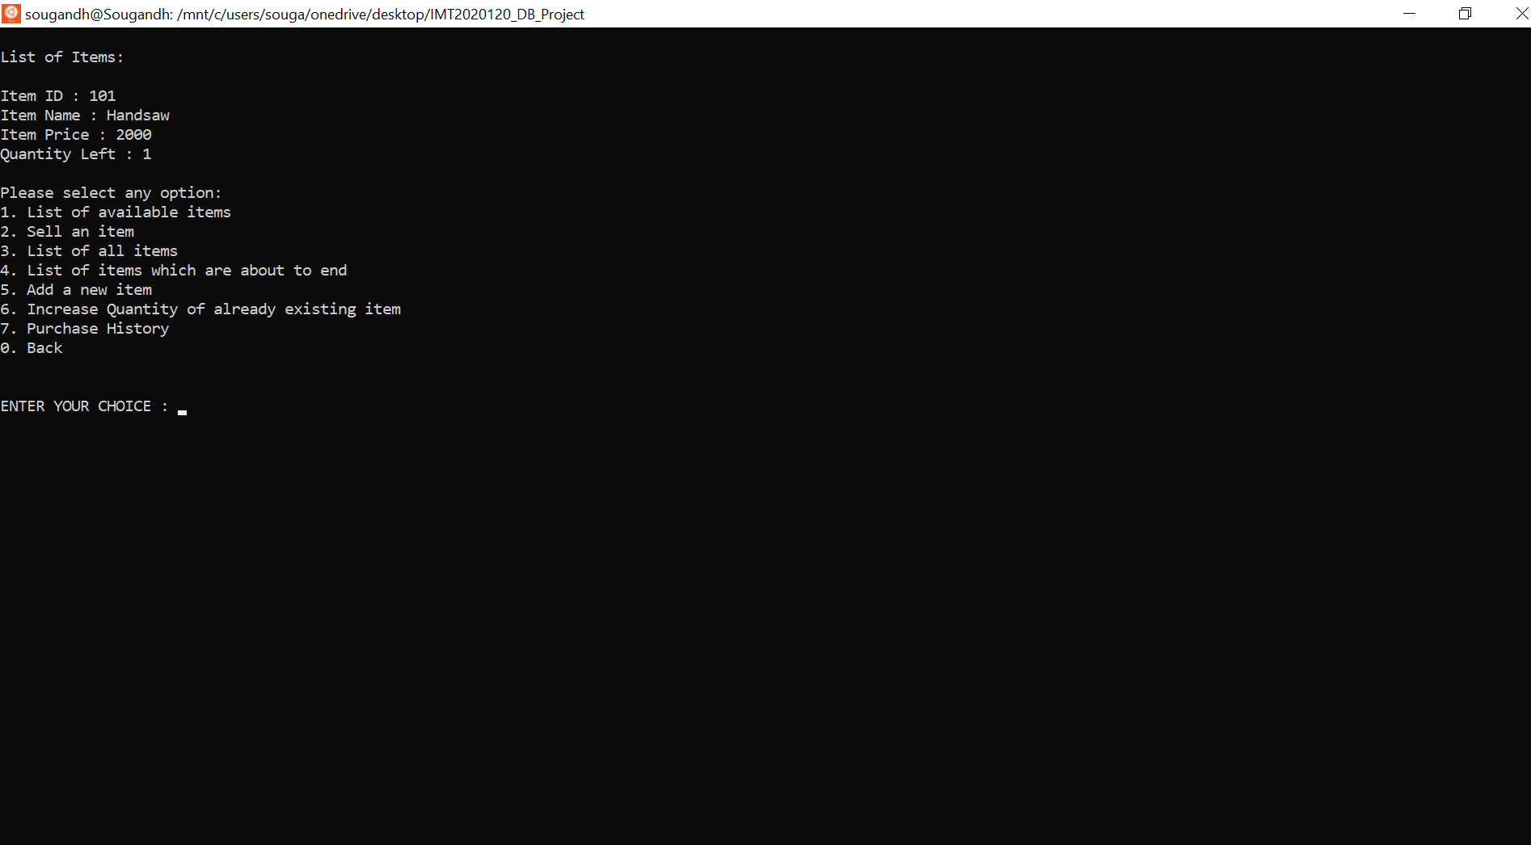

* Add New Item

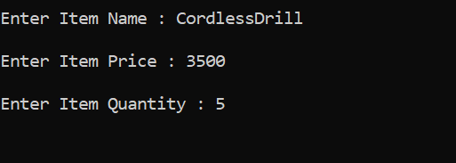

* Successfully added in table

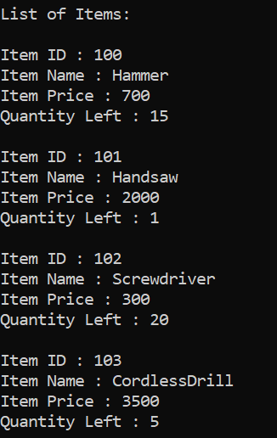

* Adding Quantity

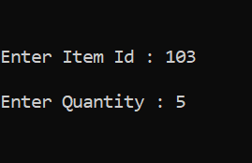

* Successful addition

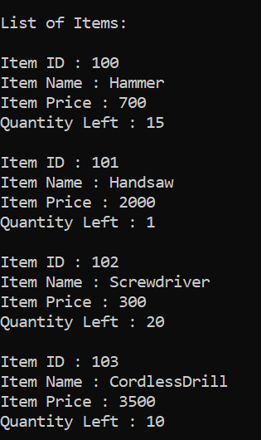

* Sold the only handsaw which is left -> Present in all items but not in available items

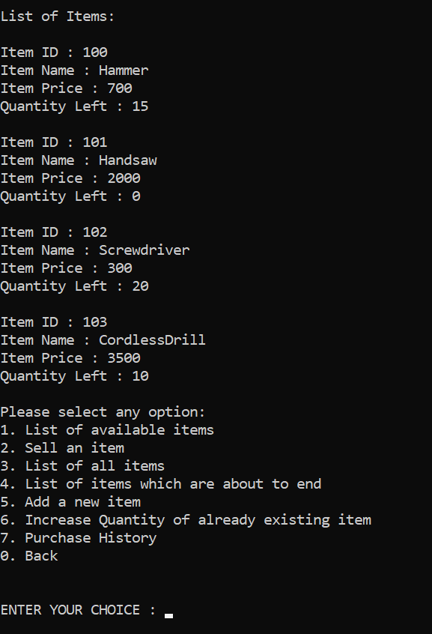 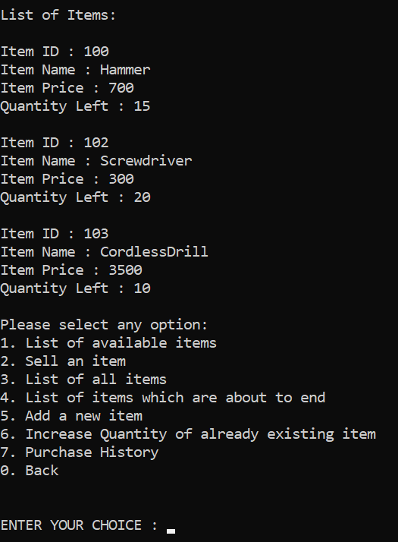

* Purchase History

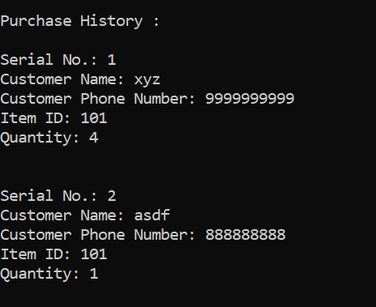

* Shop owner login

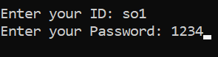

* Shop owner menu

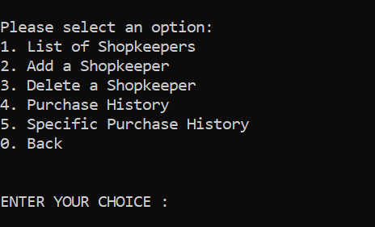

* List of shopkeepers

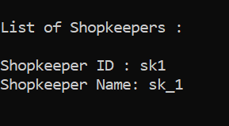

* Adding shopkeeper

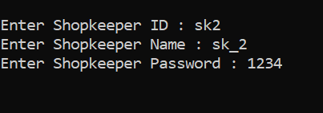

* Updated List

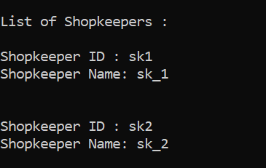

* Delete shopkeeper credentials

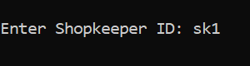

* Updated List

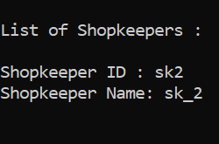

* Specific Purchase History

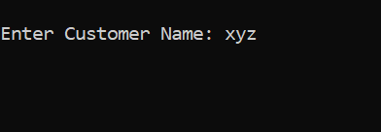

* Output of specific search

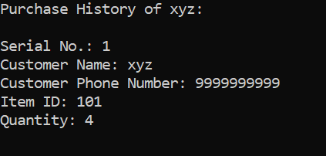

* Exit

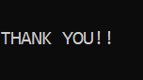

* Error message in case tables aren’t updated properly or due to wrong input



* Incorrect Login

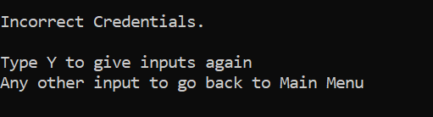

**Notes & Instructions to run the code**

First run the following commands in mysql command promt:

source SQL/shop_create.sql

source SQL/shop_alter.sql

source SQL/shop_insert.sql

After these run the following commands on the terminal:

export CLASSPATH='/mnt/c/……………/ mysql-connector-java-8.0.18.jar:.'

(Location of .jar file)

javac Hardwareshop.java

java Hardwareshop

Owner Credentials:

ID: so1

Password:1234