PROBLEM 1:
Write an Assembly Language Program using 8085 microprocessor for addition of two numbers and show the result.

PROBLEM STATEMENT:
Write an Assembly Language Program for addition of two numbers.

DESCRIPTION:
Add two numbers present in the location F100 and F101 and show the result in the corresponding next address F102.

ALGORITHM:
Step 1: Point the address F100 and load the address at H-L register pair.
Step 2: Put the value of the memory in the accumulator.
Step 3: Increment the pointer by one to get the address of the next location and load the address at the H-L register pair.
Step 4: Add the value of the memory with the value loaded previously in the accumulator.
Step 5: Increment the pointer by one and copy the value of the accumulator.
Step 6: Display the value of the pointed address.
Step 7: STOP

FLOWCHART:
START

Take Input Of Two 16 Bit Numbers

Add The Two Numbers

Store The Sum In Memory

Initialise Accumulator with 00

Find Carry After Addition

Store The Carry In Memory

END

PROGRAM CODE:
Address | Label | Opcode | Operands | Machine Code | Comments
F100H |  | LXI | H,F100H | 21 00 F1 | Point the address
F103H |  | MOV | A,M | 7E | Move the value of memory at Accumulator
F104H |  | INR | H | 24 | Increase the value of H
F105H |  | ADD | M | 86 | Add the value of M with accumulator
F106H |  | INR | H | 24 | Increase the value of H with 1
F107H |  | STA | F102H | 32 02 F1 | Store the value of Accumulator at the address F102
F10AH |  | HLT |  | 76 | Stop The Program

RESULT:-
INPUT:
Address | Data
F100 | 13
F101 | 1A

OUTPUT:
Address | Data
F102 | 2D

INPUT:
Address | Data
F100 | A25
F101 | 3CB

OUTPUT:
Address | Data
F102 | DEG

INPUT:
Address | Data
F100 | DAD
F101 | BAD

OUTPUT:
Address | Data
F102 | 95A

DISCUSSION:
The 8085 microprocessor can be used to add two 8-bit numbers. The addition operation is performed using the ADD instruction. When the result of the addition is within the 1-byte range. When a carry is generated we can use JNC instruction to read the carry flag and evaluate the program.

Problem: 2
Program-
Write 8085 Assembly language program to subtract two 8-bit numbers.
Problem Statement-
Write 8085 Assembly language program to subtract two 8-bit numbers and store the result at two locations.
Description-
Two hexadecimal numbers are stored at 8000H and 8001H, the program subtract these numbers and store the result at location 8050H and 8051H.
Algorithm-
1. Load the value 00H into the C register.
2. Load the address of minuend into the H and L registers (HL = 8000H).
3. Load the value from memory location HL (8000H) into the register.
4. Increment HL to point to the next memory location (address of subtrahend).
5. Load the value from memory location HL (8001H) into the B register.
6. Subtract the value in the B register from the accumulator.
If no carry (borrow) occurred, jump to step 8 else, go to step 7.
7. Increment the value in the C register.
8. Load the destination address into the H and L registers (HL = 8050H).
9. Store the value of the accumulator register into memory location HL (8050H).
10. Increment HL to point to the next memory location (8051H).
11. Store the value of the C register into memory location HL (8051H).
12. Halt.

Flowchart-
Start

X=Minuend
Y=Subtrahend

C

Store the value of X in Accumulator(A), store Y in B register, store 00 in c(carry)

A=A-B

Carry=0
Increment C
yes

No
Store destination address in H(LXI H,8050)

Store the value of A in M

Increment register pair (H,L)

Store the value of c in M
End

Program Code-
Address | Label | Opcode | Operands | Machine  Code | Comments
F000 |  | MVI | C,00H | 0E,00 | Clear C register
F002 |  | LXI | H,8000H | 21,00,80 | Load the value F000H into HL.
F005 |  | MOV | A,M | 7E | Load A from memory location HL.
F006 |  | INX | H | 23 | Increment HL.
F007 |  | MOV | B,M | 46 | Load B from memory location HL.
F008 |  | SUB | B | 90 | Subtract B from A.
F009 |  | JNC | STORE | D2,0D, F1 | Jump to STORE if no carry (CY=0).
F00C |  | INR | C | 0C | Increment C.
F00D | STORE | LXI | H,8050H | 21,50,80 | Load HL with 8050H.
F010 |  | MOV | M,A | 77 | Store A in memory location HL.
F011 |  | INX | H | 23 | Increment HL.
F012 |  | MOV | M,C | 71 | Store C in memory location HL.
F013 |  | HLT |  | 76 | Terminate the program.

Result-
Case 1
Input Output
Address | Data |  | Address | Data
8000 | 78 |  | 8050 | 54
8001 | 24 |  | 8051 | 00

Case 2
Input Output
Address | Data |  | Address | Data
8000 | 24 |  | 8050 | 00
8001 | 24 |  | 8051 | 00

Case 3
Input Output
Address | Data |  | Address | Data
8000 | 24 |  | 8050 | FC
8001 | 28 |  | 8051 | 01

Conclusion-
In conclusion, the provided 8085 Assembly language program subtracts two 8-bit numbers stored at memory locations 8000H and 8001H and stores the result at memory location 8050H. The program also checks for a borrow and stores it at memory location 8051H.This program's logic and execution steps can serve as a valuable reference for more advanced tasks on the 8085 microprocessor platform. As with any programming problem where subtraction is needed we can apply this in that types of program.
Problem: 3

Problem Statement

Write 8085 Assembly language program to multiply two 8-bit numbers stored in memory location and store the 16-bit results into the memory.

Description

We are saving the input data at location 8000H and 8001H. The result is storing at location 8050H and 8051H.

Algorithm

Step I: Initialize the data segment.

Step II: Get the first number.

Step III: Get the second number as counter.

Step IV: Initialize result = 0.

Step V: Result = Result + First number.

Step VI: Decrement counter

Step VII: If counter not 0, go to step V.

Step VIII : Display the result.

Step IX: Stop

Flowchart

Start

Get the first number

Get second number and initialize as counter

Result = 0

Result = Result + first number

Decrement counter

Is
Count =0
No

Yes
End

Program Code
Address | Labels | Mnemonics | Comments
F000 |  | LXI H,800H | Load first operand address
F003 |  | MOV B,M | Store first operand to B
F004 |  | INX H | Increase HL pair
F005 |  | XRA A | Clear accumulator
F006 |  | MOV C,A | Store Acc content to register C
F007 | LOOP | ADD M | Add memory element with Acc
F008 |  | JNC SKIP | When Carry flag is 0, skip next task
F00B |  | INR C | Increase C when carry is 1
F00C | SKIP | DCR B | Decrease B register
F00D |  | JNZ LOOP | Jump to loop when Z flag is not 1
F010 |  | LXI H,8050H | Load Destination address
F013 |  | MOV M,C | Store C register content into memory
F014 |  | INX H | Store C register content into memory
F015 |  | MOV M,A | Store Acc content to memory
F016 |  | HLT | Terminate the program

Results

Set 1:
Input Output
Address | Data
8000 | 30
8001 | 0
Address | Data
8050 | 0
8051 | 0

Set 2:
Input Output
Address | Data
8000 | 03
8001 | 02
Address | Data
8000 | DC
8001 | AC

Set 3:
Input Output
Address | Data
8050 | 93
8051 | D0
Address | Data
8050 | 06
8051 | 0

Conclusion

The 8085 has no inbuilt multiplication operation. To get the result of multiplication, we should use the repetitive addition method . After multiplying two 8-bit numbers, it may generate 1-byte or 2-byte numbers, so we are using two registers to hold the results.

Problem 4
Program:
Write 8085 Assembly language program to divide two 8-bit numbers and store the result.
Description:
Two 8-bit numbers are given. This program divides the first number (dividend) by the second
number (divisor) and returns the quotient and remainder as output. E.g.
12 / 03 = Quotient = 04; Remainder = 00
45 / 04 = Quotient = 11; Remainder = 01

Algorithm:
Step 1: Start.
Step 2: Take input of dividend and divisor.
Step 3: Subtract divisor from dividend and raise a counter by 1.
Step 4: Repeat step 3 until the value of dividend is less than value of divisor or use a counter with value of divisor counting down to 1.
Step 5: Store the quotient (counter mentioned in step 3) and reminder (reminder = copy of dividend after finding out quotient using step 3 and step 4) in memory.
Step 6: End.

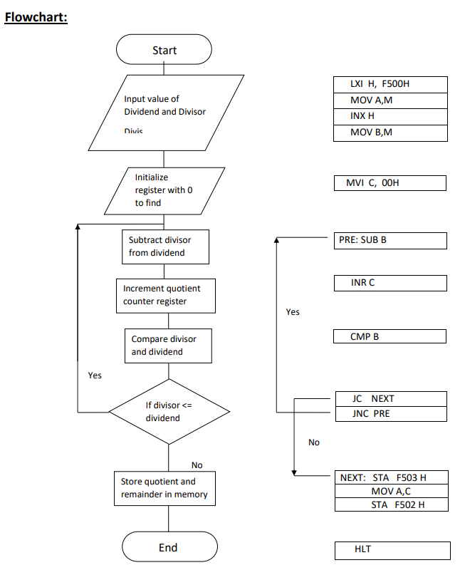

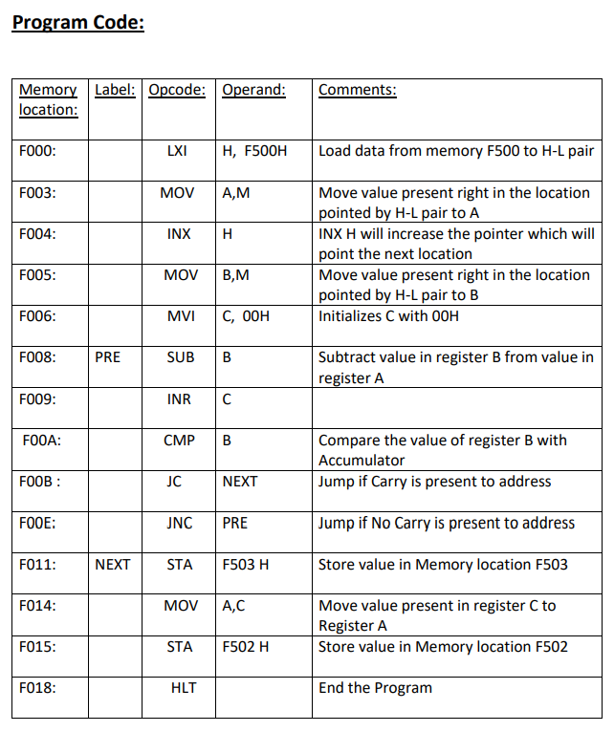
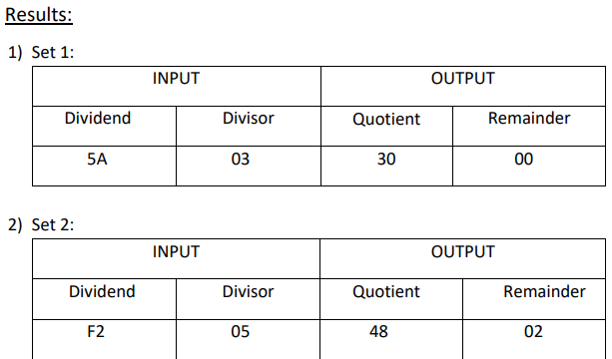

Discussion:
The 8085 has no division operation. To get the result of the division, we should use the repetitive subtraction method. By using this program, we will get the quotient and the remainder. 8020H will hold the quotient, and 8021H will hold the remainder. We are saving the data at location 8000H and 8001H. The result is storing at location 8050H and 8051H.

Problem 5
Program: Write an assembly language program in 8085 microprocessor to sort a given list of n numbers using Bubble Sort.

Aim: Size of list is stored at 2040H and list of numbers from 2041H onwards.

Algorithm –
- Load size of list in C register and set D register to be 0
- Decrement C as for n elements n-1 comparisons occur
- Load the starting element of the list in Accumulator
- Compare Accumulator and next element
- If accumulator is less than or equal to the next element jump to step 8
- Swap the two elements
- Set D register to 1
- Decrement C
- If C>0 take next element in Accumulator and go to point 4
- If D=0, this means in the iteration, no exchange takes place consequently we know that it won’t take place in further iterations so the loop in exited and program is stopped
- Jump to step 1 for further iterations

Flowchart:
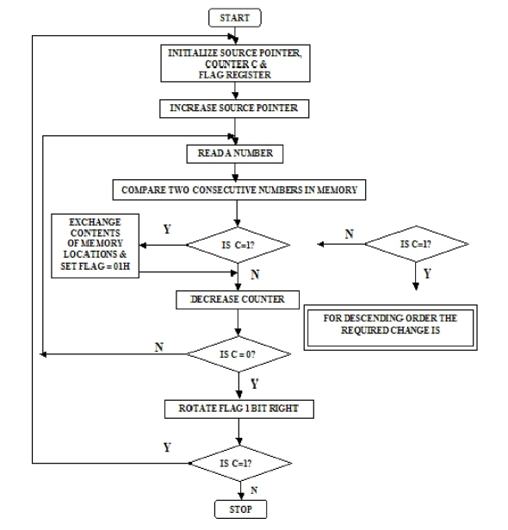

Program Code–
Address | Label | Instruction | Comment
2000H | START | LXI H, 2040H | Load size of array
2003H |  | MVI D, 00H | Clear D register to set up a flag
2005H |  | MOV C, M | Set C register with number of elements in list
2006H |  | DCR C | Decrement C
2007H |  | INX H | Increment memory to access list
2008H | CHECK | MOV A, M | Retrieve list element in Accumulator
2009H |  | INX H | Increment memory to access next element
200AH |  | CMP M | Compare Accumulator with next element
200BH |  | JC NEXTBYTE | If accumulator is less then jump to NEXTBYTE
200EH |  | JZ NEXTBYTE | If accumulator is equal then jump to NEXTBYTE
2011H |  | MOV B, M | Swap the two elements
2012H |  | MOV M, A
2013H |  | DCX H
2014H |  | MOV M, B
2015H |  | INX H
2016H |  | MVI D, 01H | If exchange occurs save 01 in D register
2018H | NEXTBYTE | DCR C | Decrement C for next iteration
2019H |  | JNZ CHECK | Jump to CHECK if C>0
201CH |  | MOV A, D | Transfer contents of D to Accumulator
201DH |  | CPI 01H | Compare accumulator contents with 01H
201FH |  | JZ START | Jump to START if D=01H
2022H |  | HLT | HALT
Explanation-
Conclusion:
Bubble sort is a simple sorting algorithm that repeatedly steps through the list to be sorted, compares each adjacent pair of elements, and swaps them if they are in the wrong order. The algorithm gets its name from the way smaller elements “bubble” to the top of the list. Here’s an 8085 assembly language program for bubble sort

Problem 6
Program
Write 8085 Assembly language program to check whether both the nibbles of 8 bit number are equal or not.

Description:
This program takes a byte as input and checks whether the upper 4 bits (nibble) and lower 4 bits (nibble) are equal or not. If equal 00H else, if not equal 01H is stored into memory.

Algorithm:
Step 1: Load register pair H-L with the address F100H
Step 2: Load the input Byte into accumulator, A.
Step 3: Load the input Byte into register D.
Step 4: Rotate Right Accumulator 4 times.
Step 5: XOR accumulator with content of register D.
Step 6: If zero flag is set(1), Load 00H into Accumulator.
Step 7: If zero flag is not set(0), Load 01H into Accumulator.
Step 8: Store contents of accumulator into memory location F101H. Step 9: Stop.

Flow Chart:
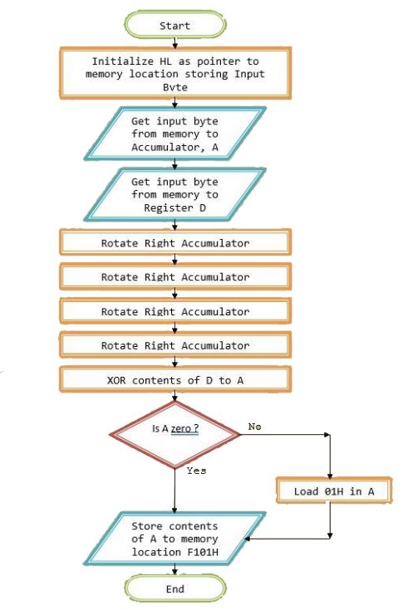

Program Code:
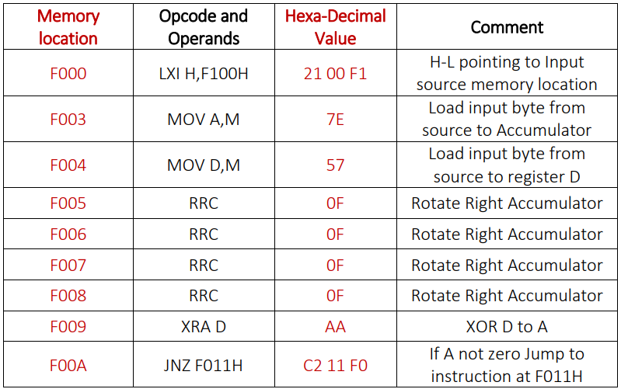
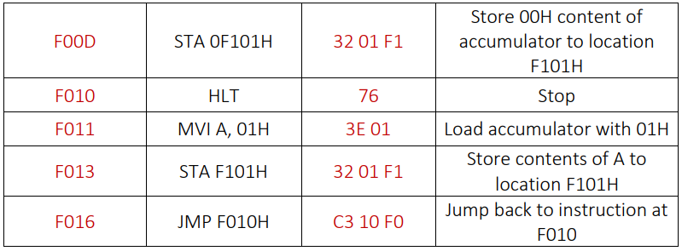

Results:
Set 1:
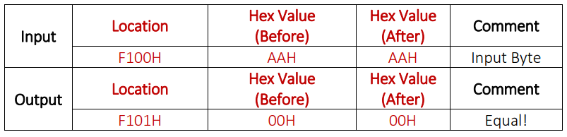

Set 2:
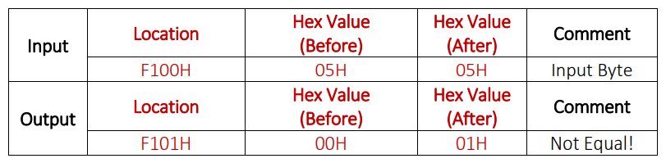

Discussion:
There may arise a situation when user may need to point to the operands in place of directly writing the inputs. For such a situation we can tweak the program to take operand addresses as input. Same may be with the output, where user may need the result at particular memory location. To make it possible we have to change the program to take output location as another input.

PROBLEM 7:
Write an Assembly Language Program to find the largest number in a data array.

PROBLEM STATEMENT:
Assembly Language Program to find the largest number in a data array.

DESCRIPTION:
This program will find the largest number in the given array of any length and will store the number in a predefined memory location.

ALGORITHM:
Step 1: Store the address of the counter (number of elements in the array) in H-L pair.
Step 2: Copy the value in the address hold by H-L pair to C register.
Step 3: Increment H-L pair by 1.
Step 4: Copy the value in the address hold by H-L pair to accumulator.
Step 5: Decrement the counter(C) by 1.
Step 6: Increment H-L pair by 1.
Step 7: Compare the new number in M with number in accumulator.
Step 8: If the number in the accumulator is larger go to Step 10.
Else go to Step 9.
Step 9: Copy the content of M to A(accumulator).
Step 10: Decrement the counter by 1.
Step 11: If the counter is not 0 go to Step 6.
Else go to Step 12,
Step 12: Store the content of accumulator.
Step 13: Stop.

FLOWCHART:
START

Initialize H-L Pair

Get Counter in reg. C
No
Yes
No
No
Yes

Is
No. in A > next
No ?

Get larger number in
Accumulator
Decrement Counter
Is Count=0 ?
Get 1st number in
Accumulator
Store Result
END

PROGRAM:

Address | Machine Code | Label | Mnemonics | Operand
2000 | 21, 00, 25 |  | LXI | H, 2500H
2003 | 4E |  | MOV | C, M
2004 | 23 |  | INX | H
2005 | 7E0D |  | MOV | A, M
2006 | 0D |  | DCR | C
2007 | 23 | LOOP | INX | H
2008 | BE |  | CMP | M
2009 | D2, 0D, 20 |  | JNC | AHEAD
200C | 7E |  | MOV | A, M
200D | 0D | AHEAD | DCR | C
200E | C2, 07, 20 |  | JNZ | LOOP
2011 | 32, 50, 24 |  | STA | 2450H
2014 | 76 |  | HLT

Example 1:
INPUT

Address | Data
  OUTPUT
2500 | 4
2501 | 98
2502 | 75
2503 | 99
2504 | A0
Address | Data
2450 | A0

Example 2:

INPUT

Address | Data
  OUTPUT
2501 | A2
2501 | E4
2502 | 78
2503 | 3B
Address | Data
2450 | E4

INPUT
OUTPUT
Example 3:

Address | Data
2500 | 10
2501 | 20
2502 | 56
2503 | 9A
2504 | B8
Address | Data
2450 | B8

DISCUSSION:
The 1st number of the series is placed in the accumulator and it is compared with the 2nd number residing in the memory. The larger of the numbers is placed in the accumulator. Again this number which is in the accumulator is compaerd with the 3rd number of the series and larger number is placed in the accumulator. This process of comparison is repeated till all the numbers of the series are comopared and the largest number is stored in the desired memory location. Learning this program help us to sort any array in ascending or descending order.

Problem -8
Problem Statement:
Write 8085 Assembly language program to transfer a block of N-bytes in forward order. Move the block of bytes from source location starting at F001H to destination location starting from F020H.
Description:
N no. of data bytes has started from memory location F101H. Transfer the entire block of data to memory location F120H in forward order.
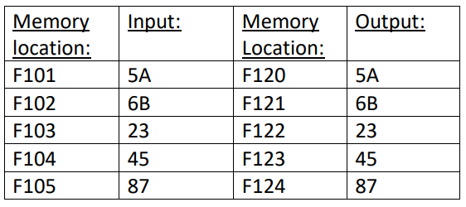
Algorithm:
Step 1: Start
Step 2: Load register pair H-L with the address F100H
Step 3: Load Block Size N, i.e. counter, to B.
Step 4: Increment register pair H-L to F101H
Step 5: Load register pair D-E with the address F120H
Step 6: Move the content at memory location pointed to by H-L into accumulator
Step 7: Store the content of accumulator into memory pointed by D-E
Step 8: Increment value of register pair H-L and D-E by 1
Step 9: Decrements value of register B by 1
Step 10: If zero flag not equal to 1, go to Step 5.
Step 11: Stop

Flow Chart:
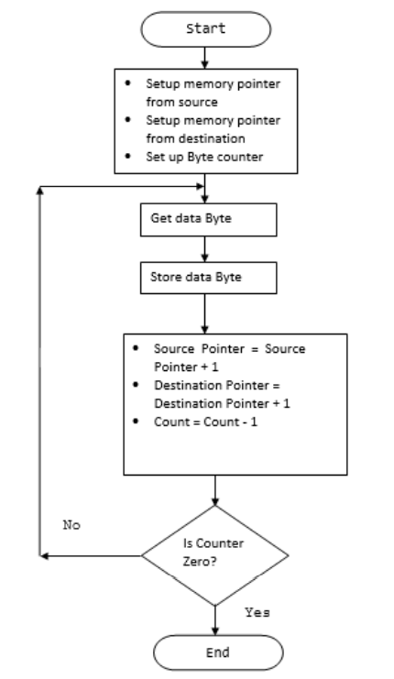

Program Code:
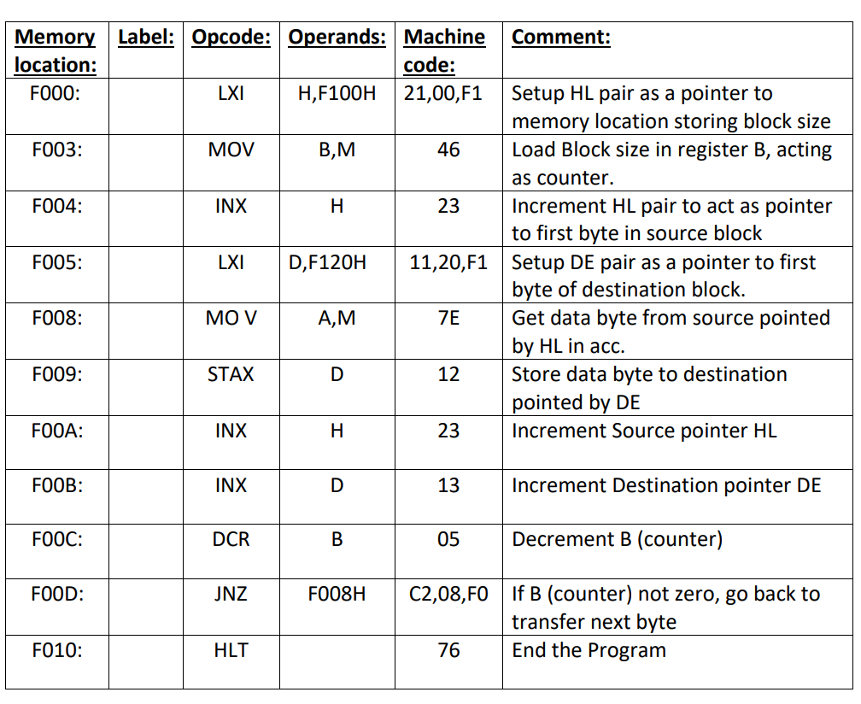
Results:
Set 1:
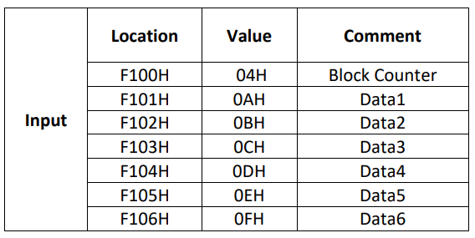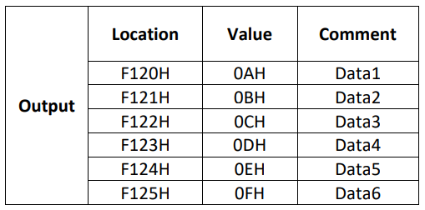

Set 2:
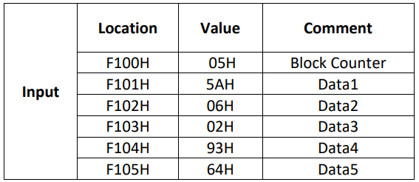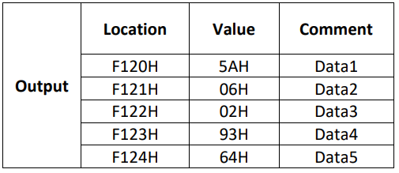

Discussion:
To solve this problem, we are taking the size of the block at first. The DE register pair is set to point at destination address F000H. The HL pair is set to point to the last element of the block. If the block size is 0A, then the last block will be at F00A. At first HL is pointing to F000, and took the block size from there and store to C. Now add C with the L register to get the last block address. Now take each element from memory pointed by HL, and store it back to the memory pointed by the DE. Then increase the DE, and decrease the HL. Thus the entire block will be moved in reverse direction.

Problem 9
Problem
Write 8085 Assembly language program to transfer a block of N-bytes in reverse order.
Description:
The block is stored at location F001H onwards, the size of the block is stored at F000H. The block will be moved at location F020H onwards. Move a block of 10 data (stored from F001H -F00AH to the target location from F020H - F029AH) in the reverse order. They are actually stored.

Algorithm:
Step 1: Load register pair H-L with the address F000H
Step 2: Load register pair D-E with the address F020H
Step 3: Move the content at memory location into accumulator
Step 4: Store the content of accumulator into memory pointed by D-E
Step 5: Point source to previous address
Step 6: Point destination to next address
Step 7: Decrement of C by 1
Step 8: If zero flag not equal to 1, go to step 3
Step 9: Stop

Flowchart:
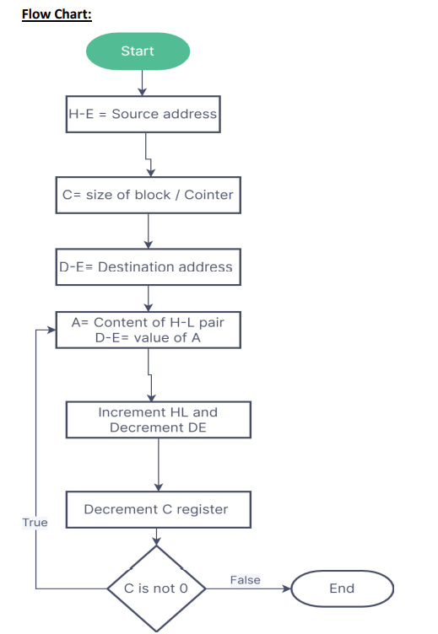

Program Code:

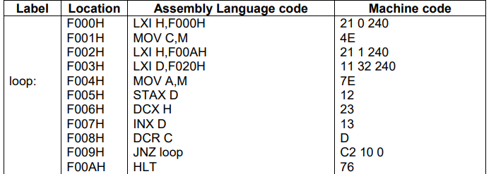

Result:
Set 1:
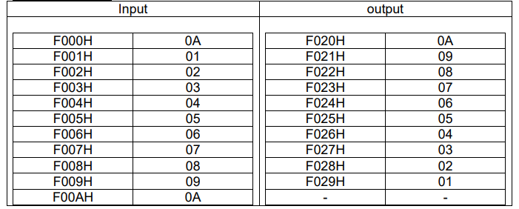
Set 2:
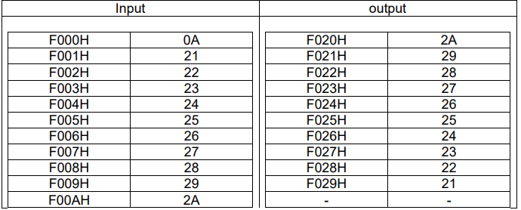

Discussion:
To solve this problem, we are taking the size of the block at first. The D-E register pair is set to point at the destination address F020H. The H-L pair is set to point to the last element of the block. If the block size is 0A, then the last block will be at F00AH. At first H-L is pointing to F000H, and took the block size from there and stores it to C. Now add C with the L register to get the last block address. Now take each element from memory pointed by H-L, and store it back to the memory pointed by the D-E. Then increase the D-E, and decrease the H-L. Thus the entire block will be moved in reverse direction.

Problem: 10
Problem Statement:
Write 8085 Assembly Language Program to find the Two’s complement of an
8-bit number.
Description:
This program will find the Two’s complement of an 8-Bit number and will store the result in a predefined memory location.
Algorithm:
Step 1: Initialize the data memory.
Step 2: Load the number in AX.
Step 3: Find 2’scomplement of number.
Step 4: Display the result.
Step 5: Stop.
Flow Chart:
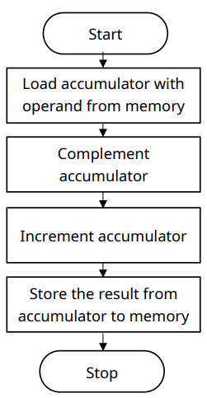

Program Code:
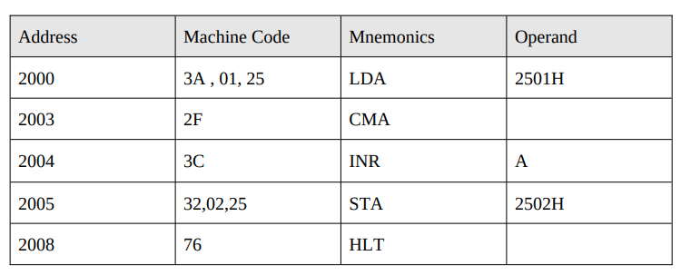

Results:
Set 1:
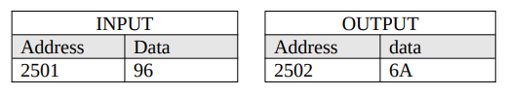
Set 2:
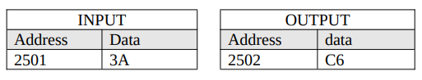
Discussion:
In 8085, there is CMA instruction to complement a number. Then we can add 01 with it to make it 2’s complement. While adding 01 with it, the carry may generate. We will store it to 2500H, and the actual complemented value will be at 2502H.

Problem :11
Problem Statement:
Write 8085 Assembly language program to convert Hexadecimal number into its equivalent ASCII in Hexadecimal form.
Description:
A hexadecimal number is given, the program converts this number into its corresponding ASCII value and stores the result in the output locations F201H and F202H.
Algorithm:
Step 1: Load the input data from the memory location and move the data to register B.
Step 2: Call Subroutine ASCII.
Step 3: Move content of Accumulator to register L and content of register B to Accumulator.
Step 4: Rotate Accumulator Right five times
Step 5: Again call subroutine ASCII.
Step 6: Move content of Accumulator to register H.
Step 5: Store content of register pair HL to memory location F201.
Step 6: ASCII :
Multiply the value of the Accumulator with 0F.
Compare the accumulator value with 0A.
If Carry Flag == 1:
Call subroutine Go
Else:
Add 07 with Accumulator
GO:
Add 30 with Accumulator Return

Flow Chart:
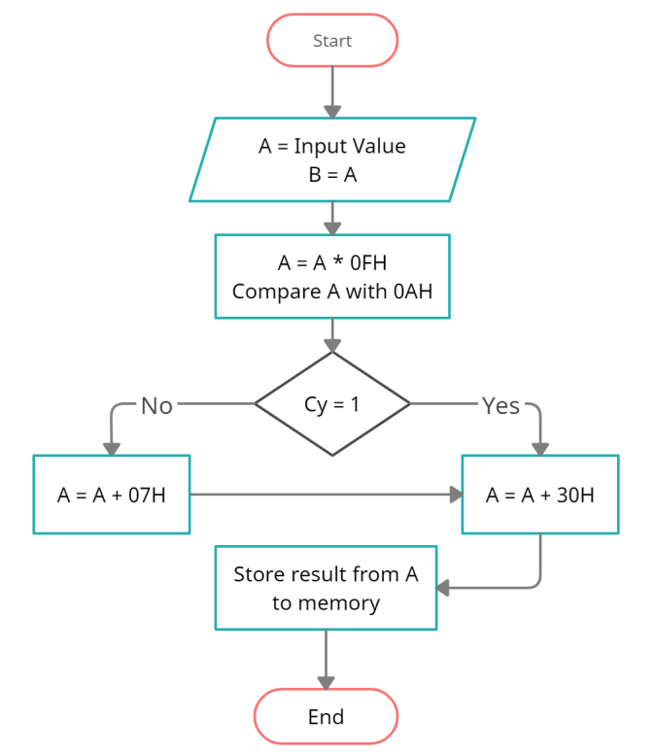
Program Code:
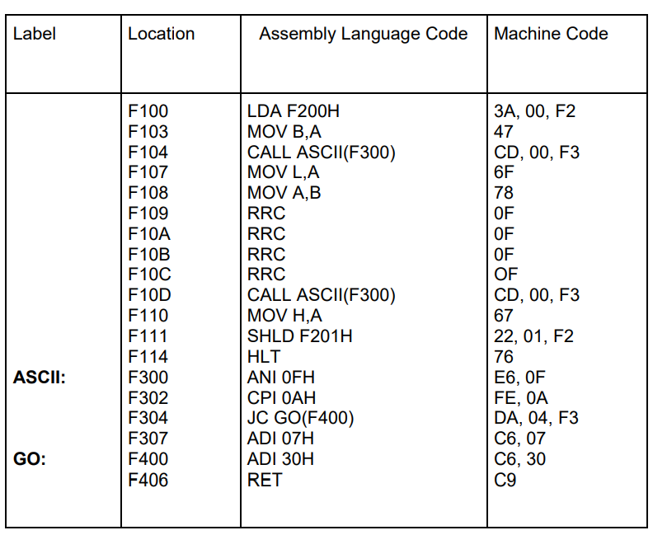
Results:
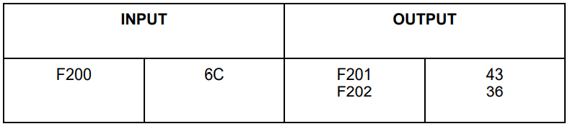

Discussion:
This program converts a Hexadecimal Number into its corresponding ASCII number by getting the second byte separately for two times, then based on the comparison the value 07H or 30H or both gets added to get the corresponding ASCII value.

Problem :12
Problem Statement:
Write a program in 8085 assembly language for shifting a 16 bit binary number by 3 bit to the right.

Description:
A 16-bit binary number is given. The program is used for shifting this binary number by 3 bit to the right.

Algorithm:
Step 1: Load the data in HL pair.
Step 2: Move the data memory to C register.
Step 3: Increment by 1 the HL pair
Step 4: Move the data memory to accumulator.
Step 5: Rotate right Accumulator.
Step 6: Store the value accumulator.
Step 7: Decrement by 1 the HL pair.
Step 8: Rotate Accumulator right.
Step 9: Store the value Accumulator.
Step 10: Decrement the value of C register.
Step 11: JNZ and GO the Step 5.

Program Code:
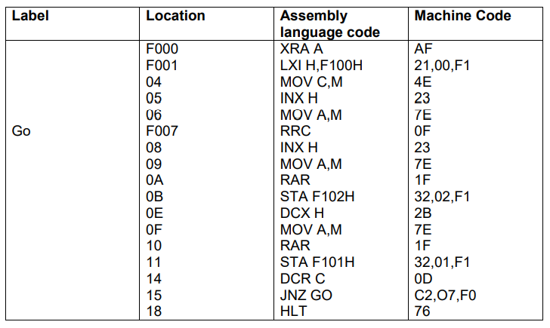

Results:
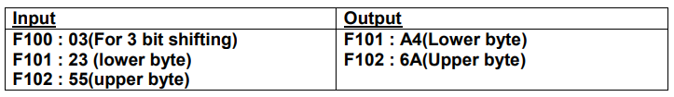

Discussion:
1. Here we take 16 bits data from specific user location to memory after XRA instruction. It nullifies the previous content of the accumulator then using RRC , we can rotate the accumulator right and with RRC instruction we also can rotate the accumulator through carry. Then stores shifted data in one location.
2. With this knowledge of the program we can build other types of shifting and rotating problems

Problem: 13
Problem Statement:
Write 8085 Assembly language program to generate a Fibonacci series.
Description:
This program generates the first ten elements of the Fibonacci sequence using registers and store them in memory locations F050H.
Algorithm:
Step1: Initialize register D with 00, and register E with 01
Step2: Load register pair H-L with address F050H
Step3: Move the content of M in C.
Step4: Increment M by 1 so that M point next memory location
Step5: Move the content of D in M.
Step6: Decrease C by 1
Step7: Jump if carry to the step 21
Step8: Jump if zero to the step 21
Step9: Increment M by 1 so that M point next memory location
Step10: Move the content of M in E.
Step11: Decrease C by 1
Step12: Jump if zero to the step 21
Step13: Increment M by 1 so that M point next memory location
Step14: Move the content of D in A
Step15: Addition E with A
Step16: Move the content of D in E.
Step17: Move the content of E in A.
Step18: Move the content of M in A
Step19: Decrease C by 1
Step20: Jump to step 13 if ZF = 0 otherwise Halt the program
Step21: Halt the program

Flow Chart:

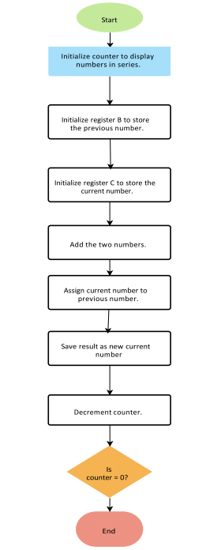

Program Code:
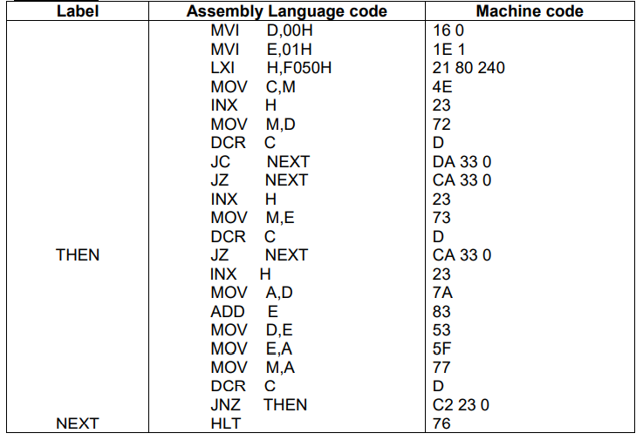

Results:
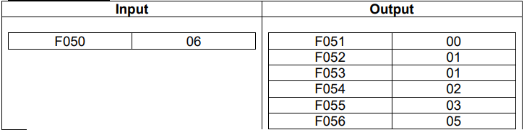
Discussion:
This program will generate the Fibonacci numbers. The Fibonacci numbers follows this relation F(i) = F(i - 1) + F(i - 2) for all i >2 with F(1) = 0, F(2) = 1.This program generates Fibonacci series in hexadecimal numbers.

Problem : 14
Problem Statement:
Write 8085 Assembly language program to convert a binary number to its equivalent gray code.

Description:
A hexadecimal number is given as input. The program converts the 8-bit number stored at F200H to its equivalent gray code and the result will be stored at F201H memory location.

Algorithm:
1. Start.
2. Load the data from address F200 in A (Accumulator).
3. Move the data of A into register B.
4. Set the Carry Flag (CY) to 1.
5. Complement Carry Flag.
6. Rotate the bits of A to right.
7. XOR the contents of register A and B.
8. Store the result at memory address F201.
9. Stop.

Flow Chart:
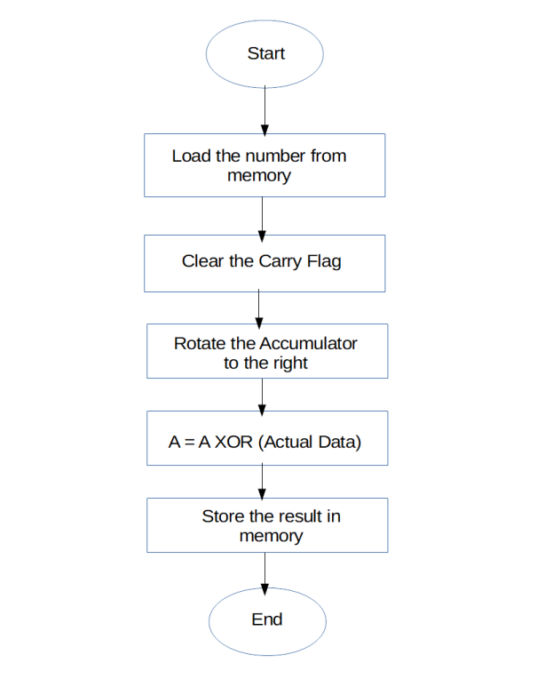
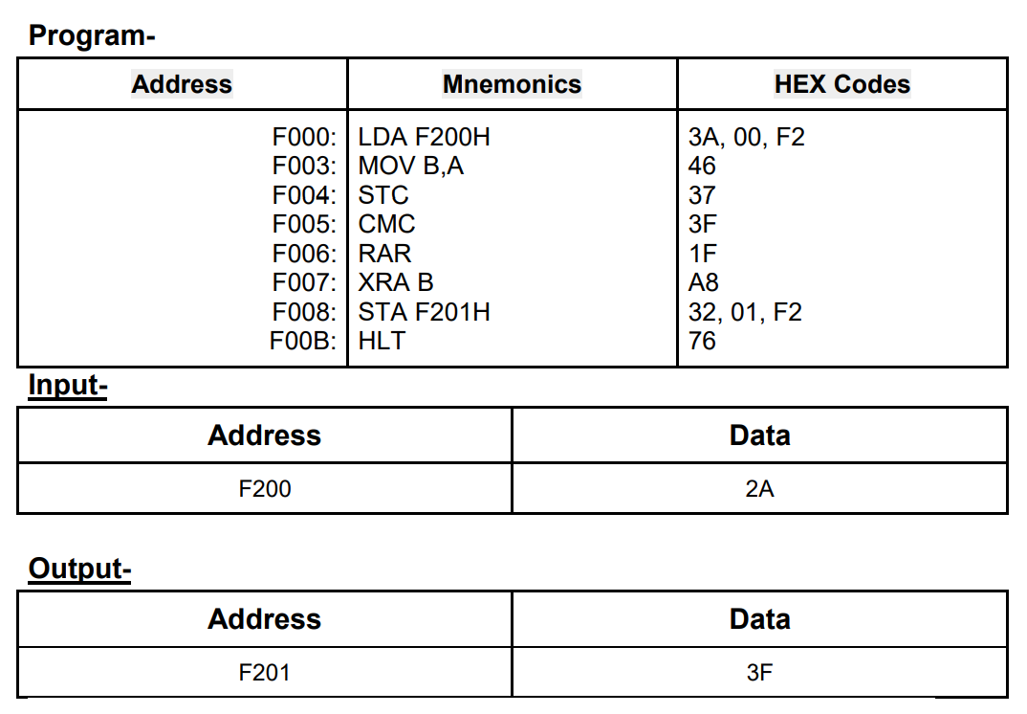

Discussion:
In this program we are converting binary to gray code. The procedure is simple. At first we have to shift the content to the right, then perform XOR operation with the shifted content and the actual content. Thus we will get the gray code. For an example if the number is 2AH, then the binary value will be (0010 1010), after shifting the value will be (0001 0101), now by XORing (0010 1010) and (0001 0101), the result will be (0011 1111) = 3FH

