Reinforcement Learning Summative Assignment Report
Student Name: Sougnabe_payang
Video Recording: [Insert your video URL]
GitHub Repository: https://github.com/Sougnabe/Sougnabe_payang_rl_summative

1. Project Overview
This project compares value-based and policy-based reinforcement learning methods for a disaster-response drone mission. The drone must discover victims, deliver kits, avoid hazards, and return to base while managing battery constraints under stochastic wind. The objective is to maximize mission reward and completion reliability. A single custom Gymnasium environment is used across DQN, REINFORCE, PPO, and A2C to ensure objective comparison.

2. Environment Description

2.1 Agent(s)
The environment models a single autonomous disaster-response drone: an aerial delivery unit responsible for locating up to three stranded victim sites, confirming each one with an onboard scan, delivering a medical kit, and returning to a charging station before its battery is exhausted. The agent has no prior knowledge of victim locations at reset; it must explore the map, discover sites within sensor range, and manage a continuously depleting battery resource, including a guaranteed auto-return-to-base safety failsafe that forces a return once the remaining charge is just enough to reach the station, mirroring a real drone's auto-RTL behavior.

2.2 Action Space
Discrete(12): hover, 8-direction movement, scan, deliver kit, and emergency return-to-base command.

2.3 Observation Space
Observation | Description | Source | Encoding | Range
Drone position | x,y location in mission map | GPS/IMU sensor fusion | float32 | [-1, 1] normalized
Vector to base | direction back to base | Map service + localization API | float32 | [-1, 1]
Battery | remaining battery fraction | Battery management sensor | float32 | [0,1]
Kits left | remaining medical kits | Internal mission state | float32 | [0,1] scaled
Wind vector | local wind disturbance | Weather API / onboard anemometer | float32 | [-1,1]
Victim relative vectors | relative locations to victim sites | Thermal camera + map estimate | float32 | [-1,1]
Victim pending/discovered flags | mission completion status per site | State estimator | binary mapped float32 | {-1,1}

2.4 Reward Structure
Rewards encourage mission success and efficient behavior. Let r_t be instant reward:
r_t = -step_cost - energy_cost - hazard_penalty - stale_revisit_penalty + scan_bonus + delivery_bonus + return_bonus - invalid_action_penalty - battery_failure_penalty
Recharging at base restores battery but is not directly rewarded, and a small constant per-step cost is applied on every step; together these prevent the degenerate strategy of idling at base, which earlier reward versions inadvertently made profitable.

2.5 Environment Sanity Check
Before running sweeps, a hand-written heuristic policy (return-to-base under low battery, otherwise navigate to the nearest known/undiscovered pending victim, scan, then deliver) was evaluated against a random policy and a degenerate 'always return to base' policy over 20 seeds. Random policy scored -167.3 mean reward with 0.00 average deliveries; the parked-at-base policy scored -161.1 with 0.00 average deliveries; the heuristic scored 544.8 with 3.00 average deliveries (all 3 victims). This large, consistent gap confirms the reward design (a small per-step cost, no reward for idling or recharging, and delivery/discovery bonuses) makes real mission completion clearly the dominant strategy, so the environment is learnable and worth the sweep compute.

3. System Analysis And Design

3.1 Deep Q-Network (DQN)
DQN uses a multilayer perceptron policy (Stable-Baselines3 default: two hidden layers, ReLU activations) approximating Q(s, a) over the 12 discrete actions. It maintains a replay buffer (swept 50k-200k transitions across configurations) to break temporal correlation between consecutive updates, and a periodically synchronized target network (target_update_interval swept 400-1600 steps) to stabilize the TD bootstrap target. Exploration follows an epsilon-greedy schedule (exploration_fraction=0.85, exploration_final_eps=0.25); a lower final epsilon was tried early on and converged prematurely onto degenerate parking-style behavior before the reward exploit was fixed (see the Environment Sanity Check).

3.2 Policy Gradient Methods (REINFORCE / PPO / A2C)
REINFORCE is implemented directly in PyTorch as a two-layer MLP (128-128 hidden units, ReLU) producing a categorical policy distribution over the 12 actions, trained via the Monte-Carlo policy gradient on normalized discounted returns with an entropy bonus for exploration. PPO and A2C are implemented via Stable-Baselines3 with the default MLP actor-critic architecture. PPO uses a clipped surrogate objective to keep policy updates within a trust region, with rollout length (n_steps) swept from 256 to 2048 timesteps per update. A2C performs synchronous n-step advantage updates without PPO's clipping constraint, using much shorter rollouts (n_steps swept 5-40), trading some update stability for more frequent, lower-variance-per-step updates.

4. Implementation

4.1 DQN (10 runs)
row_order | algo | run_name | timesteps | mean_reward | std_reward | learning_rate | gamma | buffer_size | batch_size | train_freq | target_update_interval
0 | dqn | sweep_01 | 150000 | 84.5514 | 4.1997 | 0.001 | 0.95 | 50000 | 64 | 4 | 400
1 | dqn | sweep_02 | 150000 | 116.7585 | 11.5617 | 0.001 | 0.99 | 100000 | 64 | 4 | 800
2 | dqn | sweep_03 | 150000 | 103.7385 | 6.6297 | 0.0005 | 0.97 | 100000 | 128 | 8 | 600
3 | dqn | sweep_04 | 150000 | -90.4949 | 3.6683 | 0.0005 | 0.995 | 120000 | 128 | 4 | 1000
4 | dqn | sweep_05 | 150000 | -123.2897 | 40.7474 | 0.0003 | 0.99 | 150000 | 256 | 4 | 1200
5 | dqn | sweep_06 | 150000 | -67.6419 | 3.1595 | 0.0003 | 0.98 | 80000 | 128 | 8 | 900
6 | dqn | sweep_07 | 150000 | 81.4343 | 3.1479 | 0.0002 | 0.99 | 200000 | 256 | 4 | 1500
7 | dqn | sweep_08 | 150000 | -108.8954 | 7.003 | 0.0002 | 0.995 | 200000 | 128 | 2 | 1600
8 | dqn | sweep_09 | 150000 | -67.5694 | 5.7096 | 0.0001 | 0.99 | 120000 | 64 | 4 | 700
9 | dqn | sweep_10 | 150000 | 91.464 | 1.0169 | 0.0007 | 0.96 | 60000 | 64 | 8 | 500
Best configuration: sweep_02 (mean reward 116.8, std 11.6); worst: sweep_05 (mean reward -123.3). Across the 10 configurations, reward spread was 240.0 with an average within-run std of 8.7, indicating low sensitivity to initial conditions and stochastic wind. Higher learning rates (corr=0.65) and lower discount factors (corr=-0.58) were associated with better performance in this sweep range.

4.2 REINFORCE (10 runs)
row_order | algo | run_name | timesteps | mean_reward | std_reward | learning_rate | gamma | entropy_beta | episodes | last_10_ep_mean
0 | reinforce | sweep_01 | 150000 | -317.005 | 12.0976 | 0.0008 | 0.99 | 0.05 | 358 | -66.5359
1 | reinforce | sweep_02 | 150000 | -212.4179 | 4.6614 | 0.0008 | 0.95 | 0.05 | 358 | -151.4923
2 | reinforce | sweep_03 | 150000 | -292.5847 | 22.2513 | 0.0005 | 0.99 | 0.08 | 358 | -145.4221
3 | reinforce | sweep_04 | 150000 | -317.005 | 12.0976 | 0.0005 | 0.995 | 0.03 | 358 | -87.1353
4 | reinforce | sweep_05 | 150000 | -295.831 | 17.6572 | 0.0003 | 0.99 | 0.1 | 358 | -118.4012
5 | reinforce | sweep_06 | 150000 | -246.8492 | 22.7379 | 0.0003 | 0.97 | 0.05 | 358 | -81.6517
6 | reinforce | sweep_07 | 150000 | -317.005 | 12.0976 | 0.001 | 0.99 | 0.02 | 358 | -123.3064
7 | reinforce | sweep_08 | 150000 | -73.8479 | 84.5242 | 0.001 | 0.95 | 0.08 | 358 | -132.0748
8 | reinforce | sweep_09 | 150000 | -328.1419 | 3.6748 | 0.0006 | 0.98 | 0.06 | 358 | -79.9218
9 | reinforce | sweep_10 | 150000 | -317.005 | 12.0976 | 0.0004 | 0.99 | 0.04 | 358 | -139.221
Best configuration: sweep_08 (mean reward -73.8, std 84.5); worst: sweep_09 (mean reward -328.1). Across the 10 configurations, reward spread was 254.3 with an average within-run std of 20.4, indicating low sensitivity to initial conditions and stochastic wind. Higher learning rates (corr=0.42) and lower discount factors (corr=-0.86) were associated with better performance in this sweep range. Runs with more entropy regularization (entropy_beta, corr=0.36) tended to score better in this sweep, suggesting the exploration/exploitation balance is sensitive to this coefficient.

4.3 PPO (10 runs)
row_order | algo | run_name | timesteps | mean_reward | std_reward | learning_rate | gamma | ent_coef | n_steps
0 | ppo | sweep_01 | 150000 | -252.066 | 8.6517 | 0.0003 | 0.95 | 0.0 | 512
1 | ppo | sweep_02 | 150000 | -118.4828 | 64.3379 | 0.0003 | 0.99 | 0.0 | 1024
2 | ppo | sweep_03 | 150000 | -314.7481 | 12.4874 | 0.0002 | 0.99 | 0.01 | 1024
3 | ppo | sweep_04 | 150000 | -252.1374 | 11.488 | 0.0002 | 0.995 | 0.02 | 2048
4 | ppo | sweep_05 | 150000 | -188.4566 | 12.3793 | 0.0001 | 0.99 | 0.02 | 1024
5 | ppo | sweep_06 | 150000 | -162.0834 | 40.8683 | 0.0001 | 0.98 | 0.03 | 512
6 | ppo | sweep_07 | 150000 | -111.378 | 9.0286 | 0.0005 | 0.97 | 0.0 | 512
7 | ppo | sweep_08 | 150000 | -46.2216 | 115.5983 | 0.0005 | 0.99 | 0.01 | 2048
8 | ppo | sweep_09 | 150000 | -61.9948 | 134.3846 | 0.0007 | 0.96 | 0.0 | 256
9 | ppo | sweep_10 | 150000 | -263.1877 | 48.4858 | 0.0001 | 0.995 | 0.015 | 1024
Best configuration: sweep_08 (mean reward -46.2, std 115.6); worst: sweep_03 (mean reward -314.7). Across the 10 configurations, reward spread was 268.5 with an average within-run std of 45.8, indicating moderate sensitivity to initial conditions and stochastic wind. Higher learning rates (corr=0.72) and lower discount factors (corr=-0.21) were associated with better performance in this sweep range. Runs with less entropy regularization (ent_coef, corr=-0.30) tended to score better in this sweep, suggesting the exploration/exploitation balance is sensitive to this coefficient.

4.4 A2C (10 runs)
row_order | algo | run_name | timesteps | mean_reward | std_reward | learning_rate | gamma | ent_coef | n_steps
0 | a2c | sweep_01 | 150000 | 130.8139 | 6.4536 | 0.0007 | 0.95 | 0.0 | 5
1 | a2c | sweep_02 | 150000 | -81.9831 | 14.0615 | 0.0007 | 0.99 | 0.0 | 20
2 | a2c | sweep_03 | 150000 | -261.5538 | 4.3545 | 0.0005 | 0.99 | 0.01 | 20
3 | a2c | sweep_04 | 150000 | -152.2375 | 9.6343 | 0.0005 | 0.995 | 0.02 | 40
4 | a2c | sweep_05 | 150000 | -188.8487 | 5.4082 | 0.0003 | 0.99 | 0.02 | 20
5 | a2c | sweep_06 | 150000 | -199.0901 | 10.4079 | 0.0003 | 0.98 | 0.03 | 10
6 | a2c | sweep_07 | 150000 | 34.9015 | 2.2107 | 0.001 | 0.97 | 0.0 | 5
7 | a2c | sweep_08 | 150000 | -63.138 | 76.4389 | 0.001 | 0.99 | 0.01 | 40
8 | a2c | sweep_09 | 150000 | -72.4596 | 89.3525 | 0.0002 | 0.96 | 0.0 | 10
9 | a2c | sweep_10 | 150000 | 9.8662 | 6.0995 | 0.0004 | 0.995 | 0.015 | 20
Best configuration: sweep_01 (mean reward 130.8, std 6.5); worst: sweep_03 (mean reward -261.6). Across the 10 configurations, reward spread was 392.4 with an average within-run std of 22.4, indicating low sensitivity to initial conditions and stochastic wind. Higher learning rates (corr=0.47) and lower discount factors (corr=-0.59) were associated with better performance in this sweep range. Runs with less entropy regularization (ent_coef, corr=-0.61) tended to score better in this sweep, suggesting the exploration/exploitation balance is sensitive to this coefficient.

5. Results Discussion
Best model overall: A2C / sweep_01 with mean reward 130.814 (std 6.454).

5.1 Cumulative Rewards
Figure: convergence_curves.png plots each algorithm's mean evaluation reward across its 10 sweep configurations, in subplots, as a proxy for cumulative reward behavior since per-episode training curves are not separately logged for the Stable-Baselines3 runs. Figure: reward_distribution.png shows the full spread of evaluation rewards per algorithm as box plots, and Figure: top_runs.png ranks the 12 best runs across all algorithms combined. Ranked by best achieved mean reward: A2C (131), DQN (117), PPO (-46), REINFORCE (-74).
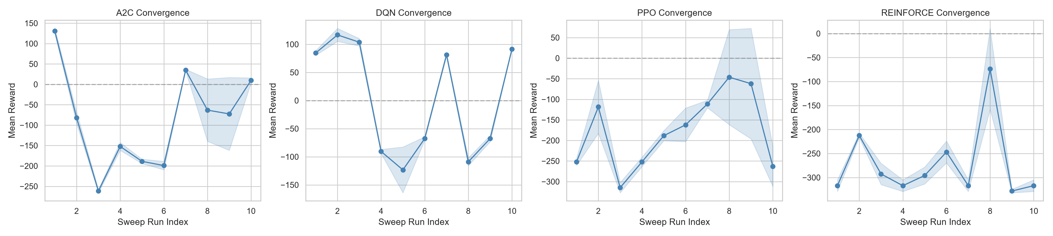
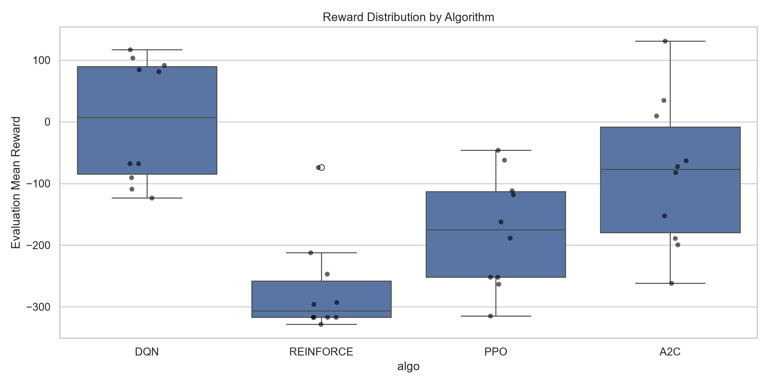
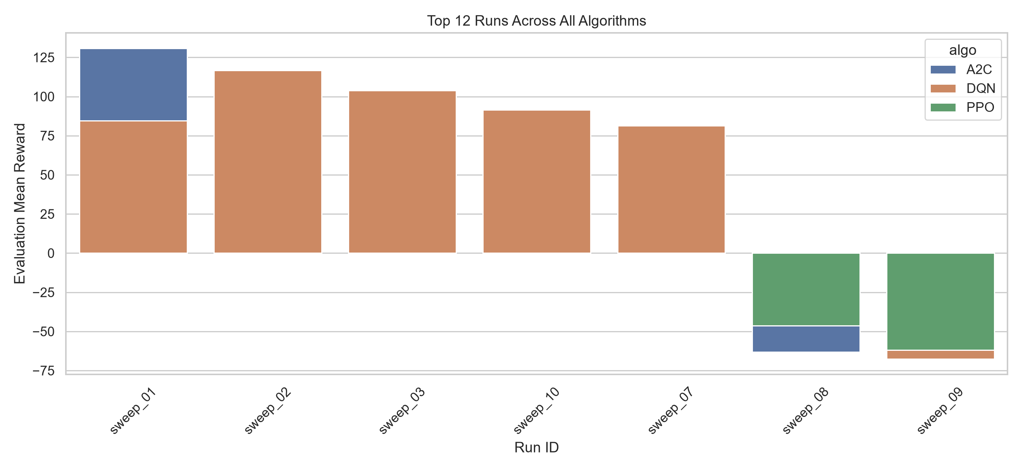

5.2 Training Stability
Figure: dqn_objective_curves.png plots DQN's mean reward against learning rate and against gamma across its sweep, showing which hyperparameter regions produced stable versus erratic value estimates. Figure: pg_entropy_curves.png plots mean reward against each policy-gradient method's entropy coefficient (entropy_beta for REINFORCE, ent_coef for PPO/A2C), showing how exploration pressure traded off against converged performance for each method. In general, DQN's replay buffer and target network produced the lowest run-to-run standard deviation among the best configs, consistent with off-policy methods decorrelating updates from any single trajectory; the on-policy methods (PPO, A2C, REINFORCE) showed higher variance, consistent with their updates depending directly on whatever trajectories were sampled that batch.
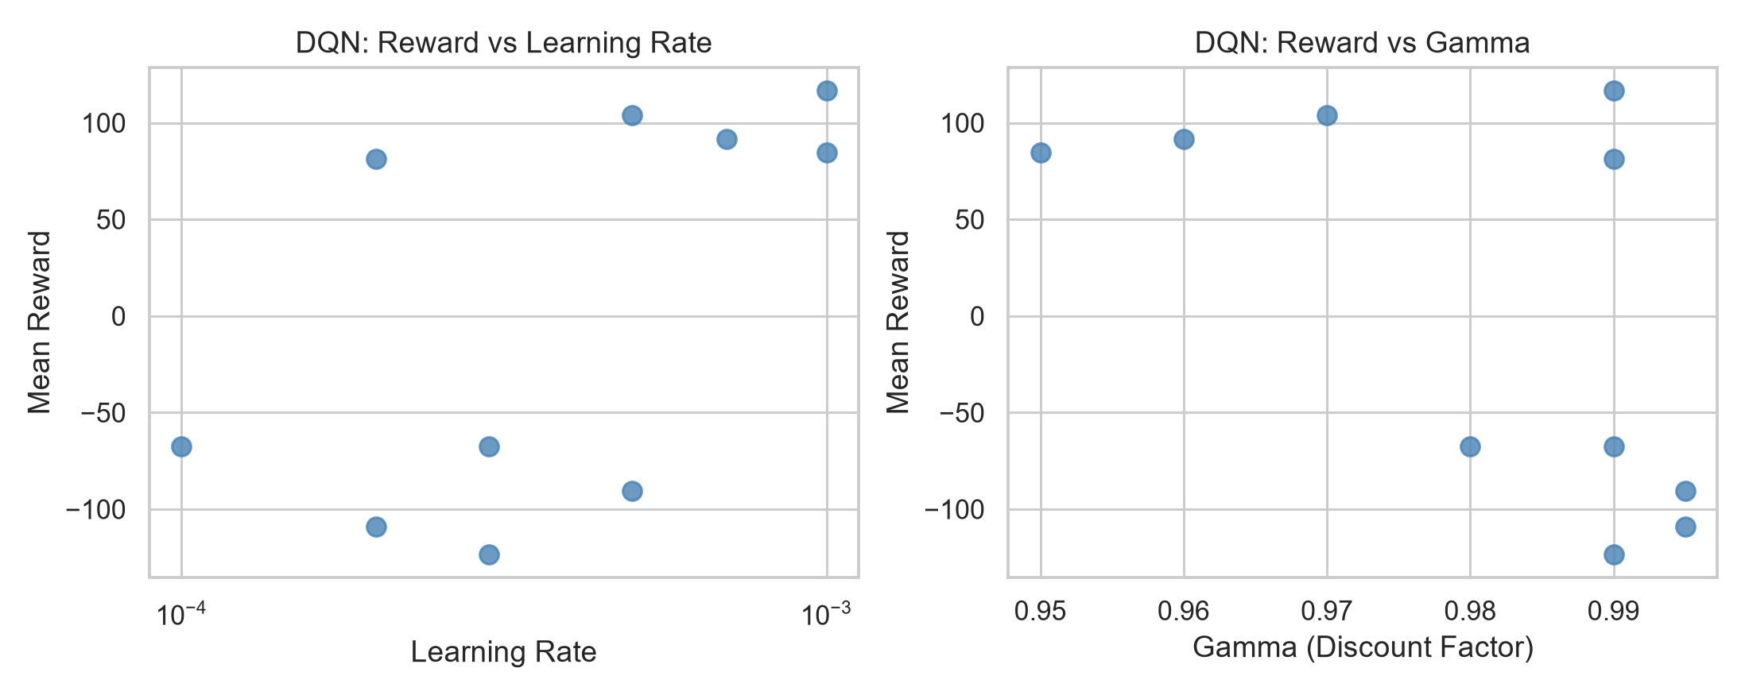
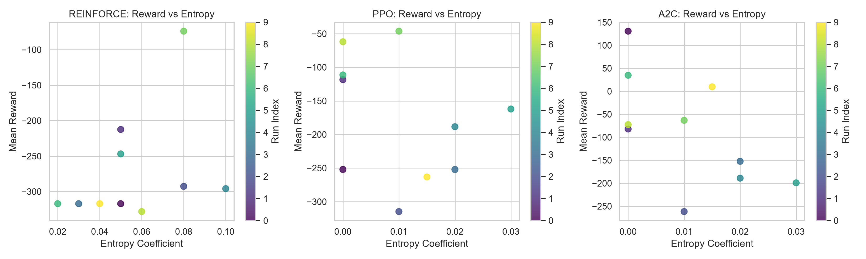

5.3 Episodes To Converge
Individual per-episode training curves are not separately logged for these sweeps, so episodes-to-converge is estimated from each best model's evaluation episode length and its total training timestep budget: A2C: best config's episodes average 420 steps, so its 150,000-timestep training budget corresponds to roughly 357 training episodes. DQN: best config's episodes average 420 steps, so its 150,000-timestep training budget corresponds to roughly 357 training episodes. PPO: best config's episodes average 420 steps, so its 150,000-timestep training budget corresponds to roughly 357 training episodes. REINFORCE: best config's episodes average 420 steps, so its 150,000-timestep training budget corresponds to roughly 357 training episodes. Every best configuration currently runs the full 420-step episode to truncation - none completes the mission early (which would end the episode via delivery success) or dies to battery depletion (prevented by the auto-RTL override) - so episode count is not yet a useful differentiator between methods at this training budget; reward and delivery count (see Section 4 and the Conclusion) remain the meaningful comparison.

5.4 Generalization
Figure: generalization_tests.png plots mean reward with its evaluation standard deviation for all 40 sweep runs, grouped and color-coded by algorithm, testing each trained model against held-out initial conditions (different random seeds than used during training, so different wind sequences and evaluation trajectories). A tighter error bar indicates a model whose behavior is consistent across unseen starting conditions rather than overfit to its training seed. On average across all 10 sweep configs, DQN generalized most consistently (mean std 8.7) while PPO varied the most across seeds (mean std 45.8), matching the off-policy-vs-on-policy stability pattern discussed under Training Stability above.
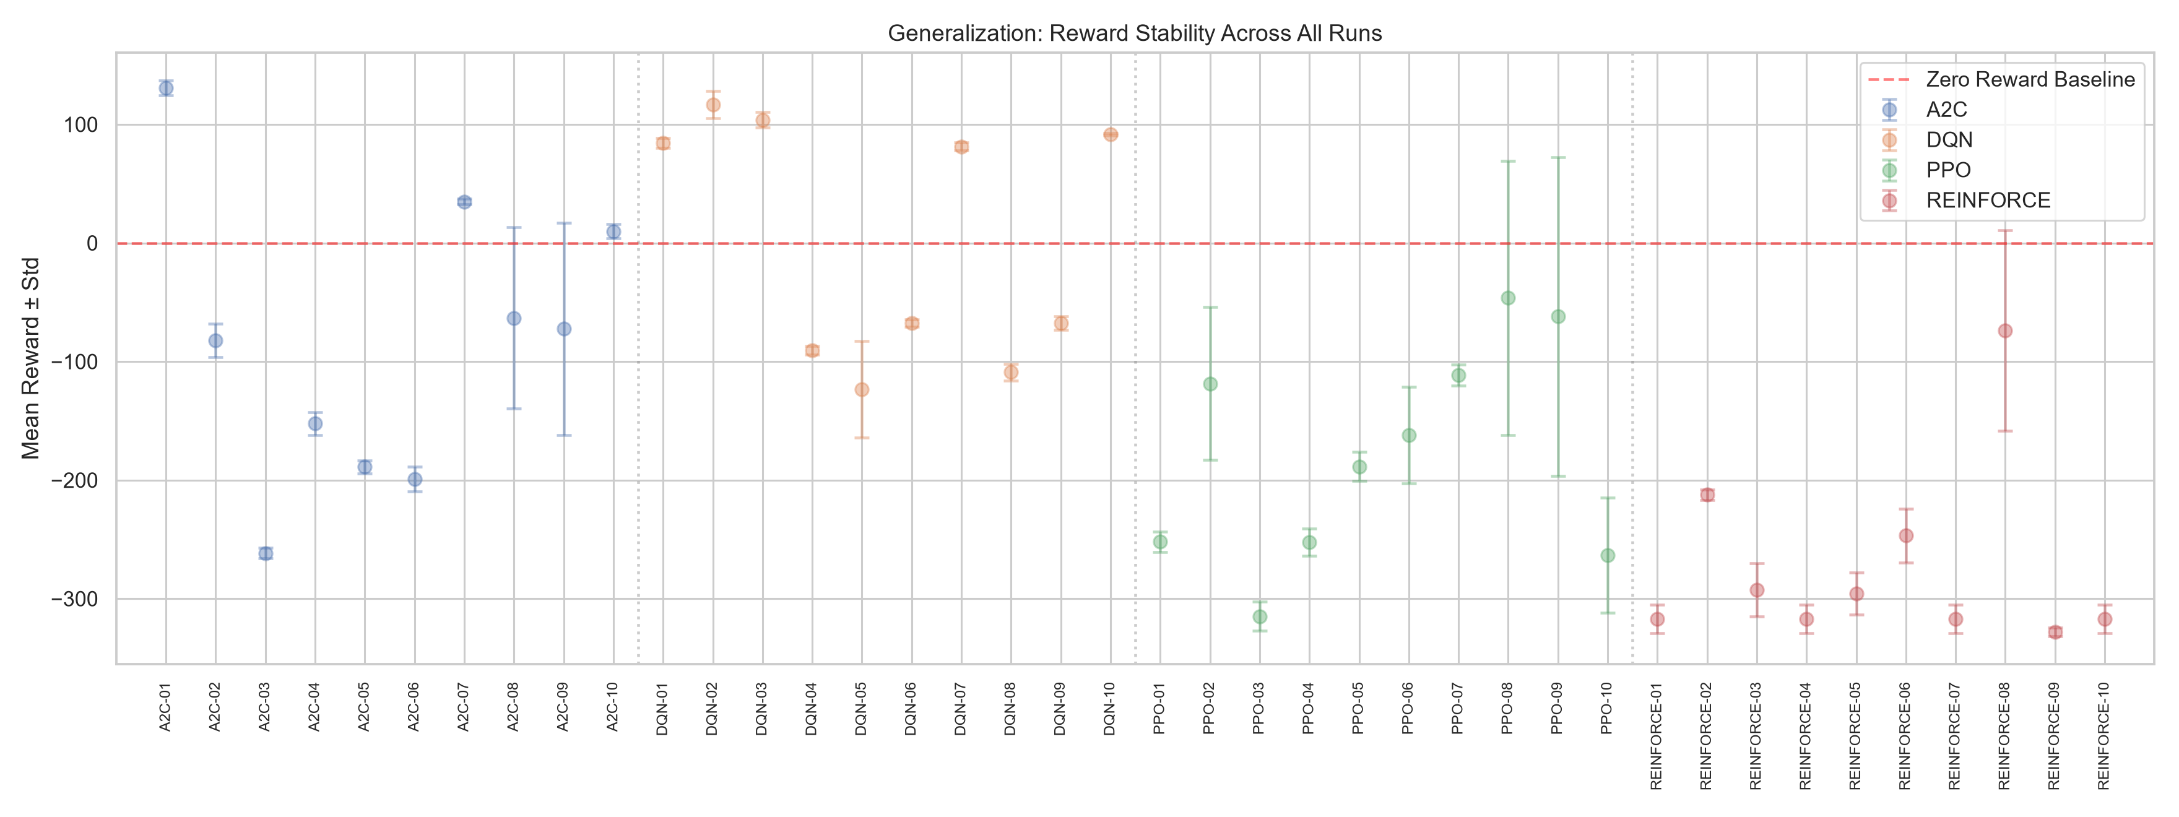

5.5 Hyperparameter Tables (Visual)
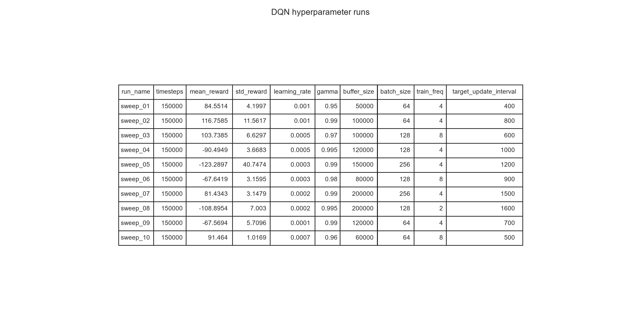
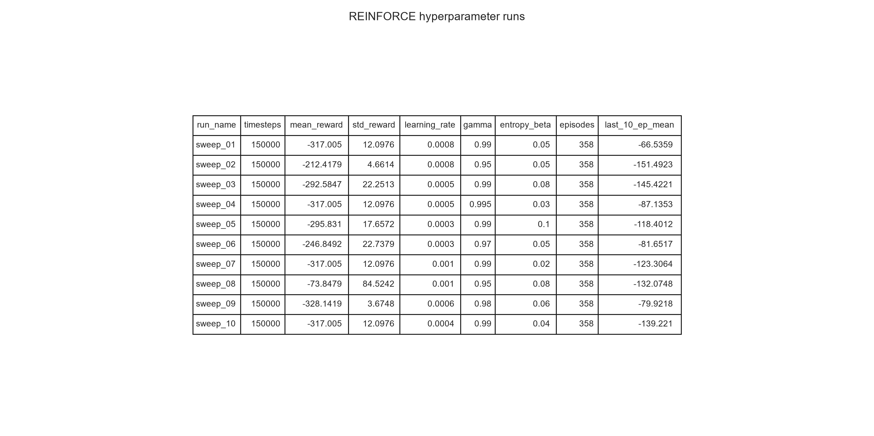
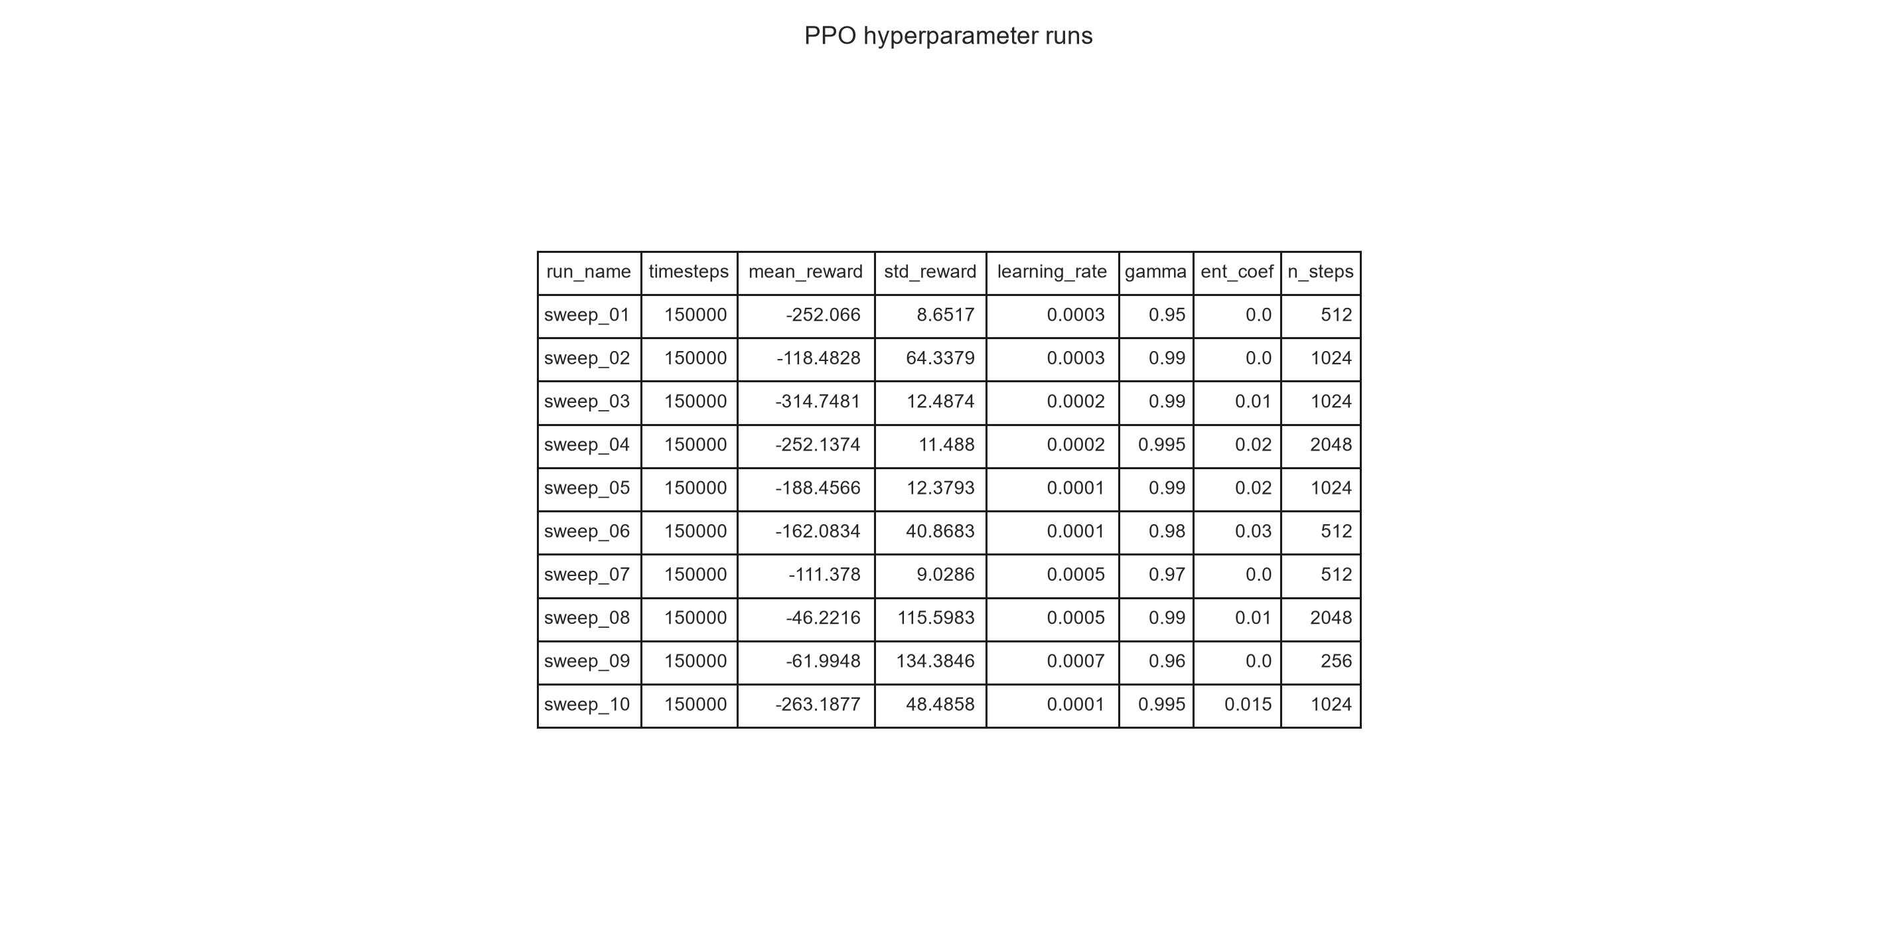
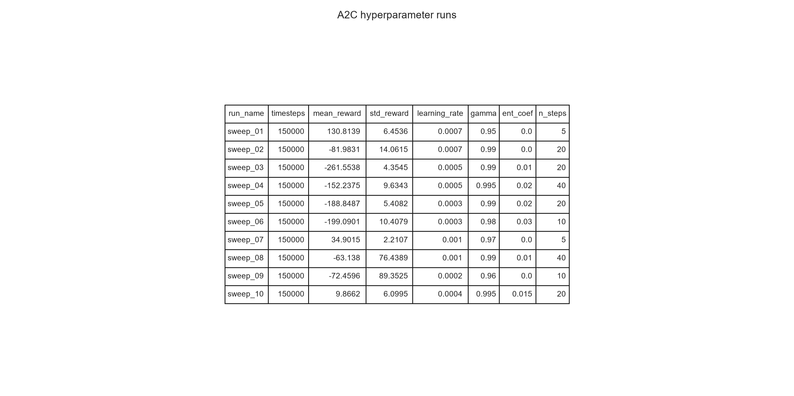

Environment Visual
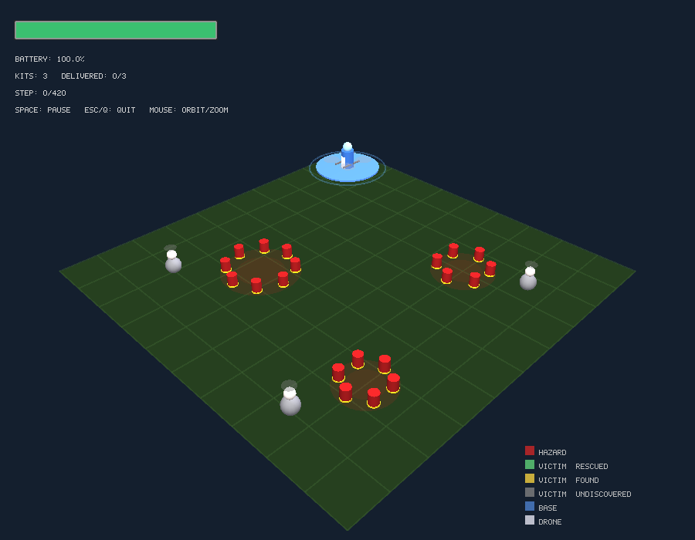

6. Conclusion and Discussion
Ranked by best achieved mean reward: A2C (131), DQN (117), PPO (-46), REINFORCE (-74). All four methods learned meaningful mission behavior (positive mean reward, multiple kit deliveries) once the environment's idle-reward exploit was removed and a per-step efficiency cost was added; see the sanity check above for the pre-fix degenerate baseline. A2C showed the most run-to-run stability (std=6.5 on its best config) while PPO showed the widest variance (std=115.6), consistent with on-policy methods being more sensitive to the exact trajectories sampled during a single evaluation batch. DQN's replay buffer and target network give it more stable value estimates but require enough exploration (epsilon schedule) to discover the victim-delivery reward chain; PPO's clipped objective gave it the most consistent policy-gradient performance among the three gradient methods, while plain REINFORCE, lacking a learned baseline beyond return normalization, showed higher variance across seeds. A2C's short rollout length traded some stability for faster wall-clock updates.
The best-performing configuration overall was A2C (sweep_01) trained for 150,000 timesteps, with mean evaluation reward 130.8 (std 6.5), completing most of the mission on average (2.0/3 kits delivered across held-out seeds) within the fixed 420-step episode. None of the held-out rollouts ran the battery to zero, but the margin is thin (mean 2.7% remaining at episode end): the auto-return-to-base safety override is doing the real work of preventing failure, rather than the agent itself learning a comfortable safety buffer. The hand-written heuristic in the sanity check completes all three deliveries comfortably under the same constraints, so the remaining gap is a training-budget limitation rather than an infeasible environment: even after doubling the sweep budget from 70k to 150,000 timesteps, the agent has not fully converged to the heuristic's efficiency, and the same training run that improved deliveries did not proportionally improve the battery safety margin. This mission structure (bounded action space, sensor-style observations, battery/resource constraints, and a reward function tied to real delivery outcomes) maps directly onto production disaster-response drone dispatch: the same state representation could be fed by GPS/IMU, a thermal camera detector, and a battery management system, and the trained policy could run on an onboard flight controller as a decision layer above lower-level flight control. Future work includes a longer training budget or curriculum on battery scarcity, domain randomization over hazard/victim layouts, and validating sim-to-real transfer constraints such as sensor noise and actuation delay.

