Ce document décrit la procédure de configuration d’un serveur Jenkins, Nexus, Sonarqube pour la mise en place d’un pipeline CI complet.

First step : install Jenkins
Firstly, launch an EC2 instance to run Jenkins
Name : jenkins-server
OS : Ubuntu
Amazon Machine Image : Ubuntu 24.04
Instance type : t2.small (we need at least 2Gio of memory)
Key pair : jenkins-key.pem
Security group : name(jenkins -sg), description(jenkins -sg)
Allow ssh inbound rule from MyIP
Allow Custom TCP with port 8080 from MyIP (To use it in the browser)
Launch the instance
Conect to the instance with ssh
Secondly, to install Jenkins, go the doc of Jenkins and get the command to install Jenkins on a ubuntu server : click here(https://www.jenkins.io/doc/book/installing/linux/)
This is step of installing jenkins on ubuntu
sudo apt update
sudo apt install openjdk-21-jdk -y

sudo wget -O /etc/apt/keyrings/jenkins-keyring.asc \
https://pkg.jenkins.io/debian-stable/jenkins.io-2023.key

echo "deb [signed-by=/etc/apt/keyrings/jenkins-keyring.asc]" \
https://pkg.jenkins.io/debian-stable binary/ | sudo tee \
/etc/apt/sources.list.d/jenkins.list > /dev/null

sudo apt-get update
sudo apt-get install jenkins -y

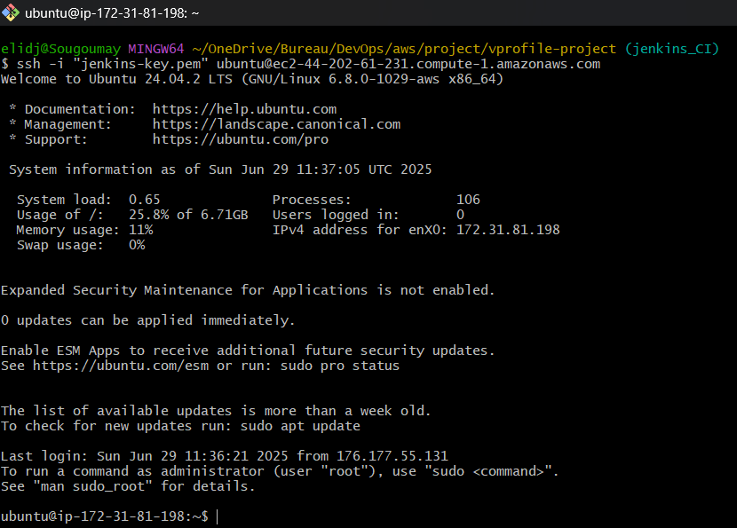
Switch as root user : sudo -i
Execute the commands below to install Jenkins on the server
Check Jenkins status to be sure it’s running
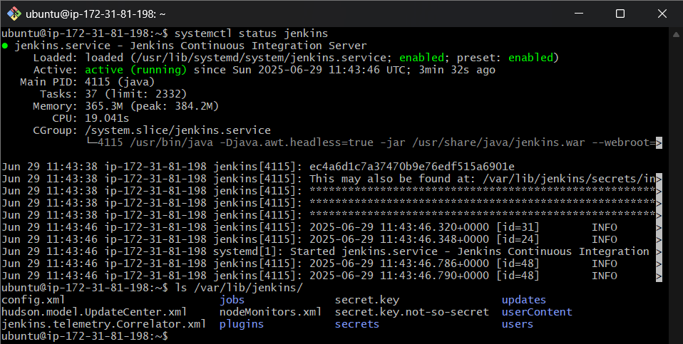
Check to connect to the server on the browser with port 8080. The next image is the first step
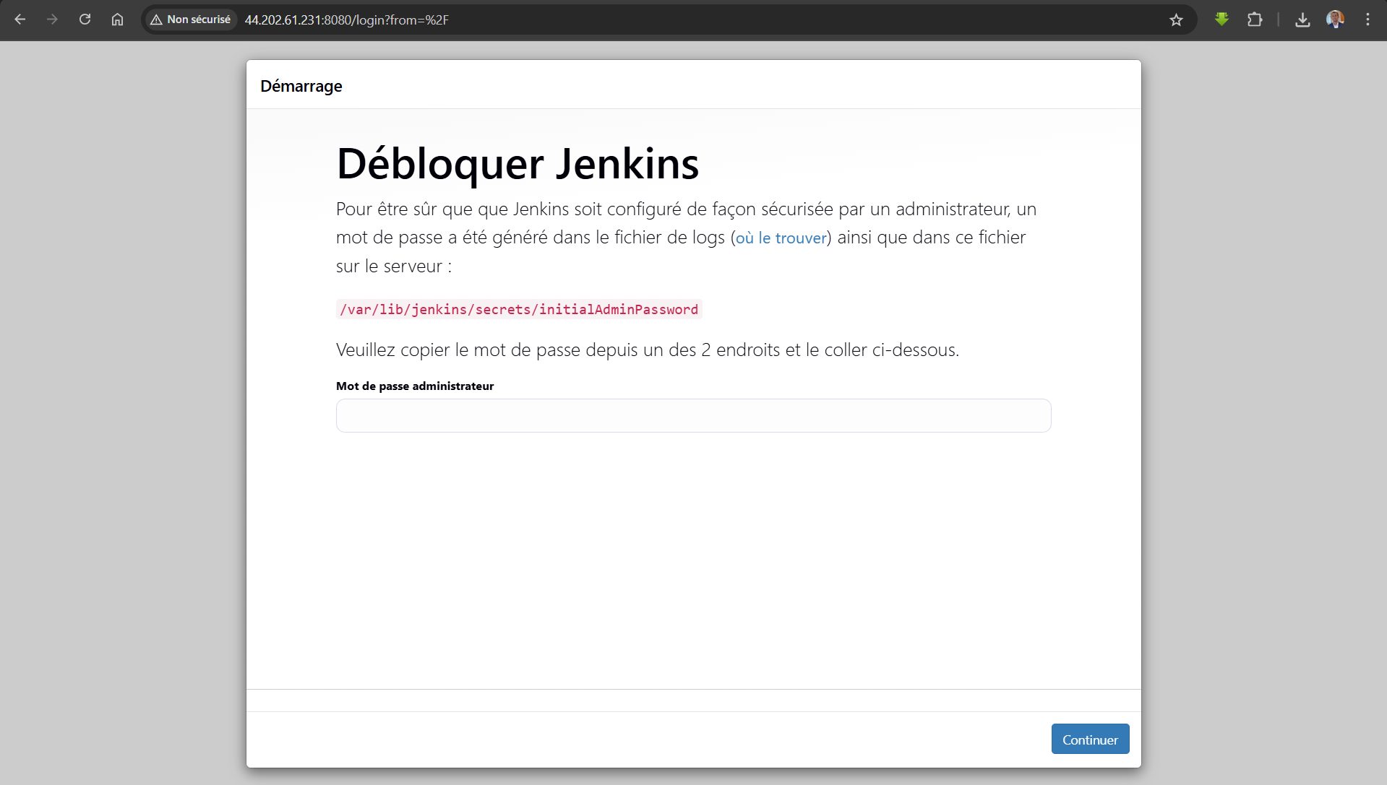
To have the password of the administrator, execute the next command
cat /var/lib/jenkins/secrets/initialAdminPassword : ec4a6d1c7a37470b9e76edf515a6901e
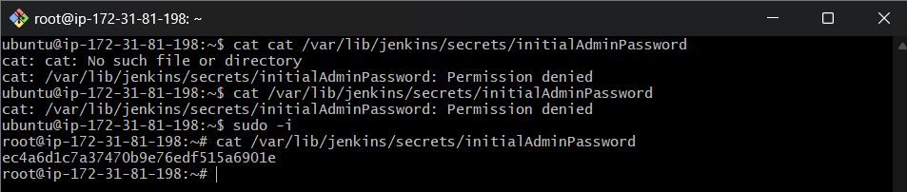
The next step is this
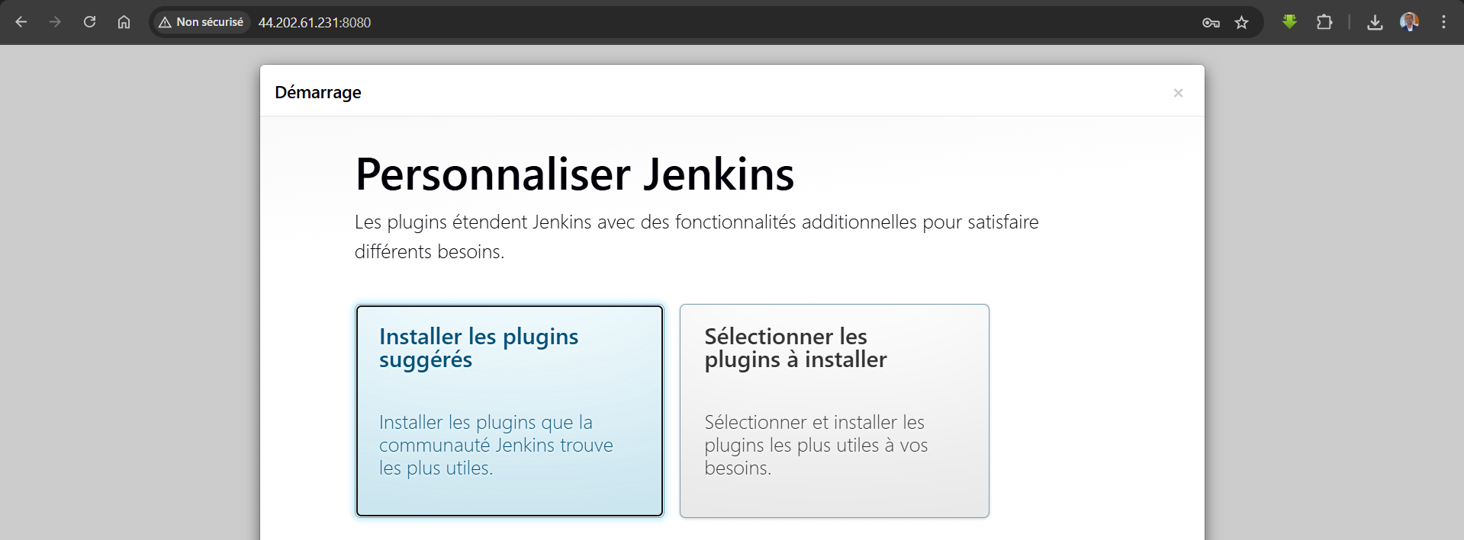
Click to select plugin install
Select nodejs and click install
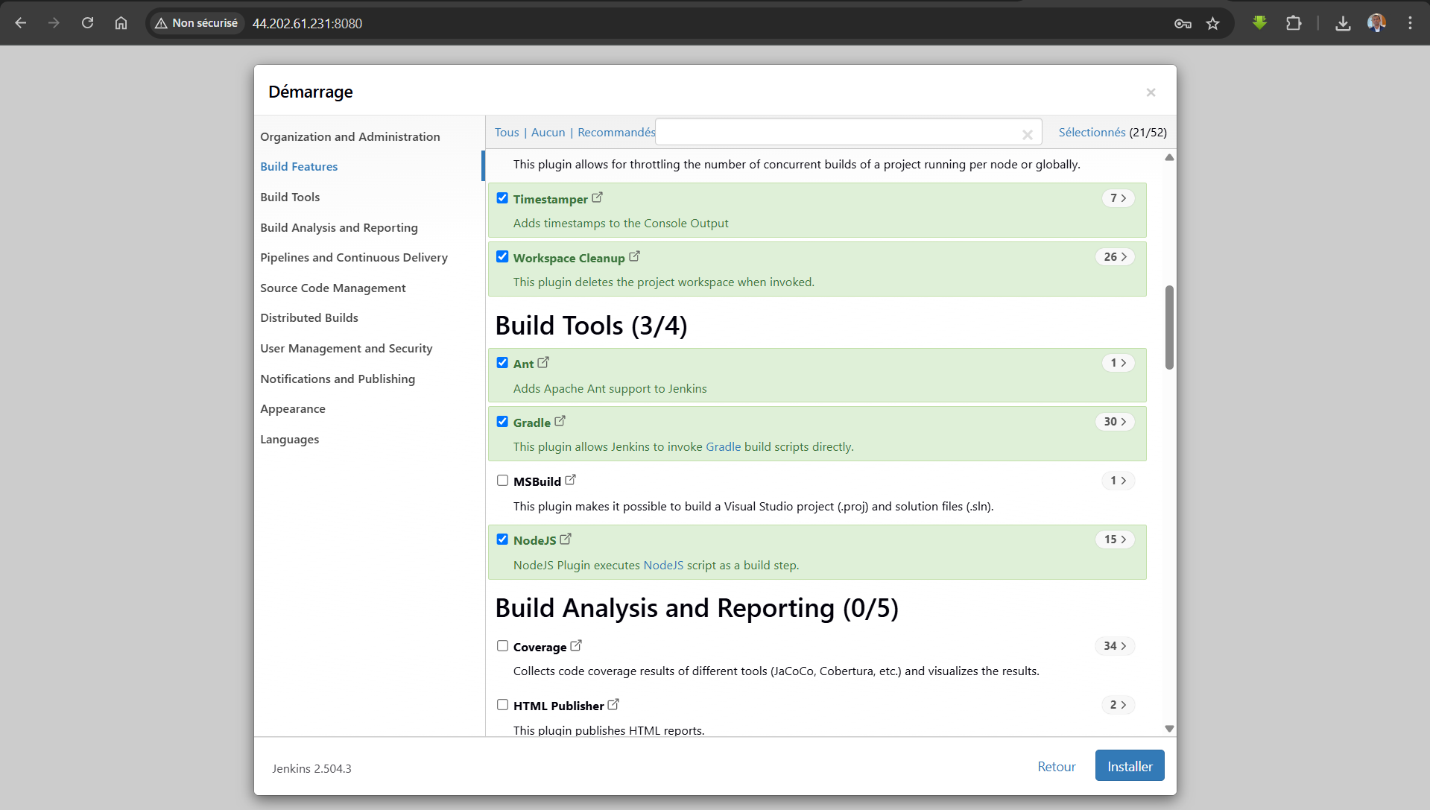
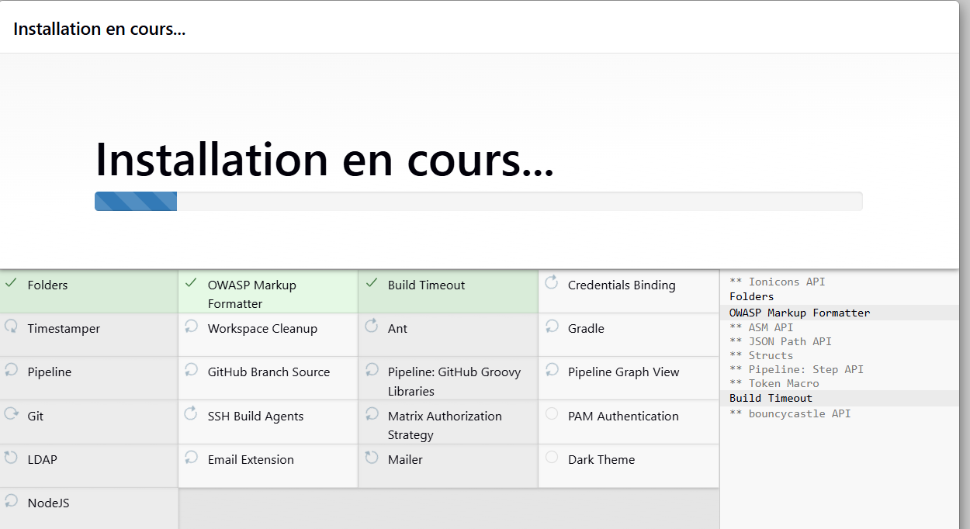
Create the first admin user
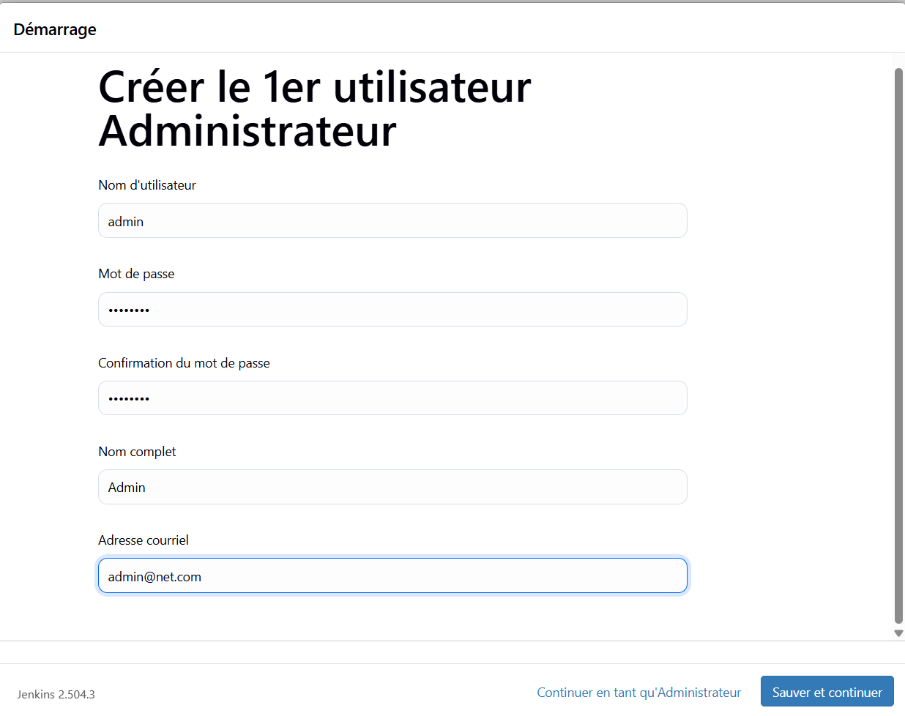
Choose default configuration of url and continue to get the next page
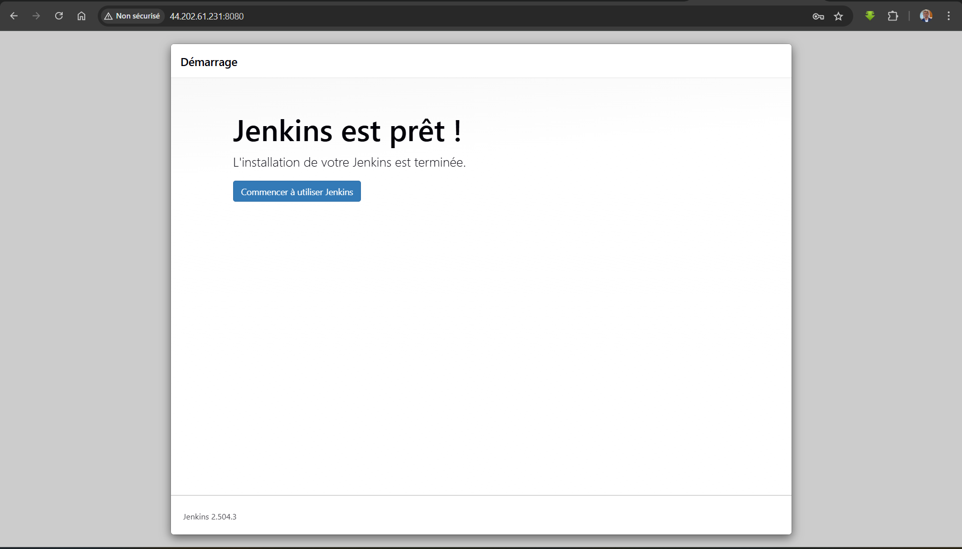
Finally, this is the dashboard

Second step : launch the nexus server
On crée d’abord une instance d’EC2 avec les paramètres suivants :
Name : nexus-server
OS : Amazon Linux
Amazon Machine Image : Amazon Linux 2023 Kernel-6.1 AMI
Instance type : t2.medium (on a besoin de plus de ressources)
Key pair : nexus-key.pem
Security group : name(nexus-sg), description(nexus-sg)
Allow ssh inbound rule from MyIP
Allow Custom TCP with port 8081 from MyIP
Allow Custom TCP with port 8081 from Jenkins-SG
In the github repo, branch Jenkins_CI, copy the content of the file userdata/nexus-setup.sh and paste it toe User data file of Advance details section to setup-up the server while launching the instance
Launch the instance to get the server

To verify if everything is Ok, we will check nexus status, java -version et and the conf file in /opt/nexus/. So, we need to :
Connect to the instance with ssh
Switch to root user : sudo -i
Check nexus status : systemctl status nexus the status is running
ls /opt/nexus/
java -version
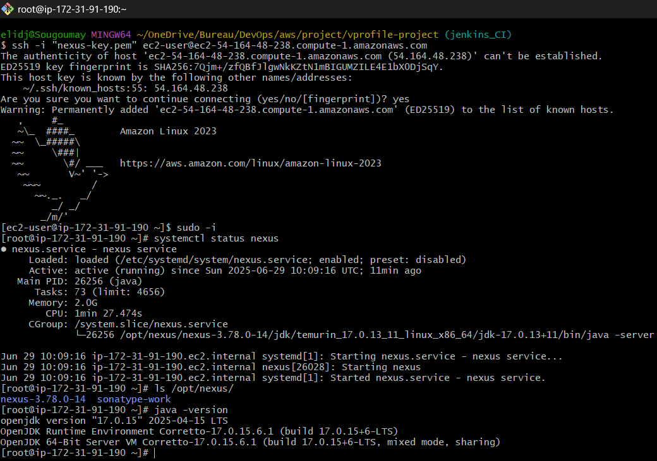

Now we need to check the connexion to the front through the browser in port 8081
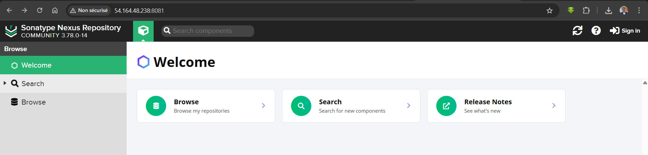
Click to the sign in button to have instructions to get username and password
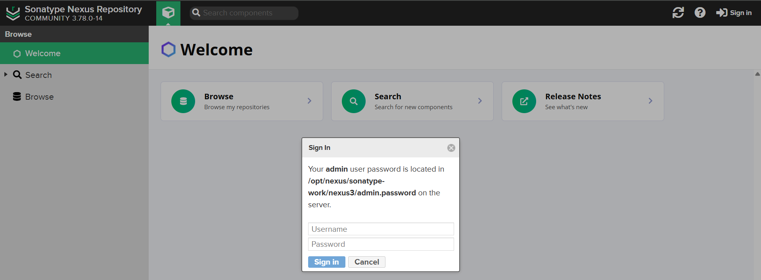
In our case, the command to get the password for admin user is : cat /opt/nexus/sonatype-work/nexus3/admin.password
Copy your password and connect as admin
Change your password to admin123 (this is password is used in the next step within the pipeline)
Enable anonymous access
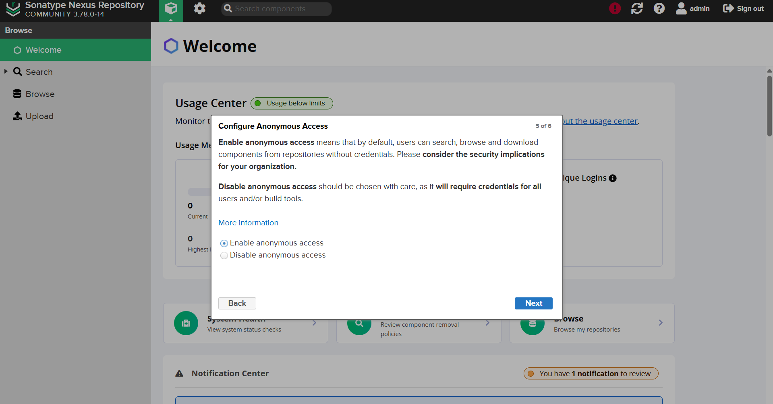
Here we go, that is the admin dashboard
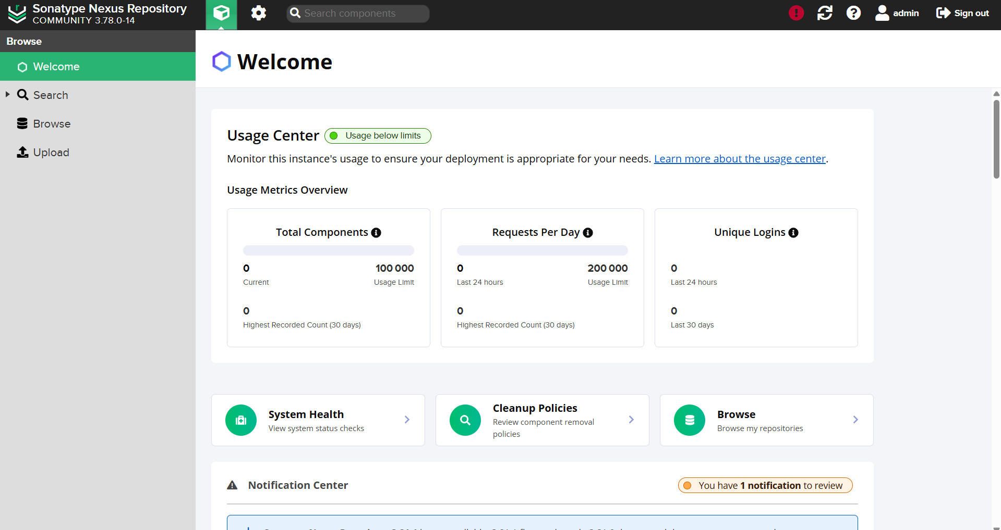

Third step : launch the sonar server
Firstly, we need to launch an EC2 instances with the next parameters :
Name : sonar-server
OS : Ubuntu
Amazon Machine Image : Ubuntu 24.04
Instance type : t2.medium (we need more resources than the micro type)
Key pair : sonar-key.pem
Security group : name(sonar-sg), description(sonar-sg)
Allow ssh inbound rule from MyIP
Allow Custom TCP with port 80 from MyIP (because we have nginx in the front)
Allow Custom TCP with port 80 from jenkins-sg with description Allow Jenkins to communicate
In the github repo, branch Jenkins_CI, copy the content of the file userdata/sonar-setup.sh and paste it toe User data file of Advance details section to setup-up the server while launching the instance
Launch the instance to get the server
Now check if sonar is running by using the browser (take the public IP address and paste in the browser, no need to specify port because the nginx front is running in port 80)
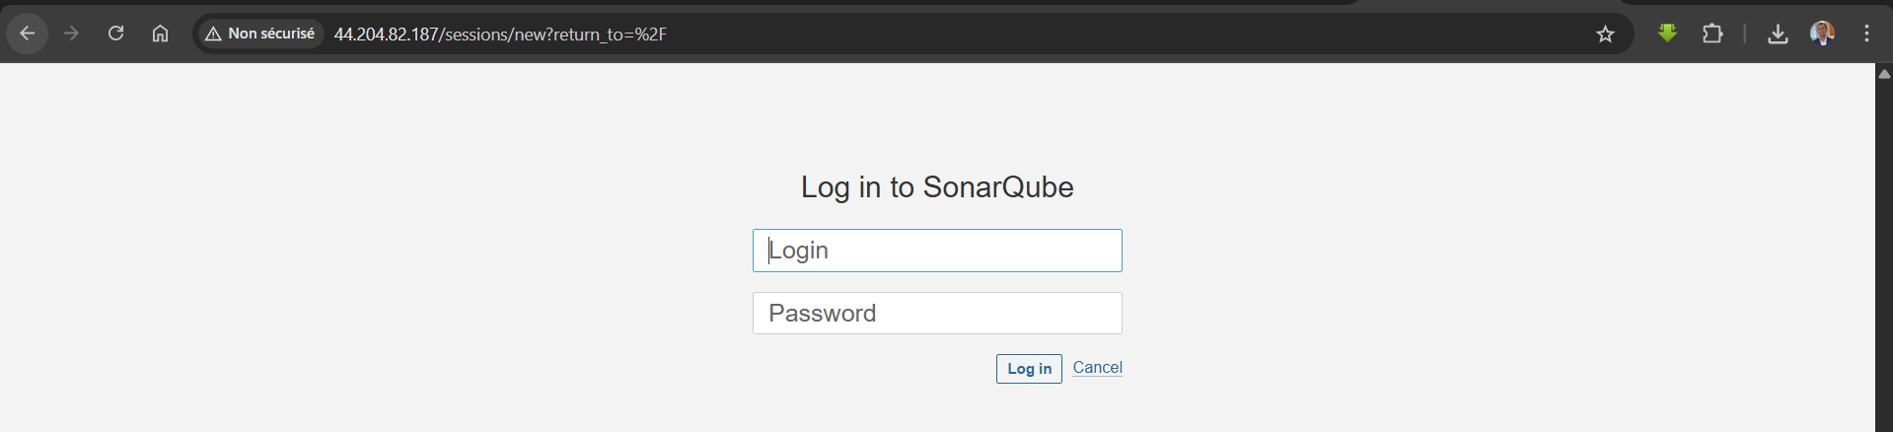
The login is admin and the password is admin
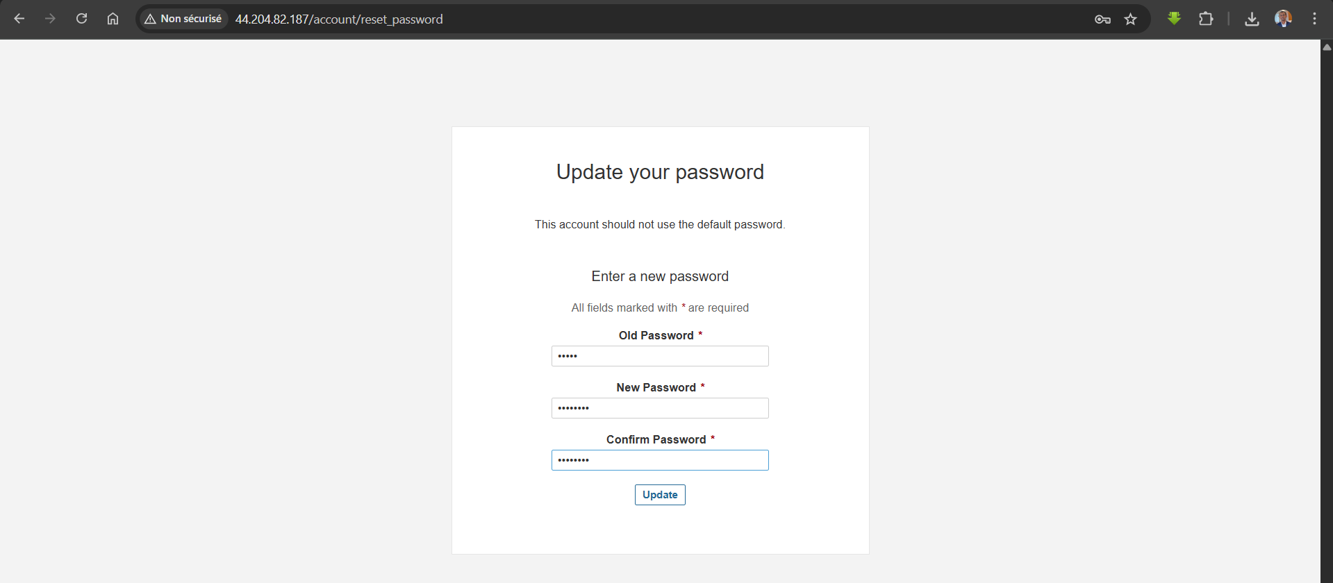
The next step is to change the password, I chose admin123
Now we are connected, this is the dashboard
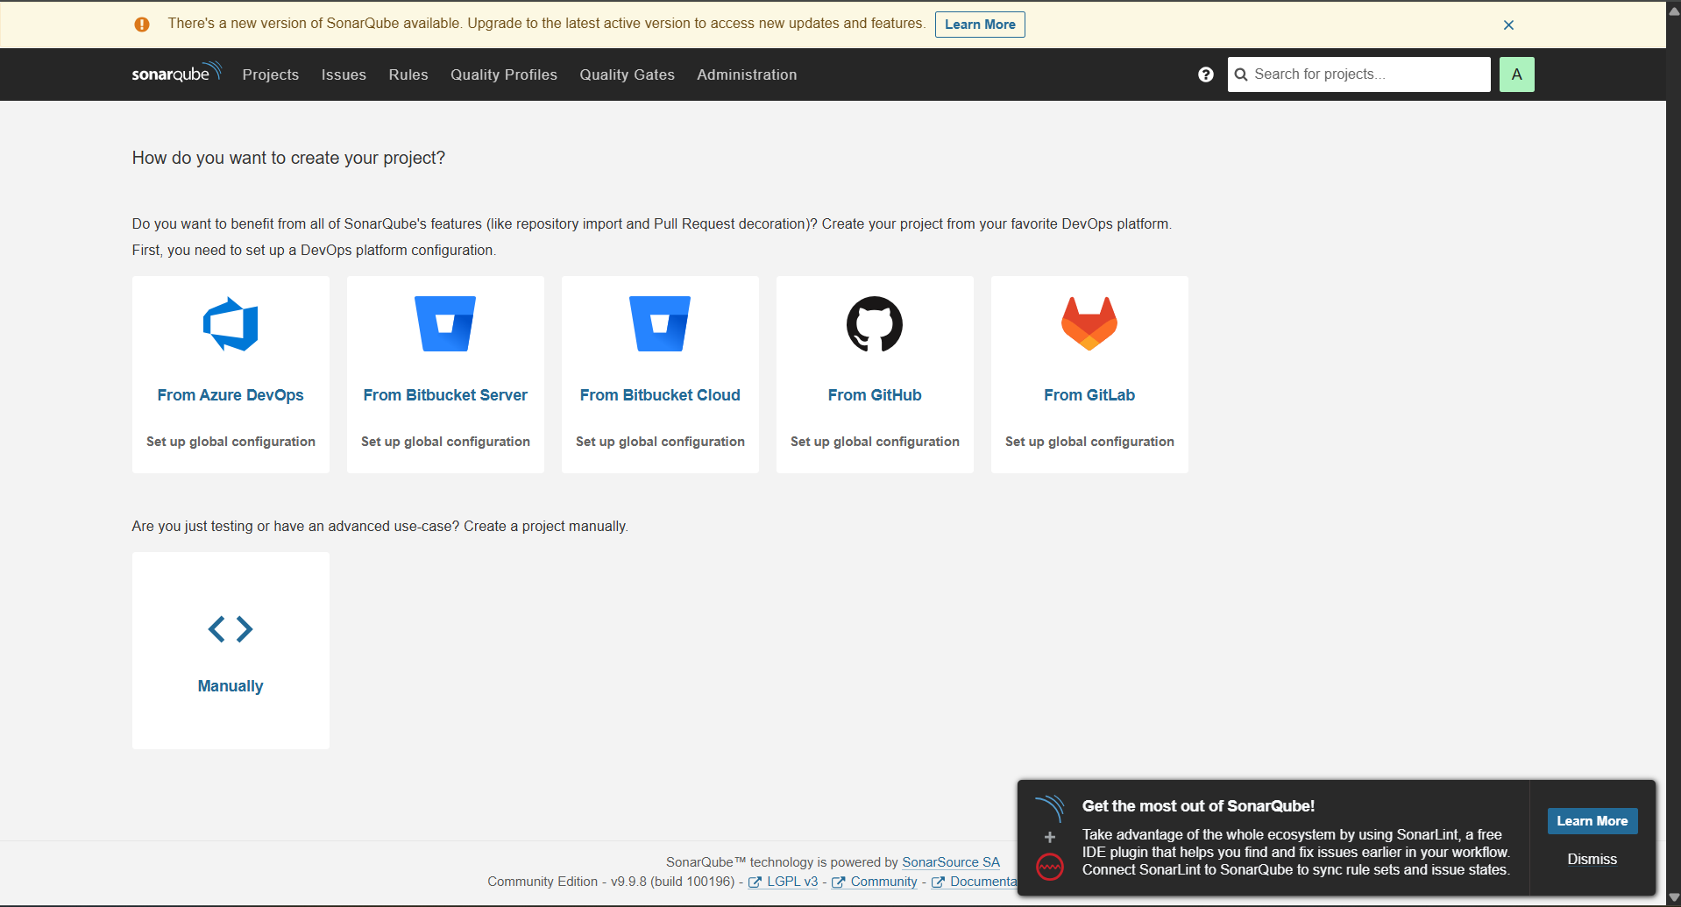
Install Plugins for CI
In this step, we gonna install plugins for Sonar, Nexus, BuildTimestamp, Pipeline Maven Integration.
To do that, connect into the Jenkins Server, go to Manage Jenkins, click into Manage Plugins, switch to available, search sonarqube scanner, nexus artifact uploader, build timestamp, pipeline maven integration, pipeline utility stepsand check them all. Then click to install

