This documentation is done to describe all the process for building this pipeline using Jenkins
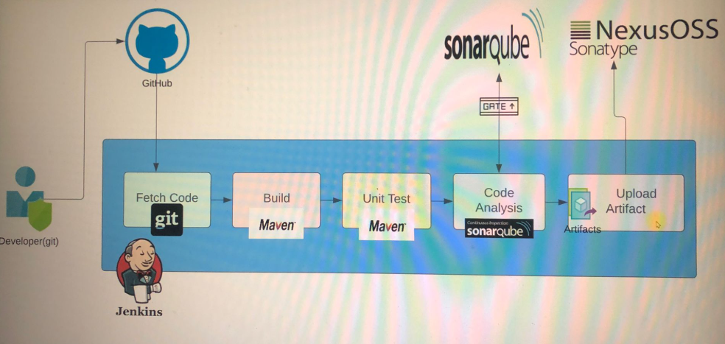

First step : install Jenkins
Firstly, launch an EC2 instance to run Jenkins
Name : jenkins-server
OS : Ubuntu
Amazon Machine Image : Ubuntu 24.04
Instance type : t2.small (we need at least 2Gio of memory)
Key pair : jenkins-key.pem
Security group : name(jenkins -sg), description(jenkins -sg)
Allow ssh inbound rule from MyIP
Allow Custom TCP with port 8080 from MyIP (To use it in the browser)
Launch the instance
Conect to the instance with ssh
Secondly, to install Jenkins, go the doc of Jenkins and get the command to install Jenkins on a ubuntu server : click here(https://www.jenkins.io/doc/book/installing/linux/)
This is step of installing jenkins on ubuntu
sudo apt update
sudo apt install openjdk-21-jdk -y

sudo wget -O /etc/apt/keyrings/jenkins-keyring.asc \
https://pkg.jenkins.io/debian-stable/jenkins.io-2023.key

echo "deb [signed-by=/etc/apt/keyrings/jenkins-keyring.asc]" \
https://pkg.jenkins.io/debian-stable binary/ | sudo tee \
/etc/apt/sources.list.d/jenkins.list > /dev/null

sudo apt-get update
sudo apt-get install jenkins -y

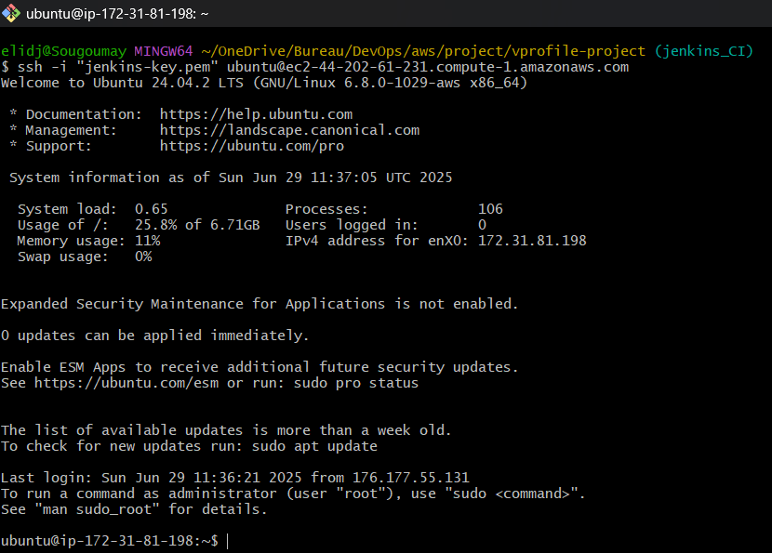
Switch as root user : sudo -i
Execute the commands below to install Jenkins on the server
Check Jenkins status to be sure it’s running
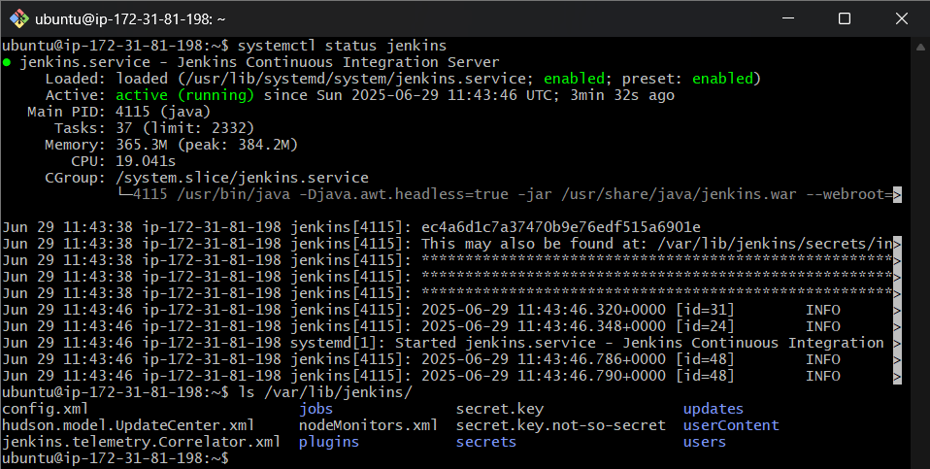
Check to connect to the server on the browser with port 8080. The next image is the first step
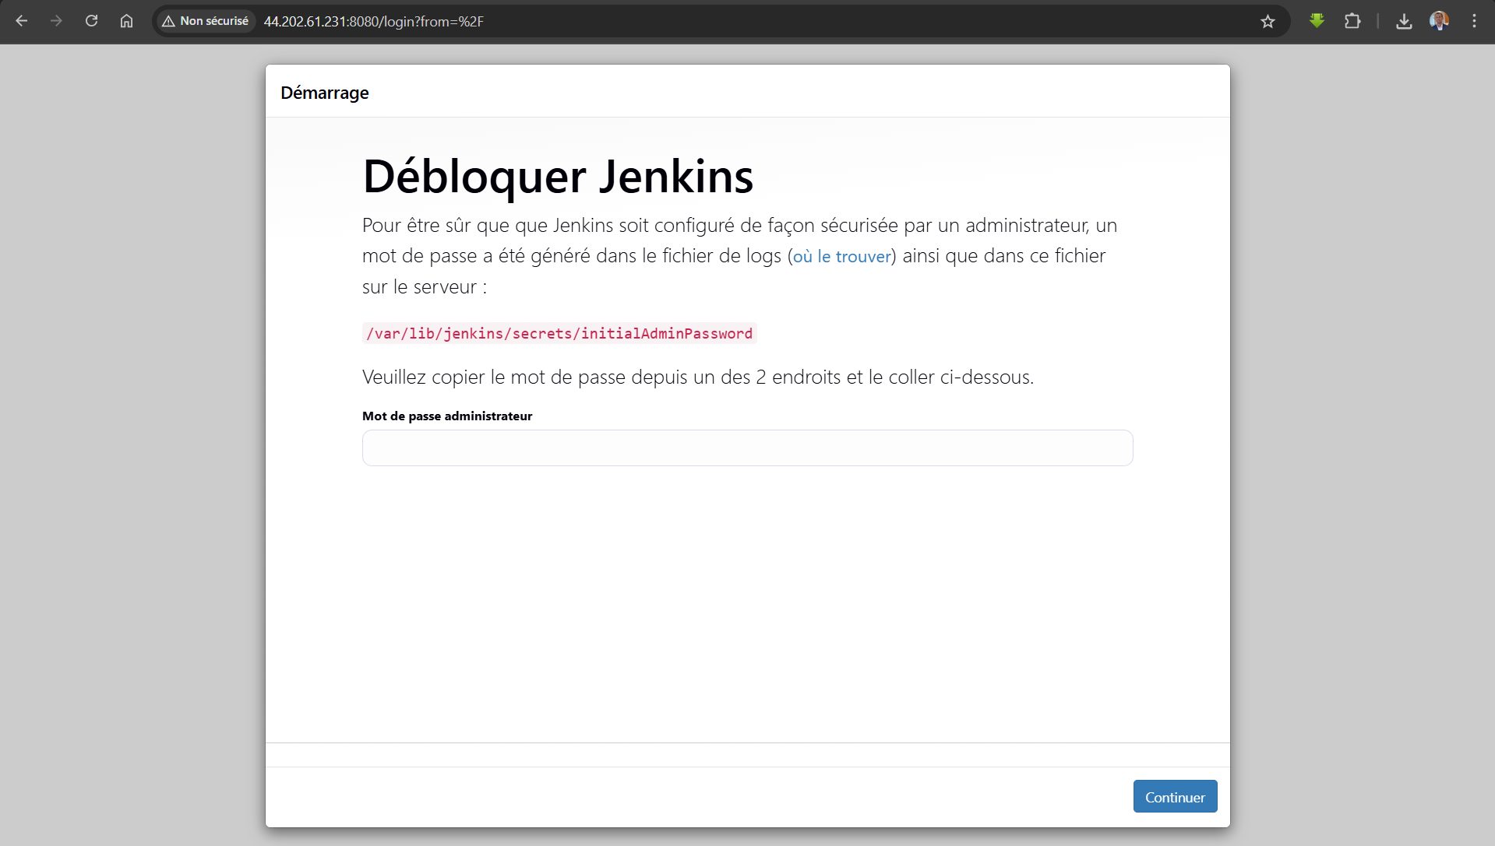
To have the password of the administrator, execute the next command
cat /var/lib/jenkins/secrets/initialAdminPassword : ec4a6d1c7a37470b9e76edf515a6901e
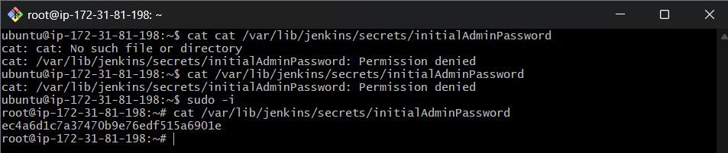
The next step is this
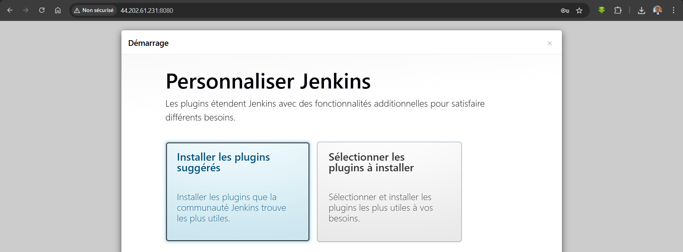
Click to select plugin install
Select nodejs and click install
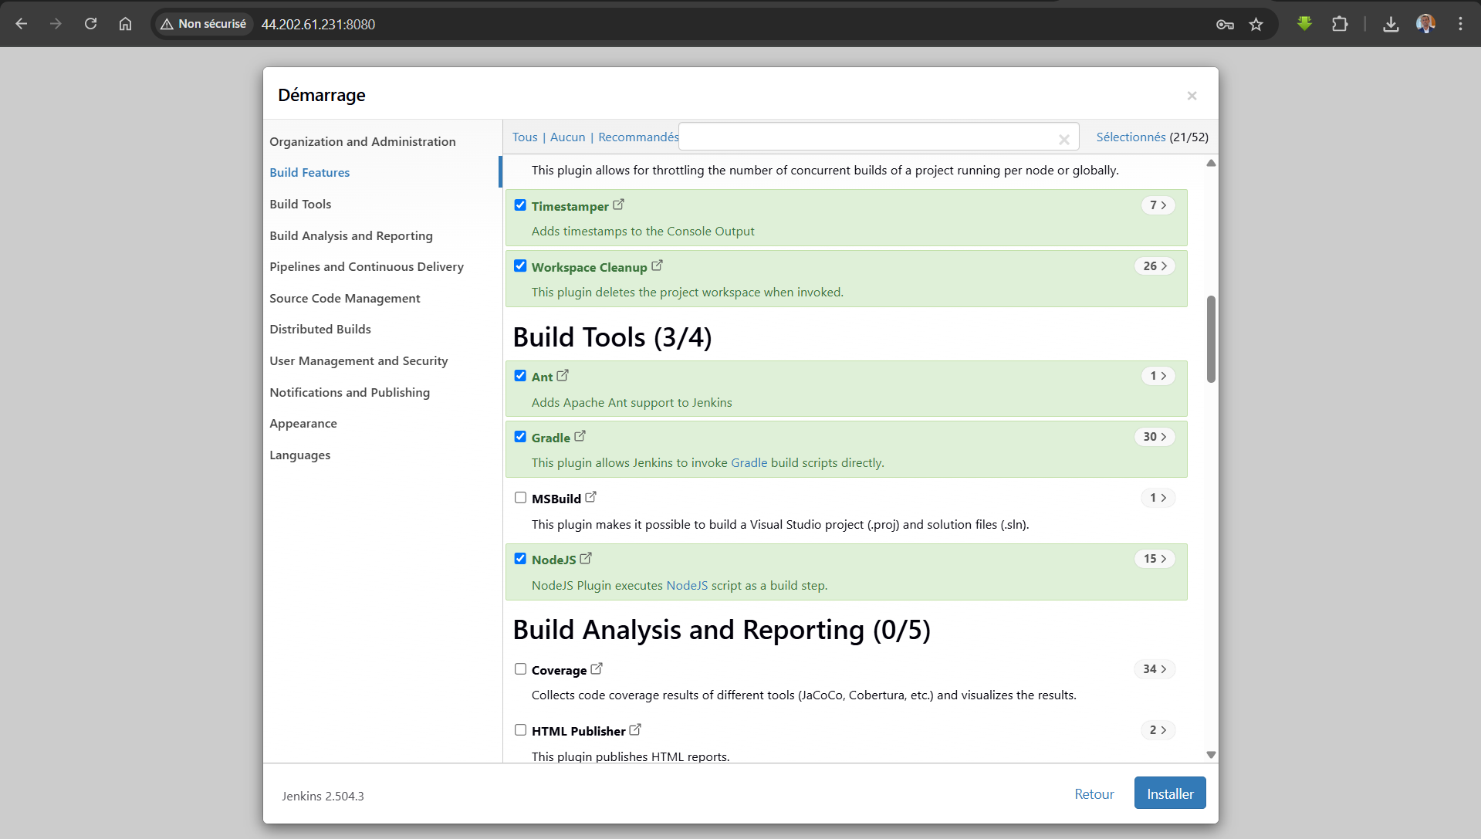
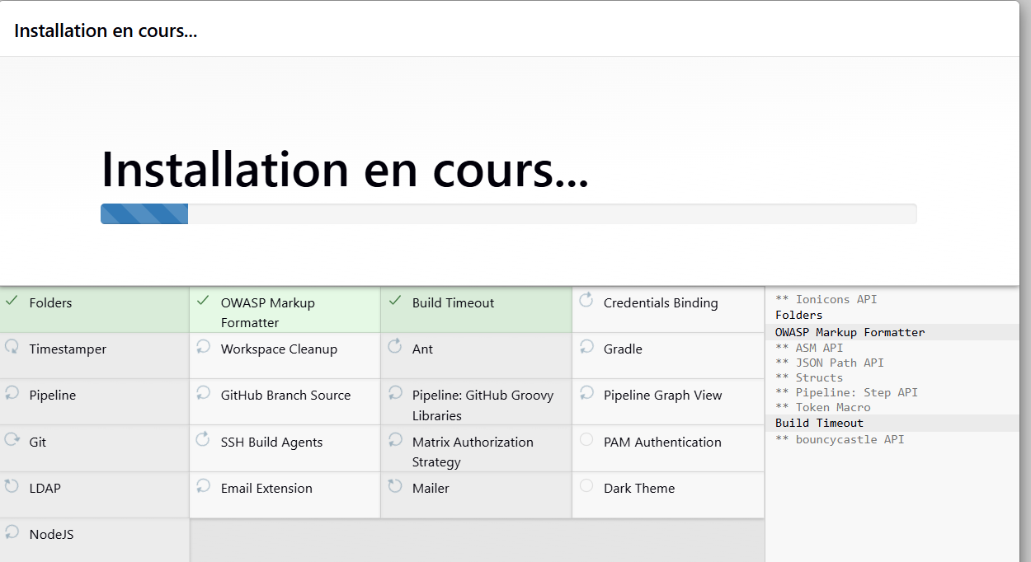
Create the first admin user
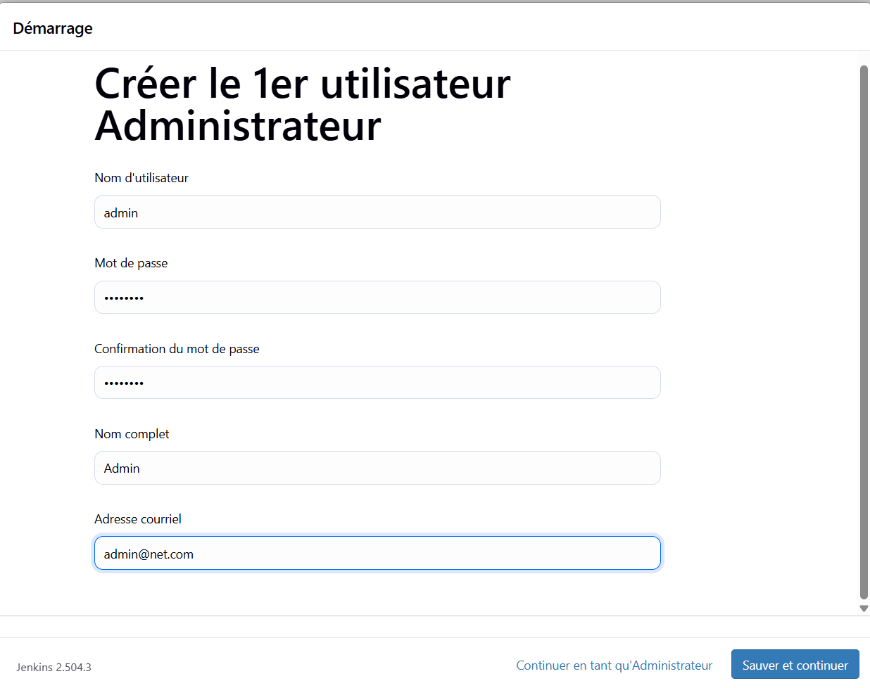
Choose default configuration of url and continue to get the next page
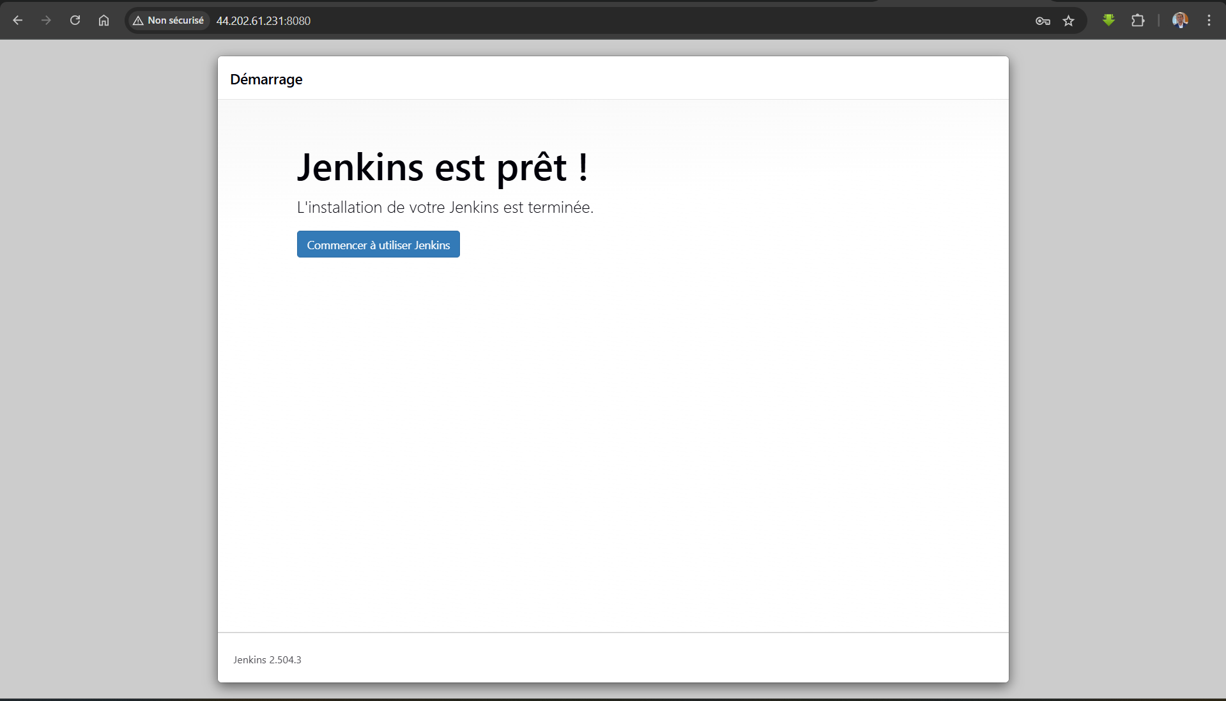
Finally, this is the dashboard

Installation of tools
In this step, we need to install some important tools four our exercise such as Maven and JDK. Follow the next steps :
Click to manage Jenkins
Click to tools
Scroll down and click to add JDK
Give the name JDK17
Uncheck install automatically if selected by default
To have Java_Home, connect to the server with ssl command
Switch to admin user : sudo -i
Update and install JDK17 : apt update && apt install openjdk-17-jdk -y
Execute the command to have jdk home : ls /usr/lib/jvm/
You will see two line : java-17-openjdk-amd64 and java-21-openjdk-amd64
The full path of JDK17 is : /usr/lib/jvm/java-17-openjdk-amd64
Give a name and choose the version 3.9.x of Maven in the select list
Click to save to finish

Second step : launch the nexus server
On crée d’abord une instance d’EC2 avec les paramètres suivants :
Name : nexus-server
OS : Amazon Linux
Amazon Machine Image : Amazon Linux 2023 Kernel-6.1 AMI
Instance type : t2.medium (on a besoin de plus de ressources)
Key pair : nexus-key.pem
Security group : name(nexus-sg), description(nexus-sg)
Allow ssh inbound rule from MyIP
Allow Custom TCP with port 8081 from MyIP
Allow Custom TCP with port 8081 from Jenkins-SG
In the github repo, branch Jenkins_CI, copy the content of the file userdata/nexus-setup.sh and paste it toe User data file of Advance details section to setup-up the server while launching the instance
Launch the instance to get the server

To verify if everything is Ok, we will check nexus status, java -version et and the conf file in /opt/nexus/. So, we need to :
Connect to the instance with ssh
Switch to root user : sudo -i
Check nexus status : systemctl status nexus the status is running
ls /opt/nexus/
java -version
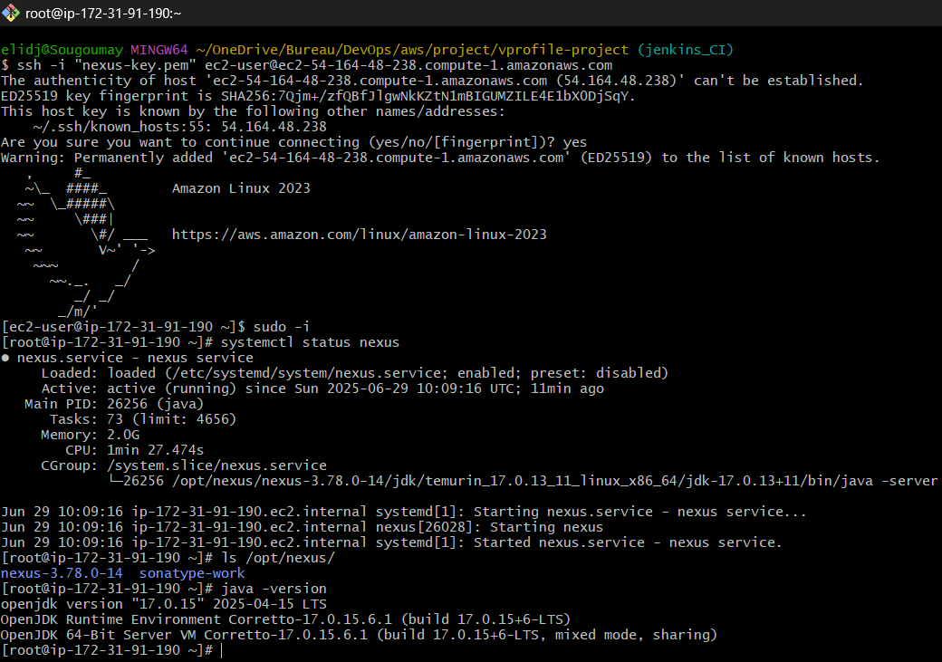

Now we need to check the connexion to the front through the browser in port 8081
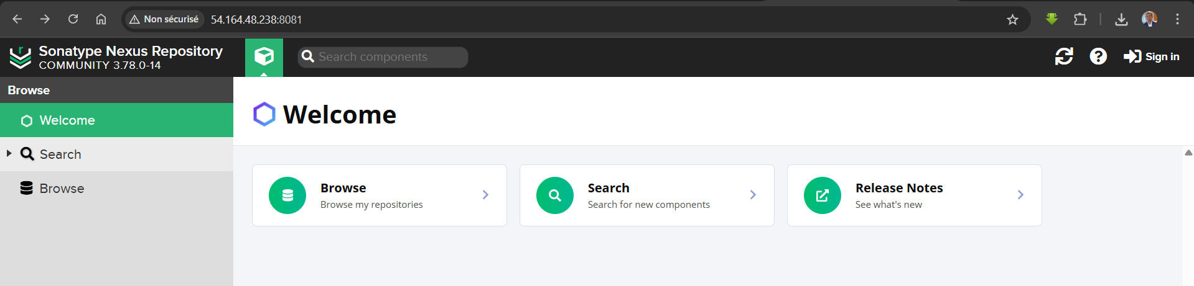
Click to the sign in button to have instructions to get username and password
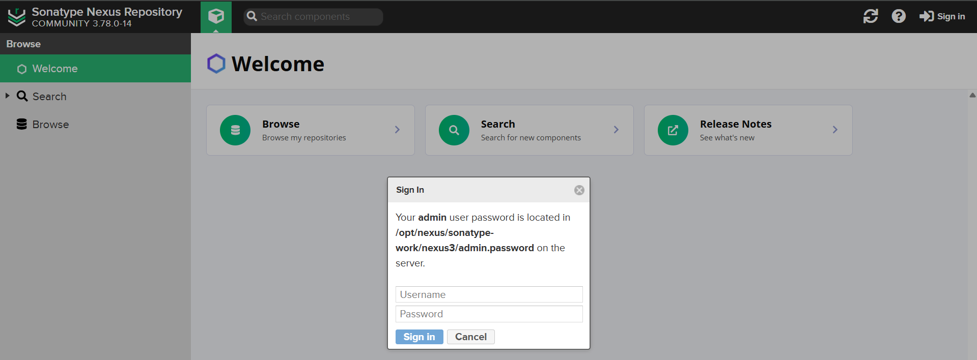
In our case, the command to get the password for admin user is : cat /opt/nexus/sonatype-work/nexus3/admin.password
Copy your password and connect as admin
Change your password to admin123 (this is password is used in the next step within the pipeline)
Enable anonymous access
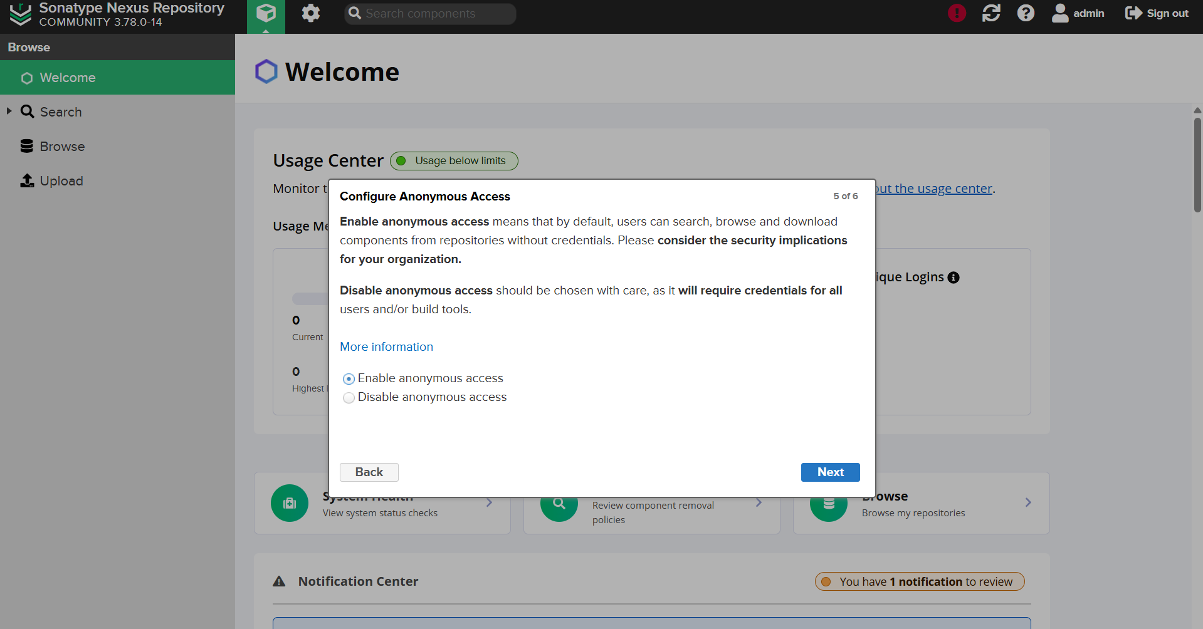
Here we go, that is the admin dashboard
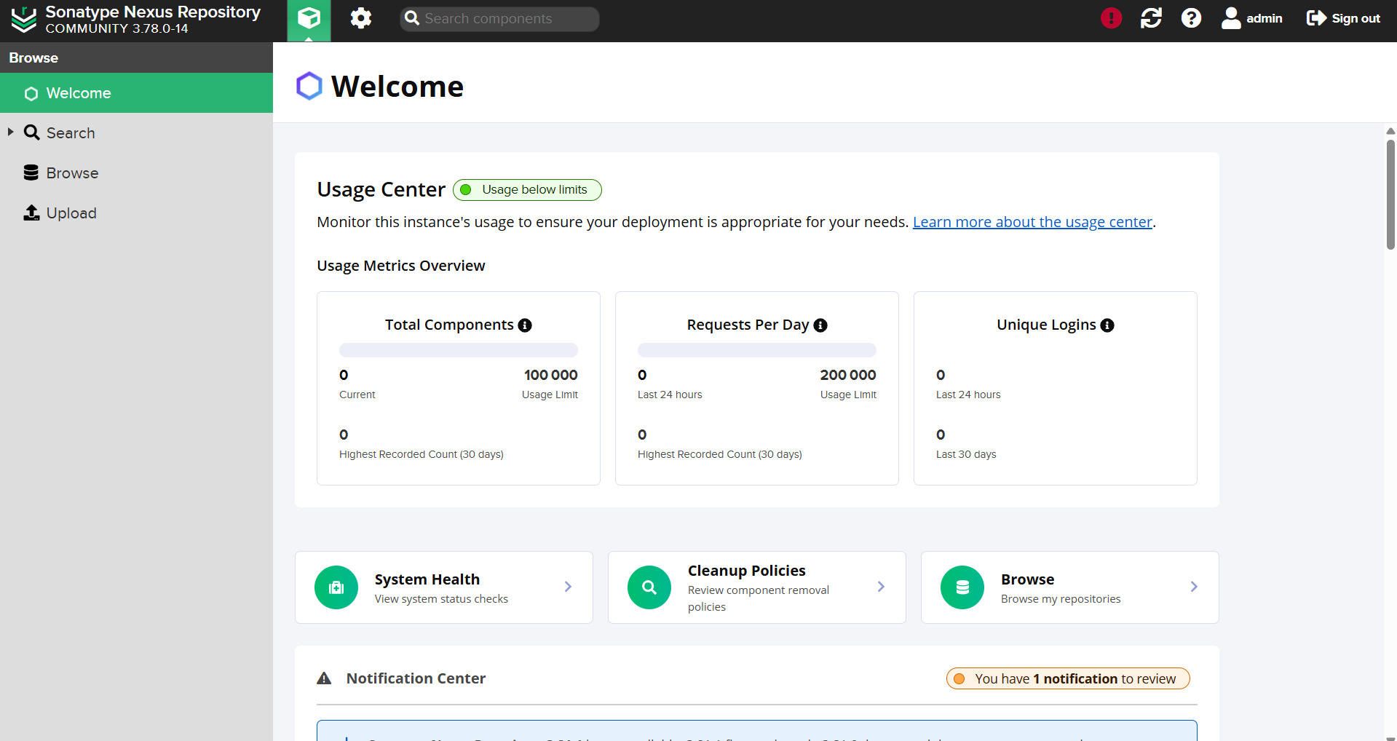

Third step : launch the sonar server
Firstly, we need to launch an EC2 instances with the next parameters :
Name : sonar-server
OS : Ubuntu
Amazon Machine Image : Ubuntu 24.04
Instance type : t2.medium (we need more resources than the micro type)
Key pair : sonar-key.pem
Security group : name(sonar-sg), description(sonar-sg)
Allow ssh inbound rule from MyIP
Allow Custom TCP with port 80 from MyIP (because we have nginx in the front)
Allow Custom TCP with port 80 from jenkins-sg with description Allow Jenkins to communicate
In the github repo, branch Jenkins_CI, copy the content of the file userdata/sonar-setup.sh and paste it toe User data file of Advance details section to setup-up the server while launching the instance
Launch the instance to get the server
Now check if sonar is running by using the browser (take the public IP address and paste in the browser, no need to specify port because the nginx front is running in port 80)
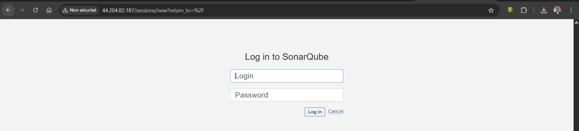
The login is admin and the password is admin
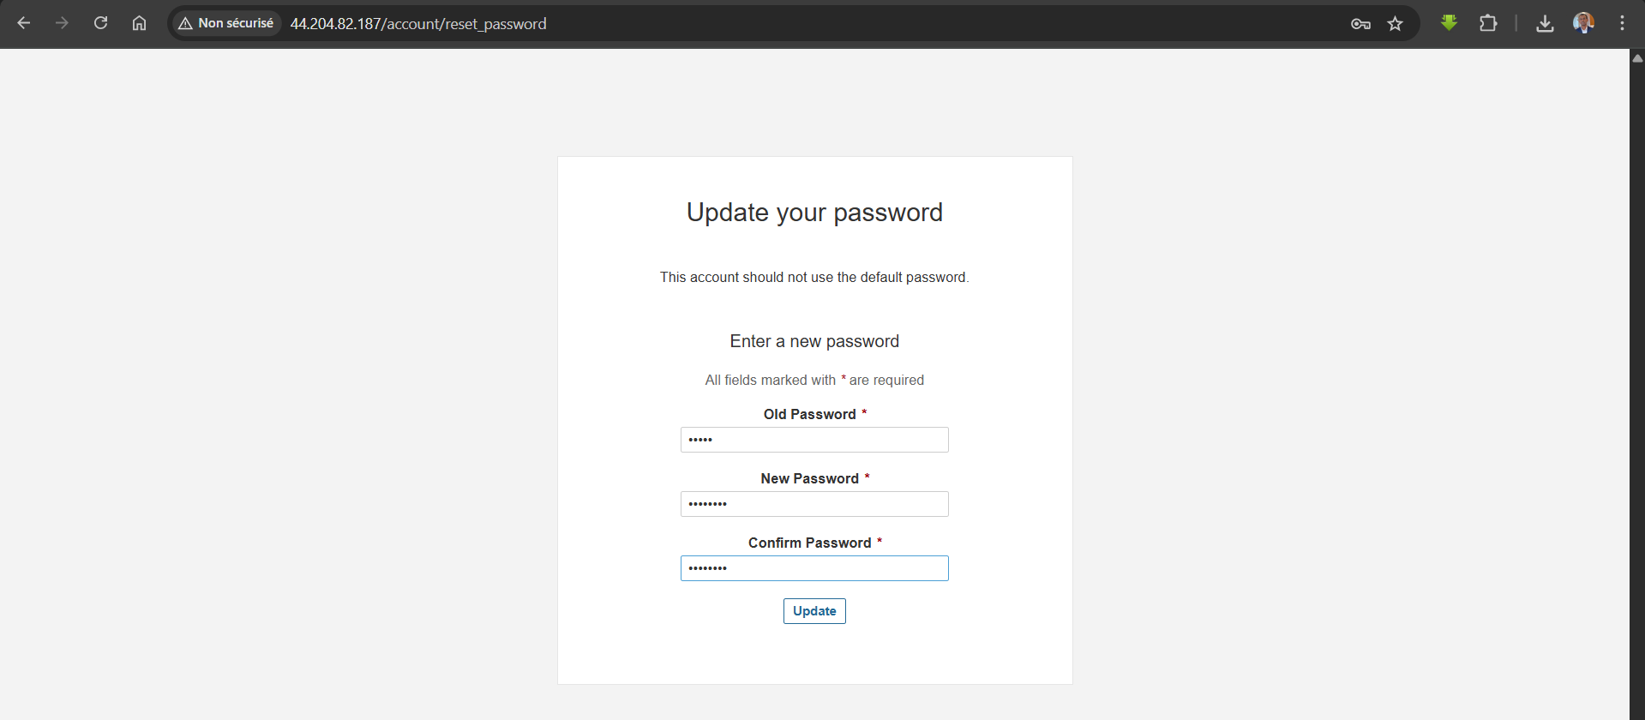
The next step is to change the password, I chose admin123
Now we are connected, this is the dashboard
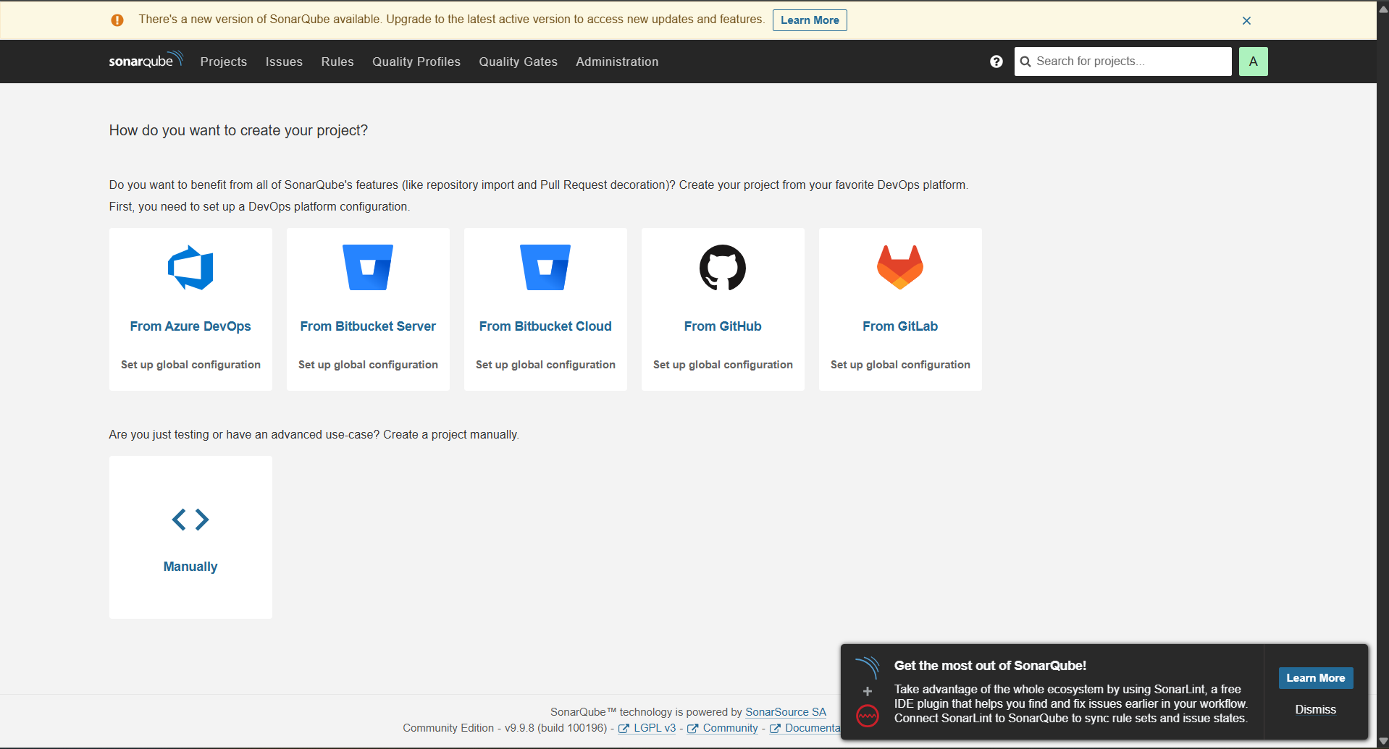

Install Plugins for CI
In this step, we gonna install plugins for Sonar, Nexus, BuildTimestamp, Pipeline Maven Integration.
To do that, connect into the Jenkins Server, go to Manage Jenkins, click into Manage Plugins, switch to available, search sonarqube scanner, nexus artifact uploader, build timestamp, pipeline maven integration, pipeline utility steps and check them all. Then click to install
The next is to execute a pipeline with the next code
pipeline {
agent any
tools {
maven "MAVEN3.9"
jdk "JDK17"
}
stages {
stage('Fetch code') {
steps {
git branch: 'jenkins_CI',
url: 'https://github.com/Sougoumay/vprofile-project'
}
}
stage('Unit Test') {
steps {
sh 'mvn test'
}
}
stage('Build') {
steps {
sh 'mvn install -DskipTests'
}
post {
success {
echo 'Archiving artifact'
archiveArtifacts artifacts: '**/*.war'
}
}
}
}
}

Go to the dashboard (Jenkins in web)
New Item
Give a name
Select pipeline
Click OK
Paste the code on the script input
Execute
Save
Launch the build
Code Analysis
SonarQube Scanner tool
Sonar server details
From sonar we need token
To analyze the code with SonarQube, Jenkins and SonarQube must be in run. The we need three things :
SonarQube Scanner tool in Jenkins
Sonar server details in Jenkins
Token from Sonarqube to authorize Jenkins taking actions
First of all, to install Sonarqube Scanner, go to Jenkins dashboard
Click to manage Jenkins
Click to tools
Scroll down until SonarQube scanner and click to Add SonarQube Scanner
Give the name Sonar6.2
Choose the version 6.2.1.4610
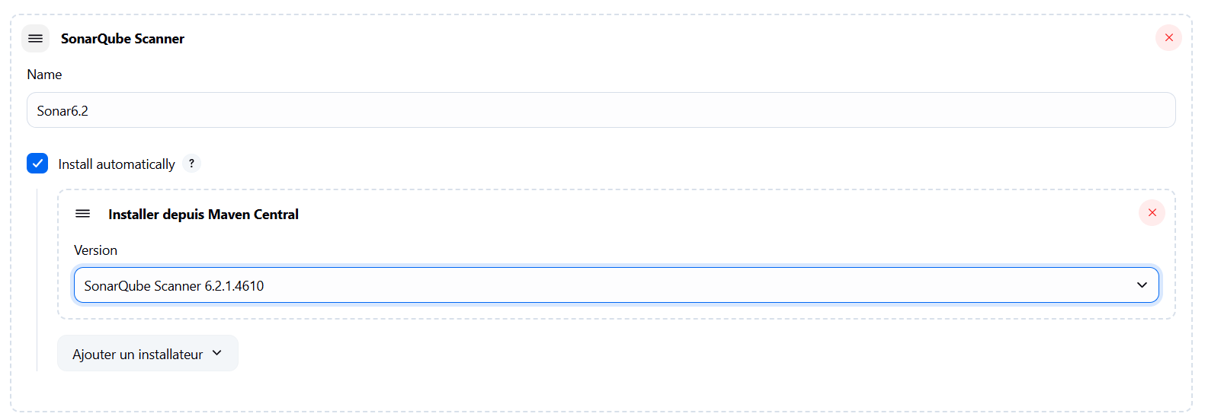
In the next step, we need to store Sonarqube Server details in the Jenkins. SonarQube Server tool will scan the code and then we need to upload result to sonarqube server. For that we need to store the information of sonarqube server. Follow the next steps
Go to manage Jenkins
Go to System
Scroll down until you find Sonarqube server
Check environment variables
Click on Add Sonarqube
Give the name sonarserver
Server url will be the private ip of sonar, go to AWS, copy and paste (http://private-ip)
For the authentication we need Sonar token
Now connect to sonar server with public ip in the browser
Login with your credentials (admin and admin123)
In the top right click to the symbol A
Click to my account
Click to security
Give the name Jenkins
Select User Token
Then Generate
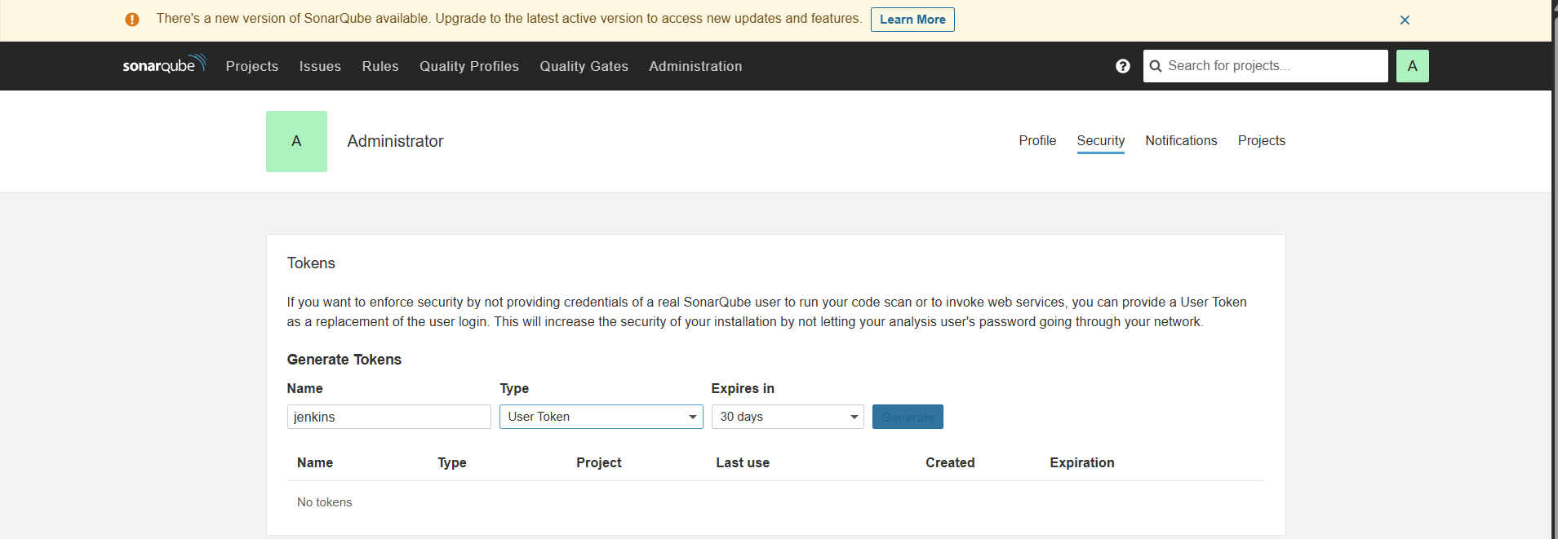
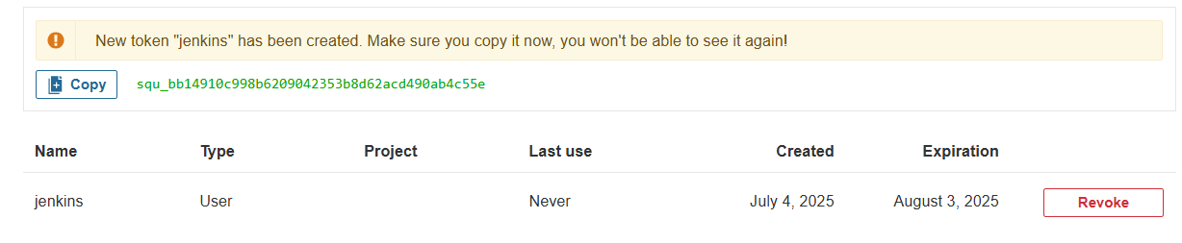
Copy your token (if you olost, you have to remove this one and generate a new one)
Go to Jenkins
Click to add (in the authentication section of sonarqube servers(Jenkins))
Select the type secret text
Paste the token in the secret field
Give sonartoken as ID and description
Click to add
Then choose sonarqube in the list
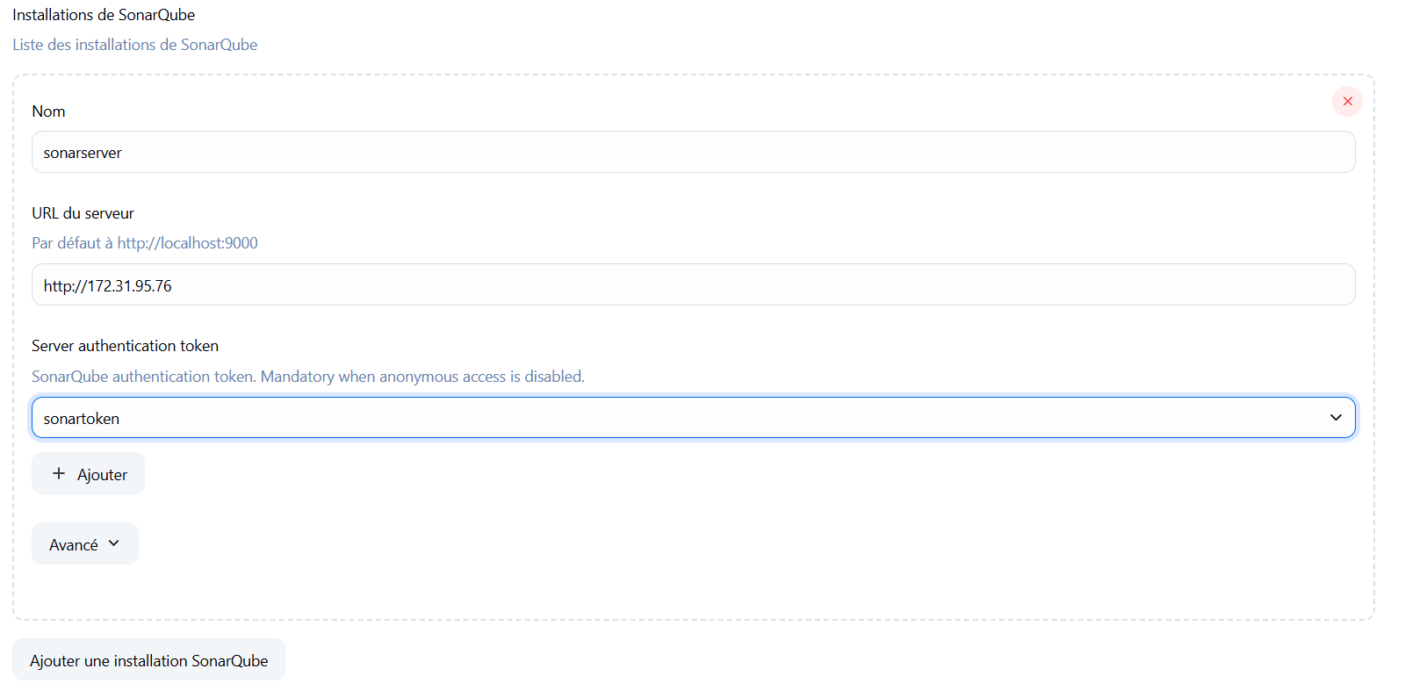
Be sure to authorize Jenkins to communicate with sonar by adding an inbound rule on sonar security group, with type http

In the code of the pipeline we executed before, put the build stage before the unit test stage, then add this new stage
stage('Checkstyle Analysis') {
steps {
sh 'mvn checkstyle:checkstyle'
}
}
stage('Sonar code Analysis') {
environment {
scannerHome = tool 'Sonar6.2'
}
steps {
withSonarQubeEnv('sonarserver') {
sh '''${scannerHome}/bin/sonar-scanner -Dsonar.projectKey=vprofile \
-Dsonar.projectName=vprofile-repo \
-Dsonar.projectVersion=1.0 \
-Dsonar.sources=src/ \
-Dsonar.java.binaries=target/test-classes/com/visualpathit/account/controllerTest/ \
-Dsonar.junit.reportsPath=target/surefire-reports/ \
-Dsonar.jacoco.reportsPath=target/jacoco.exec \
-Dsonar.java.checkstyle.reportPaths=target/checkstyle-result.xml'''
}
}
}
Now, create a new item (pipeline), copy paste this code and run the pipeline

Here we go, our pipeline is executed successfully
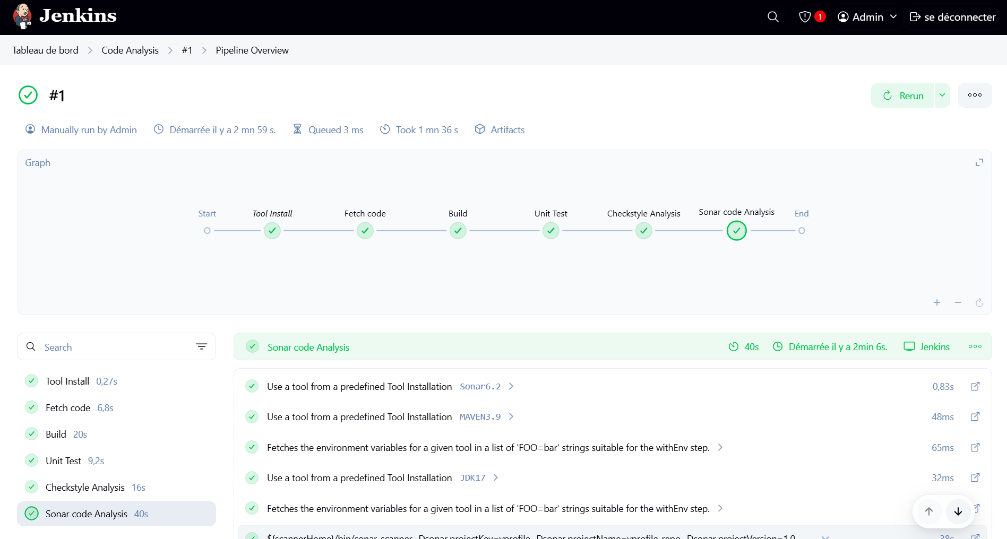

Go to sonar server and you will have this picture
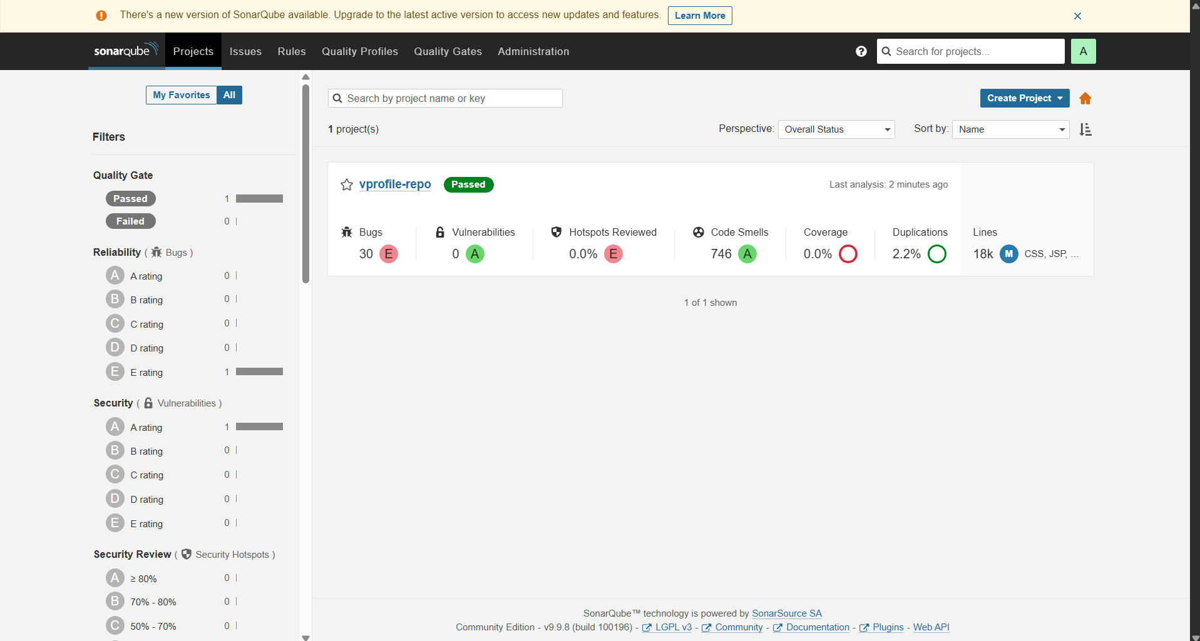
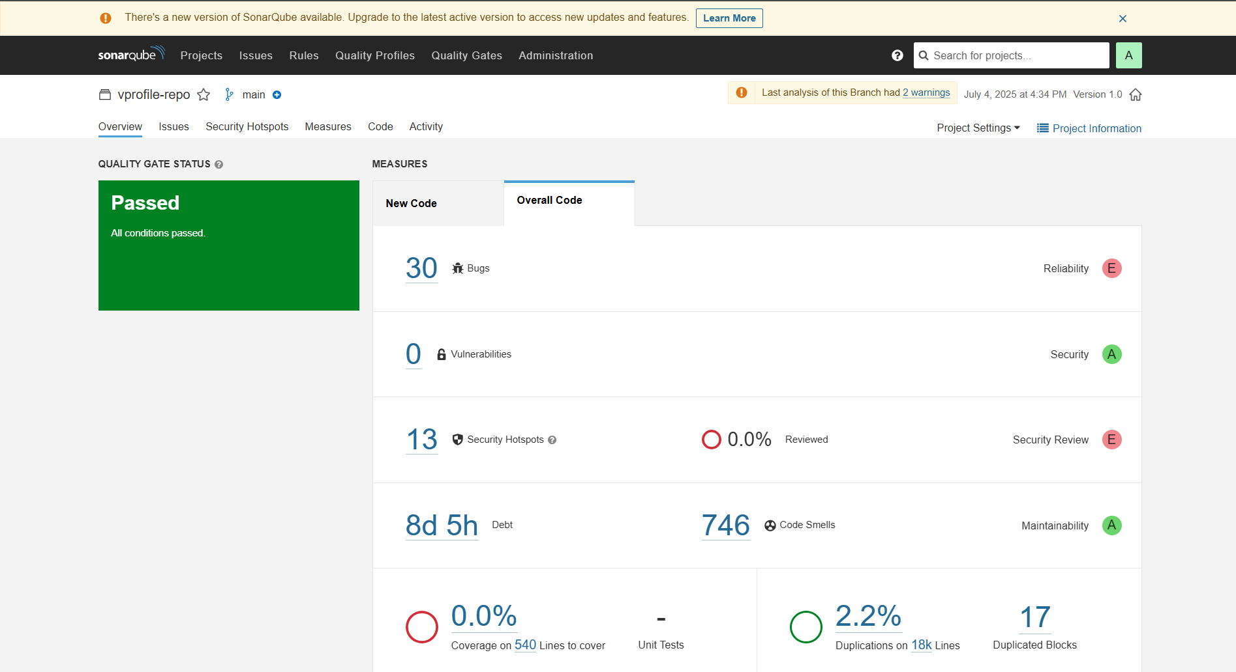

Everything is good and the pipeline passed, this is the default quality gate. In the next step, we will define Quality Gate to determine when the analysis will be a success or not.
To define a quality gate,
Go to SonarQube dashboard
Go to quality gate section
Click to create button
Give a name : Jenkins-QG
Save to create the quality gate
Scroll Down
Click to Unlock editing
Click to Add Condition
Choose On Overall Code
In Quality Gate fails when, you have lots off condition, in this exercise, I choosed Bugs
Give 10 as Value (There are 30 bugs, so this time, the result will not pass)
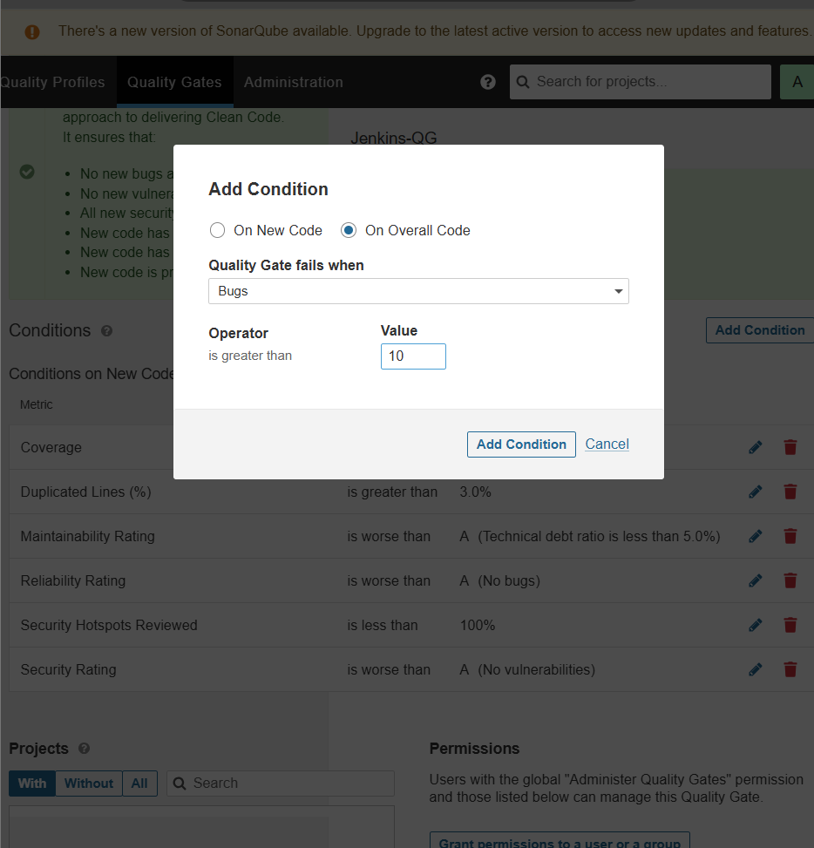
After that
Go to Projects Section
Choose our project (vprofile-repo)
Click to project settings
Click to quality gate
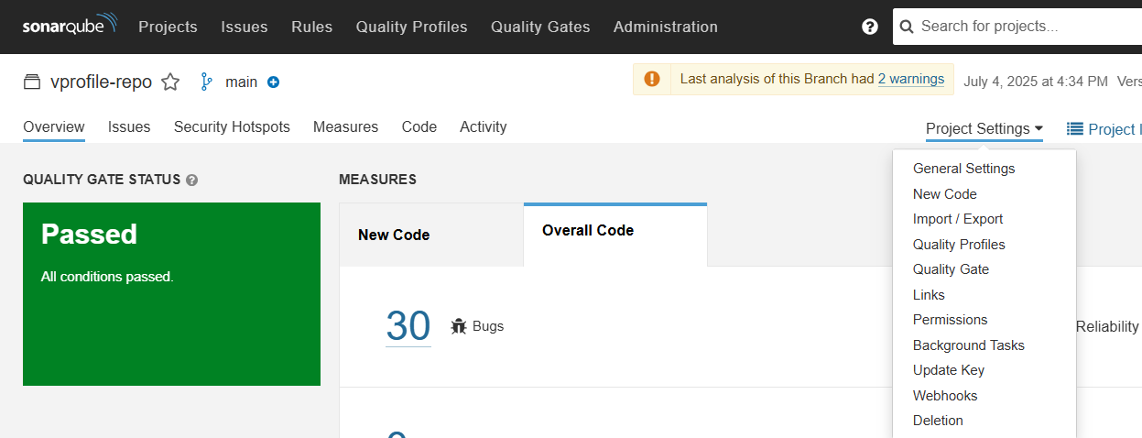
Choose Always use a specific quality gate
Select Jenkins-QG
Then Save
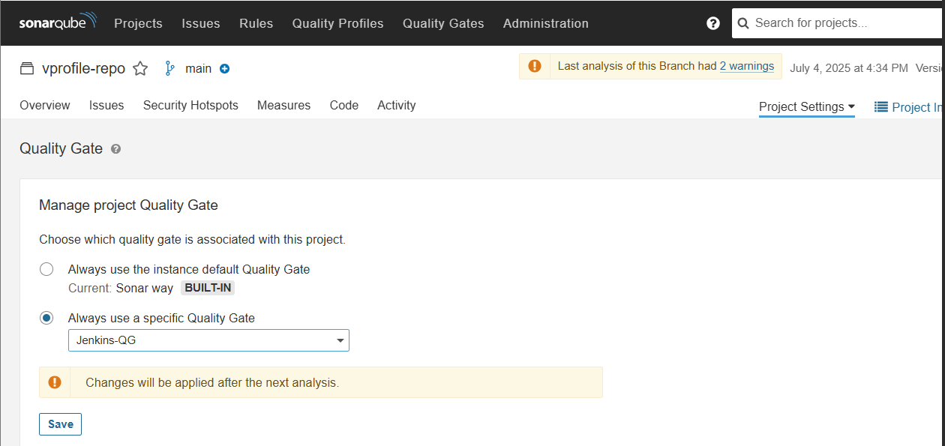

Once the quality gate is checked, sonarqube will sent the result to Jenkins. So we need to create a webhook. Still on Sonarqube,
choose the project,
click to project settingsc
lick to webhook to create one
Click to create
Give the name : Jenkins-CI-WebHook
The url will be http://private-ip-of-jenkins:8080/sonarqube-webhook
Click on create
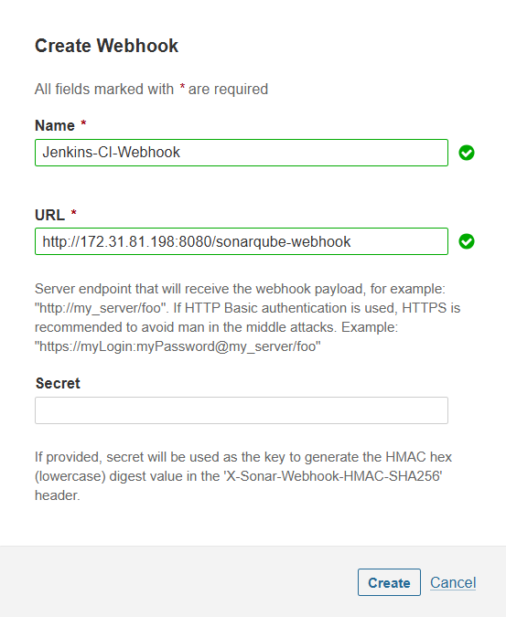
Add this stage on the pipeline
stage("Quality Gate") {
steps {
timeout(time: 1, unit: 'HOURS') {
waitForQualityGate abortPipeline: true
}
}
}
Update our pipeline code on jenkins to adding this stage below, to do that
Go to the dashboard of Jenkins
Click to the Analysis Code Pipeline
Click to configure
Scroll down, put the code at the end of the Sonar code analysis stage
Save and Run the build
Now, the pipeline will fail because there are more than 10 Bugs, SonarQube Analysis will not pass, so the last stage of the pipeline will fail
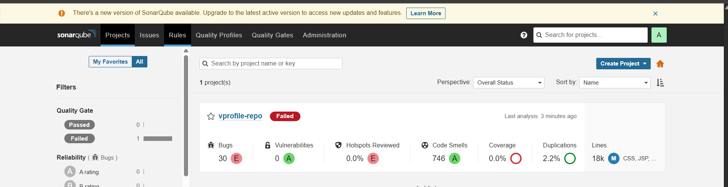
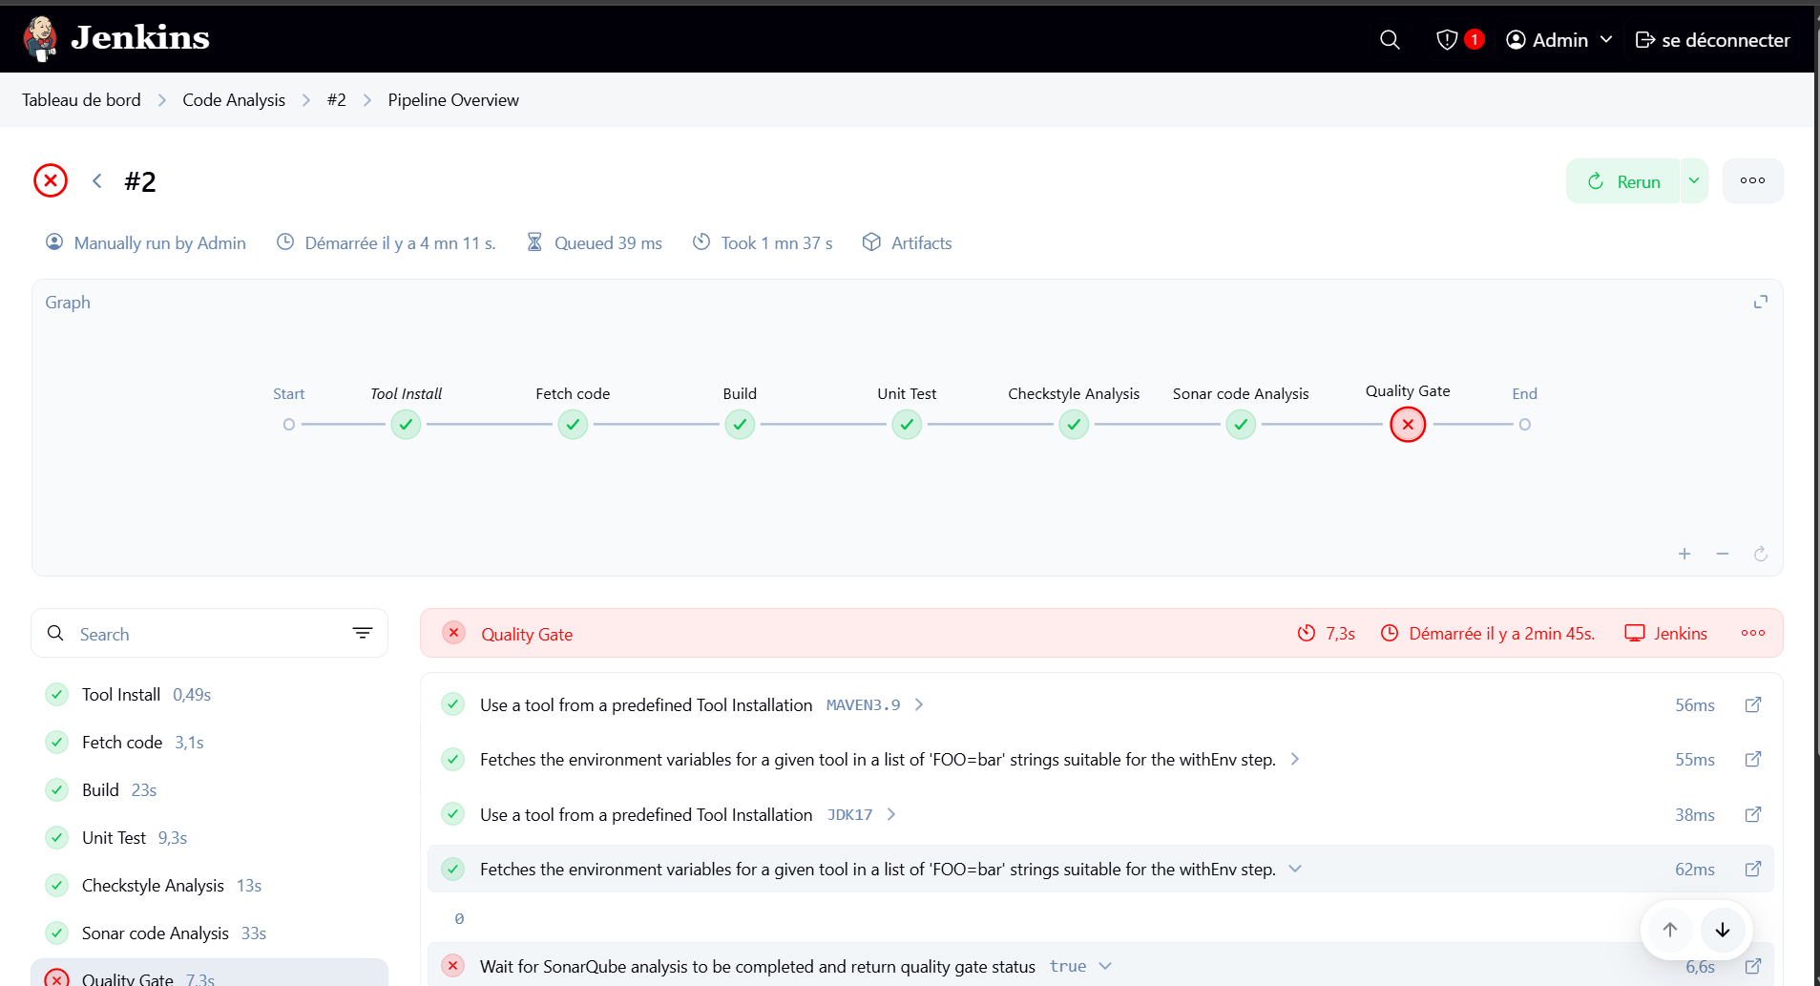

In the next step, we will store the artefacts in Nexus Reposiotry. To have a success pipeline, I switch the quality gate to the default.

Upload docker images to ECR
To build an image within Jenkins and push it to ecr, we need the next informations
- AWS
  - IAM USER with ACCESS Keys
  - ERC Registry (Docker registry from AWS)
- Plugins
  - Docker
  - Docker pipeline
  - Ecr
- Jenkins
  - Store AWS Access Keys(credentials)
  - Install Docker Engine in Jenkins

To it, we will follow the next steps
- Install AWS CLI
- Install docker engine in Jenkins
  - Add Jenkins user to docker group & reboot
- Create IAM User
- Create ECR repo
- Plugins
  - ECR, docker pipeline, AWS SDK for credentials
- Store AWS credentials in Jenkins
- Run the pipeline

Install AWS CLI on Jenkins
- Do a ssh to Jenkins
- Sudo apt update
- Sudo snap install aws-cli –classic
- Sudo -i
- Follow docker installation on ubuntu : https://docs.docker.com/engine/install/ubuntu/
- Add Jenkins user into the docker group : usermod -a -G docker Jenkins
- Check Jenkins is added : id Jenkins

Create IAM user with Access Keys
- Go to aws management console
- Go to IAM services
- Click on create user
- Give the name Jenkins then next
- In the permissions policies choose Attach policies directly
  - Search container and check AmazonEC2ContainerRegistryFullAccess
  - Search ECS and check AmazonECS_FullAccess
- Click on next and create user
- Click on the user Jenkins
- Click to the security credentials section
- Scroll down and click on create access key
- Select CLI
- Check the confirmation
- Click on next and on create access key
- Download your credentials and keep them safe
- Click on done

Create the ECR Registry
- Search ECR and go the Amazon elastic container registry service
- Click on create
- Give the name vprofileappimg
- Click on create

Install All Plugins
Go to Jenkins on the browser
Click on manage Jenkins
Click on Plugins
Search AWS and check AWS SDK :: All
Search ECR and check Amazon ECR
Search for docker plugin and check CloudBees Docker build and publish and Docker pipeline
Click on install
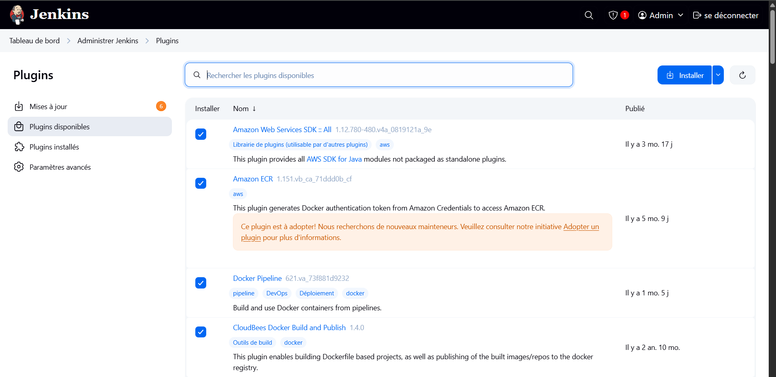

Add AWS Access Keys (credentials) to Jenkins
- Go to Jenkins
- Click on manage Jenkins
- Click on credentials
- On the stores scoped to Jenkins, click on System
- Click on Global credentials
- Click on Add Credentials
- Click AWS Credentials on the type list
- Give to ID and description the name : awscreds
- Give your Access key ID and the secret access key from your credentials downloaded in the previous step
- Click on create

Now you can run the pipeline. The code is on my github repo in the branch docker

