Cette documentation est faite pour décrire les étapes du deploiement de vprofile sur AWS en utilisant les services fournis par Beanstalk.

Create a security group for the bakend, this security group is named vprofile-rearch-backend-sg
After the creation of this sg, we all authorize all inbound traffic from itself to authorize our different services to communicate each other
Create a key pair : vprofile-rearch-key-pair
Create an Amazon RDS
We cannot use ssh to connect to RDS and change parameters for connection to the database
So we will create Parameter groups while we are creating the RDS
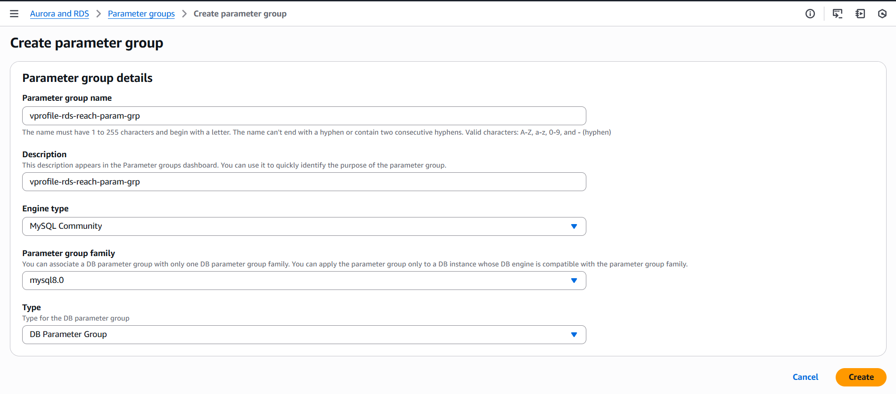

Create a subnet group for the RDS : we selected all the subnets
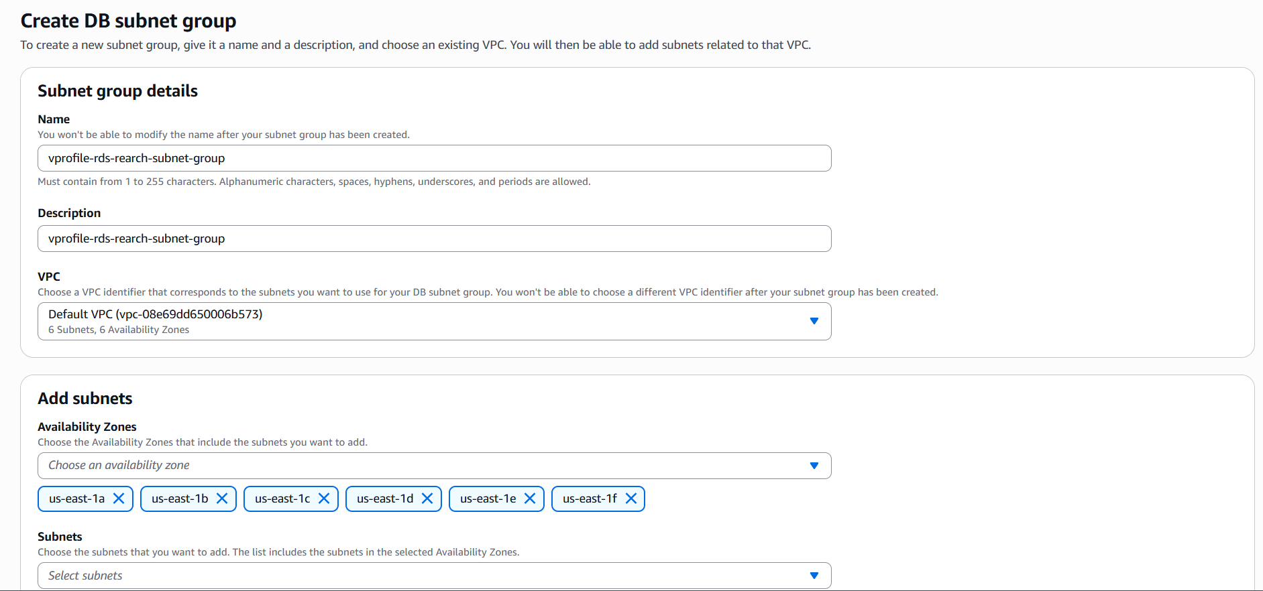

Create a database
There are all the parameters chosen during the creation of the database
Creation method : standard
Engine options : MySQL
Engine version MySQL 8.0.x
Templates : Free Tier (we have production, dev/test options)
Availability and durability : Single DB instance is chosen by default where we choose Free Tier templates
DB instance identifier : vprofile-rds-rearch
Master username : I kept admin but you can change for more security if needed
Credentials management : Self-managed
I checked auto generate password
I disabled the storage autoscaling for this exercise
VPC security group : the security groupe created above vprofile-rearch-backend-sg) is selected and the default isn’t selected
Initial database name in additional configuration : accounts
DB parameter group : the parameter groups created in the first step of the RDS is selected
Create an ElastiCache
The creation of ElastiCache need the same steps of the RDS procedure
Create a Parameter groups like in the picture below
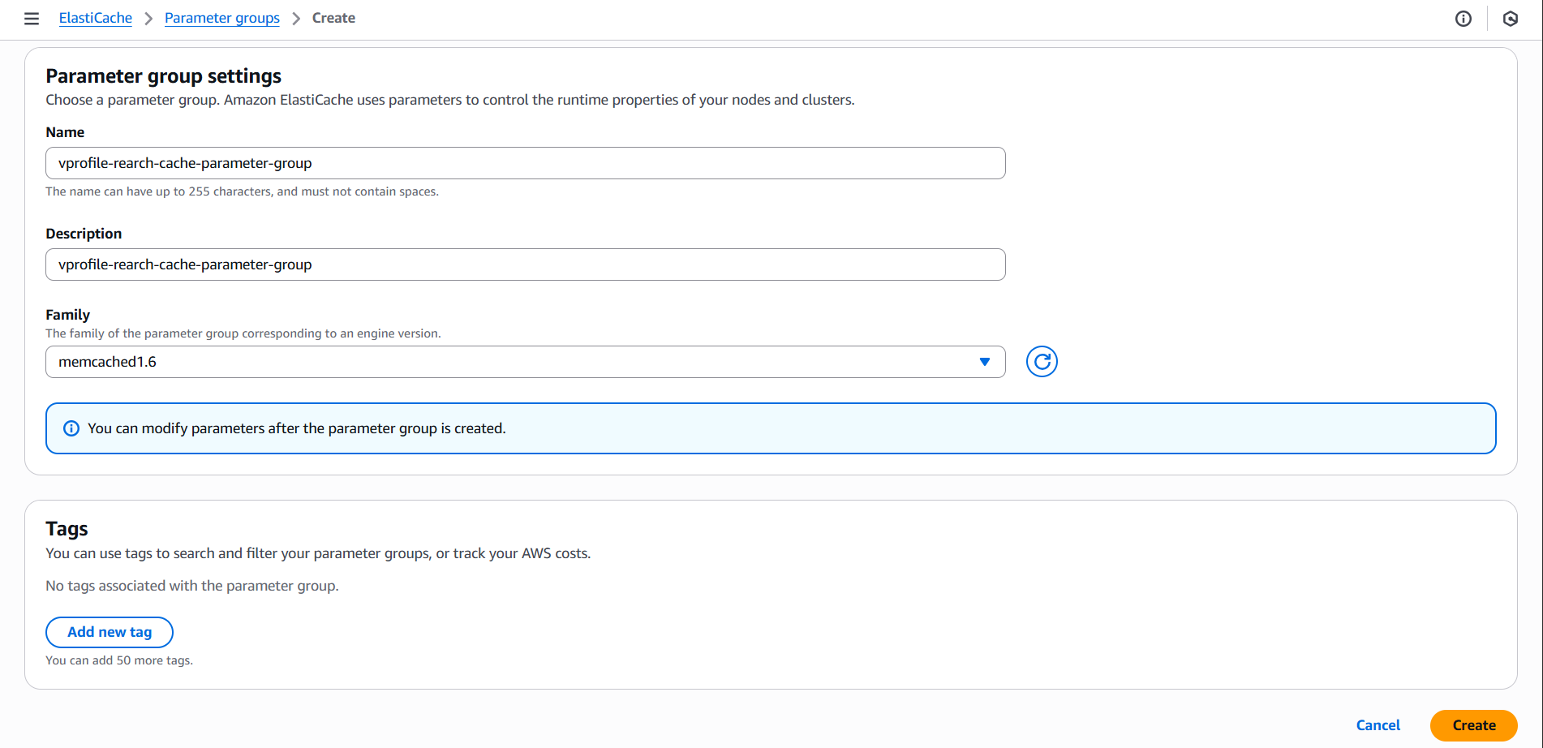
Create a subnet group
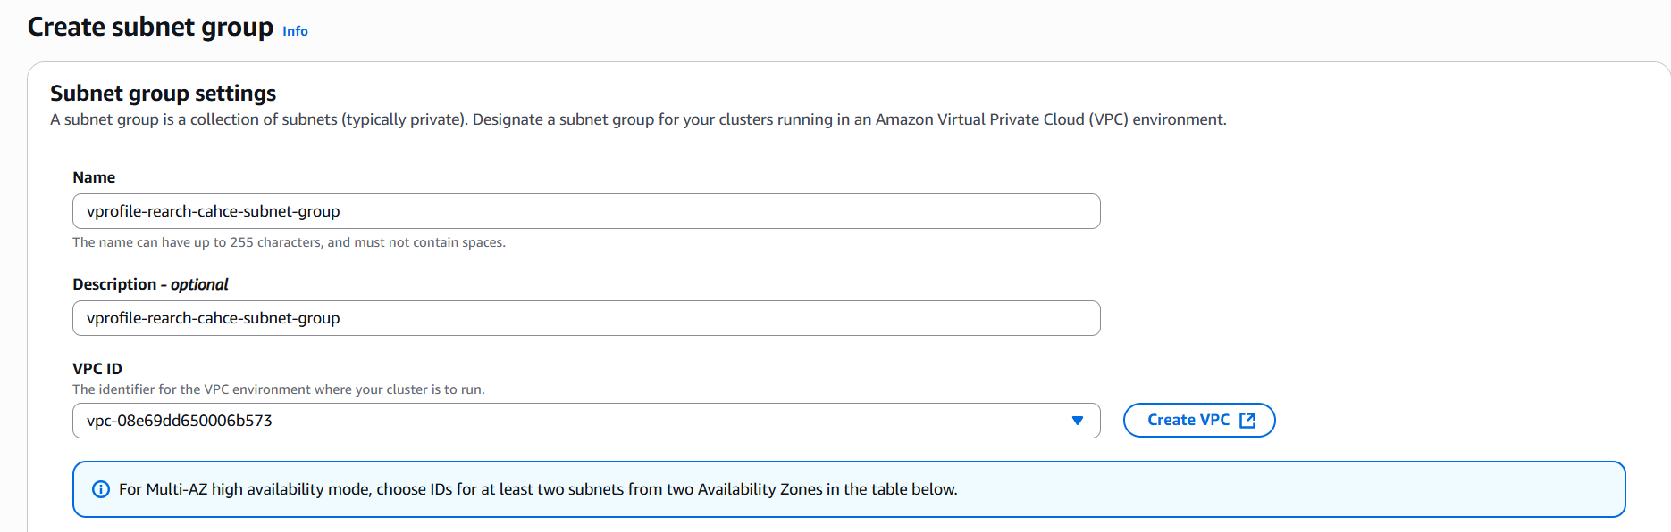
Create a Memcached caches : the parameters used to create this service are :
Deployment option : Design your own cache (I need to Know all the option)
Creation method : Cluster cache (Standard create)
Location : AWS Cloud
Cluster info name : vprofile-rearch-cache
Parameter group in Cluster setting section : vprofile-rearch-cache-parameter-group (created in the previous section)
Node type cached : t2.micro (the smallest off all type)
In the next step, in security group section, we manage and choose vprofile-rearch-backend-sg who is the SG of our backend

Create Amazon MQ
Ine the step 2, I selected the Single instance broker
In the step 3, we have the below parameters
Broker name : vprofile-rearch-rabbitmq
Broker instance type : mq.t3.micro
Username : Admin
Password : VprofileRabbit2025
Broken engine version : 3.13
The Create a new configuration with default values is selected in the Broker configuration
Private access is selected in the network security
Default VPC and subnet is selected in the VPC and subnets section
In the security group, I chose vprofile-rearch-backend-sg created for our backend

Initialization of the database
To initialize the database, we need firstly to lunch an EC2 instance in the same availability zone with the RDS database created above
After the creation of EC2 instance, we need to be connected to to the EC2 and make the next command to install mysql-client and git:
sudo -i
apt update install mysql-client git -y

After we need two things
The information of our RDS database (endpoint of the rds, username and password)
Allow this instance security group to talk to the RDS security group (the RDS SG is vprofile-rearch-backend-sg). So in the RDS SG, we will add an inbound rule with type=MySQL/Aurora and the custom is the security of this EC2 instance
Now we need to connect to the database : mysql -h vprofile-rds-rearch.c6doiawyq7fz.us-east-1.rds.amazonaws.com -u admin -pjipRul09CVxpceaO5bqo accounts

