SAP Certification Notes
Personal reference – certifications, renewal rules, and useful links

Certifications Targeted (Technical + Functional)
- Related area: BTP, HANA and ABAP
- C_S4EWM – Extended Warehouse Management (EWM) in SAP S/4HANA
- C_FIORD – SAP Fiori (development / B.Tech track)
- C_TS4CFI – Finance, SAP S/4HANA
- C_TS462 – Sales, SAP S/4HANA
- C_THR81 – HR (Human Resources / SAP SuccessFactors-HCM area)
- C_TS422 – Production Planning and Manufacturing, SAP S/4HANA
- C_ABAPD – ABAP backend developer
- C_ADBTP – SAP Certified Associate – Administrator for SAP BTP (most advanced and in-demand)

Exam Attempts and Renewal
- Can take 2 certificates, with 2 attempts for each certificate.
- Renewal certificates can be renewed freely, but only before they expire.
- After expiry, the certificate must be paid for again.

Language Options
- Danish, French, Mandarin, German, Spanish – combining these languages with SAP global certificates can be a strong career advantage.
- Germany, France, Norway, Ireland , Denmark, Spain

Useful Links
- SAP S4/HANA: https://stockholm.cob.csuchico.edu/fiori
- SAP ABAP: merida.cob.csuchico.edu:8038 – SAP WebGUI
- SAP Universal ID: Software Downloads
- SAP Software Center: me.sap.com/softwarecenter
- SAP EXAM LINK: https://learning.sap.com/lecturers

Account Details
- SAP Universal ID username: P2012822579, PW- *************
- Login through Email ID: souhardyagayenset@sanjivani.edu.in

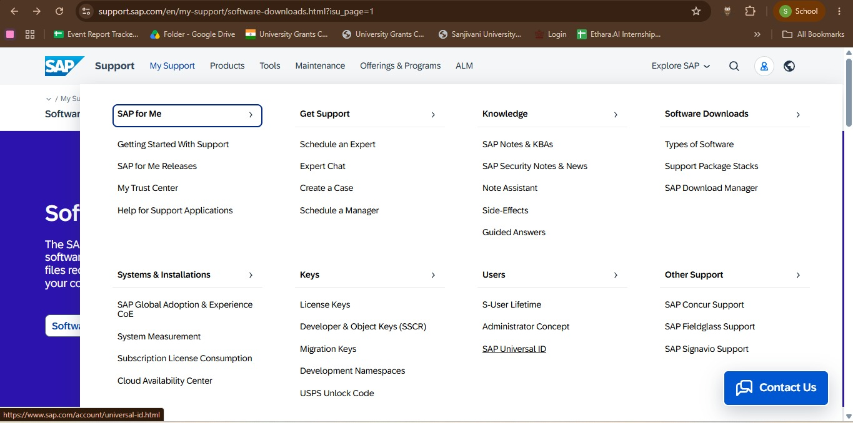
https://support.sap.com/en/my-support/software-downloads.html?isu_page=1

https://www.sap.com/account/universal-id.html
SAP Universal ID

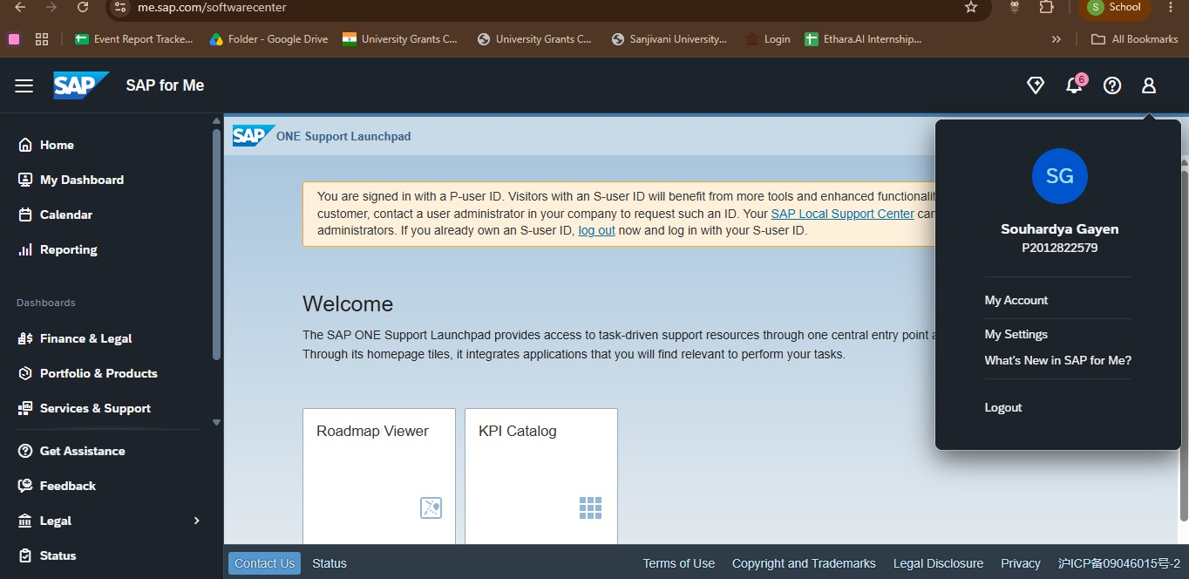
https://me.sap.com/softwarecenter
Login Here for check

Status
- Ready to take the exam.

You can Use Both for Learn
SAP Software/SAP Website but software is better

SAP HANA Login: (Learner Login)
ID-LEARN-421
Pw- *************
Client-ID-475
Link- https://stockholm.cob.csuchico.edu/sap/bc/ui2/flp
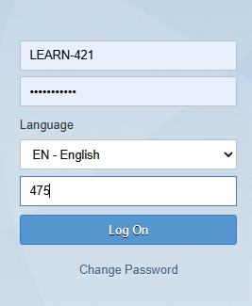

SAP HANA Login: (Teacher Login)
ID-TEACH-008
Pw- *************
Client-ID-475
Link- https://stockholm.cob.csuchico.edu/sap/bc/ui2/flp
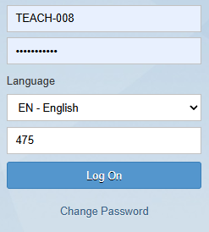

SAP ABAP LOGIN:
ID-SANJ-007
PW- *************
Client ID-105
Link:- https://merida.cob.csuchico.edu:8038/sap/bc/gui/sap/its/webgui/
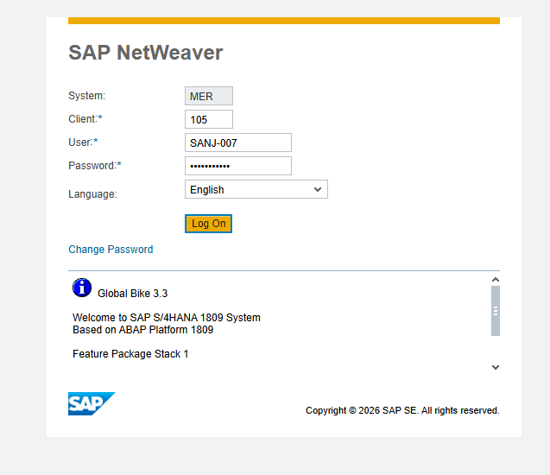

After Login
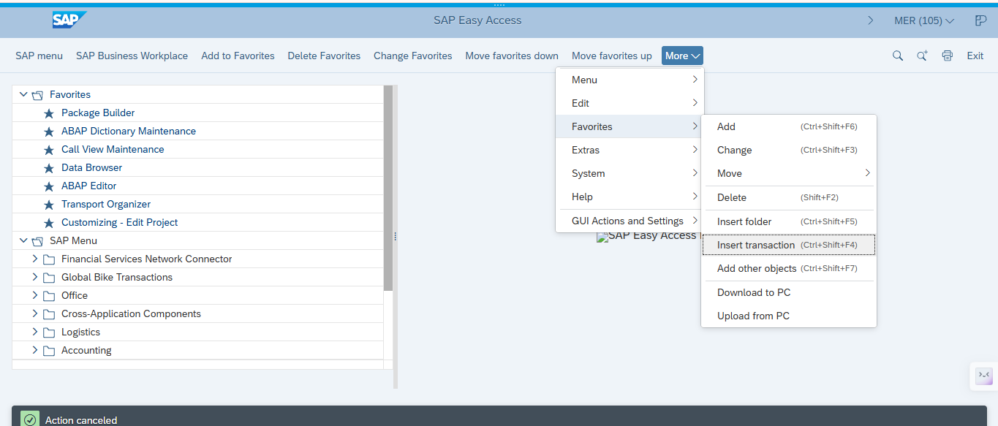

Process of ABAP Step-by-step guide
SE21
SE11
SE10 (Transaction check/status check)
SM30
SE10 (Transaction check/status check)
SE16
SE38

First step-1
Create a Package
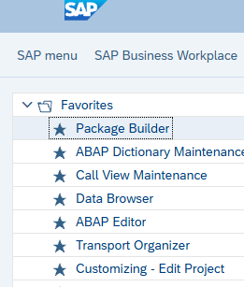

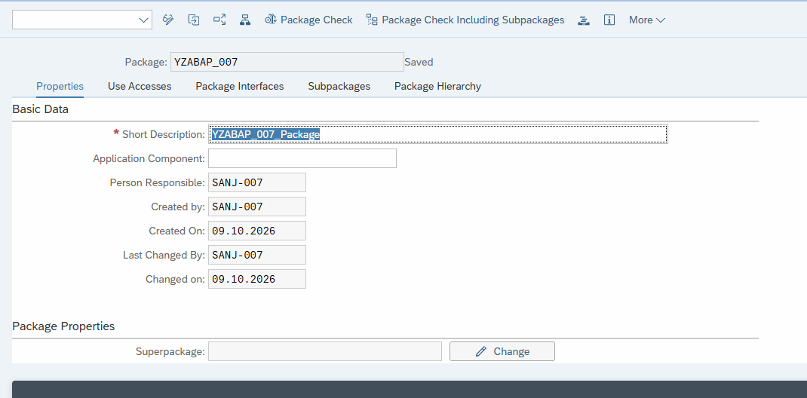

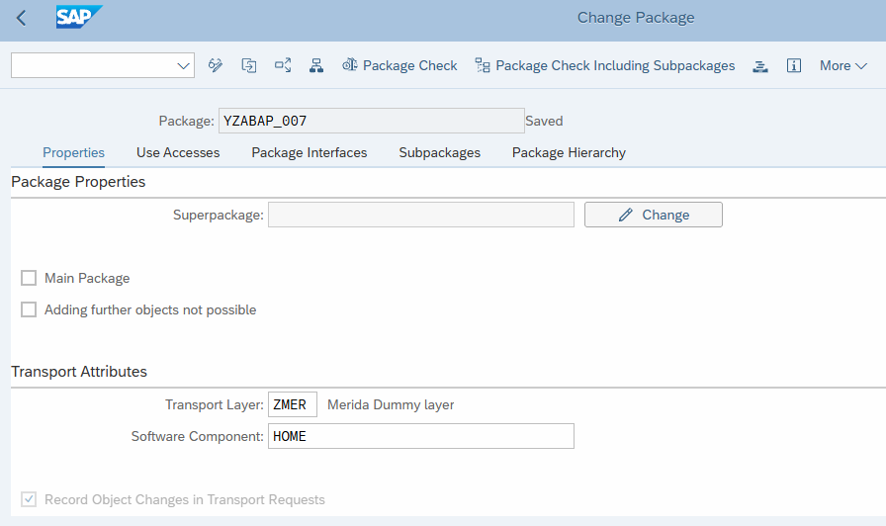

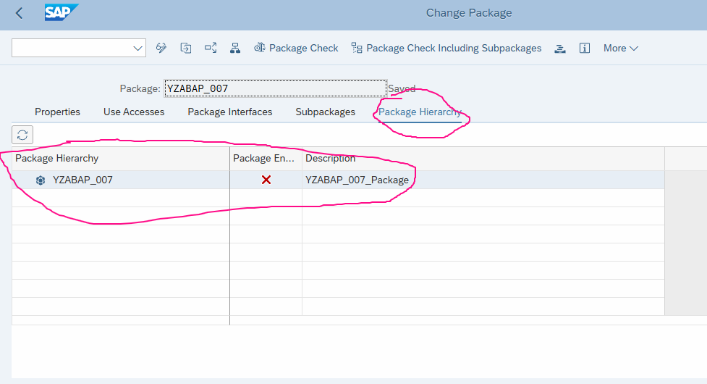

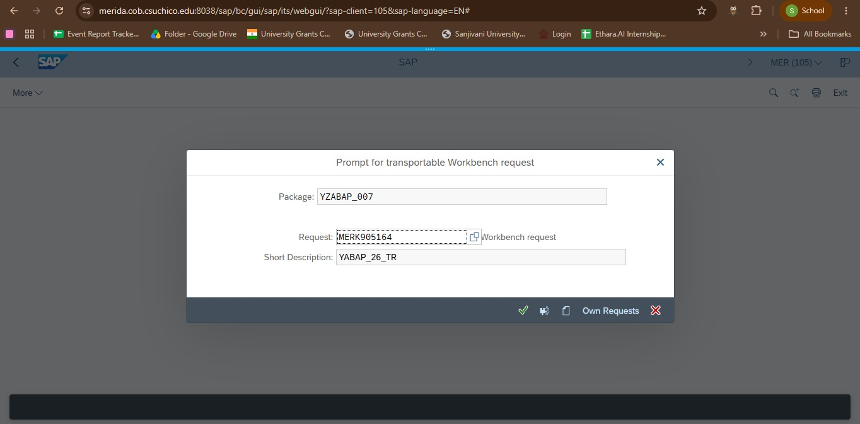
Package ID: YZABAP_007

***Extra Notes***----------------------------------------
[10:38 am, 10/10/2026] souhardyagayen99: vendor master data LFA1
[10:38 am, 10/10/2026] souhardyagayen99: pricing master data T6A3S
[10:38 am, 10/10/2026] souhardyagayen99: for Sales VKORG
[10:38 am, 10/10/2026] souhardyagayen99: IBUPA for Bussiness partner
[10:39 am, 10/10/2026] souhardyagayen99: IBUPA Vendor for vendor
[10:54 am, 10/10/2026] souhardyagayen99: WE80
WE20
idoc in SAP
WRICEF W=Workflow, R=Report, I=Interface, C=change Request, E= Enhancement, F=Form

[11:04 am, 10/10/2026] souhardyagayen99: Dynpro Structure
Transaction Code
Fields
Screen
Attributes
PBO
PAI
[12:15 pm, 10/10/2026] souhardyagayen99: SE16 for see SAP Transaction Tables
[12:18 pm, 10/10/2026] souhardyagayen99: MARA Material Master Data
[12:30 pm, 10/10/2026] souhardyagayen99: parallely open 6 screen in SAP
[12:32 pm, 10/10/2026] souhardyagayen99: Command Purpose
/nSE16 Opens transaction SE16 in the current session, leaving the current transaction
/oSE16 Opens transaction SE16 in a new SAP session
/nMM01 Opens transaction MM01 in the current session
/oMM01 Opens transaction MM01 in a new SAP session
/i Closes the current SAP GUI session
/n Ends the current transaction and returns to the SAP Easy Access screen
/nex Logs off from SAP GUI immediately, closing all sessions without the normal confirmation
/o Displays the session overview, where you can create or manage sessions
Easy way to remember:
- /n = New transaction in the same session.
- /o = Open a new session.
- /i = Close the current session.

----------***------------------
SE

DOMAIN NAME
YSTUD_ID_007 saved
YSTUD_NAME_007
YSTUD_AGE_007
YSTUD_COURSE_007
YSTUD_GENDER_007
YSTUD_EMAIL_007

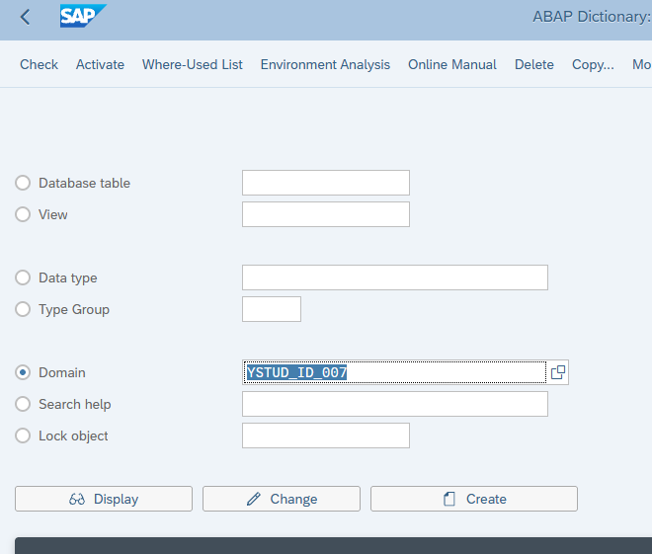

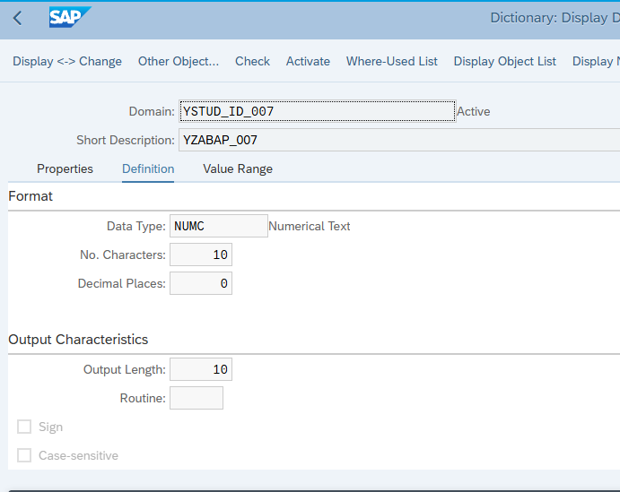
Check ---> Activate-->Save--> Give Packege anme properly what you have given previously
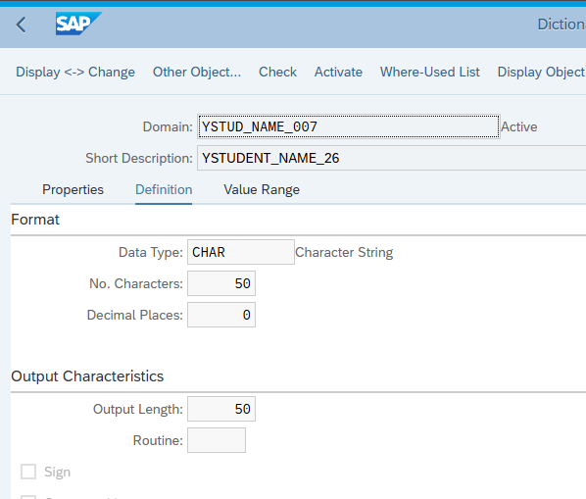
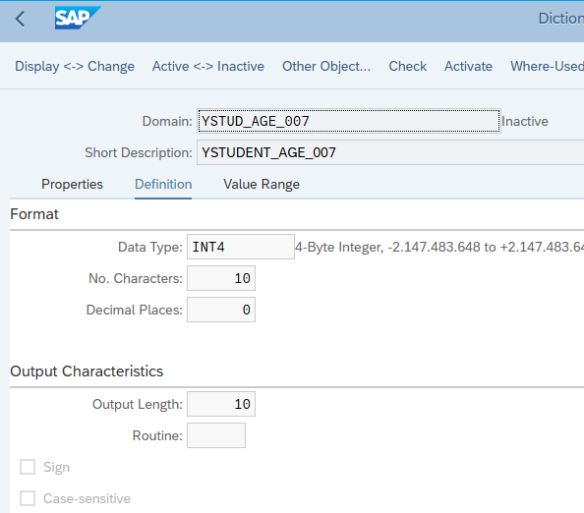

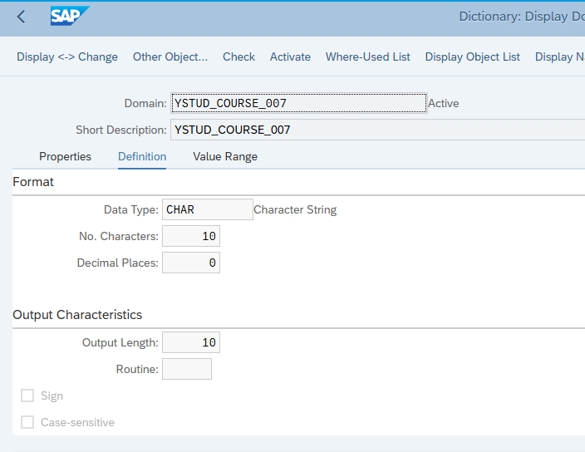
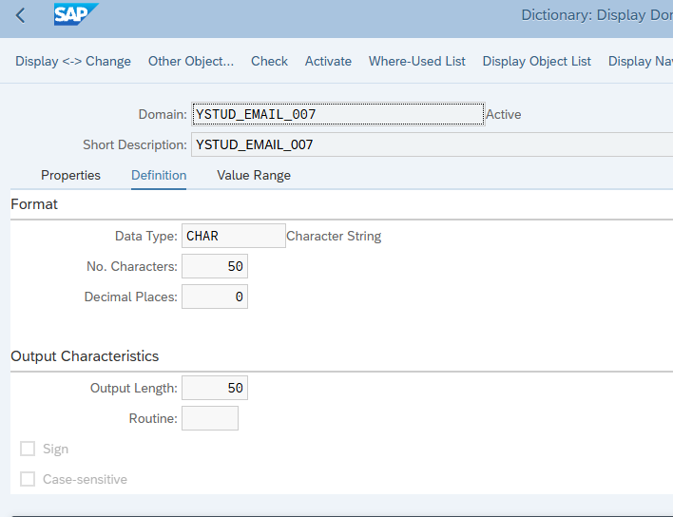
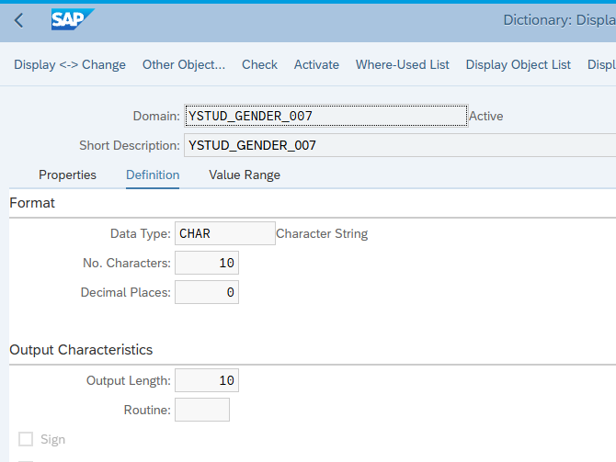
You must have to cilck save-->check ---> activate
Data Type
YSTUDENT_ID_007
YSTUDENT_NAME_007
YSTUDENT_AGE_007
YSTUDENT_COURSE_007
YSTUDENT_EMAIL_007
YSTUDENT_GENDER_007

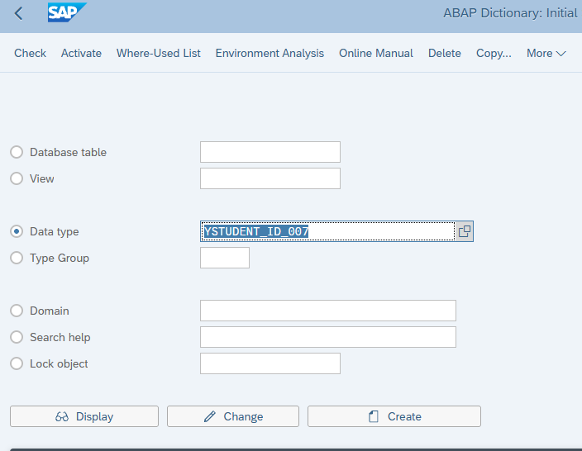
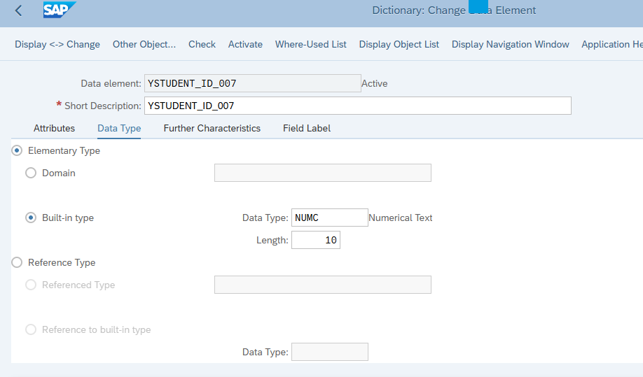
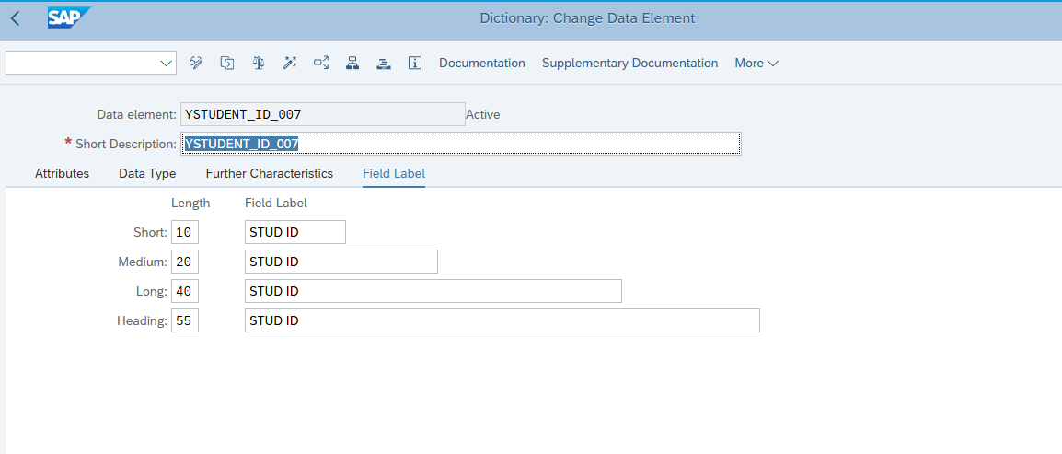

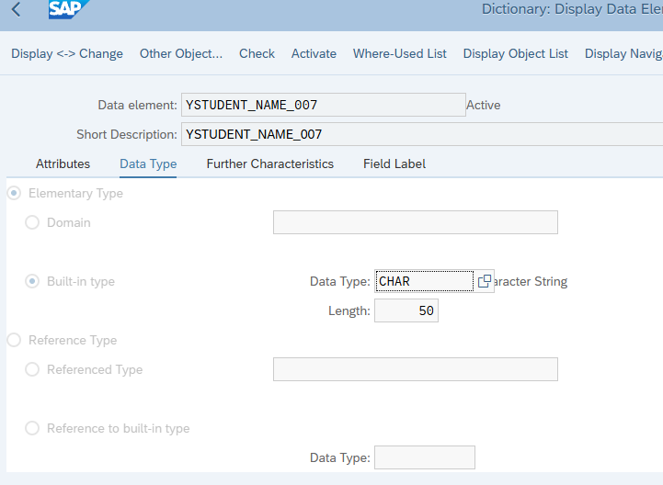
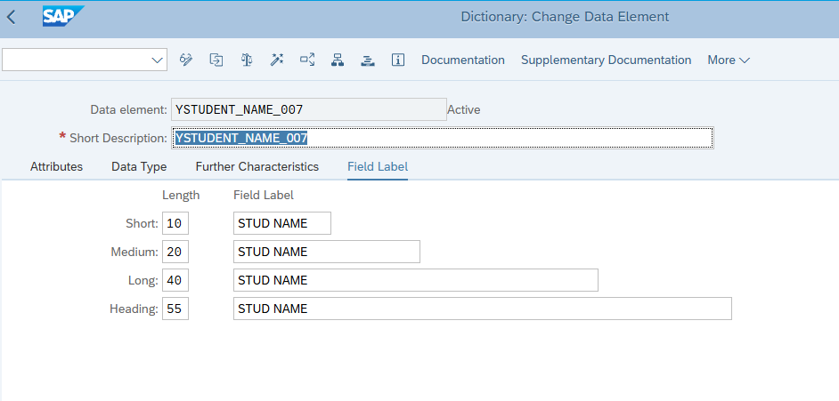

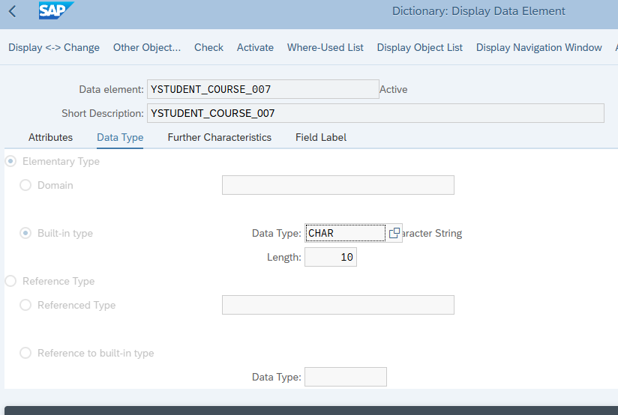
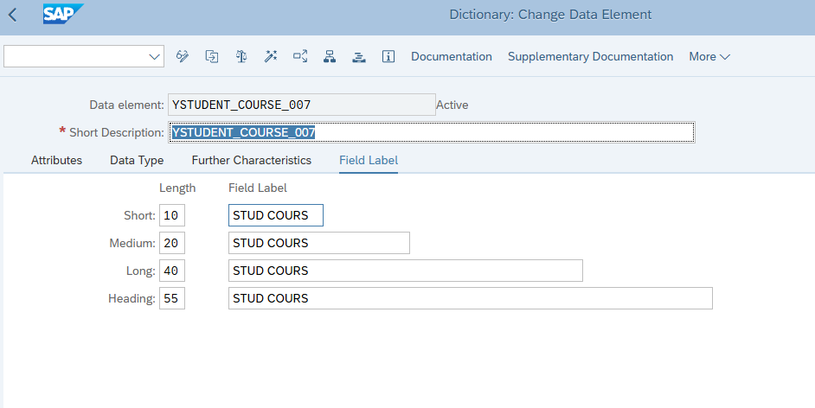

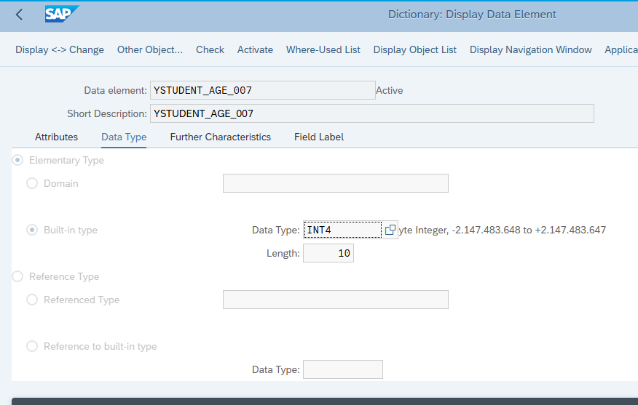
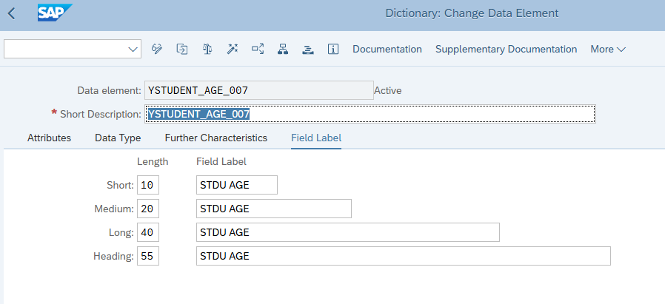

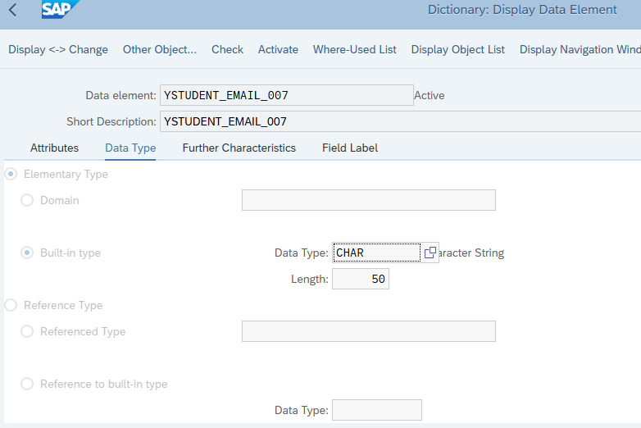
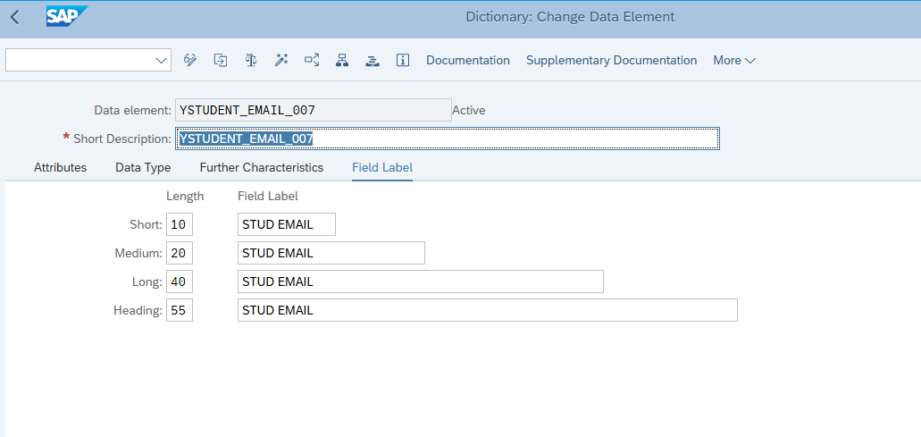

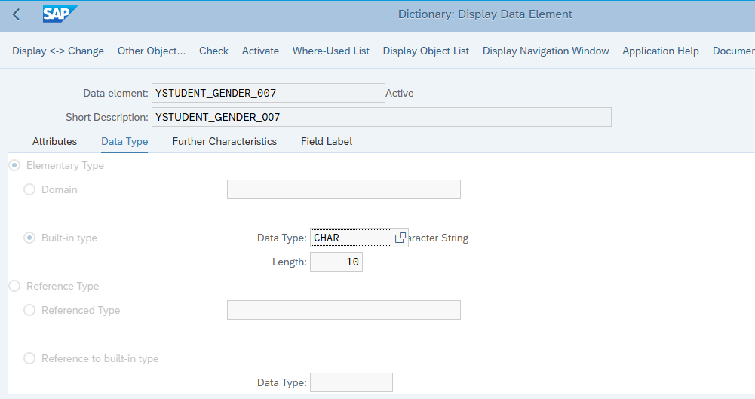
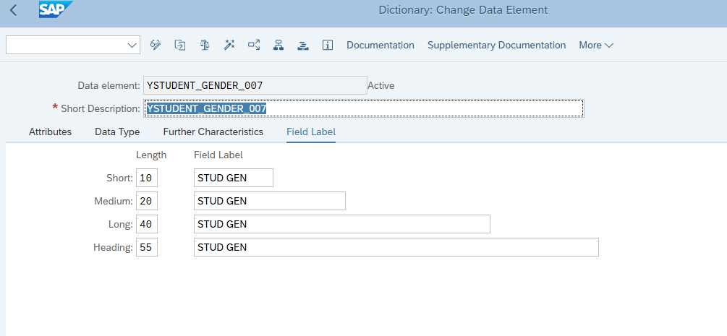

Database Table:
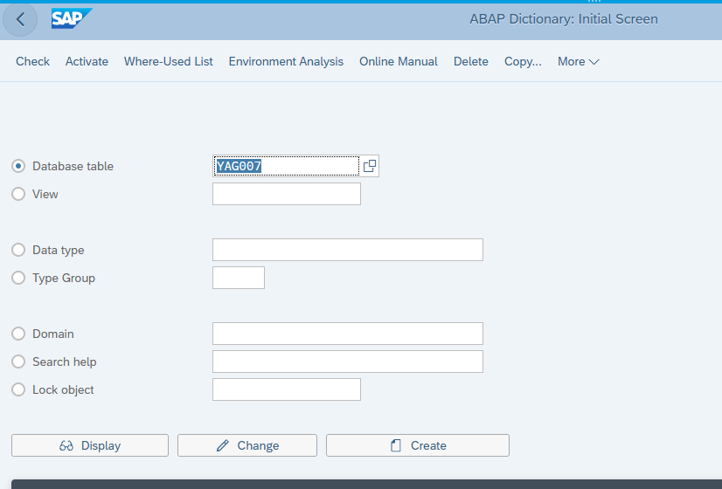

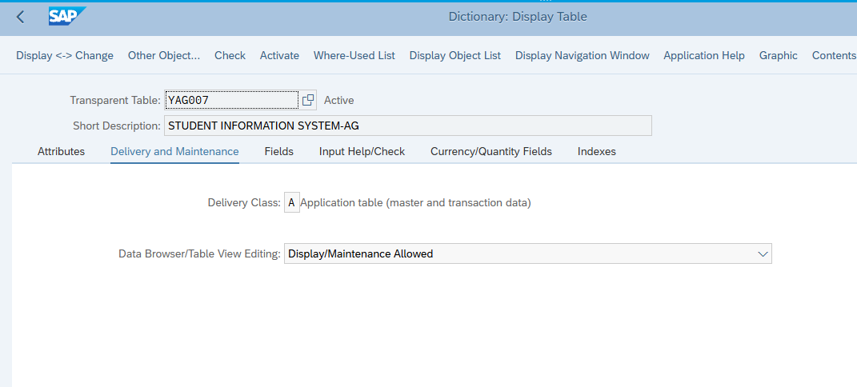

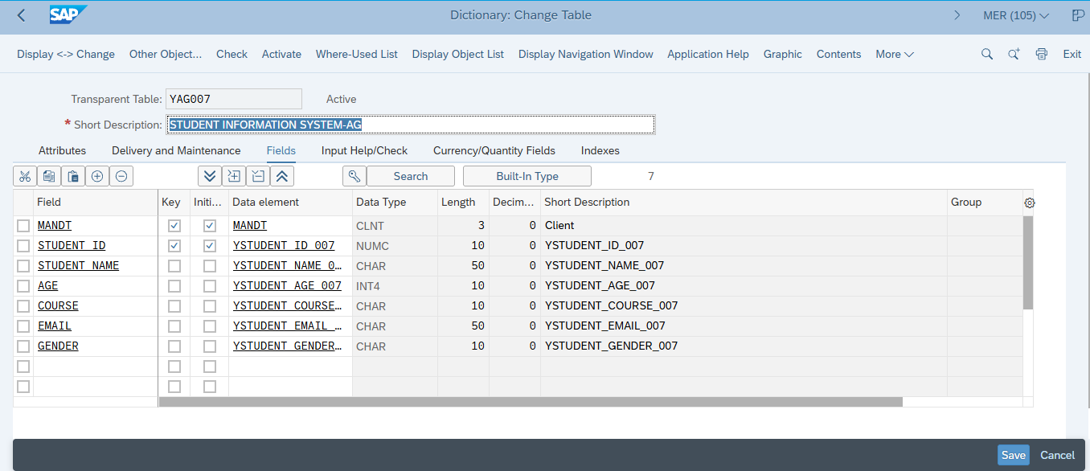
This is very Crucial Table that mahe to map correctly in each data type and size

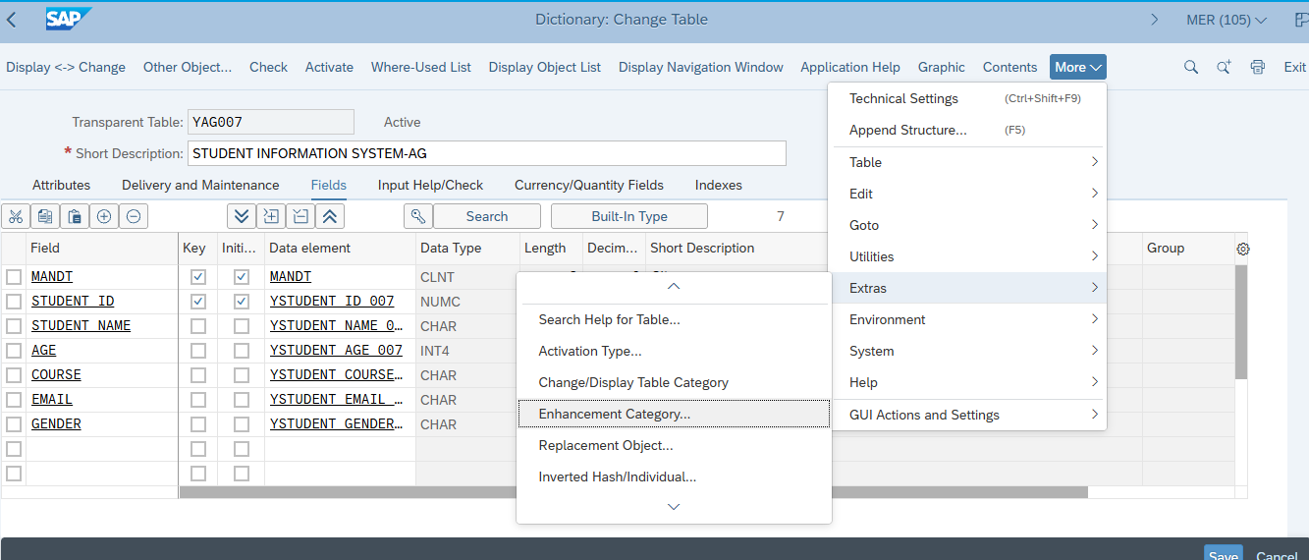

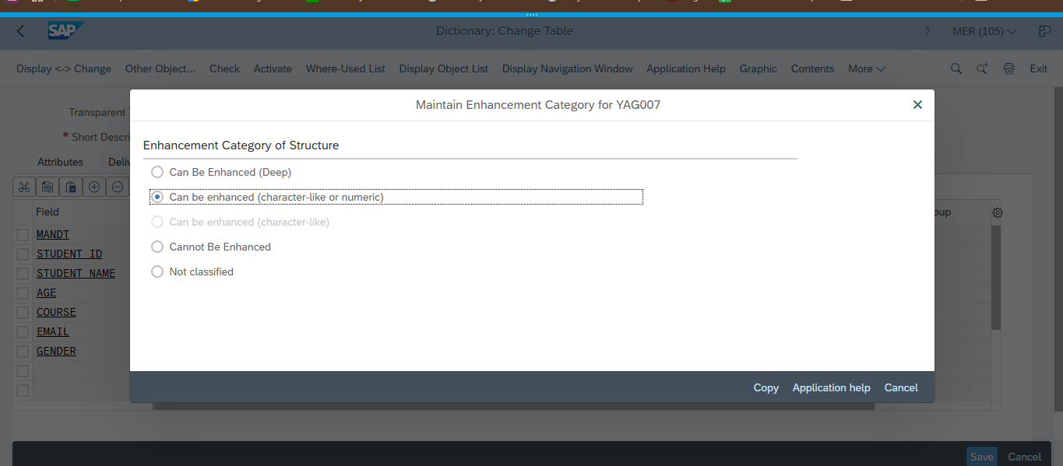

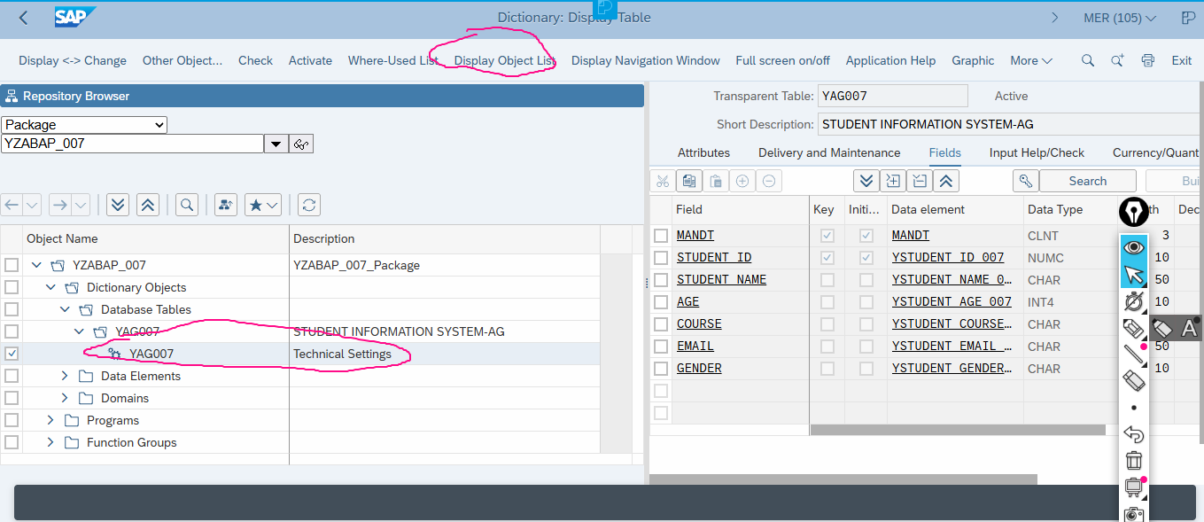
Click Technical setting
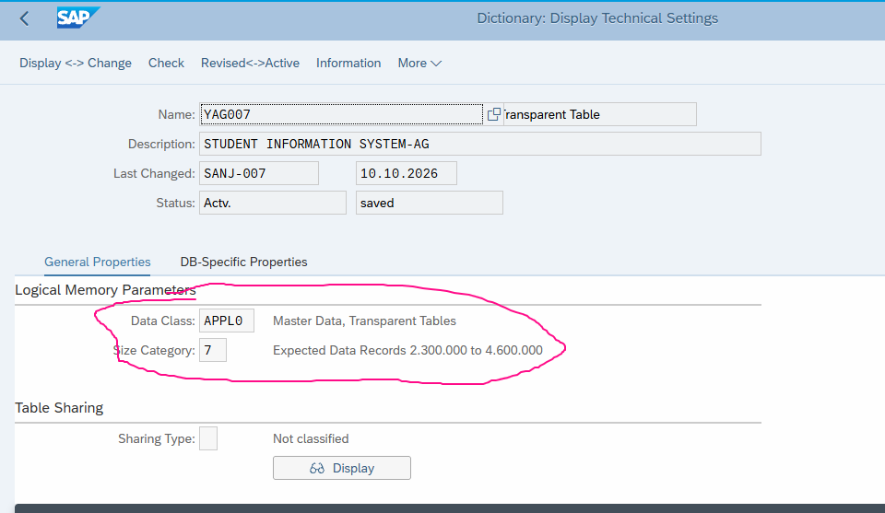
Save
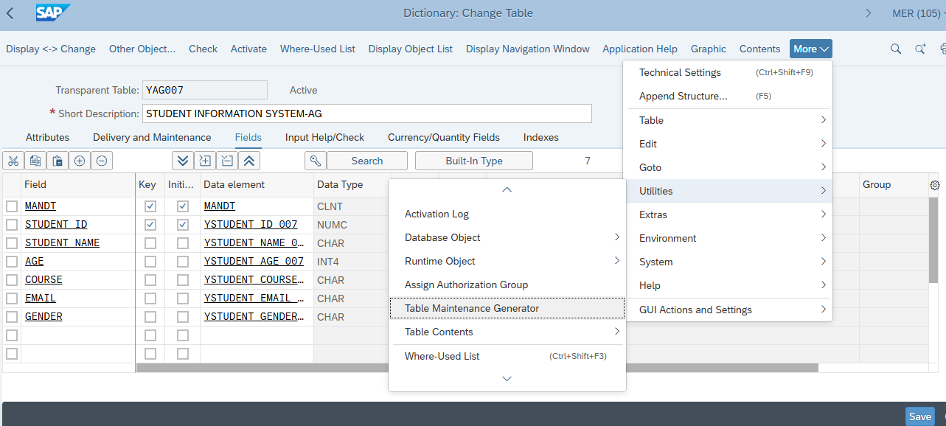
SAVE--->ACTIVATE--->then this option will come

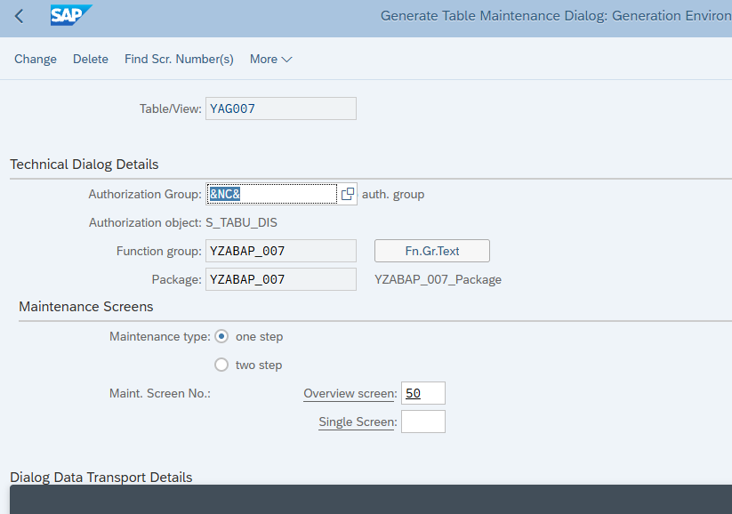
Create ---> save

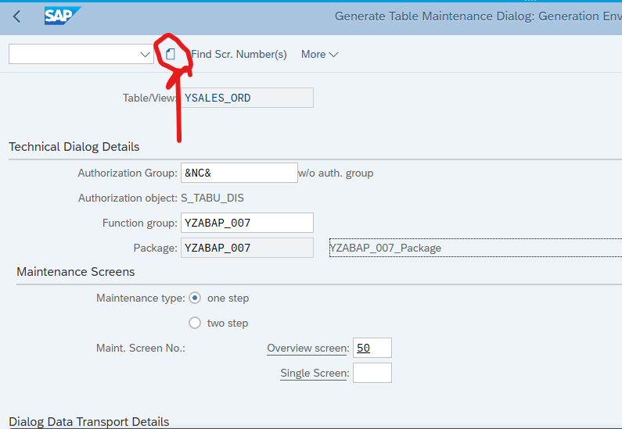

SM30
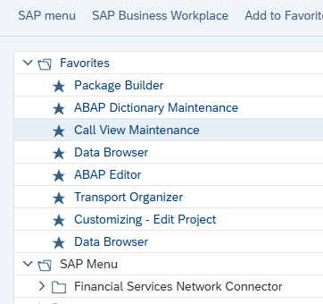

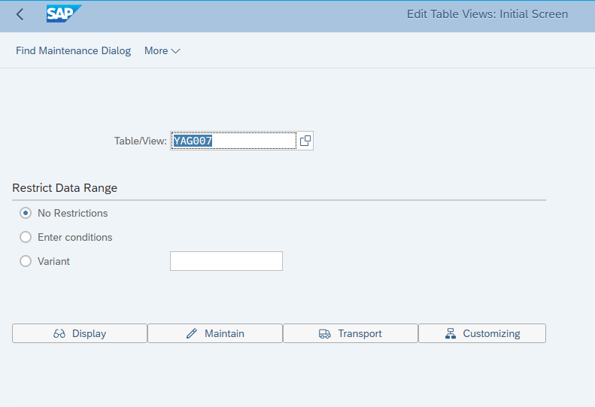

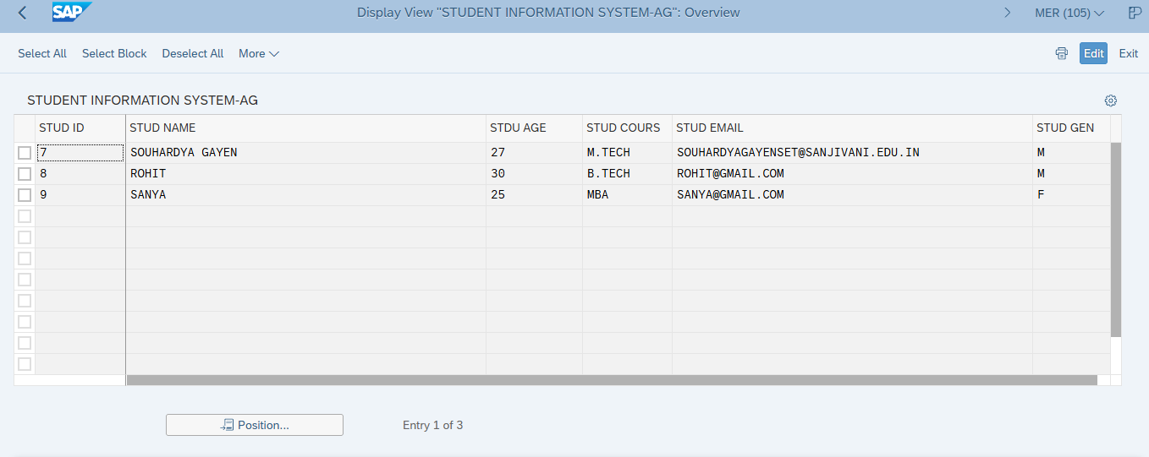
Edit--->New Item-->Save

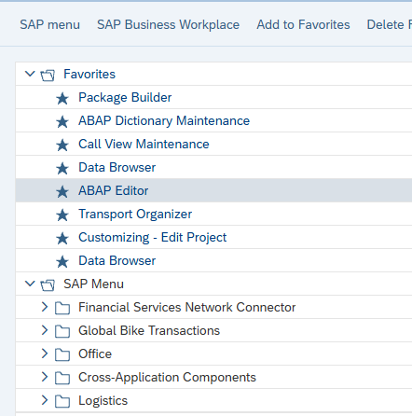

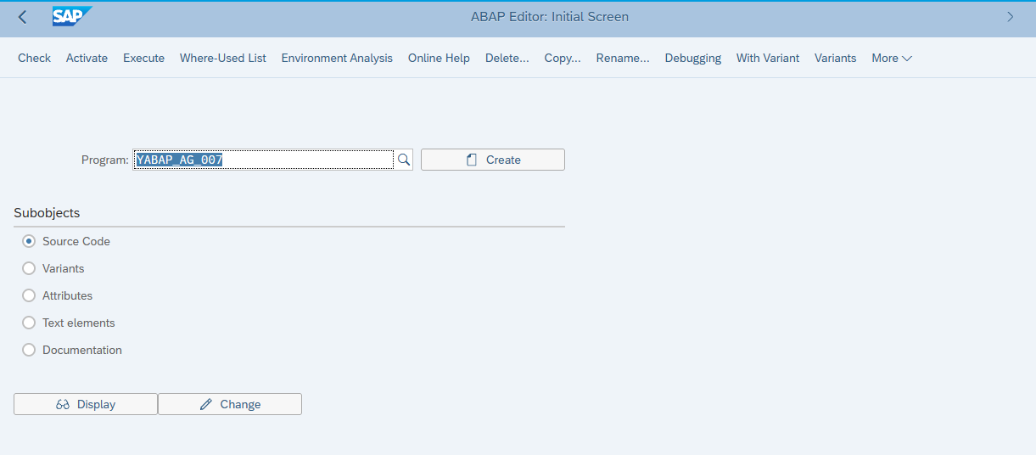
Click Create
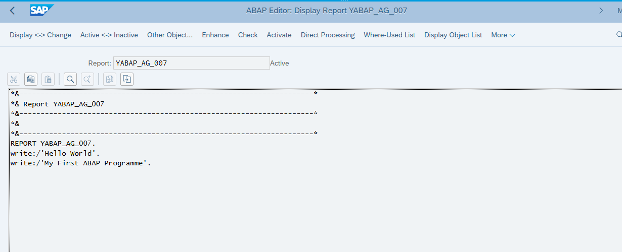
check ---> Activate---> F8

Final OUTPUT
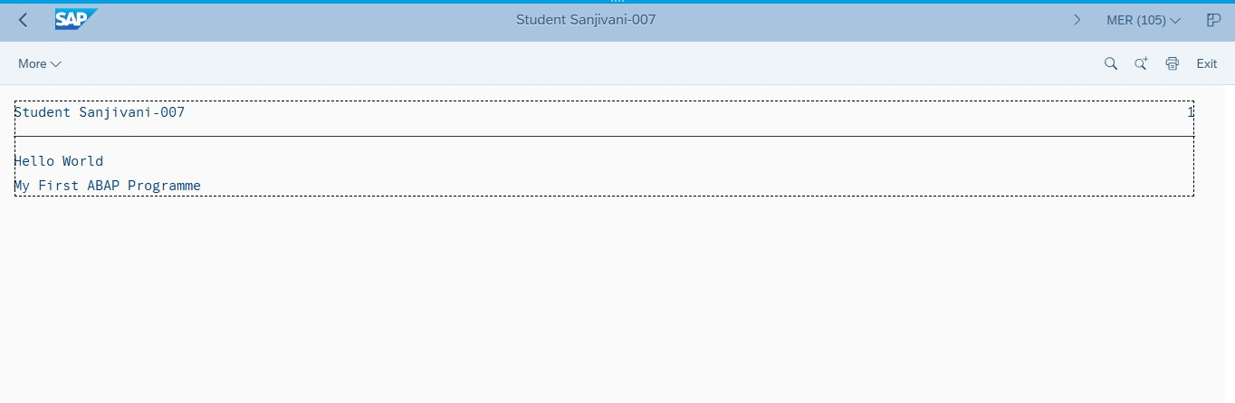

Transport Organizer and Data Browser used for view only
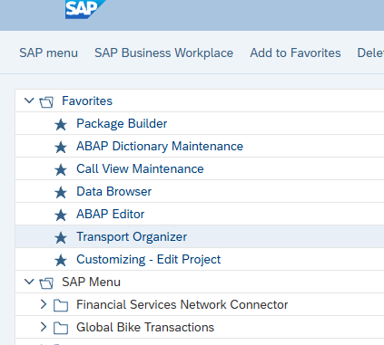
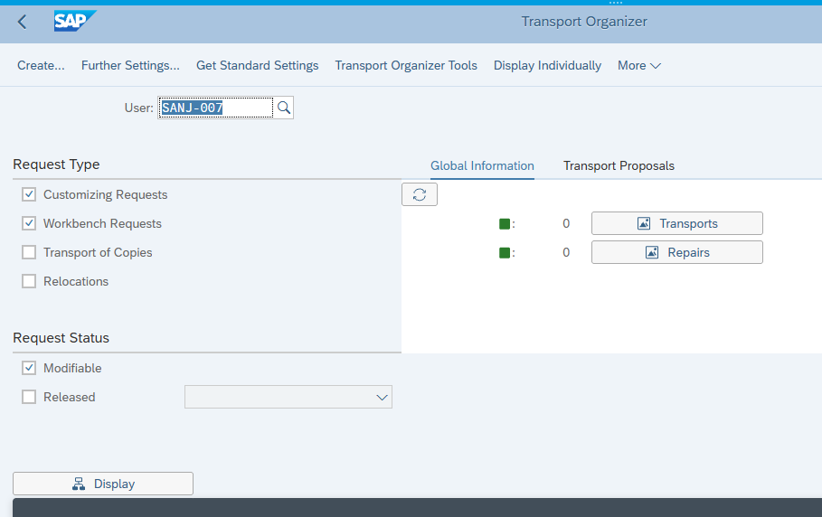
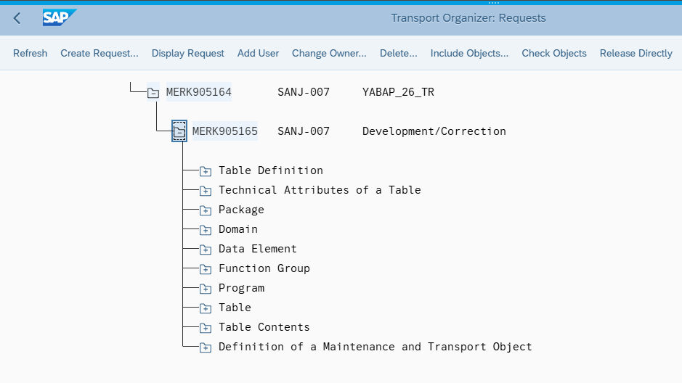
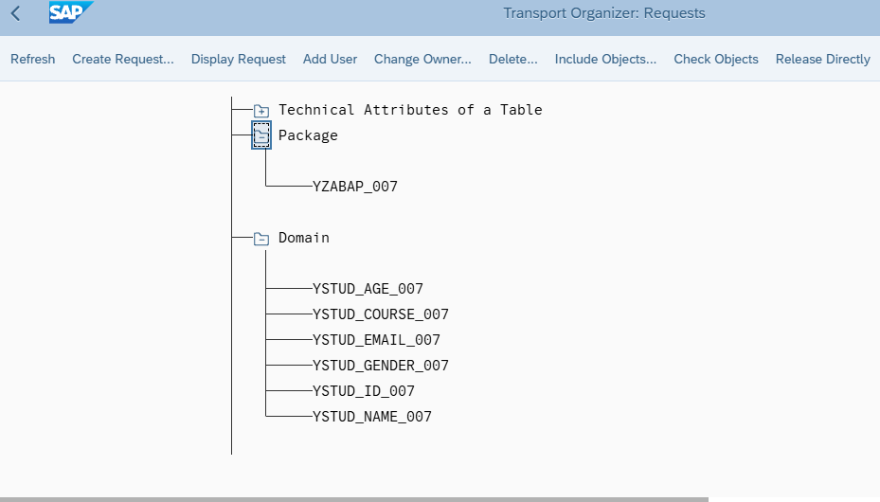

In Data browser:
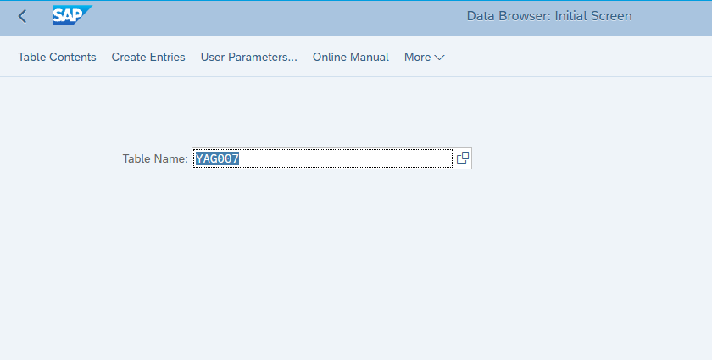
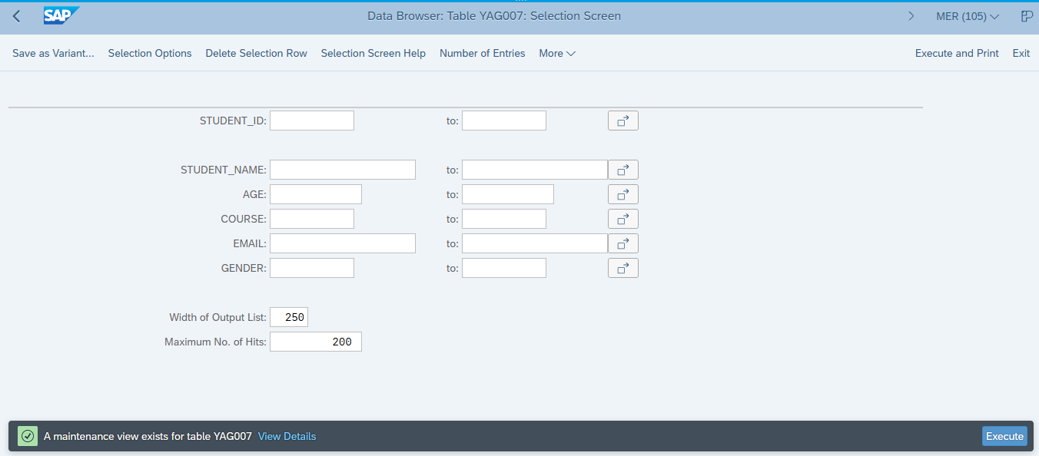

Click Execute

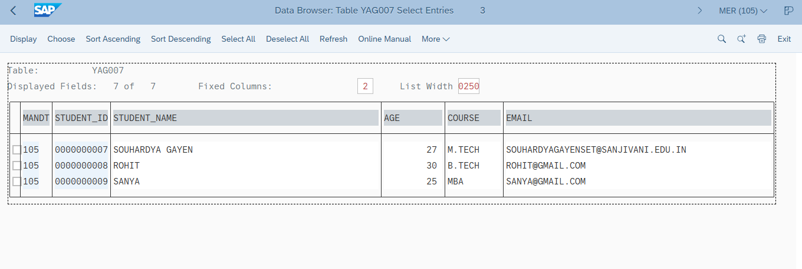
Sir will provide this things…………………
SAP Software download link:
Eclipse Addons link of SAP
Case Study of ABAP
Script.…

Next lecture 23 OCT 2026 & 24 OCT 2026……..

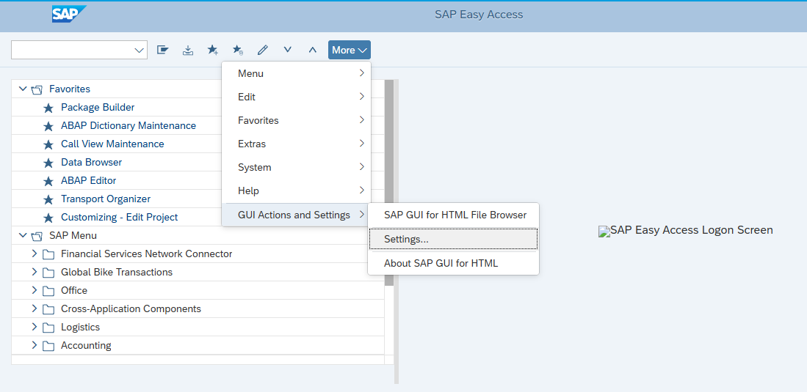

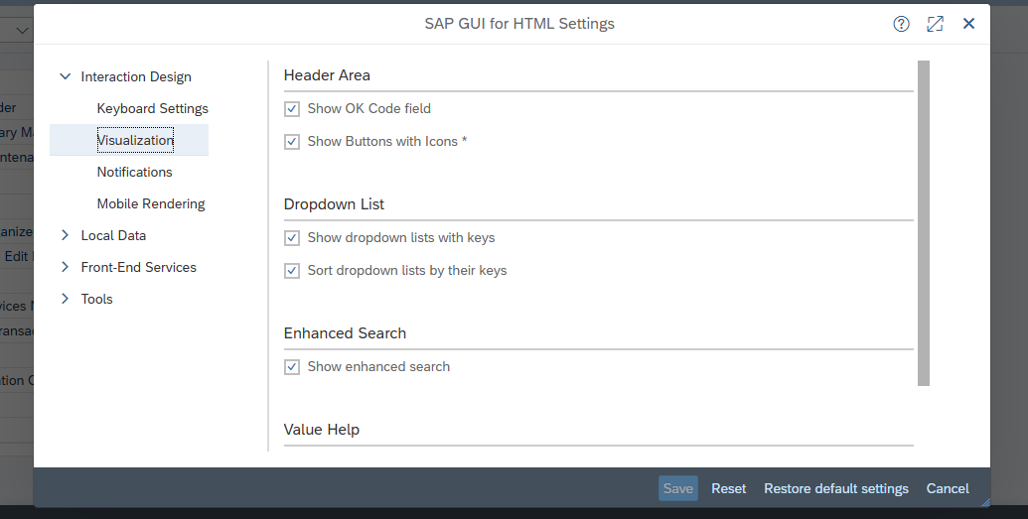
Then check mark and then Save to enable search bar

Eclipse SAP HANA and ABAP Installation:
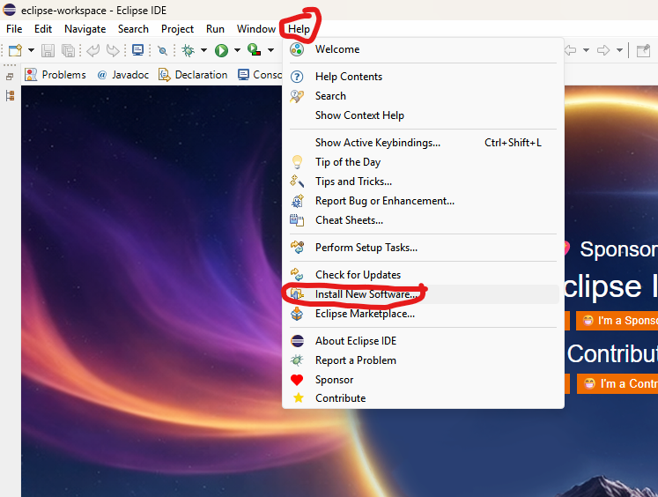

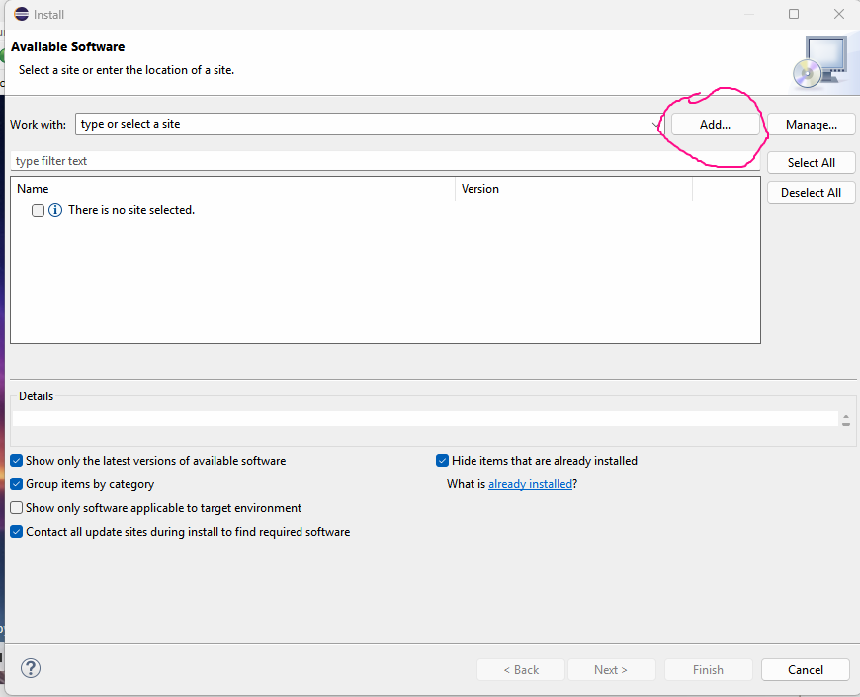

• Name: ABAP Development Tools
• Location: https://tools.hana.ondemand.com/latest
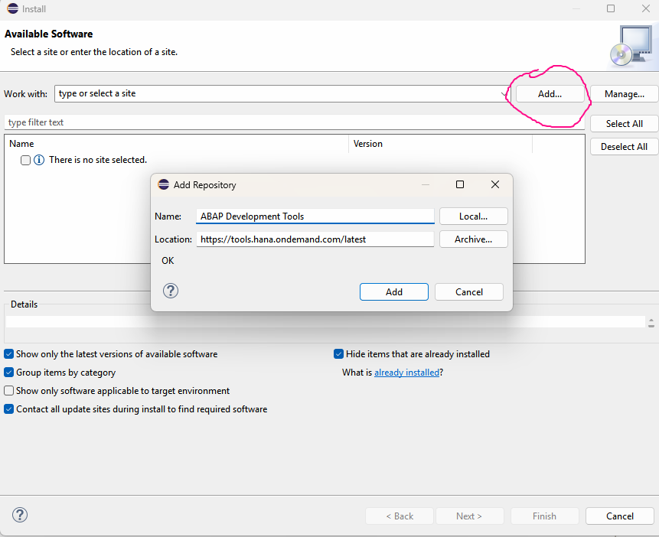
Click on ADD
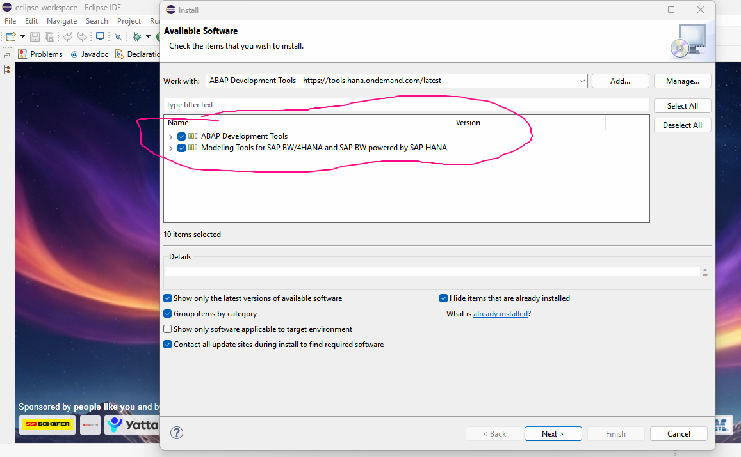
Select both module and click next
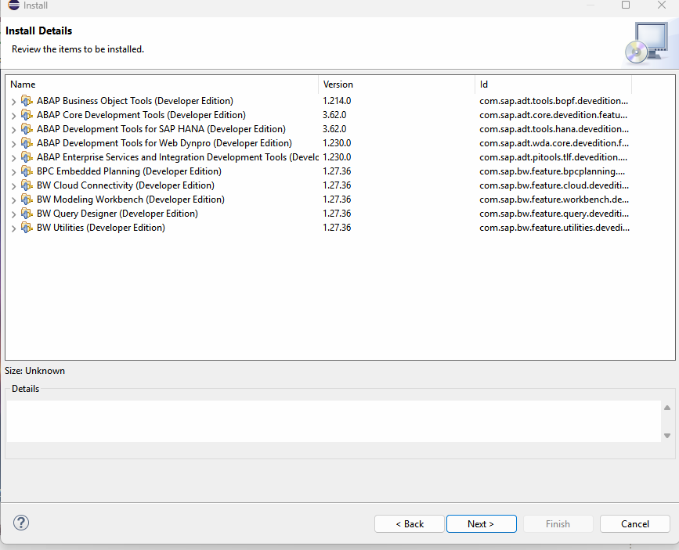
Click Next
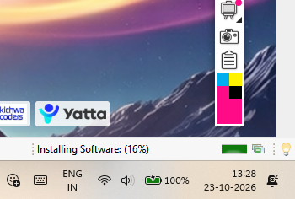
It is showing that Installing…..
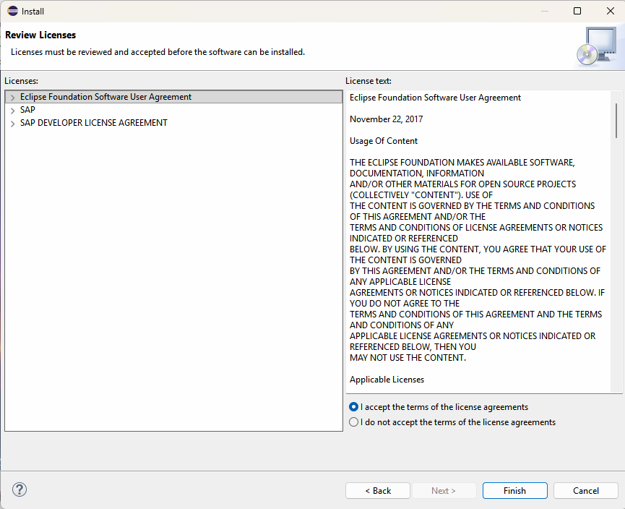
I accept --->finish
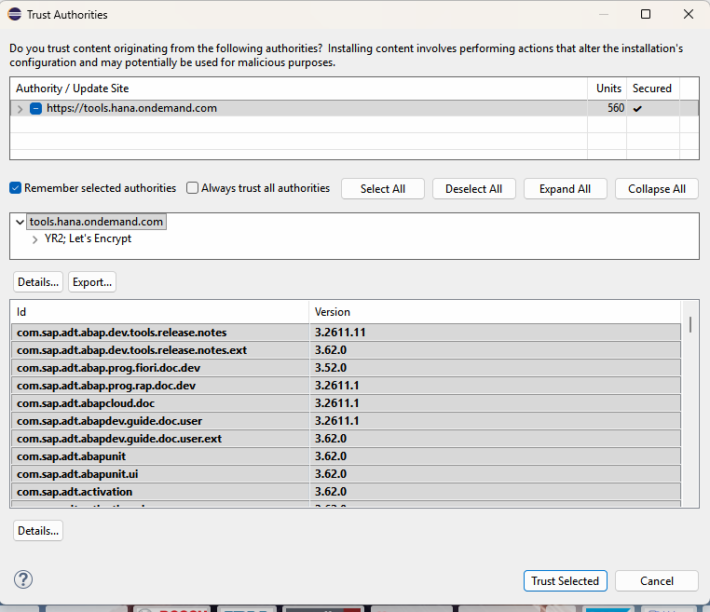
Restart Eclipse
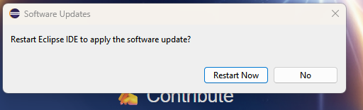
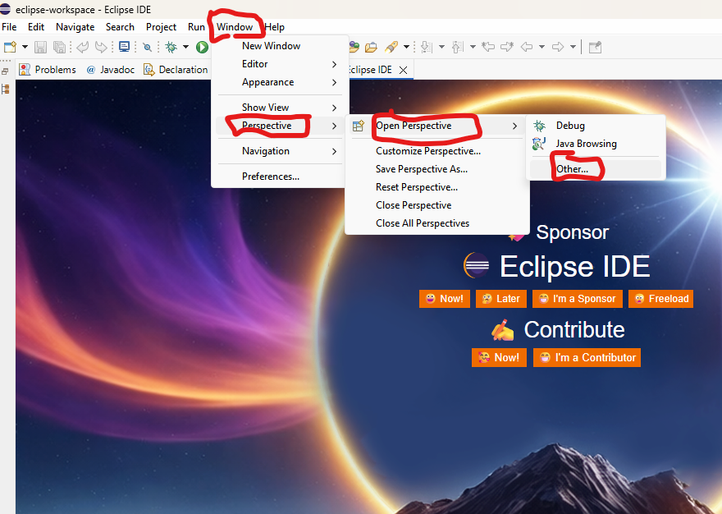
In others perspective you can see ABAP & HANA options
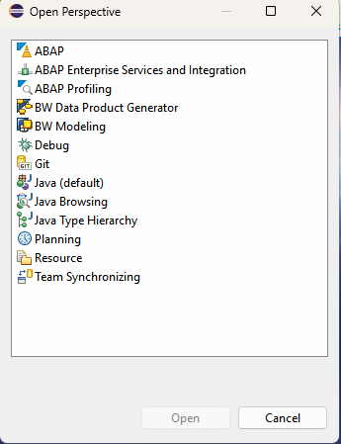
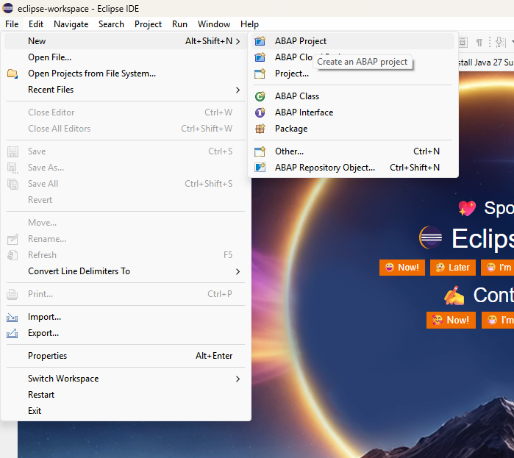
Connection type- Custom Application Server
Application Server- merida.cob.csuchico.edu
https://merida.cob.csuchico.edu:8038/sap/bc/gui/sap/its/webgui/?
Instance No-38
System Name-Merida
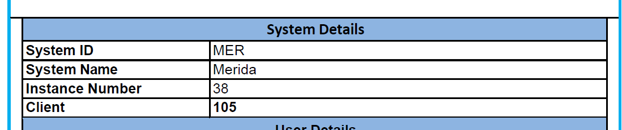
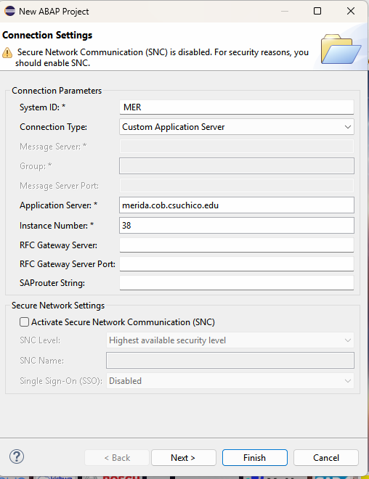

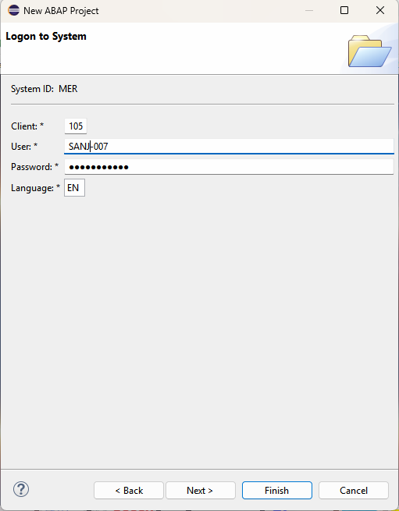

--------------------***----------------------

SE38
YAG27.txt
Click Change

And Paste this code

*&---------------------------------------------------------------------*
*& Report YABAP_AG_007
*& Purpose: Display student records from table YAG007
*&---------------------------------------------------------------------*
*REPORT YABAP_AG_007.

DATA: gt_students TYPE TABLE OF yag007,
gs_student TYPE yag007.

START-OF-SELECTION.

SELECT *
FROM yag007
INTO TABLE @gt_students.

IF sy-subrc = 0.

WRITE: / 'STUDENT INFORMATION SYSTEM'.
ULINE.

LOOP AT gt_students INTO gs_student.

WRITE: / 'Student ID :', gs_student-student_id.
WRITE: / 'Student Name :', gs_student-student_name.
WRITE: / 'Age :', gs_student-age.
WRITE: / 'Course :', gs_student-course.
WRITE: / 'Email :', gs_student-email.
WRITE: / 'Gender :', gs_student-gender.

ULINE.

ENDLOOP.

ELSE.

WRITE: / 'No student records found in table YAG007.'.

ENDIF.

Before paste clear the code ide
Now Check---> Activate--->Execute(F8) [Direct Processing]
OUTPUT
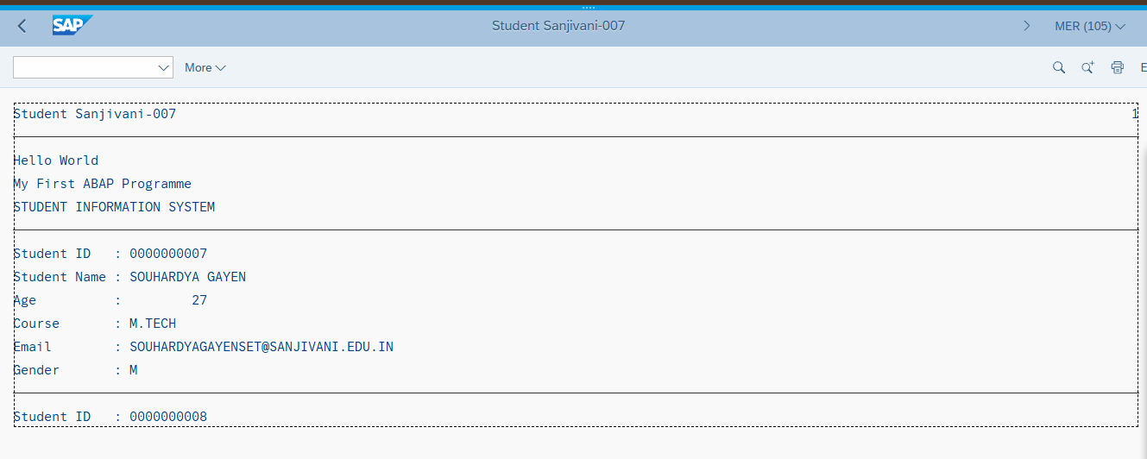

------------------------------------------********------------------------------------------------------

SU01 (Unloack Transaction Code)
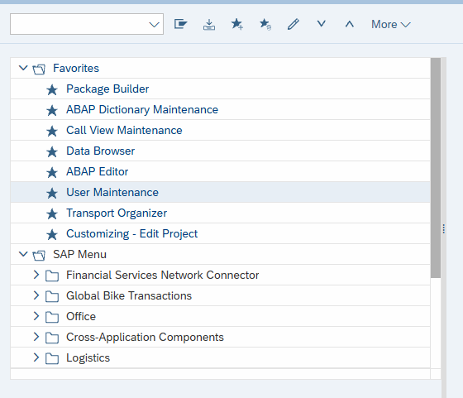

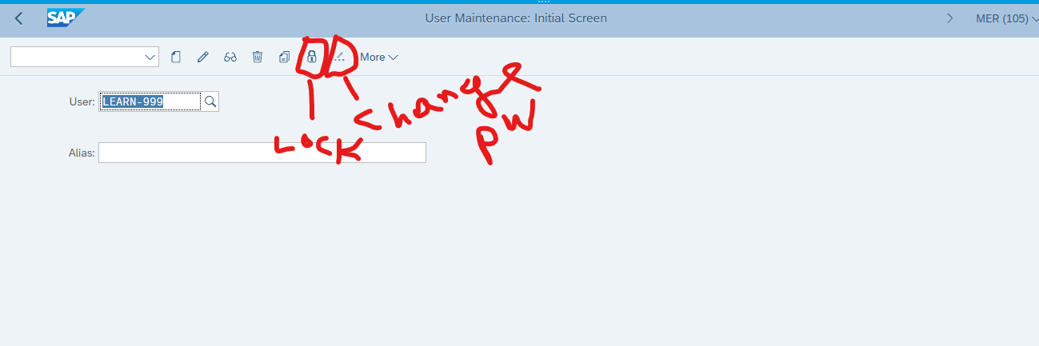

------------------------------------------****----------------------------------------------

SE38
YAG28.txt
Click Change

*&---------------------------------------------------------------------*
*& Report YABAP_AG_007
*& Student Search Application Using Parameters
*& Database Table: YAG007
*&---------------------------------------------------------------------*

REPORT YABAP_AG_28.

PARAMETERS:
p_id TYPE yag007-student_id,
p_name TYPE yag007-student_name,
p_course TYPE yag007-course.

DATA:
gt_students TYPE TABLE OF yag007,
gs_student TYPE yag007.

START-OF-SELECTION.

IF p_id IS INITIAL
AND p_name IS INITIAL
AND p_course IS INITIAL.

SELECT *
FROM yag007
INTO TABLE @gt_students.

ELSE.

SELECT *
FROM yag007
INTO TABLE @gt_students
WHERE student_id = @p_id
OR student_name = @p_name
OR course = @p_course.

ENDIF.

IF gt_students IS NOT INITIAL.

WRITE: / 'STUDENT SEARCH RESULTS'.
ULINE.

WRITE: / 'STUDENT ID',
20 'STUDENT NAME',
40 'AGE',
50 'COURSE',
65 'GENDER'.

ULINE.

LOOP AT gt_students INTO gs_student.

WRITE: / gs_student-student_id,
20 gs_student-student_name,
40 gs_student-age,
50 gs_student-course,
65 gs_student-gender.

ENDLOOP.

ULINE.

WRITE: / 'Total Records:', lines( gt_students ).

ELSE.

WRITE: / 'No matching student records found.'.

ENDIF.

Before paste clear the code ide
Paste this code and click ---->save-->check-->Activate-->Execute(F8) [Direct Processing]
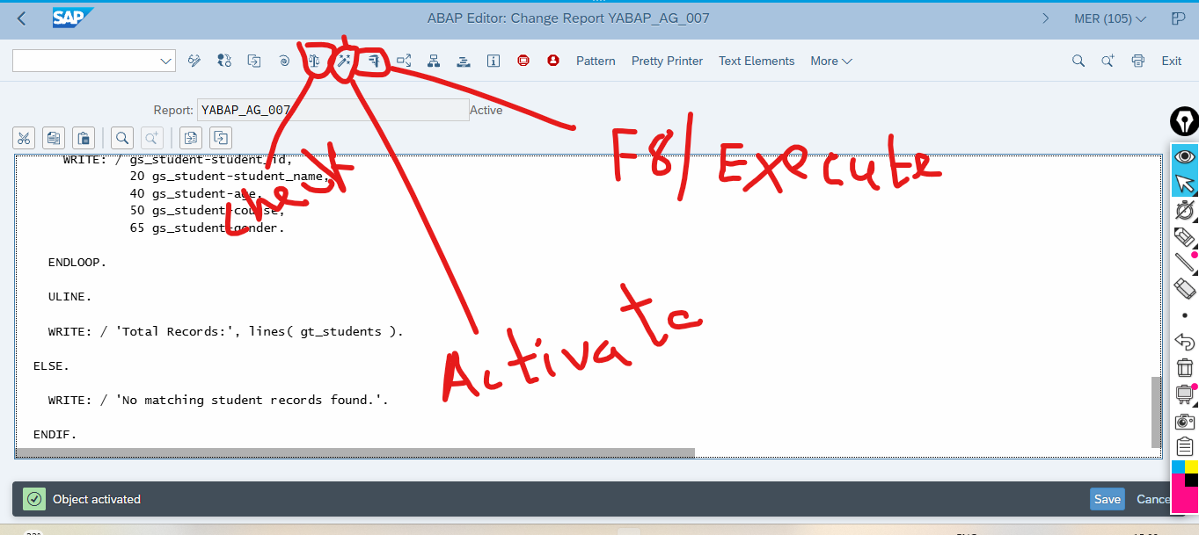

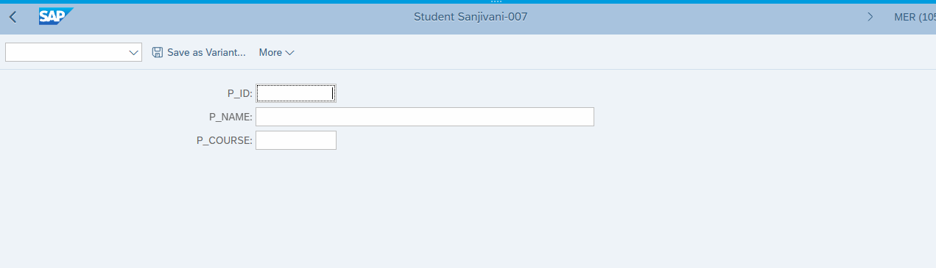
P_ID- 7 or 8 or 9
Then Execute
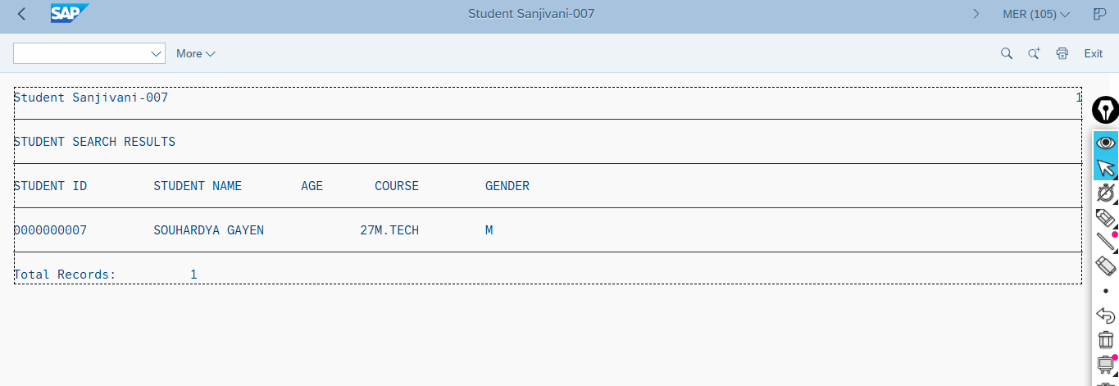

YAG29.txt

*&---------------------------------------------------------------------*
*& Report YABAP_AG_29
*& Student Registration Application
*& Database Table: YAG007
*&---------------------------------------------------------------------*

REPORT YABAP_AG_29.

PARAMETERS:
p_id TYPE yag007-student_id,
p_name TYPE yag007-student_name,
p_age TYPE yag007-age,
p_course TYPE yag007-course,
p_email TYPE yag007-email,
p_gender TYPE yag007-gender.

DATA:
gs_student TYPE yag007.

START-OF-SELECTION.

*---------------------------------------------------------------------*
* STEP 1: VALIDATE MANDATORY FIELDS
*---------------------------------------------------------------------*

IF p_id IS INITIAL
OR p_name IS INITIAL
OR p_age IS INITIAL
OR p_course IS INITIAL.

WRITE: / 'ERROR: ID, Name, Age and Course are mandatory.'.
RETURN.

ENDIF.

*---------------------------------------------------------------------*
* STEP 2: CHECK DUPLICATE STUDENT ID
*---------------------------------------------------------------------*

SELECT SINGLE student_id
FROM yag007
WHERE student_id = @p_id
INTO @DATA(lv_student_id).

IF sy-subrc = 0.

WRITE: / 'ERROR: Student ID already exists.'.
RETURN.

ENDIF.

*---------------------------------------------------------------------*
* STEP 3: PREPARE STUDENT RECORD
*---------------------------------------------------------------------*

gs_student-student_id = p_id.
gs_student-student_name = p_name.
gs_student-age = p_age.
gs_student-course = p_course.
gs_student-email = p_email.
gs_student-gender = p_gender.

*---------------------------------------------------------------------*
* STEP 4: INSERT STUDENT INTO DATABASE
*---------------------------------------------------------------------*

INSERT yag007 FROM @gs_student.

IF sy-subrc = 0.

COMMIT WORK AND WAIT.

WRITE: / 'STUDENT REGISTERED SUCCESSFULLY'.
ULINE.

WRITE: / 'Student ID :', gs_student-student_id.
WRITE: / 'Student Name :', gs_student-student_name.
WRITE: / 'Age :', gs_student-age.
WRITE: / 'Course :', gs_student-course.
WRITE: / 'Email :', gs_student-email.
WRITE: / 'Gender :', gs_student-gender.

ELSE.

ROLLBACK WORK.

WRITE: / 'ERROR: Student registration failed.'.

ENDIF.

Before paste clear the code ide
Check-->Activate-->Execute
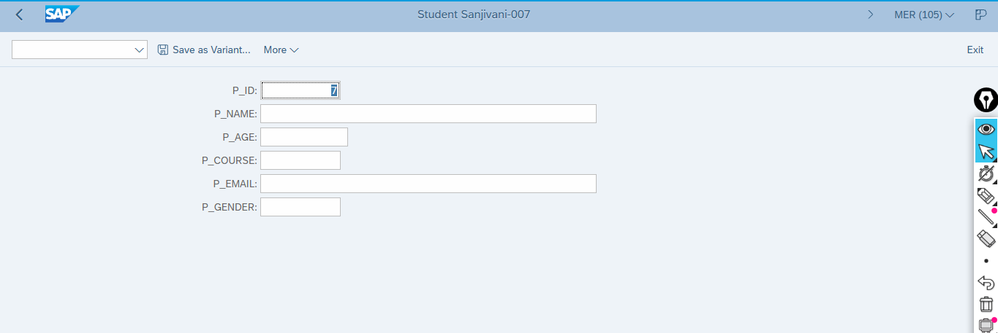
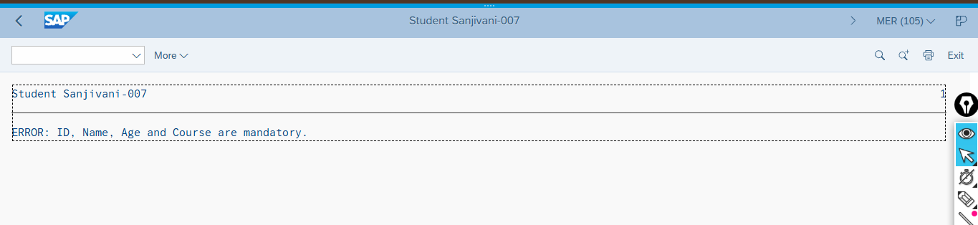

Field | Sample value
P_ID | 1000000001
P_NAME | RAHUL
P_AGE | 20
P_COURSE | BTECH
P_EMAIL | rahul@example.com
P_GENDER | M

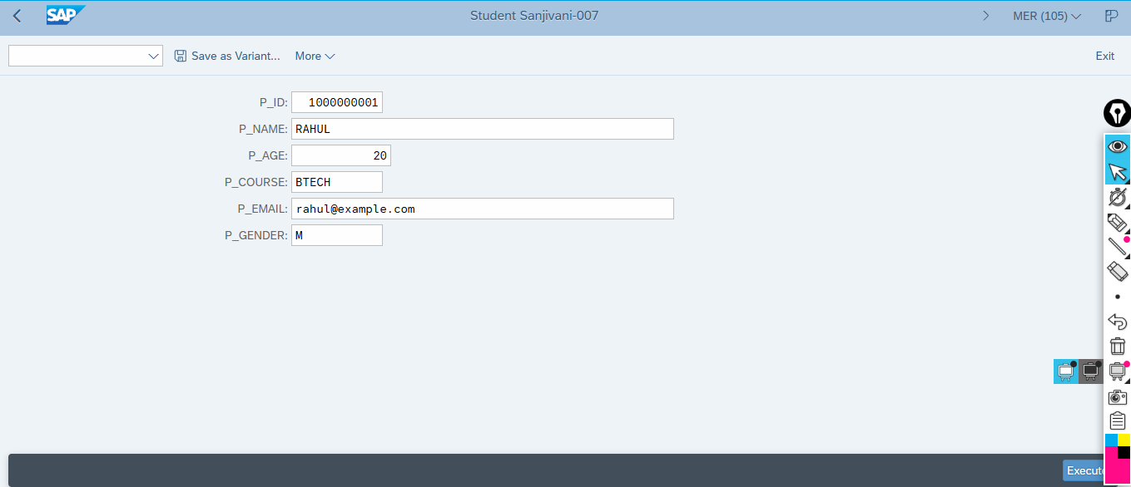
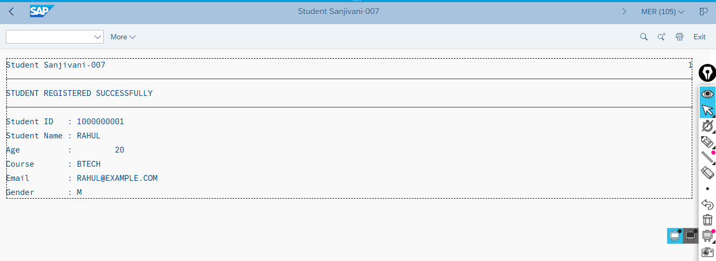
I have done reverse Entry

CRUDE Operation in SAP

YAG30.txt

*&---------------------------------------------------------------------*
*& Report YABAP_AG_30
*& Student Information System - ALV Display
*& Database Table: YAG007
*&---------------------------------------------------------------------*

REPORT YABAP_AG_30.

*---------------------------------------------------------------------*
* INTERNAL TABLE
*---------------------------------------------------------------------*

TABLES yag007.

DATA: gt_students TYPE STANDARD TABLE OF yag007,
gs_student TYPE yag007.

*---------------------------------------------------------------------*
* SELECTION SCREEN
*---------------------------------------------------------------------*

SELECT-OPTIONS:
s_id FOR yag007-student_id,
s_name FOR yag007-student_name,
s_course FOR yag007-course.

*---------------------------------------------------------------------*
* MAIN PROCESSING
*---------------------------------------------------------------------*

START-OF-SELECTION.

SELECT *
FROM yag007
INTO TABLE @gt_students
WHERE student_id IN @s_id
AND student_name IN @s_name
AND course IN @s_course.

IF gt_students IS INITIAL.

MESSAGE 'No student records found' TYPE 'I'.

ELSE.

*---------------------------------------------------------------------*
* DISPLAY ALV
*---------------------------------------------------------------------*

TRY.

cl_salv_table=>factory(
IMPORTING
r_salv_table = DATA(go_alv)
CHANGING
t_table = gt_students
).

go_alv->get_functions( )->set_all( abap_true ).

go_alv->get_columns( )->set_optimize( abap_true ).

go_alv->display( ).

CATCH cx_salv_msg INTO DATA(gx_error).

MESSAGE gx_error->get_text( ) TYPE 'I'.

ENDTRY.

ENDIF.

Before paste clear the code panel
Then Check--->Activate--->Execute(F8)
And Give Range 7-10
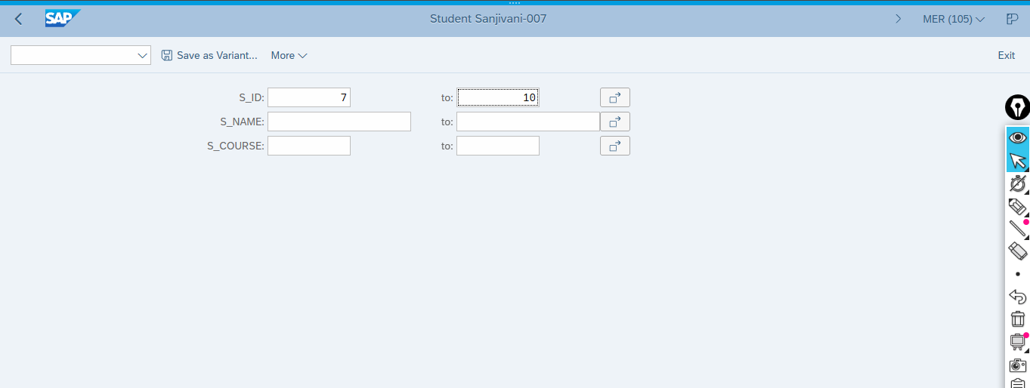

OUTPUT:
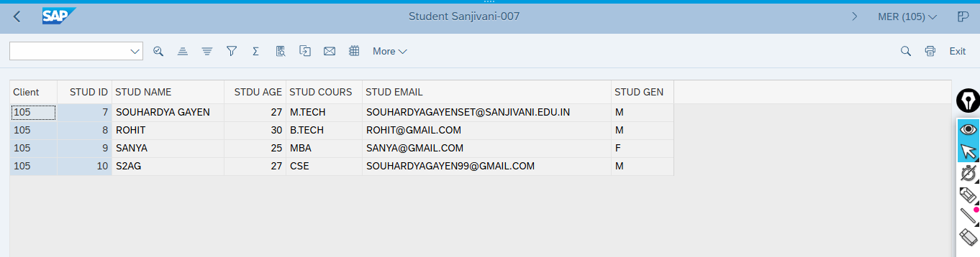

SE93
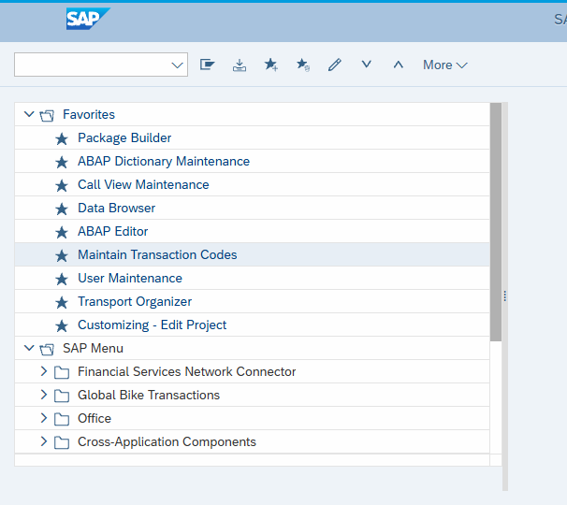
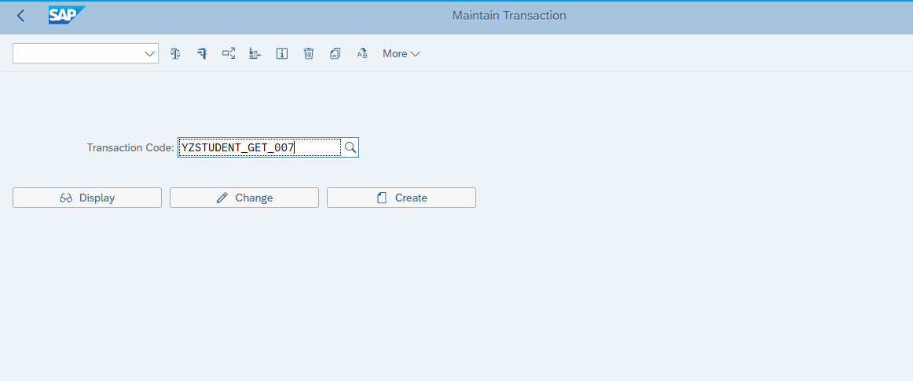
Create
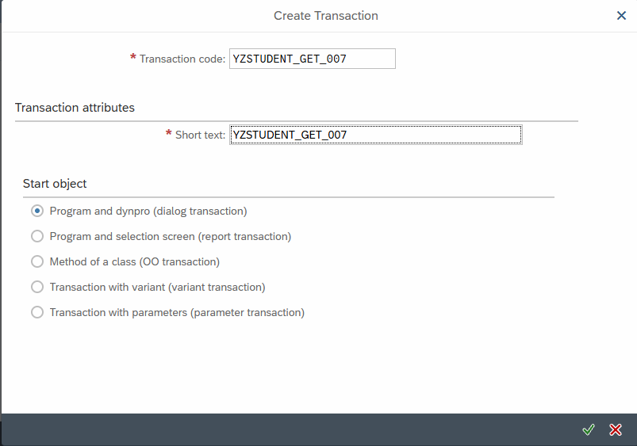

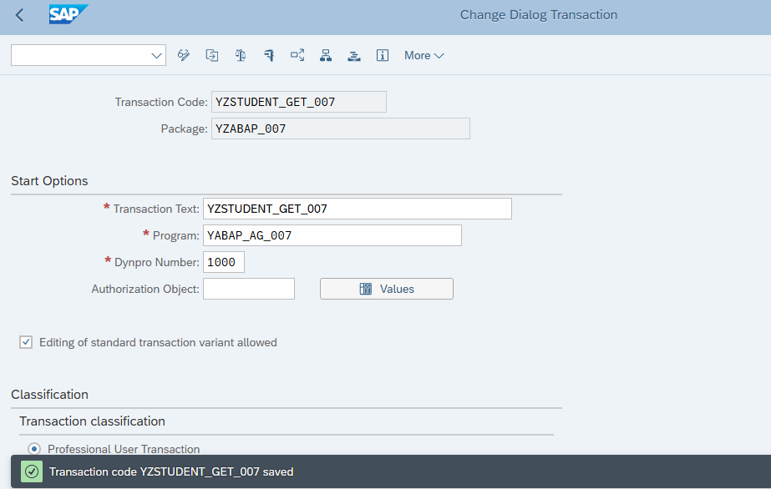
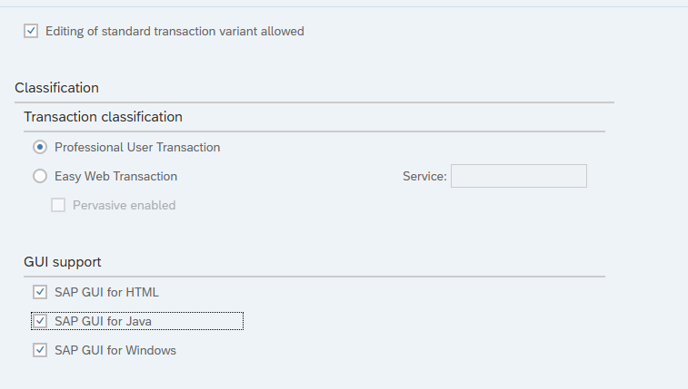
Click Save
Transaction code YZSTUDENT_GET_007 saved

------------------------------------------------------*****-----------------------------------------------------
ST22 (Transaction Code)
DUMP for Checking there is any Dump value are present or not

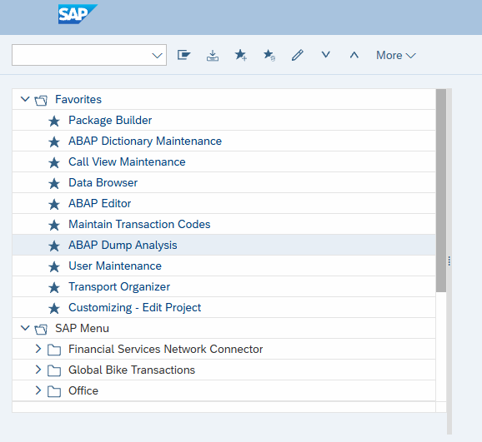
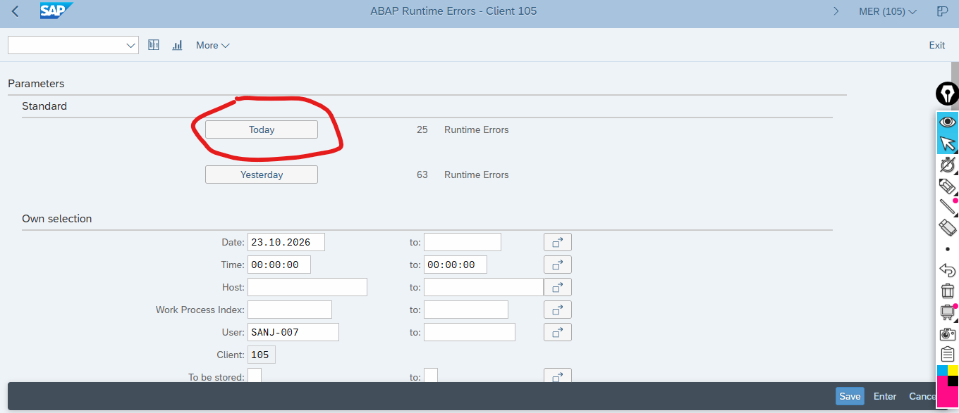
Click Today
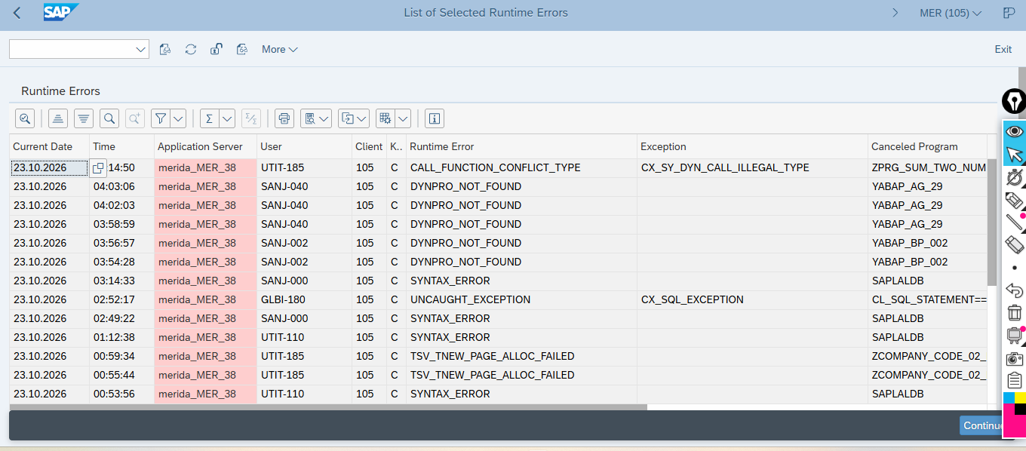
It will give you direction but not give any solution

--------------------------------------******-----------------------------------------------------

SE93
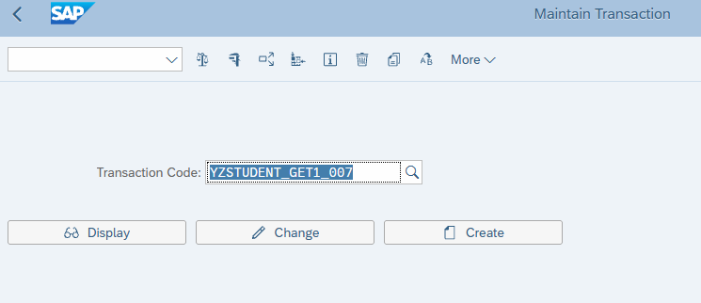
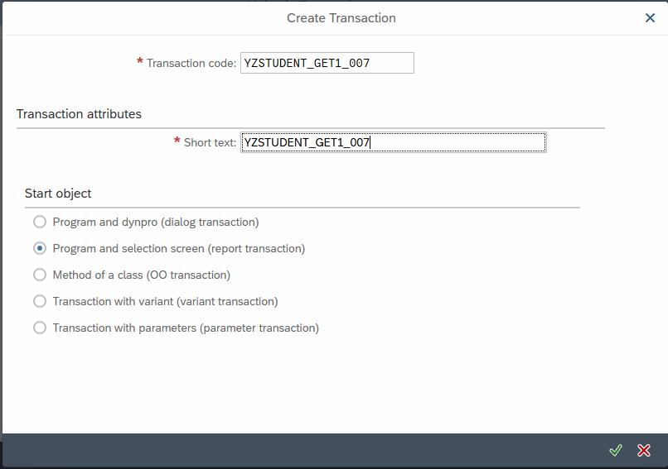
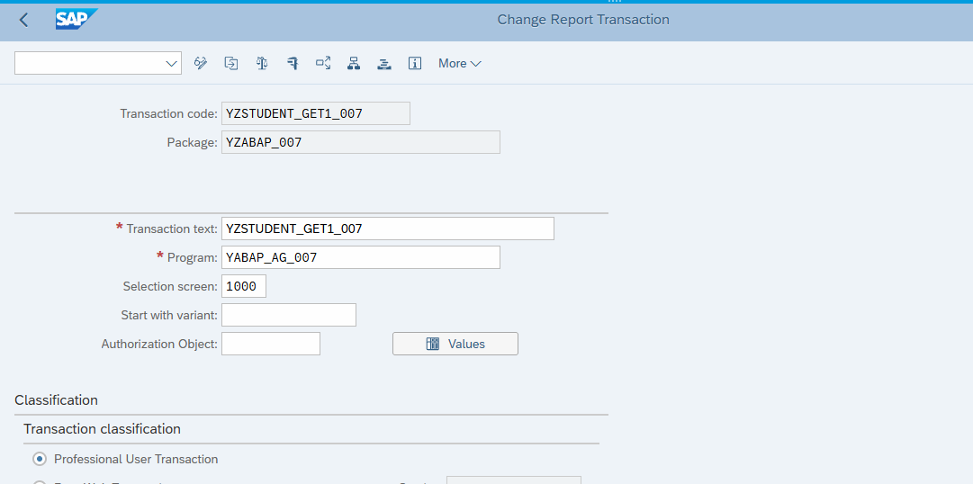

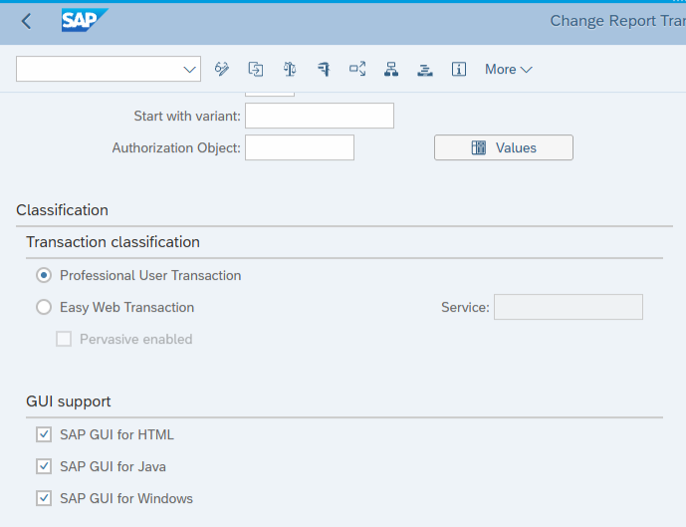
Click Save-->Check--->activate--->Execute(F8)
Transaction code YZSTUDENT_GET1_007 saved
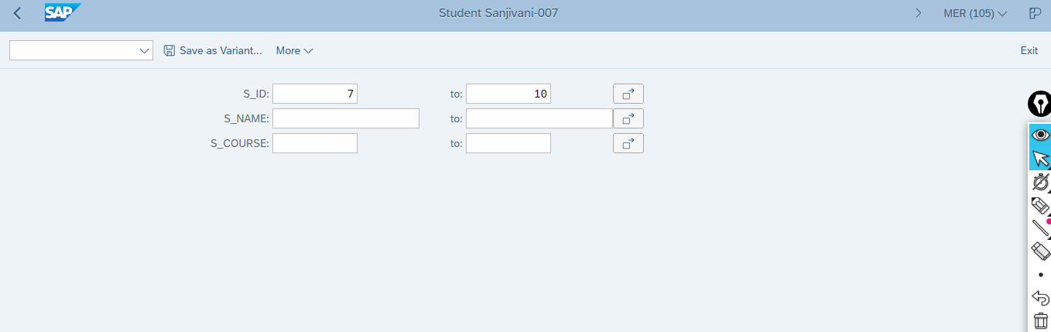
Click Execute
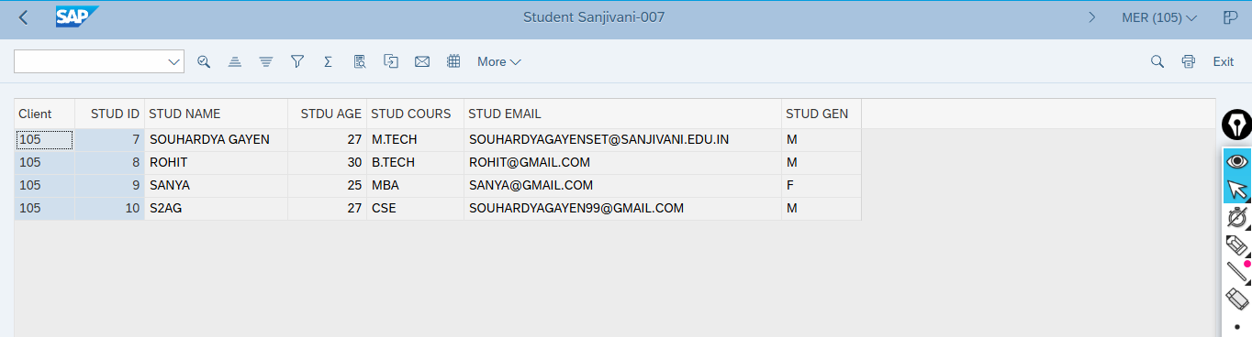

SE80(transaction code)
Workbench
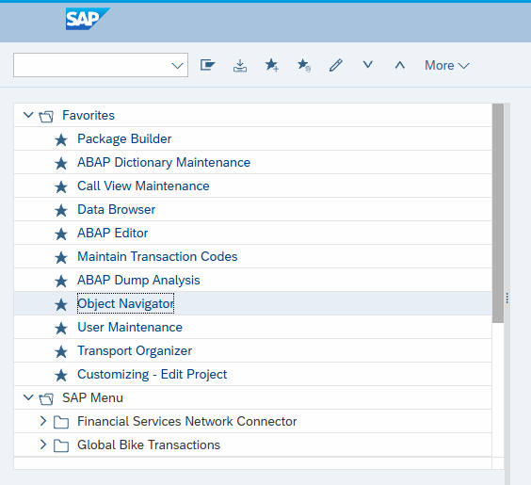
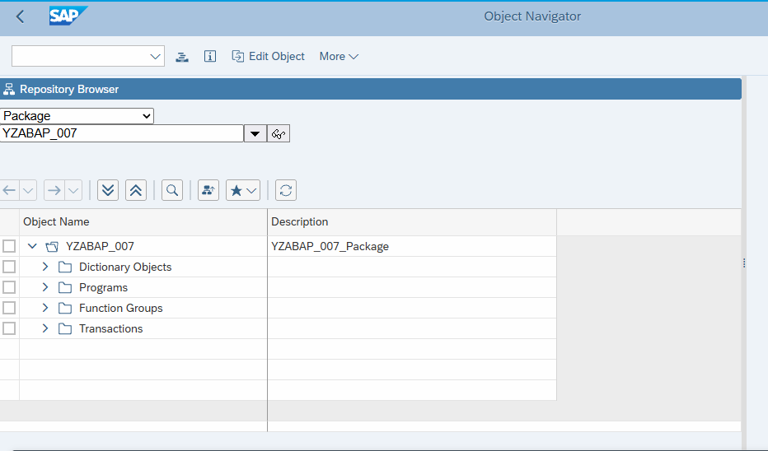

YABA_31 CRUD

*&---------------------------------------------------------------------*
*& Report YABAP_AG_31
*& Purpose: Update Student Records
*& Database Table: YAG007
*&---------------------------------------------------------------------*

REPORT YABAP_AG_31.

* CRUD - Create, Read, Update and Delete

*---------------------------------------------------------------------*
* SELECTION SCREEN
*---------------------------------------------------------------------*

PARAMETERS:
p_id TYPE yag007-student_id OBLIGATORY,
p_name TYPE yag007-student_name OBLIGATORY,
p_age TYPE yag007-age OBLIGATORY,
p_course TYPE yag007-course OBLIGATORY,
p_email TYPE yag007-email,
p_gender TYPE yag007-gender OBLIGATORY.

*---------------------------------------------------------------------*
* DATA DECLARATION
*---------------------------------------------------------------------*

DATA gs_student TYPE yag007.

*---------------------------------------------------------------------*
* MAIN PROCESSING
*---------------------------------------------------------------------*

START-OF-SELECTION.

* Step 1: Find the student

SELECT SINGLE *
FROM yag007
WHERE student_id = @p_id
INTO @gs_student.

IF sy-subrc <> 0.
MESSAGE 'Student ID does not exist' TYPE 'I'.
RETURN.
ENDIF.

* Step 2: Update student details

gs_student-student_name = p_name.
gs_student-age = p_age.
gs_student-course = p_course.
gs_student-email = p_email.
gs_student-gender = p_gender.

* Step 3: Update database record

UPDATE yag007 FROM @gs_student.

IF sy-subrc = 0.

COMMIT WORK AND WAIT.

MESSAGE 'Student record updated successfully' TYPE 'S'.

ELSE.

ROLLBACK WORK.

MESSAGE 'Student record update failed' TYPE 'E'.

ENDIF.

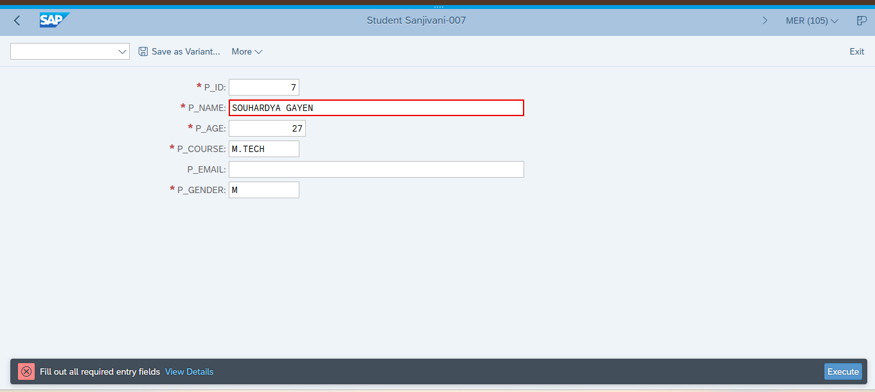
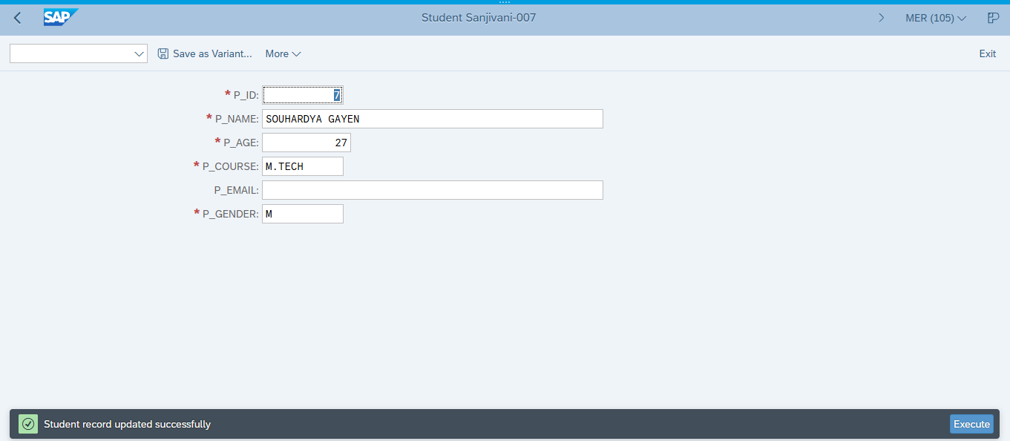

YABAP_AG_32

*&---------------------------------------------------------------------*
*& Report YABAP_AG_32
*& Purpose: Delete Student Records
*& Database Table: YAG007
*&---------------------------------------------------------------------*

REPORT yabap_ag_32.

*---------------------------------------------------------------------*
* SELECTION SCREEN
*---------------------------------------------------------------------*

PARAMETERS:
p_id TYPE yag007-student_id OBLIGATORY.

*---------------------------------------------------------------------*
* DATA DECLARATION
*---------------------------------------------------------------------*

DATA:
gs_student TYPE yag007.

*---------------------------------------------------------------------*
* MAIN PROCESSING
*---------------------------------------------------------------------*

START-OF-SELECTION.

* Step 1: Check whether the student exists

SELECT SINGLE *
FROM yag007
WHERE student_id = @p_id
INTO @gs_student.

IF sy-subrc <> 0.
MESSAGE 'Student ID does not exist' TYPE 'I'.
RETURN.
ENDIF.

* Step 2: Delete the student record

DELETE FROM yag007
WHERE student_id = @p_id.

* Step 3: Check the deletion result

IF sy-subrc = 0.

COMMIT WORK AND WAIT.

MESSAGE 'Student record deleted successfully' TYPE 'S'.

ELSE.

ROLLBACK WORK.

MESSAGE 'Student record deletion failed' TYPE 'E'.

ENDIF.

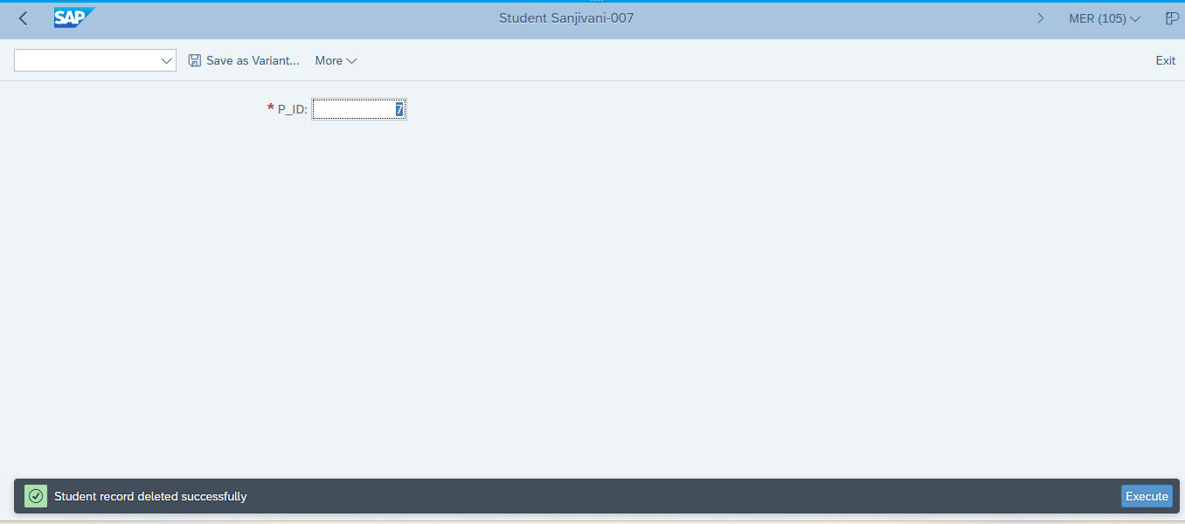

YABAP_AG_33

*&---------------------------------------------------------------------*
*& Report YABAP_AG_33
*& Purpose: Student Input Validation and Registration
*& Database Table: YAG007
*&---------------------------------------------------------------------*

REPORT yabap_ag_33.

*---------------------------------------------------------------------*
* SELECTION SCREEN
*---------------------------------------------------------------------*

PARAMETERS:
p_id TYPE yag007-student_id OBLIGATORY,
p_name TYPE yag007-student_name OBLIGATORY,
p_age TYPE yag007-age OBLIGATORY,
p_course TYPE yag007-course OBLIGATORY,
p_email TYPE yag007-email,
p_gender TYPE yag007-gender OBLIGATORY.

*---------------------------------------------------------------------*
* DATA DECLARATION
*---------------------------------------------------------------------*

DATA:
gs_student TYPE yag007,
gv_existing_id TYPE yag007-student_id.

*---------------------------------------------------------------------*
* MAIN PROCESSING
*---------------------------------------------------------------------*

START-OF-SELECTION.

* Step 1: Validate Student ID

IF p_id IS INITIAL.
MESSAGE 'Student ID cannot be blank' TYPE 'E'.
ENDIF.

* Step 2: Validate Student Name

IF p_name IS INITIAL.
MESSAGE 'Student name cannot be blank' TYPE 'E'.
ENDIF.

* Step 3: Validate Age

IF p_age <= 0 OR p_age > 100.
MESSAGE 'Age must be between 1 and 100' TYPE 'E'.
ENDIF.

* Step 4: Validate Course

IF p_course IS INITIAL.
MESSAGE 'Course cannot be blank' TYPE 'E'.
ENDIF.

* Step 5: Validate Gender

TRANSLATE p_gender TO UPPER CASE.

IF p_gender <> 'M' AND p_gender <> 'F'.
MESSAGE 'Gender must be M or F' TYPE 'E'.
ENDIF.

* Step 6: Check for Duplicate Student ID

SELECT SINGLE student_id
FROM yag007
WHERE student_id = @p_id
INTO @gv_existing_id.

IF sy-subrc = 0.
MESSAGE 'Student ID already exists' TYPE 'E'.
ENDIF.

* Step 7: Prepare Student Record

CLEAR gs_student.

gs_student-student_id = p_id.
gs_student-student_name = p_name.
gs_student-age = p_age.
gs_student-course = p_course.
gs_student-email = p_email.
gs_student-gender = p_gender.

* Step 8: Insert Student Record

INSERT yag007 FROM @gs_student.

IF sy-subrc = 0.

COMMIT WORK AND WAIT.

MESSAGE 'Student registered successfully' TYPE 'S'.

ELSE.

ROLLBACK WORK.

MESSAGE 'Student registration failed' TYPE 'E'.

ENDIF.

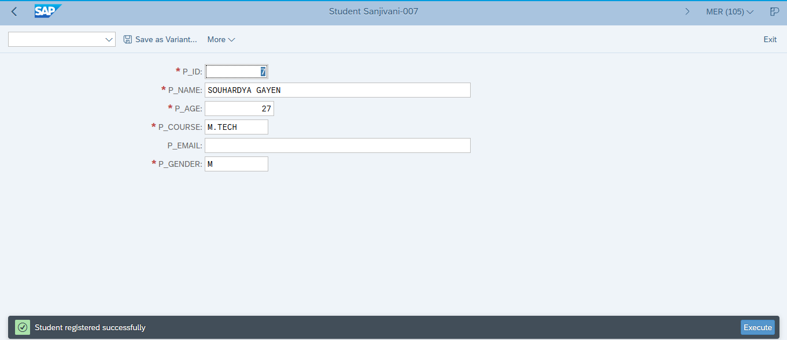

YABAP_AG_34

*&---------------------------------------------------------------------*
*& Report YABAP_AG_34
*& Purpose: Internal Tables and Loops
*& Database Table: YAG007
*&---------------------------------------------------------------------*

REPORT yabap_ag_34.

*---------------------------------------------------------------------*
* DATA DECLARATION
*---------------------------------------------------------------------*

TYPES: BEGIN OF ty_student,
student_id TYPE yag007-student_id,
student_name TYPE yag007-student_name,
age TYPE yag007-age,
course TYPE yag007-course,
gender TYPE yag007-gender,
END OF ty_student.

DATA:
gt_students TYPE STANDARD TABLE OF ty_student,
gs_student TYPE ty_student,
gv_count TYPE i.

*---------------------------------------------------------------------*
* MAIN PROCESSING
*---------------------------------------------------------------------*

START-OF-SELECTION.

* Step 1: Retrieve students from database

SELECT student_id,
student_name,
age,
course,
gender
FROM yag007
INTO TABLE @gt_students.

* Step 2: Check whether records exist

IF gt_students IS INITIAL.
WRITE: / 'No student records found'.
RETURN.
ENDIF.

* Step 3: Count the records

DESCRIBE TABLE gt_students LINES gv_count.

WRITE: / '============================================'.
WRITE: / ' STUDENT INFORMATION SYSTEM'.
WRITE: / '============================================'.
WRITE: / 'Total Students:', gv_count.
SKIP.

* Step 4: Display column headings

WRITE: / 'ID',
15 'STUDENT NAME',
40 'AGE',
48 'COURSE',
62 'GENDER'.

ULINE.

* Step 5: Loop through internal table

LOOP AT gt_students INTO gs_student.

WRITE: / gs_student-student_id,
15 gs_student-student_name,
40 gs_student-age,
48 gs_student-course,
62 gs_student-gender.

ENDLOOP.

SKIP.
WRITE: / '============================================'.
WRITE: / 'Student report completed successfully'.
WRITE: / '============================================'.

Check-->Activate-->Execute(F8)
OUTPUT

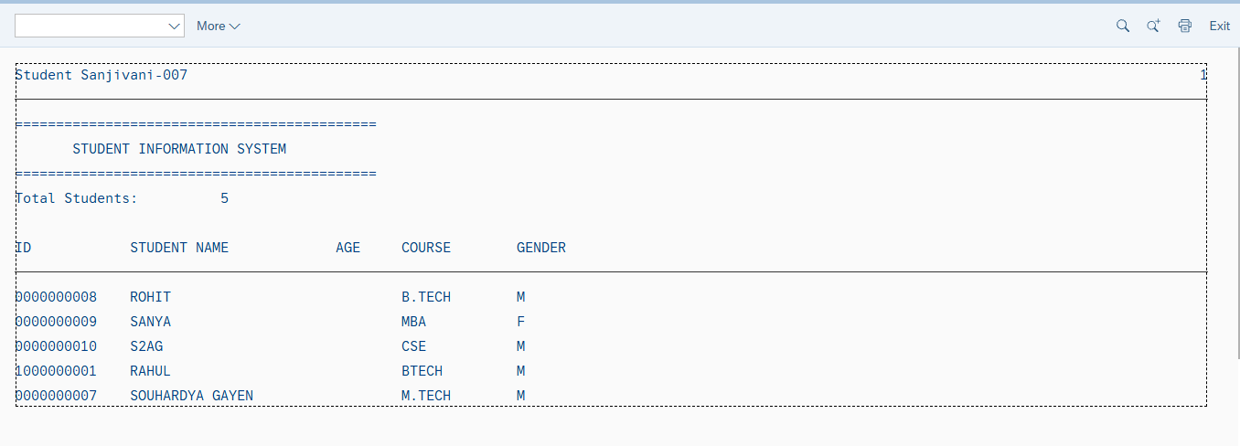

Interview Question
SCC1 TransactionCode Used for release of transaction code from client
Sanbox is mainthings here we are doing all backend works…..
When clients wants sandbox access, (SAP gives only development team access) SAP usally don’t give that access because here backend team is doing hit and trail method

Functional Team ---> Teachnical Team (Development Team) ---> Sandbox (Admin SAP) you can war room (cl1/cl2/cl3/cl4….)

WE02
BD87 to trigger the idox to the further thing

SMARTSTYLES
It is used for UI Maintainance
SMARTFORMS
Most of the revenew is coming here 60% SAP developer’s are working here…..

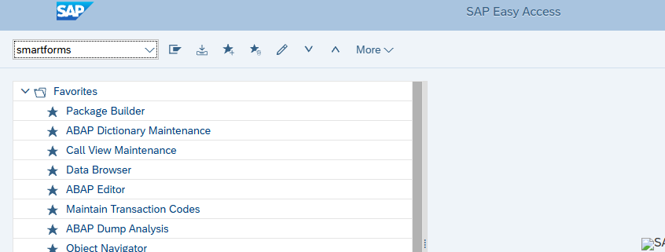
Type here
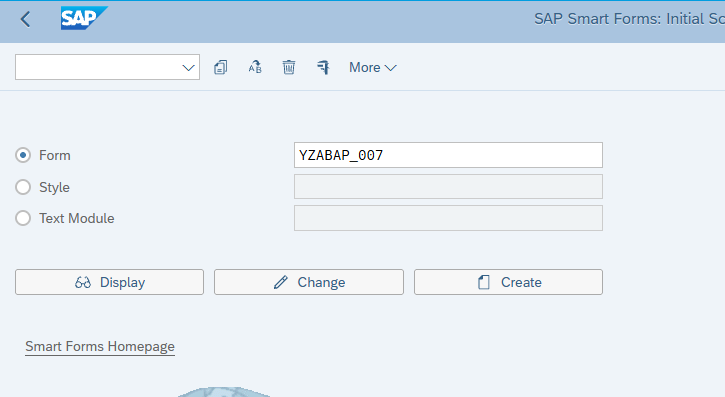
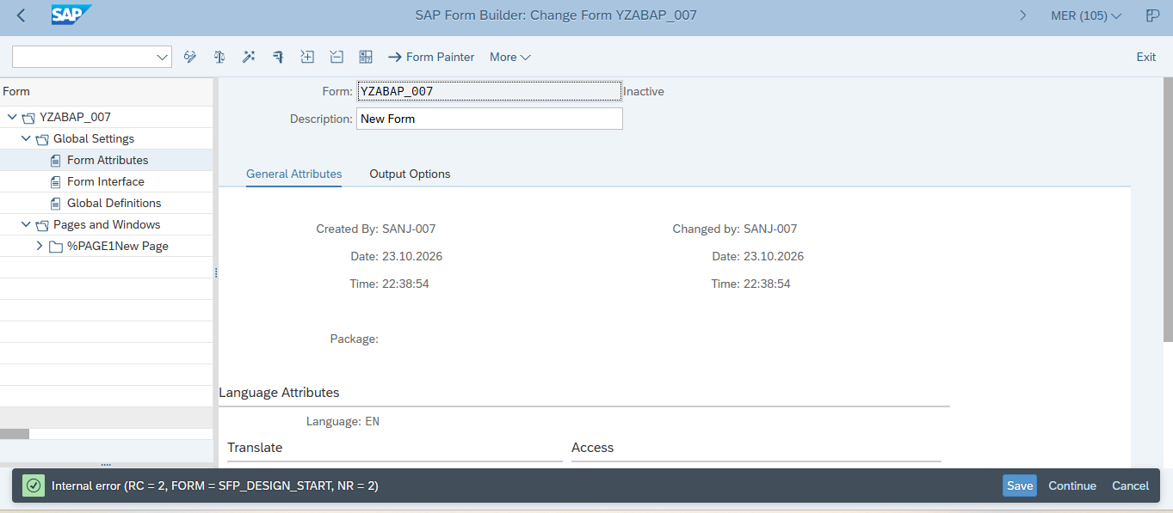
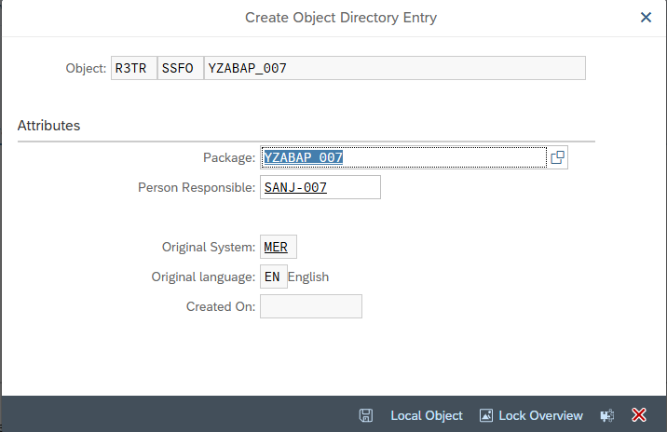
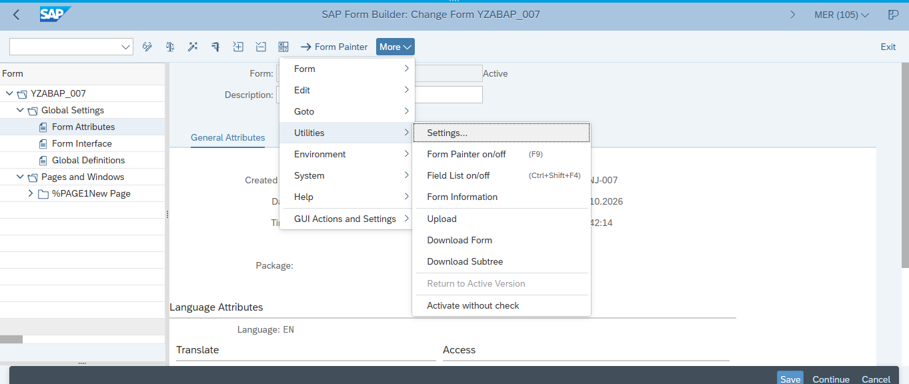
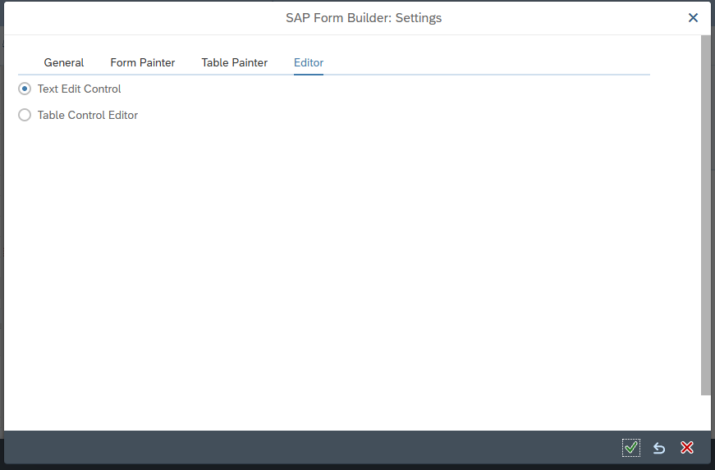

SPRO
If you have SPRO Access Then you are the real SAP Consultant
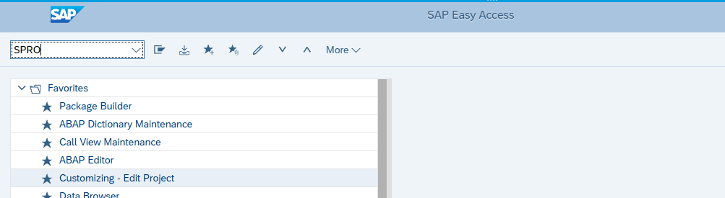

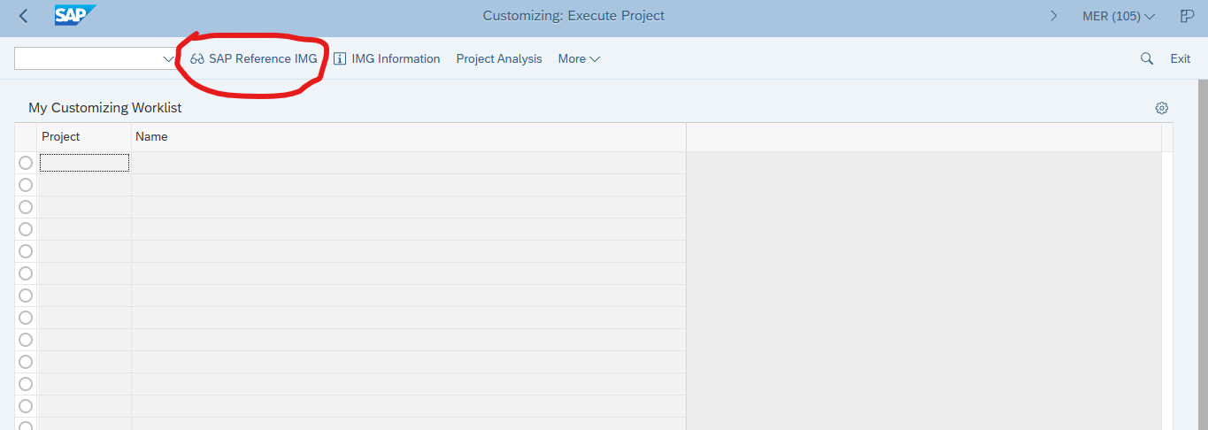
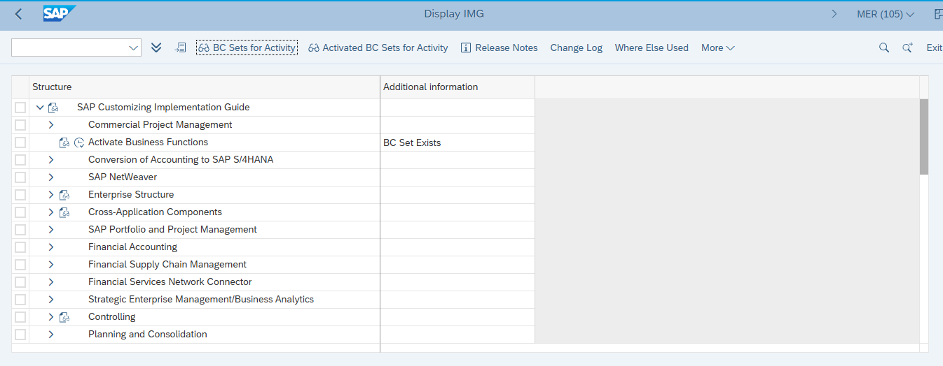

SE16 Transaction Code is Used to see All Table data
It is actually Master Table Data
MARA Transaction Code is Material data Management

YAGFM
SE80
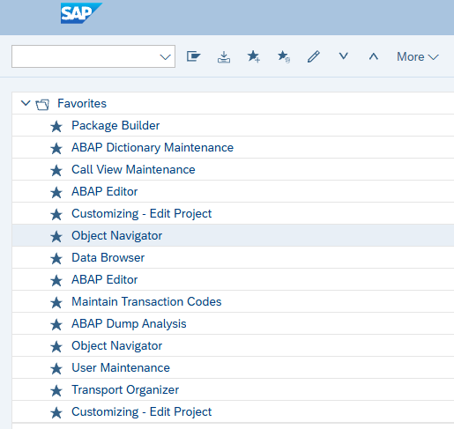
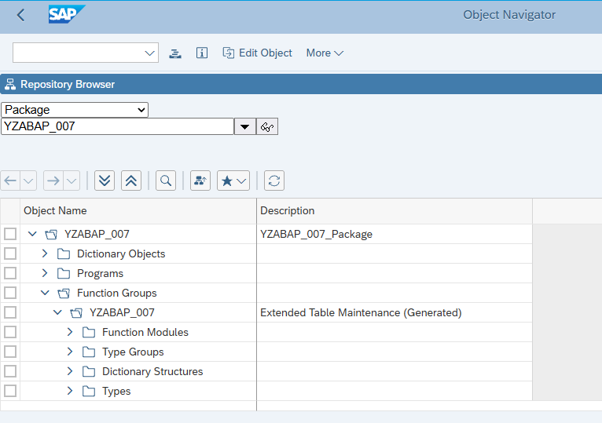
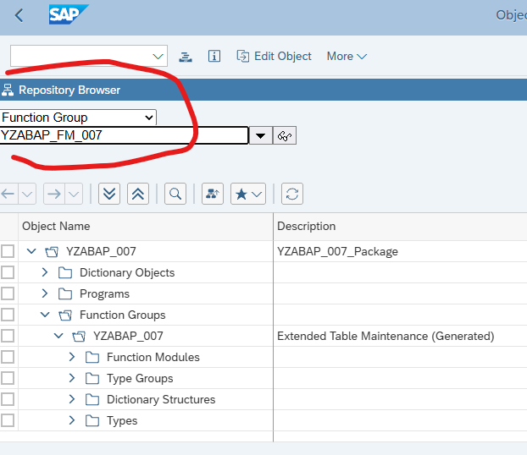
Press---> Enter
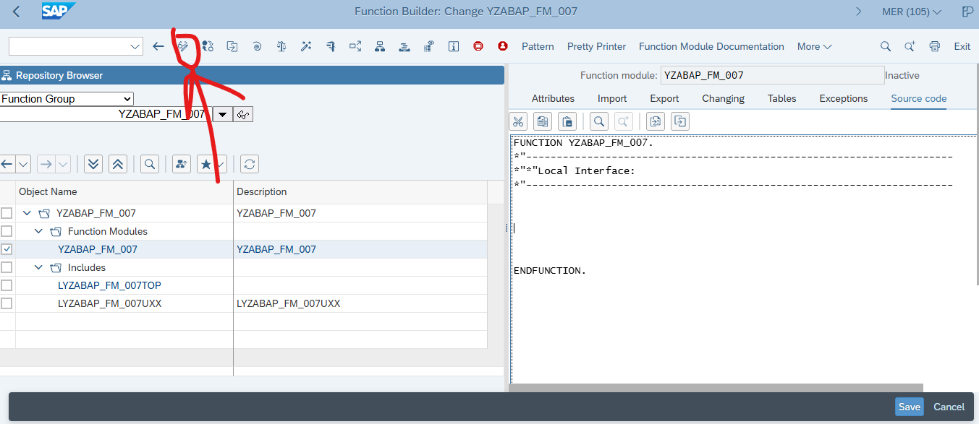

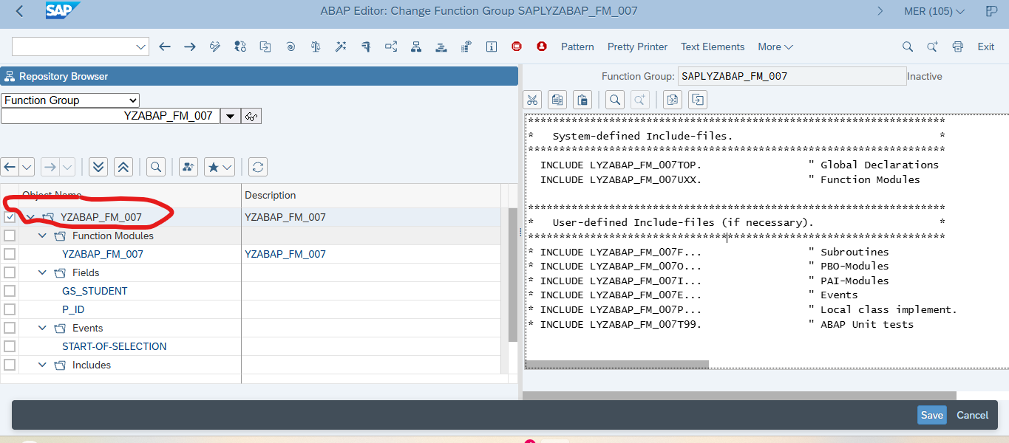

Paste code here

*&---------------------------------------------------------------------*
*& Report YABAP_AG_41
*& Purpose: Retrieve Student Using Function Module
*& Database Table: YAG007
*&---------------------------------------------------------------------*

REPORT yabap_ag_007.

PARAMETERS p_id TYPE yag007-student_id OBLIGATORY.

DATA gs_student TYPE yag007.

START-OF-SELECTION.

CALL FUNCTION 'YAG_GET_STUDENT'
EXPORTING
iv_student_id = p_id
IMPORTING
es_student = gs_student
EXCEPTIONS
student_not_found = 1
OTHERS = 2.

CASE sy-subrc.

WHEN 0.

WRITE: / 'STUDENT DETAILS'.
ULINE.

WRITE: / 'Student ID :', gs_student-student_id.
WRITE: / 'Student Name :', gs_student-student_name.
WRITE: / 'Age :', gs_student-age.
WRITE: / 'Course :', gs_student-course.
WRITE: / 'Gender :', gs_student-gender.

WHEN 1.

MESSAGE 'Student ID does not exist' TYPE 'I'.

WHEN OTHERS.

MESSAGE 'Error retrieving student details' TYPE 'I'.

ENDCASE.

SAVE Enhance---> Check---> Activate

That I can call anyhere anytime like global veriable define

SE37
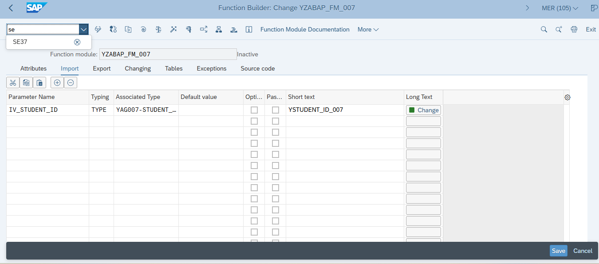
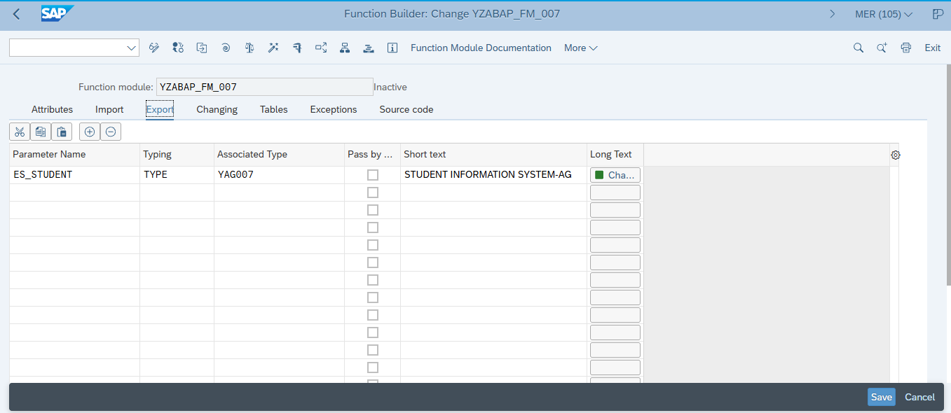
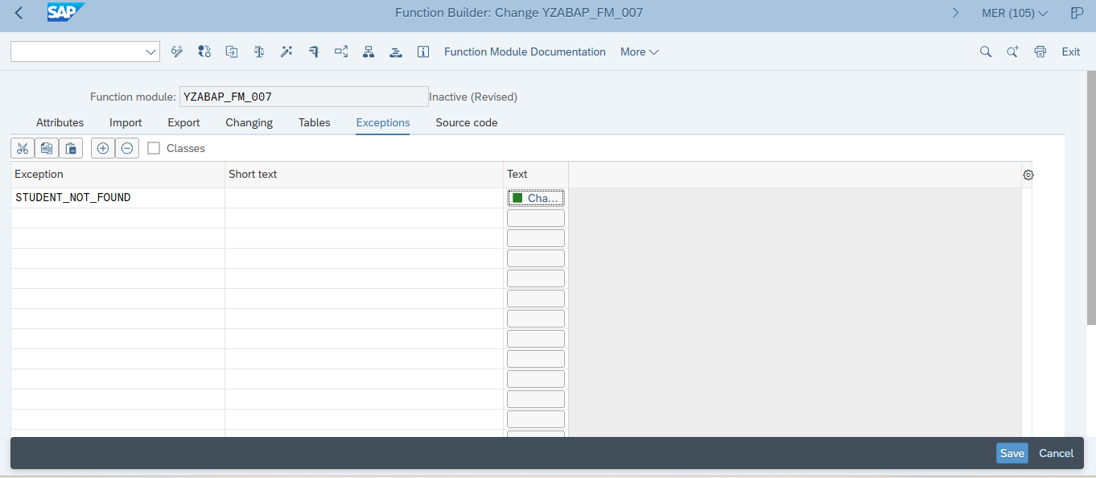
Click Source code
And then paste it …

FUNCTION yzabap_fm_007.

CLEAR es_student.

SELECT SINGLE *
FROM yag007
WHERE student_id = @iv_student_id
INTO @es_student.

IF sy-subrc <> 0.
RAISE student_not_found.
ENDIF.

ENDFUNCTION.

Then Click Activate
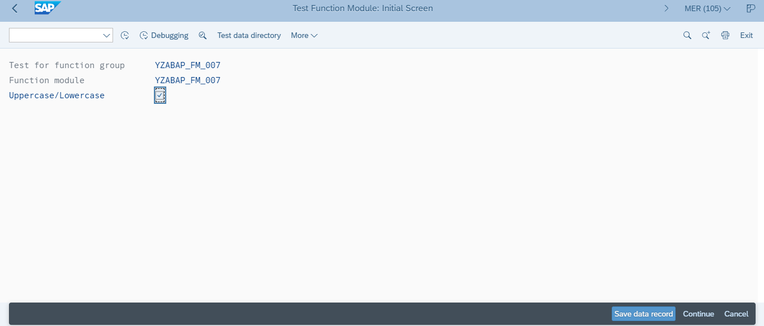

New Homework for practice:

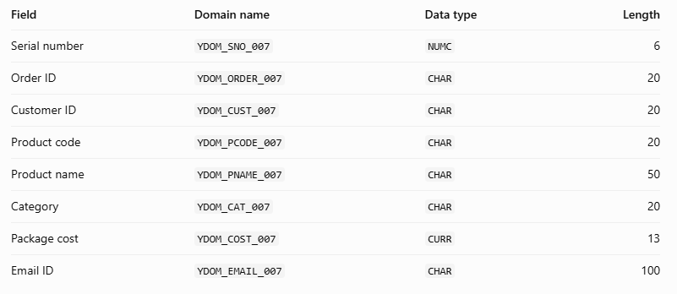

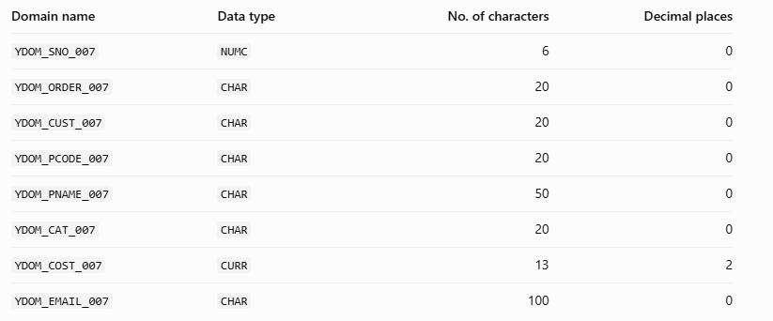

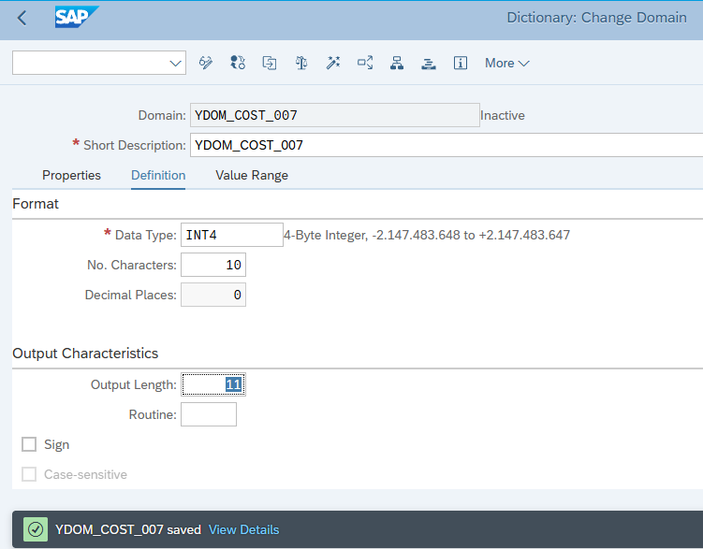
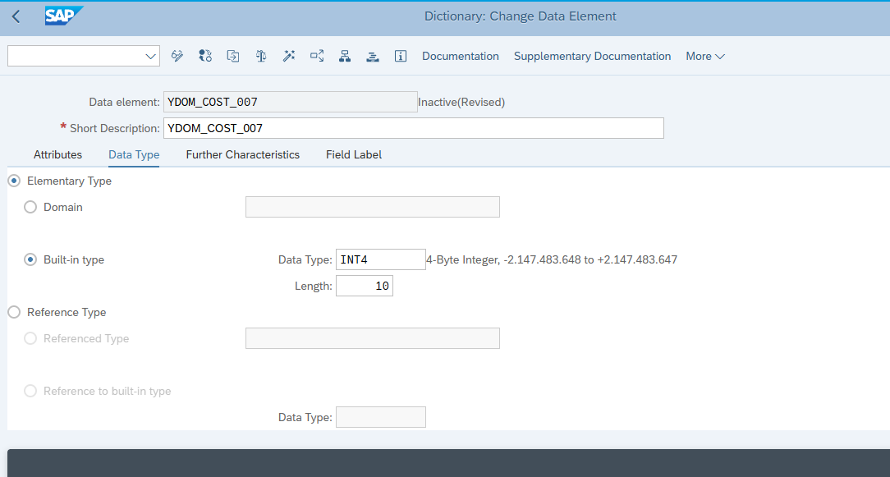

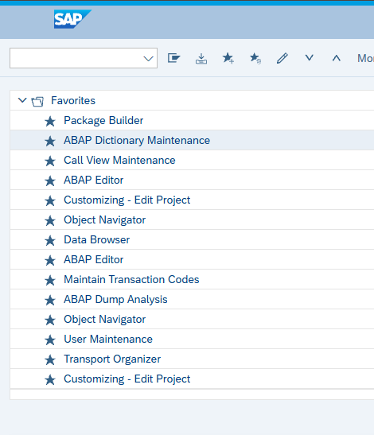
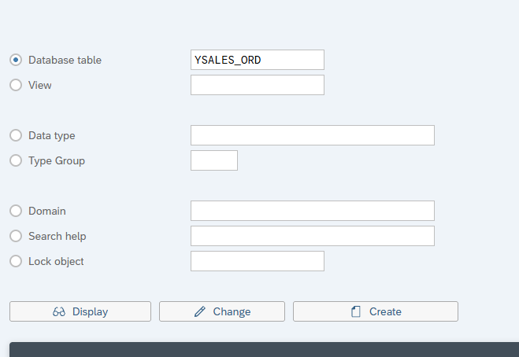

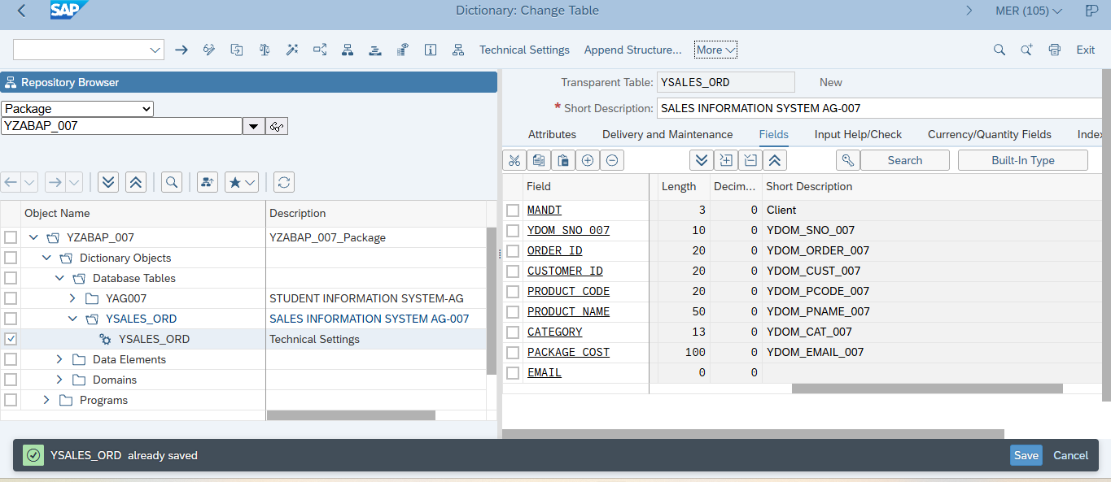

Save-->activate-->then
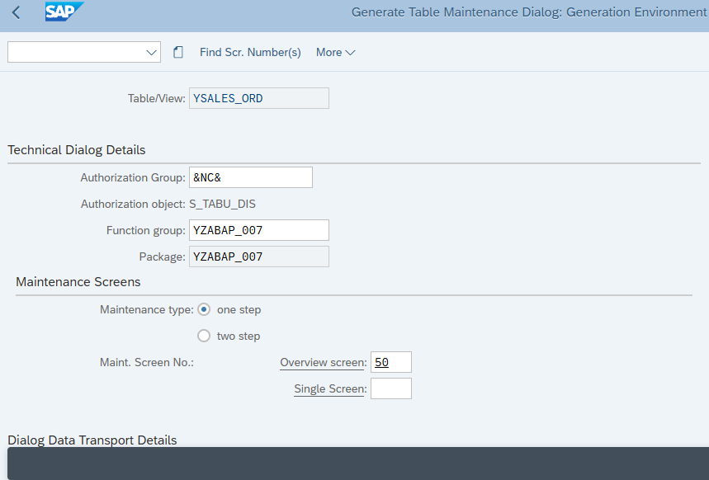

****MOST IMP***

SAP ABAP (Teach Login ID)
Link- https://merida.cob.csuchico.edu:8038/sap/bc/gui/sap/its/webgui/#
Client ID-105
System- MER
User ID-SUKG-000
Pw-**************




