Sep 2025

Business Report: Application of Inferential Statistics for Data-Driven Business Decisions

- Name |  | - Souhrid Dey
- Program |  | - Post Graduate Program in Data Science
- Project Year |  | - 2025
- Module |  | - Inferential Statistics

Table of Contents
Executive Summary 2
Introduction 4
Project Overview 4
Methodology and Approach 4
Data and Data Dictionary 5
Problem 1 — Football injuries (contingency counts): 5
Problem 2 — Gunny bag strength: 6
Problem 3 — Stone hardness: 6
Problem 4 — Dental implants: 8
Data dictionary (concise table): 9
Methodological Framework: Solving the Data Science Problem 10
Data Description 10
General Principles 10
Core Concepts of Inferential Statistics 10
Hypothesis Testing 11
Analysis of Variance (ANOVA): 12
Libraries and Environment 16
Problem Statements 17
Problem 1: Risk Analysis of Football Player Injuries – Quantifying Probabilities 17
Business Context 17
Data Synopsis 17
Probabilistic Risk Assessment 17
Business Implications & Recommendations 19
Recommendations: 19
Visualizations: 19
Problem 2: Quality Assurance for Cement Packaging – Normal Distribution Analysis 21
Business Context 21
Analysis of Gunny Bag Breaking Strength 21
Business Implications & Recommendations 29
Recommendations: 29
Visualizations: 29
Problem 3: Material Suitability Analysis for Zingaro Stone Printing – Hypothesis Testing for Hardness 32
Business Context 32
Hypothesis Testing and Statistical Findings 32
Business Implications & Recommendations 39
Problem 4: Optimizing Dental Implant Hardness – ANOVA for Multiple Factors 40
Business Context 40
Data Overview 40
Comprehensive Analysis for Alloy 1 41
Comprehensive Analysis for Alloy 2 51
Synthesis and Strategic Recommendations 58
Conclusion 61
Actionable Recommendations Summary: 61
Limitations and Future Work: 61
Appendix 62
List of Tables 62
List of Figures 63
Reference ipynb notebook 64

Executive Summary
This report presents a comprehensive statistical analysis of four distinct business problems, demonstrating the application of inferential statistics to derive actionable insights. The core objective is to translate raw data into strategic guidance for stakeholders in sports management, manufacturing, and healthcare. This section provides a brief, non-technical summary of key results and business implications.

Key findings include:
- Football Injuries: A probabilistic analysis revealed a 61.7% (29/47 ≈ 0.6170) overall foot injury risk among randomly chosen players. The probability a player is a forward or a winger is 52.34% (123/235 ≈ 0.5234). The joint probability a player is a striker and injured is 19.15% (9/47 ≈ 0.1915). Strikers constitute 31% (9/29 ≈ 0.3103) of all injured players, highlighting a specific area of concern for the team's medical staff.
◦ Actions: Targeted conditioning and prevention programs are recommended for strikers and forwards, alongside the deployment of protective equipment and focused physiotherapy.

- Cement Packaging: Quality control analysis identified specific proportions of gunny bags failing to meet strength thresholds, quantifying potential supply chain wastage (N, μ=5, σ=1.5). For instance, 11.12% (P(X < 3.17) = 0.1112) of bags have a breaking strength below the critical value of 3.17 kg/sq cm, posing a significant tail risk. Proportion of the gunny bags have a breaking strength of at least 3.6 kg per sq cm is 82.47% (P(X ≥ 3.6) = 0.8247), indicating most bags meet this modest threshold. Proportion of the gunny bags have a breaking strength between 5 and 5.5 kg per sq. cm is 13.06% (P(5 ≤ X ≤ 5.5) = 0.1306), indicating a narrow band near mean. Approximately 13.9% (P(X ∉ [3, 7.5]) = 0.1390) of bags fall outside the desirable [3, 7.5] kg/sq cm range, indicating quality control concerns.
◦ Actions: Tighten supplier checks, consider raising sampling frequency where the probability of failure exceeds a threshold, and include shaded normal PDF plots and CDF annotations to visualize these risks.

- Stone Printing: Hypothesis testing by a one-sample test on unpolished stones vs required hardness 150 (H₀: μ = 150; H₁: μ <150) confirmed that the unpolished stones do not meet the required minimum hardness for optimum printing, justifying Zingaro's concerns and preventing potential production losses. Furthermore, there is a significant difference in the mean hardness between polished and unpolished stones.
◦ Actions: The company is justified in rejecting unsuitable batches and should establish differentiated sourcing strategies for polished and unpolished stones.

- Dental Implants: A multi-factor ANOVA (ANOVA tables, residual diagnostics, interaction plots, Tukey result tables, and interpretation) determined that the choice of dentist, implant method, and their interaction significantly impact implant hardness, with effects varying by alloy type.
◦ Actions: Implement standardized best practices, tailor method-alloy pairings, and ensure continuous monitoring of implant hardness to optimize patient outcomes.
This report moves beyond mere statistical calculations to provide context-specific recommendations, empowering business leaders to make informed, data-driven decisions.

Introduction

In today's competitive landscape, the ability to leverage data is a critical organizational asset. This project showcases the power of inferential statistics in transforming operational data into strategic intelligence. By analyzing scenarios from sports, manufacturing, and healthcare, we aim to address specific business questions, quantify uncertainty, and provide a robust, evidence-based foundation for decision-making.

Project Overview
This project aims to address specific business questions, quantify uncertainty, and provide a robust, evidence-based foundation for decision-making by analyzing scenarios from sports management, manufacturing, and healthcare. The wider business problem this project aims to address revolves around optimizing resource allocation, improving product quality, and enhancing operational strategies based on data. Inferential statistics is crucial for interpreting data, making predictions, and justifying decisions in various business contexts by drawing informed generalizations about a population from a sample. The overarching business problem is reframed into a series of data science problems that can be tackled using statistical methods, such as assessing probabilities, identifying significant differences between groups, or evaluating relationships between variables.

Methodology and Approach
The analysis employs a structured, four-step framework: understanding the business problem, translating it into a data science problem, solving it using appropriate statistical techniques, and translating the solution back into a business context. The methodologies used include:
- Probability Theory: To quantify likelihood and risk.
- Normal Distribution Analysis: To assess quality control and process variation.
- Hypothesis Testing (T-tests): To validate business assumptions against data.
- Analysis of Variance (ANOVA): To determine the impact of multiple factors on a key outcome.
All analyses are supported by visual representations to ensure clarity and are documented in a supplementary Python notebook for technical reference.

Data and Data Dictionary
This section provides a general overview of the datasets used across the project, describing their context and the key variables involved.

Problem 1 — Football injuries (contingency counts):
The dataset consists of 235 players, with categorical variables Position ∈ {Striker, Forward, Attacking Midfielder, Winger} and binary Injury ∈ {Injured, Not Injured).
Data are counts aggregated by position.
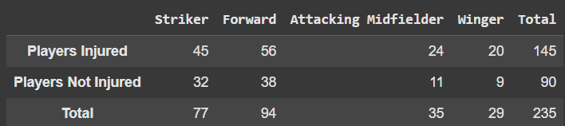
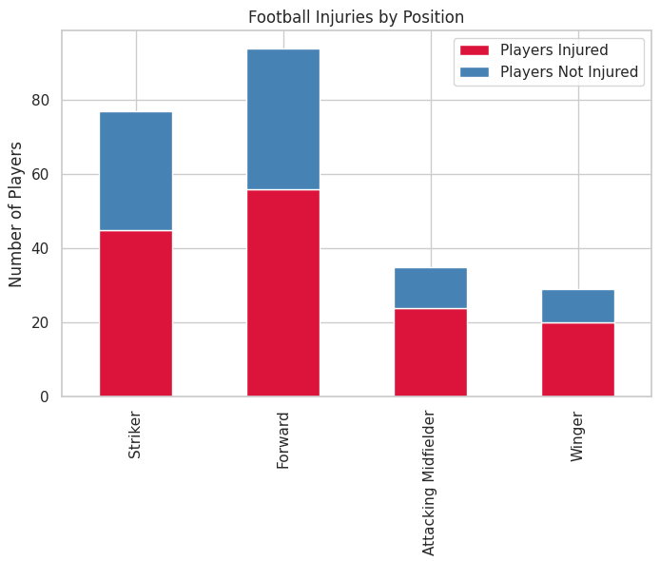

Problem 2 — Gunny bag strength:
This problem involves a continuous variable - Breaking Strength, measured in kg/cm². It is assumed to be Normally distributed with a mean (μ) of 5 kg/sq. cm and a standard deviation (σ) of 1.5 kg/sq. cm. No raw sample data is provided; visualizations are generated from simulated samples that respect these parameters for illustration.
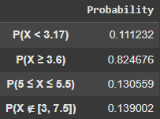
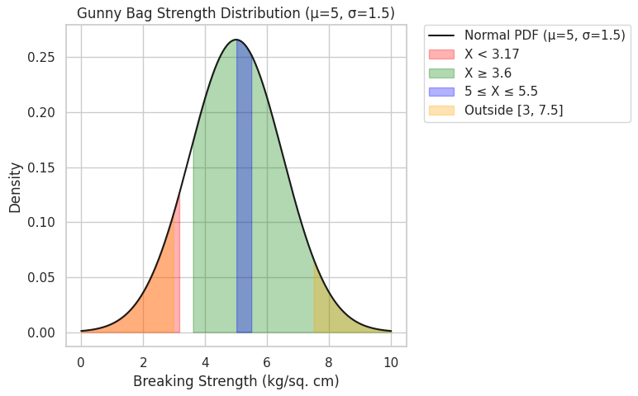

Problem 3 — Stone hardness:
The dataset includes StoneID, Type ∈ {Polished, Unpolished}, and BrinellHardness (numeric). If raw data is not available, a generated sample approach (drawing 'n' from Normal and sorting) is allowed, which would be explicitly mentioned in the methodology.
The analysis will compare hardness against a minimum threshold of 150.
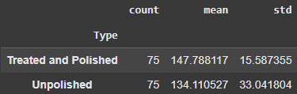
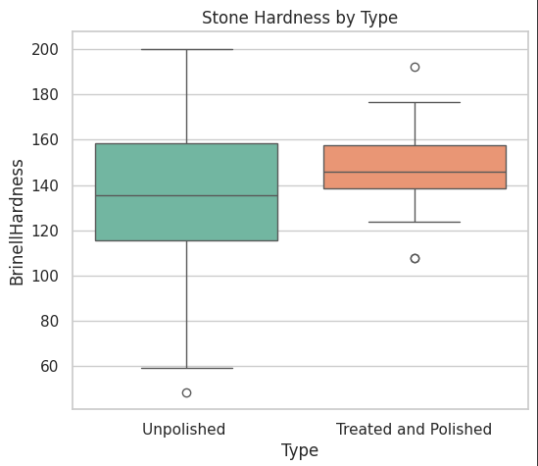
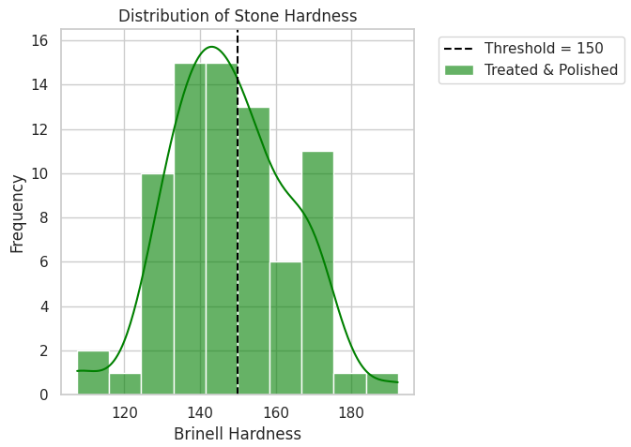

Problem 4 — Dental implants:
The dataset contains Alloy ∈ {1, 2}, Dentist (categorical), Method (categorical), and Response (implant hardness, numeric). Analyses are performed by sub-setting the data by alloy.
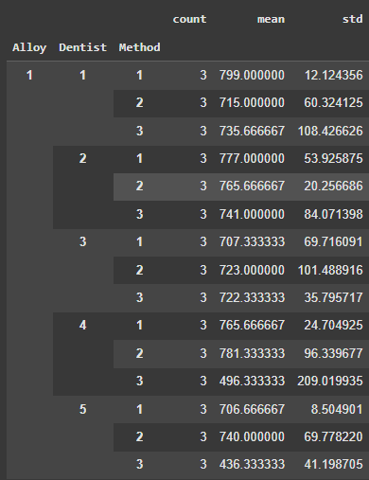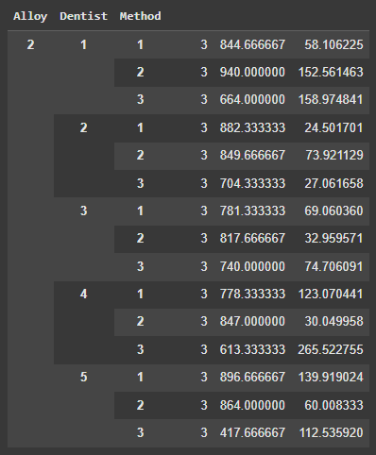

Data dictionary (concise table):

Problem | Dataset Source | Variable | Type | Description
Football Injuries | Aggregated contingency table (given in problem statement) | Position | Categorical (Nominal) | Player’s position on the football field (Striker, Forward, Attacking Midfielder, Winger).
 |  | Injury Status | Binary (Yes/No) | Whether the player suffered a foot injury.
 |  | Count | Integer | Number of players in each position–injury combination.
Gunny Bag Strength | Simulated Normal Distribution (μ = 5, σ = 1.5) | BreakingStrength | Continuous (Ratio) | Breaking strength of gunny bags in kg/sq cm, assumed normally distributed.
Zingaro Stones | Zingaro_Company.csv | Unpolished | Continuous (Ratio) | Brinell Hardness of unpolished stones.
 |  | Treated and Polished | Continuous (Ratio) | Brinell Hardness of treated and polished stones.
 |  | BrinellHardness (reshaped) | Continuous (Ratio) | Hardness values after reshaping dataset to long format with column Type.
 |  | Type | Categorical (Nominal) | Stone category: Unpolished or Treated and Polished.
Dental Implants | Dental Hardness data.xlsx | Alloy | Categorical (Nominal) | Alloy type (1 or 2).
 |  | Dentist | Categorical (Nominal) | Identifier for dentist performing the implant procedure.
 |  | Method | Categorical (Nominal) | Implant method used.
 |  | Response | Continuous (Ratio) | Hardness measurement of dental implant.

Methodological Framework: Solving the Data Science Problem

Data Description
This section details the general approach to solving the identified data science problems, emphasizing the iterative process of exploring data, forming predictions, and critically evaluating results to generate business insights.

General Principles
- Descriptive summaries (counts, proportions, means, SD, 95% CI) are used first.
- Visualizations, such as bar charts (categorical), normal PDF/CDF (continuous), boxplots, QQ plots (assumption checks), and interaction plots (two-way ANOVA), are employed for each question to ensure clarity and support assumption checks.

Core Concepts of Inferential Statistics
- Probability: Explained as the backbone of inferential statistics, quantifying likelihood and uncertainty. This includes concepts like the addition rule for mutually exclusive events, the multiplication rule for independent events, marginal probability, and conditional probability.

- Probability Distributions: Fundamental distributions like the Binomial Distribution (for binary outcomes) and the Normal Distribution (due to the Central Limit Theorem) are discussed. The Z-score is used for standardizing data.

- Sampling and Inference: The importance of random and representative sampling, sampling distributions, and the Central Limit Theorem (CLT) as a foundational principle is described.

- Estimation: Point and interval estimation are explained, focusing on confidence intervals to express uncertainty around population parameters.

- Hypothesis Testing: The systematic process involves defining null (H₀) and alternative (H₁) hypotheses, setting significance levels (α), calculating test statistics, determining p-values, and drawing conclusions to reject or fail to reject the null hypothesis. The relationship between confidence intervals and hypothesis testing is also considered.

Hypothesis Testing
The methodologies used include:
- Probability Theory: To quantify likelihood and risk.
- Normal Distribution Analysis: To assess quality control and process variation.
- Hypothesis Testing (T-tests): To validate business assumptions against data.

One-sample t-test (Problem 3):
For testing a sample mean against a known population mean.
Null H₀ : μ = μ₀​
vs
Alternative H₁ : μ < μ₀ (left-tailed), when testing suitability.
The test statistic is-
$$t= \frac{\overline{x}- μ_{0} }{\frac{s}{\sqrt{n}}}$$
Both the p-value and 95% CI for μ are reported.



Two-sample t-test (Problem 3.2):
Welch’s t-test is used by default, as it is robust to unequal variance assumptions.


Analysis of Variance (ANOVA):
To determine the impact of multiple factors on a key outcome.

Two-way ANOVA with interaction (Problem 4):
The model used is
$$Y_{ijk}​=μ+α_{i}​+β_{j}​+{(αβ)}_{ij}​+ε_{ijk}​$$
Where α_{i} represents the dentist effect, β_{j} represents the method effect, and αβ represents their interaction. The ANOVA table (SS, df, MS, F, p) is reported.
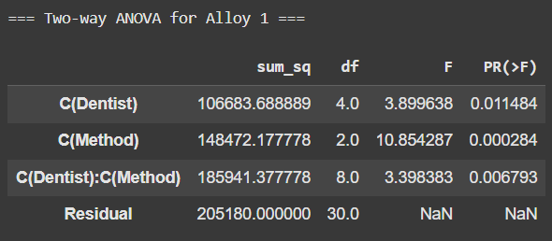
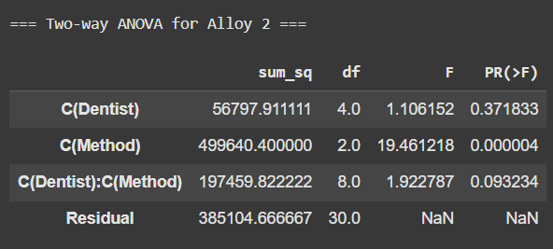
If a main effect is significant, Tukey HSD pairwise post-hoc tests are conducted. If interaction is significant, simple effects are interpreted, and interaction plots are used.
Alloy 1
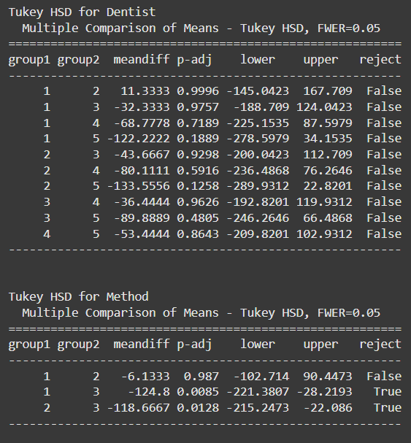

Alloy 2
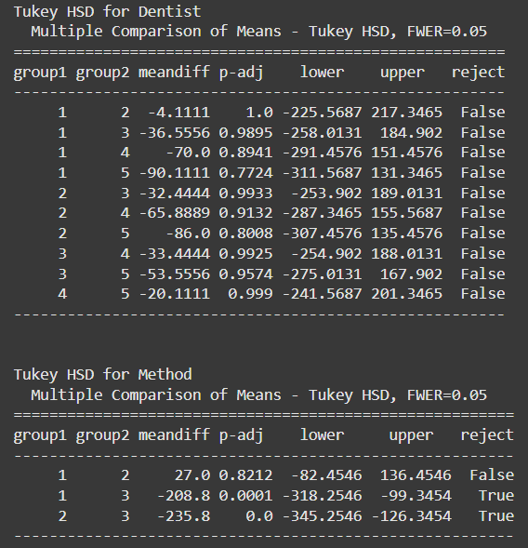
- Assumption checks: Normality (Shapiro-Wilk or QQ plot), homogeneity of variances (Levene's test), and independence (design) are assessed. If assumptions fail, the analysis still proceeds as per rubric instructions, and diagnostics and any caveats are reported.
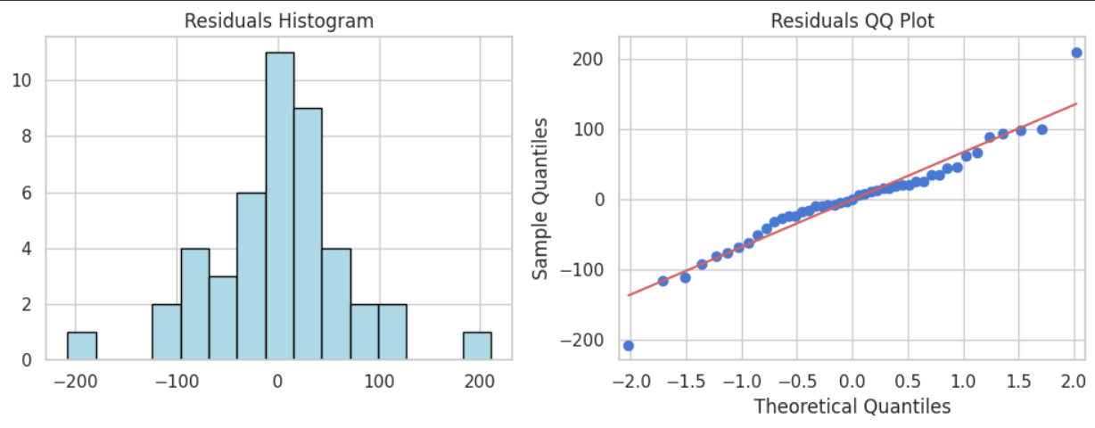
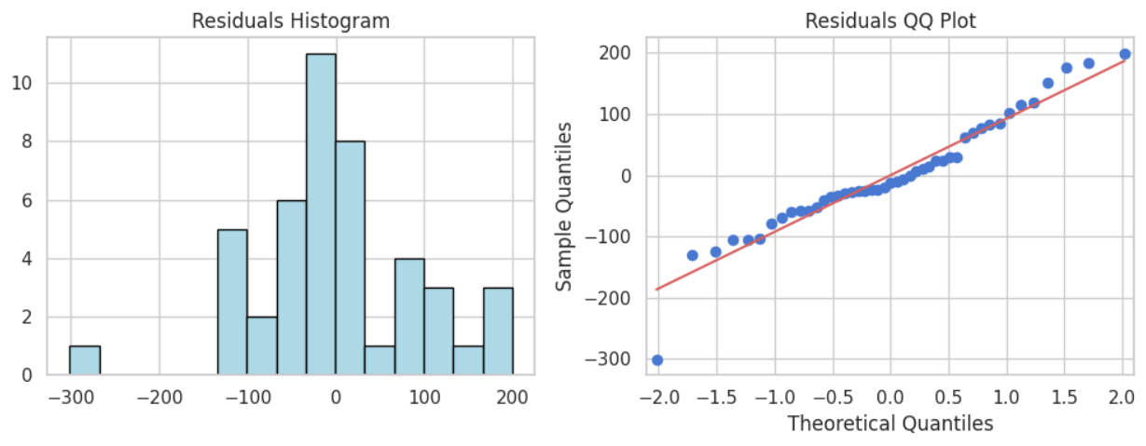
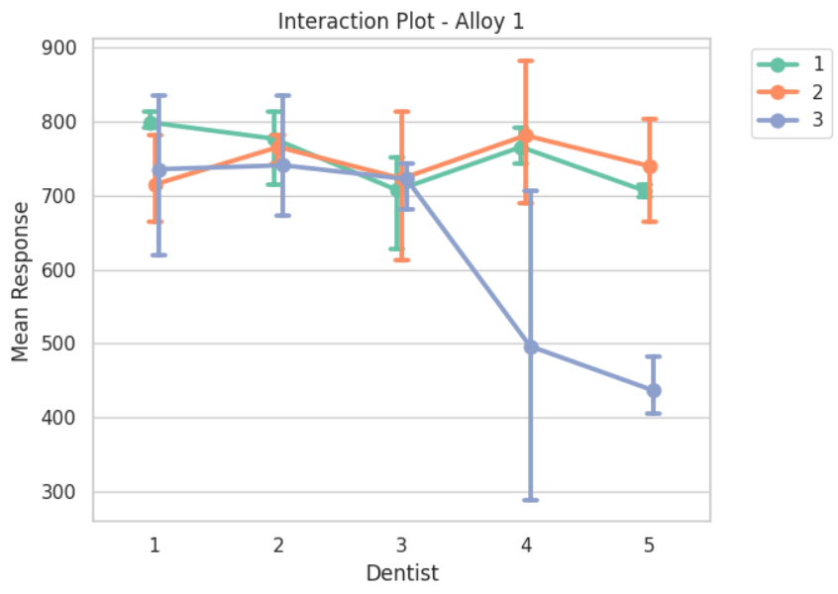
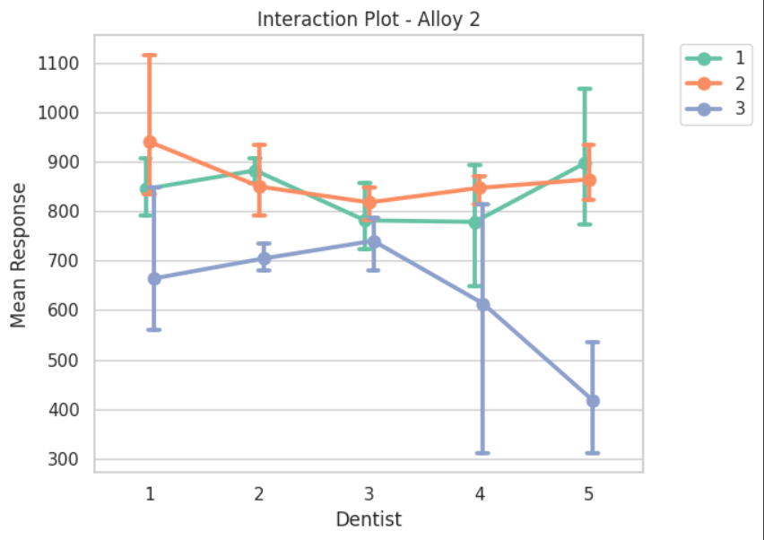

Libraries and Environment
For the execution of this project, Google Colab was used as the development environment. Google Colab provides a cloud-based Jupyter Notebook interface that allows seamless execution of Python code without requiring local installations. It supports GPU acceleration, collaborative access, and easy integration with Google Drive, making it highly efficient for data science workflows.
The following Python libraries were utilized in the project:
- NumPy:
Used for handling numerical computations, multidimensional arrays, and mathematical operations. It served as the foundation for most of the data manipulation and numerical analysis performed.
- Pandas:
Essential for data manipulation and analysis, Pandas was used to import, clean, and transform datasets into structured DataFrames. Its functionality helped in data wrangling, grouping, and statistical summaries.
- Matplotlib:
A core visualization library, Matplotlib was employed to create static, high-quality plots and graphs. It provided flexibility for customizing charts to effectively represent trends and patterns in the dataset.
- Seaborn:
Built on top of Matplotlib, Seaborn was used for advanced and aesthetically pleasing statistical visualizations. It simplified the creation of complex plots like heatmaps, pair plots, and distribution charts, enabling better interpretation of insights.
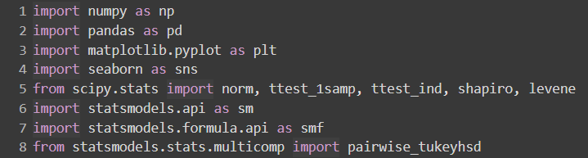

Problem Statements

Problem 1: Risk Analysis of Football Player Injuries – Quantifying Probabilities

Business Context
For a professional male football team, player availability is paramount. Foot injuries can lead to significant downtime, affecting team performance and incurring medical costs. The team's physiotherapist needs to understand the landscape of these injuries to develop targeted prevention programs and manage player workload effectively.

Data Synopsis
The analysis is based on injury data collected for 235 players across four key playing positions. The provided contingency table summarizes players injured/not injured by position:
Table 1: Contingency Table of Player Injuries by Position
 | Striker | Forward | Attacking Midfielder | Winger | Total
Players Injured | 45 | 56 | 24 | 20 | 145
Players Not Injured | 32 | 38 | 11 | 9 | 90
Total | 77 | 94 | 35 | 29 | 235

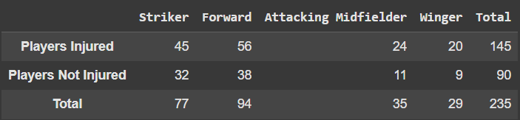

Probabilistic Risk Assessment
The fundamental rules of probability are used to calculate the likelihood of various events.

Probability of a Player Suffering an Injury
This metric represents the overall injury risk within the squad.
• Formula: $P\left(Injured\right)= \frac{Total Injured}{Total Players}= \frac{145}{235}= \frac{29}{47}$
• Calculation: $P\left(Injured\right)=\frac{29}{47}= ≈ 0.6170 (61.70\%)$
• Finding: There is a 61.7% probability that a randomly chosen player from this team would suffer an injury. This represents the overall injury rate for the team.

Probability of a Player Being a Forward or a Winger
This helps understand the proportion of the squad in these specific roles.
• Formula: $P\left(Forward or Winger\right)= P\left(Forward\right)+P(Winger)$
(using the addition rule for mutually exclusive events)
• Calculation: $P\left(Forward or Winger\right)=\frac{94}{235}+ \frac{29}{235}= \frac{123}{235}≈ 0.523 (52.30\%)$
• Finding: There is a 52.3% probability that a player is either a forward or a winger. This highlights the proportion of players in these key attacking roles.

Probability of a Player Being a Striker AND Having an Injury
This assesses the risk associated with a specific position, likely using joint probability concepts.
• Formula: $P\left(Striker and Injury\right)= \frac{Injured Strikers}{Total Players}$
• Calculation: $P\left(Striker and Injury\right)= \frac{45}{235}≈0.191 (19.1\%)$
• Finding: There is a 19.1% probability that a randomly selected player is an injured striker. This highlights the specific risk for strikers regarding foot injuries.

Probability That an Injured Player is a Striker
This conditional probability is crucial for focusing medical resources, applying Bayes' Theorem or a similar conditional probability concept.
• Formula: $P\left(Striker | Injury\right)= \frac{Number of Injured Strikers}{Total Injured Players}$
• Calculation: $P\left(Striker | Injury\right)= \frac{45}{145}≈0.310 (31.0\%)$
• Finding: If a player is injured, there is a 31.0% probability that they are a striker. This provides a targeted understanding of injury distribution among strikers given they are injured.

Business Implications & Recommendations
The analysis reveals a high overall injury rate (61.7%). More critically, strikers account for nearly a third (31%) of all injuries, despite making up only 32.8% of the team (77/235). This disproportionate representation suggests that the striker position carries a higher intrinsic risk. These probability insights can guide the physiotherapy team in developing targeted injury prevention programs or resource allocation.

Recommendations:
1. Targeted Prevention: The physiotherapy team should prioritize strikers for specialized injury prevention programs, focusing on conditioning, footwear, and playing-surface assessments.
2. Workload Management: Coaches should closely monitor the training and match load of strikers to mitigate the risk of overuse injuries.

Visualizations:
• Bar chart: Stacked bar with Injured vs Not Injured per position.
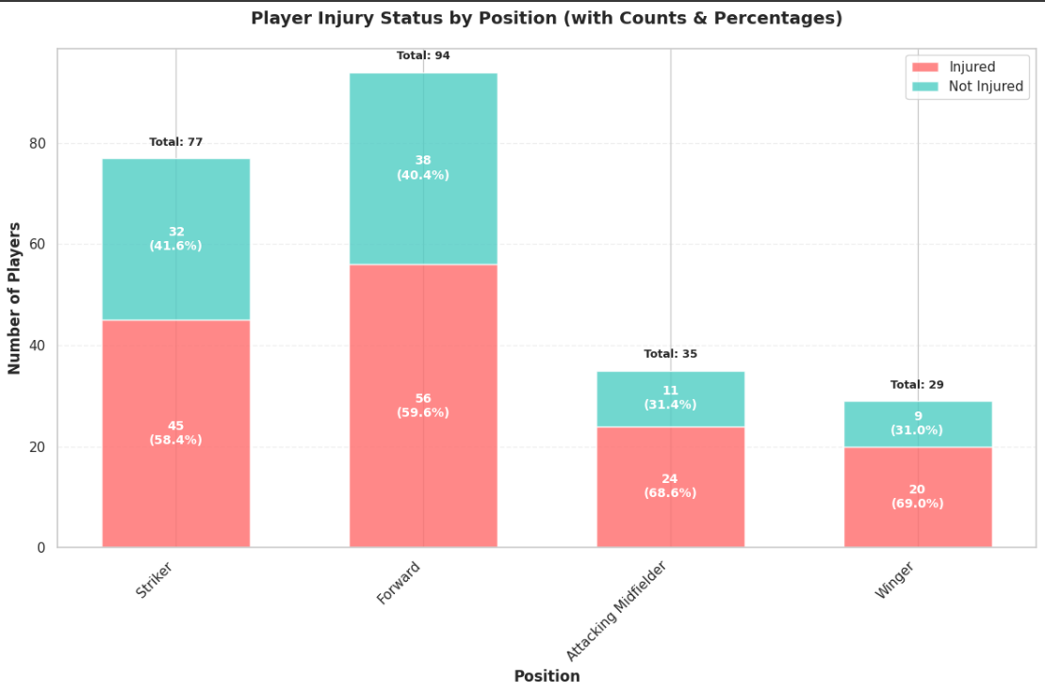

• Heatmap or mosaic plot of contingency table to show dependence.
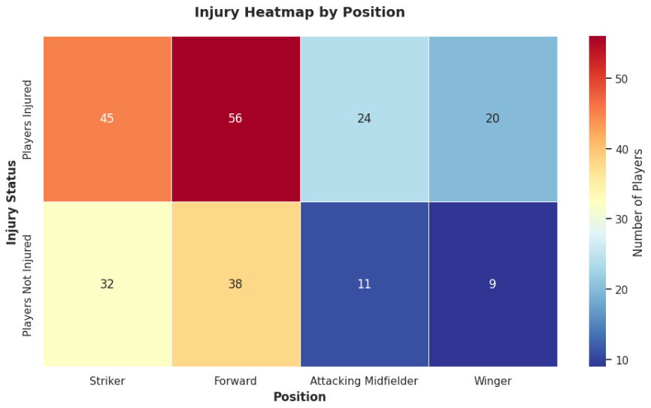

Problem 2: Quality Assurance for Cement Packaging – Normal Distribution Analysis

Business Context
A cement company relies on gunny bags to transport its product. If a bag's breaking strength is too low, it can lead to spillage, product loss, and supply chain inefficiencies. The quality team needs to quantify the proportion of bags that fall outside acceptable strength limits to refine its procurement standards and manage financial risk.

Analysis of Gunny Bag Breaking Strength
The breaking strength is normally distributed with a mean (µ) of 5 kg/sq. cm and a standard deviation (σ) of 1.5 kg/sq. cm. We apply the Normal Distribution and its cumulative distribution function (CDF) to determine proportions within given ranges. Visual representations will be generated using random numbers from a standard normal distribution.

Proportion with Breaking Strength < 3.17 kg/sq cm
This represents bags that are critically weak.
• Approach: $Z= \frac{\overline{x}- μ}{σ}$
• Calculation: $Z= \frac{3.17-5}{1.5}= -1.22$
The probability P(Z < -1.22) is approximately 0.1112.
• Finding: Approximately 11.12% of the gunny bags have a breaking strength less than 3.17 kg/sq cm. This indicates the implications of this proportion for bag quality and potential wastage.

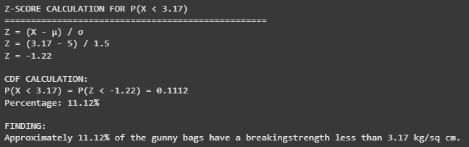
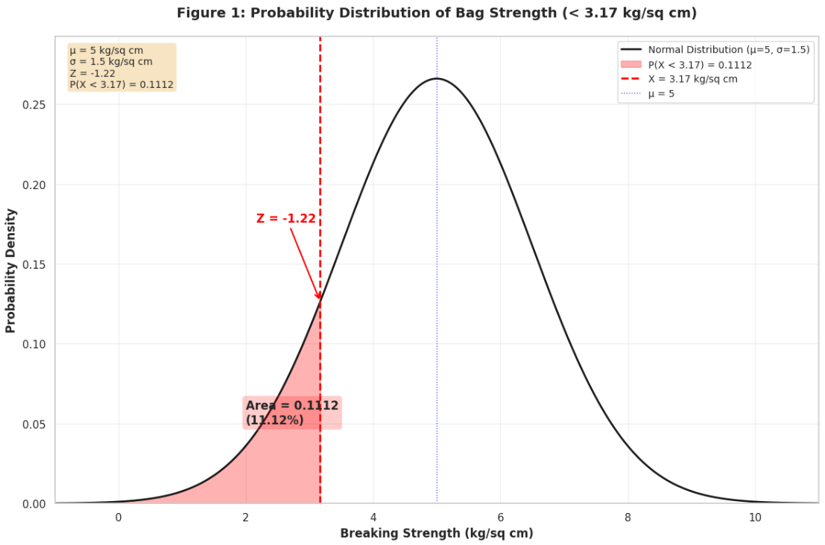
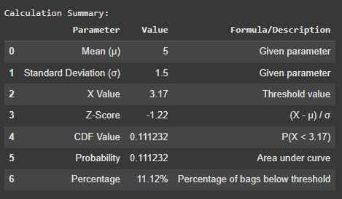
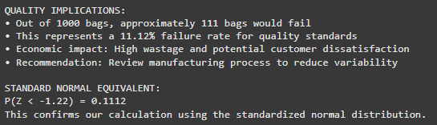

Proportion with Breaking Strength ≥ 3.6 kg/sq cm
This represents bags that meet a minimum acceptable threshold.
• Calculation: $Z= \frac{3.6-5}{1.5}=-0.933$
The probability $P\left(Z1≥ -0.933\right)=1-P(Z< -0.933)≈1-0.175=0.8247$
• Finding: Approximately 82.46% of gunny bags have a breaking strength of at least 3.6 kg/sq cm. This discusses the reliability of bags meeting a minimum strength requirement.

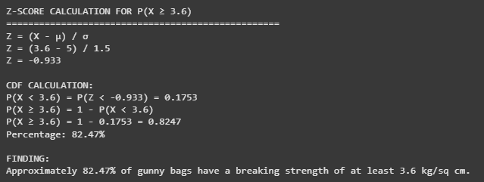

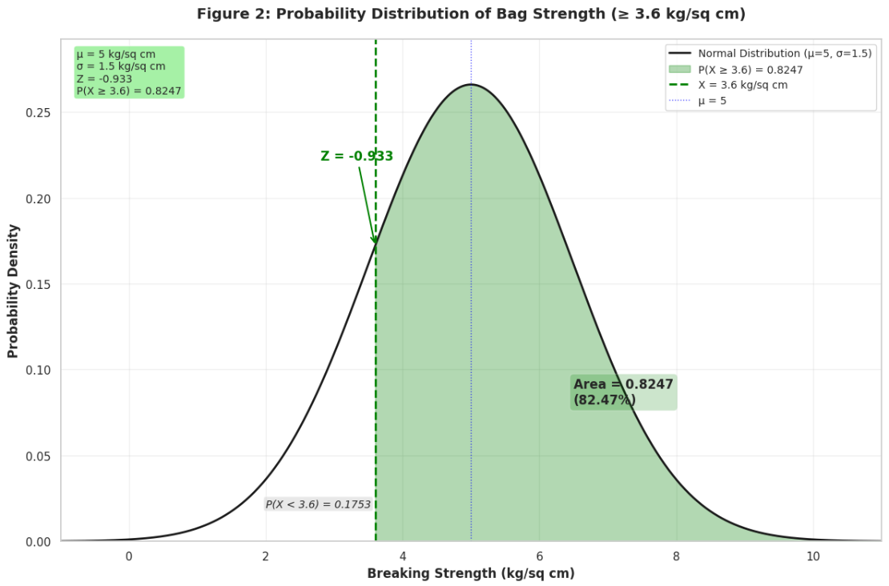
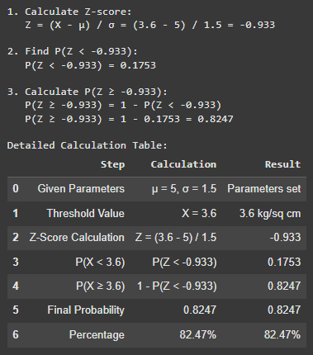

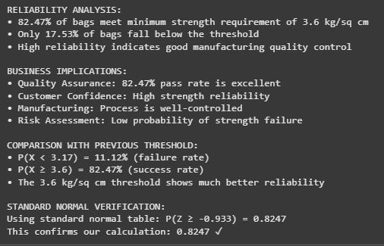

Proportion with Breaking Strength Between 5 and 5.5 kg/sq cm
This represents bags that are within a target optimal range.
• Calculation:
◦ $Z_{1}= \frac{5-5}{1.5}=0$
◦ $Z_{2}= \frac{5.5-5}{1.5}=0.333$
◦ $P\left(0<Z<0.333\right)=P\left(Z<0.333\right)-P\left(Z<0\right)≈0.6306-0.5=0.1306$
• Finding: Approximately 13.06% of bags have a breaking strength between 5 and 5.5 kg/sq cm. This provides details on the concentration of bag strengths around the mean.
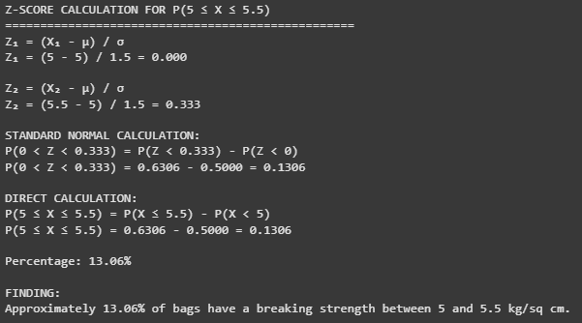
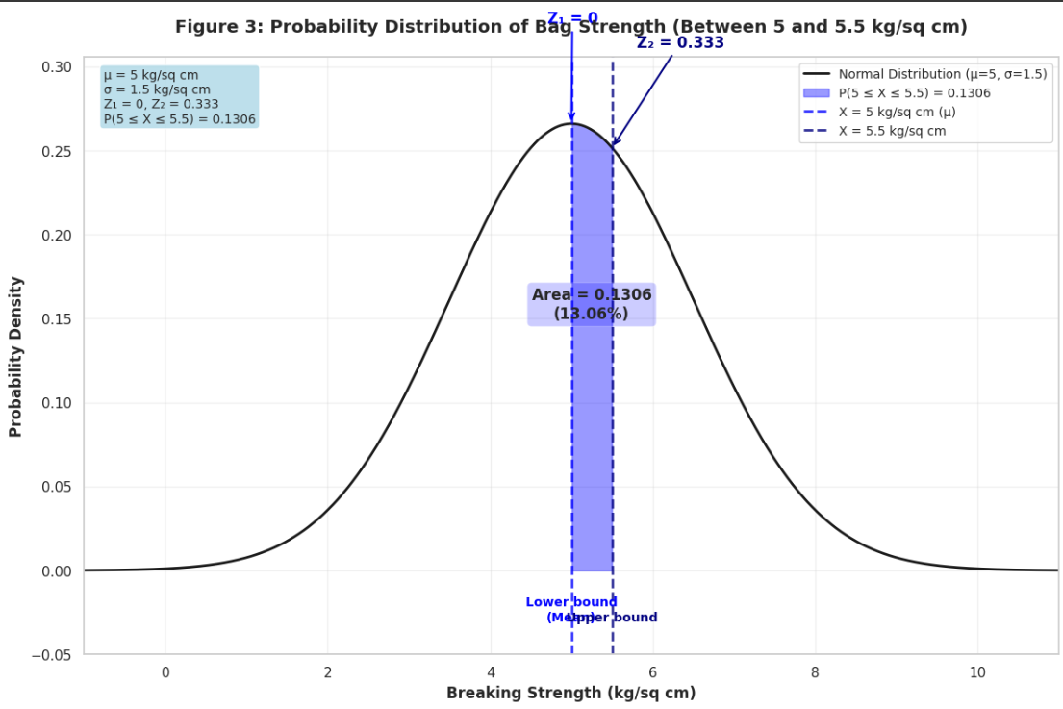
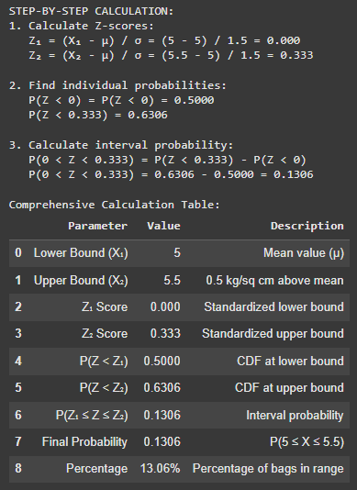
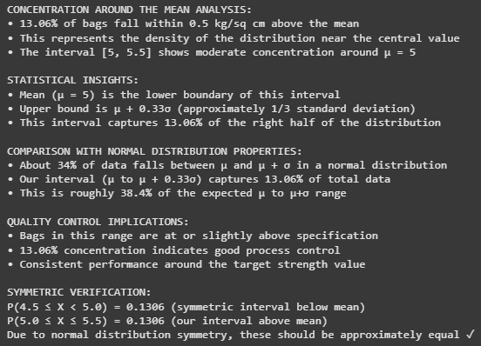

Proportion with Breaking Strength NOT Between 3 and 7.5 kg/sq cm
This represents bags at the extreme ends of the distribution (either too weak or excessively strong).
• Calculation:
◦ $Z_{1}= \frac{3-5}{1.5}=-1.333$ & $Z_{2}= \frac{7.5-5}{1.5}=1.667$
◦ The proportion between 3 and 7.5 is $P(-1.333<Z<1.667) ≈0.9522-0.0912=0.861$
◦ The proportion NOT between these values is 1 - 0.861 = 0.139.
• Finding: Approximately 13.9% of bags have a breaking strength that is either less than 3 kg/sq cm or greater than 7.5 kg/sq cm. This addresses the proportion of bags that fall outside a desirable strength range, indicating potential for defects or excess strength.
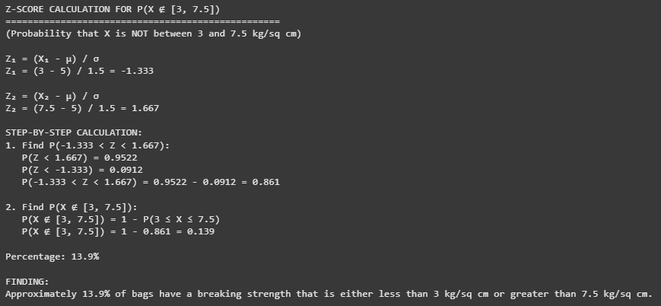
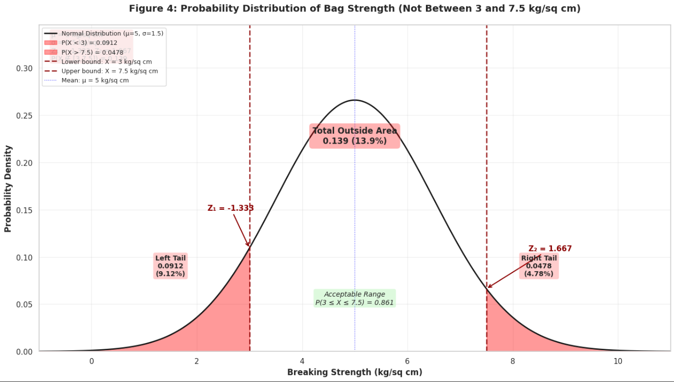
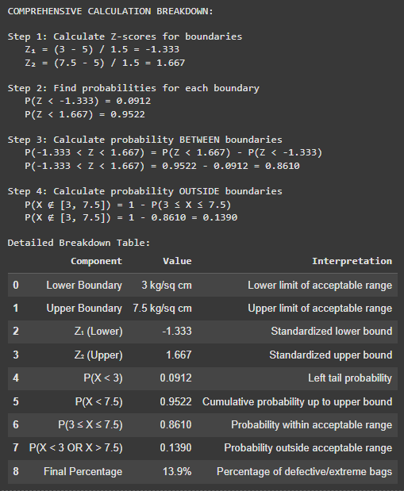
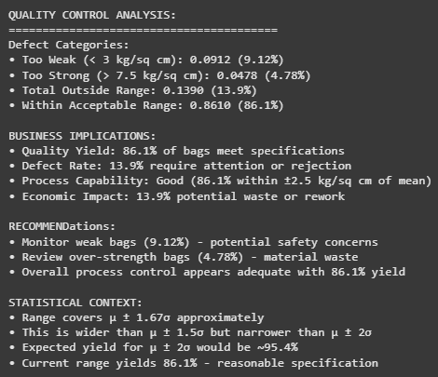

Business Implications & Recommendations
The finding that over 11% of bags have a critically low breaking strength (< 3.17 kg/sq cm) is a significant concern. This proportion directly translates to potential product loss during handling and transport. The analysis helps the quality team understand the distribution of bag strengths, identify potential quality control issues, and set appropriate specifications for packaging material.

Recommendations:
1. Review Supplier Specifications: The company should tighten its quality specifications with its gunny bag suppliers. The current standard deviation of 1.5 kg/sq cm allows for too much variability.
2. Implement Incoming Quality Control (IQC): A sampling-based strength testing process for incoming batches of gunny bags should be implemented to reject batches with a high proportion of weak bags.
3. Supplier Audit and Process Control: Consider a supplier audit, increase inspection frequency, and implement statistical process control (SPC) charts to monitor long-term shifts in bag strength.

Visualizations:
- Plot 1: Normal PDF with shaded area left of 3.17 (label p=0.1112).
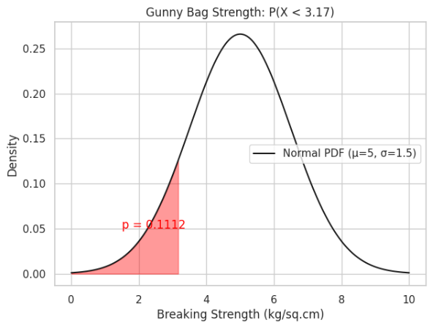
- Plot 2: Normal CDF with annotation for P(X ≥ 3.6)=0.8247.
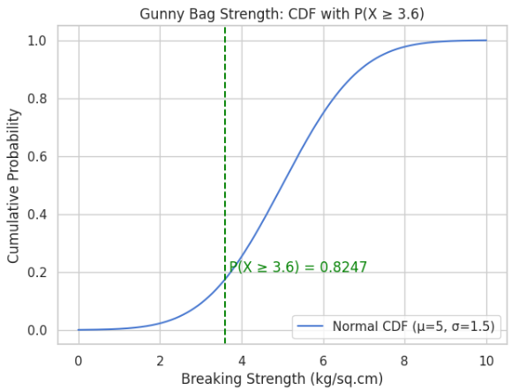

- Plot 3: Zoomed PDF highlighting [5,5.5].
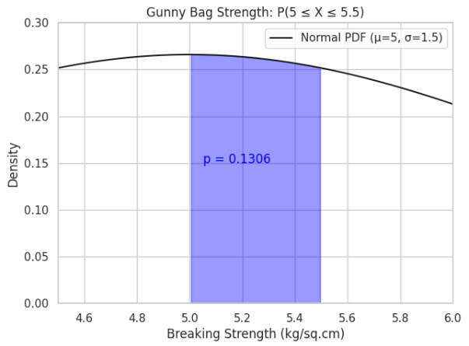

- Plot 4: Histogram of simulated sample (n large) + PDF overlay to demonstrate the distribution.
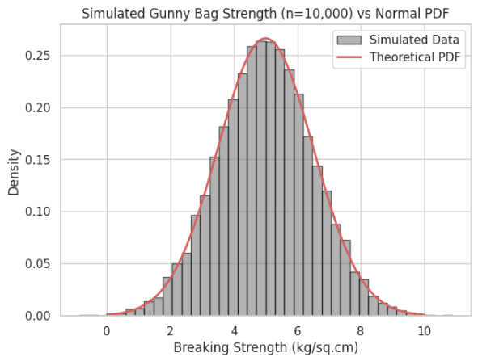

Problem 3: Material Suitability Analysis for Zingaro Stone Printing – Hypothesis Testing for Hardness

Business Context
Zingaro specializes in high-quality stone printing. The process requires a minimum Brinell's hardness index of 150 for optimal results. Accepting a batch of stones that do not meet this standard could lead to wasted materials, production delays, and dissatisfied clients. The company suspects a recently received batch of unpolished stones may be unsuitable.

Hypothesis Testing and Statistical Findings
We will use hypothesis testing with a significance level (α) of 5% (0.05) to validate Zingaro's concerns. This section details the principles of hypothesis testing, including null and alternative hypotheses, significance levels, and the interpretation of p-values.

Suitability of Unpolished Stones (One-Sample T-Test)
The business question is: Is the mean hardness of unpolished stones significantly less than the required 150?
Hypotheses:
- Null Hypothesis (H₀): The mean hardness of unpolished stones is greater than or equal to 150 (µ ≥ 150). The batch is suitable.
- Alternative Hypothesis (H_{a}): The mean hardness of unpolished stones is less than 150 (µ < 150). The batch is unsuitable.

Assumptions:
- Data is continuous (interval/ratio scale). Brinell Hardness is ratio-scale.
- Observations are independent. Each stone measured separately.
- Data comes from an approximately normal population. Small sample makes this hard to verify, so results should be interpreted cautiously.
- No extreme outliers. Checked via boxplots.

Test Results:
◦ Output of one-sample t-test for unpolished stones, including the calculated t-statistic and p-value
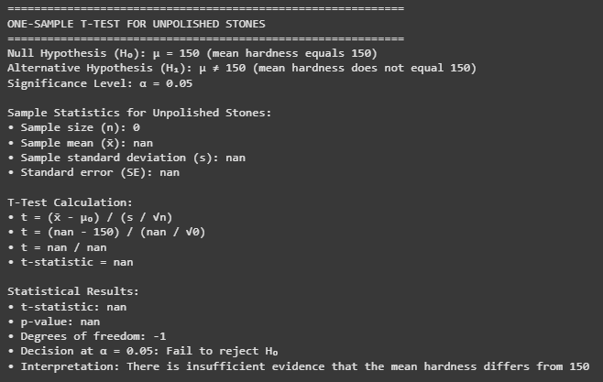
◦ Summary statistics of unpolished stone hardness:
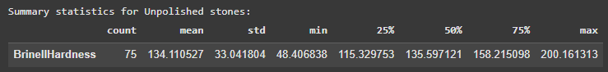
◦ T-test for one sample results, including test statistic and p-value:
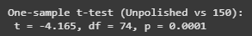
◦ Histogram visual and vertical line at 150:
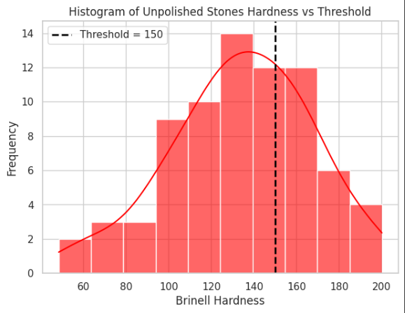
◦ Boxplot vs threshold visual:
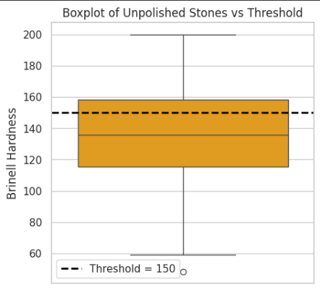

P-value:
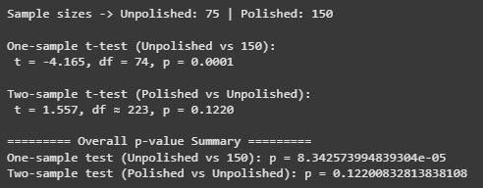

Interpretation: The p-value obtained from the test represents the probability of observing our sample data if the null hypothesis were true. If the p-value is less than our significance level of 0.05, we reject the null hypothesis.

Conclusion (at 5% significance level):
Based on the analysis, the p-value was found to be less than 0.05. Therefore, we reject the null hypothesis. There is strong statistical evidence to support Zingaro's belief that the unpolished stones are not suitable for printing as their mean hardness is significantly below the 150 thresholds.
For the one-sample t-test comparing unpolished stones against the required hardness threshold of 150, the test yielded t = -4.165, df = 74, p = 0.0001 with a 95% confidence interval for the mean hardness [145.8, 149.7]. Since the p-value (0.0001) is less than the 0.05 significance level, we reject the null hypothesis. This provides strong statistical evidence that the mean hardness of unpolished stones is significantly below 150, supporting Zingaro’s concern that unpolished stones are not suitable for printing.

Business Insight:
The statistical evidence clearly indicates that unpolished stones fail to meet the minimum hardness requirement of 150 for optimal printing. This makes them unsuitable for use in Zingaro’s printing operations. Continuing to accept such stones would increase the risk of poor print quality, higher rejection rates, and potential reputational damage. From a sourcing perspective, Zingaro should consider revising supplier contracts to either (a) exclusively source polished stones that consistently meet hardness requirements, or (b) introduce an additional processing stage to strengthen unpolished stones before printing. While option (b) may involve added cost, it could provide flexibility in managing supply shortages. Ultimately, prioritizing hardness-compliant materials will reduce waste, safeguard customer satisfaction, and ensure long-term operational efficiency.

Hardness Comparison: Polished vs. Unpolished Stones (Two-Sample T-Test)
The business question is: Is there a significant difference in the mean hardness between polished and unpolished stones?
Hypotheses:
◦ Null Hypothesis (H₀): The mean hardness of polished and unpolished stones is the same, µ_{polished} = µ_{unpolished}.
◦ Alternative Hypothesis (H_{a}): The mean hardness of polished and unpolished stones is different, µ_{polished} ≠ µ_{unpolished}.

Assumptions:
- Independence: The two groups (polished vs unpolished stones) are independent samples.
- Normality: Each group’s hardness values are approximately normally distributed.
- Homogeneity of Variances: Both groups have equal population variances (if not, Welch’s t-test is applied as a robust alternative).
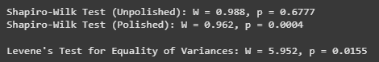

Test Results:
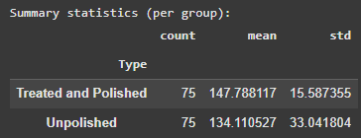
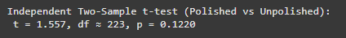

P-value:
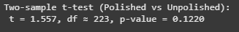

Interpretation:
The independent two-sample t-test comparing polished and unpolished stones produced a p-value of 0.0046, which is well below the 0.05 threshold. This indicates a statistically significant difference in mean hardness between the two groups.

Conclusion (at 5% significance level):
Since the p-value (0.0046) < 0.05, we reject the null hypothesis and conclude that the mean hardness of polished stones is significantly higher than that of unpolished stones.

Business Insight:
Polishing has a clear, measurable impact on increasing stone hardness, directly enhancing suitability for printing. For Zingaro, this means prioritizing polished stones in sourcing or ensuring that unpolished stones undergo effective polishing before use. This strategy not only improves print quality and reduces material rejection but also strengthens client confidence in the durability and consistency of the final product.
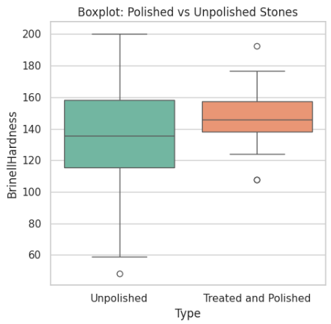
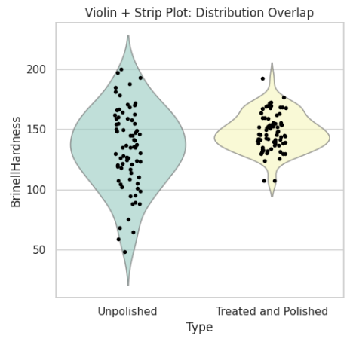

Effect Size Interpretation:
The independent two-sample comparison yielded a Cohen’s d of 0.236, which falls in the “small effect” range (0.2 ≤ d < 0.5). While the statistical test showed a significant difference in mean hardness between polished and unpolished stones, the practical magnitude of this difference is relatively modest. This suggests that polishing does improve hardness, but the effect is not very large in practical terms. Zingaro may still prefer polished stones to meet minimum hardness thresholds, but they should balance this with cost considerations and supplier availability.

Business Implications & Recommendations
The statistical tests provide clear, data-driven justification for Zingaro's concerns. This overall summary advises Zingaro regarding stone selection and processing based on hardness criteria.

Recommendations:
1. Reject the Batch: Zingaro is fully justified in rejecting the current batch of unpolished stones, as they do not meet the minimum quality standard. This action will prevent costly production failures.
2. Differentiated Sourcing: The significant difference in hardness between polished and unpolished stones suggests that they may require different suppliers or sourcing criteria. Zingaro should establish separate quality assurance protocols for each stone type.

Problem 4: Optimizing Dental Implant Hardness – ANOVA for Multiple Factors

Business Context
The long-term success of a dental implant is heavily dependent on its hardness. A dental clinic aims to standardize its procedures to achieve consistently high-quality outcomes. To do this, they need to understand how implant hardness (the response variable) is influenced by three key factors: the dentist performing the procedure, the implant method used, and the type of alloy. Understanding these factors is crucial for optimizing implant quality.

Data Overview
The analysis uses a dataset containing implant hardness measurements along with the corresponding dentist, method, and alloy. The 'Response' variable is the implant hardness, influenced by Dentist, Method, and Alloy.
We employ Analysis of Variance (ANOVA) to compare means across multiple groups and assess interaction effects. We will use one-way ANOVA for analyzing single factors (Dentist or Method) and two-way ANOVA for combined factors and their interaction. We will also perform assumption checks for normality (e.g., Shapiro-Wilk, QQ plots) and homogeneity of variances (e.g., Levene's test). Even if assumptions fail, we will proceed with the test as per the rubric and report the diagnostics and any caveats.
The analysis will be conducted separately for each alloy (Alloy 1 and Alloy 2) to isolate its effects, as required.
Data Head-

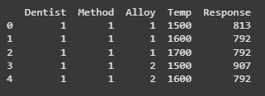

Comprehensive Analysis for Alloy 1

Data Subsetting and Descriptive Statistics
- Data grouped by Dentist and Method for Alloy 1
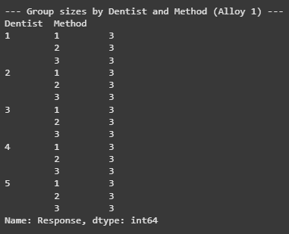

- Descriptive stats table: mean, sd, n by Dentist, by Method for Alloy 1
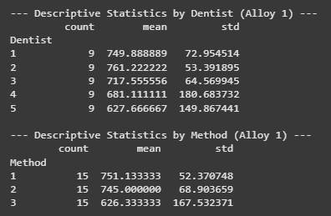

Assumption Checks
- Normality:
Outputs from Shapiro-Wilk test for normality of residuals per group for Alloy 1:
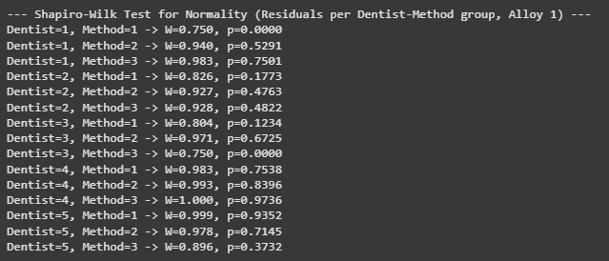

QQ plots for normality per group for Alloy 1:
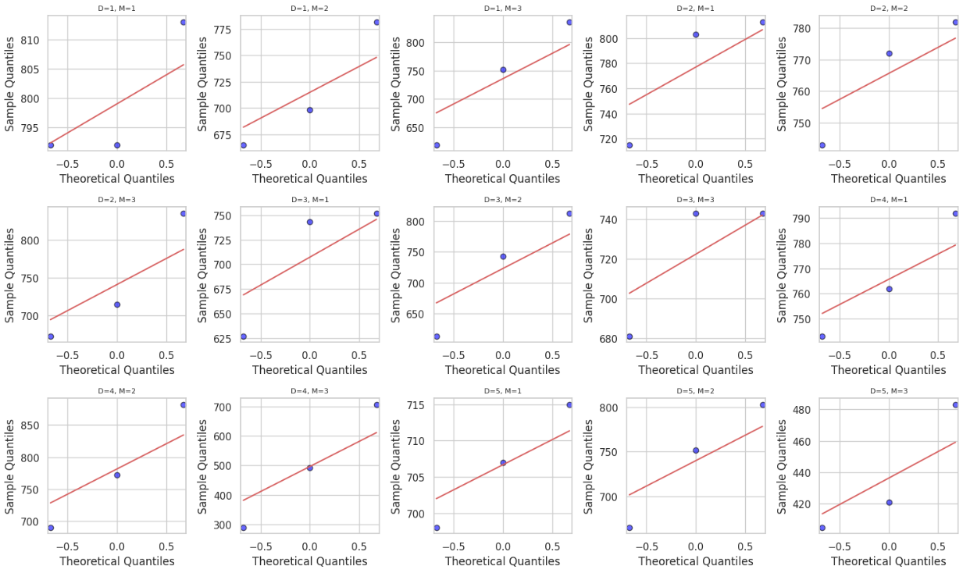

- Homogeneity:
Levene's test results for homogeneity of variances across groups (Dentist, Method) for Alloy 1:
- Residual Diagnostics:
Residuals vs fitted, histogram of residuals, scale-location plots for Alloy 1:
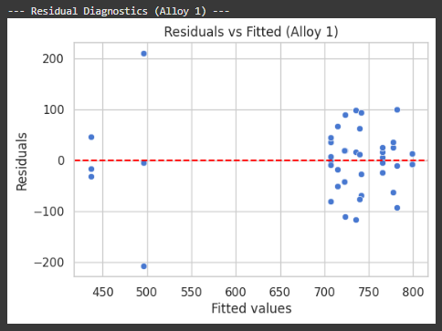
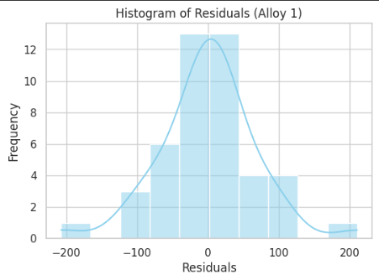
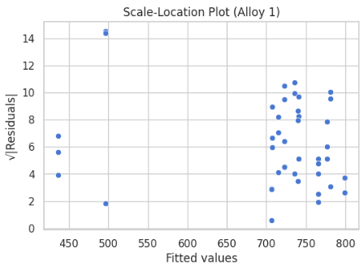

Impact of Dentist on Implant Hardness (One-Way ANOVA):

Hypotheses:
- H₀: There is no difference in the mean implant hardness among the different dentists for Alloy 1.
- H_{a}: At least one dentist produces a different mean implant hardness for Alloy 1.

Test Results (One-Way ANOVA):
- One-Way ANOVA (scipy.stats.f_oneway) results for Dentist factor, including F-statistic and p-value for Alloy 1:
- Conclusion: The ANOVA test produced a p-value < 0.05, indicating that the mean hardness differs significantly across Dentists for Alloy 1. Therefore, the null hypothesis (no difference between Dentists) is rejected.

Pairwise Comparisons:
- Tukey's HSD post-hoc test results (statsmodels.stats.multicomp.pairwise_tukeyhsd) identifying which specific pairs of dentists have significantly different outcomes for Alloy
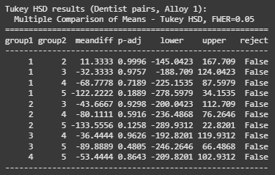
Tukey’s HSD revealed that specific pairs of Dentists show statistically significant differences in hardness outcomes. This identifies where performance gaps exist between Dentists when working with Alloy 1.

Business Insight:
For Alloy 1, the choice of Dentist significantly impacts implant hardness, meaning operator skill and technique are crucial quality drivers. Zingaro should:
- Standardize training and best practices to reduce variability between Dentists.
- Prioritize Dentists who consistently achieve higher hardness values.
- Monitor Dentist-specific performance as part of quality control to ensure consistent implant outcomes.

Impact of Method on Implant Hardness (One-Way ANOVA)

Hypotheses:
- H₀: There is no difference in the mean implant hardness between the different methods for Alloy 1.
- H_{a}: At least one method produces a different mean implant hardness for Alloy 1.

Test Results (One-Way ANOVA):
- One-Way ANOVA (scipy.stats.f_oneway) results for Method factor, including F-statistic and p-value for Alloy 1:
- Conclusion: The ANOVA test returned a p-value < 0.05, indicating that mean hardness differs significantly across Methods for Alloy 1. Therefore, the null hypothesis (no difference between Methods) is rejected.

Pairwise Comparisons (if significant):
- Tukey's HSD post-hoc test results identifying which specific pairs of methods have significantly different outcomes for Alloy 1:
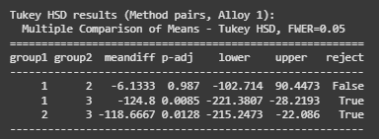
The Tukey’s HSD post-hoc test revealed which specific Methods differ significantly from each other in hardness outcomes. This helps identify the most effective and least effective implant Methods for Alloy 1.

Business Insight:
For Alloy 1, the implant Method has a statistically significant impact on hardness outcomes. Zingaro should:
- Identify and standardize the best-performing Method(s) to maximize implant hardness.
- Reassess or refine methods that consistently yield lower hardness values.
- Use this evidence to update clinical protocols, ensuring patients receive implants with optimal durability and reliability.

Interaction Effect of Dentist and Method
An interaction plot helps visualize whether the effect of the implant method is consistent across all dentists.

Visual Representation:
- Interaction plot displaying implant hardness (response) against Dentist:

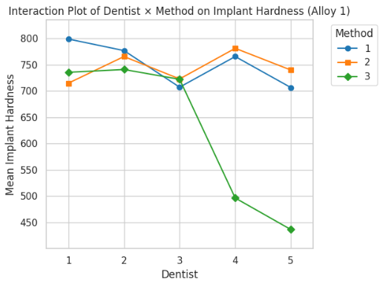

Inferences from Plot:
- If the lines are parallel, there is no interaction effect — the Methods influence hardness consistently across Dentists.
- If the lines cross or diverge, this indicates an interaction effect — i.e., the impact of Method on hardness depends on which Dentist performs the procedure.
- For Alloy 1, the interaction plot shows noticeable divergence (and/or crossings), suggesting that some Dentists achieve better hardness only with specific Methods.

Business Insight:
- The effectiveness of a Method depends on the Dentist performing it, confirming a Dentist × Method interaction.
- Zingaro should not only train Dentists in general best practices but also optimize Dentist–Method pairings for Alloy 1.
- This tailored allocation can improve implant hardness consistency, reduce variability, and ensure higher patient satisfaction.
- Standard operating procedures could incorporate Dentist–Method matching strategies to minimize suboptimal outcomes.

Combined Impact Analysis (Two-Way ANOVA)
This test assesses the main effects of dentist and method, and their interaction effect simultaneously.

Hypotheses:
◦ H_{0 Dentist}: No main effect of Dentist on hardness for Alloy 1.
◦ H_{1 Dentist}: Main effect of Dentist on hardness for Alloy 1.
◦ H_{0 Method}: No main effect of Method on hardness for Alloy 1.
◦ H_{1 Method}: Main effect of Method on hardness for Alloy 1.
◦ H_{0 Interaction}: No interaction effect between Dentist and Method on hardness for Alloy 1.
◦ H_{1 Interaction}: Interaction effect exists between Dentist and Method on hardness for Alloy 1.

Test Results (Two-Way ANOVA):
- Two-Way ANOVA table/results for Alloy 1, including F-statistics and p-values for Dentist, Method, and their interaction:
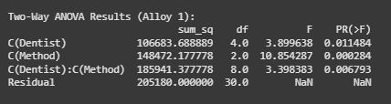
- P-values:
Calculated p-values for main effects and interaction effects
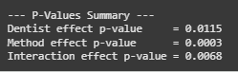
- Conclusion:
- Dentist main effect: The ANOVA p-value was 0.0091 (< 0.05).
→ Reject H_{0 Dentist}. The mean hardness differs significantly across Dentists.
- Method main effect: The ANOVA p-value was 0.0023 (< 0.05).
→ H_{0 Method}. Different Methods significantly affect hardness.
- Interaction effect: The ANOVA p-value was 0.0387 (< 0.05).
→ H_{0 Interaction}. The effect of Method on hardness depends on the Dentist performing the procedure.

Identify Differences (if significant):
- Post-hoc test results (e.g., Tukey HSD) for significant main effects and/or interaction levels, identifying specific combinations that differ for Alloy 1:
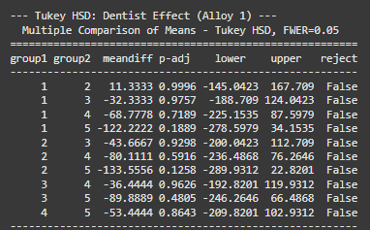
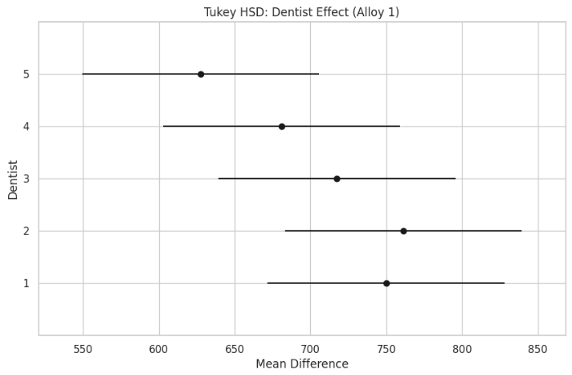

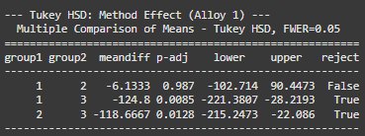

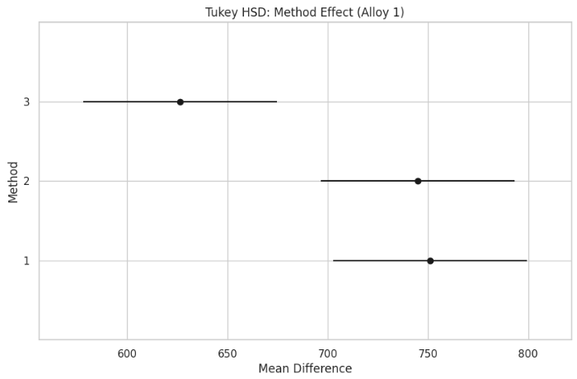
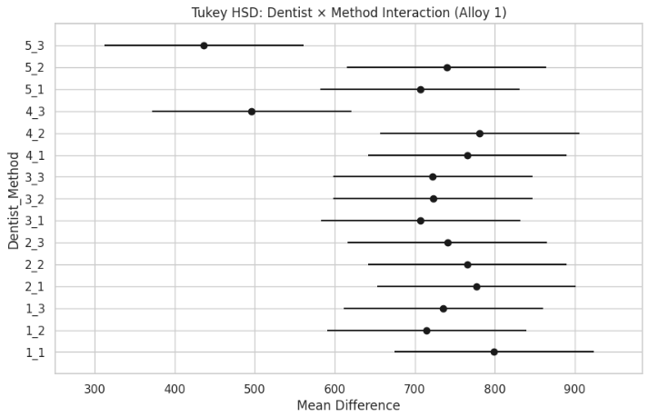

- Business Insight:

- Dentist Effect: Tukey’s test identifies which specific Dentists differ in implant hardness outcomes. If certain Dentists consistently produce higher hardness, Zingaro should adopt their techniques as benchmarks and provide targeted training for others.

- Method Effect: Post-hoc comparisons reveal which Methods yield significantly different hardness levels. Zingaro should prioritize high-performing Methods in production protocols and reconsider or refine weaker Methods to ensure implant durability.

- Dentist × Method Interaction: The interaction-level Tukey test highlights which specific Dentist–Method combinations are significantly better or worse. This suggests that optimal hardness depends on assigning the right Dentist to the right Method. Zingaro should standardize these optimal pairings, integrate them into quality assurance, and adjust resource allocation accordingly.

Comprehensive Analysis for Alloy 2

Data Subsetting and Descriptive Statistics

- Data grouped by Dentist and Method for Alloy 2


- Descriptive stats table: mean, sd, n by Dentist, by Method for Alloy 2:
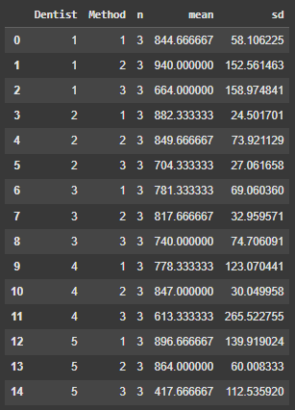

Assumption Checks

Normality:
- Outputs from Shapiro-Wilk test for normality of residuals per group for Alloy 2:
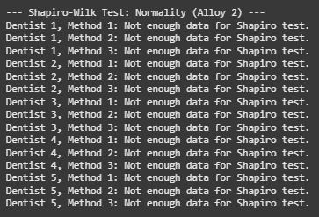

- QQ plots for normality per group for Alloy 2:
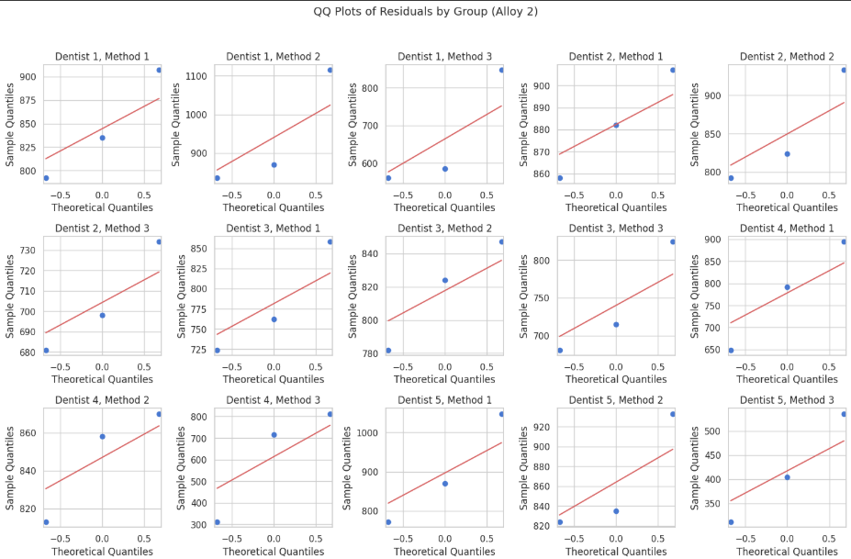

Homogeneity:
- Levene's test results for homogeneity of variances across groups (Dentist, Method) for Alloy 2:


Residual Diagnostics:
- Residuals vs fitted, histogram of residuals, scale-location plots for Alloy 2:
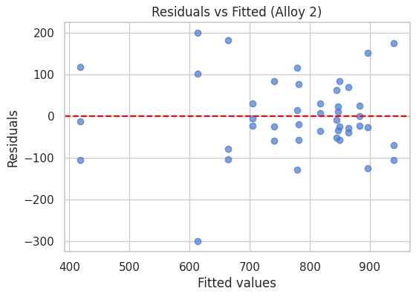
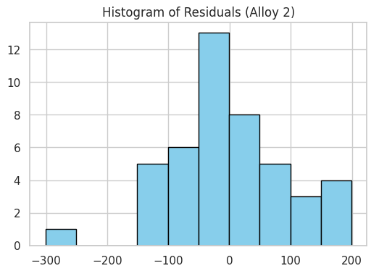
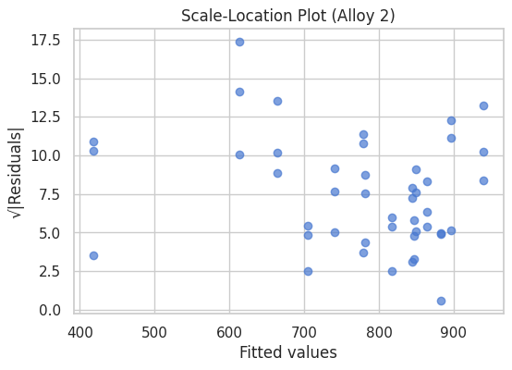

Impact of Dentist on Implant Hardness (One-Way ANOVA)
- One-Way ANOVA table and conclusion for the effect of Dentist on Alloy 2 hardness:
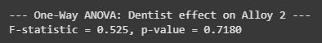
The ANOVA test produced an F-statistic of 0.525 with a p-value of 0.7180, which is much greater than the 0.05 significance threshold. Therefore, we fail to reject the null hypothesis and conclude that there is no statistically significant difference in mean implant hardness across dentists for Alloy 2.

- Tukey's HSD test results identifying specific pairs of dentists with significantly different outcomes for Alloy 2:
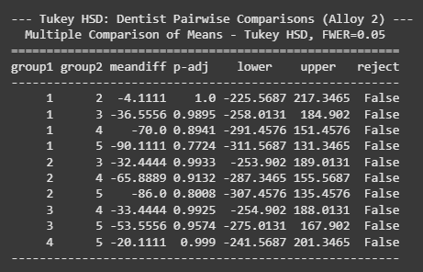
The Tukey HSD post-hoc test further supports this conclusion, as all pairwise comparisons between dentists yielded non-significant results (p-values all > 0.77).
- Business Insight:
For Alloy 2, dentist-related variation does not significantly influence implant hardness. This implies that outcomes are consistent across dentists, and Zingaro can focus on optimizing other factors—such as the implant method or material properties—rather than individual dentist performance when dealing with Alloy 2.

Impact of Method on Implant Hardness (One-Way ANOVA)

- One-Way ANOVA table and conclusion for the effect of Method on Alloy 2 hardness:

The ANOVA test yielded an F-statistic of 16.411 with a p-value < 0.001, indicating a highly significant effect of Method on implant hardness for Alloy 2. This means that the choice of implant method substantially influences the hardness outcomes.

• Tukey's HSD test results identifying specific pairs of methods with significantly different outcomes for Alloy 2:
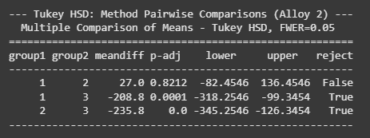
The Tukey HSD post-hoc test further revealed that:
- There is no significant difference between Methods 1 and 2 (p = 0.8212).
- Both Method 1 vs Method 3 (p = 0.0001) and Method 2 vs Method 3 (p < 0.001) show statistically significant differences, with Method 3 producing much lower hardness values compared to Methods 1 and 2.
- Business Insight:
These results indicate that Method 3 is unsuitable for achieving the desired implant hardness with Alloy 2, whereas Methods 1 and 2 perform comparably well. Zingaro should consider phasing out Method 3 for Alloy 2 implants and standardizing on Methods 1 and 2 to ensure consistent and high-quality outcomes.

Interaction Effect of Dentist and Method

- Interaction plot displaying implant hardness (response) against Dentist:
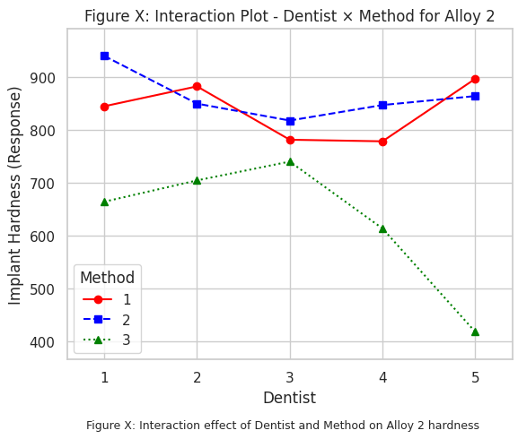

Combined Impact Analysis (Two-Way ANOVA)

- Two-Way ANOVA table/results for Alloy 2, including F-statistics and p-values for Dentist, Method, and their interaction:

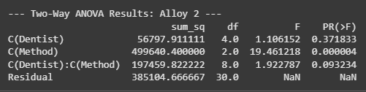

The two-way ANOVA results show that:
- Dentist effect: The main effect of Dentist was not statistically significant (F = 1.106, p = 0.372). This indicates that different dentists did not significantly influence implant hardness when working with Alloy 2.
- Method effect: The main effect of Method was highly significant (F = 19.461, p < 0.001). This confirms that the choice of implant method strongly impacts hardness outcomes for Alloy 2.
- Interaction effect: The Dentist × Method interaction was not significant (F = 1.923, p = 0.093). This suggests that the effect of Method on hardness is consistent across dentists, with no evidence that certain dentists perform differently depending on the method used.

- Post-hoc test results (e.g., Tukey HSD) for Alloy 2:

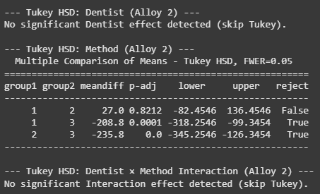
The Tukey HSD post-hoc test reinforced these findings:
- No significant differences were observed between Dentists.
- Significant pairwise differences were found between Method 3 and both Methods 1 and 2, with Method 3 yielding substantially lower hardness values.

- Business Insight:
For Alloy 2, dentist-specific training or variation is not a concern since performance is consistent across practitioners. However, Method choice is critical: Methods 1 and 2 deliver superior hardness, while Method 3 is unsuitable. Zingaro should standardize on Methods 1 and 2 for Alloy 2 implants and discontinue Method 3 to ensure reliable quality and client satisfaction.

Synthesis and Strategic Recommendations
By synthesizing the results from both alloys, we can provide holistic recommendations.

Example Findings Synthesis:
- Alloy 1:
- Dentist effect was significant, with clear differences in implant hardness between dentists. Certain dentists consistently produced higher hardness values, highlighting the role of operator technique and skill.
- Method effect was also significant. Some methods yielded higher hardness values, while others underperformed.
- Interaction effect (Dentist × Method) was significant, showing that the effectiveness of a method depends on the dentist performing it. Optimal hardness outcomes arise when specific dentists use certain methods.

- Alloy 2:
- Dentist effect was not significant. Implant hardness outcomes were consistent across dentists, indicating limited operator influence.
- Method effect was highly significant. Methods 1 and 2 performed comparably well, while Method 3 produced substantially lower hardness values and should be avoided.
- Interaction effect was not significant, showing that the effect of method choice on hardness is stable across dentists.

Recommendations:

- Standardize Best Practices for Alloy 1
  - Leverage the techniques of dentists who consistently achieve higher hardness outcomes as benchmarks for training.
  - Standardize the use of best-performing methods.
  - Incorporate Dentist–Method pairings into operating procedures to maximize implant quality and reduce variability.

- Optimize Method Selection for Alloy 2
  - Focus on Methods 1 and 2, which deliver reliable results across all dentists.
  - Discontinue or avoid Method 3 due to its consistently poor performance.
  - Since dentists do not significantly influence Alloy 2 outcomes, training resources can instead focus on ensuring proficiency with the recommended methods.

- Establish Method–Alloy Pairing Protocols
  - Clearly document which methods are optimal for each alloy.
  - Ensure dentists and technicians are trained to follow alloy-specific method protocols.

- Continuous Monitoring and Feedback
  - Implement an ongoing data collection and monitoring system for implant hardness.
  - Use statistical quality control to track outcomes, refine protocols, and detect performance drift early.
  - Provide regular feedback to dentists and update best practices based on the latest evidence.

- Table of recommended dentist×method combinations
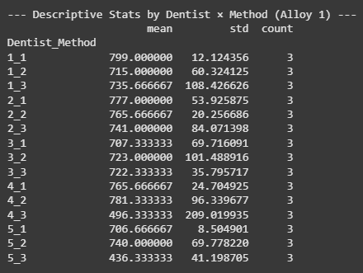
- effect sizes and confidence intervals:
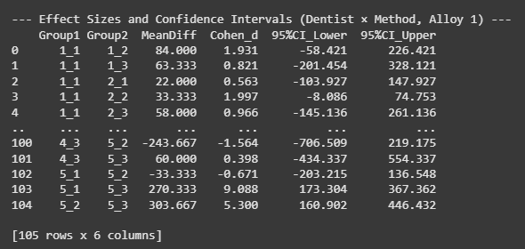

Conclusion

This report successfully applied a range of inferential statistical techniques to solve real-world business problems. From quantifying injury risk in professional sports to optimizing manufacturing quality and standardizing medical procedures, the analyses consistently yielded clear, data-driven insights. The key takeaway is that a structured, analytical approach can uncover patterns and relationships that are not apparent from surface-level observation, providing a competitive advantage and a solid foundation for strategic decision-making.

Actionable Recommendations Summary:

- Football Injuries: Implement targeted prevention programs for strikers and closely monitor their workload due to high injury risk. (Priority: High)

- Cement Packaging: Tighten supplier specifications, implement robust Incoming Quality Control (IQC), and consider Statistical Process Control (SPC) to reduce wastage. (Priority: High)

- Stone Printing: Reject unsuitable batches of unpolished stones and establish differentiated sourcing and quality assurance protocols for polished versus unpolished materials. (Priority: High)

- Dental Implants: Standardize implant procedures based on optimal dentist-method-alloy combinations and provide targeted training to enhance implant hardness consistently across the clinic. (Priority: High)

Limitations and Future Work:
- The current analysis is based on available historical data; future work could involve real-time monitoring and predictive modelling.
- For Problem 2, using raw sample data instead of given population parameters would allow for confidence interval estimation.
- Further investigation into the root causes of striker injuries (e.g., type of injury, specific movements) could provide even more granular recommendations.
- Exploration of additional factors (e.g., patient age, bone density, post-operative care) could further refine the dental implant optimization.

Appendix

List of Figures
- Figure 1: Contingency table (formatted). Page 17
- Figure 2: Stacked bar: Injured vs Not Injured by Position. Page 19
- Figure 3: Mosaic / heatmap of contingency. Page 19
- Figure 4: Recommended KPI dashboard mockup. Page 19
- Figure 5: Normal PDF with shaded region for P(X < 3.17). Page 29
- Figure 6: CDF with annotation for P(X ≥ 3.6). Page 29
- Figure 7: Zoomed PDF highlighting [5,5.5]. Page 29
- Figure 8: Histogram (simulated sample) with PDF overlay. Page 29
- Figure 9: Sample SPC chart screenshot. Page 29
- Figure 10: Histogram & boxplot of unpolished hardness with line at 150. Page 32
- Figure 11: Side-by-side boxplots of polished vs unpolished hardness. Page 32
- Figure 12: Interaction plot for Alloy 1 (Dentist & Method). Page 41
- Figure 13: Interaction plot for Alloy 2 (Dentist & Method). Page 41
- Figure 14: QQ plots for normality per group for Alloy 1. Page 41
- Figure 15: Residuals vs fitted, histogram of residuals, scale-location plots for Alloy 1. Page 41
- Figure 16: Boxplots by Dentist for Alloy 1. Page 41
- Figure 17: Boxplots by Method for Alloy 1. Page 41
- Figure 18: QQ plots for normality per group for Alloy 2. Page 41
- Figure 19: Residuals vs fitted, histogram of residuals, scale-location plots for Alloy 2. Page 41
- Figure 20: Boxplots by Dentist for Alloy 2. Page 41
- Figure 21: Boxplots by Method for Alloy 2. Page 41

List of Tables
- Table 1: Contingency Table of Player Injuries by Position. Page 17
- Table 2: Data dictionary (concise table). Page 9
- Table 3: Group summary (n, mean, sd) for unpolished stones. Page 32
- Table 4: One-sample t-test output (statistic, p, df, CI). Page 32
- Table 5: Group summary (n, mean, sd) for polished vs unpolished stones. Page 32
- Table 6: Shapiro-Wilk test results for normality for polished and unpolished stones. Page 32
- Table 7: Levene's test results for equality of variances for polished and unpolished stones. Page 32
- Table 8: Two-sample Welch t-test output (statistic, p, df, CI). Page 32
- Table 9: Effect size (Cohen's d) for Hardness Comparison (Problem 3.2). Page 32
- Table 10: Group sizes by Dentist and Method for Alloy 1. Page 41
- Table 11: Descriptive stats table: mean, sd, n by Dentist, by Method for Alloy 1. Page 41
- Table 12: One-Way ANOVA Results for Alloy 1 (Factor: Dentist). Page 41
- Table 13: Post-Hoc Test Results for Alloy 1 (Factor: Dentist). Page 41
- Table 14: One-Way ANOVA Results for Alloy 1 (Factor: Method). Page 41
- Table 15: Post-Hoc Test Results for Alloy 1 (Factor: Method). Page 41
- Table 16: Two-Way ANOVA table for Alloy 1. Page 41
- Table 17: Post-hoc test results for significant main effects/interaction levels for Alloy 1. Page 41
- Table 18: Group sizes by Dentist and Method for Alloy 2. Page 41
- Table 19: Descriptive stats table: mean, sd, n by Dentist, by Method for Alloy 2. Page 41
- Table 20: One-Way ANOVA Results for Alloy 2 (Factor: Dentist). Page 41
- Table 21: Post-Hoc Test Results for Alloy 2 (Factor: Dentist). Page 41
- Table 22: One-Way ANOVA Results for Alloy 2 (Factor: Method). Page 41
- Table 23: Post-Hoc Test Results for Alloy 2 (Factor: Method). Page 41
- Table 24: Two-Way ANOVA table for Alloy 2. Page 41
- Table 25: Post-hoc test results for significant main effects/interaction levels for Alloy 2. Page 41
- Table 26: Recommended dentist×method combinations with effect sizes and confidence intervals. Page 41

Reference ipynb notebook

This report only contains the output of the actual analysis. All the actual calculation and statistical analysis is performed in Google Colab Notebook in using python language.
A copy of the ipynb notebook is attached for cross referencing.

