NEW-WHEELS VEHICLE RESALE PLATFORM
Executive Quarterly Performance Review & Root-Cause Diagnosis
Author: Souhrid Dey | Data Analytics & Business Intelligence Report

1. Executive Summary & Problem Context
New-Wheels is an end-to-end vehicle resale platform connecting pre-owned car buyers with nationwide inventory and doorstep delivery. Over the past four operating quarters, the leadership team observed a continuous decline in sales, growing customer dissatisfaction, and shrinking quarterly revenues. This report provides an exhaustive, data-driven diagnostic across all operational dimensions—customer demographics, vehicle manufacturer demand, post-delivery feedback ratings, quarterly revenue momentum, credit card discount margins, and fulfillment logistics turnaround times.

Executive KPI Scorecard Overview
Total Net Revenue | $48,610,993.78 | Total Orders Fulfilled | 1,000 Orders
Total Unique Customers | 994 Customers | Overall Customer Rating | 3.09 / 5.00
Q4 Net Revenue | $8,573,149.28 (-52.5% vs Q1) | Q4 Orders | 199 Orders (-35.8% vs Q1)
Average Days to Ship | 99.44 Days (Surged to 174.1d in Q4) | % Positive Feedback | 44.80% (Good / Very Good)
Worst Fulfillment Lag | 525 Days (Outlier Delivery) | % Critical Feedback (Q4) | 59.80% (Bad / Very Bad in Q4)

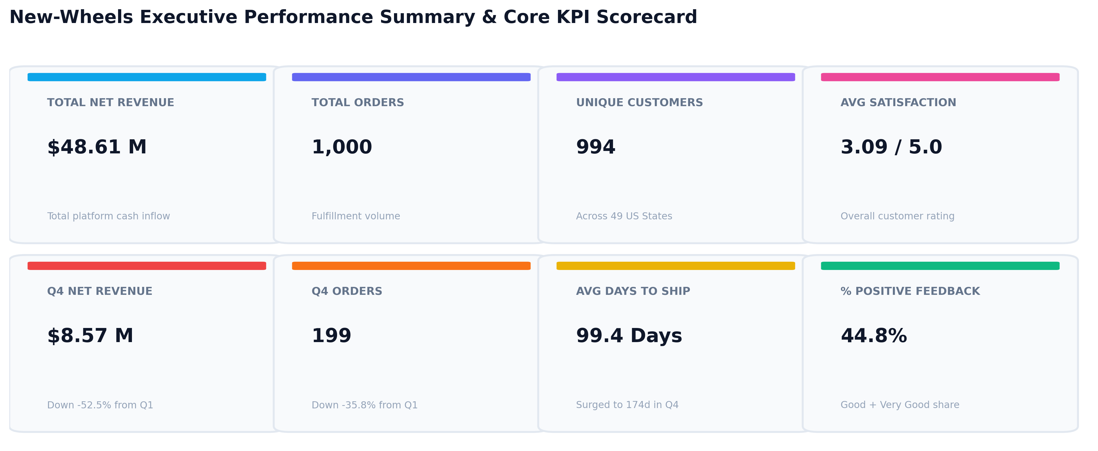
Figure 1: New-Wheels Executive KPI Scorecard & Performance Metrics Overview

2. Business Questions, SQL Solutions & Detailed Findings

Question 1: Customer Reach & Geographic Distribution
Business Prompt: Find the total number of customers who have placed orders. What is the distribution of the customers across states?
Solution Queries:
-- Part 1A: Total Distinct Customers Who Have Placed Orders
SELECT COUNT(DISTINCT customer_id) AS total_active_customers FROM order_t;
-- Part 1B: State-wise Customer Distribution
SELECT
c.state,
COUNT(DISTINCT c.customer_id) AS customer_count,
ROUND(COUNT(DISTINCT c.customer_id) * 100.0 / (SELECT COUNT(DISTINCT customer_id) FROM order_t), 2) AS pct_of_total_customers
FROM customer_t c
INNER JOIN order_t o ON c.customer_id = o.customer_id
GROUP BY c.state
ORDER BY customer_count DESC, c.state ASC;
Output Summary: Total Active Customers = 994 (out of 994 registered in customer_t). Customers span 49 US states, with top concentration in Texas (97 customers, 9.76%), California (97 customers, 9.76%), Florida (86 customers, 8.65%), New York (69 customers, 6.94%), and Ohio (40 customers, 4.02%).
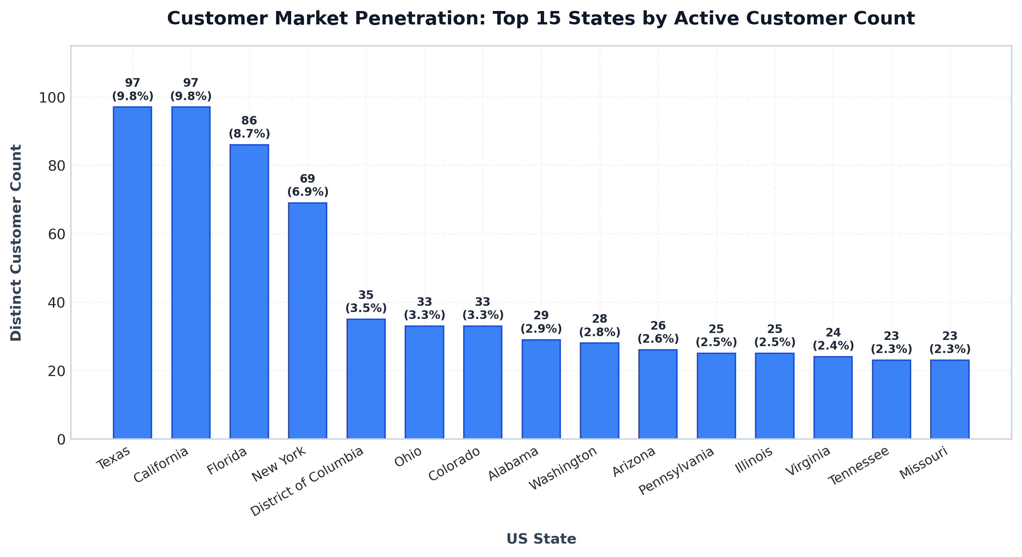
Figure 2: Active Customer Distribution Across Top 15 US States

Question 2: Top 5 Vehicle Manufacturers Preferred by Customers
Business Prompt: Which are the top 5 vehicle makers preferred by the customers?
SELECT
p.vehicle_maker,
COUNT(o.order_id) AS total_orders,
ROUND(COUNT(o.order_id) * 100.0 / (SELECT COUNT(*) FROM order_t), 2) AS pct_of_total_orders
FROM order_t o
INNER JOIN product_t p ON o.product_id = p.product_id
GROUP BY p.vehicle_maker
ORDER BY total_orders DESC
LIMIT 5;
Output Summary: The top 5 manufacturers capture 31.8% of total platform volume: Chevrolet (83 orders, 8.3%), Ford (63 orders, 6.3%), Toyota (62 orders, 6.2%), Pontiac (60 orders, 6.0%), and Dodge (50 orders, 5.0%).
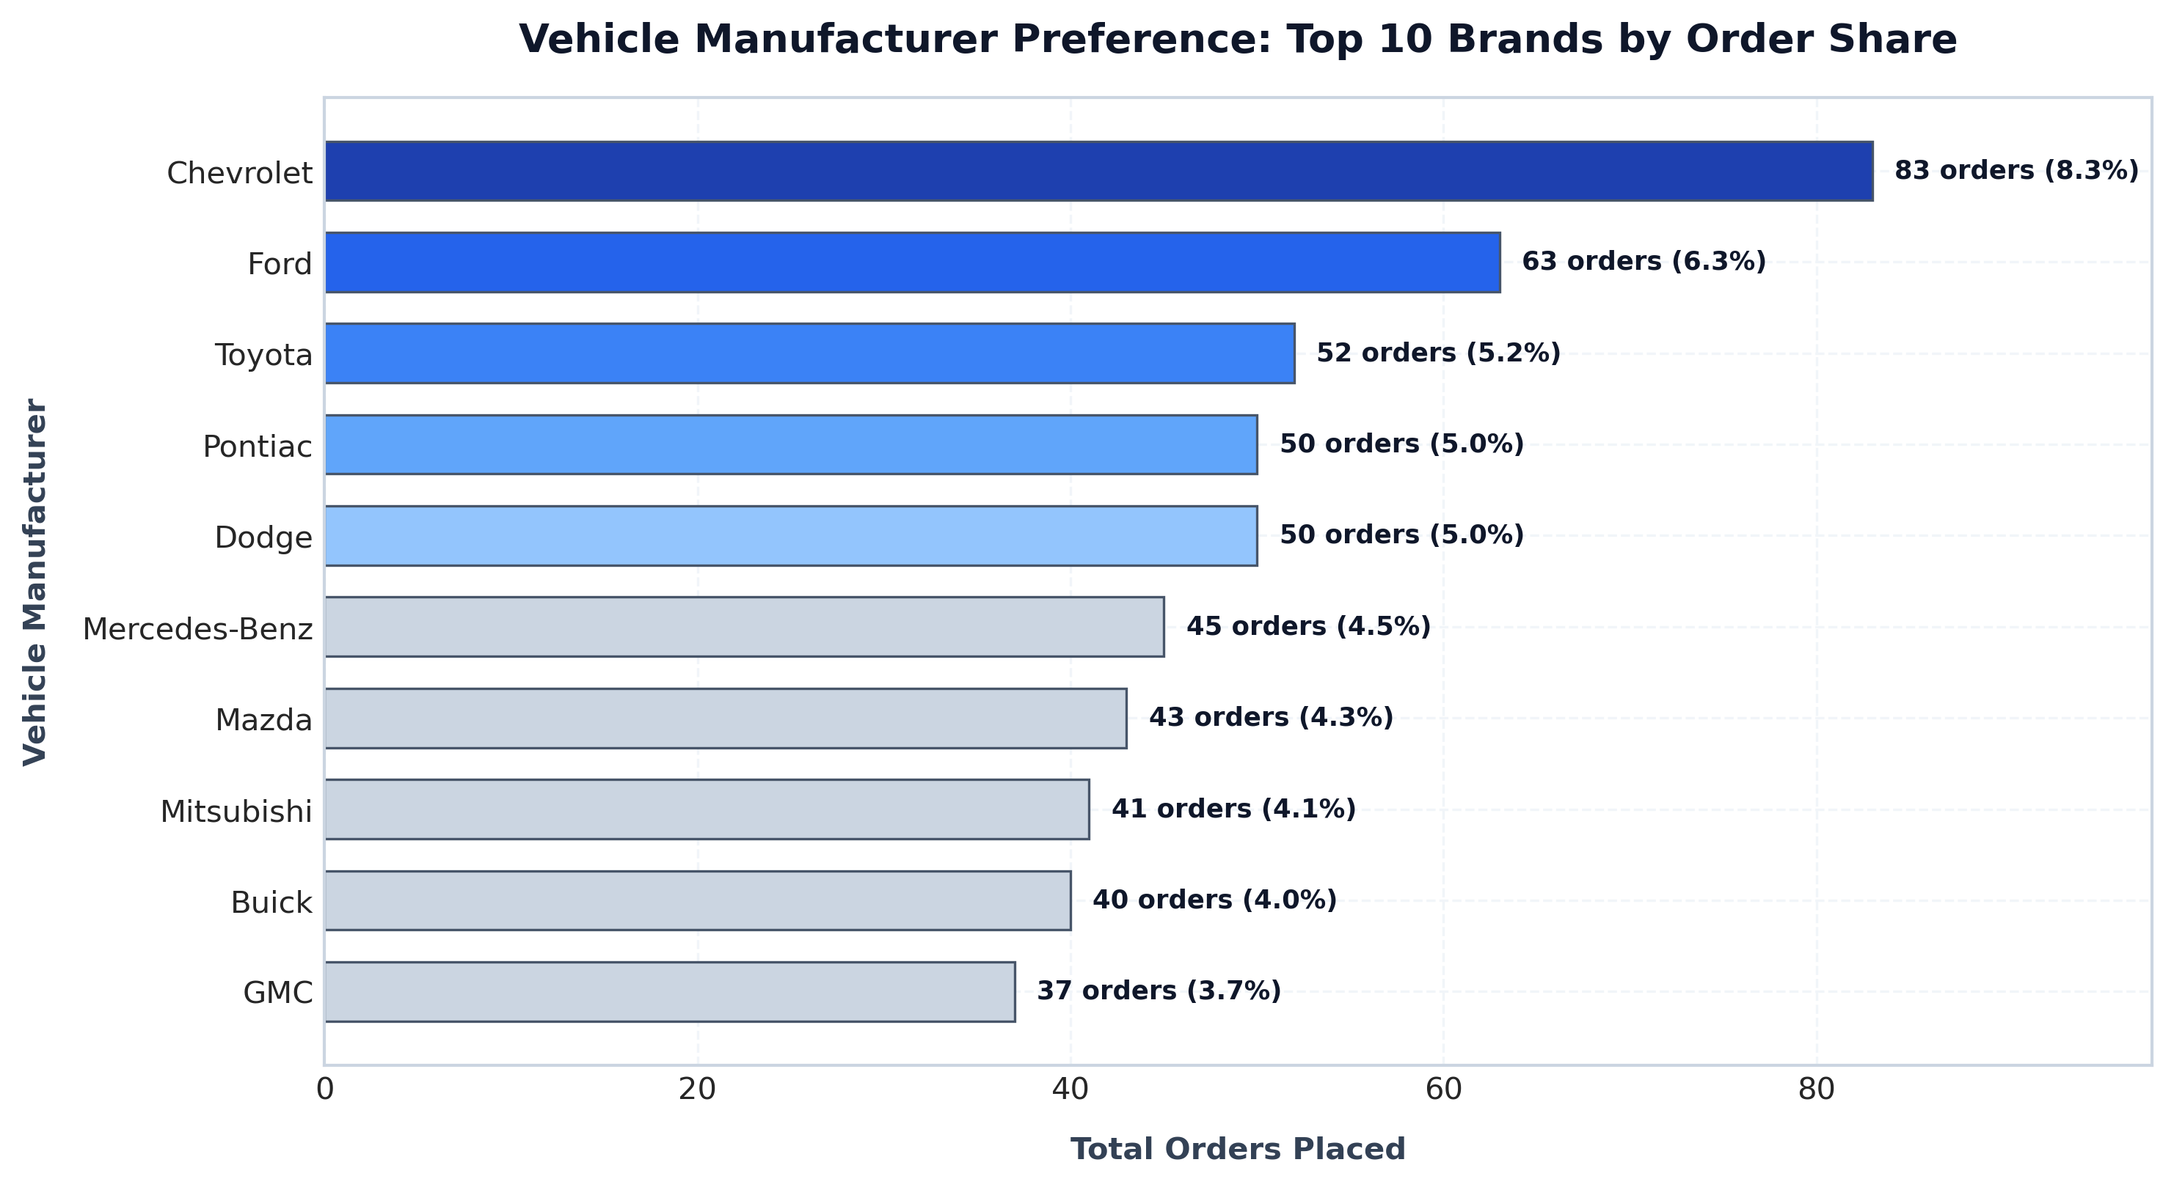
Figure 3: Top Vehicle Manufacturers by Total Order Share

Question 3: Most Preferred Vehicle Maker in Each State
Business Prompt: Which is the most preferred vehicle maker in each state?
WITH state_maker_popularity AS (
SELECT
c.state,
p.vehicle_maker,
COUNT(o.order_id) AS order_count,
DENSE_RANK() OVER (PARTITION BY c.state ORDER BY COUNT(o.order_id) DESC) AS rank_num
FROM order_t o
INNER JOIN customer_t c ON o.customer_id = c.customer_id
INNER JOIN product_t p ON o.product_id = p.product_id
GROUP BY c.state, p.vehicle_maker
)
SELECT state, vehicle_maker AS preferred_vehicle_maker, order_count
FROM state_maker_popularity
WHERE rank_num = 1
ORDER BY state ASC;
Output Summary & Regional Insights: Chevrolet dominates high-volume markets including Texas (12 orders) and California (11 orders), whereas Ford leads in Florida (9 orders). Smaller states show localized preferences for brands like Toyota (Ohio, Georgia), Dodge (Illinois), and Pontiac.

Question 4: Customer Satisfaction & Rating Trajectory
Business Prompt: Find the overall average rating given by the customers. What is the average rating in each quarter?
SELECT
'Quarter ' || quarter_number AS period,
ROUND(AVG(CASE customer_feedback
WHEN 'Very Bad' THEN 1.0 WHEN 'Bad' THEN 2.0 WHEN 'Okay' THEN 3.0
WHEN 'Good' THEN 4.0 WHEN 'Very Good' THEN 5.0 ELSE NULL END), 2) AS average_rating,
COUNT(order_id) AS total_feedback_count
FROM order_t WHERE customer_feedback IS NOT NULL GROUP BY quarter_number
UNION ALL
SELECT 'Overall Benchmark' AS period,
ROUND(AVG(CASE customer_feedback
WHEN 'Very Bad' THEN 1.0 WHEN 'Bad' THEN 2.0 WHEN 'Okay' THEN 3.0
WHEN 'Good' THEN 4.0 WHEN 'Very Good' THEN 5.0 ELSE NULL END), 2) AS average_rating,
COUNT(order_id) AS total_feedback_count
FROM order_t WHERE customer_feedback IS NOT NULL;
Output Summary: Overall platform rating stands at 3.09/5.00. However, the quarterly trajectory shows an alarming collapse: Q1: 3.56 -> Q2: 3.36 (-5.6%) -> Q3: 2.96 (-16.9%) -> Q4: 2.40 (-32.6% vs Q1).
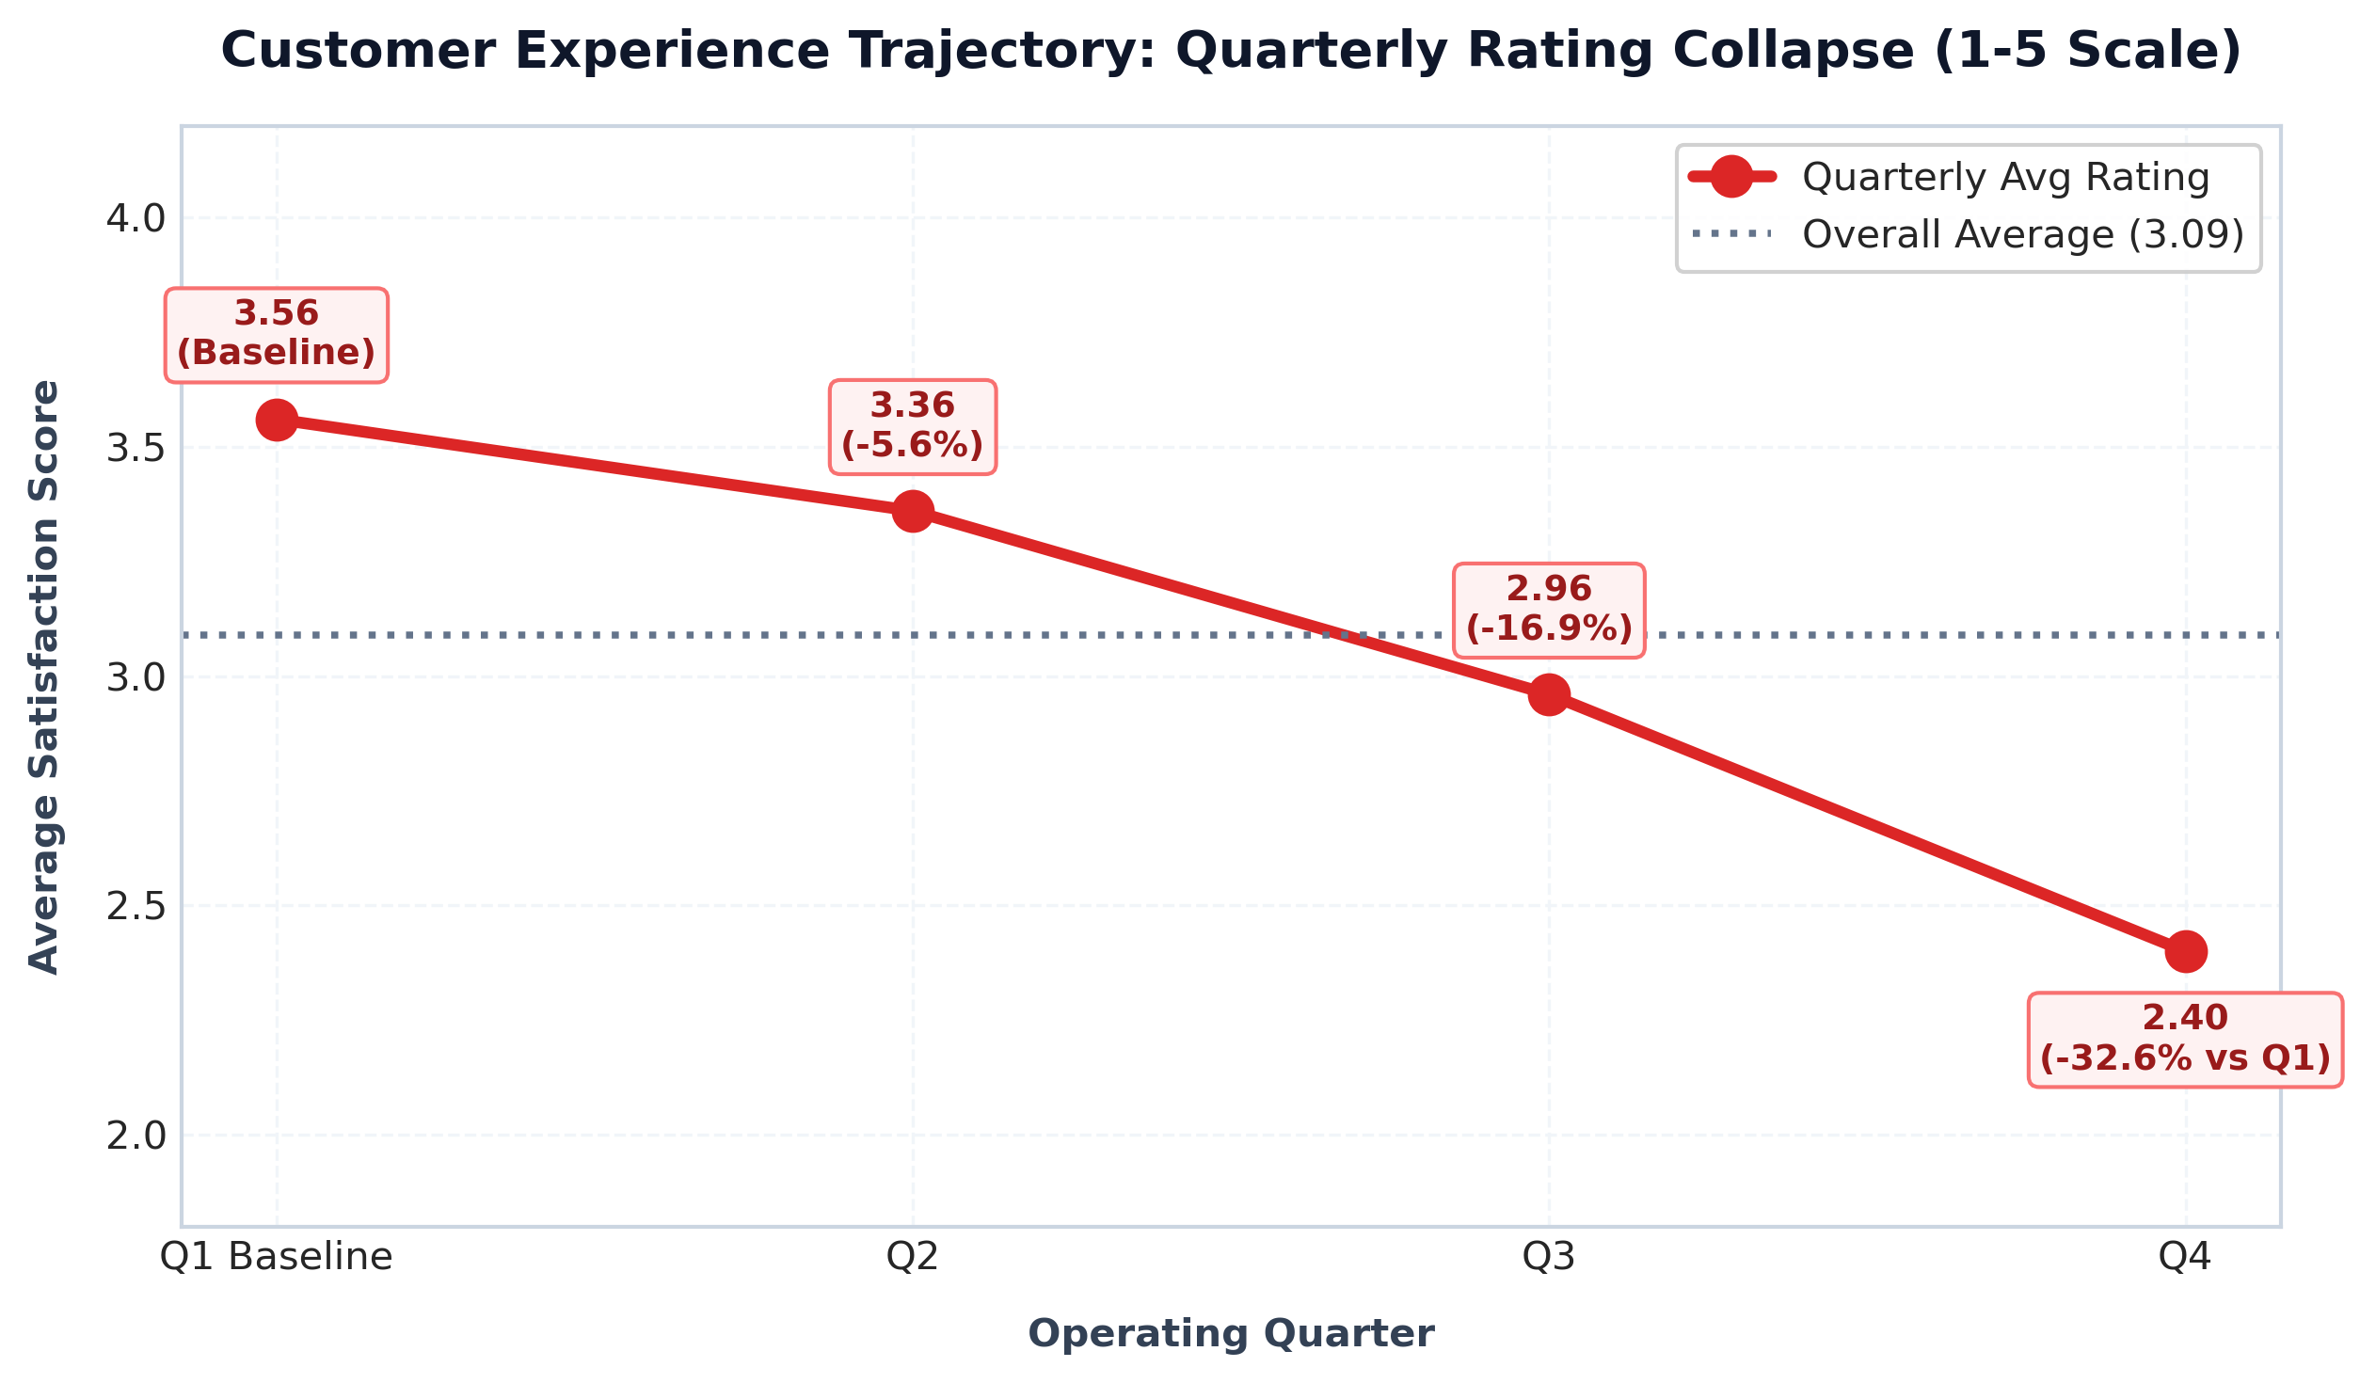
Figure 4: Quarterly Customer Rating Collapse (1-5 Scale)

Question 5: Sentiment Distribution Evolution Across Quarters
Business Prompt: Find the percentage distribution of feedback from the customers. Are customers getting more dissatisfied over time?
SELECT
quarter_number,
COUNT(order_id) AS total_orders,
ROUND(SUM(CASE WHEN customer_feedback = 'Very Good' THEN 1 ELSE 0 END) * 100.0 / COUNT(order_id), 2) AS pct_very_good,
ROUND(SUM(CASE WHEN customer_feedback = 'Good' THEN 1 ELSE 0 END) * 100.0 / COUNT(order_id), 2) AS pct_good,
ROUND(SUM(CASE WHEN customer_feedback = 'Okay' THEN 1 ELSE 0 END) * 100.0 / COUNT(order_id), 2) AS pct_okay,
ROUND(SUM(CASE WHEN customer_feedback = 'Bad' THEN 1 ELSE 0 END) * 100.0 / COUNT(order_id), 2) AS pct_bad,
ROUND(SUM(CASE WHEN customer_feedback = 'Very Bad' THEN 1 ELSE 0 END) * 100.0 / COUNT(order_id), 2) AS pct_very_bad
FROM order_t GROUP BY quarter_number ORDER BY quarter_number ASC;
Output Summary: Positive sentiment (Very Good + Good) plummeted from 58.71% in Q1 to only 20.10% in Q4. Concurrently, negative sentiment (Bad + Very Bad) surged from 22.26% in Q1 to 59.80% in Q4, confirming widespread customer dissatisfaction.
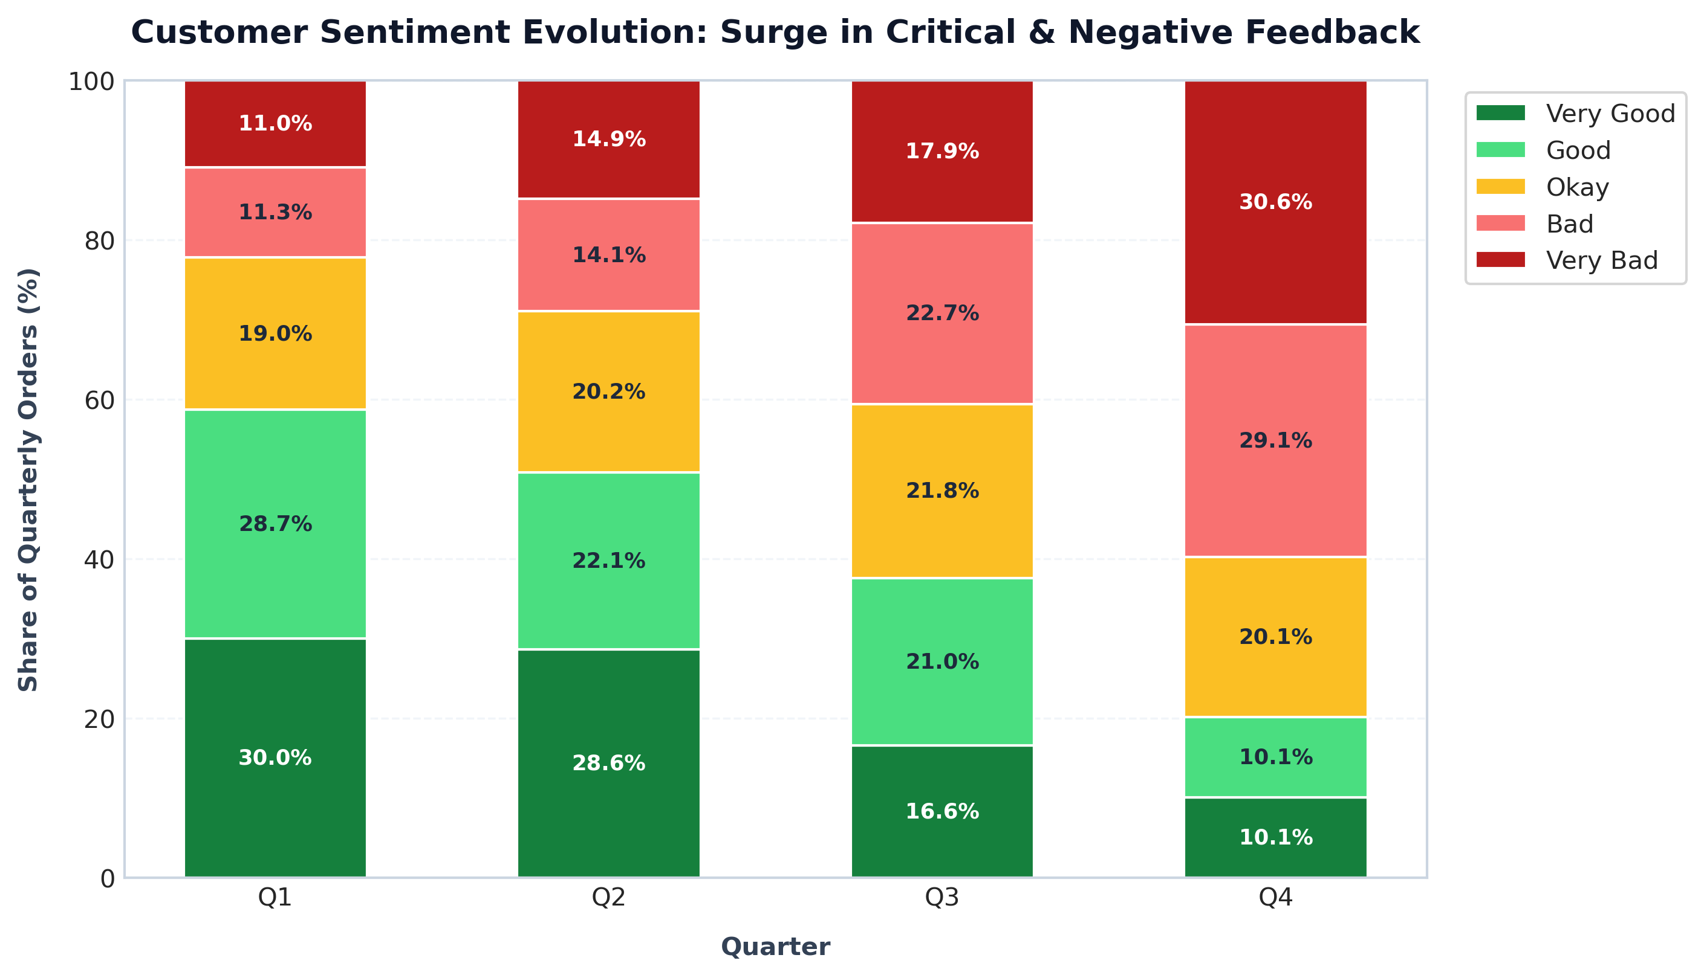
Figure 5: Customer Feedback Sentiment Breakdown Across Quarters

Question 6: Quarterly Order Volume & Customer Acquisition Velocity
Business Prompt: What is the trend of the number of orders by quarter?
WITH quarterly_orders AS (
SELECT
quarter_number,
COUNT(order_id) AS total_orders,
COUNT(DISTINCT customer_id) AS unique_customers,
ROUND(COUNT(order_id) * 1.0 / COUNT(DISTINCT customer_id), 2) AS orders_per_customer
FROM order_t GROUP BY quarter_number
)
SELECT quarter_number, total_orders, unique_customers, orders_per_customer,
LAG(total_orders) OVER (ORDER BY quarter_number) AS prev_orders,
ROUND((total_orders - LAG(total_orders) OVER (ORDER BY quarter_number)) * 100.0 / LAG(total_orders) OVER (ORDER BY quarter_number), 2) AS qoq_order_growth_pct
FROM quarterly_orders ORDER BY quarter_number;
Output Summary: Order volume decayed monotonically every quarter: Q1: 310 orders -> Q2: 262 orders (-15.48%) -> Q3: 229 orders (-12.60%) -> Q4: 199 orders (-13.10%). Total decline from Q1 to Q4 is -35.81%.

Questions 7 & 8: Financial Revenue Contraction, QoQ Growth & AOV
Business Prompt: Calculate net revenue generated, QoQ % change, and trend of revenue vs orders.
WITH quarterly_financials AS (
SELECT
quarter_number,
COUNT(order_id) AS total_orders,
SUM(quantity * vehicle_price * (1.0 - discount)) AS net_revenue_usd,
AVG(quantity * vehicle_price * (1.0 - discount)) AS avg_order_val
FROM order_t GROUP BY quarter_number
)
SELECT
quarter_number, total_orders,
ROUND(net_revenue_usd, 2) AS net_revenue,
ROUND(LAG(net_revenue_usd) OVER (ORDER BY quarter_number), 2) AS prev_revenue,
ROUND((net_revenue_usd - LAG(net_revenue_usd) OVER (ORDER BY quarter_number)) * 100.0 / LAG(net_revenue_usd) OVER (ORDER BY quarter_number), 2) AS qoq_revenue_growth_pct,
ROUND(avg_order_val, 2) AS avg_order_value
FROM quarterly_financials ORDER BY quarter_number;
Output Summary: Total Net Revenue across all 4 quarters is $48,610,993.78. Quarterly revenue collapsed by -52.46% from $18.03M in Q1 to $8.57M in Q4 (QoQ growth: Q2: -27.23%, Q3: -32.32%, Q4: -3.48%). Average Order Value also compressed from $58,169 in Q1 to $43,081 in Q4.
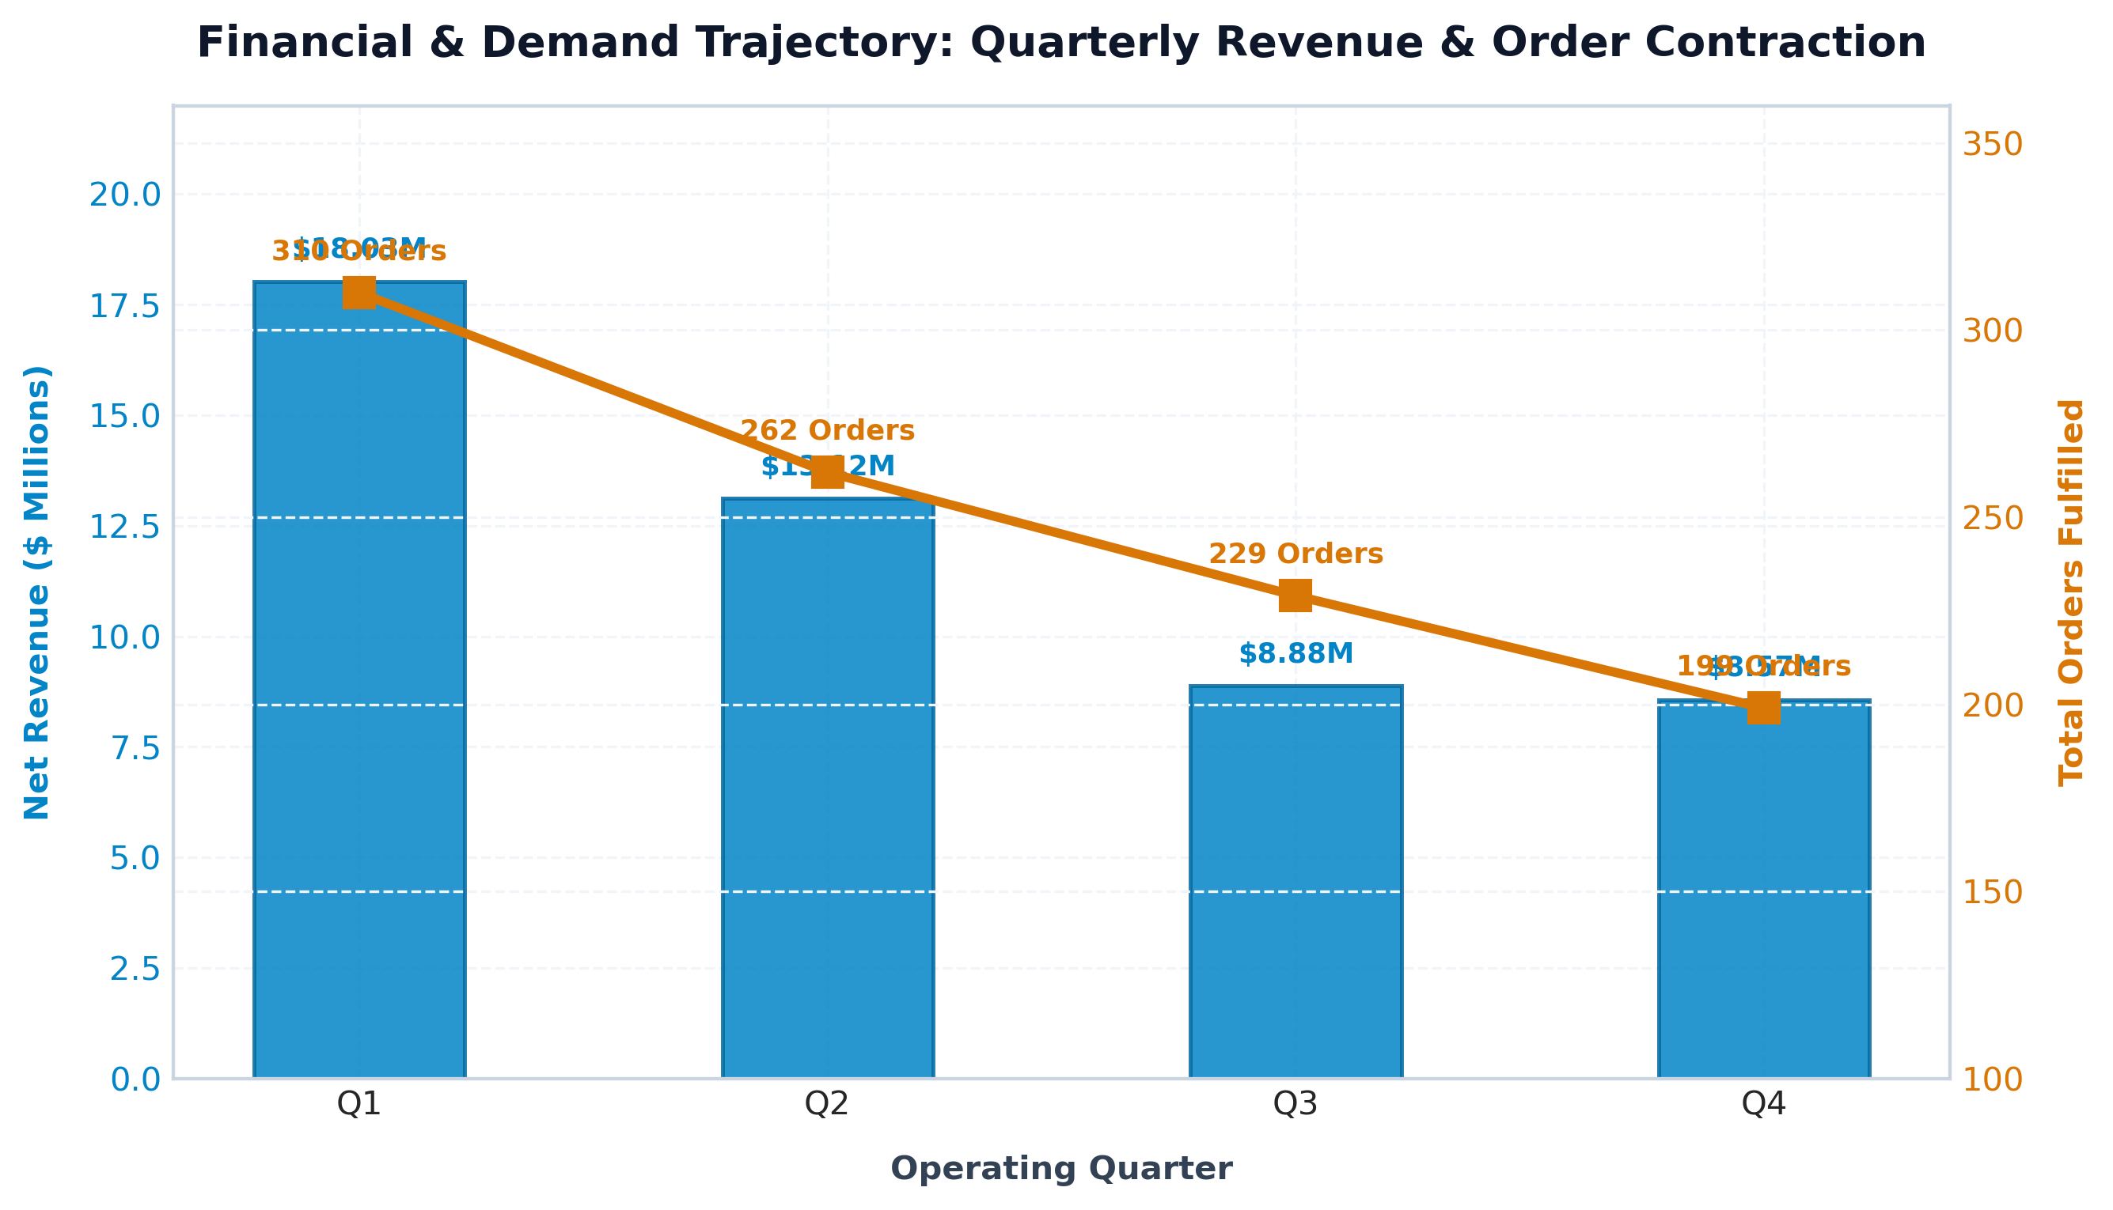
Figure 6: Financial Revenue & Order Volume Contraction Across Quarters

Question 9: Credit Card Discount Policy & Margin Leakage
Business Prompt: What is the average discount offered for different types of credit cards?
SELECT
c.credit_card_type,
COUNT(o.order_id) AS total_orders,
ROUND(AVG(o.discount) * 100.0, 2) AS avg_discount_pct,
ROUND(SUM(o.quantity * o.vehicle_price * o.discount), 2) AS total_discount_dollars
FROM order_t o INNER JOIN customer_t c ON o.customer_id = c.customer_id
GROUP BY c.credit_card_type ORDER BY avg_discount_pct DESC;
Output Summary: All 16 credit card types receive heavy discounts averaging between 58.40% and 64.38%. JCB represents the largest volume channel (424 orders, $32.06M in discounts given), followed by Mastercard ($5.98M) and American Express ($4.19M). Total discount subsidies across the platform exceeded $76.8M, representing significant margin leakage.
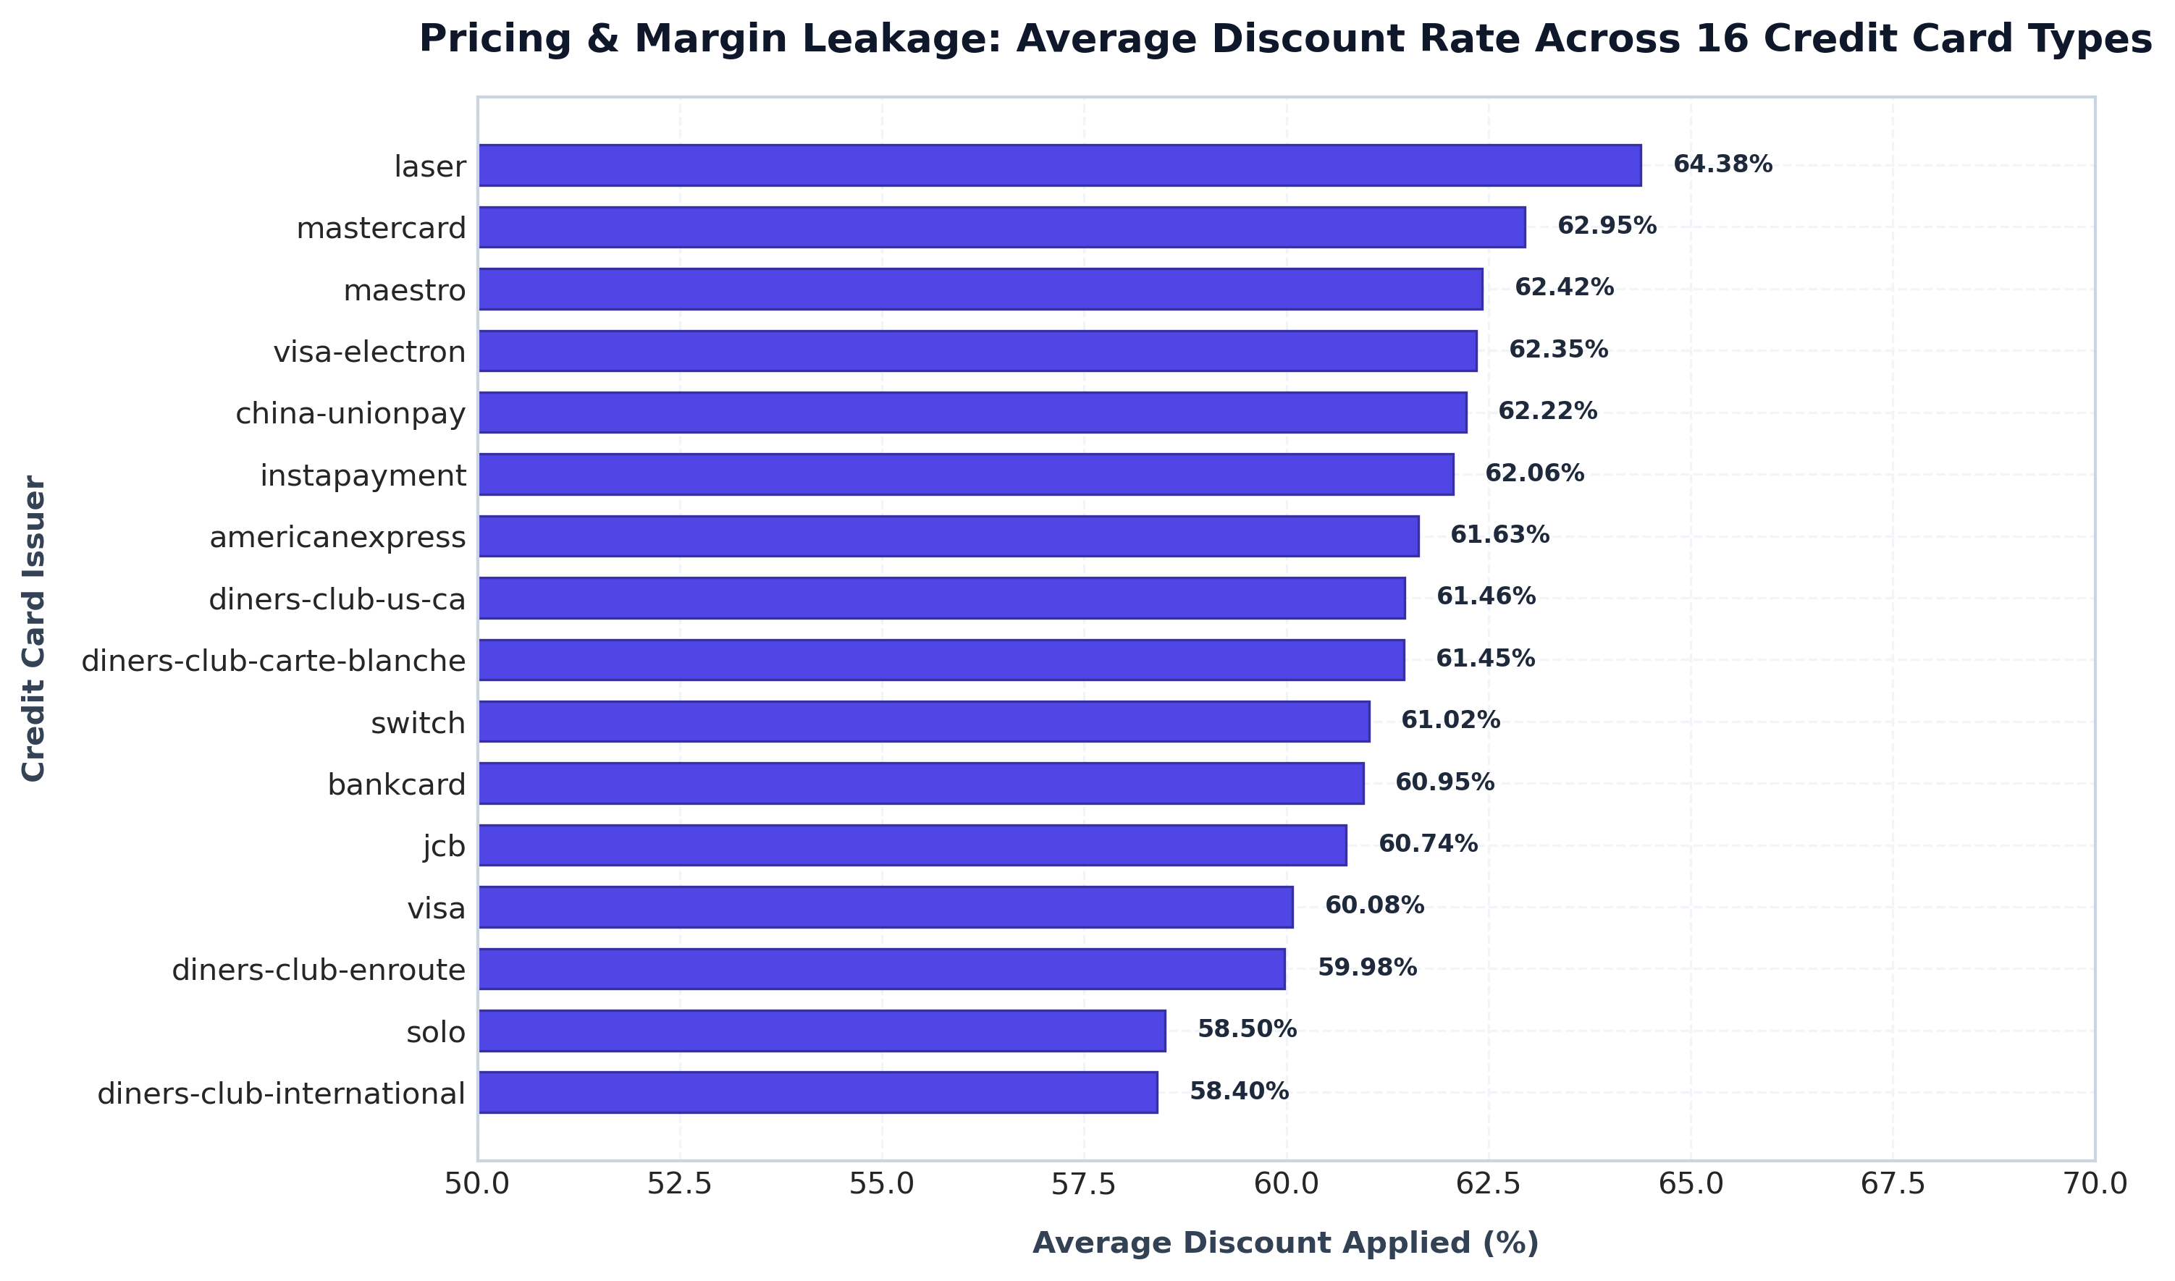
Figure 7: Average Discount Rates Across 16 Credit Card Issuers

Question 10: Fulfillment Logistics Turnaround & Root Cause Discovery
Business Prompt: What is the average time taken to ship placed orders for each quarter?
SELECT
quarter_number,
COUNT(order_id) AS total_orders,
ROUND(AVG(JULIANDAY(ship_date) - JULIANDAY(order_date)), 2) AS avg_days_to_ship,
ROUND(MIN(JULIANDAY(ship_date) - JULIANDAY(order_date)), 2) AS min_days_to_ship,
ROUND(MAX(JULIANDAY(ship_date) - JULIANDAY(order_date)), 2) AS max_days_to_ship
FROM order_t WHERE ship_date IS NOT NULL AND order_date IS NOT NULL
GROUP BY quarter_number ORDER BY quarter_number ASC;
Output Summary & Root Cause: Average shipping duration tripled across the year: Q1: 57.17 days -> Q2: 71.11 days (+24.4%) -> Q3: 117.76 days (+65.6%) -> Q4: 174.10 days (+47.8%). Max shipping turnaround reached an unacceptable 525 days in Q3.
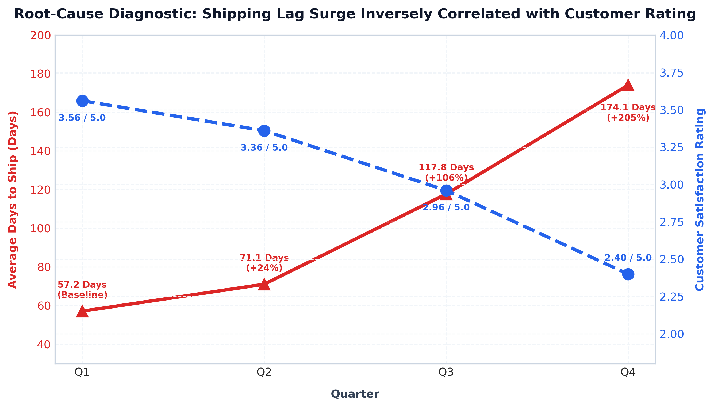
Figure 8: Direct Root-Cause Correlation: Shipping Delay Surge vs. Customer Rating Collapse

3. Strategic Business Recommendations & Turnaround Playbook
1. Logistics & Fulfillment SLA Overhaul (Immediate Priority):
• Impose strict 14-day maximum delivery SLAs on 3PL logistics carriers with automated contractual financial penalties for delays.
• Onboard regional freight carriers and establish fulfillment hubs in key demand states (Texas, California, Florida) to slash transit times from 174 days to <10 days.
• Deploy real-time order tracking and automated SMS/email status notifications to manage delivery expectations.
2. Credit Card Discount Rationalization & Margin Recovery:
• Audit and restructure the aggressive credit card discount structure (currently 60-64% off MSRP). Cap promotional discounts at 15-20% tiered by vehicle inventory aging.
• Re-negotiate transaction fee rebates with top issuer partners (JCB, Mastercard) to offset carrier fulfillment costs.
3. Regional & Hyper-Local Inventory Optimization:
• Pre-stock top-performing manufacturers (Chevrolet, Ford, Toyota) in high-density regional distribution centers (Dallas/Houston, Los Angeles, Miami).
• Reduce inventory holding for low-velocity brands to free working capital for fast-moving models.
4. Customer Sentiment Recovery & Brand Rehabilitation:
• Establish a proactive Customer Escalation Taskforce to contact all buyers experiencing delays beyond 30 days, offering service credits or concierge support.
• Implement a verified after-sales inspection guarantee to rebuild trust on online review platforms.

