

2022

ITP4507

**REPORT**

**IT114015 2B**

**Ching Chun Hung 210020835**

Contents

**Introduction** **5**

**Assumptions regarding the problem context** **5**

User 5

Programmer 5

**Application design with class diagram** **6**

Building package 7

Command package 8

CommandFactory 8

Command 9

Memento Package 10

**Discussion and explanation on each of the design patterns applied to the application** **12**

Command package 12

Building package 13

Memento package 14

**User Guide** **15**

Create Building 15

Display Buildings 16

Modify Building 16

Edit rooms 17

Add room 18

Delete room 18

Modify room 18

Undo 19

Redo 19

List undo/redo 20

exit system 20

**Test Plan and Test Cases** **21**

Expected Output of normal flow 23

general test 23

display building test 25

modify building test 25

edit rooms test 26

undo/redo test 28

**Well documented Source Code** **30**

main.java 30

Building package 31

apartment.java 31

ApartmentFactory.java 32

Building.java 33

BuildingFactory.java 34

House.java 34

HouseFactory.java 35

Room.java 36

Command Package 37

AddroomsCommand 37

AddroomsCommandFactory 38

Command 38

CommandFactory 38

CreateBuildingCommand 39

CreateBuildingCommandFactory 40

DeleteroomsCommand 41

DeleteroomsCommandFactory 42

DisplayCommand 43

DisplayCommandFactory 44

EditRoomCommand 44

EditRoomCommandFactory 45

ExitCommand 46

ExitCommandFactory 46

ListUndoRedoCommand 46

ListUndoRedoCommandFactory 47

ModifyBuildingCommand 47

ModifyBuildingCommandFactory 49

ModifyroomsCommand 50

ModifyroomsCommandFactory 51

RedoCommand 51

RedoCommandFactory 52

UndoCommand 52

UndoCommandFactory 53

Memento Package 54

BuildingMemento 54

Caretaker 55

Memento 57

ModifyRoomMemento 58

# Introduction

Our company plans to develop a building management system (BMS) for maintaining different kinds of building records, However, the current exit system is not open-close. Thus, as a system analyst of the company I have been required to redesign and develop BMS with design patterns.

# 

# Assumptions regarding the problem context

## User

1. The user input a not exists command in the main system page.
2. The user input the not match the variable type.
3. The user does undo but the undo list is empty
4. The user does redo but the redo list is empty
5. The user input exists buildingNo while the building already exists.
6. The user input does not exist building id while in modify building
7. The user inputs an empty value when entering.
8. The user inputs negative about the number of rooms.
9. The user input does not exist in room id while in the editing room
10. The user wrong input the details of the building while selecting create building type.

## Programmer

1. The programmer hard to find the bug source and fix it.
2. It needs to change many codes when adding a new function
3. It is difficult for others to take over these codes and hard to maintain
4. The system is easier to problem appear when bigger.
5. It needs to add many codes when adding a new building type.

# 

# Application design with class diagram

# 

## Building package

There is the building package, there are 7 classes(BuildingFactory, ApartmentFactory, HouseFactory, Room, House, Apartment, and Building), there are natively provided classes apart from BuildingFactory, ApartmentFactory and HouseFactory, the aim is to create these objects, like create much building.

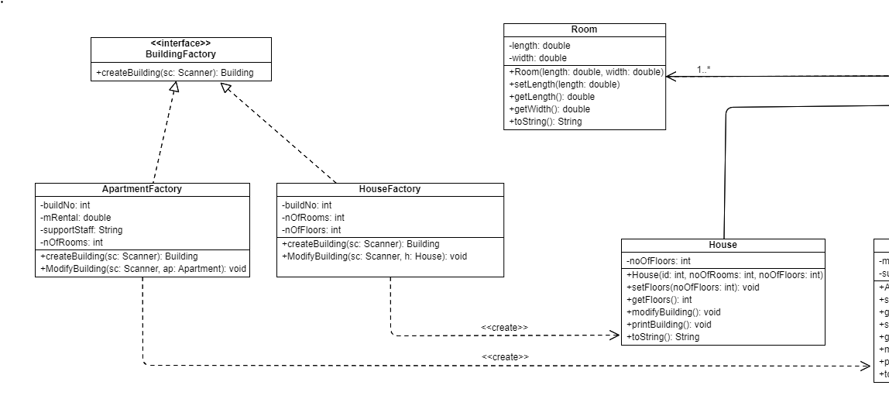

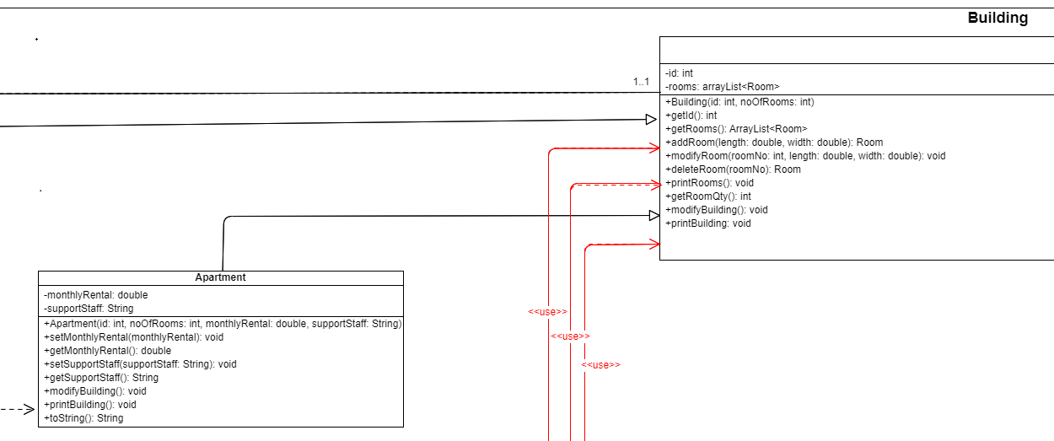

## 

## Command package

### CommandFactory

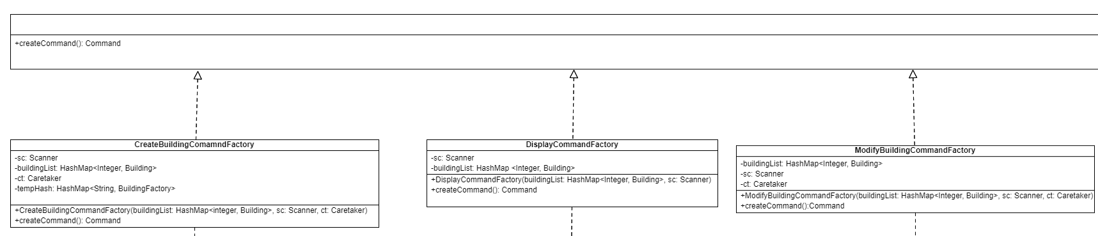

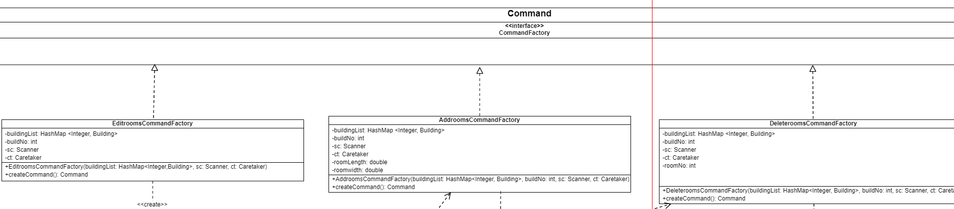

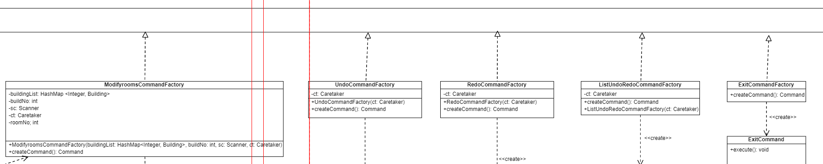

There is the command factory, these classes need to create many commands, such as create, edit, display and delete commands, etc. And these classes implement the Command Factory.

### 

### Command

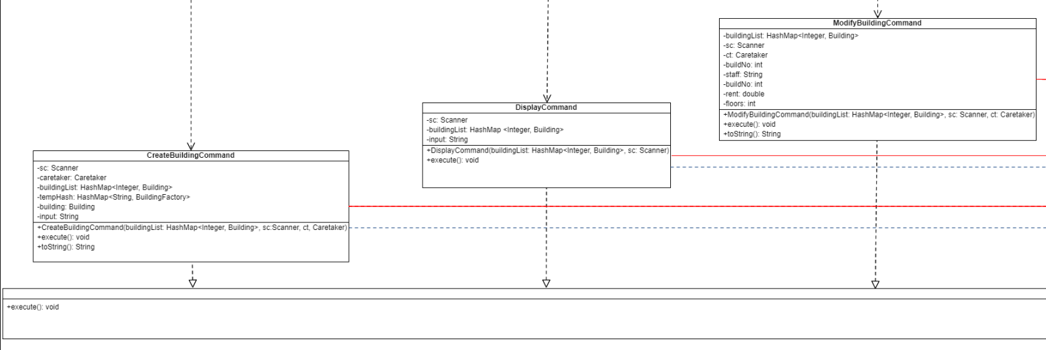

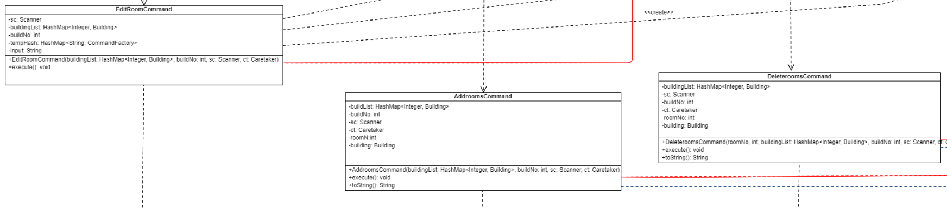

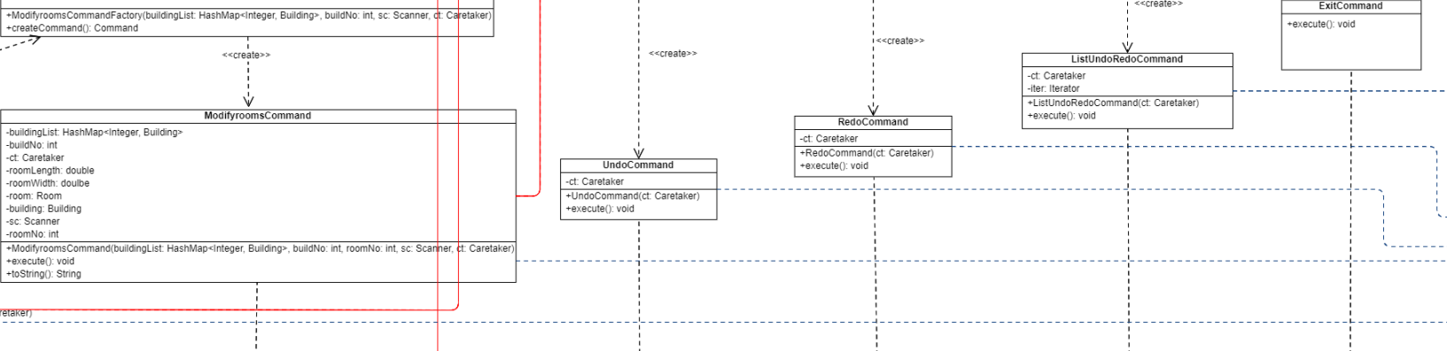

There are many commands, these command classes create by the command factory, and they will execute the command, for example, the exit command will execute the exit action. the system will run what command depending on user input.

Also, some command class use building classes in Building package, such as room command, modifyBuilding command.

## Memento Package

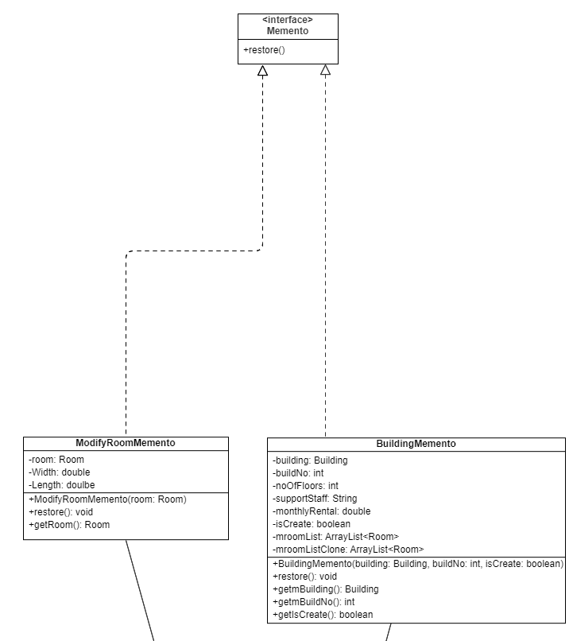

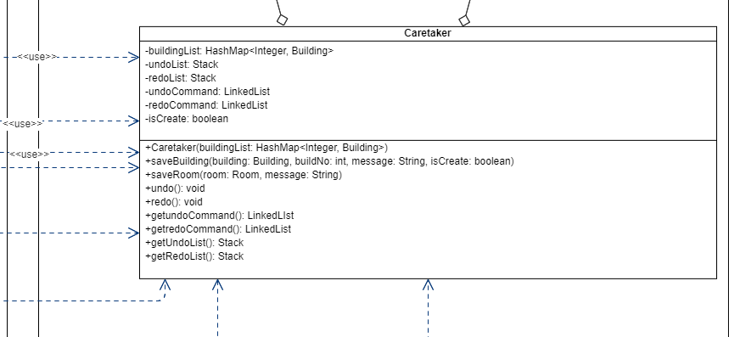

There are two memento classes to save state, BuildingMemento is saved add and modifyBuilding, also it saves add and deletes room too. And the ModifyRoomMemento is only a save modify room action.

Also, many command classes will use the caretaker class to save to memento and provide undo and redo functions.

# 

# Discussion and explanation on each of the design patterns applied to the application

## Command package

* The new system used a command pattern and factory pattern and declares an interface for all commands.
* The Command interface class provides an abstract execute() method.
* The CommandFactory is an abstract factory that declares an interface for providing the createcommand() method.
* ConcreeteFactory implements the operations to create concrete command objects. For example, createBuildingCommand will execute the command to create a different building using BuildingFactory.

**Why use command pattern and command factory In Command package:**

The system is more flexible to manage different command if the system needs to add other commands in the future, it just needs to create a new command and command factory, and easy to maintain.

## 

## Building package

* The new system used a factory pattern for building packages.
* BuildingFactory is an AbstractFactory that declares an interface for provide createbuilding() method
* ConcreteFactory in this system will implement the operation to create concrete building objects
* Building is an Abstractclass that declares an interface for the type of building object. Therefore Apartments and houses currently exist ConcreteProject that defines a building object to be created by the corresponding ConcreteFactory.
* Building is also an Originator that is used in Memento pattern.

**Why use factory pattern in Building package:**

It is because the system may not only have two types of building in the future, factory patterns can let the system minimize code duplication, if the system needs to add a new building, just extend a factory class, this is faster than the now method.

## 

## Memento package

* The System uses the Memento pattern to provide save state, undo and redo functions.
* The memento is another object that saves the current state of the object, and provides restore() method to return the state of the object, and getIscreate() method to identify the state of an object that has been created.
* There are two mementos (BuildingMemento & ModifyRoomMemento). Also, there has a memento interface to give an abstract method.
* The BuildingMemento saves the state of the building, it includes creating and modify the building, and also it saves add room and deletes room of the building.

The ModifyRoomMemento only saves the state when the user modifies the room.

* Caretaker manages the timing of the saving of the state of building, saves the Memento and, if needed, uses Memento to restore the state of the building.

**Why use Memento pattern:**

**Memento pattern can provided a undo & redo function to avoid the user creating a wrong building, the user just need to enter undo command to go back to the previous action.**

# 

# 

# User Guide

## Create Building

First you need to input “a” to start to add building command

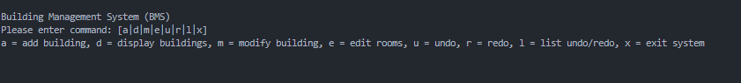

The System will ask you for Building Type, you can type “a” or “h” to create an Apartment or house.



Don’t worry to input wrong type



When you enter “a” to create apartment, the system will ask you building no, monthly rental, and support staff, just follow the system text to input.

After that, the system will ask you the number of rooms, it will ask you “n” times length and width when you input “n” number of rooms.

Finally, the building is created and the system will print the building detail to show you.

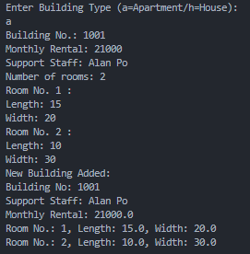

When you enter “h” to create house, system will ask you about Building no and the number of floors, and the create room method is the same as creating an apartment.

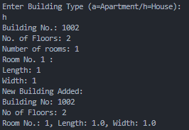

## Display Buildings

First you need to input “d” in the interface.

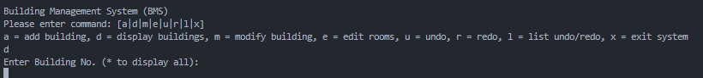

The system will ask you building no, you can enter a number or you can enter * to display all building. but display all will not show room detail.

It is display an error when the building not existing.



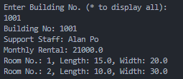

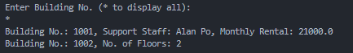

## Modify Building

First you need to input “m” in the interface.

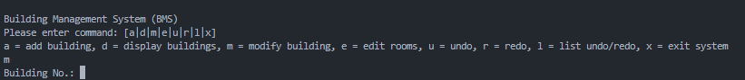

if the building No is a apartment, it will ask you the new value of monthly rental and support staff.

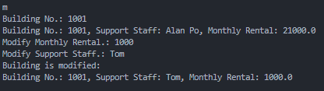

if the building No is a house, it will ask you the new value of number of floors.

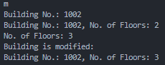

## Edit rooms

First you need to input “e” in the interface



The System will ask for your building no first, and the system will show add room, modify room and delete room commands.

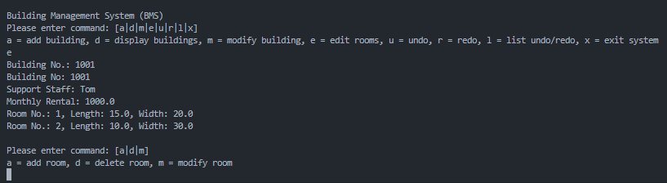

you can enter “a” to add room, “d” to delete room and “m” to modify room

### 

### Add room

The system will ask you for the Length and Width to add a new room, and the system will show new detail when you add a room successfully.

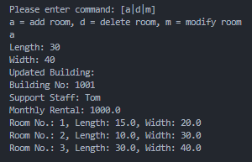

### Delete room

The system will ask you for a room number, and you can delete a existing room successfully

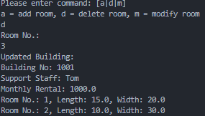

### Modify room

The system will ask you for a room number to modify, and you can input a new length and new width to modify the current room.

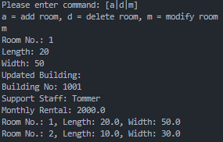

## Undo

First you need to input “u” in interface



It is successful if there is no any message

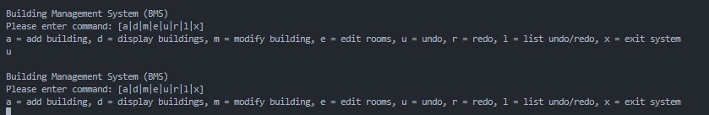

it will show “nothing undo” when you have never done add building, edit rooms and modify building.



## Redo

First you need to input “r” in interface



It is successful if there is no any message

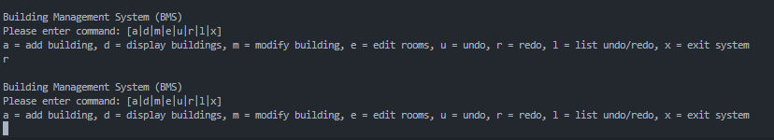

it will show “nothing redo” when you have never done undo command



## 

## 

## 

## List undo/redo

First you need to input “l” in interface



It will show all of undo and redo, you can see there are 8 things wait for undo in this image

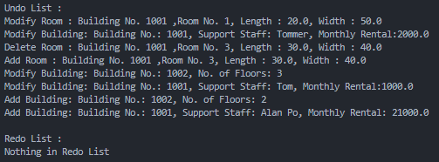

It will show “Nothing in Undo/Redo List” when no thing to undo or redo

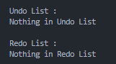

## exit system

First you need to input “x” in interface



You can see the interface has been closed when exit system

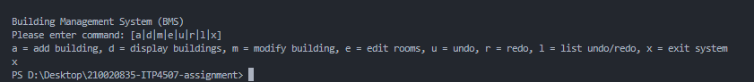

# 

# Test Plan and Test Cases

**–-general test –**

a

dddd ←-Wrong input

a

1000

5000

Tommer

1

10

20

r ←-should be empty

d

buildno ←-Wrong input

e

1000

c ←-Wrong input

j ←-Wrong input

a

30

40

a

h

1001

2

2

5

6

7

8

**—-display building test—**

d

100 ←-Wrong input

d

1000

d

*

**—-modify building test—**

m

1000

50000

Tom

m

1001

3

**—-edit rooms test—**

e

1000

a

50

50

e

1000

m

3

60

60

e

1000

d

3

**—-undo/redo test—**

l

u

u

u

l

d

1000

r

r

r

l

d

1000

x

## Expected Output of normal flow

### general test

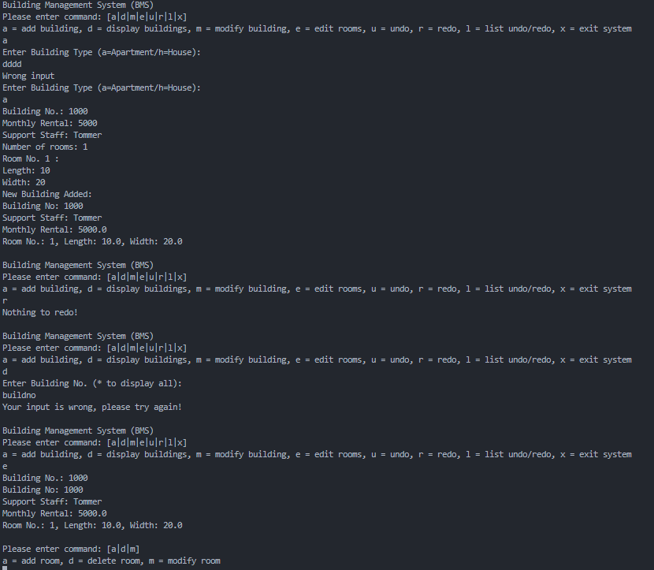

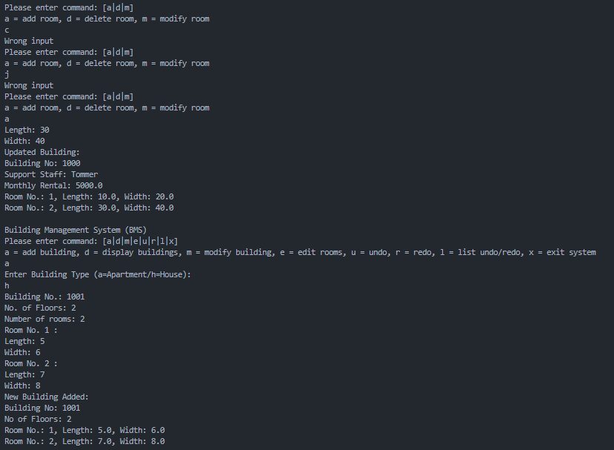

### display building test

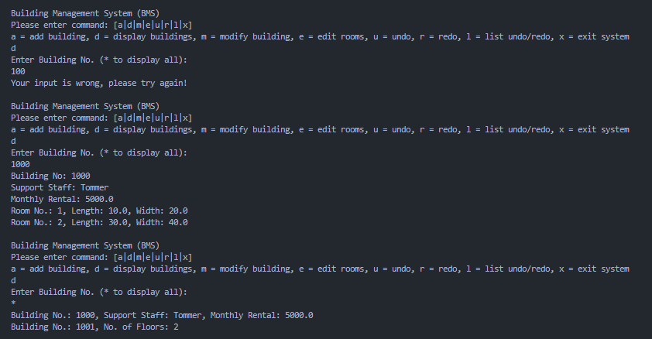

### modify building test

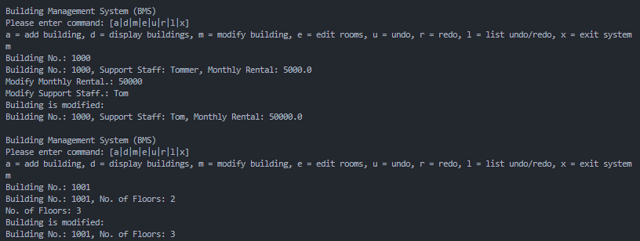

### edit rooms test

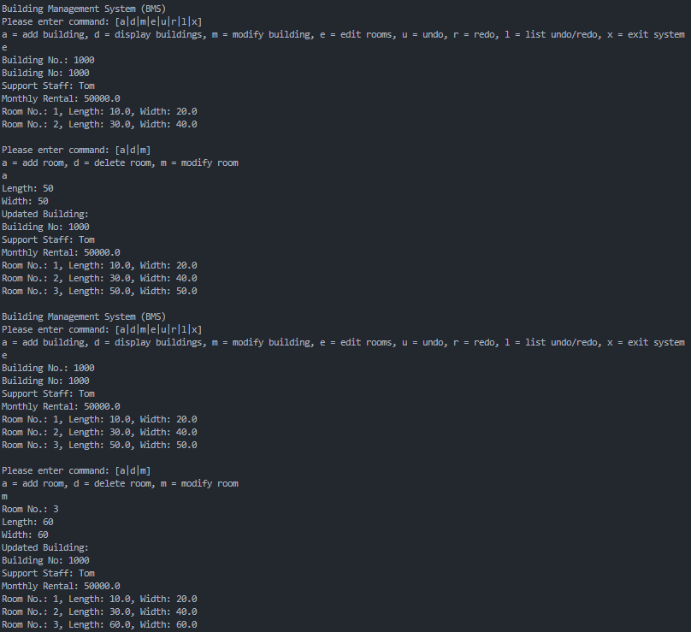

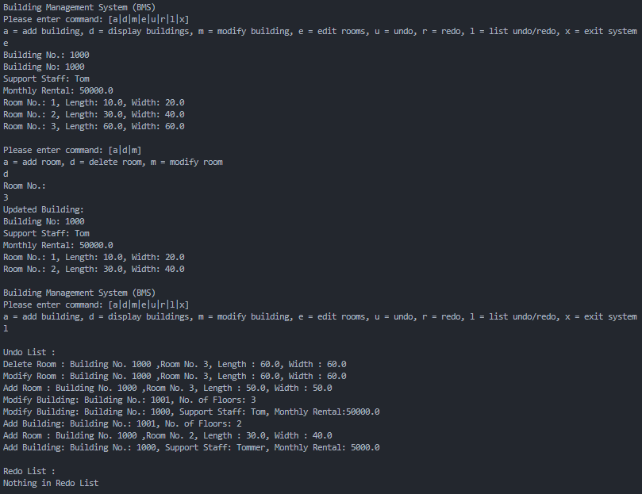

### undo/redo test

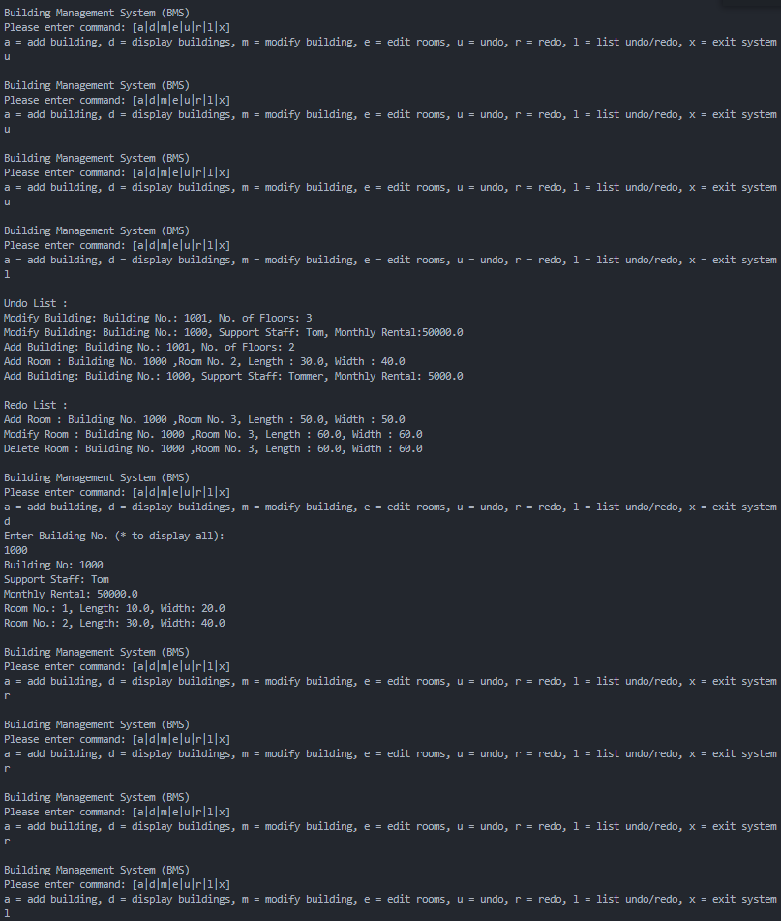

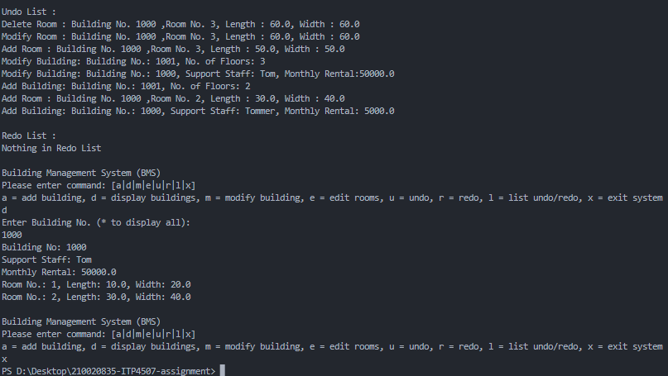

# 

# Well documented Source Code

### main.java

import java.util.*;

import Building.*;

import Command.*;

import Memento.*;

public class main {

public static Scanner sc = new Scanner(System.in);

public static void main(String[] args) throws ClassNotFoundException, InstantiationException, IllegalAccessException {

//a hashmap to store all building, the key is building number

HashMap<Integer, Building> buildingList = new HashMap<>();

Caretaker ct = new Caretaker(buildingList);

HashMap<String, CommandFactory> f = new HashMap<>();

f.put("a", new CreateBuildingCommandFactory(buildingList, sc, ct));

f.put("d", new DisplayCommandFactory(buildingList, sc));

f.put("m", new ModifyBuildingCommandFactory(buildingList, sc, ct));

f.put("e", new EditRoomCommandFactory(buildingList, sc, ct));

f.put("u", new UndoCommandFactory(ct));

f.put("r", new RedoCommandFactory(ct));

f.put("l", new ListUndoRedoCommandFactory(ct));

f.put("x", new ExitCommandFactory());

Command com;

String input;

while (true) {

try{

System.out.println(

"\nBuilding Management System (BMS) \n"+

"Please enter command: [a|d|m|e|u|r|l|x] \n"+

"a = add building, d = display buildings, m = modify building, e = edit rooms, u = undo, r = redo, l = list undo/redo, x = exit system"

);

input = sc.nextLine();

com = f.get(input).createCommand();

com.execute();

} catch(Exception e){

System.out.println("Your input is wrong, please try again!");

}

}

}

}

## Building package

### apartment.java

/*

Student: Ching Chun Hung 210020835 2B

Last Edit 13/11/2022

*/

package Building;

public class Apartment extends Building{

private double monthlyRental;

private String supportStaff;

public Apartment(int id, int noOfRooms, double monthlyRental, String supportStaff){

super(id, noOfRooms);

this.monthlyRental = monthlyRental;

this.supportStaff = supportStaff;

}

public void setMonthlyRental(double monthlyRental){

this.monthlyRental = monthlyRental;

}

public double getMonthlyRental(){

return this.monthlyRental;

}

public void setSupportStaff(String supportStaff){

this.supportStaff = supportStaff;

}

public String getSupportStaff(){

return this.supportStaff;

}

public void modifyBuilding(){

//the code was move to factory

}

public void printBuilding(){ //print with room and \n (long)

System.out.println("Building No: "+super.getId());

System.out.println("Support Staff: "+supportStaff);

System.out.println("Monthly Rental: "+monthlyRental);

super.printRooms();

}

public String toString(){ //print without room (short)

return "Building No.: "+super.getId()+", Support Staff: "+supportStaff+", Monthly Rental: "+monthlyRental;

}

}

### ApartmentFactory.java

package Building;

import java.util.Scanner;

public class ApartmentFactory implements BuildingFactory {

private int buildNo;

private double mRental;

private String supportStaff;

private int nOfRooms;

@Override

public Building createBuilding(Scanner sc) {

System.out.print("Building No.: ");

buildNo = sc.nextInt();

System.out.print("Monthly Rental: ");

mRental = sc.nextDouble();

System.out.print("Support Staff: ");

sc.nextLine();

supportStaff = sc.nextLine();

System.out.print("Number of rooms: ");

nOfRooms = sc.nextInt();

Building apartmentBuilding = new Apartment(buildNo, nOfRooms, mRental, supportStaff);

//Since you need to addRoom immediately after creating a building, and the Building class has this one method

for (int i = 1; i <= nOfRooms; i++) {

System.out.println("Room No. " + i + " :");

System.out.print("Length: ");

double Length = sc.nextDouble();

System.out.print("Width: ");

double Width = sc.nextDouble();

apartmentBuilding.addRoom(Length, Width);

}

System.out.println("New Building Added:");

apartmentBuilding.printBuilding();

sc.nextLine();

return apartmentBuilding;

}

//this factory provided modify building too (override the origin method)

public void ModifyBuilding(Scanner sc, Apartment ap) {

System.out.print("Modify Monthly Rental.: ");

ap.setMonthlyRental(sc.nextDouble());

System.out.print("Modify Support Staff.: ");

sc.nextLine();

ap.setSupportStaff(sc.nextLine());

System.out.println("Building is modified: ");

System.out.println(toString());

}

}

### Building.java

package Building;

import java.util.*;

public abstract class Building{

private int id;

private ArrayList<Room> rooms;

public Building(int id, int noOfRooms){

this.id = id;

this.rooms = new ArrayList<Room>(noOfRooms);

}

public int getId(){

return this.id;

}

public ArrayList<Room> getRooms(){

return this.rooms;

}

public Room addRoom(double length, double width){

Room roomId = new Room(length, width);

rooms.add(roomId);

return roomId;

}

//since the room index is 1 less than userinput

public void modifyRoom(int roomNo, double length, double width){

rooms.get(roomNo-1).setLength(length);

rooms.get(roomNo-1).setWidth(width);

}

public Room deleteRoom(int roomNo){

return rooms.remove(roomNo-1);

}

//loop the arraylist and print

public void printRooms(){

for(int i = 1; i <= rooms.size(); i++){

Room room = rooms.get(i-1);

System.out.println("Room No.: " + i + room);

}

}

public int getRoomQty(){

return rooms.size();

}

public abstract void modifyBuilding();

public abstract void printBuilding();

}

### BuildingFactory.java

package Building;

import java.util.*;

public interface BuildingFactory {

public abstract Building createBuilding(Scanner sc);

}

### House.java

package Building;

//import java.util.scanner;

public class House extends Building{

private int noOfFloors;

public House(int id, int noOfRooms, int noOfFloors){

super(id, noOfRooms);

this.noOfFloors = noOfFloors;

}

public void setFloors(int noOfFloors){

this.noOfFloors = noOfFloors;

}

public int getFloors(){

return noOfFloors;

}

public void modifyBuilding(){

//the code was move to factory

}

public void printBuilding(){

System.out.println("Building No: "+super.getId());

System.out.println("No of Floors: "+noOfFloors);

super.printRooms();

}

public String toString(){

return "Building No.: "+super.getId()+", No. of Floors: "+noOfFloors;

}

}

### HouseFactory.java

package Building;

import java.util.*;

public class HouseFactory implements BuildingFactory {

private int buildNo;

private int nOfRooms;

private int nOfFloors;

public Building createBuilding(Scanner sc) {

System.out.print("Building No.: ");

buildNo = sc.nextInt();

System.out.print("No. of Floors: ");

nOfFloors = sc.nextInt();

System.out.print("Number of rooms: ");

nOfRooms = sc.nextInt();

Building houseBuilding = new House(buildNo, nOfRooms, nOfFloors);

for (int i = 1; i <= nOfRooms; i++) {

System.out.println("Room No. " + i + " :");

System.out.print("Length: ");

double roomLength = sc.nextDouble();

System.out.print("Width: ");

double roomWidth = sc.nextDouble();

houseBuilding.addRoom(roomLength, roomWidth);

}

System.out.println("New Building Added:");

houseBuilding.printBuilding();

sc.nextLine();

return houseBuilding;

}

//this factory provided modify building too (override the origin method)

public void ModifyBuilding(Scanner sc, House h) {

System.out.print("No. of Floors: ");

h.setFloors(sc.nextInt());

System.out.println("Building is modified: ");

System.out.println(toString());

sc.nextLine();

}

}

### Room.java

package Building;

public class Room{

private double length;

private double width;

public Room(double length, double width){

this.length = length;

this.width = width;

}

public void setLength(double length){

this.length = length;

}

public void setWidth(double width){

this.width = width;

}

public double getLength(){

return length;

}

public double getWidth(){

return width;

}

public String toString(){

return ", Length: " + getLength() + ", Width: " + getWidth();

}

}

## 

## Command Package

### AddroomsCommand

package Command;

import Building.*;

import Memento.*;

import java.util.*;

public class AddroomsCommand implements Command {

private double roomLength;

private double roomWidth;

private HashMap<Integer, Building> buildingList;

private int buildNo;

private Scanner sc;

private Caretaker ct;

private Building building;

//local

private int roomNo;

public AddroomsCommand(double roomLength, double roomWidth, HashMap<Integer, Building> buildingList, int buildNo, Scanner sc, Caretaker ct) {

this.buildingList = buildingList;

this.buildNo = buildNo;

this.sc = sc;

this.ct = ct;

this.roomLength = roomLength;

this.roomWidth = roomWidth;

building = buildingList.get(buildNo);

}

public void execute() {

sc.nextLine();

roomNo = buildingList.get(buildNo).getRoomQty() + 1;

ct.saveBuidling(building, buildNo, toString(), false);

System.out.println("Updated Building:");

buildingList.get(buildNo).addRoom(roomLength, roomWidth);

buildingList.get(buildNo).printBuilding();

};

public String toString(){

return "Add Room : Building No. " + buildNo + " ,Room No. " + roomNo + ", Length : " + roomLength + ", Width : " + roomWidth;

}

}

### 

### AddroomsCommandFactory

package Command;

import java.util.*;

import Building.*;

import Memento.Caretaker;

public class AddroomsCommandFactory implements CommandFactory {

private HashMap<Integer, Building> buildingList;

private int buildNo;

private Scanner sc;

private Caretaker ct;

//local

private double roomLength;

private double roomWidth;

public AddroomsCommandFactory(HashMap<Integer, Building> buildingList, int buildNo, Scanner sc, Caretaker ct) {

this.sc = sc;

this.buildingList = buildingList;

this.buildNo = buildNo;

this.ct = ct;

}

public Command createCommand() {

System.out.print("Length: ");

roomLength = sc.nextDouble();

System.out.print("Width: ");

roomWidth = sc.nextDouble();

Command c = new AddroomsCommand(roomLength, roomWidth, buildingList, buildNo, sc, ct);

return c;

}

}

### Command

package Command;

public interface Command{

public abstract void execute();

}

### CommandFactory

package Command;

public interface CommandFactory{

public abstract Command createCommand();

}

### CreateBuildingCommand

package Command;

import java.util.*;

import Building.*;

import Memento.*;

public class CreateBuildingCommand implements Command {

private Scanner sc;

private Caretaker ct;

private HashMap<Integer, Building> buildingList;

//local

private Building building;

private String input;

private HashMap<String, BuildingFactory> tempHash;

public CreateBuildingCommand(HashMap<String, BuildingFactory> tempHash, HashMap<Integer, Building> buildingList, Scanner sc, Caretaker ct, String input) {

this.buildingList = buildingList;

this.tempHash = tempHash;

this.sc = sc;

this.ct = ct;

this.input = input;

}

public void execute() {

building = tempHash.get(input).createBuilding(sc);

buildingList.put(building.getId(), building);

ct.saveBuidling(building, building.getId(), this.toString(), true);

}

public String toString(){

return "Add Building: "+buildingList.get(building.getId()).toString();

}

}

### 

### CreateBuildingCommandFactory

package Command;

import java.util.*;

import Building.*;

import Memento.*;

public class CreateBuildingCommandFactory implements CommandFactory{

private HashMap<Integer, Building> buildingList;

private Scanner sc;

private Caretaker ct;

private String input;

private HashMap<String, BuildingFactory> tempHash;

public CreateBuildingCommandFactory(HashMap<Integer, Building> buildingList, Scanner sc, Caretaker ct) {

this.sc = sc;

this.buildingList = buildingList;

this.ct = ct;

this.tempHash = new HashMap<>();

tempHash.put("a",new ApartmentFactory());

tempHash.put("h",new HouseFactory());

}

@Override

public Command createCommand() {

System.out.println("Enter Building Type (a=Apartment/h=House):");

input = sc.nextLine();

while(!input.equals("a")&&!input.equals("h")){

System.out.println("Wrong input");

System.out.println("Enter Building Type (a=Apartment/h=House):");

input = sc.nextLine();

}

Command c = new CreateBuildingCommand(tempHash, buildingList, sc, ct, input);

return c;

}

}

### 

### DeleteroomsCommand

package Command;

import Building.*;

import Memento.*;

import java.util.*;

public class DeleteroomsCommand implements Command {

private HashMap<Integer, Building> buildingList;

private Scanner sc;

private int buildNo;

private Caretaker ct;

private int roomNo;

private Building building;

public DeleteroomsCommand(int roomNo, HashMap<Integer, Building> buildingList, int buildNo, Scanner sc, Caretaker ct) {

this.roomNo = roomNo;

this.buildingList = buildingList;

this.buildNo = buildNo;

this.sc = sc;

this.ct = ct;

building = buildingList.get(buildNo);

}

public void execute() {

ct.saveBuidling(building, buildNo, toString(), false);

System.out.println("Updated Building:");

buildingList.get(buildNo).deleteRoom(roomNo);

buildingList.get(buildNo).printBuilding();

sc.nextLine();

};

public String toString() {

return "Delete Room : Building No. " + buildNo + " ,Room No. " + roomNo + ", Length : "+ buildingList.get(buildNo).getRooms().get(roomNo-1).getLength() + ", Width : " + buildingList.get(buildNo).getRooms().get(roomNo-1).getWidth();

}

}

### 

### DeleteroomsCommandFactory

package Command;

import java.util.*;

import Building.*;

import Memento.Caretaker;

public class DeleteroomsCommandFactory implements CommandFactory {

private HashMap<Integer, Building> buildingList;

private int buildNo;

private Scanner sc;

private Caretaker ct;

private int roomNo;

public DeleteroomsCommandFactory(HashMap<Integer, Building> buildingList, int buildNo, Scanner sc, Caretaker ct) {

this.buildingList = buildingList;

this.buildNo = buildNo;

this.sc = sc;

this.ct = ct;

}

public Command createCommand() {

System.out.println("Room No.: ");

roomNo = sc.nextInt();

Command c = new DeleteroomsCommand(roomNo, buildingList, buildNo, sc, ct);

return c;

}

}

### 

### DisplayCommand

package Command;

import Building.*;

import java.util.*;

public class DisplayCommand implements Command {

private HashMap <Integer,Building> buildingList;

private Scanner sc;

private String input;

public DisplayCommand(HashMap<Integer,Building> buildingList, Scanner sc) {

this.buildingList = buildingList;

this.sc = sc;

this.input = "";

}

public void execute() {

System.out.println("Enter Building No. (* to display all):");

input = sc.nextLine();

if (input.equals("*")) {

//use Treemap to sort the hasmap by BuildingNo integer

Map<Integer, Building> sorted = new TreeMap<>(buildingList);

//use for each loop the hashmap

for (Map.Entry i : sorted.entrySet()) {

System.out.println(sorted.get(i.getKey()).toString());

}

} else {

buildingList.get(Integer.parseInt(input)).printBuilding();

}

}

}

### 

### DisplayCommandFactory

package Command;

import java.util.*;

import Building.*;

public class DisplayCommandFactory implements CommandFactory {

private Scanner sc;

private HashMap<Integer, Building> buildingList;

public DisplayCommandFactory( HashMap<Integer, Building> buildingList, Scanner sc){

this.buildingList = buildingList;

this.sc = sc;

}

public Command createCommand(){

return new DisplayCommand(buildingList, sc);

}

}

### EditRoomCommand

package Command;

import java.util.*;

import Building.*;

import Memento.*;

public class EditRoomCommand implements Command {

private Scanner sc;

private HashMap<Integer, Building> buildingList;

private int buildNo;

private HashMap<String, CommandFactory> tempHash = new HashMap<>();

private String input;

public EditRoomCommand(HashMap<Integer, Building> buildingList, int buildNo, Scanner sc, Caretaker ct) {

this.sc = sc;

this.buildingList = buildingList;

this.buildNo = buildNo;

tempHash.put("a",new AddroomsCommandFactory(buildingList, buildNo, sc, ct));

tempHash.put("d",new DeleteroomsCommandFactory(buildingList, buildNo, sc, ct));

tempHash.put("m",new ModifyroomsCommandFactory(buildingList, buildNo, sc, ct));

}

public void execute() {

buildingList.get(buildNo).printBuilding();

System.out.println("");

System.out.println("Please enter command: [a|d|m]");

System.out.println("a = add room, d = delete room, m = modify room");

input = sc.next();

sc.nextLine();

while(!input.equals("a")&&!input.equals("d")&&!input.equals("m")){

System.out.println("Wrong input");

System.out.println("Please enter command: [a|d|m]");

System.out.println("a = add room, d = delete room, m = modify room");

input = sc.nextLine();

}

tempHash.get(input).createCommand().execute();

}

}

### EditRoomCommandFactory

package Command;

import java.util.*;

import Building.*;

import Memento.Caretaker;

public class EditRoomCommandFactory implements CommandFactory {

private HashMap<Integer, Building> buildingList;

private Scanner sc;

private Caretaker ct;

private int buildNo;

public EditRoomCommandFactory(HashMap<Integer, Building> buildingList, Scanner sc, Caretaker ct) {

this.sc = sc;

this.buildingList = buildingList;

this.ct = ct;

}

@Override

public Command createCommand() {

System.out.print("Building No.: ");

buildNo = sc.nextInt();

return new EditRoomCommand(buildingList, buildNo, sc, ct);

}

}

### 

### ExitCommand

package Command;

public class ExitCommand implements Command {

public void execute() {

System.exit(0);

}

}

### ExitCommandFactory

package Command;

public class ExitCommandFactory implements CommandFactory{

public Command createCommand(){

return new ExitCommand();

}

}

### ListUndoRedoCommand

package Command;

import java.util.*;

import Memento.*;

public class ListUndoRedoCommand implements Command {

private Caretaker ct;

private Iterator iter;

public ListUndoRedoCommand(Caretaker ct) {

this.ct = ct;

}

public void execute() {

System.out.println("");

System.out.println("Undo List :");

if (!ct.getundoCommand().isEmpty()) {

iter = ct.getundoCommand().iterator();

while (iter.hasNext()) {

String m = (String) iter.next();

System.out.println(m);

}

} else {

System.out.println("Nothing in Undo List");

}

System.out.println("");

System.out.println("Redo List :");

if (!ct.getredoCommand().isEmpty()) {

iter = ct.getredoCommand().iterator();

while (iter.hasNext()) {

String m = (String) iter.next();

System.out.println(m);

}

} else {

System.out.println("Nothing in Redo List");

}

}

}

### ListUndoRedoCommandFactory

package Command;

import Memento.*;

public class ListUndoRedoCommandFactory implements CommandFactory {

private Caretaker ct;

public ListUndoRedoCommandFactory(Caretaker ct) {

this.ct = ct;

}

public Command createCommand() {

return new ListUndoRedoCommand(ct);

}

}

### ModifyBuildingCommand

package Command;

import Building.*;

import Memento.*;

import java.util.*;

public class ModifyBuildingCommand implements Command {

private HashMap<Integer, Building> buildingList;

private Scanner sc;

private Caretaker ct;

private String staff;

private int buildNo;

private double rent;

private int floors;

public ModifyBuildingCommand(HashMap<Integer, Building> buildingList, Scanner sc, Caretaker ct) {

this.buildingList = buildingList;

this.sc = sc;

this.ct = ct;

}

public void execute() {

System.out.print("Building No.: ");

buildNo = sc.nextInt();

if (buildingList.get(buildNo) instanceof Apartment) {

System.out.println(buildingList.get(buildNo).toString());

System.out.print("Modify Monthly Rental.: ");

rent = sc.nextDouble();

System.out.print("Modify Support Staff.: ");

sc.nextLine();

staff = sc.nextLine();

} else if (buildingList.get(buildNo) instanceof House) {

System.out.println(buildingList.get(buildNo).toString());

System.out.print("No. of Floors: ");

floors = sc.nextInt();

}

ct.saveBuidling(buildingList.get(buildNo), buildNo, this.toString(), false);

// check building type to modify

if (buildingList.get(buildNo) instanceof Apartment) {

Apartment apartment = (Apartment) buildingList.get(buildNo);

apartment.setMonthlyRental(rent);

apartment.setSupportStaff(staff);

System.out.println("Building is modified: ");

System.out.println(apartment.toString());

} else if (buildingList.get(buildNo) instanceof House) {

House house = (House) buildingList.get(buildNo);

house.setFloors(floors);

System.out.println("Building is modified:");

System.out.println(house.toString());

sc.nextLine();

}

}

public String toString() {

if (buildingList.get(buildNo) instanceof Apartment) {

return "Modify Building: " + "Building No.: " + buildNo + ", Support Staff: " + staff + ", Monthly Rental:"

+ rent;

} else {

return "Modify Building: " + "Building No.: " + buildNo + ", No. of Floors: " + floors;

}

}

}

### ModifyBuildingCommandFactory

package Command;

import Building.*;

import Memento.*;

import java.util.*;

public class ModifyBuildingCommandFactory implements CommandFactory {

private HashMap<Integer, Building> buildingList;

private Scanner sc;

private Caretaker ct;

public ModifyBuildingCommandFactory(HashMap<Integer, Building> buildingList, Scanner sc, Caretaker ct) {

this.buildingList = buildingList;

this.sc = sc;

this.ct = ct;

}

public Command createCommand() {

Command c = new ModifyBuildingCommand(buildingList, sc, ct);

return c;

}

}

### 

### ModifyroomsCommand

*/

package Command;

import Building.*;

import Memento.*;

import java.util.*;

public class ModifyroomsCommand implements Command {

private HashMap<Integer, Building> buildingList;

private int buildNo;

private Caretaker ct;

private int roomNo;

private double roomLength;

private double roomWidth;

private Room room;

private Scanner sc;

private Building building;

public ModifyroomsCommand(HashMap<Integer, Building> buildingList, int buildNo, int roomNo, Scanner sc, Caretaker ct) {

this.buildingList = buildingList;

this.buildNo = buildNo;

this.roomNo = roomNo;

this.ct = ct;

this.sc = sc;

building = buildingList.get(buildNo);

room = building.getRooms().get(roomNo);

}

public void execute() {

System.out.print("Room No.: ");

roomNo = sc.nextInt();

System.out.print("Length: ");

roomLength = sc.nextDouble();

System.out.print("Width: ");

roomWidth = sc.nextDouble();

sc.nextLine();

ct.saveRoom(room, toString());

System.out.println("Updated Building:");

buildingList.get(buildNo).modifyRoom(roomNo, roomLength, roomWidth);

buildingList.get(buildNo).printBuilding();

}

public String toString(){

return "Modify Room : Building No. " + buildNo + " ,Room No. " + roomNo + ", Length : "+ roomLength + ", Width : " + roomWidth;

}

}

### ModifyroomsCommandFactory

package Command;

import java.util.*;

import Building.*;

import Memento.Caretaker;

public class ModifyroomsCommandFactory implements CommandFactory {

private HashMap<Integer, Building> buildingList;

private int buildNo;

private Scanner sc;

private Caretaker ct;

private int roomNo;

public ModifyroomsCommandFactory(HashMap<Integer, Building> buildingList, int buildNo, Scanner sc, Caretaker ct) {

this.buildingList = buildingList;

this.buildNo = buildNo;

this.sc = sc;

this.ct = ct;

}

public Command createCommand() {

Command c = new ModifyroomsCommand(buildingList, buildNo, roomNo,sc, ct);

return c;

}

}

### RedoCommand

package Command;

import Memento.*;

public class RedoCommand implements Command {

private Caretaker ct;

public RedoCommand(Caretaker ct) {

this.ct = ct;

}

public void execute() {

if (!ct.getRedoList().isEmpty()) {

ct.redo();

} else {

System.out.println("Nothing to redo!");

}

}

}

### RedoCommandFactory

package Command;

import Memento.*;

public class RedoCommandFactory implements CommandFactory {

private Caretaker ct;

public RedoCommandFactory(Caretaker ct) {

this.ct = ct;

}

public Command createCommand() {

return new RedoCommand(ct);

}

}

### UndoCommand

package Command;

import Memento.*;

public class UndoCommand implements Command {

private Caretaker ct;

public UndoCommand(Caretaker ct) {

this.ct = ct;

}

public void execute() {

if (!ct.getUndoList().isEmpty()) {

ct.undo();

} else {

System.out.println("Nothing to undo!");

}

};

}

### 

### UndoCommandFactory

package Command;

import Memento.*;

public class UndoCommandFactory implements CommandFactory {

private Caretaker ct;

public UndoCommandFactory(Caretaker ct) {

this.ct = ct;

}

@Override

public Command createCommand() {

return new UndoCommand(ct);

}

}

## 

## Memento Package

### BuildingMemento

package Memento;

import Building.*;

import java.util.*;

public class BuildingMemento implements Memento {

private Building building;

private int buildNo;

// house

private int noOfFloors;

// apartment

private String supportStaff;

private double monthlyRental;

private boolean IsCreate;

//

private ArrayList<Room> mroomList;

private ArrayList<Room> mroomListClone;

public BuildingMemento(Building building, int buildNo, boolean IsCreate) {

this.buildNo = buildNo;

this.building = building;

this.IsCreate = IsCreate;

if (this.building instanceof House) {

this.noOfFloors = ((House) this.building).getFloors();

} else if (this.building instanceof Apartment) {

this.supportStaff = ((Apartment) this.building).getSupportStaff();

this.monthlyRental = ((Apartment) this.building).getMonthlyRental();

}

this.mroomListClone = (ArrayList) building.getRooms().clone();

this.mroomList = building.getRooms();

}

// save the state

public void restore() {

if (building instanceof House) {

((House) building).setFloors(noOfFloors);

} else if (building instanceof Apartment) {

((Apartment) building).setSupportStaff(supportStaff);

((Apartment) building).setMonthlyRental(monthlyRental);

}

mroomList.clear();

mroomList.addAll(this.mroomListClone);

}

public Building getmbuilding() {

return building;

}

public int getmbuildingNo() {

return buildNo;

}

public boolean getIsCreate() {

return IsCreate;

}

}

### Caretaker

package Memento;

import java.util.*;

import Building.*;

public class Caretaker {

private HashMap<Integer, Building> buildingList;

private Stack undoList;

private Stack redoList;

private LinkedList<String> undoCommand;

private LinkedList<String> redoCommand;

private boolean IsCreate;

public Caretaker(HashMap<Integer, Building> buildingList) {

this.buildingList = buildingList;

undoList = new Stack();

redoList = new Stack();

undoCommand = new LinkedList<String>();

redoCommand = new LinkedList<String>();

}

public void saveBuidling(Building building, int buildingNo, String message, boolean IsCreate) {

undoList.push(new BuildingMemento(building, buildingNo, IsCreate));

undoCommand.push(message);

}

public void saveRoom(Room mroom, String message) {

undoList.push(new ModifyRoomMemento(mroom));

undoCommand.push(message);

}

public void undo() {

if (!undoList.isEmpty()) {

if (undoList.peek() instanceof BuildingMemento) {

BuildingMemento undom = (BuildingMemento) undoList.pop();

BuildingMemento remember = new BuildingMemento(undom.getmbuilding(), undom.getmbuildingNo(), IsCreate);

if (undom.getIsCreate()) {

redoList.push(undom);

buildingList.remove(undom.getmbuildingNo());

} else {

redoList.push(remember);

undom.restore();

}

if (!undoCommand.isEmpty()) {

String message = (String) undoCommand.pop();

redoCommand.push(message);

}

}

else if (undoList.peek() instanceof ModifyRoomMemento) {

ModifyRoomMemento undom = (ModifyRoomMemento) undoList.pop();

ModifyRoomMemento remember = new ModifyRoomMemento(undom.getRoom());

redoList.push(remember);

undom.restore();

if (!undoCommand.isEmpty()) {

String message = (String) undoCommand.pop();

redoCommand.push(message);

}

}

} else {

System.out.println("\nNothing to Undo");

}

}

public void redo() {

if (!redoList.isEmpty()) {

if (redoList.peek() instanceof BuildingMemento) {

BuildingMemento redom = (BuildingMemento) redoList.pop();

BuildingMemento remember = new BuildingMemento(redom.getmbuilding(), redom.getmbuildingNo(),

IsCreate);

if (redom.getIsCreate()) {

undoList.push(redom);

buildingList.put(redom.getmbuildingNo(), redom.getmbuilding());

} else {

undoList.push(remember);

redom.restore();

}

if (!redoCommand.isEmpty()) {

String message = (String) redoCommand.pop();

undoCommand.push(message);

}

}

else if (redoList.peek() instanceof ModifyRoomMemento) {

ModifyRoomMemento redom = (ModifyRoomMemento) redoList.pop();

ModifyRoomMemento remember = new ModifyRoomMemento(redom.getRoom());

undoList.push(remember);

redom.restore();

if (!redoCommand.isEmpty()) {

String message = (String) redoCommand.pop();

undoCommand.push(message);

}

}

} else {

System.out.println("\nNothing to Redo");

}

}

public LinkedList getundoCommand() {

return (LinkedList) this.undoCommand.clone();

}

public LinkedList getredoCommand() {

return (LinkedList) this.redoCommand.clone();

}

public Stack getRedoList() {

return redoList;

}

public Stack getUndoList() {

return undoList;

}

}

### Memento

package Memento;

public interface Memento {

public void restore();

}

### 

### ModifyRoomMemento

package Memento;

import Building.*;

public class ModifyRoomMemento implements Memento {

//room content

private Room room;

private double Width;

private double Length;

public ModifyRoomMemento(Room room) {

this.room = room;

this.Width = room.getWidth();

this.Length = room.getLength();

}

public void restore() {

room.setLength(Length);

room.setWidth(Width);

}

public Room getRoom() {

return room;

}

}