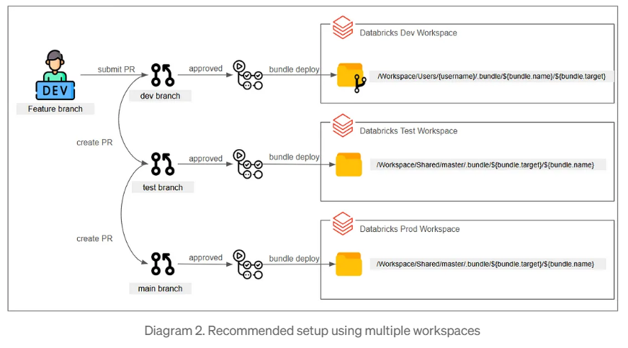

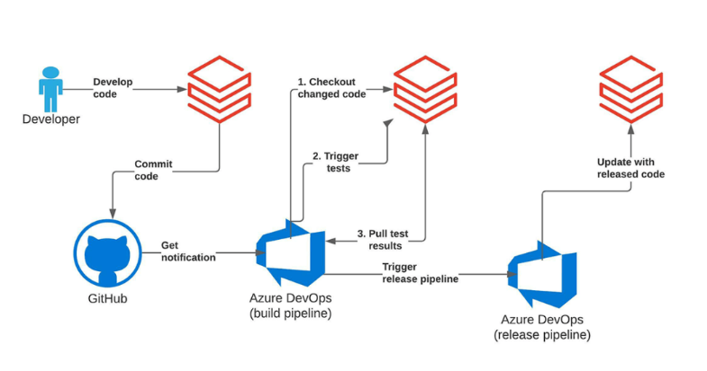

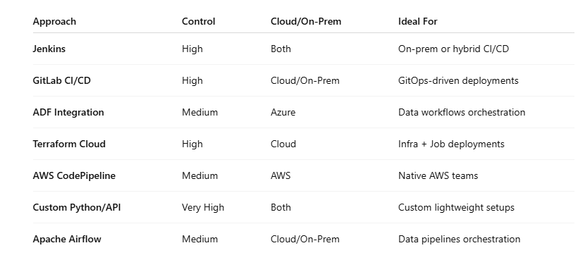f you want **cloud-native, scalable CI/CD**, Azure DevOps and GitHub Actions are top picks.  
But for **data-centric workflows**, ADF and Airflow shine.  
For **IaC-driven infra + job deployment**, Terraform Cloud is solid.  
And for **total control**, a Python API-based approach is surprisingly powerful.