AI ASSISTED LAB ASSIGNMENT-7.1
Name:K.Soujanya
Roll_no:2503A52412
Batch_no:14
Lab 7: Error Debugging with AI: Systematic approaches to
finding and fixing bugs

TASK1: Syntax Errors – Missing Parentheses in Print
Statement
PROMPT: Provide a Python snippet with a missing parenthesis in a print
statement (e.g., print &quot;Hello&quot;). Use AI to detect and fix the syntax
error.
INPUT:
Bug: Missing parenthesis in print statement

def greet():
print("Hello, AI Debugging Lab!"

greet()

OUTPUT:
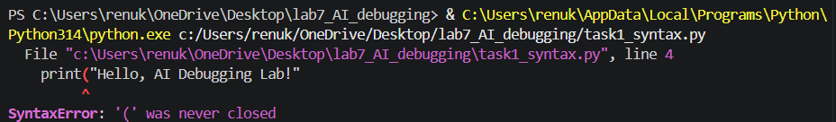

Explanation The error in the code is due to a missing closing parenthesis ) for the print() function. In Python, the print() function requires both an opening and a closing parenthesis to properly enclose the string that you want to print..
THE CORRECTED CODE SHOULD BE:
def greet():
print("Hello, AI Debugging Lab!")
greet()
OUTPUT:

TASK2: (Incorrect condition in an If Statement)
PROMPT: Task: Supply a function where an if-condition mistakenly uses =
instead of ==. Let AI identify and fix the issue.
INPUT:
def check_number(n):
if n = 10:
return "Ten"
else:
return "Not Ten"
OUTPUT:
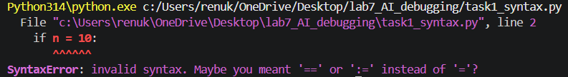
EXPLANATION: The error occurs because the assignment operator (=) is used instead of the comparison operator (==) in the if condition.
The = operator assigns a value,
whereas == compares two values. Therefore, n = 10 must be replaced with n == 10 to correctly check whether the number is equal to 10.
THE CORRECTED CODE SHOULD BE:
def check_number(n):
if n == 10:
return "Ten"
else:
return "Not Ten"

print(check_number(10))
print(check_number(5))
OUTPUT:
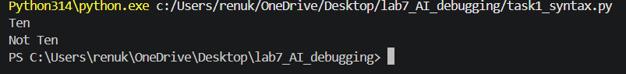

TASK3: (Runtime Error – File Not Found)
PROMPT: Task: Provide code that attempts to open a non-existent file and
crashes. Use AI to apply safe error handling.
INPUT:
def read_file(filename):
with open(filename, 'r') as f:
return f.read()

print(read_file("nonexistent.txt"))
OUTPUT:
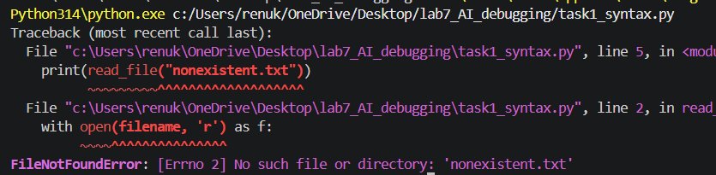
EXPLANATION:
Here, Python searches for the specified file in the current folder. Since nonexistent.txt does not exist, Python raises a FileNotFoundError.
The original program does not handle this error, so the program crashes and displays an error message.
THE CORRECTED CODE SHOULD BE:
def read_file(filename):
try:
with open(filename, 'r') as f:
return f.read()
except FileNotFoundError:
return "Error: File not found."

print(read_file("nonexistent.txt"))
OUTPUT:
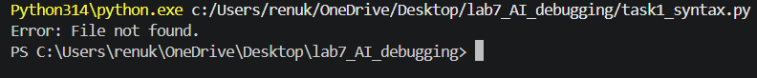

TASK4: (Calling a Non-Existent Method)
PROMPT: Give a class where a non-existent method is called (e.g.,
obj.undefined_method()). Use AI to debug and fix.
INPUT:
class Car:
def start(self):
return "Car started"

my_car = Car()
print(my_car.drive()) # drive() is not defined
OUTPUT:
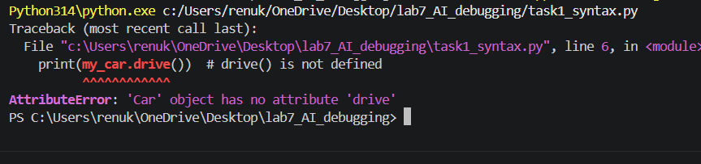
EXPLANATION:
The Car class contains only the start() method. There is no drive() method, but the program is trying to call:
THE CORRECTED CODE SHOULD BE:
class Car:
def start(self):
return "Car started"

def drive(self):
return "Car is driving"

my_car = Car()

print(my_car.start())
print(my_car.drive())

# Assert test cases
assert my_car.start() == "Car started"
assert my_car.drive() == "Car is driving"
assert isinstance(my_car, Car)

print("All tests passed!")
OUTPUT:
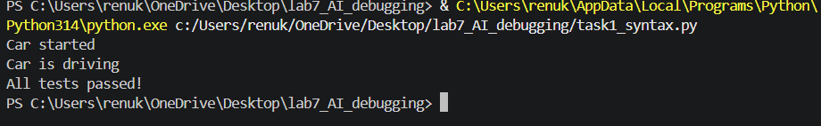
TASK5: (TypeError – Mixing Strings and Integers in
Addition)
PROMPT: Provide code that adds an integer and string (&quot;5&quot; + 2) causing
a TypeError. Use AI to resolve the bug.
INPUT:
def add_five(value):
return value + 5

print(add_five("10"))
OUTPUT:
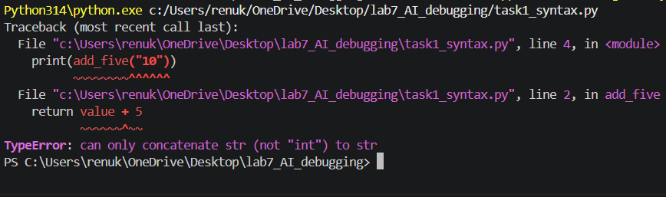
EXPLANATION: TypeError: can only concatenate str (not "int") to str
THE CORRECTED CODE SHOULD BE:
def add_five(value):
return int(value) + 5

print(add_five("10"))

# Assert test cases
assert add_five("10") == 15
assert add_five("5") == 10
assert add_five("20") == 25
OUTPUT:
