Introduction:

The level of debt a company incurs to finance its operations and expansion, also known as leverage, can have a significant impact on both the potential return on investment and the level of risk involved. This study aims to conduct a thorough analysis of corporate leverage in Australia and the UK between 2007 and 2022. The research will investigate different aspects of leverage, such as its trends and distribution, coverage distribution, changes in leverage ratios following the Covid pandemic, prevalence of zero-leverage firms, and factors that determine leverage, using correlation and regression analysis. The main objective of this research is to provide valuable insights into the capital structure of firms in these countries and identify the crucial factors that affect corporate leverage.

Literature Review:

The literature examining corporate leverage ratios has extensively analyzed the effects of capital structure on firm risk, cost, and value. In this review, we provide an overview of the existing research on corporate leverage ratios, focusing on Australia and the UK from 2007 to 2022.

In a comprehensive study of capital structure using international data, Raghuram G. Rajan and Luigi Zingales (1995) identified financial market development, economic growth, and firm size as important determinants of capital structure decisions. Firms typically follow a target debt-to-equity ratio and adjust their debt levels accordingly.

Gianni La Cava and Callan Windsor (2016) investigated the reasons behind firms' cash holdings and found that cash reserves serve as a buffer against uncertainty, enabling firms to fund unforeseen investment opportunities and maintain financial flexibility. Additionally, cash holdings are associated with firm size, profitability, and investment opportunities.

In 2009, the International Monetary Fund (IMF) conducted a study on East Asian leverage ratios and found that firms in this region have higher leverage ratios than those in other regions due to their reliance on bank financing and limited access to equity markets.

Other studies have examined the determinants of leverage in specific industries. For example, studies in the real estate sector have shown that leverage is positively correlated with asset size, profitability, and property type, while studies in the manufacturing industry have found that leverage is positively related to firm size, asset tangibility, and earnings volatility.

Overall, the literature suggests that capital structure decisions are influenced by a range of factors, such as financial development, economic growth, firm size, profitability, and investment opportunities. While the literature provides a broad understanding of the factors that affect leverage decisions, additional research is necessary to investigate the specific factors that influence corporate leverage in Australia and the UK.Descriptive Data Analysis and Data Visualization:

During the period of 2007-2022, an analysis of leverage ratios in Australia and the UK was conducted, which uncovered some noteworthy observations. The leverage ratio, which reflects the proportion of a company's total debt to total assets, had an average value of 0.24 and a standard deviation of 0.26 for Australian companies, and an average of 0.22 with a standard deviation of 0.20 for UK companies. The highest leverage ratios observed were 0.92 and 0.84 for Australia and the UK, respectively.

Figures 1 and 2 demonstrate the distribution of leverage ratios for Australian and UK companies, respectively, utilizing box plots. From these visualizations, it can be observed that the distribution of leverage ratios varies, and there are some outliers presents. In Australia, the leverage ratio slightly increased from 2007-2009, decreased from 2010-2019, and rose significantly in 2020 after the COVID-19 pandemic (with a mean value of 0.27). A similar trend was seen for UK companies, with an increase in leverage ratios during and after COVID-19 (2019-2021). Fig 3 and Fig 4 display the cat-plot of leverage distribution in Australia and the UK, respectively, in line with quantiles and mean.

The study also examined the coverage ratio, which measures the earnings before interest and taxes (EBIT) divided by the interest expense. Figures 5 and 6 illustrate the coverage ratio for Australian and UK companies, respectively, from 2007-2022. The coverage ratio declined sharply pre- and post-COVID, with the minimum average value of 6.43 in 2021 for Australian companies and 7.00 for UK companies. This suggests that companies were facing financial difficulties due to COVID-19 and may have had trouble meeting their financial obligations, such as interest payments on their debt, with their current level of earnings. The high leverage and low coverage ratios indicate that companies had taken on a significant amount of debt to survive during the COVID-19 crisis and may not have adequate means to pay it back.

In conclusion, this study's descriptive analysis and data visualization provide valuable insights into the leverage and coverage ratios of Australian and UK companies from 2007-2022, with trends and patterns affected by the COVID-19 pandemic. These findings can be useful for investors, policymakers, and company decision-makers to make informed decisions regarding financial planning and risk management.

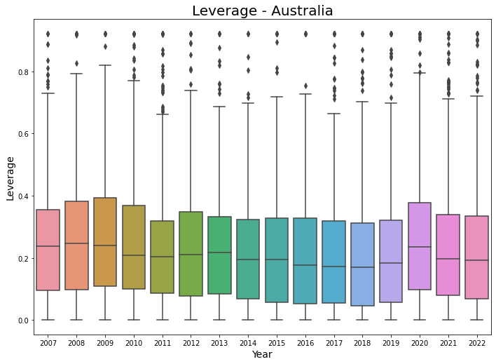

Fig1: Leverage Australia

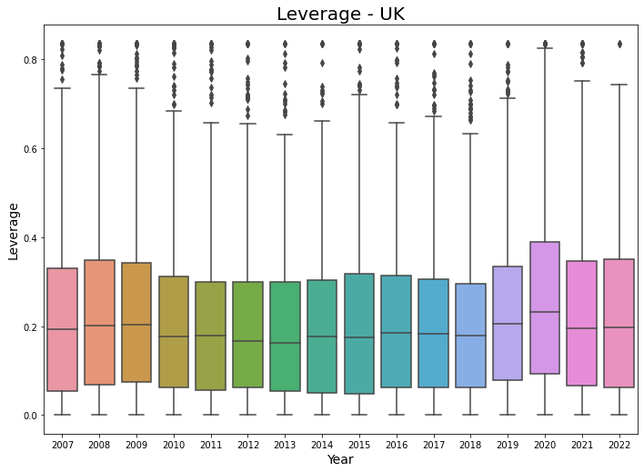

Fig 2 : Leverage UK

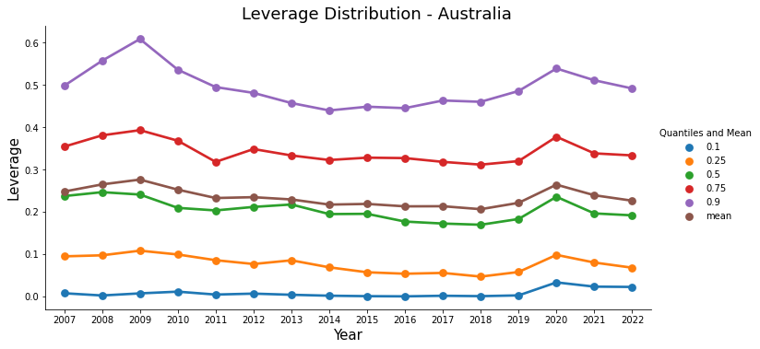

Fig 3: Leverage Distribution Australia

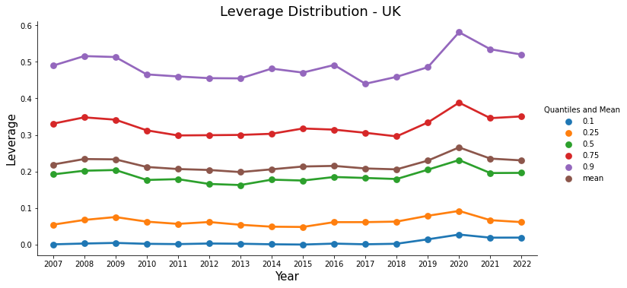

Fig 4: Leverage Distribution UK

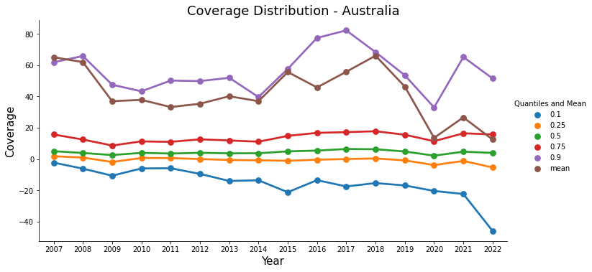

Fig 5: Coverage Distribution Australia

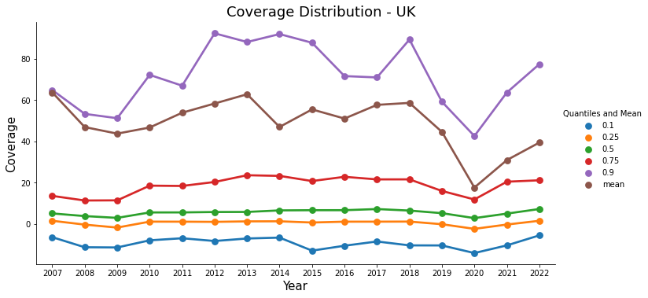

Fig 6: Coverage Distribution UK

Leverage Distribution in Both Countries:

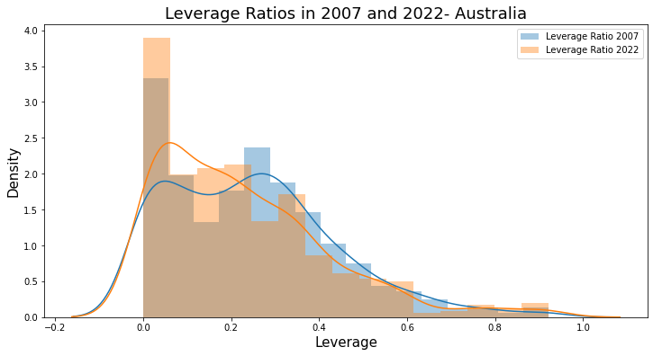

Fig 7: Leverage ratios in 2007 and 2022- Australia

The figure presented displays a distplot of leverage ratios observed in 2007 and 2022. In 2022, the highest density (2.5) was observed at a leverage ratio of 0.0, while the density (1.9) was observed at a leverage ratio of 0.3 in 2007. Comparing the leverage ratios between the two years reveals that the 2007 leverage ratio was shifted to the right compared to the 2022 leverage ratio. These findings indicate that, despite the higher density of leverage ratios in 2022, the level of leverage was lower in 2022 compared to 2007.

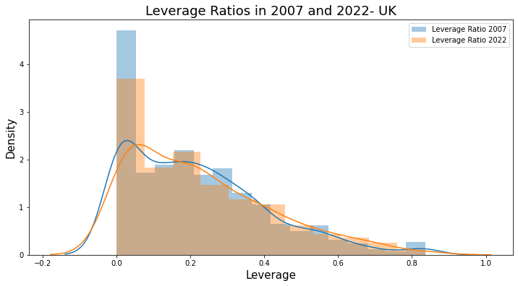

Fig 8: Leverage ratios in 2007 and 2022- UK

The figure shows a distribution plot of UK companies' leverage ratios in 2007 and 2022. The plot demonstrates that the highest density of leverage ratios was observed at 0.0 leverage for both years. However, the 2022 leverage ratio distribution was shifted towards the right when compared to the 2007 distribution, indicating that UK companies used higher amounts of leverage in 2022 than in 2007, despite the similarity in density.

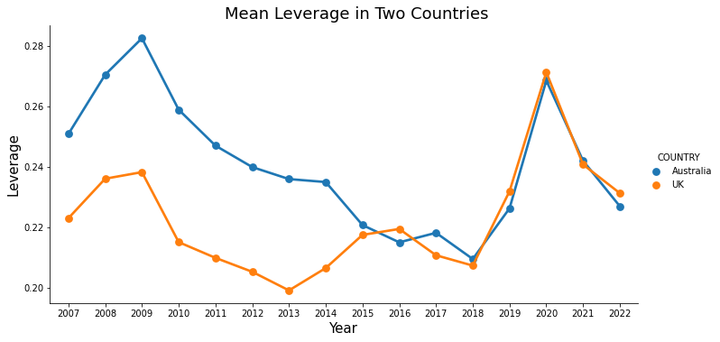

Fig:9: Mean leverage ratios in Australia and UK

The findings indicate that the average leverage ratios for both Australia and the UK were highest during the COVID-19 pandemic, while they decreased after the 2008 economic crisis. It is worth noting that the plotted data indicates Australia had a higher mean leverage ratio compared to the UK.

Analysis of Zero Leverage firms:

The examination of firms with zero leverage provides insightful trends in Australia and the UK. In Australia, the count of companies with no leverage increased steadily until 2016, reaching a peak of 51 firms. However, with the advent of COVID-19, the number of such firms sharply dropped to only 4 and then further to a minimum of 1 in 2022. A comparable trend was observed in the UK, where the count of zero leverage firms was highest in 2007 with 104 companies. While the figures reduced over time, the decline was not significant until the COVID pandemic. In 2020, the number of zero leverage firms was 5, which then reduced to only 1 in 2022. These findings suggest that the pandemic had a profound influence on the financial structures of companies, with many choosing to take on debt to remain afloat during these challenging times.

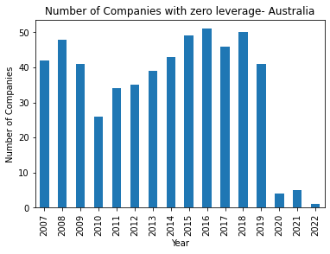

Fig 10: No. Of Companies with zero leverage- Australia

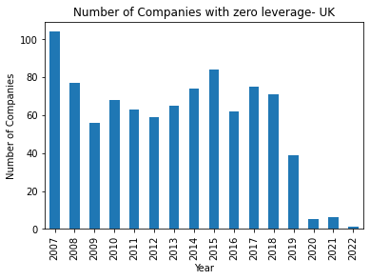

Fig 11: No. Of Companies with zero leverage- UK

Analysis of determinants of leverage

In this section, we analyze the determinants of Leverage ratio in Australia and the UK. We start by explaining the relations between different firm characteristics such as Tangibility, market to book, profitability, and coverage with the leverage ratio. We do this by creating scatter plots between each of these variables and the leverage ratio.

**Tangibility and leverage:**

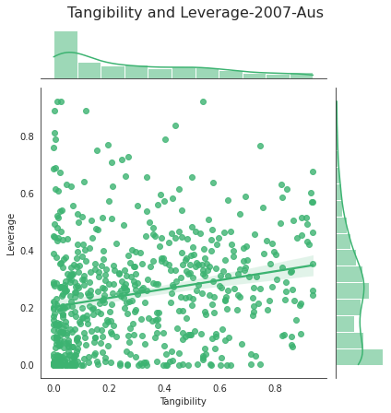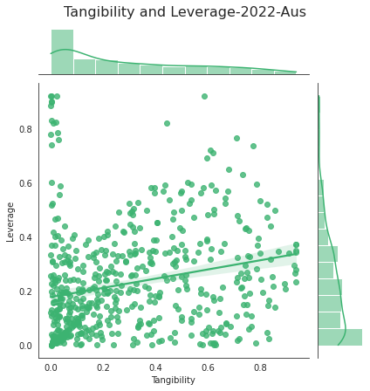 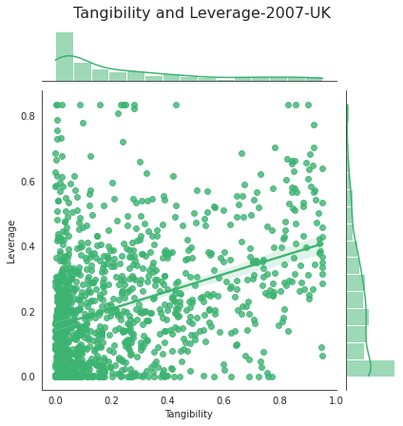 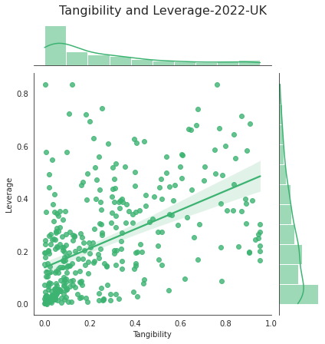

Fig 12(a, b, c, d): Tangibility and Leverage relationship

The four figures, 12(a, b, c, d), illustrate the connection between tangibility and leverage for Australian and UK firms in 2007 and 2022. The data indicates a relatively weak positive correlation between these factors for Australian firms, whereas a stronger correlation is observed for UK firms. The variation in correlation strength could potentially be linked to industry makeup, economic circumstances, regulatory frameworks, or business strategies.

**Market to Book and Leverage:**

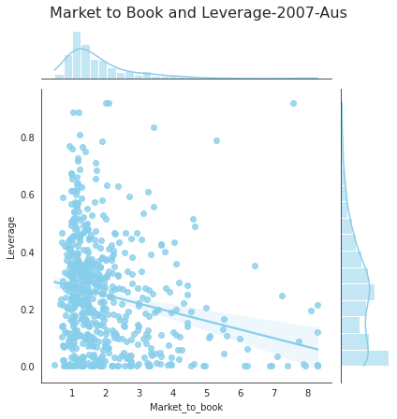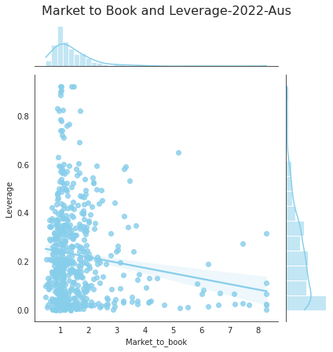 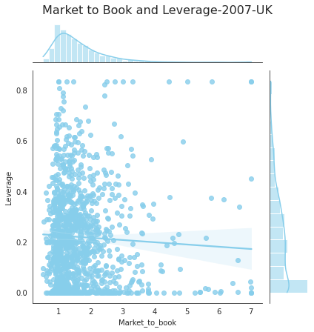 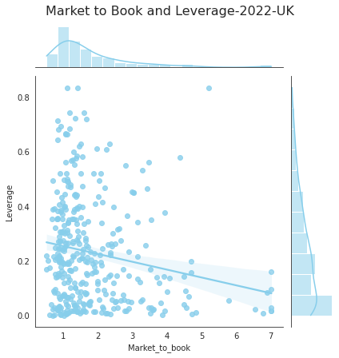

Fig 13(a, b, c, d): Market to Book and Leverage relationship

The correlation between Market to Book (MTB) and Leverage ratios in Australia and the UK in 2007 and 2022 is shown in Figures 13(a, b, c, d). Both countries exhibit a negative correlation between the two ratios, with a weak correlation in 2007 and a stronger correlation in 2022 after the COVID pandemic. Firms with higher MTB ratios tend to have lower leverage ratios, indicating a preference for equity financing over debt financing. The increased negative correlation in 2022 may be attributed to the pandemic and higher risk aversion among investors and lenders.

**Profitability and Leverage**

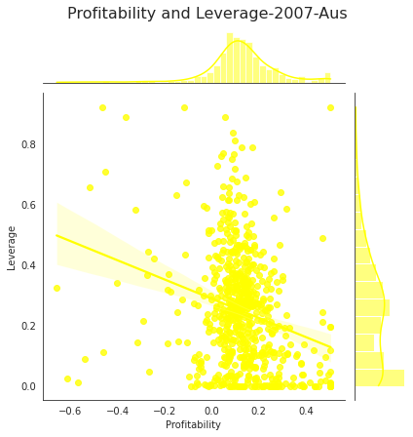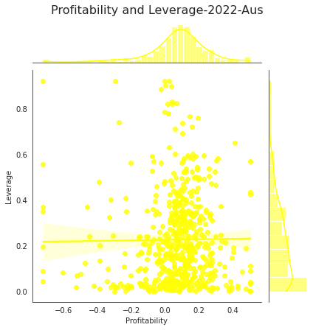 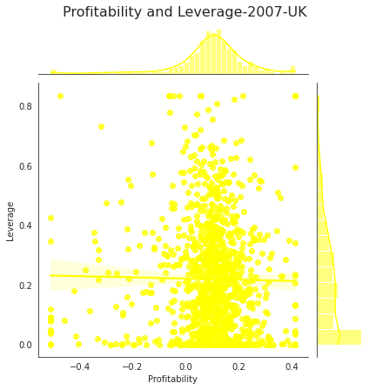 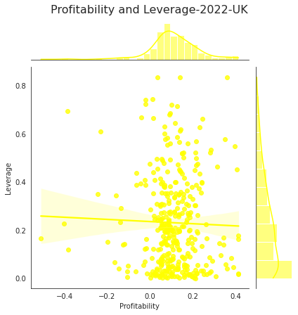

Fig 14(a, b, c, d): Profitability and Leverage relationship

The correlation between Profitability and Leverage ratio in Australia and the UK in 2007 and 2022 is shown in Figure 14(a, b, c, d). The plots reveal a negative correlation in Australia in 2007, which became absent in 2022. In the UK, there was a weak negative correlation in both years. This suggests that profitable firms may have lower reliance on debt financing, likely due to their lower risk profile. However, the relationship between profitability and leverage ratio may also depend on various factors, including market conditions and the impact of COVID-19.

**Coverage and Leverage:**

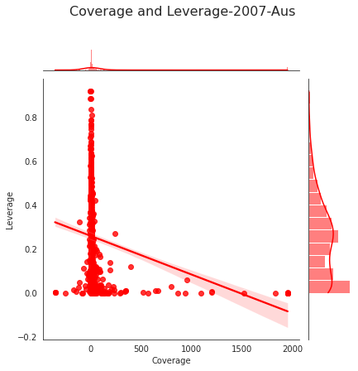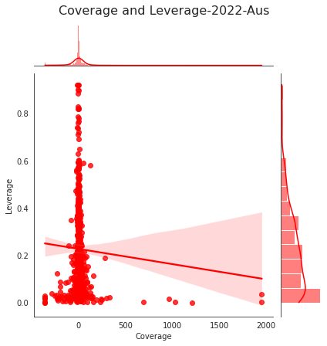 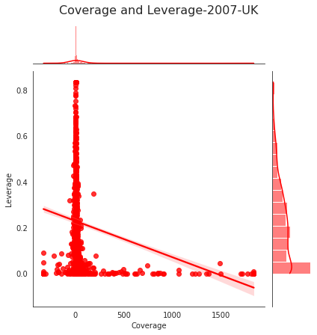 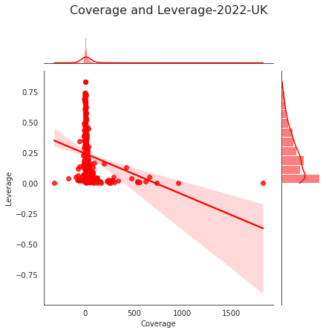

Fig15(a, b, c, d): Coverage and Leverage Relationship

The negative correlation between Coverage and Leverage in Australia and the UK in 2007 and 2022 is evident from Figure 15(a, b, c, d). The plots indicate that higher leverage is associated with lower coverage, with the maximum leverage observed at zero coverage. This relationship highlights the potential risk that firms with lower coverage ratios face due to their reliance on debt financing. Factors such as changes in market conditions or economic factors may have influenced the relationship between these variables over time. Considering this relationship is crucial in the financing decisions of firms.

Correlation analysis:

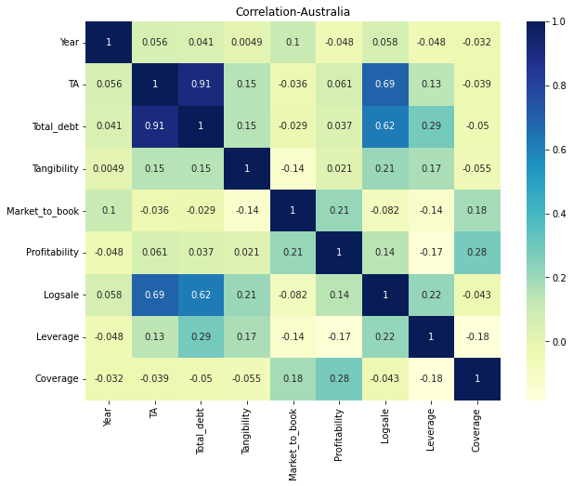 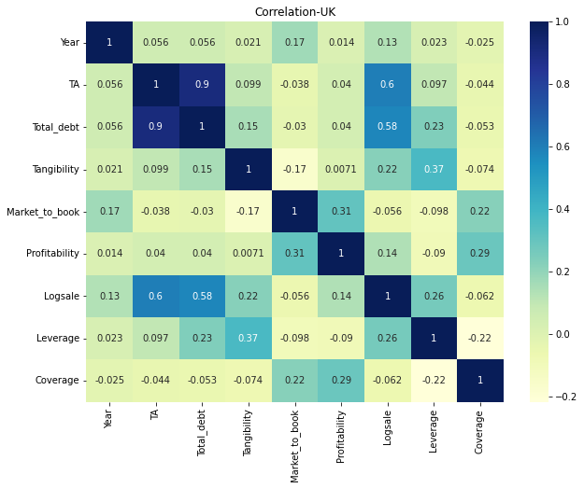

Fig 16 (a, b): Correlation Analysis for Australia and the UK

The correlation matrices of Australian and UK firms reveal significant insights into the interrelationships between financial variables. The strong positive correlation between total debt and leverage in Australian firms suggests that higher debt financing results in higher leverage. Moreover, profitable Australian firms have higher coverage ratios, while larger firms tend to rely more on debt financing. The negative correlation between coverage and leverage implies that firms with higher coverage ratios have lower leverage.

In UK firms, there is a moderate positive correlation between tangibility and debt financing, indicating that firms with more tangible assets are more inclined to use debt financing. Additionally, the negative correlation between market-to-book and tangibility suggests that companies with higher market values have fewer tangible assets. More profitable UK firms are perceived as lower risk, and the high positive correlation between log sale and debt financing indicates that larger firms may have greater financing needs. Lastly, the high negative correlation between coverage and leverage in UK firms reinforces the relationship between higher coverage ratios and lower leverage.

Regression Analysis

**Use of simple linear regression**

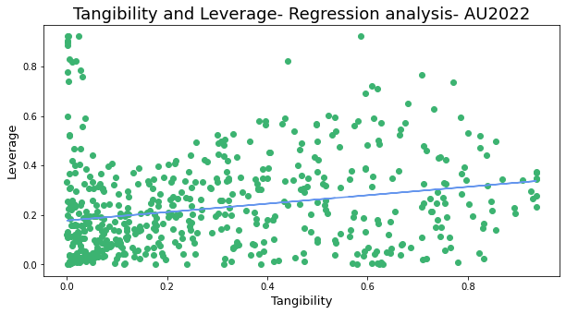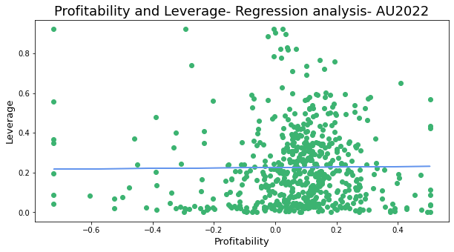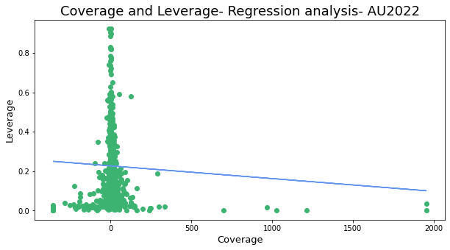

Fig 17(a, b, c): Linear Regression Analysis for Australia

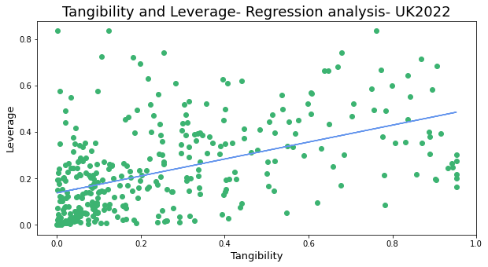 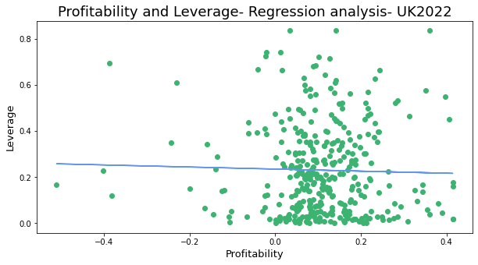

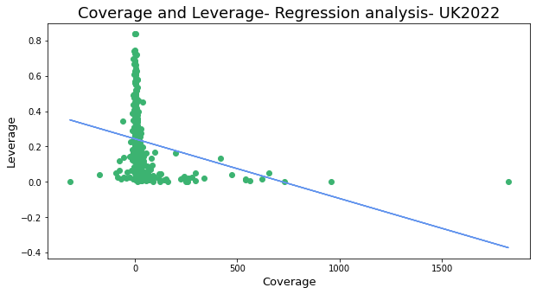

Fig 18(a, b, c): Linear Regression Analysis for the UK

The regression analysis in the report utilized one independent variable - tangibility, profitability, and coverage - to forecast the leverage for Australian and UK firms. The outcomes were in accordance with the scatter plots and showed that there is a positive correlation between tangibility and leverage, a weak negative to weak positive correlation between profitability and leverage, and a strong negative correlation between coverage and leverage. These findings suggest that firms with more tangible assets tend to rely on debt financing, whereas firms with higher coverage ratios have a tendency towards lower leverage. Furthermore, the weak connection between profitability and leverage suggests that having higher profits does not necessarily correspond to higher leverage ratios.

**Ordinary Least square method**

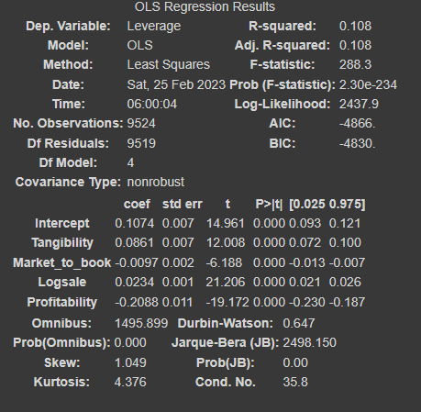

Fig 19: OLS Regression Results for Australia

The regression analysis conducted for Australia found that all independent variables, except for Market-to-book, have a significant statistical relationship with leverage. The positive relationship between Tangibility and leverage suggests that firms with more tangible assets tend to use more debt financing. The positive relationship between Logsale and leverage implies that larger firms tend to have higher financing needs and may rely more on debt financing. In contrast, profitability has a negative relationship with leverage, suggesting that more profitable firms tend to use less debt financing.

However, the adjusted R-squared value of 0.108 indicates that the independent variables in this analysis only explain a small portion of the variation in leverage. Therefore, other variables not considered in this study may also play a significant role in determining a firm's leverage. Businesses should carefully consider their financial decisions, including financing choices, to ensure their long-term success and financial stability.

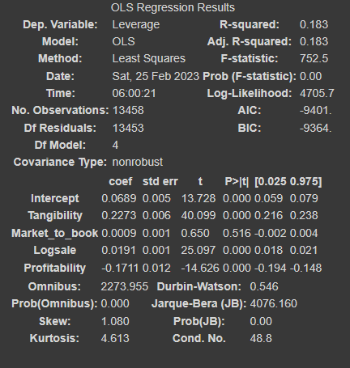

Fig 20: OLS Regression results for UK

The results of the OLS regression for the UK reveal a strong positive relationship between leverage and tangibility, indicating that firms with more tangible assets tend to have higher leverage ratios. In contrast, there is a negative relationship between profitability and leverage, implying that more profitable firms tend to have lower leverage ratios. Notably, the market-to-book ratio and logsale were found to have weak or insignificant relationships with leverage in the UK.

The R-squared value of 0.183 indicates that the model explains a moderate proportion of the variation in leverage, suggesting that other factors beyond those considered in this analysis may also play a role in determining leverage ratios for UK firms. These findings provide valuable insights into the factors affecting leverage for UK firms and can help guide financial management decisions.

Conclusion

In conclusion, this study explored different aspects of corporate leverage in Australia and the UK between 2007 and 2022. The analysis involved descriptive statistics and data visualization, which provided valuable insights into the capital structure of firms in these countries. The leverage ratio increased slightly in Australia between 2007 and 2009, followed by a decline from 2010 to 2019, and a significant increase in 2020 due to the COVID-19 pandemic. The same trend was observed in the UK. The coverage ratio showed a rapid decline before and after the pandemic, indicating financial struggles for companies during this period. Both countries experienced a notable increase in the number of firms with a leverage ratio of zero over time. Specifically, the highest density was observed at a leverage ratio of 0.0 in Australia in 2022, while it was observed at a leverage ratio of 0.3 in 2007.