**Creating the project and add to the Github:**

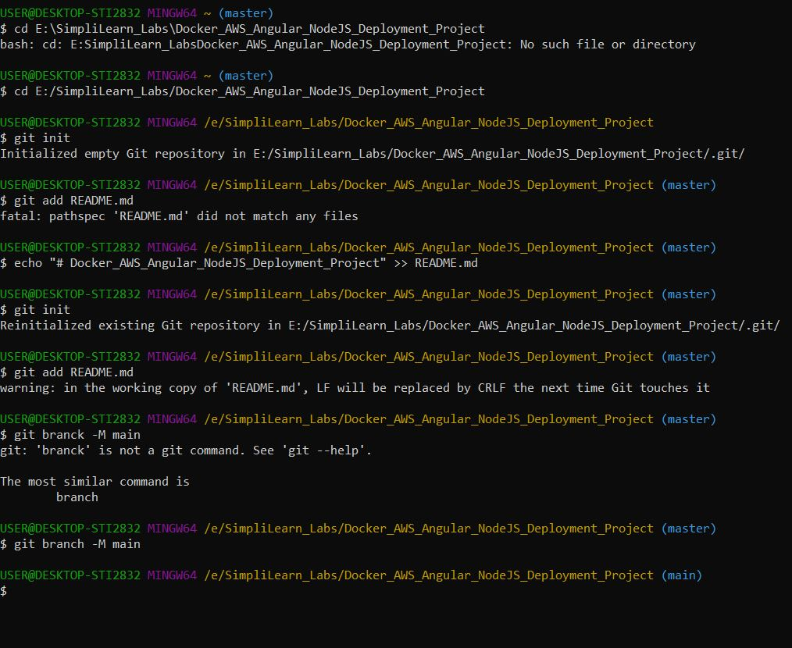

Git Commits for the Angular Project:

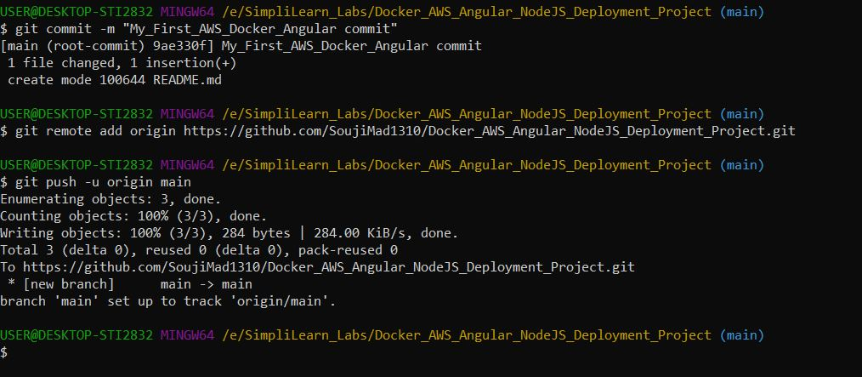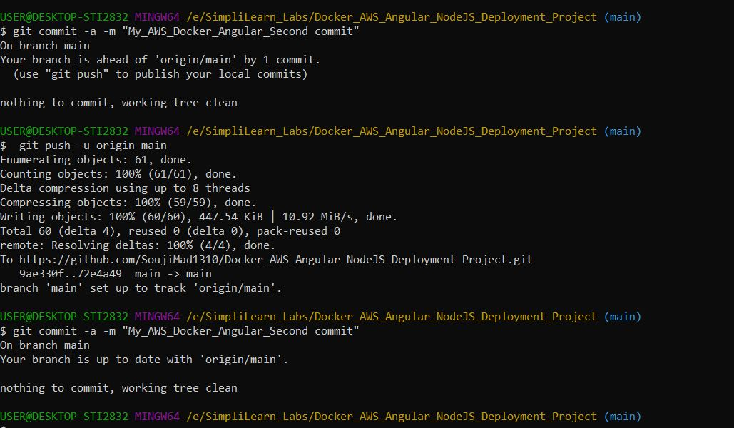

**Docker Image Creation:**

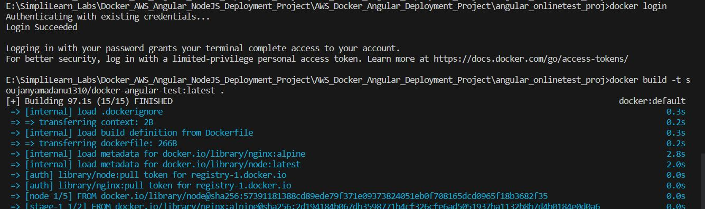

**At Docker Desktop:**

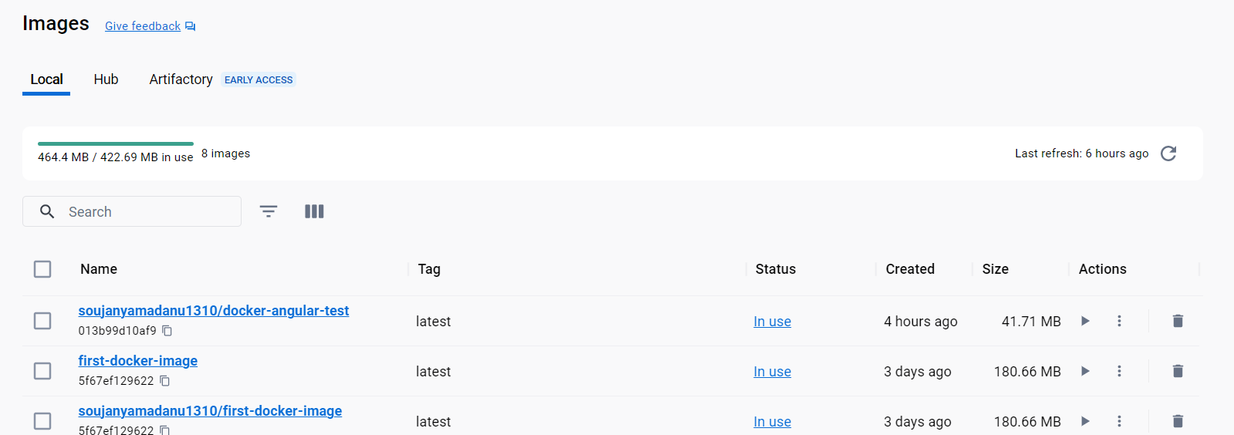

**Docker push:**

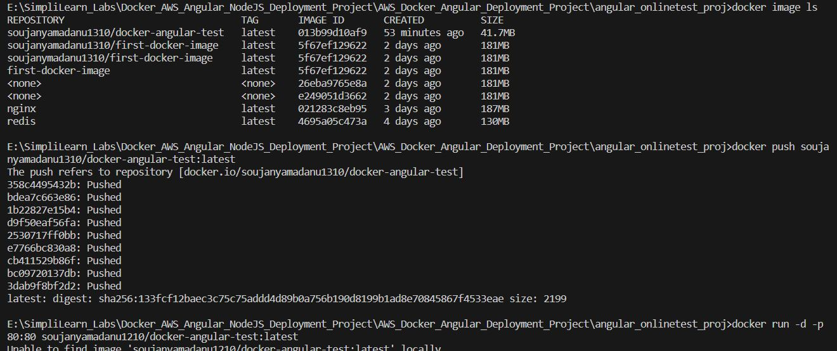

**Docker run:**

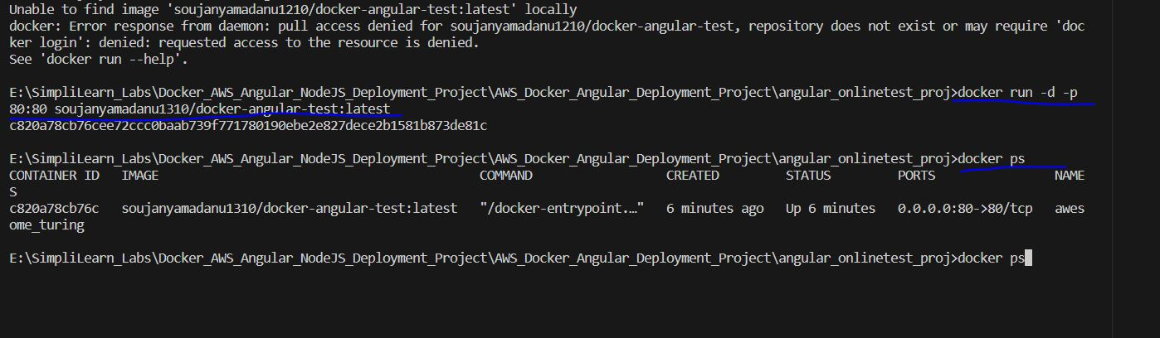

**Git hub commit:**

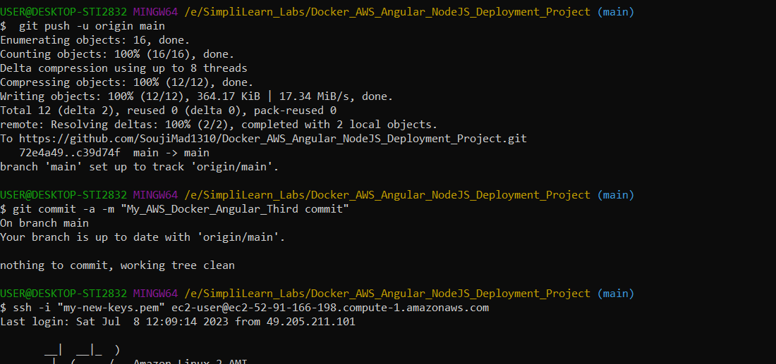

**Creating instance in AWS: EC2**

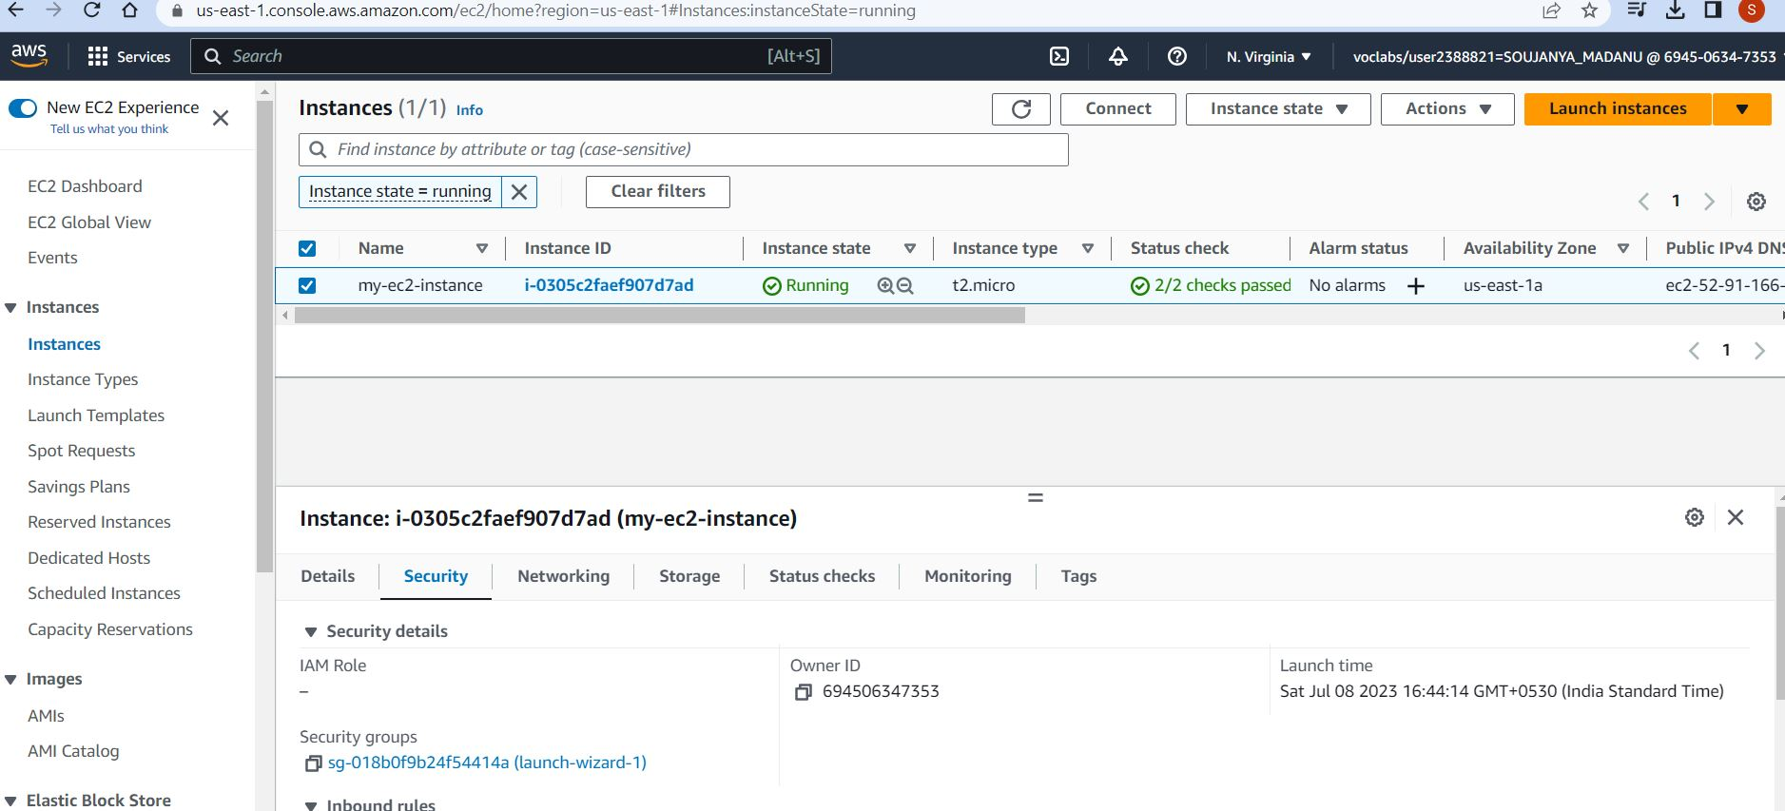

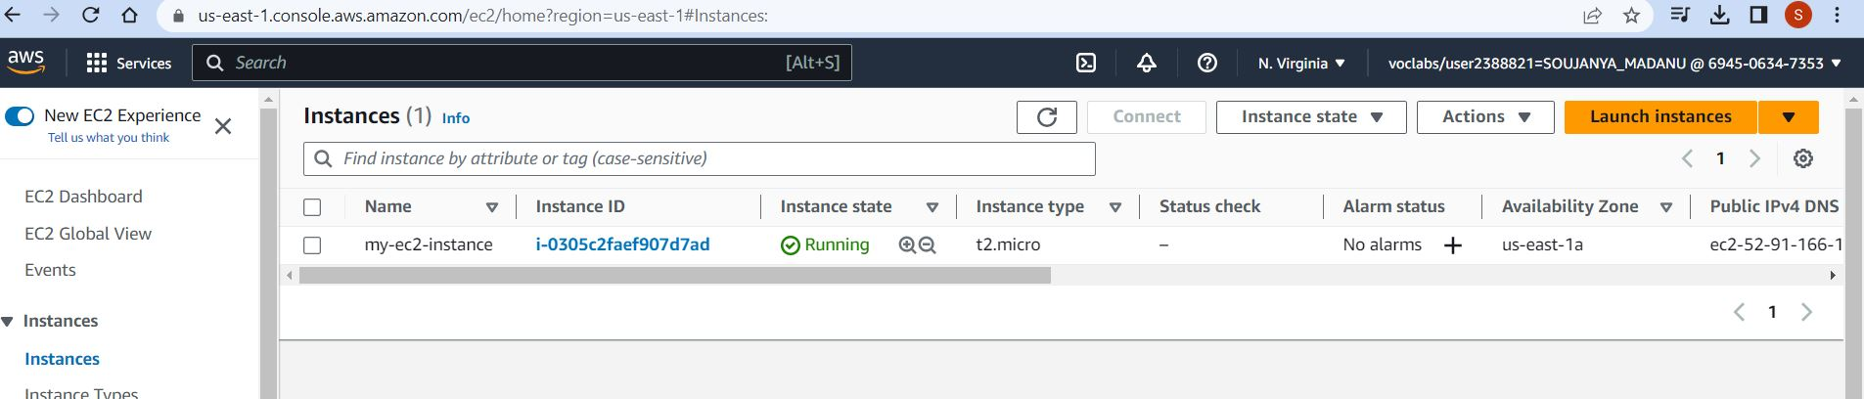

**Setting the Inbounce Rule:**

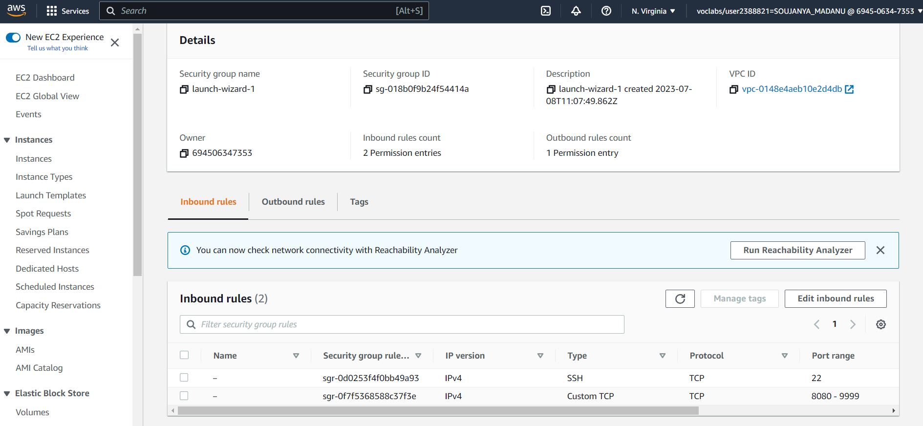

**Adding EC2 instance to gitbash:**

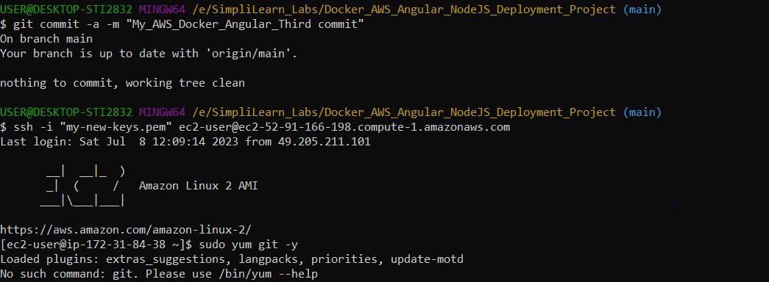

**Docker installation in gitbash:**

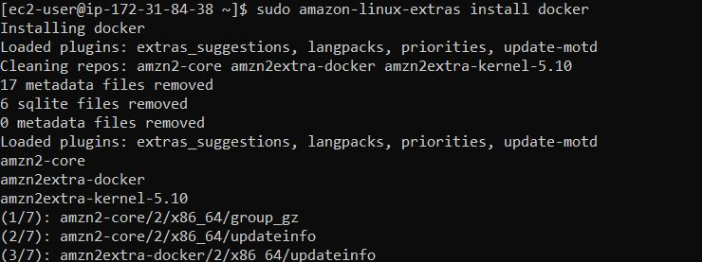

**Start the docker service:**

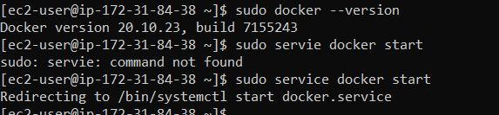

**Pull the Docker image:**

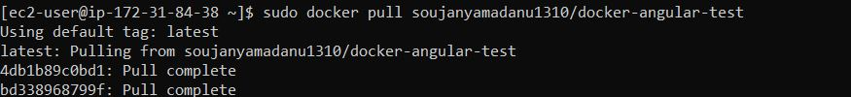

**Docker Run:**



**Executing the docker image attached:**

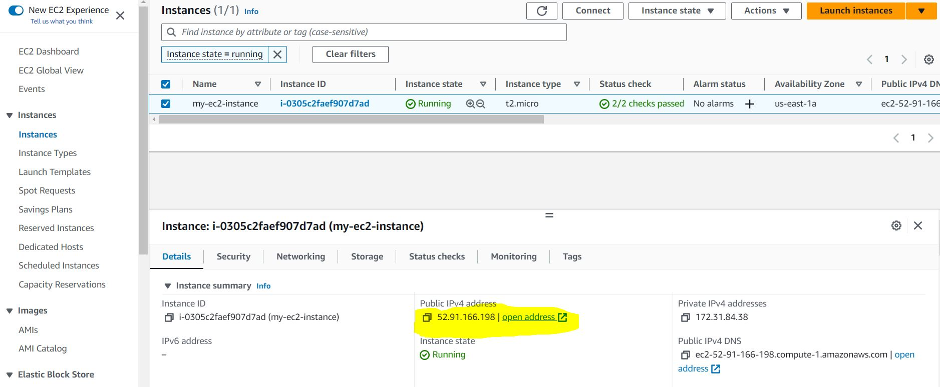

**Output at the browser:**

**By using ng serve:**

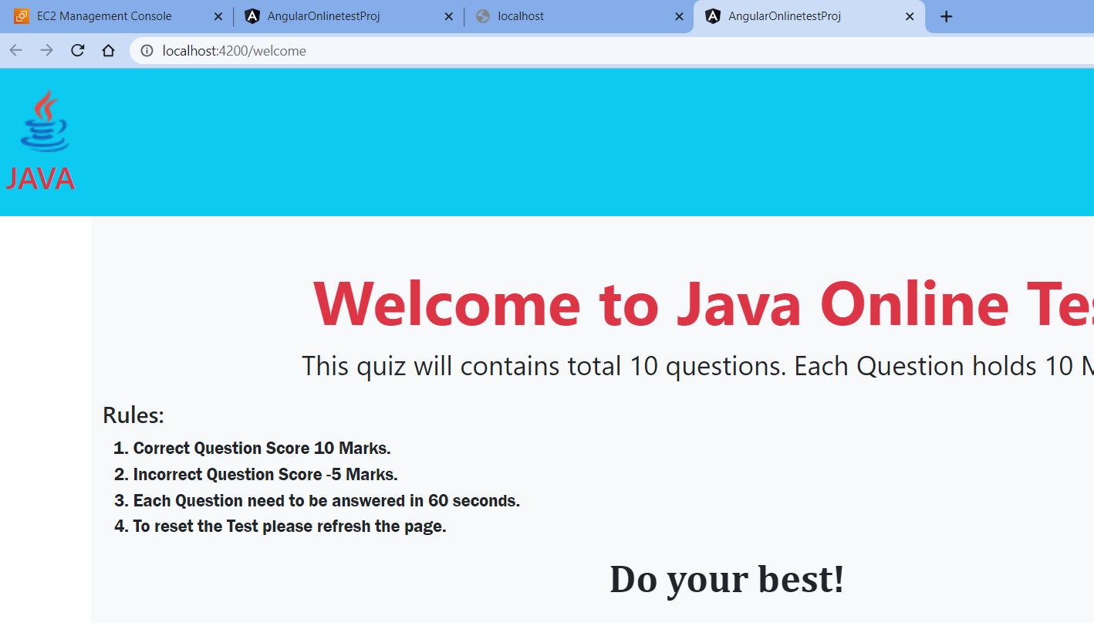

**By using Docker Image:**

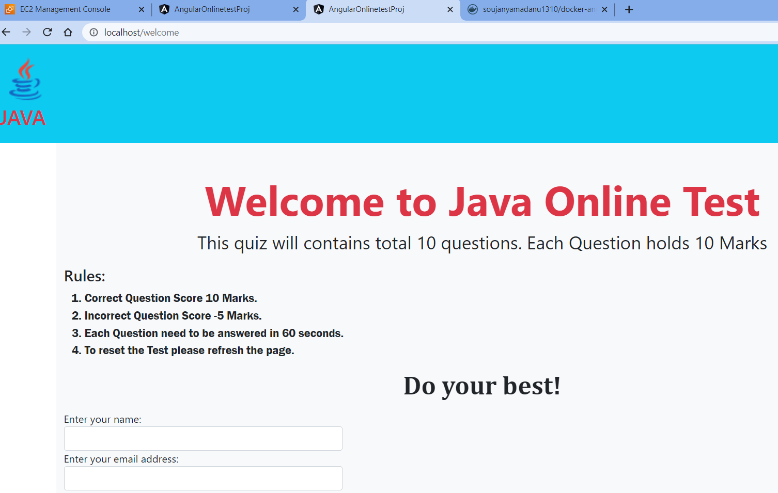

**By using EC2 instance:**

