UNICORN VYSOKÁ ŠKOLA S.R.O.

Software Engineering and Big Data



MASTER THESIS

Analysis of Factors Influencing Quality of Life in an Urban Environment: A Case Study of Prague Using Urban Planning Data

Thesis Author: Bc. Joseph Meurer
Thesis Supervisor: Ing. Ivo Milota

Statutory Declaration

I hereby declare that I have written my bachelor thesis on the topic of Analysis of Factors Influencing Quality of Life in an Urban Environment: A Case Study of Prague Using Urban Planning Data by myself, under the guidance of my thesis supervisor, using only the technical publications and other information sources that are all quoted in the thesis and listed in the bibliography. I declare that artificial intelligence tools have been used only for support activities and in accordance with the principle of academic ethics.
As the author of this master thesis, I also declare that in association with its writing, I have not violated the copyright of any third party or parties, and I am fully aware of the consequences of provisions of s. 11 et seq. of Act No. 121/2000 Coll., the Copyright Act.
Furthermore, I hereby declare that the submitted hard copy of this bachelor thesis is identical to the electronic version I have submitted.

In Prague on ………. …….……………………………
(Bc. Joseph Meurer)

Acknowledgements

E.g.: I would like to thank the supervisor of my bachelor thesis, First Name Last Name (plus academic titles), for his/her methodological, pedagogical, and expert assistance, and for his/her invaluable advice when writing my bachelor thesis…



Analysis of Factors Influencing Quality of Life in an Urban Environment: A Case Study of Prague Using Urban Planning Data

Abstract

Abstract in English. The abstract shall briefly and accurately characterize the contents of your thesis. Typically, it provides information on your goals, employed methods, solution procedure, and research results. It may also contain brief information on used resources. The abstract is usually 100–500 words long.

Keywords: thesis keywords, no less than 5, no more than 10

Table of Contents

Introduction 7
1 Definitions and Theoretical Pillars 8
1.1 The evolution of Quality of life 8
1.2 The Holistic Perspective: The WHOQOL Framework 8
1.2.1 The WHOQOL Method 9
1.3 Subjective Well-Being (SWB): The Psychological Foundation 14
1.3.1 The Three Hallmarks of SWB 14
1.3.2 Three General Components of SWB 15
1.3.3 Key Psychological Findings and Theories 15
1.3.4 Measurement Challenges 16
1.4 Chapter Summary – Theoretical Foundations of Quality of Life 18
2 Quality of Life in the Urban Context 20
2.1 Defining the “Urban Quality of Life” (QOUL) 20
2.2 The Impact of the Physical Environment on Urban Dwellers 21
2.2.1 Healthy Neighborhood Design 21
2.2.2 Healthy Transportation Networks 22
2.2.3 Healthy Natural Environments 23
2.2.4 Healthy Housing 23
2.2.5 Healthy Food Systems 24
2.3 Proximity and the “15-Minute City” Concept 25
2.3.1 The Core Framework: Six Essential Functions and Four Dimensions 25
2.3.2 Sustainability, Resilience, and Place Identity 25
2.3.3 Global Implementation and Variations 26
2.4 The Smart City Paradigm and Data-Driven Governance 26
2.5 Chapter Summary – Quality of Life in Urban Context 27
3 Key Indicators for Measuring Urban Well-being 29
3.1 Environmental Indicators: Air Quality and Noise Pollution 29
3.1.1 Key Indicator Thresholds 29
3.1.2 Health and Policy Implications 30
3.2 Mobility and Transportation Infrastructure 30
3.2.1 Key Mobility Indicators 30
3.2.2 Intermodality and Sustainability 31
3.3 Accessibility to Public Services 31
3.3.1 Dimensions of Urban Accessibility 31
3.3.2 The Role of Spatial Equity 32
3.4 Safety and Socio-Economic Stability 32
3.4.1 Dimensions and Physical Safety 32
3.4.2 Socio-Economic Stability 33
3.4.3 Integrating Subjective Well-being 33
3.5 Chapter Summary – Key Indicators for Measuring Urban Well-being 33
4 Quantitative QOL Assessment 35
4.1 Comparative Analysis of Current QOL Ranking Methodologies 35
4.2 Challenges in Data Normalization and Weighting 36
4.3 The Role of Open Data Platforms (Golemio Case Study) 37
4.4 Chapter Summary – Quantitative QOL Assessment 38
5 Scenario-Based Case Studies in Urban Prague 40
5.1 Case Study 1: The “Senior Citizen” (Mobility & Safety Focus) 40
5.2 Case Study 2: The “Young Tech Professional” (Connectivity & Comforts) 40
5.3 Case Study 3: The “Young Family” (Environment & Stability) 41
5.4 Chapter Summary - Scenario-Based Case Studies in Prague 41
6 Practical Part 43
7 Conclusion 44
List of Sources 45
List of Figures (Provincial Health Services Authority, 2014) 46
List of Tables 47
List of Charts 48
List of Appendices 49
Appendix A 50

Introduction

Definitions and Theoretical Pillars
This chapter talks about the most important ideas about Quality of Life (QOL). It looks at how the idea has changed over time and how people in different fields, like public health, psychology, and social sciences, understand it today.

The chapter also talks about important frameworks, like the WHOQOL approach, and how subjective well-being affects how people see their lives. These ideas are important for the next chapters, which use them to talk about cities and numbers.

The evolution of Quality of life
Quality of Life (QOL) used to mean only money, but now it means everything that makes people happy. People thought that things like Gross Domestic Product (GDP) were good signs of social progress in the middle of the 20th century (STIGLITZ et al., 2009, p. 21). People were getting angrier and angrier with this system, though, because it didn't care about things that matter in life, like health, education, and the state of the environment.

Consequently, the concept evolved in the 1960s and 1970s through the incorporation of social indicators to provide a more comprehensive assessment of well-being. Researchers began to recognize that quality of life (QOL) encompasses both objective and subjective components, highlighting the significance of personal experiences and happiness (DIENER, 1984, p. 542).

The World Health Organization (WHO, 2012, p. 11) defined QOL as how people see their place in life in terms of their values and culture. This was a key moment in the growth of QOL. This description makes it clear that the idea is both general and unique to each person.

A lot of people today think that quality of life (QOL) is a complicated idea that includes mental, financial, social, and environmental factors. OECD and other modern frameworks combine these parts to make a more accurate and useful picture of well-being (OECD, 2020, p. 38).

The Holistic Perspective: The WHOQOL Framework
The World Health Organization (WHO) defines the term "QOL" as follows:

“individuals' perceptions of their position in life in the context of the culture and value systems in which they live and in relation to their goals, expectations, standards and concerns” (WHO, 2012, p. 11).

The WHO manual (2012, p. 11) says that this concept is broad and includes a person's physical and mental health, their level of autonomy, and how they interact with others and their surroundings. The WHO says that QOL is a personal assessment that cannot be summed up in simple words like "well-being" or "lifestyle." The WHOQOL framework also puts the person's own thoughts and feelings ahead of objective medical findings or clinical disabilities. Thereby, the evaluation is based on how the person experiences health problems and external factors in different areas of their daily life (WHO, 2012, p. 11).

The WHOQOL Method
The WHO User Manual (2012, p. 12) says that the WHOQOL method was meant to be a single tool for measuring quality of life that could be used with other tools in different places. It took several centers with a range of ethnic backgrounds to fully optimize the quality of life instruments. Question writing, question selection, coming up with a response scale, and pilot testing in a number of centers and domains were the major steps. Standardization, or making sure that settings are the same, and language problems were the hardest parts of making the instrument. There were differences in the level of industrialization, the number of health services, and other things that could be used to measure quality of life, like the main religion, the role of the family, and how people see time and themselves. This was done to ensure that the collaboration was truly international.

Table 1: Field centres involved in the developments of the WHOQOL Instrument
Field centre | Language
Zagreb, Croatia | Croatian
Tilburg, the Netherlands | Dutch
Melbourne, Australia | English (Australian)
Bath, United Kingdom | English (UK)
Seattle, USA | English (USA)
Paris, France | French
Beer-Sheva, Israel | Hebrew
Delhi, India* | Hindi
Tokyo, Japan* | Japanese
St. Petersburg, Russia | Russian
Harare, Zimbabwe | Shona
Panama City, Panama | Spanish (Panama)
Barcelona, Spain* | Spanish
Madras, India | Tamil
Bangkok, Thailand | Thai
Source: WHO User Manual (2012, p. 12)

The asterisks (*) in the table show that these centers started later in the process but still helped with the pilot tests.

Another thing that made the WHOQOL method unique was that quality of life researchers provided feedback repeatedly, and at each stage of the instrument's growth, this feedback was gathered and changed at the local level. This approach combined existing knowledge about measuring quality of life with the insights of healthcare professionals and patients during the tool's development. It is becoming increasingly clear that the patients' perspective is the most important one in quality of life ratings (Smart and Yates, 1987; Calman, 1987; Breslin, 1991; Gerin, Dazord, Boissel et al., 1992; Patrick and Erikson, 1993). It is therefore essential that the patients agree with the measure. Health workers and researchers are likely to use the WHOQOL tool, so their agreement is crucial. (WHO, 2012, p. 12)

The WHOQOL-1000 was developed in three different stages. The stages involved concept clarification, qualitative piloting, development piloting, and refinement.

In the first step, idea clarification, people from all over the world worked together to come up with a common definition of quality of life. After reading a lot of research, experts and investigators from field centers came up with a list of broad areas they thought affected a person's quality of life. Each domain was further broken down into several specific places (facets) that summed up each domain. (WHO, 2012, p. 13)

The qualitative pilot in the second stage involved four steps:
- Exploration of the quality of life construct across cultures
- Definition of the facets to be assessed
- Generation of a global question pool
- Development of equivalent response scales for different language versions of the WHOQOL

To achieve those aims, the focus groups were run in 12 field centres simultaneously. Focus groups at each centre generated their own suggestions for facets of life that contributed to its quality. Twenty-nine facets were developed for the WHOQOL pilot. In each center, different focus groups were formed consisting of healthy individuals and those who are sick or disabled and currently using health services to discuss various aspects and develop questions. To include facets, there had to be agreement within and between cultures among health workers, "healthy" people in the general population, and people who needed health services because they were sick or disabled.

Table 2: WHOQOL Pilot assessment domains and facets
Domain I | Physical
1 | Pain and discomfort
2 | Energy and fatigue
3 | Sexual activity
4 | Sleep and rest
5 | Sensory functions
Domain II | Psychological
6 | Positive feelings
7 | Thinking, learning, memory, and concentration
8 | Self-esteem
9 | Bodily image and appearance
10 | Negative feelings
Domain III | Level of independence
11 | Mobility
12 | Activities of daily living
13 | Dependence on medicinal substances and medical aids
14 | Dependence on nonmedicinal substances (alcohol, tobacco, drugs)
15 | Communication capacity
16 | Work capacity
Domain IV | Social relationships
17 | Personal relationships
18 | Social support
19 | Activities as provider/supporter
Domain V | Environment
20 | Freedom, physical safety, and security
21 | Home environment
22 | Work satisfaction
23 | Financial resources
24 | Health and social care: accessibility and quality
25 | Opportunities for acquiring new information and skills
26 | Participation in and opportunities for recreation/leisure activities
27 | Physical environment (pollution/noise/traffic/climate)
28 | Transport
Domain VI | Spirituality/religion/personal beliefs
29 | Overall quality of life and general health perceptions
Source: WHO User Manual (2012, pp. 15-16)

Thereafter, the WHOQOL coordinating group put together all the questions from all the centers to make a world question pool with 1800 questions. They were able to narrow down the questions to about 1000 after giving it a lot of thought and research. After the questions were created, each investigator from the various field centers ranked them based on how well they reflect a person's quality of life in their respective country. Following this step, the WHOQOL group selected 236 questions for the WHOQOL pilot instrument. (WHO, 2012, pp. 15-16)

Finally, a five-point Likert scale was used for all parts of the test. To verify that the results were the same all over the world, researchers used a visual analog scaling method to set anchor points (like "Never–Always") for four types of responses: intensity, capacity, frequency, and rating. For the 25%, 50%, and 75% gaps between these points, this process found specific words that describe those gaps. The main result was that the pilot tool had 236 questions that covered 29 areas plus general health. These 29 parts can be broken down into six main groups (see Table 2). The tool was ready to be translated and tested in the field across several centers at this point. (WHO, 2012, p. 17)

The third stage involved distributing the WHOQOL pilot form to 15 ethnically diverse field centers as part of the pilot testing process for development. Instructions, titles, and the order of the questions on the pilot WHOQOL were all made the same. All questions were about the two weeks before the evaluation was sent out. In the test instrument, questions were mostly grouped by the type of answer. For example, all of the "Satisfaction" questions were grouped together. But because a brief description was not enough for some aspects (like mobility, spirituality/religion/personal views, work capacity, and job satisfaction), questions that asked about these aspects were put together one by one. Before the response scales were added to the pilot WHOQOL, it was tested with a small group of health care users to see if there were any issues with the wording, the response scales, the instructions, the relevance of the questions, and folks' overall thoughts on the measure. Field centers could add more questions, but most of the 236 core questions were already omitted because they were area-specific and not useful for the whole questionnaire. That is why those questions were not added at the end. (WHO, 2012, p. 18)
The WHOQOL pilot data was used to determine items that had problems with frequency or reliability or that could not tell the difference between sample groups of sick and well people. These were taken out of the WHOQOL-100 tool. Five aspects of the WHOQOL-100 were taken out because they had too many items that did not fit the statistical rules. These were sensory functions, dependence on non-medicinal substances, communication ability, activities as a provider or supporter, and work happiness. (WHO, 2012, p. 19)

Table 3: WHOQOL-100 Domains and Facets
Domain I | Physical Capacity
1 | Pain and discomfort
2 | Energy and fatigue
3 | Sleep and rest
Domain II | Psychological
4 | Positive feelings
5 | Thinking, learning, memory, and concentration
6 | Self-esteem
7 | Bodily image and appearance
8 | Negative feelings
Domain III | Level of Independence
9 | Mobility
10 | Activities of daily living
11 | Dependence on medication or treatments
12 | Work capacity
Domain IV | Social Relationships
13 | Personal relationships
14 | Social support
15 | Sexual activity
Domain V | Environment
16 | Physical safety and security
17 | Home environment
18 | Financial resources
19 | Health and social care: accessibility and quality
20 | Opportunities for acquiring new information and skills
21 | Participation in and opportunities for recreation/leisure activities
22 | Physical environment (pollution/noise/traffic/climate)
23 | Transport
Domain VI | Spirituality/Religion/Personal Beliefs
24 | Overall quality of life and general health perceptions
Source: WHO User Manual (2012, p. 19)
After statistically reducing the number of items, 24 special facets and one general facet were chosen, with four items in each facet.

Subjective Well-Being (SWB): The Psychological Foundation
Subjective Well-Being (SWB), a theory created by Ed Diener, is at the heart of the psychological study of how living in cities affects mental health. SWB moves the focus from external measures (like a city's GDP or infrastructure density) to the person who lives there and what they experience. Life satisfaction, positive affect, and negative affect make up Diener's three-part model that describes this basis.

The Three Hallmarks of SWB
The first hallmark was subjectivity, which means something different to each person. Things like money, health, or fighting in the city do not affect a person's well-being unless that person sees them that way. Positive measures are the second hallmark. These include having positive emotions like happiness or satisfaction, not just having negative emotions like sadness or worry. The last hallmark is global assessment, which is how someone thinks about their entire life as a whole. It can be broken down into different areas, such as work, marriage, and neighborhood (DIENER, 1948, pp. 543-544).

Three General Components of SWB
Diener showed that SWB can be broken down into three separate but connected components. When these parts are in an urban setting, they behave differently depending on where they are.

The first component is life satisfaction, which was called the cognitive part because it involves a person making a conscious, evaluative decision about their life by comparing it to the standards they set for themselves. In a city setting, the person might have said that their life is satisfactory because they have a short commute and a safe area. The second component is the positive affect, which is called the emotional part. It is the number of times that positive feelings and moods happen, like happiness, love, and pride. In an urban setting, this could mean that a person has a lot of good interactions, like a nice walk through a park, which raises the frequency of positive affects. The last component is the negative affect, which is also called the emotional part. It is the frequency of negative feelings like anger, guilt, or shame. For example, in cities, stresses like noise pollution and too many people can directly cause bad affects (DIENER, 1948, p. 543).

Key Psychological Findings and Theories
Diener questions long-held ideas about what makes people happy and presents a number of different theoretical frameworks. This is the first set of ideas: "The Independence of Affect." Diener found that feeling positive and feeling adverse are not two ends of the same line. A person can have both high positive and high negative affect at the same time (DIENER, 1984, p. 547). Diener's second theory is called "Frequency vs. Intensity." It says that the frequency of positive feelings is a better way to show SWB than the intensity of rare events. This means that small changes made over time, such as incremental improvements in public spaces or community engagement initiatives, are more useful for urban planners than big projects that only happen once (DIENER, 1984, p. 549). The third and last concept is the “Top-Down vs. Bottom-Up Theory." The term "bottom-up" refers to judging life by what you see and hear, while "top-down" refers to a person's overall happiness (DIENER, 1984, p. 542).

Measurement Challenges
Diener talks about how we "score" happiness by comparing "Multi-Item Scales" to "Single-Item Scales," which are quick but can cause mood swings. A more stable and accurate picture of a person's mental state can be gained from tools like the Satisfaction with Life Scale (SWLS) (DIENER, 1984, p. 546). This table illustrates how Diener summarized the various methods that different studies used to create a scale:

Table 4: Subjective Well-Being Scales
Study | Scales | Description
Cantril, 1965 | Self-Anchoring Ladder  (single item) | A nine-rung ladder is anchored at the top  with "best life for you" and at the bottom  with "worst possible life for you."  Respondent marks one rung.
Gurin, Veroff, & Feld (1960) | Gurin Scale (single item) | To a question about how things are these days, respondent chooses among "very happy" "pretty happy," and "not too happy."
Andrews & Withey (1976) | Delighted-Terrible Scale  (single item) | To a question about "how happy you feel about how happy you are," the respondent selects one of seven responses ranging from "delighted" to "terrible."
Lawton, 1975 | PGCMS (multi-item, geriatric) | 17-item scale measures lonely dissatisfaction, agitation, and attitude toward one's aging. Revision of the original PGCMS.
Morris & Sherwood (1975) | PGC-M (multi-item, geriatric) | Revision of the original PGCMS.
Neugarten, Havighurst, &  Tobin (1961) | LSI (multi-item, geriatric) | Factors measured include zest vs. apathy, resolution, fortitude, and congruence between desired and achieved goals.
Wood, Wylie, & Sheafor (1969) | LSI-Z (multi-item, geriatric) | 13-item revision of the LSI.
Kozma & Stones (1980) | MUNSH (multi-item, geriatric) | 24-item scale measures positive and negative  affect and experiences.
Tellegen (1979) | Differential Personality  Questionnaire-Well-Being  subscale (multi-item, general  use) | 21-item subscale of an omnibus personality  inventory measures a combination of  positive affect, positive attitudes, and  optimism.
Campbell, Converse, &  Rodgers (1976) | Index of General Affect (multiitem, general use) | Subjects rate their lives on eight semantic  differential scales such as enjoyable-miserable.
Underwood and Moore (1980) | Mood Survey (multi-item,  general use) | Two subscales measure hedonic level and  hedonic variability or reactivity (16 items).
Dupuy (1978) | General Well-Being Schedule  (multi-item, general use) | Seven specific aspects of well-being are  assessed: life satisfaction, health concerns,  depressed mood, person-environment fit,  coping, energy level, and stress.
Fordyce (1978) | Self-Description Inventory  (multi-item, general use) | Several subscales are included: achieved  personal happiness, happy personality,  happiness values and attitudes, and happy  life-style. Two forms are available that  correlate .95.
Bradburn (1969) | Affect Balance Scale | 10 items designed to measure both positive  and negative affect.
Fordyce (1977b) | Happiness Measures | Asks respondents to estimate the percent of  time they are happy, unhappy, and neutral.  Also includes an 11-choice scale on which  respondents rate overall happiness.
Kammann & Flett (1983) | Affectometer | Measures the frequency of positive and  negative affect.
Larsen (1983) | Affect Intensity Measure | Measures the typical strength or intensity of  a person's affective responses.
Diener, Emmons, Larsen, &  Griffin (1983) | Satisfaction with Life Scale | Measures general life satisfaction and is  suitable for all ages, from adolescents to  adults
Source: Subjective Well-Being (DIENER, 1984, p. 546)

Chapter Summary – Theoretical Foundations of Quality of Life
This chapter established the conceptual foundations of Quality of Life (QOL) by combining medical, psychological, and social perspectives.

Key insights are:
- QOL is a multidimensional construct, encompassing physical, psychological, social, and environmental domains
- The WHOQOL framework provides a structured and internationally validated model for measuring QOL.
- Subjective Well-Being (SWB) introduces the individual perspective, emphasizing life satisfaction and emotional states.
- Objective conditions alone are insufficient: perception and experience play a central role in determining well-being.

Overall, this chapter highlights that QOL must be understood as a combination of objective conditions and subjective evaluations, forming the theoretical basis for further urban analysis.

Figure 1: Chapter Summary – Theoretical Foundations of Quality of Life
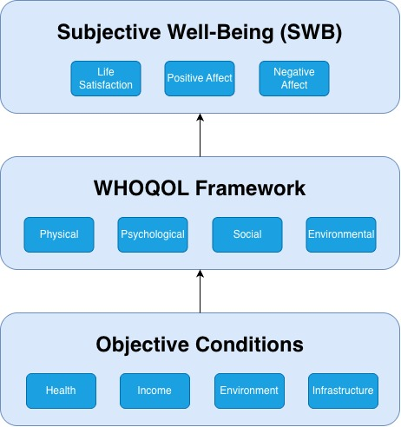
Source: author’s own work

Quality of Life in the Urban Context
As cities have changed over time, city planning has gone from just building functioning infrastructure to making sure that everyone is healthy and happy. As cities are becoming more crowded, it’s harder to keep a good level of living. To accomplish this, we must deepen our understanding of how the physical environment influences individuals' cognition and social conduct. This chapter examines various facets of Quality of Urban Life (QOUL) and explores how space can enhance it.

Defining the “Urban Quality of Life” (QOUL)
Quality of Urban Life (QOUL) is a multifaceted term that includes the complicated relationship between the physical environment and human experiences. Marans (2012, p. 10) stated that QOUL cannot be fully understood through a single perspective. It requires a dual-methodological framework that combines objective environmental factors with subjective resident perspectives.

Objective indicators of urban life usually include the city’s physical, measurable features like its appearance, density, quality of infrastructure, and quick access to public services (MARANS, 2012, p. 11). These indicators are a useful starting point for city planning, but they aren’t enough on their own because they don’t show how people really live and interact with their surroundings. On the other hand, subjective metrics consider how the person feels about their community, their happiness with it, and their overall well-being (MARANS, 2012, p. 10).

The "bottom-up" conceptual framework says that these subjective indicators are affected by personal features such as socio-demographic factors, expectations, and different standards of comparison (MARANS, 2012, p. 12). Because of this, the same objective urban state may make different groups of people pleased or very unhappy. For students and politicians, this integrated approach is important because it links “top-down“ physical design with how people actually live (MARANS, 2012, p. 10), ultimately ensuring that urban planning considers the diverse needs and preferences of various community groups. By aligning research outcomes with subjective assessments, urban design methodologies can be more effectively aligned with human requirements, leading to urban environments that are more responsive and egalitarian (MARANS, 2012, p. 10).

The Impact of the Physical Environment on Urban Dwellers
The “build environment” is the term for physical surroundings that people have built or changed, such as homes, communities, schools, workplaces, parks, business areas, and transportation systems. These things affect our daily lives (PROVINCIAL HEALTH SERVICES AUTHORITY, 2014, p. 2). These places, which can be big cities or small towns, have a big impact on the health and well-being of the people who live there (PROVINCIAL HEALTH SERVICES AUTHORITY, 2014, p. 2). Five related physical characteristics define the link between health and the built environment (PROVINCIAL HEALTH SERVICES AUTHORITY, 2014, pp. 6, 15).

Figure 2: Physical Features of a Healthy Built Environment
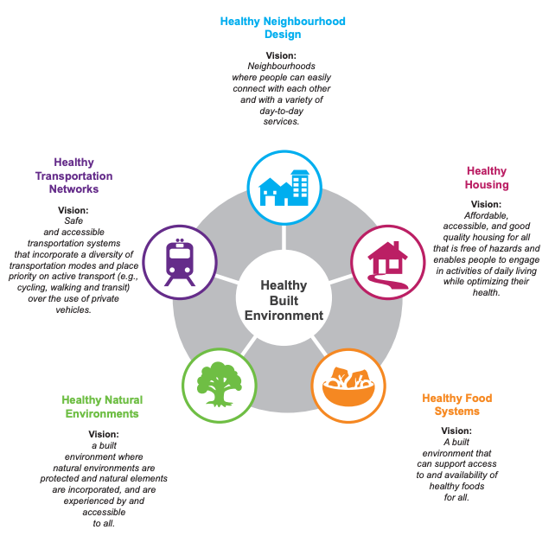
Source: Healthy Built Environment Linkages: A Toolkit for Design Planning, Health. (PROVINCIAL HEALTH SERVICES AUTHORITY, 2014, p. 15)

Healthy Neighborhood Design
The vision of a healthy neighborhood design is the following:
“Neighborhoods where people can easily connect with each other and with a variety of day-to-day services” (PROVINCIAL HEALTH SERVICES AUTHORITY, 2014, p. 17).

Figure 3: Healthy Neighborhood Design

Source: (PROVINCIAL HEALTH SERVICES AUTHORITY, 2014, p. 16).

Neighborhoods are where people live, work, and play every day. So, the way these places are laid out and built is very important for public health and well-being. Land use policies, such as zoning rules, transportation planning, and site design, have a big impact on health outcomes. Things like how close you are to work, how easy it is to get healthy food, and how safe public places are all closely related to how much exercise you get, how good your diet is, and how much free time you have, which all lead to better mental and physical health.

The "three Cs" framework is typically used to reach these goals:
- Complete
- Compact
- Connected

This form of development is meant to make active transportation easier, such as walking, biking, and using public transportation. This will help create communities that are better for the environment and people's health. (PROVINCIAL HEALTH SERVICES AUTHORITY, 2014, p. 17).

Healthy Transportation Networks
The vision of a healthy transportation network is the following:

“Safe and accessible transportation systems that incorporate a diversity of transportation modes and place priority on active transport (e.g., cycling, and transit) over the use of private vehicles.” (PROVINCIAL HEALTH SERVICES AUTHORITY, 2014, p. 21).

Figure 4: Healthy Transportation Networks

Source: (PROVINCIAL HEALTH SERVICES AUTHORITY, 2014, p. 16).

Transportation networks are essential for daily movement, and their design is a major factor in public health. Decisions about urban planning and land use have a big impact on people's choices about how to get around by affecting how easy it is to use public transportation, how safe it is to ride a bike, and how possible it is to walk.

Urban areas can encourage people to be more active by making walking, biking, and using public transportation more important.

This will improve the physical and mental health of everyone in the area (PROVINCIAL HEALTH SERVICES AUTHORITY, 2014, p. 21).

Healthy Natural Environments
The vision of a healthy natural environment is the following:

“A built environment where natural environments are protected and natural elements are incorporated, and are experienced by and accessible to all.” (PROVINCIAL HEALTH SERVICES AUTHORITY, 2014, p. 25).

Figure 5: Healthy Natural Environments

Source: (PROVINCIAL HEALTH SERVICES AUTHORITY, 2014, p. 16).

It is important for public health and well-being to include natural areas in city planning. Land-use plans that put ecological connectivity first can help lessen the negative health effects of building too many homes in cities. For example, the planned use of greenways and public parks provides important ecosystem services like filtering air and lowering the effects of urban heat islands. They also make it easier to get around and enjoy nature, which can lead to increased physical activity and improved mental well-being for residents.

Urban planning interventions that create livable spaces not only encourage people to be active, but they also make a big difference in the mental health of the population (PROVINCIAL HEALTH SERVICES AUTHORITY, 2014, p. 25).

Healthy Housing
The vision of healthy housing is the following:

“Affordable, accessible, and good quality housing for all that is free of hazards and enables people to engage in activities of daily living while optimizing their health.” (PROVINCIAL HEALTH SERVICES AUTHORITY, 2014, p. 32).

Figure 6: Healthy Housing

Source: (PROVINCIAL HEALTH SERVICES AUTHORITY, 2014, p. 16).

We spend most of our time at home, where we eat, sleep, hang out with friends and family, and sometimes even work. Home is an essential human right, yet not all homes are built to the same standards.

Housing differences, such as quality, accessibility, and cost, all affect the health of the individuals who reside there. These effects might be good or bad for our health, both in the short and long term, as they can influence factors such as mental well-being, physical health outcomes, and overall quality of life. This is why the way we design our houses is so crucial for our health and happiness.

For example, a stable and affordable home that provides a warm, safe, and healthy living environment can improve your health. All of these things are parts of healthy housing that can help people eat well, act well, and have excellent relationships. Healthy housing can help people feel better mentally and physically and improve their quality of life (PROVINCIAL HEALTH SERVICES AUTHORITY, 2014, p. 32).

Healthy Food Systems
The vision of a healthy food system is the following:

“A built environment that can support access to and availability of healthy foods for all” (PROVINCIAL HEALTH SERVICES AUTHORITY, 2014, p. 29).

Figure 7: Healthy Food Systems

Source: (PROVINCIAL HEALTH SERVICES AUTHORITY, 2014, p. 16).

Food systems decide what food we can get and how we choose what to eat. The food we eat is essential for our health. Land use affects food production, which affects food quality, availability, and variety. Think about where our food comes from, how it is made, and the journey it takes to get to our communities:
- Is the food equally accessible to everyone when it arrives to our community?
- What kinds of cuisine can you find in different parts of town?

The first step to making our food systems healthier should be to make it easier for people to procure and find nutritious food and to teach them about healthy food systems (PROVINCIAL HEALTH SERVICES AUTHORITY, 2014, p. 29).

Proximity and the “15-Minute City” Concept
The “15-Minute City” is an urban planning idea based on “chrono-urbanism,” which says that the quality of life in cities goes down as people have to spend more time getting around, especially in their cars.

Carlos Moreno first suggested this idea in 2016. It calls for a residential urban layout where everyone can access their basic necessities within a 15-minute walk or bike ride of their residences. The idea is to “fix” the broken cities and communities that modernist planning and car-dependent urban development have generated (MORENO et al., 2021, p. 100).

The Core Framework: Six Essential Functions and Four Dimensions
The main purpose of the 15-minute city is to let people do six important social activities close to home:
- Live
- Work
- Shop
- Obtain medical treatment
- Go to school, and
- Have fun

To achieve these goals, Moreno et al. (2021, p. 101) highlight four significant aspects that cities must integrate into their structure.
- Density: This is the best number of people per square kilometer that can help with local service and delivery and resource utilization (MORENO et al., 2021, pp. 100-101).
- Proximity: This dimension is both spatial and temporal, ensuring that services are easily accessible within a small radial distance, hence preventing time wastage and environmental impact (MORENO et al., 2021, pp. 100-101).
- Diversity: Involves establishing mixed-use zones that offer a wide range of services and encourage individuals from different backgrounds to interact with each other (MORENO et al., 2021, pp. 100-101).
- Digitalization: Smart city technologies like the Internet of Things (IoT), artificial intelligence (AI), and big data might be utilized to improve service delivery and encourage new ideas like bike-sharing and virtual communications (MORENO et al., 2021, p. 101).

Sustainability, Resilience, and Place Identity
The COVID-19 pandemic greatly sped up the adoption of the 15-minute city model. Global lockdowns showed how weak car-dependent, scattered urban areas are (MORENO et al., 2021, pp. 94, 101).

Cities can make themselves more resilient by putting a high value on proximity. This way, even during large disruptions, citizens will still be able to acquire the fundamental goods and services they need and stay connected to their communities (MORENO et al., 2021, pp. 94, 101).

The model promotes “soft mobility” (walking and cycling) and cuts down on the time lost in traffic, which is positive for the environment because it lowers CO₂ emissions (MORENO et al., 2021, pp. 96, 101). The idea helps “place identity” by getting cities to use their distinctive cultural and community heritage to their advantage (MORENO et al., 2021, p. 99). This helps cities stay competitive while also building trust and close ties between residents (MORENO et al., 2021, pp. 99, 100).

Global Implementation and Variations
The “Paris en Commun” program, which is led by Mayor Anne Hidalgo and intends to make Paris a “city of proximity,” is the most well-known example of this approach (MORENO et al., 2021, p. 100):
- China: there are “15-minute walkable neighborhoods” that promote healthy lifestyles and the prevention of chronic diseases (MORENO et al., 2021, p. 97).
- Australia and the United States: there is the “20-minute city” model that focuses on making it easy to locate work (MORENO et al., 2021, pp. 97, 98).

These variations have different time indications or focal points, but they all have the same main goal: to make cities more livable and less dependent on cars (MORENO et al., 2021, p. 98).

The Smart City Paradigm and Data-Driven Governance
The idea of a "smart city" has changed from a focus on basic computerization to a complex integration of systems that connect the physical, digital, and social parts of city life.

Batty et al. (2012, p. 481) say that a smart city is one where information and communication technologies (ICT) are used with traditional infrastructure and coordinated and integrated with new digital technologies. This integration is not just an addition. It changes the city into a "sentient" being that can monitor itself in real time and respond on its own through a "constellation of instruments" at different scales (Batty et al., 2012, p. 482).

The transition from a 20th-century emphasis on energy and materials to a 21st-century emphasis on information is central to this definition (BATTY et al., 2012, p. 482). A city is considered "smart" when it has intelligence functions that combine large amounts of data to make the city more sustainable, competitive, and better for its residents (BATTY et al., 2012, p. 482). This necessitates the city operating as a "laboratory for innovation," wherein digital tools not only observe human behavior but also actively influence novel forms of social organization and democratic engagement (BATTY et al., 2012, pp. 482, 485).

The model also suggests that data-driven governance needs to find a balance between being technically efficient and fair to everyone. A smart city must address the digital divide and ensure that the system's "intelligence" is utilized to foster broad participation and transparent governance (BATTY et al., 2012, p. 485).

According to Batty et al. (2012, p. 483), the main goal of the smart city framework is to shift away from offering services in isolated silos. Instead, the aim is to create a comprehensive urban ecosystem. This ecosystem would leverage real-time data to inform long-term strategic planning. This approach effectively addresses the complex issues associated with contemporary urbanization.

Chapter Summary – Quality of Life in Urban Context
This chapter looked at how urban environments and planning frameworks affect Quality of Life. The main conclusions are:

- Urban quality of life depends on how well physical infrastructure and human experience work together.
- The built environment, encompassing housing, transportation, and green spaces, directly impacts health and well-being.
- The idea of a 15-minute city is based on three main ideas
  - being close to things
  - being easy to get to
  - lasting a long time
- The smart city model brings in government that makes decisions based on data and city management that happens in real time.

In short, the quality of life in cities isn't just about the roads and buildings; it's also about how well cities combine accessibility, sustainability, and design that puts people first.
Figure 8: Chapter Summary – Quality of Life in Urban Context
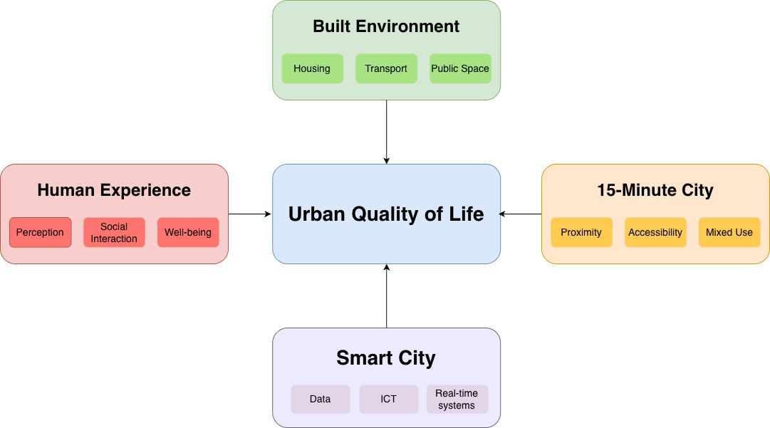
Source: author’s own work

Key Indicators for Measuring Urban Well-being
To move from the theoretical framework of urban design to a practical assessment of quality of life, a definitive set of measurable indicators must be established. The "15-minute city" is a great idea for how cities should be close to each other (see Section 2.3). However, how well a person is doing depends on how well their immediate surroundings work. People don't think of quality of life as just one number; they think of it as the mix of the physical, social, and economic conditions that make up a city's daily life.

This chapter breaks these conditions down into four main groups:
- Socio-economic security
- Mobility
- Accessibility
- Environmental health.

By looking at these specific areas, we can see the clear differences between a city that is just functional and one that actively promotes human flourishing. In the next few sections, we'll talk about the best ways to judge how well a city is doing today. These include air quality, transportation networks, the availability of public services, and how safe a neighborhood feels.

Environmental Indicators: Air Quality and Noise Pollution
The World Health Organization (WHO) says that air pollution is one of the biggest environmental threats to human health, causing about 7 million deaths each year (WHO, 2021) (see Section 1.2). The new Global Air Quality Guidelines (AQG) show a change in how we measure urban health. Recent long-term studies show that health problems, such as heart and lung diseases, happen at much lower levels of pollution than the 2005 standards said (WHO, 2021; Hoffmann et al., 2021).

The WHO says that "classical" pollutants should have strict annual and short-term exposure limits to protect people who live in cities. The most important of these indicators are

Key Indicator Thresholds
Particulate Matter ( ${PM}_{2.5}$)
The annual guideline has been halved from $10 μ\frac{g}{m^{3}}$ to $5 μ\frac{g}{ m^{3}}$, reflecting its capacity to penetrate the blood-brain barrier and cause systemic inflammation (WHO, 2021, p. 73).

Nitrogen Dioxide (${NO}_{2}$)
Frequently associated with traffic emissions, the annual limit was reduced from $40 μ\frac{g}{m^{3}}$ to $10 μ\frac{g}{m^{3}}$ (WHO, 2021, p. 121).

Ozone ($O_{3}$)
For the first time, a peak season guideline of $60 μ\frac{g}{m^{3}}$ has been introduced to account for long-term respiratory impacts during high-heat months (WHO, 2021, p. 109).

Health and Policy Implications
The framework makes it clear that there is no “safe” level of exposure to particulate matter. However, these goals can cut the number of diseases around the world by up to 80% in places with a lot of pollution (WHO, 2021, p. 4).

The WHO provides cities that are unable to meet these strict air quality levels with "interim targets" to assist them in gradually improving air quality (WHO, 2021, p. 5). The guidelines say that taking care of these environmental indicators has two benefits. It helps fight climate change by cutting down on short-lived climate pollutants, and it improves public health right away (WHO, 2021, p. 153).

Mobility and Transportation Infrastructure
The safety, efficiency, and inclusiveness of a city's transportation network are all important parts of modern urban well-being. The World Business Council for Sustainable Development (WBCSD, 2015) says that mobility should be looked at from many angles, considering both economic productivity and social equity (p. 5). Modern indicators don't just look at how fast transit is; they also look at "system performance" and how to reduce bad side effects like traffic jams and accidents (WBCSD, 2015, p. 7).

Key Mobility Indicators
The WBCSD framework lists a number of important metrics for judging how good urban infrastructure is:

Affordability of Public Transport
This indicator shows how much it costs for the "poorest group" of people to use public transportation. High well-being cities make sure that important movement isn't stopped by cost, which means that no one is left out (WBCSD, 2015, p. 52).

Commuting Travel Time
The quality of life in cities goes down as the amount of time spent in transit goes up. The report provides a standard scale, with a 10-minute commute being the best and a 90-minute commute being the worst for people's health (WBCSD, 2015, p. 39).

Traffic Safety
The number of people who die in traffic accidents is a useful way to tell how beneficial the infrastructure is. "Active travel," like walking and biking, is beneficial for public health (WBCSD, 2015, p. 44), but you need a safe place to do it.

Comfort and Pleasure
Along with its practical use, the "experience" of movement, which includes how many people are in a vehicle and how nice public spaces look, is seen as a unique factor that affects how happy people are in cities (WBCSD, 2015, p. 50).

Intermodality and Sustainability
To move toward sustainable mobility, we need "intermodal connectivity," which means that different modes of transportation should work together flawlessly. For example, bike-sharing stations should be located near major rail hubs (WBCSD, 2015, p. 55). Cities can improve the environment by lowering the number of private internal combustion engine (ICE) vehicles. This will help with the urban heat island effect and noise pollution (WBCSD, 2015, p. 11).

Accessibility to Public Services
Accessibility is a key link between a city's infrastructure and the health of its people. It looks at how easy it is for people to get to important social and environmental resources, such as healthcare facilities, parks, and public transportation options.

The OECD (2020) says that accessibility isn't just about how far away something is. It's also about how useful and easy-to-use public services are that help people and their social capital (p. 215).

This indicator is important because not having enough access to healthcare, education, or environmental amenities is directly linked to lower life satisfaction and higher social exclusion (OECD, 2020, p. 27).

Dimensions of Urban Accessibility

Environmental Quality and Green Space
How close residents are to "public open spaces" is a positive sign of how well a city is doing. The OECD says that people who live in cities with plentiful green spaces nearby are much happier (OECD, 2020, pp. 157–158).

These places are good for your mental health and help you deal with climate change by providing opportunities for relaxation, social interaction, and physical activity, which are essential for overall well-being. Furthermore, the quality of these spaces, not just their existence, is a key factor in how useful they are for the community (OECD, 2020, p. 162).

Socio-Economic Accessibility of Institutions
Accessibility also means that local institutions, like schools and hospitals, are open to everyone. The framework stresses that "personal security" or high costs that keep vulnerable groups from using public services hurt their well-being (OECD, 2020, p. 215).

Personal Security and Service Reach
The infrastructure of a city is only as safe as it is easy to access to. The OECD says that "perceived safety" in public places is necessary for people to be able to access local services, especially at night (OECD, 2020, p. 218). Therefore, when looking at the "reach" of public services, you also need to look at how safe the roads are that lead to those services (OECD, 2020, p. 220).

The Role of Spatial Equity
The OECD says that "spatial equity" is the most important way to measure accessibility. This means looking at whether services are spread out fairly across different urban neighborhoods. When bad public transportation or geographic centralization makes it hard to get around, it creates "pockets of disadvantage" that hurt the city's overall socio-economic stability (OECD, 2020, p. 31).

Safety and Socio-Economic Stability
The last part of urban well-being moves the focus from physical infrastructure to the safety and lived experience of the people who live there. The Stiglitz-Sen-Fitoussi Report (2009) contends that conventional economic indicators, like GDP, inadequately reflect the "insecurity" that significantly undermines quality of life (Stiglitz et al., 2009, p. 41). Urban stability should be assessed through a dual perspective: the objective reality of physical safety and the subjective predictability of socio-economic status.

Dimensions and Physical Safety

Objective vs. Perceived Safety
Crime statistics are a good starting point, but "perceived safety" is how safe people feel in their daily lives is a better measure of urban well-being (Stiglitz et al., 2009, p. 54). Fear can cause people to "socially withdraw," which hurts the trust and interaction that a city needs to work.

Resilience to Shocks
Safety also means that the city can protect its people from outside shocks, like natural disasters or economic downturns. The report stresses that a lack of "physical and environmental security" has a bigger effect on vulnerable groups, which makes the gap in well-being between different urban areas even bigger (Stiglitz et al., 2009, p. 74).

Socio-Economic Stability

Economic Insecurity
Stability is not just having a job right now; it's also not having "wealth volatility." The report says that the constant fear of losing your job or home is a "well-being tax" that makes people less happy with their lives, even those who are currently working (Stiglitz et al., 2009, p. 198).

Social Connections and Capital
A stable city is one that encourages "social capital." A key sign of long-term social cohesion is a city's ability to create spaces where people from different socio-economic backgrounds can interact (Stiglitz et al., 2009, p. 183).

Integrating Subjective Well-being
The report says that policymakers need to pay more attention to subjective well-being data, which is how people rate their own lives and safety, in addition to traditional objective measures (Stiglitz et al., 2009, p. 58). This is necessary for a city to have "socio-economic stability." This keeps urban development focused on people and able to deal with the problems that come with living in a city today.

Chapter Summary – Key Indicators for Measuring Urban Well-being
This chapter took abstract ideas and turned them into clear ways to measure how well cities are doing:
- Urban QOL can be structured into four main domains: environment, mobility, accessibility, and socio-economic stability.
- Environmental factors such as air quality have direct health impacts and are critical indicators.
- Mobility indicators focus on efficiency, affordability, and safety of transport systems
- Accessibility and spatial equity determine how fairly services are distributed across the city
- Safety includes both objective conditions and subjective perception, influencing social behavior

Overall, the chapter demonstrates that urban well-being can be systematically evaluated using integrated indicator frameworks, enabling data-driven analysis.

Figure 9: Chapter Summary – Key Indicators for Measuring Urban Well-being
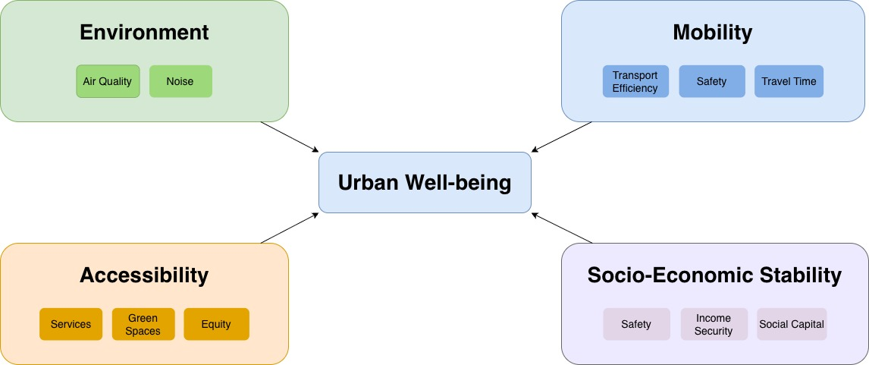
Source: author’s own work

Quantitative QOL Assessment
Quantitative evaluation of Quality of Life (QOL) serves as a crucial link between theoretical frameworks and the execution of practical urban policy.

The previous chapters talked about the ideas and steps that are necessary for the health of cities. This section, on the other hand, talks about how these traits are turned into indexes that can be watched, compared, and used to help people make decisions.

Quantitative QOL methodologies seek to convert intricate urban data into uniform rankings or composite indicators, thereby facilitating the evaluation, comparison, and longitudinal monitoring of cities. This method, on the other hand, has trouble choosing indicators, normalizing them, weighing them, and getting the data, which has a big effect on the final conclusions (OECD, 2020, p. 38).

Comparative Analysis of Current QOL Ranking Methodologies
Many worldwide frameworks have been developed to assess and compare the quality of life across various locations. Some of the most well-known ones include:
- OECD Better Life Index
- Mercer Quality of Living Ranking
- Economist Intelligence Unit (EIU) Global Livability Index

Even though the goals of these methods are the same, they employ various indicators, bring them together in different ways, and focus on distinct ideas.

OECD Better Life Index
The OECD Better Life Index looks at both objective things (like income and living circumstances) and subjective things (like how pleased you are with your life). Users can also decide how significant each factor is to them (OECD, 2020, p. 40). People recognize that the quality of life for each person is varied and can alter based on the situation.

Mercer and EIU rankings
The Mercer and EIU rankings, on the other hand, employ expert reviews and pre-set weighting methods to compare cities and assess how consistent they are (STIGLITZ et al., 2009, p. 62).

A major difference between the two methods is how they deal with subjective well-being. The frameworks developed by the Stiglitz-Sen-Fitoussi Commission expressly incorporate subjective measurements as fundamental elements of quality of life assessment, in contrast to other frameworks that emphasize objective indicators of infrastructure and economic stability (STIGLITZ et al., 2009, p. 58). This disagreement illustrates that urban studies still don't agree on how to define quality of life: by what people see or by what they actually go through.

Also, the approaches differ in how well they depict the small aspects of space. Some indexes only work on a national or metropolitan level, which could make it hard to distinguish which city is which. More recent methods look at neighborhoods to see how safe, clean, and convenient they are to get to (OECD, 2020, p. 31). This adjustment is in keeping with the growing relevance of ideals like making cities work for each area and spatial equality.

In short, the existing QOL ranking systems are good for comparing cities, but you need be careful with their results because different approaches might give the same city quite varied ranks.

Challenges in Data Normalization and Weighting
One of the major issues with quantitative QOL evaluation is making sure that different types of data can be compared and that they are given the proper amount of weight. There are many things that make up the quality of life in cities, and each one has its own size, unit, and distribution. You can't compare these indicators until they appear the same. Min-max scaling and z-score normalization are two common approaches to do this (OECD, 2020, p. 39).

But normalizing makes things a lot harder:
- The method you execute it can change the findings a lot, especially if the data set has outliers or distributions that aren't even. For instance, if you use min-max normalization, the order of cities can alter if their values are very high or very low.
- Normalization typically presupposes that there are straight lines between the things that measure quality of life and the quality of life itself. This could be too simple to comprehend how things really function.

The problem gets worse when you gain weight. When you allocate weights to indicators, you are deciding which parts of your life are the most essential to you. A lot of people pick equal weighting because it's easy, but it could not indicate what people really care about or how different cultures work. Using experts to weigh things can be unfair and biased, while data-driven methods like principal component analysis may not be easy to understand (STIGLITZ et al., 2009, p. 65).

You should also think about how to achieve a balance between being helpful and being able to compare. A standard weight scale can help you compare products from all around the world, but it won't tell you what people in each place require. For example, one community might care more about how pure the air is than another city does about how affordable housing is. This problem highlights how crucial it is to have frameworks that can be utilized in many different ways and for many different purposes.

Because there is so much useful information, it's tougher to do. Urban datasets frequently exhibit missing values, inconsistent measuring methodologies, and temporal discrepancies.

It's simple to observe these challenges when you try to mix real-time data streams from smart city systems that have trouble with data dependability and interoperability (BATTY et al., 2012, p. 485).

Normalization and weighing are technical stages, but they also make us think about and define what a decent quality of life is in a new way. If you want QOL indexes to be useful and trustworthy, you need to be honest about how you came up with your methods.

The Role of Open Data Platforms (Golemio Case Study)

Open data platforms reveal us a lot more about how fantastic it is to live in cities. You may utilize these tools to find out about cities, put everything together, and send it out right away. This makes the government more open and gives individuals the knowledge they need to make choices.

A lot of individuals in Prague know about the Golemio platform. People can use the city's network to acquire information and do analytics. Golemio gathers data from a lot of different sources, such weather sensors, public services, and transportation networks. This makes it simple to see how cities change throughout time. Like ecosystems, smart cities use data all the time to grow and improve.

One of the best things about systems like Golemio is that they always check to make sure the QOL data is correct and up to date. Open data websites keep you up to date on subjects like public transportation, air pollution, and traffic delays. On the other hand, most indexes use datasets that are rarely, if ever, updated. This makes it easier and faster to find out how well cities are performing.

When data is available, more people can find out about and get involved in what's going on. They help produce innovative apps and analytical tools that can improve life in the city better by offering consumers, scholars, and developers access to data. According to the principles of data-driven governance, governments should be accessible and accountable. Our strategy respects these guidelines (BATTY et al., 2012, p. 485).

There are a lot of difficulties with using free data, though. We need to fix concerns with privacy, standards, and interoperability as soon as possible so that everyone may use the data. The digital gap may also make it tougher for some people to get to these resources, which would make the differences that already exist much worse.

Adding platforms like Golemio to QOL evaluation frameworks is a huge step toward generating a better and more accurate image of how well people live in cities, even with these issues. Cities may employ both old and new data technology to make their plans more adaptable and better meet the demands of their residents.

Chapter Summary – Quantitative QOL Assessment
This chapter focused on the quantitative measurement of QOL through indices, data processing, and digital platforms:

- QOL rankings differ due to methodological choices in indicators, normalization, and weighting.
- Data normalization is necessary for comparability but can distort results depending on the method used.
- Weighting introduces subjective decisions about what aspects of life are most important.
- Open data platforms such as Golemio enable real-time and high-resolution urban analysis.
- Smart city systems transform cities into data-driven, adaptive environments

In conclusion, quantitative QOL assessment is a powerful tool, but its results depend heavily on methodological transparency and data quality.
Figure 10: Chapter Summary – Quantitative QOL Assessment
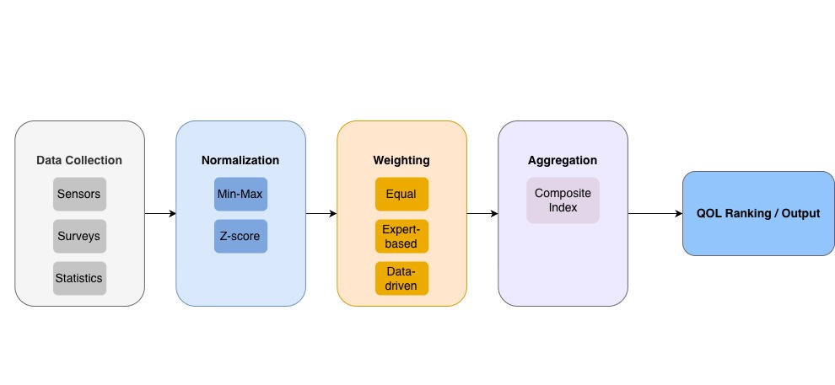

Source: author’s own work

Scenario-Based Case Studies in Urban Prague
This chapter translates the theoretical foundations of Urban Quality of Life (QOUL) into tangible experiences for individuals. Employing a "bottom-up" conceptual approach, the study examines how three distinct "personas" perceive Prague's objective urban infrastructure, including aspects such as transportation density and the distribution of green spaces.

Case Study 1: The “Senior Citizen” (Mobility & Safety Focus)

Profile
Jan is 75 years old and lives in a newly renovated apartment in Holešovice, Prague 7. The Level of Independence and Physical Environment domains of the WHOQOL framework have a big impact on QOUL for older people like Jan.

Mobility and Transportation
The "Healthy Transportation Network" greatly improves Jan's quality of life. He needs the low-floor buses and barrier-free tram changes in Prague to do his "Activities of Daily Living." For a young professional, a 15-minute walk could take 25 minutes. This means that the "Proximity" part of the 15-minute city needs to think about "soft mobility," which is slower.

Safety and Social Well-being
Diener's theory suggests that Jan's perception of his neighborhood as secure enhances his life satisfaction (the cognitive component). "Healthy Neighborhood Design" that promotes "social support" and well-lit public benches keeps people from feeling "negative affect" when they're alone.

Green Spaces and Climate Comfort
People in paved areas of Prague can feel "Pain and Discomfort" because of the "Urban Heat Island" effect. Stromovka Park and other "healthy natural environments" are important "ecosystem services" because they cool things down and give people a place to "Participate in Recreation."

Case Study 2: The “Young Tech Professional” (Connectivity & Comforts)

Profile
Elena, a 28-year-old software engineer, resides in a modern studio in Karlín. She employs the "Work Capacity" and "Smart City Paradigm" components of the WHOQOL-100 to evaluate her environment. For her, the city is a living, breathing system, a space where digital and physical elements seamlessly integrate.

Neighborhood and Daily Life
The vibrant mix of residential, commercial, and recreational areas in Karlín injects a certain richness into daily life, creating space for those small, positive interactions that make a difference. Diener suggests that the frequent "Positive Affects" stemming from her ability to stroll from her "Healthy Housing" to a coworking space or a specialty cafe in a mere fifteen minutes outweigh the significance of major life events when it comes to lasting happiness.
Mobility and Digital Integration
Elena's character exemplifies the "Digitalization" aspect of the 15-minute city. Specifically, her ability to optimize "Intermodality" is demonstrated by her capacity to switch between the metro and a shared bike, contingent upon prevailing traffic conditions. Real-time data, such as that provided by platforms like Golemio, facilitates this adaptability.

Health, Stress, and Home Environment
Even with ample financial resources, city life still brings her stress. She's susceptible to illness, citing "traffic" and "air pollution" as culprits. Living in a city that prioritizes "soft mobility" and offers a "Home Environment" that's both "free of hazards" and soundproof has made her significantly happier. She enjoys a peaceful, connected neighborhood, which is a welcome contrast to her demanding job.

Case Study 3: The “Young Family” (Environment & Stability)

Profile
The Novák family, a couple in their thirties residing in a residential area of Prague 6, known as Dejvice, have two young children. The Novák family, prioritizing environmental and social considerations, endeavors to achieve "Spatial Equity" in their utilization of public services.

Access to Services and Urban Design
The "Go to School" and "Get Medical Treatment" components of the 15-minute city model are of paramount importance to families. Consequently, a "Healthy Neighborhood Design," which strategically locates schools and pediatricians in readily accessible and secure areas, directly contributes to "Socio-Economic Stability" by minimizing both travel time and associated expenses.

Children's Well-being and Green Spaces
The physical and mental well-being of children is closely linked to their exposure to healthy natural environments. Dejvice provides children with opportunities to learn and develop through play, thanks to its public playgrounds and a focus on ecological connectivity.

Housing and Stability
For families, a healthy home is one that offers affordable, well-maintained space conducive to their everyday lives. A family's overall life satisfaction improves when they perceive their home environment as stable and free from hazards.

Air Quality and Urban Environment
Urban areas face a significant challenge: elevated air pollution, including PM2.5 and PM10, near busy roads like Evropská street, presents a risk to public health. Greenways, which contribute to cleaner air, serve as valuable environmental markers, offering a glimpse into the quality of life within a city

Chapter Summary - Scenario-Based Case Studies in Prague
This chapter applied theoretical and quantitative frameworks to real-life scenarios in Prague:
- QOL varies significantly depending on individual needs, age, and lifestyle.
- The elderly population prioritizes accessibility, safety, and mobility.
- Young professionals value connectivity, flexibility, and urban amenities.
- Families focus on environmental quality, stability, and access to services.
- The same urban environment can produce different subjective experiences, confirming the importance of SWB.

Overall, the chapter demonstrates that urban QOL must be analyzed from a “bottom-up” perspective, where individual experiences complement objective data.

Figure 11: Chapter Summary - Scenario-Based Case Studies in Prague
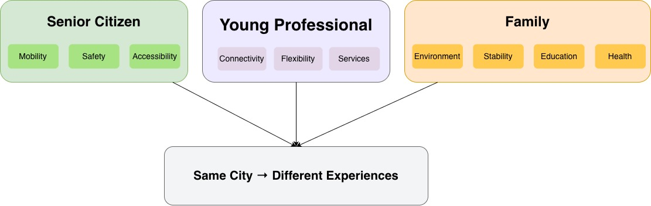
Source: author’s own work

Practical Part

Conclusion

List of Sources
Introducing the „15-Minute City“: Sustainability, Resilience and Place Identity in Future Post-Pandemic Cities. MORENO, Carlos, et al. 2021. 1, 2021, Smart Cities, Vol. 4, pp. 93–111.
Quality of Urban Life Studies: An Overview and Implications for Environment-Behaviour Research. MARANS, Robert W. 2012. 2012, Procedia - Social and Behavioral Sciences, Vol. 35, pp. 9–22.
Subjective well-being. DIENER, Ed. 1984. 3, s.l. : Psychological Bulletin, 1984, Psychological Bulletin, Vol. 95, pp. 542–575.
Smart cities of the future. BATTY, M., K.W. AXHAUSEN, F. GIANNOTTI, et al. 2012. 1, December 05, 2012, The European Physical Journal Special Topics, Vol. 214, pp. 481-518.
World Health Organization. 2012. WHOQOL User Manual. World Health Organization. [Online] World Health Organization, March 1, 2012. [Cited: 2 21, 2026.] https://www.who.int/tools/whoqol.
Provincial Health Services Authority. 2014. Healthy Built Environment Linkages: A Toolkit for Design, Planning, Health. BC Centre for Disease Control (BCCDC). [Online] 1.1, October 2014. [Cited: March 16, 2026.] [online]. https://www.bccdc.ca/pop-public-health/Documents/linkagestoolkitrevisedoct16_2014_full1.pdf.
World Health Organization. 2021. WHO global air quality guidelines: particulate matter (PM2.5 and PM10), ozone, nitrogen dioxide, sulfur dioxide and carbon monoxide. Geneva : World Health Organization, 2021.
OECD. 2020. How’s Life? 2020: Measuring Well-being. Paris : OECD Publishing, 2020.
Stiglitz, Joseph E., Sen, Amartya and Fitoussi, Jean-Paul. 2009. Report by the Commission on the Measurement of Economic Performance and Social Progress. Commission on the Measurement of Economic Performance and Social Progress. Paris : s.n., 2009.
World Business Council for Sustainable Development. 2015. SMP2.0 Sustainable Mobility Indicators – 2nd Edition. Geneva : WBCSD, 2015.

List of Figures (Provincial Health Services Authority, 2014)
Figure 1: Chapter Summary – Theoretical Foundations of Quality of Life 19
Figure 2: Physical Features of a Healthy Built Environment 21
Figure 3: Healthy Neighborhood Design 22
Figure 4: Healthy Transportation Networks 22
Figure 5: Healthy Natural Environments 23
Figure 6: Healthy Housing 24
Figure 7: Healthy Food Systems 24
Figure 8: Chapter Summary – Quality of Life in Urban Context 28

List of Tables
Table 1: Field centres involved in the developments of the WHOQOL Instrument 9
Table 2: WHOQOL Pilot assessment domains and facets 10
Table 3: WHOQOL-100 Domains and Facets 13

List of Charts

List of Appendices

Appendix A

