TECHNICAL ASSESSMENT DOCUMENTATION
Leave Management System
System workflow, architecture, implementation, and design decisions
A role-based, responsive application for employee leave requests, manager approvals, and administrative account management.
Application | Leave Management System
Technology | Go, PostgreSQL / Supabase, React
Prepared | 30 July 2026
Assessment focus: design thinking • implementation • database • UX • quality

1. Executive Summary
The Leave Management System is a compact, role-based web application that supports three core workflows: employees submit and track leave, managers review requests from their assigned team, and administrators maintain accounts, reporting relationships, and yearly balances. The deployed application runs as a single Go server with an embedded React frontend and a Supabase-backed PostgreSQL database.
Design goal Keep the assessment understandable and demonstrable while preserving production-minded boundaries: verified identity, server-side authorization, transactional decisions, database constraints, and responsive UI.

Evaluation Alignment
Evaluation area | Evidence in the solution | Why it matters
System design | Single-server deployment, trust boundaries, role-based workflows | Simple to operate and explain
Backend | Go HTTP API, middleware, transactions, typed errors | Correct and maintainable behavior
Database | Foreign keys, exclusions, balance checks, triggers | Integrity survives application bugs
UI / UX | Role-specific screens and responsive layouts | Usable on PC, tablet, and mobile
Code quality | Layered packages, tests, linting, vetting | Evidence of disciplined delivery

2. System Workflow
- A user signs in through Supabase Authentication. The frontend exchanges the access token for an HttpOnly backend session cookie.
- The Go API verifies the token locally through the project JWT secret or cached JWKS, with a secure Supabase verification fallback.
- The backend loads the application profile and derives the authoritative user role and employee identifier.
- Employees submit leave requests; the service rejects invalid dates, cross-year requests, and overlaps.
- Only the assigned manager or an administrator can decide a pending request. Approval and leave-balance deduction occur in one transaction.
- Administrators create or update accounts through the Supabase Admin API and synchronize application profiles, manager assignment, departments, and balances.
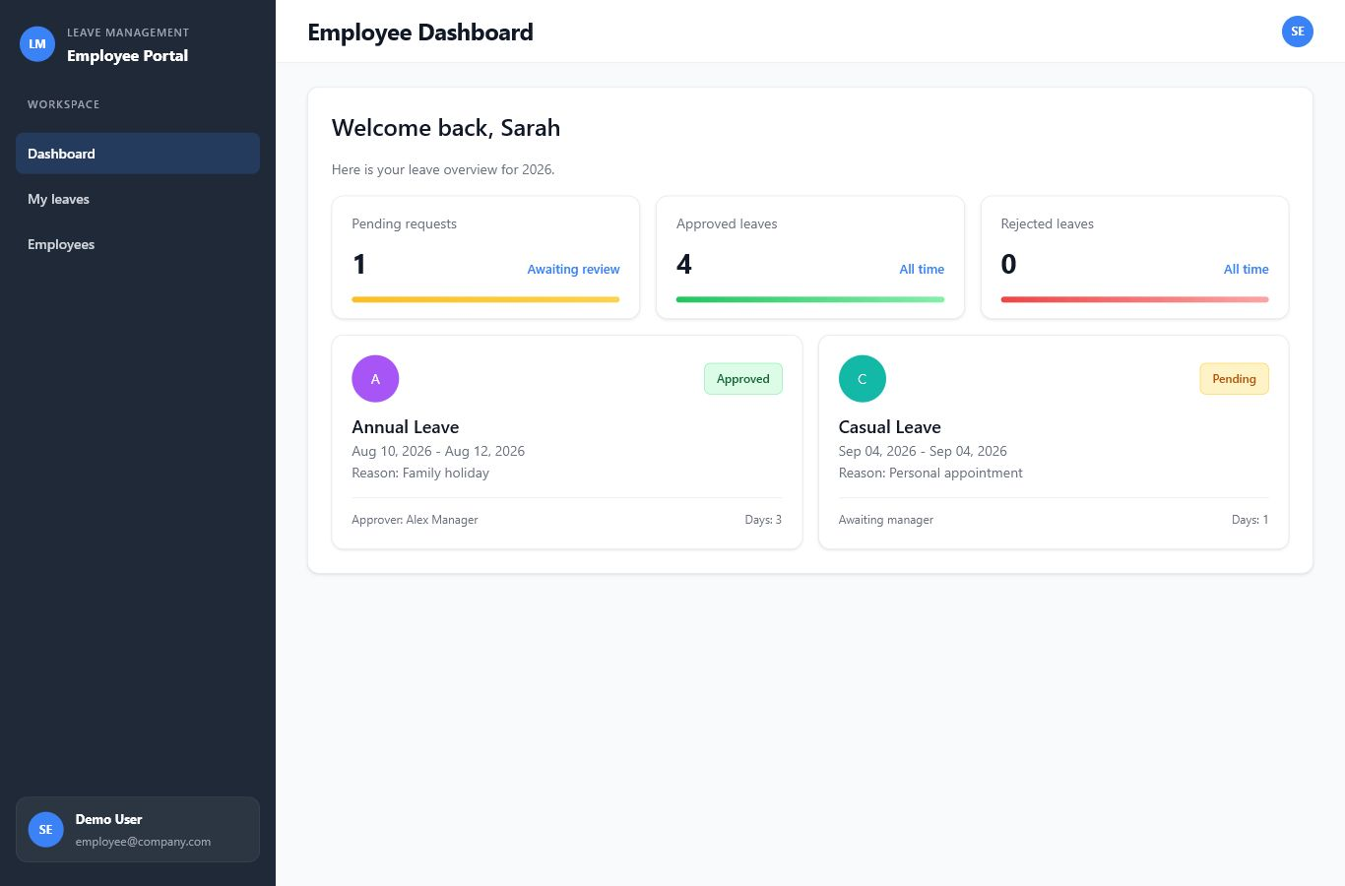
Figure 1. Employee dashboard showing leave status and recent requests.

Employee Experience
- View personal pending, approved, and rejected request counts.
- See yearly balance usage by leave type.
- Submit a reason, date range, and optional PDF/JPEG/PNG supporting document.
- Review personal leave history without exposing another employee's records.

Manager Experience
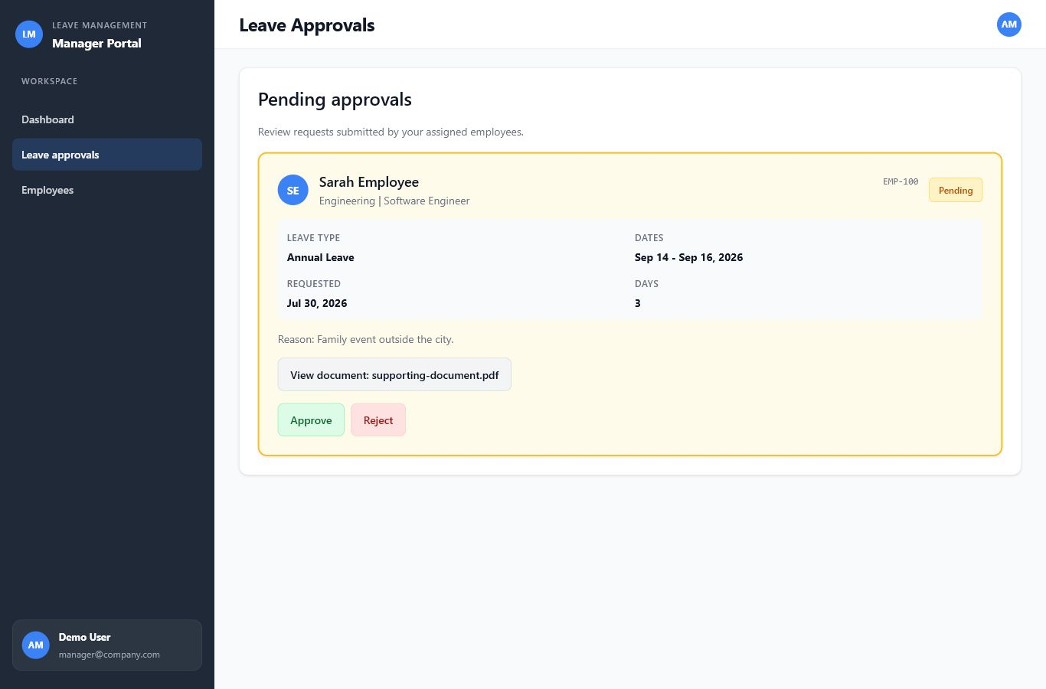
Figure 2. Manager approval card with scoped employee data, attachment access, and decision actions.
- View only employees explicitly assigned through users.manager_id.
- Review only pending requests for that team.
- Open a short-lived signed attachment URL after server-side authorization.
- Approve or reject once; repeated decisions return a conflict response.

Administrator Experience
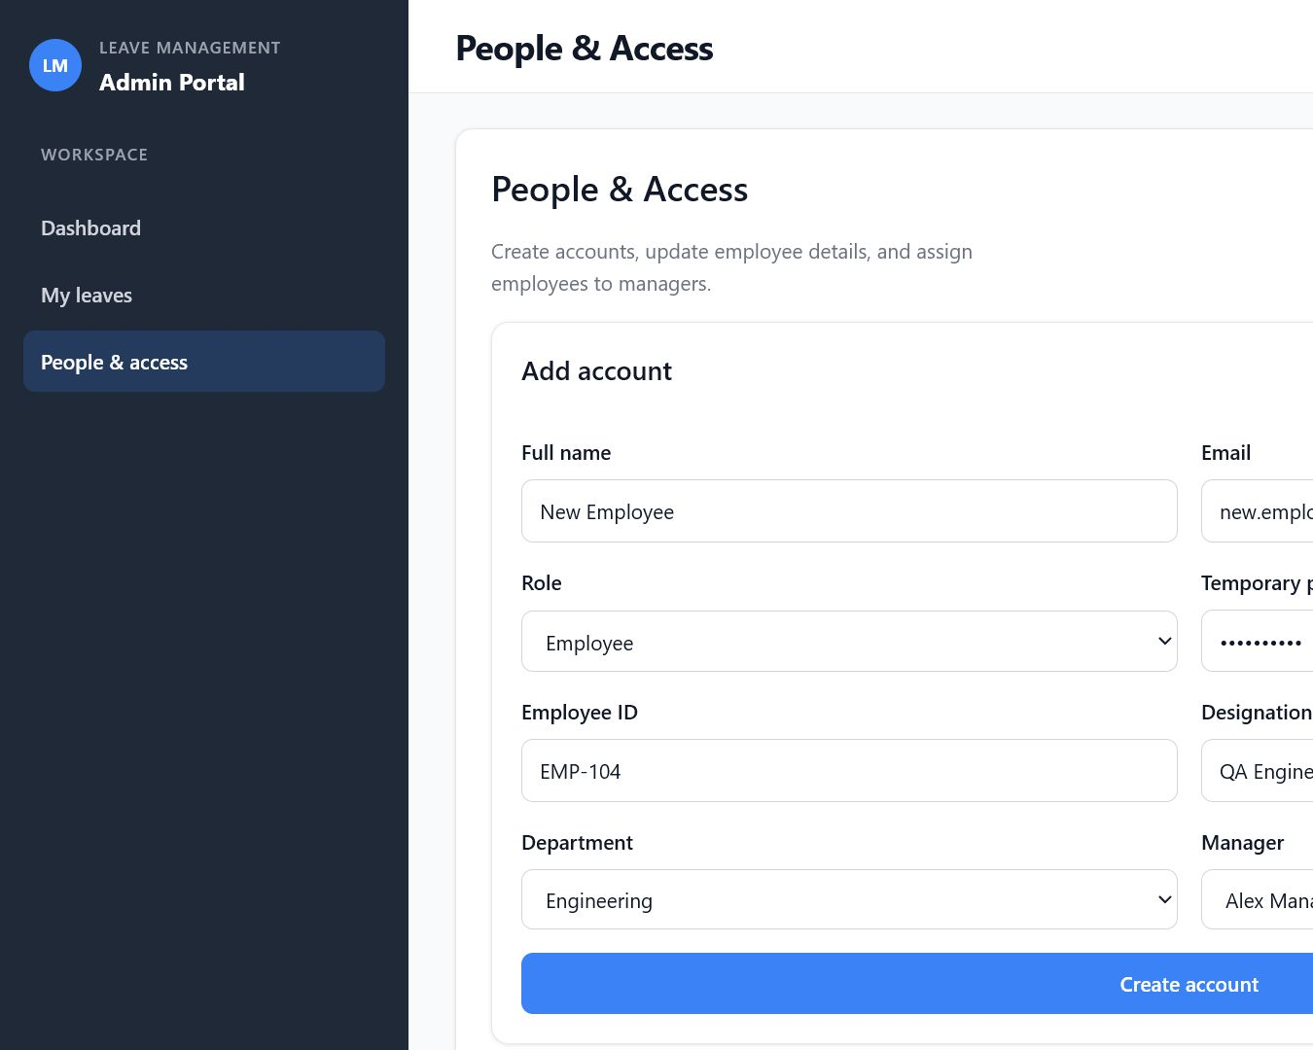
Figure 3. Administrator account creation and manager-assignment workflow.
- Create employee and manager authentication accounts.
- Update names, emails, designations, departments, and temporary passwords.
- Assign employees to valid manager-role accounts.
- Maintain annual allocations and used-day values within database constraints.

3. Architecture and System Design
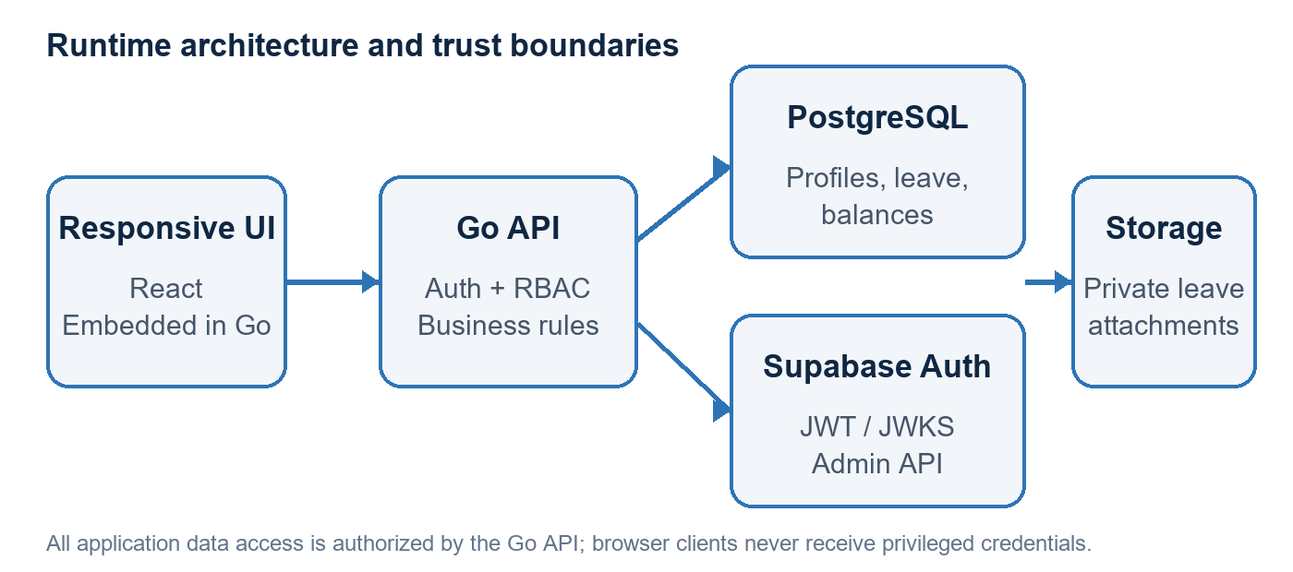
Figure 4. Runtime architecture and primary trust boundaries.

Key Design Decisions
Single Go runtime. The production server embeds the built React assets, serves the SPA, and exposes /api. Node.js is build-time only.
Server-side roles. The API derives identity from verified tokens and database profiles; client-supplied IDs and roles are never authoritative.
Database-enforced invariants. Constraints prevent overlapping active leave, invalid decisions, cross-year requests, and inconsistent balances.
Private attachments. Supporting files are stored in a private bucket and accessed through short-lived signed URLs after authorization.
Scoped caching. Cached responses are keyed per user and invalidated for related employee, manager, and administrator views after writes.

4. Backend Implementation
- Handlers own HTTP concerns: method checks, JSON decoding, status codes, and safe response bodies.
- Services implement application rules and database transactions.
- Middleware performs authentication, role checks, CSRF protection, CORS, caching, rate limiting, and request logging.
- Database initialization applies bounded retry, connection-pool limits, idle/lifetime settings, and readiness checks.
- Typed service errors map expected failures to 400, 404, 409, 502, or 503 without leaking database or provider details.
Approval transaction The leave row is locked with FOR UPDATE. A valid pending request is checked against the approver's scope, the balance row is created if required, remaining days are deducted atomically, and the decision metadata is written before commit.

Security Controls
Control | Implementation
Authentication | Supabase JWT validation with issuer, audience, expiry, algorithm, and signature checks
Authorization | Employee, manager, and admin middleware plus query-level ownership filters
Session security | HttpOnly SameSite cookie and separate CSRF token for cookie-authenticated writes
Abuse protection | IP-based general and stricter session-exchange rate limits
Secrets | Server-only service-role and database credentials; no VITE_ prefix for privileged values
Uploads | 5 MB limit, byte-derived MIME detection, allowlist, private bucket, signed access

5. Database Design
The schema is supplied as one fresh-install SQL file. It creates extensions, enum types, application tables, indexes, triggers, constraints, reference departments and leave types, the private storage bucket, and the restricted leave_app role.
Entity | Responsibility | Important relationships / rules
users | Application identity and role | ID references auth.users; manager_id is self-referencing
employees | Employment-specific profile | One-to-one with employee-role user; department reference
leave_types | Configured leave categories | Unique name and positive yearly maximum
leaves | Requests and decisions | Employee/type references; decision consistency and overlap exclusion
leave_balances | Yearly allocation and usage | Unique employee/type/year; remaining = allocated - used
departments | Organizational grouping | Referenced by employee profile

Integrity Policies
- Department is authoritative on employees, avoiding duplicate department fields that can drift.
- Pending and approved leave cannot overlap for the same employee through a GiST exclusion constraint.
- Requests cannot span calendar years; each request deducts from one yearly balance.
- Managers and administrators are management-only accounts in the current scope; only employee-role users own employee rows.
- The approval record requires approver and timestamp together, and pending records require both to be null.

6. Responsive UI / UX
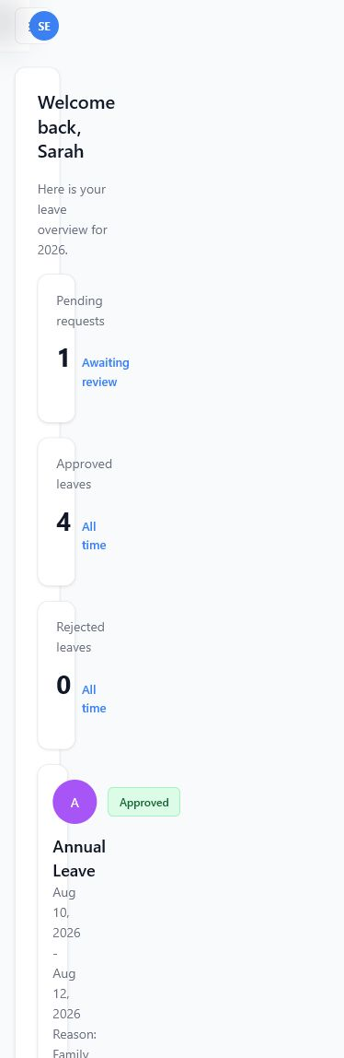
Figure 5. Mobile employee dashboard at a 390 px viewport.
The interface adapts from a full desktop sidebar to a compact tablet rail and a mobile navigation drawer. Cards and forms collapse to one column, tabular employee rows become labeled mobile cards, and action groups stack on narrow phones.
- Desktop: full navigation, multi-column statistics, and efficient data density.
- Tablet: compact sidebar, flexible card grids, and single-column administrative workspace.
- Mobile: drawer navigation, safe-area handling, 44 px touch targets, 16 px form inputs, and no horizontal overflow.
- Accessibility: semantic labels, keyboard-operable controls, visible focus states, status text, and reduced-motion support.

7. Code Quality and Verification
- Go packages separate database initialization, middleware, handlers, services, and data models.
- Frontend code separates pages, reusable components, authentication context, API helpers, and shared styles.
- No static business data is used by the application API; records come from PostgreSQL.
- The frontend API client rejects non-JSON responses and preserves safe backend error messages.
- Generated production assets are embedded into the Go binary for a consistent runtime artifact.
Check | Coverage | Current result
go test ./... | Middleware, JWT, handlers, validation, attachment helpers | Pass
go vet ./... | Go static analysis | Pass
npm run lint | React / JavaScript quality rules | Pass
vitest run | Frontend utilities and API behavior | Pass
vite build | Production frontend compilation | Pass
npm audit | Known dependency vulnerabilities | 0 vulnerabilities

8. Deployment and Configuration
- Create or reset the Supabase project and run backend/internal/database/schema.sql once.
- Create a long random password for leave_app and place its URL-encoded connection string in SUPABASE_DB_URL.
- Configure Supabase URL, anon key, server-only service-role key, cookie security, allowed origins, pool sizes, and rate limits.
- Build the React frontend and copy the output into backend/cmd/web.
- Run the Go server directly or package it as a container. Use /health/live and /health/ready for orchestration checks.
- For multiple instances, place a load balancer in front and replace the in-memory limiter/cache with shared infrastructure if strict global consistency is required.

9. Trade-offs and Future Improvements
- In-memory cache and rate limiting are intentionally simple; Redis is the natural next step for multi-instance deployment.
- Managers are management-only in the current assessment. If managers request personal leave, add an employee profile policy for those accounts.
- The cross-year policy rejects requests rather than splitting deductions, keeping the assessment behavior explicit and auditable.
- A production rollout should add browser end-to-end tests against a disposable Supabase test project and centralized observability.
- Email notifications and audit-event reporting are deliberately outside the core assessment scope but fit naturally behind the service layer.

10. Conclusion
The solution demonstrates a complete, explainable path from responsive user interaction to authenticated API handling, transactional business rules, and database-enforced integrity. Its design stays intentionally small enough for a technical assessment while showing the engineering practices expected in a production system: clear trust boundaries, scoped access, safe failure behavior, deterministic setup, verification, and documentation.
Assessment outcome The application directly addresses all six evaluation categories and can be demonstrated through three concise role-based workflows.

