TECHNICAL DESIGN DOCUMENT
Theme & Epic Generation
Ingestion and Data Science Solution
Contents
1. Executive Summary
2. Source of Truth and Data Ownership
3. Ingestion Design Flow
4. Target Storage and Unified Index Schema
5. Data Science Solution
5.1 Condense Step
5.2 Ticket Context Extraction
5.3 Unified Index Retrieval Lanes
5.4 Candidate Merge, Ranking and Review Pool
5.5 LLM Selection Prompt and Output
5.6 Quality Metrics for Value Stream Selection
6. Theme Generation Solution
6.1 Orchestration Sequence
6.2 Context Passed to Each Generation Call
6.3 Final Theme Package Returned for Review

1. Executive Summary
SMEs and Business Architects analyze IDMT Engagement Requests, review idea cards and attachments, select approved Value Streams and Stages, and create Jira Themes, Epics and capability hierarchies. The solution accelerates that workflow by producing a structured, evidence-backed recommendation package for SME review.
The design has two modules: an ingestion module that converts historical IDMT tickets into a trusted corpus with lineage and ground-truth labels, and a data science module that uses governed catalogues plus historical evidence to recommend Value Streams, Stages, Theme content, Business Needs, and L2/L3 capabilities. The SME remains the final approver; Jira remains the system of record for approved artifacts.
2. Source of Truth and Data Ownership
The table below captures authoritative inputs, target stores and value added by each curated asset. idp_teg_data is the sole AI Search index; different entity types are separated by metadata and document style.
Entity | Source of Truth | Destination | Extraction / Processing
Engagement Request (ER) | Jira API + iTech DB audit | Cosmos historic IDMT document + idp_teg_data | iTech DB identifies eligible ERs and Theme links. Jira API fetches description, attachments and Theme data. Extraction, LLM summary, and VS fuzzy match with LLM confirmation enrich the record. The themes[] ground truth stores only valueStreamId and valueStreamName for each resolved Value Stream.
Value Stream | Sightline | Cosmos catalogue + idp_teg_data valueStream document | dedupe, JSON organization, metadata tagging and ingestion into the unified search index.
Value Stage, L2, L3 | Sightline | Cosmos catalogue; | organize, version and ingest.
Theme details | Jira API | Cosmos historic IDMT document; | Theme description text extraction;

3. Ingestion Design Flow
End-to-end ingestion sequence
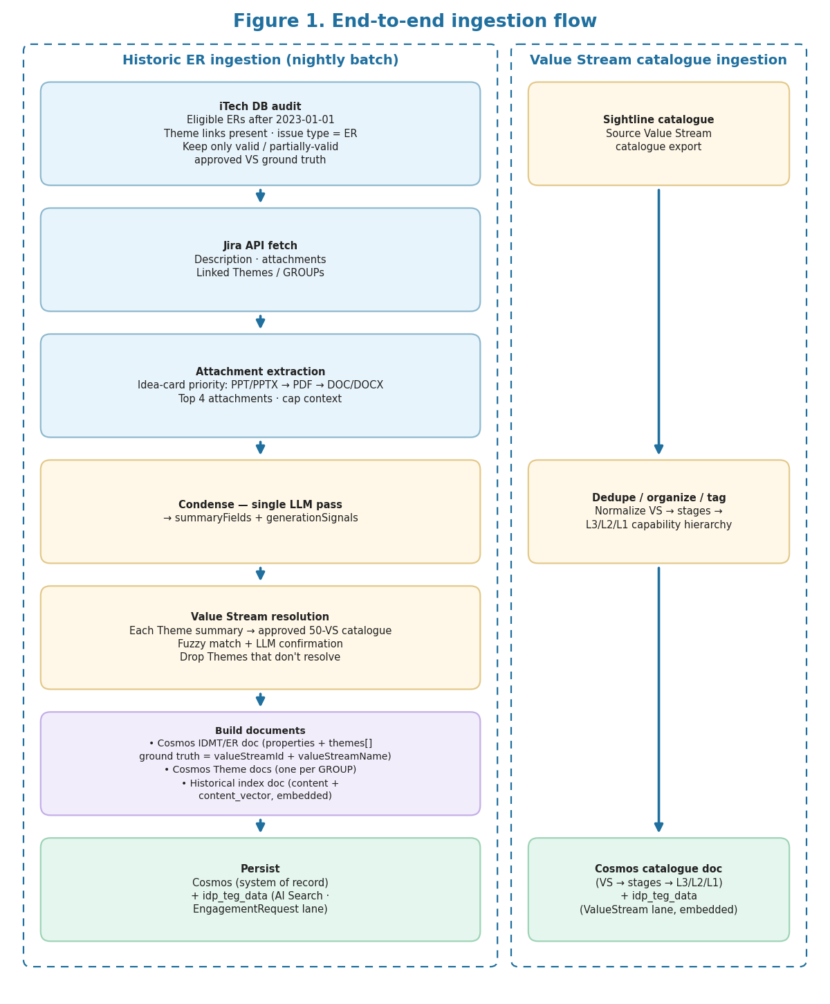
Figure 1. End-to-end ingestion flow using iTech DB for eligibility audit and idp_teg_data as the unified AI Search index.
The ingestion module starts by identifying usable historical tickets instead of ingesting every IDMT ticket. The iTech DB audit finds Engagement Requests after 2023-01-01, checks Theme links, confirms issue type, and limits ingestion to records with valid or partially valid approved Value Stream ground truth. The selected records are then fetched from Jira, enriched, persisted in Cosmos, and indexed into idp_teg_data.
• Attachment extraction prioritizes the likely idea card: PPT/PPTX first, then PDF, then DOC/DOCX. The top four supported attachments are extracted.
• PPT is prioritized because SMEs confirmed it is the most common idea-card format.
• The consolidated context is capped before LLM calls to reduce noise and control token usage.
• Only approved Value Stream and Stage names pass validators; invalid or unsupported labels are excluded from ground-truth training data.
4. Target Storage and Unified Index Schema
Cosmos stores durable source lineage, historical ground truth, catalogue metadata and future SME feedback. idp_teg_data is the unified AI Search index. It contains multiple document styles separated by entityType and metadata: historical IDMT documents and Value Stream catalogue documents.
4.1 Cosmos historic IDMT document - top-level fields
Field | Description
id | Document id = stable Jira internal issue id (e.g. 3364549); stable across IDMT-key changes
source | Origin system, e.g., Jira
sourceId | Jira issue key, e.g. IDMT-#### (mutable business key)
entityType | Entity category, e.g., EngagementRequest
createdDate | Source creation date
createdBy | Source creator / actor
modifiedDate | Source modification date
modifiedBy | Source modifier / actor
properties | Nested object containing extracted business context and theme ground truth

4.2 Cosmos properties object
Field | Description
properties.description | Original Jira description or cleaned description
properties.summary | LLM-generated business summary
properties.title | Title of the IDMT ticket
properties.rawText | Consolidated raw context from description and extracted attachments
properties.keyTerms | Domain terms and acronyms
properties.businessProblem | Business problem / pain point
properties.businessCapability | Desired capability or outcome
properties.stakeholders | Stakeholder groups
properties.systemsAndProducts | Referenced systems, platforms and products
properties.generationSignals | The 18 condense generation signals (marketSegments, fundingModelSignals, valueProposition, ...) for Theme Description + Business Needs; stored so historic tickets can skip condense
properties.themes | Array of Theme-level ground-truth objects; expanded below

4.3 Cosmos properties.themes array object
Field | Description
key | Stable Jira theme id; reference to the Theme document id (stable across GROUP-key changes)
groupId | Jira GROUP issue key, e.g. GROUP-#### (mutable business key)
valueStreamId | Approved Value Stream id resolved from the 50-VS catalogue
valueStreamName | Canonical approved Value Stream name

Example — Cosmos IDMT/ER document
{
"id": "3364549",
"source": "Jira",
"sourceId": "IDMT-19761",
"entityType": "EngagementRequest",
"createdDate": "2024-05-31T08:12:12-05:00",
"createdBy": "U133178",
"modifiedDate": "2025-12-31T09:47:10-06:00",
"modifiedBy": null,
"properties": {
"description": "...",
"summary": "...",
"title": "...",
"rawText": "...",
"keyTerms": ["..."],
"businessProblem": "...",
"businessCapability": "...",
"stakeholders": ["..."],
"systemsAndProducts": ["..."],
"generationSignals": {
"marketSegments": ["..."],
"fundingModelSignals": ["..."],
"marketOpportunity": ["..."],
"businessSolutionObjectives": ["..."],
"valueProposition": ["..."],
"estimatedBenefits": ["..."],
"dependencies": ["..."],
"resourcesNeeded": ["..."],
"digitalExperienceSignals": [],
"productAvailabilitySignals": ["..."],
"planSignals": ["..."],
"networkSignals": [],
"productPairingSignals": ["..."],
"businessRules": ["..."],
"operationalSignals": ["..."],
"reportingSignals": ["..."],
"trainingSignals": ["..."],
"notes": []
},
"themes": [
{
"key": "3966046",
"groupId": "GROUP-23618",
"valueStreamId": "VSR00074590",
"valueStreamName": "Resolve Appeal"
}
]
}
}

4.4 Cosmos Theme document - top-level fields
Field | Description
id | Document id = stable Jira internal issue id (e.g. 3966046); referenced by properties.themes[].key
source | Origin system, e.g., JIRA
groupId | Jira GROUP issue key, e.g. GROUP-#### (mutable business key)
entityType | Entity category, e.g., Theme
parentId | Parent ER / IDMT id this Theme belongs to
parentEntityType | Parent entity type, e.g., EngagementRequest
createdDate | Source creation date
createdBy | Source creator / actor
modifiedDate | Source modification date
modifiedBy | Source modifier / actor
properties | Nested object containing the Theme content from Jira

4.5 Cosmos Theme properties object
Field | Description
properties.description | Cleaned Theme description from Jira
properties.title | Theme title from Jira

Example — Cosmos Theme document
{
"id": "3966046",
"source": "Jira",
"entityType": "Theme",
"groupId": "GROUP-23618",
"parentId": "3364549",
"parentEntityType": "EngagementRequest",
"createdDate": "...",
"createdBy": "U447949",
"modifiedDate": "...",
"modifiedBy": null,
"properties": {
"description": "...",
"title": "..."
}
}

4.6 Cosmos Value Stream catalogue document - top-level fields
Field | Description
id | Sightline-assigned Value Stream identifier used as the document id and natural key (e.g. VSR-####). References from other documents (e.g. THEME_GROUNDTRUTH_ITEM.valueStreamId) resolve directly to this field; no separate UUID is generated.
source | Catalogue source, e.g., Sightline
entityType | ValueStream
createdDate | Source creation date
createdBy | Source creator / actor
modifiedDate | Source modification date
modifiedBy | Source modifier / actor
properties | Nested Value Stream catalogue object with the approved stage hierarchy

4.7 Cosmos catalogue properties object
Field | Description
properties.valueStreamId | Approved Value Stream id
properties.valueStreamName | Canonical approved Value Stream name
properties.valueStreamDescription | Approved Value Stream description
properties.valueProposition | Value proposition of the value stream
properties.trigger | What initiates the value stream
properties.category | Domain bucket (Finance, Claims, Sales and Enrollment, ...)
properties.stakeholders | Stakeholder groups (array; split from the source semicolon list)
properties.assumptions | Catalogue assumptions for the value stream
properties.definedTerms | Glossary / defined terms for the value stream
properties.active | Whether the value stream is active (boolean)
properties.valueStages | Array of approved Value Stage objects; expanded below

4.8 Cosmos catalogue properties.valueStages array object
Field | Description
stageId | Approved Value Stage id (VSS####)
stageName | Approved Value Stage name; the generated Epic title carries this name
stageDescription | Approved Value Stage description
stageSequence | 1-indexed ordinal of the stage within its value stream
stageEntranceCriteria | Entry condition that starts the stage
stageExitCriteria | Completion condition that ends the stage
stageValueItems | Value delivered / produced by the stage
stageStakeholders | Stage stakeholder groups (array; split from the source semicolon list)
active | Whether the stage is active (boolean)
createdDate | Stage creation date (source created_date)
modifiedDate | Stage modification date (source modified_date)
capabilities | Array of L3 capability objects for the stage (each carries its L2/L1 ancestor); expanded below. Runtime predicts L3 from the stage; L3 maps 1-1 to its L2.

4.9 Cosmos catalogue capability object
Field | Description
capabilityId | L3 capability id
capabilityName | L3 capability name
capabilityDescription | L3 capability description
level | Capability level (3 for the L3 leaf)
tier | Capability tier
active | Whether the capability is active (boolean)
levelOneId | Parent L1 capability id
levelOneName | Parent L1 capability name
levelTwoId | Parent L2 capability id (1-1 with this L3)
levelTwoName | Parent L2 capability name

Example — Cosmos VS catalogue document
{
"id": "VSR00074590",
"source": "Sightline",
"entityType": "ValueStream",
"createdDate": "2021-03-14",
"createdBy": "U447949",
"modifiedDate": "...",
"modifiedBy": "...",
"properties": {
"valueStreamId": "VSR00074590",
"valueStreamName": "Resolve Appeal",
"valueStreamDescription": "...",
"valueProposition": "...",
"trigger": "...",
"category": "Claims",
"stakeholders": ["..."],
"assumptions": "...",
"definedTerms": "...",
"active": true,
"valueStages": [
{
"stageId": "VSS00074680",
"stageName": "Receive Appeal",
"stageDescription": "...",
"stageSequence": 1,
"stageEntranceCriteria": "...",
"stageExitCriteria": "...",
"stageValueItems": "...",
"stageStakeholders": ["..."],
"active": true,
"createdDate": "...",
"modifiedDate": "...",
"capabilities": [
{
"capabilityId": "CAP-L3-12",
"capabilityName": "Capture Appeal Request",
"capabilityDescription": "...",
"level": 3,
"tier": "core",
"active": true,
"levelOneId": "CAP-L1-1",
"levelOneName": "Manage Appeals",
"levelTwoId": "CAP-L2-3",
"levelTwoName": "Appeal Intake"
}
]
}
]
}
}

4.10 idp_teg_data - historical IDMT index document
Field | Description
id | Search document key
source | Origin system
sourceId | Source ticket key
entityType | Indexed entity category, e.g., historicalIdmtDocument
content | Top-level retrieval text assembled from curated fields; this is the text embedded for search
content_vector | Top-level embedding vector for content
properties | Nested object with extracted fields used for filtering, display and traceability

4.11 Historical index properties object
Field | Description
properties.summary | LLM-generated summary
properties.valueStreams | Resolved VS ground truth for this historical ER - array of {valueStreamId, valueStreamName}; used as historic evidence in the VS retrieval lane

Note: supportType, reason and evidence were removed from valueStreams[] along with the historic direct/implied classification step (see section 5.4 for the rationale).
Example — idp_teg_data historical IDMT index document
{
"id": "3364549",
"source": "Jira",
"sourceId": "IDMT-19761",
"entityType": "EngagementRequest",
"content": "<curated retrieval text>",
"content_vector": [/* 1536 floats */],
"properties": {
"summary": "...",
"valueStreams": [
{
"valueStreamId": "VSR00074590",
"valueStreamName": "Resolve Appeal"
}
]
}
}

4.12 idp_teg_data - Value Stream index document
Field | Description
id | Search document key
source | Catalogue source, e.g., Sightline
entityType | ValueStream
content | Top-level retrieval text from valueStreamName, valueStreamDescription, category, trigger and valueProposition
content_vector | Top-level embedding vector for content
properties | Nested Value Stream catalogue object

4.13 Value Stream properties object
Field | Description
properties.valueStreamId | Approved Value Stream id
properties.valueStreamName | Canonical approved Value Stream name
properties.valueStreamDescription | Approved Value Stream description
properties.category | Domain bucket (Finance, Claims, ...); filterable facet
properties.trigger | What initiates the value stream
properties.valueProposition | Value proposition of the value stream

Example — idp_teg_data Value Stream index document
{
"id": "VSR00074590",
"source": "Sightline",
"entityType": "ValueStream",
"content": "<name + description + category + trigger + valueProposition>",
"content_vector": [/* 1536 floats */],
"properties": {
"valueStreamId": "VSR00074590",
"valueStreamName": "Resolve Appeal",
"valueStreamDescription": "...",
"category": "Claims",
"trigger": "...",
"valueProposition": "..."
}
}

The historical document content vector is generated from curated structured text rather than raw Jira markup. This keeps retrieval focused on business intent and avoids boilerplate, comments and attachment noise.

5. Data Science Solution
Once Cosmos and idp_teg_data are populated, the data science flow starts from a user-provided IDMT ticket id. The service first extracts the current ticket context from Jira, then searches the unified index in two parallel lanes: Value Stream catalogue documents and historical Engagement Request documents. The result is a ranked, evidence-backed Value Stream recommendation set for SME review.
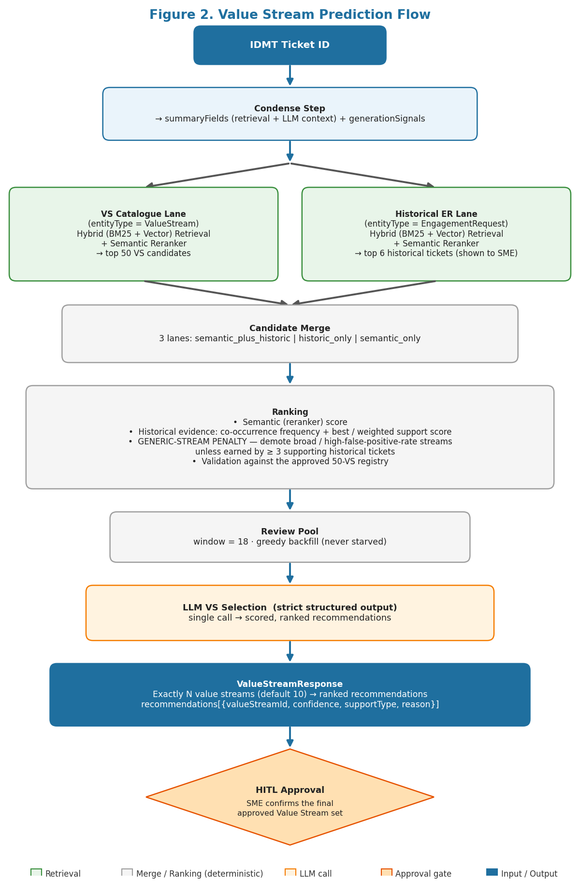
Figure 2. Data science flow from IDMT ticket id to ranked Value Stream recommendations.

5.1 Condense Step
The condense step is the first LLM call in the data science flow. It extracts structured context from the IDMT ticket source material in a single pass and returns two groups of fields: summaryFields for retrieval, routing, and LLM context, and generationSignals for Theme Description and Business Needs generation. A single extraction pass avoids re-processing the same idea card or attachment text downstream. The output is shared across all generation steps.
Source priority
• If an attachment named or tagged idea_card.ppt / idea_card.pptx exists, use it as the primary business context source.
• If the idea card is missing, fall back to the Jira ticket description plus the top four supported attachments in priority order: PowerPoint, PDF, Word document.
Output fields
Group | Fields | Used by
summaryFields | generatedSummary, businessProblem, businessCapability, keyTerms, stakeholders, systemsAndProducts | VS selection, stage prediction, Theme Description, Business Needs, L2, L3
generationSignals | marketSegments, fundingModelSignals, marketOpportunity, businessSolutionObjectives, valueProposition, estimatedBenefits, dependencies, resourcesNeeded, digitalExperienceSignals, productAvailabilitySignals, planSignals, networkSignals, productPairingSignals, businessRules, operationalSignals, reportingSignals, trainingSignals, notes | Theme Description, Business Needs

Each generationSignal field is an array of short source-grounded text strings (no per-item source/section metadata - the UI does not surface citations). Empty arrays are returned when no evidence exists. Signals are never invented; if a category is absent from the source, the array is left empty.
Contract A — Request (POST /api/condense)
{
"ticketId": "IDMT-19761"
}
Contract A — Response
{
"condensed": {
"ticketId": "IDMT-19761",
"ticketTitle": "Enabling Real-Time Quote Automation for Enterprise Accounts",
"primarySource": "idea_card.pptx",
"attachmentsUsed": ["idea_card.pptx", "business_case.pdf"],
"summaryFields": {
"generatedSummary": "Sales Operations needs a real-time CPQ integration ...",
"businessProblem": "Manual quoting delays enterprise deal closures by 3-5 days.",
"businessCapability": "Automated real-time quote generation for enterprise accounts.",
"keyTerms": ["CPQ", "quoting", "enterprise", "Salesforce"],
"stakeholders": ["Sales Ops", "IT", "Finance"],
"systemsAndProducts": ["Salesforce CPQ", "Oracle ERP", "Deal Desk Portal"]
},
"generationSignals": {
"marketSegments": ["Enterprise", "Mid-Market"],
"fundingModelSignals": ["Opex reduction via automation"],
"marketOpportunity": ["$4M ARR uplift from faster deal closure"],
"businessSolutionObjectives": ["Reduce quote cycle from 5 days to same-day"],
"valueProposition": ["Real-time pricing accuracy eliminates revision loops"],
"estimatedBenefits": ["30% reduction in deal-desk headcount hours"],
"dependencies": ["Salesforce CPQ v12 upgrade", "Oracle pricing API"],
"resourcesNeeded": ["2 FTE integration engineers", "CPQ license expansion"],
"digitalExperienceSignals": [],
"productAvailabilitySignals": ["Requires CPQ Spring 2025 release"],
"planSignals": ["Phase 1: pilot 50 enterprise accounts Q3"],
"networkSignals": [],
"productPairingSignals": ["Pairs with Order Management stream"],
"businessRules": ["Discounts above 20% require VP approval"],
"operationalSignals": ["Deal Desk SLA target: 4 hours"],
"reportingSignals": ["Quote accuracy KPI tracked in Tableau"],
"trainingSignals": ["Sales training required on new quoting UI"],
"notes": []
},
"description": "Original Jira description text ...",
"rawText": "Consolidated raw text from description and all extracted attachments ..."
},
"model": "gpt-4o",
"promptVersion": "condense-v1.2"
}

5.2 Ticket context extraction
The user provides an IDMT ticket id. The Jira API is used to inspect the ticket attachments and locate an attachment explicitly tagged or named idea_card.ppt / idea_card.pptx. If the idea card is present, it is treated as the primary source of business context. If the idea card is not found, the fallback path summarizes the IDMT ticket description and extracts the top four supported attachments using the ingestion priority order: PPT/PPTX, PDF, then DOC/DOCX.
Both paths produce the same normalized context object: generated summary, description, extracted raw text, key terms, business problem, business capability, stakeholders, and systems/products. This keeps downstream retrieval and LLM selection consistent regardless of whether the ticket contains a formal idea card.

5.3 Unified index retrieval lanes
Lane | Index filter | Retrieval method | Output
Value Stream catalogue lane | idp_teg_data where entityType = ValueStream | Hybrid search over valueStreamName, valueStreamDescription and content/content_vector + semantic reranker | Top 50 Value Stream candidates
Historical Engagement Request lane | idp_teg_data where entityType = EngagementRequest | Hybrid (BM25 + vector) + semantic reranker over content/content_vector — the same retrieval method as the catalogue lane. The semantic reranker score (0–4) is normalized to 0–1 to match the candidate-ranking scale. | Top K = 6 historical tickets shown to the user

The two retrieval calls run in parallel against the same idp_teg_data index. The user can review the six matched historical tickets and select the examples that are actually relevant. Only selected tickets are used as strong historical evidence during candidate ranking.

5.4 Candidate merge, ranking and review pool
Lane | Definition | Ranking treatment
Semantic + Historic | Value Stream appears in both lanes: the valueStream catalogue lane and the selected historical Engagement Request evidence lane. | Highest priority. Strongest signal because the candidate has catalogue-level semantic fit plus historical BA/SME precedent.
Historic-only | Value Stream is surfaced from matched historical Engagement Requests, but does not rank strongly in the catalogue semantic lane. | Retained for implied VS recall. Included when the historical hybrid+reranker score or co-occurrence frequency across selected tickets is strong, subject to the generic-stream penalty (see below).
Semantic-only | Value Stream comes from the catalogue semantic lane only. It may fit the current idea, but is not strongly supported by selected historical tickets. | Kept for coverage of new or uncommon ideas. Included after stronger overlap/historic candidates up to the LLM review-pool limit.

The two retrieval lanes produce candidate Value Streams that are merged and assigned to one of three lanes: semantic_only, historic_only, and semantic_plus_historic. Candidates in both retrieval lanes (semantic_plus_historic) are ranked highest because they have catalogue-level semantic similarity and historical BA-created precedent. historic_only candidates are retained to improve implied Value Stream recall; semantic_only candidates preserve coverage for new ideas without close historical precedent. If the gated lanes underfill the review window the pool is greedily backfilled so it is never starved. Ranking uses lane, catalogue (reranker) score, historical (hybrid+reranker) score, co-occurrence frequency across selected tickets, a data-driven generic-stream penalty, and validation against the approved Value Stream registry.
Generic-stream penalty: for each Value Stream, a corpus-derived false-positive-rate prior is computed offline from historical labeling patterns - i.e. how often that stream has historically been over-attributed across unrelated tickets. During ranking, candidates for a Value Stream with a high prior are demoted unless the current ticket has at least 3 supporting historical tickets in the selected/relevant set. The penalty is ranking-only: it never hard-excludes a candidate from the review pool, it only adjusts its position.
Note: the historic direct/implied classification step (previously applied during ingestion) was removed after an offline evaluation showed it did not improve downstream Value Stream selection accuracy. The generic-stream penalty above, derived directly from retrieval and co-occurrence signals, replaces its role in ranking.

5.5 LLM selection prompt and output
The Value Stream LLM is not given only a flat list of candidate names. It receives a curated review pool built from both retrieval lanes. Each candidate is represented as an evidence block so the model can compare catalogue similarity, historical precedent and user-selected ticket relevance before returning the final Value Stream selection.
Prompt inputs passed to the LLM
- Ticket context:
  - IDMT ticket id,
  - generated summary,
  - business problem,
  - business capability,
  - key terms,
  - stakeholders,
  - systems/products
• User control: requested number of Value Streams (default 10, exact). An optional free-text custom instruction may ONLY set this count (e.g. "give me 6"); the count is parsed deterministically and the raw text never reaches the prompt, so any non-count or malicious instruction is ignored.
• Candidate pool: candidate blocks grouped into the semantic_plus_historic, historic_only and semantic_only lanes.
• Historical ticket evidence: the six matched Engagement Requests are shown to the user first; the selected/relevant tickets are used to strengthen historical evidence in the review pool.
Candidate block format used in the review pool
Each candidate is passed as a compact block instead of a raw row. This keeps the prompt readable and makes the evidence explicit.
Candidate: Configure, Price and Quote
entity_id: VSR-####
lane: semantic_plus_historic
description: <value stream description>
category: Sales and Enrollment
trigger: <what initiates the value stream>
value: <value proposition>
semantic: score=1.42, rank=4
historical: tickets=2, best=0.82, avg=0.77, weighted=1.0, ids=[IDMT-####]

Selection and execution behavior
• Candidates appearing in both lanes are prioritized because they have catalogue-level semantic fit and historical BA precedent.
• Historic-only candidates are retained to protect implied Value Stream recall when the ticket does not explicitly name the VS.
• Semantic-only candidates are retained for new ideas where there may be no close historical ticket.
• The review pool is sent to a single selection LLM call; picks are resolved to the approved catalogue and deduplicated. (A two-call split is deferred and eval-gated.)
Expected LLM output
The LLM returns a structured Value Stream selection payload. Each selected item must include:
• valueStreamId and valueStreamName resolved to the approved catalogue.
• confidence score, 0-100.
• supportType: direct or implied.
• reason explaining the business fit in plain language.
• source tickets: included only for implied picks.

The output is exactly the requested count (default 10): after validation and dedup against the approved catalogue, the list is trimmed or padded to that number.
All LLM calls in this phase use strict structured output: the model response is constrained to a typed pydantic schema enforced by the gateway, so the candidate list, supportType, reason and confidence fields are always returned in the expected shape - no free-form parsing or post-hoc JSON repair is required.
Contract B — Request (POST /api/vs-selection)
{
"ticketId": "IDMT-19761",
"summaryFields": {
"generatedSummary": "Sales Operations needs a real-time CPQ integration ...",
"businessProblem": "Manual quoting delays enterprise deal closures by 3-5 days.",
"businessCapability": "Automated real-time quote generation for enterprise accounts.",
"keyTerms": ["CPQ", "quoting", "enterprise"],
"stakeholders": ["Sales Ops", "IT"],
"systemsAndProducts": ["Salesforce CPQ", "Oracle ERP"]
},
"requestedCount": 10,
"customInstruction": null,
"selectedHistoricalTicketIds": ["IDMT-17432", "IDMT-16890"]
}
Contract B — Response
{
"ticketId": "IDMT-19761",
"recommendations": [
{
"valueStreamId": "VSR-0042",
"valueStreamName": "Configure, Price and Quote",
"confidence": 91,
"supportType": "direct",
"reason": "Ticket explicitly targets CPQ automation for enterprise quoting workflows.",
"sourceTickets": ["IDMT-17432"]
},
{
"valueStreamId": "VSR-0017",
"valueStreamName": "Order Management",
"confidence": 74,
"supportType": "implied",
"reason": "Quote-to-order handoff dependency implied by enterprise account scope.",
"sourceTickets": ["IDMT-16890"]
}
],
"historicalTickets": [
{
"ticketId": "IDMT-17432",
"title": "CPQ Enhancements for Large Deal Desk",
"score": 0.87,
"snippet": "Automated pricing configuration for enterprise tiers ..."
},
{
"ticketId": "IDMT-16890",
"title": "Order Fulfilment Integration with CPQ",
"score": 0.72,
"snippet": "Quote-to-order handoff latency reduction ..."
}
],
"model": "gpt-4o",
"latencyMs": 34200
}

5.6 Quality metrics for Value Stream selection
- Precision is monitored on the final selected Value Streams against the curated ground-truth labels; observed range is 60-65%.
- Recall is monitored against the same ground truth, observed range is 75-82%.
Stage prediction quality metrics
Precision is monitored on the selected stages against approved stage ground truth; observed range is 38–45%.
Recall is monitored against the same ground truth; observed range is 64–70%.
Note: stage prediction precision is lower than VS selection because stage catalogues are finer-grained and ground truth labels are sparser. Recall is prioritised to ensure relevant stages are not dropped before Business Needs and L2/L3 generation.
- Latency is measured for the Value Stream LLM section end-to-end (a single selection call).
6. Theme Generation Solution
After Value Stream recommendation, a human-in-the-loop review first confirms the final Value Stream set. Theme generation starts only after this approval. Each approved Value Stream maps to one Theme package. For each approved Value Stream, the system generates the Theme title, standardized description, selected stages, Business Needs, and L2/L3 capability hierarchy using the normalized ticket context and governed catalogue data from Cosmos.
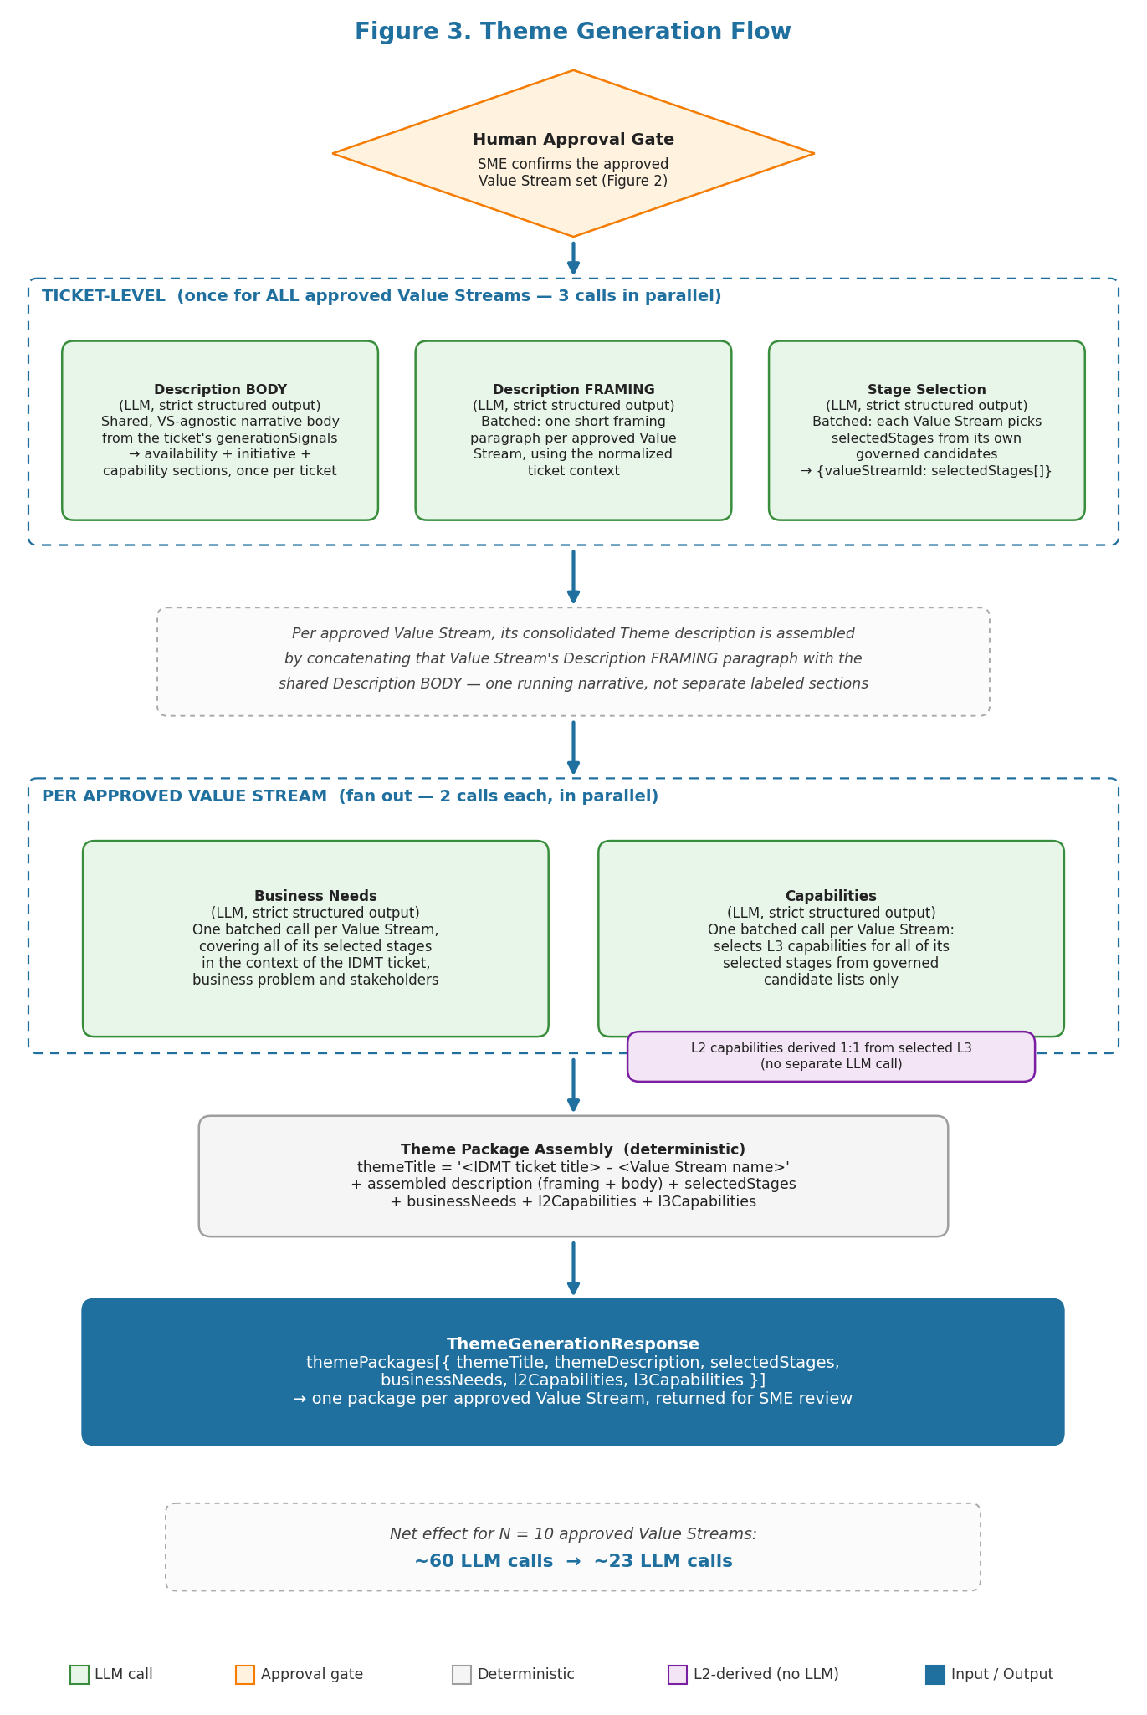
Figure 3. Theme generation flow after human approval of Value Streams.
6.1 Orchestration sequence
The sequence is approval-gated: no Theme description, stage prediction, Business Needs, or capability output is generated until the SME confirms the Value Stream set. After approval, generation runs in two bands. A ticket-level band runs once for the ticket as a whole, covering all approved Value Streams together. A per-VS band then fans out, running once for each approved Value Stream. This batching is what keeps the total LLM call count roughly linear in the number of approved Value Streams instead of multiplying every call by N.
Ticket-level calls (run once, in parallel, covering all approved Value Streams - 3 calls total regardless of N):
• Description BODY: generates the shared narrative body of the Theme Description from the ticket's generationSignals (see 6.2). This call is independent of any specific Value Stream and runs exactly once per ticket.
• Description FRAMING: generates a short per-Value-Stream framing paragraph for every approved Value Stream in a single batched call, using the normalized ticket context plus the list of approved Value Streams.
• Stage selection: predicts selectedStages for every approved Value Stream in a single batched call, using the normalized ticket context and the governed stage list for each Value Stream. Returns {stageId, stageName, reason} per selected stage; only governed catalogue stages are returned.
Per approved Value Stream (fan out, 2 calls each, in parallel across Value Streams):
• Business Needs: explains that Value Stream's selected stages in the context of the IDMT ticket, business problem, stakeholders, and desired capability.
• Capabilities: for that Value Stream, a single batched call selects the applicable L3 capabilities for all of its selected stages from the governed candidate L3 lists - it never invents capabilities. Each selected L3 maps one-to-one to its parent L2, so the L2 set is derived deterministically from the selected L3s; there is no separate L2 LLM call.
• Theme title: deterministic, built from the IDMT ticket title plus the approved Value Stream name - no LLM call.
• Theme package assembly: for each approved Value Stream, the final Theme package combines the deterministic title, the assembled description (shared body + that Value Stream's framing), Business Needs, selectedStages, and L2/L3 capabilities.
Net effect: for N approved Value Streams, the ticket-level band makes 3 calls in total and the per-VS band makes 2 calls per Value Stream, for 3 + 2N calls overall - compared with the previous architecture's roughly 6 calls per Value Stream (~6N). For N = 10 approved Value Streams this reduces the call count from roughly 60 to roughly 23.
6.2 Context passed to each generation call
All generation calls draw from the condense step output (section 5.1): summaryFields and generationSignals. Each call receives only the fields and governed catalogue slice it needs. Stage prediction and Theme Description receive the approved Value Stream from Cosmos. Business Needs, L2, and L3 additionally receive the selected stages resolved by stage prediction. Specific field lists per call are shown in the table below.
Stage Prediction
Context:
• Approved valueStreamId, valueStreamName, valueStreamDescription, valueProposition
• summaryFields: generatedSummary, businessProblem, businessCapability, keyTerms, stakeholders, systemsAndProducts
• generationSignals: businessSolutionObjectives (other signals add noise for stage matching and are omitted here)
• Cosmos catalogue: all governed stages mapped to the approved VS (stageId, stageName, stageDescription, entranceCriteria, exitCriteria, valueItems, stakeholders)
Output: one batched call returns a selectedStages array for every approved Value Stream, each entry {stageId, stageName, reason}. There is no separate stage-scope flag. The array is never left empty: if the model cannot identify specific stages with confidence for a Value Stream, it returns that Value Stream's full governed stage list with an empty reason, which signals a full-list fallback to the caller.
Theme Description
Context:
Body call (shared, once for the ticket):
• idmtTicketId, idmtTicketTitle
• summaryFields: generatedSummary, businessProblem, businessCapability, keyTerms, stakeholders, systemsAndProducts
• generationSignals: marketSegments, fundingModelSignals, marketOpportunity, businessSolutionObjectives, valueProposition, estimatedBenefits, dependencies, resourcesNeeded, digitalExperienceSignals, productAvailabilitySignals, planSignals, networkSignals, productPairingSignals, operationalSignals, reportingSignals, notes
Framing call (batched, once for all approved Value Streams):
• idmtTicketId, idmtTicketTitle
• For each approved Value Stream: valueStreamId, valueStreamName, valueStreamDescription, valueProposition
• Runs after HITL approval, in parallel with stage prediction and with the body call
Output: the framing call returns a short, Value-Stream-specific intro framing this theme; the body call returns the shared narrative body derived from the ticket's generationSignals. The two are concatenated into one consolidated, Jira-formatted Theme Description text: the framing intro, then the narrative body, then a Product Availability section populated ONLY from the provided signals (go-live status and target states/markets from planSignals - Plans here means the states/markets the offering is available in, not benefit-level plan features; insurance funding model from fundingModelSignals - ASO, Fully-Insured, or Commercial, not project/seed funding; market segments; networks; product structure/pairing), then the initiative overview, key features, and optional Digital Experience / Integration-Operational sections. Product Availability values are never invented.
Business Needs
Context:
• Approved valueStreamId, valueStreamName, valueStreamDescription, valueProposition
• All of this Value Stream's selected stages (stageId, stageName, stageDescription)
• summaryFields: generatedSummary, businessProblem, businessCapability, keyTerms, stakeholders, systemsAndProducts
• generationSignals: businessSolutionObjectives, dependencies, resourcesNeeded, digitalExperienceSignals, businessRules, operationalSignals, reportingSignals, trainingSignals, notes
• One batched call per approved Value Stream, covering all of its selected stages together. Waits for stage prediction output; runs in parallel with Capabilities (the other per-VS call).
Output: one consolidated Business Needs text covering the selected stages - grouped Value Stage -> Business Product Feature -> numbered needs, each with optional Note / Dependency / Business Rule, plus Operational Training and Operational Reporting only when their signals exist. No assumptions.
L2 Capabilities
L2 is not generated by an LLM. It is derived deterministically from the selected L3 capabilities - each L3 carries its parent L2 inline (1-1), and the L2 set is the unique parents.
Output: per Value Stream, the derived L2 capability list {capabilityId, name} - the unique parents of the L3 capabilities selected (across all of that Value Stream's selected stages) by the L3 batched call. No separate L2 generation.
L3 Capabilities
Context:
• Approved valueStreamId, valueStreamName
• All of this Value Stream's selected stages (stageId, stageName, stageDescription)
• Governed candidate L3 capabilities for each selected stage (stageId, capabilityId, name, description, tier, and parent L2) - the LLM selects from these only
• summaryFields (full ticket context) + generationSignals: businessSolutionObjectives
• One batched call per approved Value Stream, covering all of its selected stages together. Waits for stage prediction; runs in parallel with Business Needs (the other per-VS call). L2 is derived from the selected L3, not generated.
Output: per selected stage within the Value Stream, the chosen L3 capabilities {stageId, capabilityId, name, reason} drawn only from that stage's governed candidates (never invented); each maps 1-1 to its parent L2. Selection is precision-biased - typically 1-3 capabilities per stage rather than an exhaustive list.
6.3 Final Theme package returned for review
The phase returns one Theme package per approved Value Stream. The package remains a recommendation until the SME reviews and approves it for Jira writeback. The expected structured output contains:
• themeTitle: deterministic title built from IDMT ticket title + Value Stream name.
• themeDescription: standardized description narrative.
• businessNeeds: one consolidated Business Needs text for the selected stages.
• l3Capabilities: selected from the governed candidates; l2Capabilities: derived 1-1 from the selected L3.
Contract C — Request (POST /api/theme-generation)
{
"ticketId": "IDMT-19761",
"ticketTitle": "Enabling Real-Time Quote Automation for Enterprise Accounts",
"condensed": {
"summaryFields": {
"generatedSummary": "...",
"businessProblem": "...",
"businessCapability": "...",
"keyTerms": ["CPQ", "quoting", "enterprise"],
"stakeholders": ["Sales Ops", "IT"],
"systemsAndProducts": ["Salesforce CPQ", "Oracle ERP"]
},
"generationSignals": { "...": "18 signal arrays from Contract A response" }
},
"approvedValueStreams": [
{ "valueStreamId": "VSR-0042", "valueStreamName": "Configure, Price and Quote" }
]
}
Contract C — Response (Full Package — 6.3)
{
"ticketId": "IDMT-19761",
"themePackages": [
{
"valueStreamId": "VSR-0042",
"valueStreamName": "Configure, Price and Quote",
"themeTitle": "Enabling Real-Time Quote Automation -- Configure, Price and Quote",
"themeDescription": "This theme addresses the need to automate enterprise quoting
workflows by integrating Salesforce CPQ with real-time pricing APIs,
eliminating manual deal-desk bottlenecks and reducing quote cycle time
from 5 days to same-day.",
"selectedStages": [
{
"stageId": "VSS-0042-01",
"stageName": "Opportunity to Quote",
"reason": "Primary stage; ticket targets the quoting initiation workflow."
},
{
"stageId": "VSS-0042-02",
"stageName": "Quote to Order",
"reason": "Implied by the quote-to-order handoff dependency in the idea card."
}
],
"businessNeeds": "Sales Operations requires real-time quote generation to eliminate
the current 3-5 day manual cycle. The integration must support enterprise pricing
tiers, discount approval rules, and same-day SLA targets for the Deal Desk.",
"l2Capabilities": [
{
"stageId": "VSS-0042-01",
"stageName": "Opportunity to Quote",
"capabilities": [
{ "capabilityId": "L2-0042-001", "name": "Pricing and Discounting", "reason": "" },
{ "capabilityId": "L2-0042-002", "name": "Approval and Governance", "reason": "" }
]
}
],
"l3Capabilities": [
{
"stageId": "VSS-0042-01",
"stageName": "Opportunity to Quote",
"capabilities": [
{
"capabilityId": "L3-0042-0011",
"name": "Real-Time Pricing Engine Integration",
"reason": "Core requirement: live CPQ pricing feed from Oracle ERP."
},
{
"capabilityId": "L3-0042-0012",
"name": "Automated Discount Approval Workflow",
"reason": "Business rule: discounts above 20% require VP approval gate."
}
]
}
]
}
],
"model": "gpt-4o",
"promptVersion": "theme-gen-v2.1",
"latencyMs": 48700
}
Per-call slice outputs (6.2)
// Per-call slice outputs (6.2):
// Stage Prediction -> selectedStages[]
// Theme Description -> themeDescription (string)
// Business Needs -> businessNeeds (string)
// L3 Capabilities -> l3Capabilities[]
// L2 Capabilities -> l2Capabilities[] (derived 1-1 from selected L3)

