How good is our “similar past tickets” search?
A plain-language report on the search that finds similar past tickets and shows them to the model as examples. Tested on 373 real tickets. Each chart says what it shows and how to read it; a glossary is at the end.

Bottom line
- The search is GREAT at finding the right examples — the correct Value Stream shows up for 90% of tickets, usually as the very first result.
- But about HALF of what it calls a “match” only matches by coincidence — two independent checks (ignoring generic tags, and an AI reviewer) both say real relevance is ~33–37%, not the 67% the simple count suggests.
- The cause: 6 generic catch-all tags + a tail of “overloaded” tickets tagged with up to 19 Value Streams that match almost anything.
- Showing 6 past tickets is the sweet spot — more dilutes the examples without really helping.
- Fix worth doing: down-weight the generic tags and overloaded tickets when ranking — it sharpens relevance AND helps cover the hard multi-stream tickets.

1. It finds the right examples
For 90% of tickets the correct Value Stream is among the 6 pulled examples, 96% have at least one genuinely useful example, and for 288 of 373 tickets the FIRST result is already a hit. Finding good examples is not the problem.
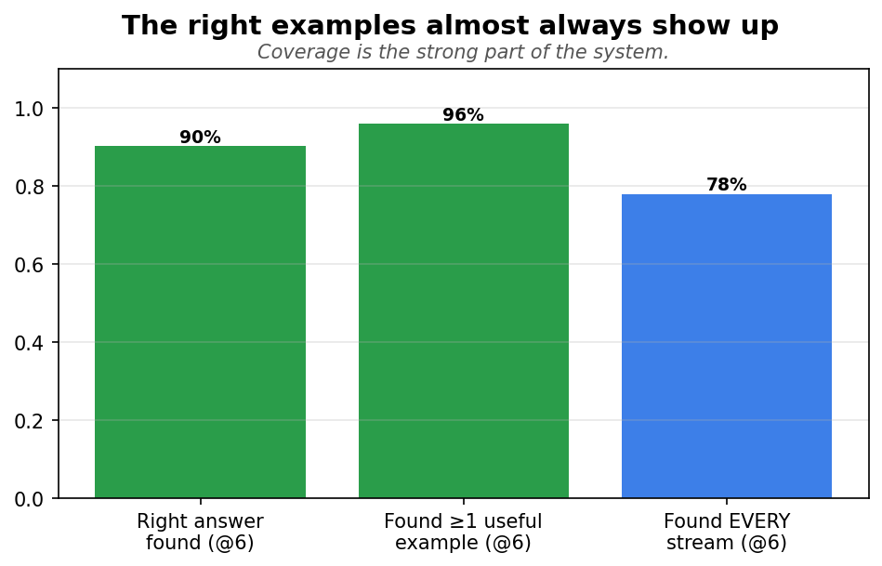

2. Not every ticket is equally hard
Half the tickets belong to a single Value Stream (easy — one answer to find); the other half belong to several, a few to as many as 19 (hard). So the coverage numbers are an average across easy and hard tickets.
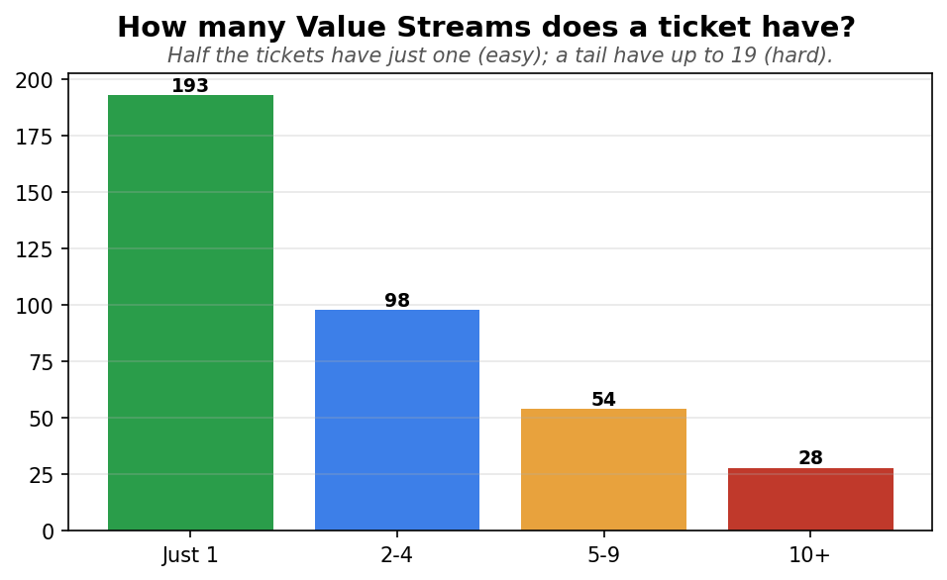

3. Hard tickets: we find most, but rarely all
On hard (multi-stream) tickets the search still surfaces 88% of the streams on average — almost as good as the 92% for easy tickets. But getting EVERY stream right happens only 63% of the time (vs 92% for easy). In plain terms: on a hard ticket we catch the obvious streams and usually miss one or two from the long tail.
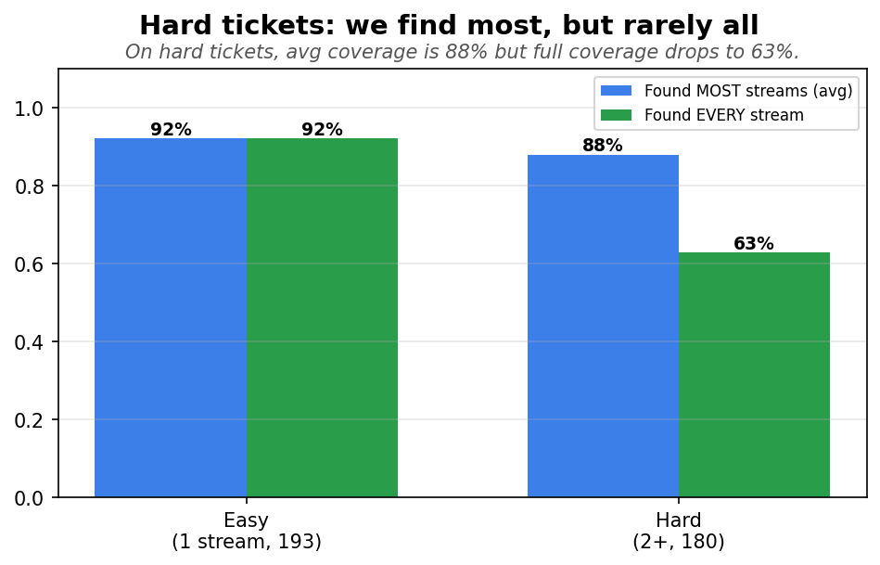

4. But “relevant” is overcounted
If we just count “shares a tag”, 67% of pulled tickets look relevant. That is misleading: removing the 6 generic tags drops it to 33%, and an AI reviewer reading the actual text puts it at 37%. A simple rule and an AI independently land in the same place — real relevance is about half the headline.
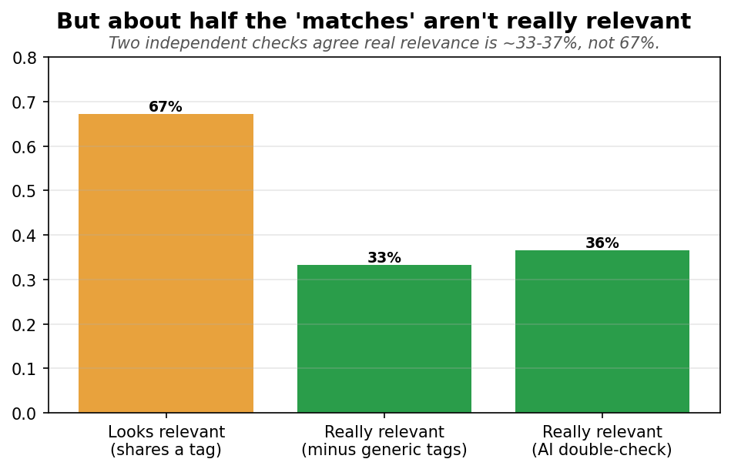

5. Every example, sorted
Splitting all 3,729 pulled tickets four ways: only 24% are real matches (right tag AND same work), 39% are lucky matches (right tag, different work), 8% are the same work tagged differently, and 29% are unrelated. So 6 in 10 “matches” are coincidences.
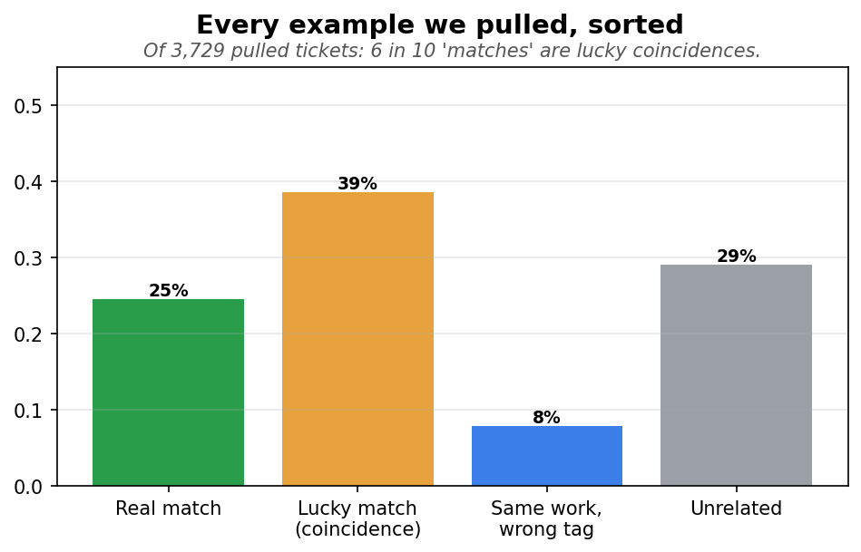

6. Why the lucky matches happen
Most pulled tickets are specific (a single tag). But a tail of “overloaded” tickets carry up to 19 tags each — those match almost any query by accident. Combined with 6 generic catch-all tags, they create the coincidental matches.
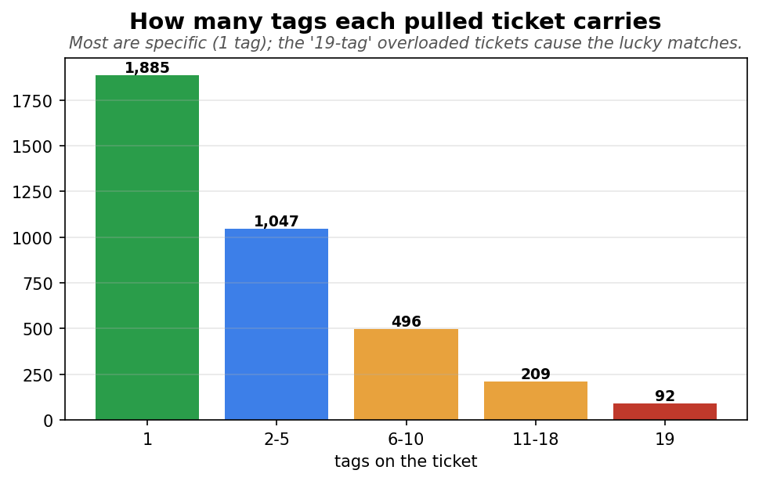

7. More examples is not better
Showing 6, 8, or 10 past tickets: more finds slightly more right answers but a steady share of the extras are junk — a near 1-for-1 trade. 6 is the sweet spot.
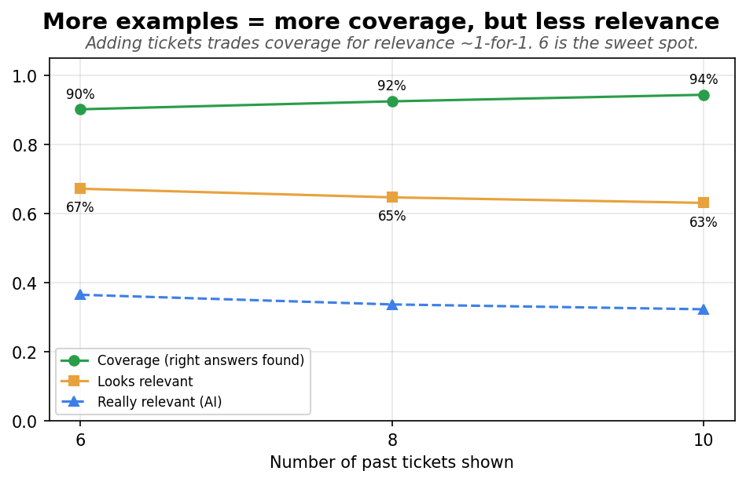

8. The first useful example is usually right at the top
For 288 of 373 tickets the #1 result is already useful; only 9 tickets found nothing relevant at all. The ranking puts good examples first — though the underlying scores barely separate good from bad (0.51 vs 0.48), so we rely on the ordering, not the score size.
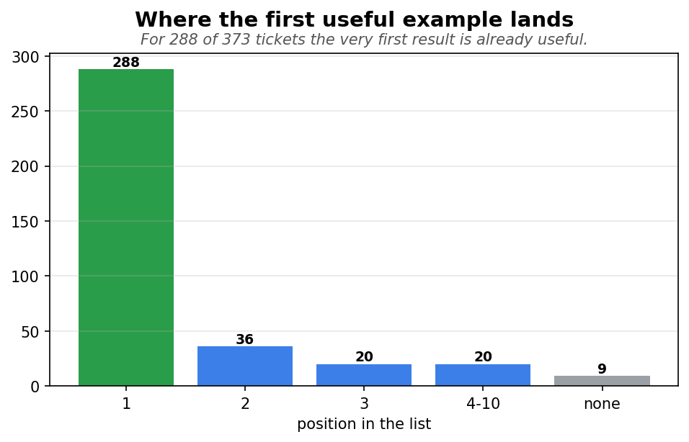

All the numbers
Measure (per ticket) | Show 6 | Show 8 | Show 10
Right answer found (coverage) | 90% | 92% | 94%
Found at least one useful | 96% | 97% | 98%
Found EVERY stream | 78% | 81% | 85%
Looks relevant | 67% | 65% | 63%
Really relevant (minus generic) | 33% | 31% | 30%
Really relevant (AI) | 36% | 34% | 32%
First useful at the top (MRR) | 0.85 | 0.85 | 0.85

Plain-language glossary
Term | What it means
Value Stream / tag | The business category a ticket belongs to — what we predict.
Coverage | Did the correct Value Stream show up among the pulled examples.
Looks relevant | An example that shares a tag with the current ticket.
Really relevant | An example that's actually about the same kind of work, not just a shared tag.
Lucky match | Shares a tag by coincidence (usually a generic tag) but is different work.
Generic / catch-all tag | A Value Stream on a large share of tickets, so sharing it means little.
Overloaded ticket | A past ticket tagged with many Value Streams — matches almost anything.
Easy / hard ticket | Easy = 1 correct Value Stream; hard = 2 or more.

