Value-Stream prediction — comparison of approaches
We predict which Value Streams a ticket belongs to. This compares a few ways of asking the model to choose, on the same 60 tickets (each run repeated 3x; numbers are the average). The two things we vary: (1) whether we show the model similar PAST tickets and the answers they got, and (2) whether we include the search engine's relevance SCORES next to each candidate. Plain-language guide to every metric is at the end.

What each approach means
Approach | What we showed the model
Current prompt | the proven evidence prompt - strict 'verify, don't over-trust precedent'.
Trust prompt | keeps the strict test for clear fits, then fills the count with precedent-backed streams.
Recall prompt | precedent as a primary signal + push completeness on multi-workflow ideas.

Bottom line
- Best approach: "Recall prompt" — it finds the most correct Value Streams (recall 78%) and has the best overall balance (F1 0.31).
- That is 5% more of the correct answers found than the weakest approach ("Current prompt", 73%) — a 7% relative jump.
- It wins on BOTH easy tickets (one correct answer: 84% → 89% found) and hard tickets (several correct answers: F1 0.44 → 0.47), so the gain is real, not just from the easy cases.
- Why it wins: when a correct Value Stream showed up in the past-ticket examples, the model picked it 83% of the time, vs only 42% when it didn't — so the model is genuinely learning from precedent, not guessing.
- Room to improve: the past examples actually CONTAINED 89% of the correct answers, but the model only USED 83% of them — about 6% of the right answers were sitting in front of it, unpicked. A more trusting prompt, or showing more past tickets, could capture that.
- Note on precision: the model always returns 10 guesses but a ticket has ~2.5 correct answers, so precision is mechanically low for everyone — judge it on RECALL and F1, not raw precision.

Head-to-head: what changes when we flip one setting
Each comparison below changes exactly ONE thing between two approaches and holds everything else fixed, so any difference is caused by that one change. 'Change' is the second approach minus the first; the arrow points to whichever side is better for that metric (recall, F1 and precedent-use: higher is better; missed answers and time: lower is better).

Does trusting precedent help?
Comparing "Current prompt" → "Trust prompt"
What we measure | Current prompt | Trust prompt | Change | Better
Recall (answers found) | 0.726 | 0.770 | +0.044 | → Trust prompt
F1 (overall balance) | 0.294 | 0.311 | +0.018 | → Trust prompt
Easy tickets: found | 0.838 | 0.943 | +0.105 | → Trust prompt
Hard tickets: F1 | 0.441 | 0.458 | +0.017 | → Trust prompt
Precedent use (lift) | 0.308 | 0.338 | +0.030 | → Trust prompt
Missed answers (count) | 42 | 35 | -7.000 | → Trust prompt
Typical time (s) | 5.090 | 6.150 | +1.060 | → Current prompt

Does precedent-first + completeness help?
Comparing "Current prompt" → "Recall prompt"
What we measure | Current prompt | Recall prompt | Change | Better
Recall (answers found) | 0.726 | 0.776 | +0.051 | → Recall prompt
F1 (overall balance) | 0.294 | 0.314 | +0.020 | → Recall prompt
Easy tickets: found | 0.838 | 0.886 | +0.048 | → Recall prompt
Hard tickets: F1 | 0.441 | 0.474 | +0.033 | → Recall prompt
Precedent use (lift) | 0.308 | 0.406 | +0.098 | → Recall prompt
Missed answers (count) | 42 | 34 | -8.000 | → Recall prompt
Typical time (s) | 5.090 | 5.260 | +0.170 | → Current prompt

1. Precision, Recall, F1
Recall = of the correct Value Streams, how many did we find. F1 = the balance of precision and recall. Best F1: "Recall prompt" (0.31). Best recall: "Recall prompt" (78%). Precision looks low everywhere because the model returns 10 guesses for ~2.5 real answers — that is by design, so read recall and F1.
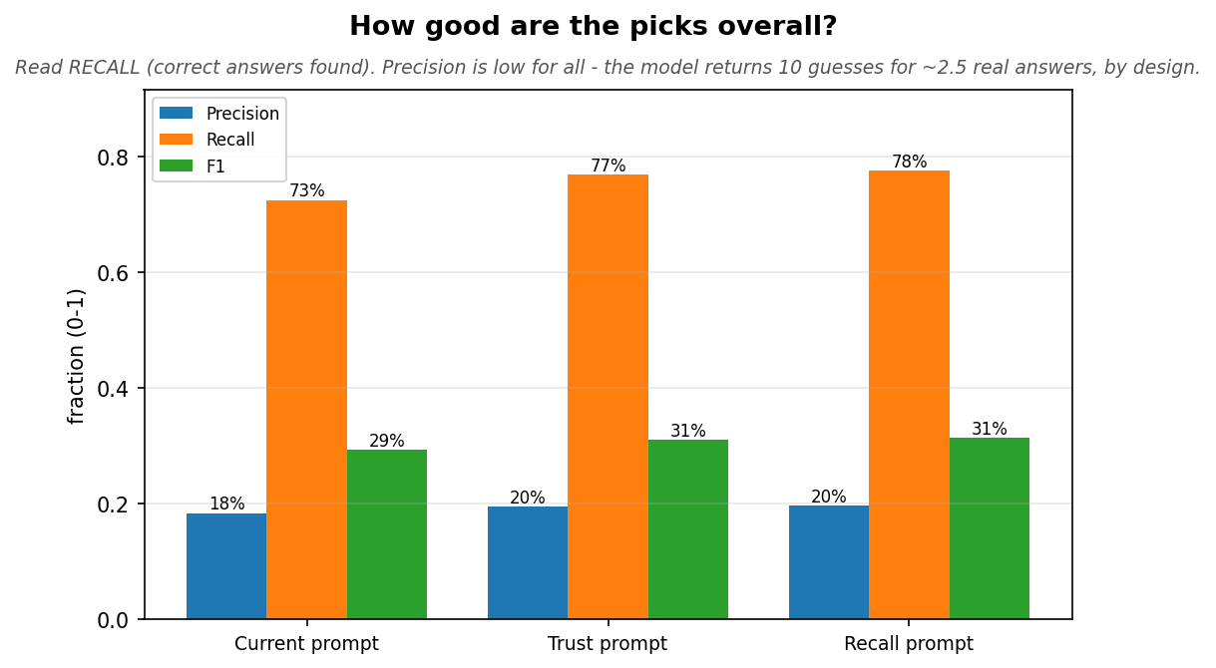

2. Does it handle hard tickets, or just easy ones?
We split tickets by how many correct Value Streams they have. EASY = exactly one correct answer; HARD = two or more. The chart shows RECALL for both (the same metric, so it's a fair comparison) — of the correct answers on that kind of ticket, how many we found. The orange (hard) bar is the one to watch: anyone can do well on easy tickets.
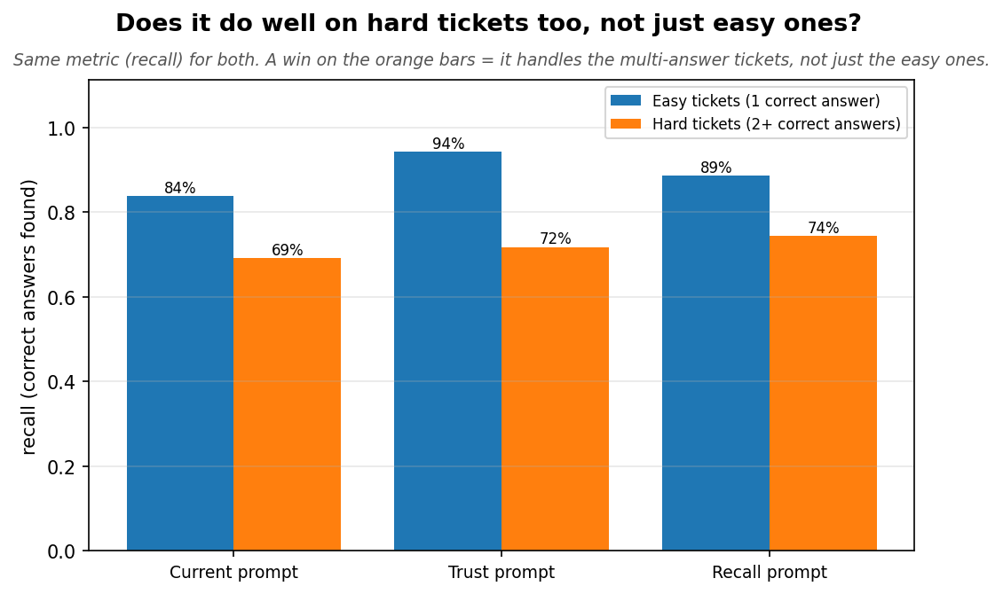
Full per-cohort numbers (n = how many tickets, P / R / F1):
Approach | Easy n | Easy P | Easy R | Easy F1 | Hard n | Hard P | Hard R | Hard F1
Current prompt | 35 | 8% | 84% | 0.15 | 25 | 32% | 69% | 0.44
Trust prompt | 35 | 9% | 94% | 0.17 | 25 | 34% | 72% | 0.46
Recall prompt | 35 | 9% | 89% | 0.16 | 25 | 35% | 74% | 0.47

3. Did the system even put the right answers in front of the model?
The model can only pick from what the system shows it. This section is about the SYSTEM (retrieval), not the model. Each bar is the fraction of correct answers present at that stage.
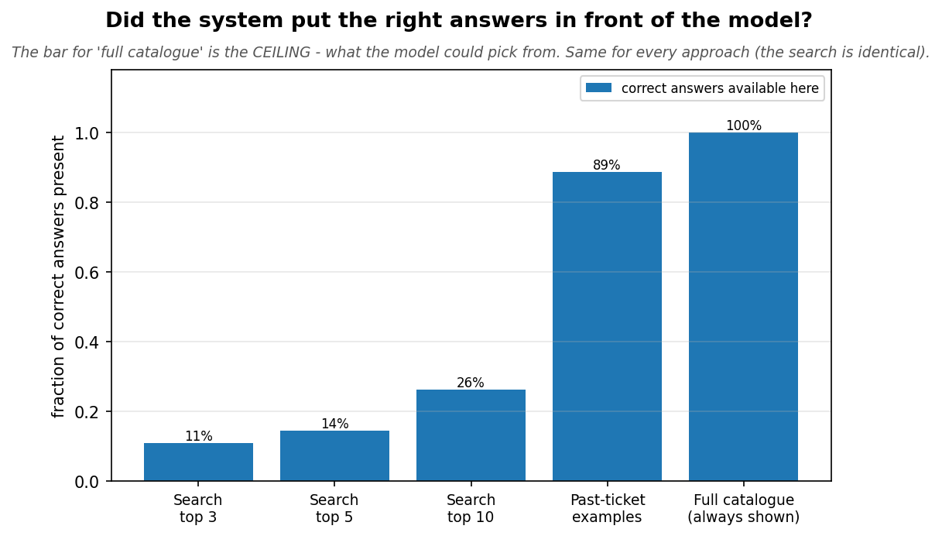
Semantic search ranking is weak — its top 10 holds only 26% of the correct answers and barely grows with depth (top 3: 11%, top 5: 14%). But because we hand the model the FULL catalogue every time, 100% of the correct answers are ALWAYS in front of it. So retrieval is not the bottleneck — the model is choosing from a complete list.
The next chart proves it. Every correct answer we missed is one of three things: never retrieved, filtered out before the model, or shown to the model which then didn't pick it. The whole bar is the total misses; the colour tells you whose fault each miss is.
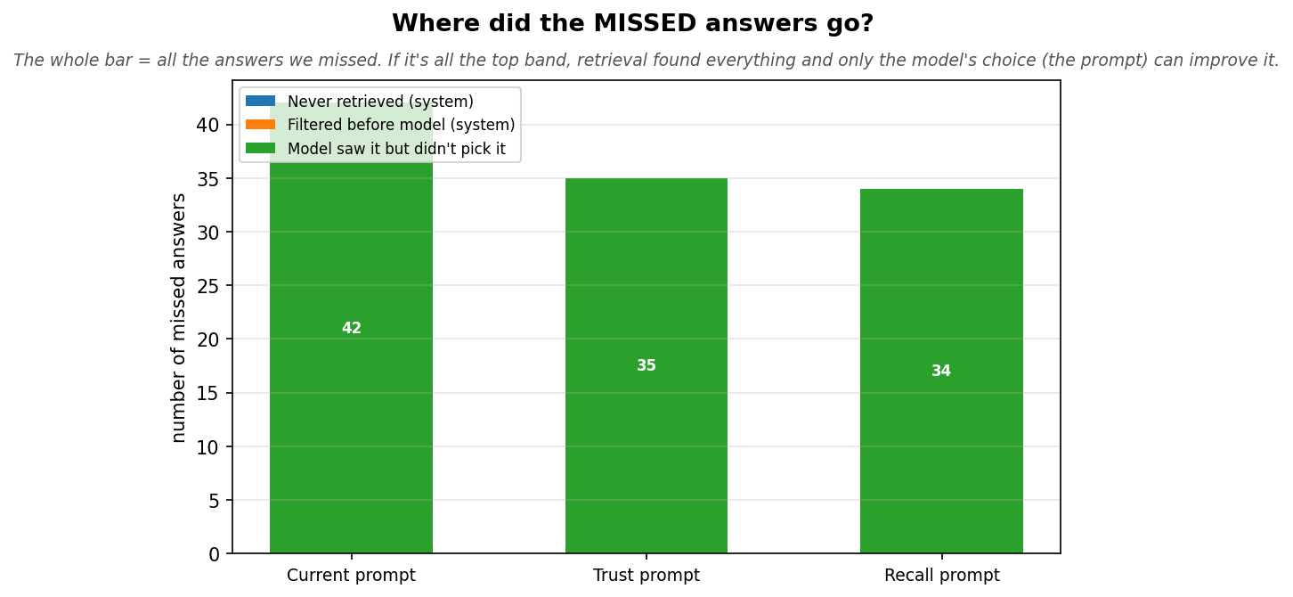
All of the misses are the top band — 'the model saw it but didn't pick it'. None were lost by retrieval. That is why the PROMPT is the only lever left: the right answers are already on the table, the model just has to choose them.

4. When we show past tickets, does the model follow them?
Only approaches that actually SHOW past tickets to the model appear here. We split the correct answers into two groups — ones a similar past ticket used, and ones it didn't — and measure how often the model picked each. A tall blue bar next to a short orange bar means the model is following the examples (it picks an answer much more when precedent backs it).
In "Recall prompt": an answer a past ticket used is picked 83% of the time vs only 42% when no past ticket used it — a +41% lift, the proof the examples drive the picks.
Headroom: the past tickets actually contained 89% of the correct answers, but the model only picked 83% of those (93% of what precedent offered). So ~6% of the right answers were shown via precedent and still missed — a more trusting prompt, or more past tickets, is where the next gain is.
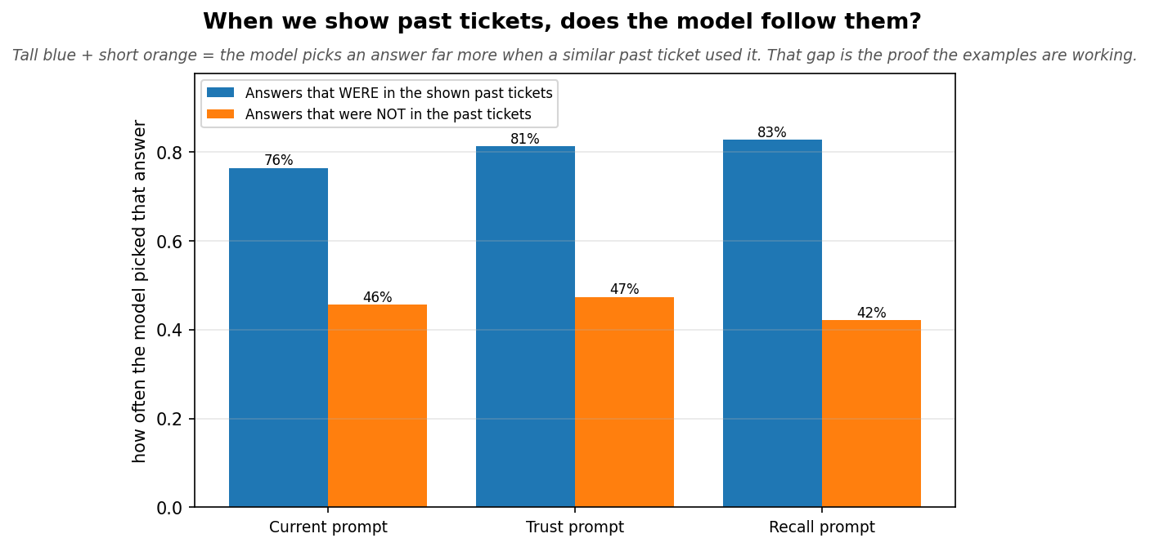

5. How long does a prediction take?
The chart shows TYPICAL (median) speed and the AVERAGE with the single slowest ticket removed. We remove it because a retry/backoff storm on one ticket can make it take thousands of seconds and wreck the average — that is an infrastructure hiccup, not the real cost. The table keeps the raw numbers so nothing is hidden.
Approach | Typical (median) | Average (outlier removed) | Raw average | Raw slowest
Current prompt | 5.1s | 5.3s | 59.9s | 3284.5s ⚠ retry-storm outlier
Trust prompt | 6.2s | 6.3s | 6.3s | 9.1s
Recall prompt | 5.3s | 5.4s | 5.4s | 7.8s
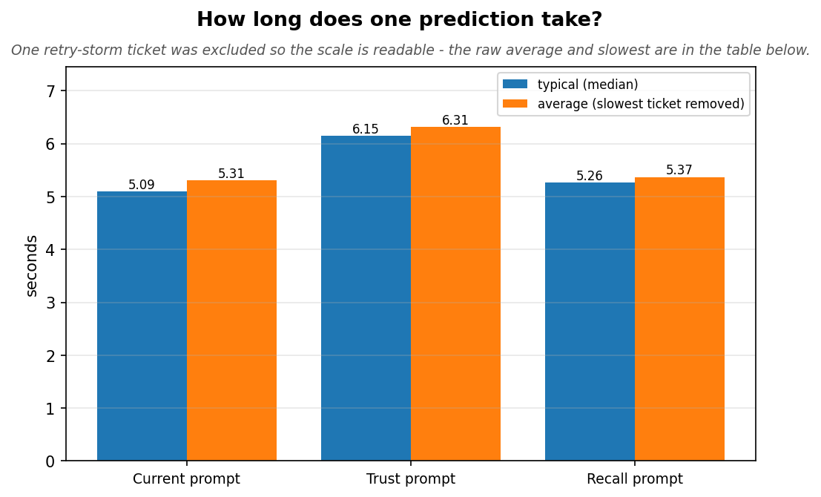

All numbers in one table
Approach | Precision | Recall | F1 | Easy R | Hard R | Precedent backed | Precedent lift | Typical time
Current prompt | 18% | 73% | 0.29 | 84% | 69% | 76% | +0.31 | 5.1s
Trust prompt | 20% | 77% | 0.31 | 94% | 72% | 81% | +0.34 | 6.2s
Recall prompt | 20% | 78% | 0.31 | 89% | 74% | 83% | +0.41 | 5.3s
Recall-type numbers are shown as percentages; F1 as a 0-1 score. Older runs that predate a metric show 'n/a' (not zero) elsewhere in this report.

What the metrics mean
Term | Plain meaning
Recall | Of the Value Streams that were actually correct, the fraction we found. Higher is better.
Precision | Of our guesses, the fraction that were correct. Low here by design (10 guesses, ~2.5 real).
F1 | A single balance score combining precision and recall. Higher is better.
Easy ticket | A ticket that has only ONE correct Value Stream - one answer to find. 'Easy: found' = how often we found that one answer.
Hard ticket | A ticket that has TWO OR MORE correct Value Streams - we must find several. Scored with F1. We track easy and hard apart so a win isn't just from the easy cases.
Precedent backed (capture) | Of the correct answers that WERE in the shown past tickets, the fraction the model actually picked. An absolute score: how much of what precedent offered did it use (the ceiling is how many were in the tickets at all). Higher = fewer precedent-backed answers left on the table.
Precedent lift | How much MORE often the model picks an answer when a past ticket used it vs when none did. A difference: (picked-rate for answers IN the past tickets) - (picked-rate for answers NOT in them). Big = the precedent is causing the pick, not general guessing; near zero = the examples make no difference. Backed says how much it captured; lift says whether the examples are the reason.
Past-ticket examples | Similar tickets from the past, shown to the model along with the answers they got.
Search relevance scores | Numbers from the search engine ranking each candidate; included or hidden.
Ceiling | The fraction of correct answers that were on the candidate list at all - the best any approach could possibly score. Here it's ~100% because the full catalogue is always shown.
Ceiling capture | Of the correct answers shown to the model, the fraction it actually picked (recall divided by the ceiling). Low = the model is leaving answers on the table.
Precedent capture | Of the correct answers that were in the SHOWN past tickets, the fraction the model picked. Only meaningful for approaches that show past tickets.
Typical (median) time | The middle ticket's time - the honest 'usual' speed. The AVERAGE can be far higher if one ticket stalls on retries; compare the two to spot an outlier.
Where misses go | Each correct answer we missed is one of: never retrieved, filtered before the model, or the model saw it and dropped it. The last one is the model's fault, not the system's.

