Value Stream selection — tuning report
How we tune the model that predicts a ticket's Value Streams. Three chapters, each on the same 60-ticket eval set: (1) which mode wins, (2) prompt engineering on that mode, (3) how many past tickets to show. Every chart states its question and how to read it; a metric glossary is at the end.

Chapter 1 — Modes: history vs no-history, scores vs no-scores

What each approach means
Approach | What we showed the model
No history + scores | All 50 streams offered with the search relevance scores; no past tickets shown.
No history | All 50 streams, scores hidden; no past tickets shown.
History + scores | All 50 streams + similar past tickets shown as examples; scores shown.
History | All 50 streams + similar past tickets shown as examples; scores hidden.

Verdict
- Showing the model similar PAST tickets is the dominant lever. Both history approaches beat both no-history approaches on recall by a wide margin (~0.59 → ~0.74), and they lift the hard multi-answer tickets too — so it is a real gain, not just the easy cases.
- The search relevance SCORES barely matter: flipping them on/off moves recall by under 0.02 either way (within run-to-run noise). The semantic ranking is weak (top-10 holds only ~26% of the correct answers), so the score is a near-useless hint. We keep the model judging on business fit plus the precedent, not the score.
- Verdict: ship History. Scores are optional (a wash); the past-ticket precedent is what wins.

Precision, Recall, F1
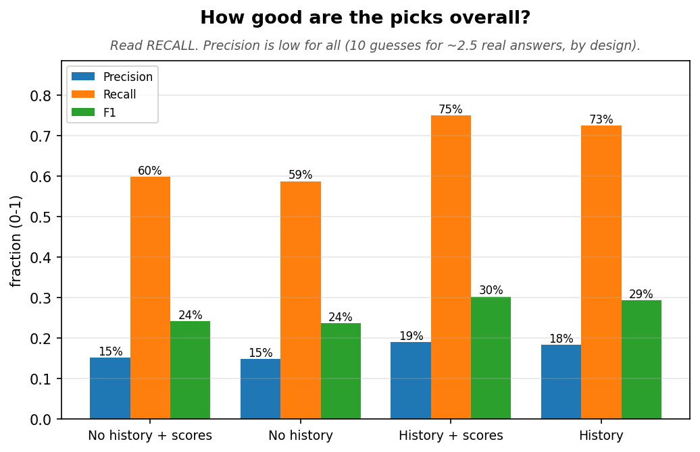

Easy vs hard tickets
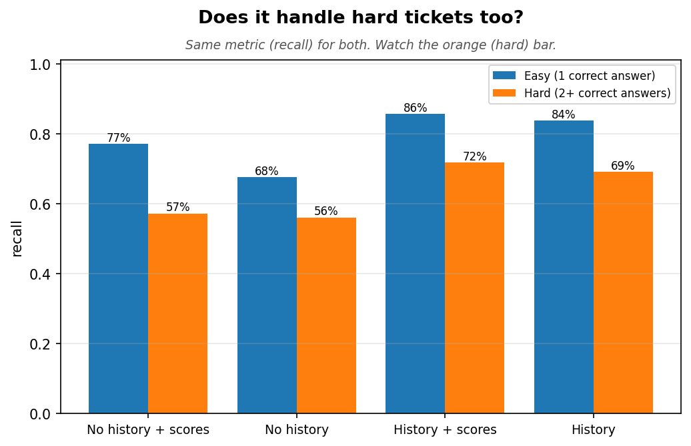
Approach | Easy n | Easy R | Hard n | Hard R
No history + scores | 35 | 77% | 25 | 57%
No history | 35 | 68% | 25 | 56%
History + scores | 35 | 86% | 25 | 72%
History | 35 | 84% | 25 | 69%

Were the right answers shown to the model?
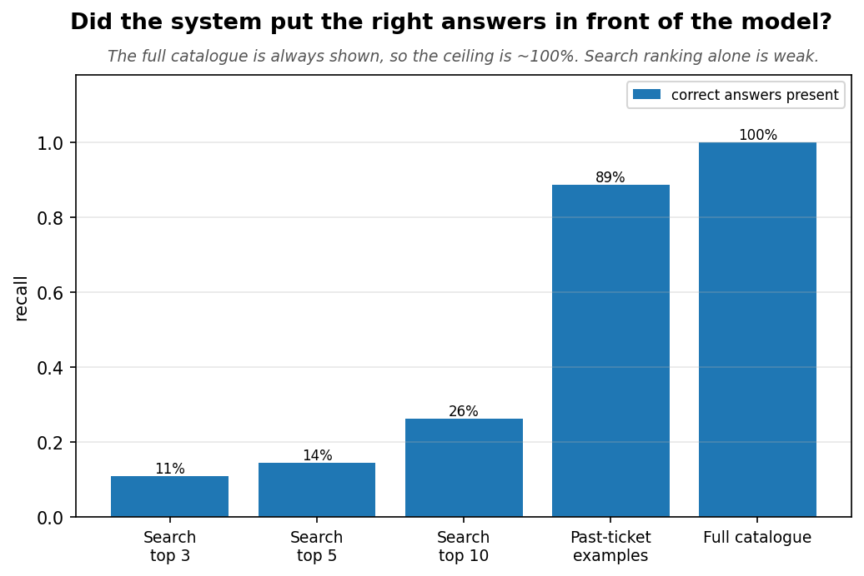
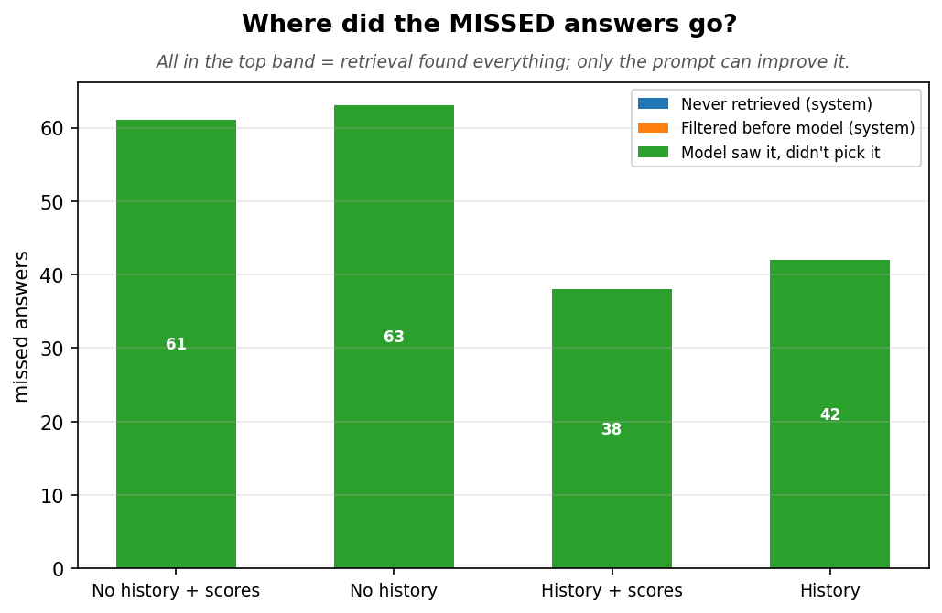

Precedent: backed vs lift
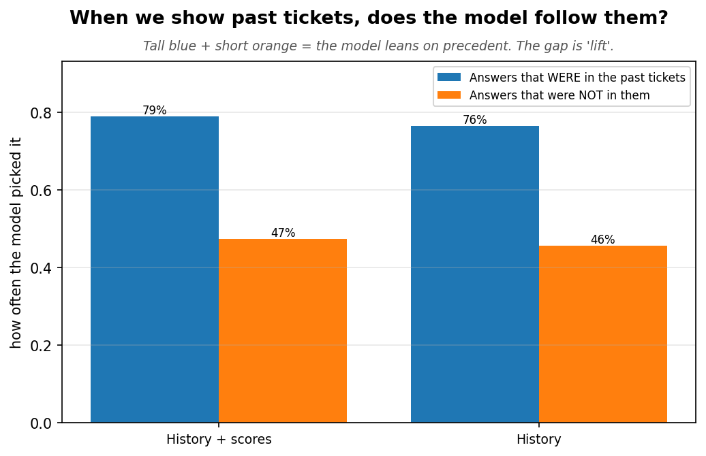
Approach | Precedent backed | Precedent lift
History + scores | 79% | +0.32
History | 76% | +0.31

Latency
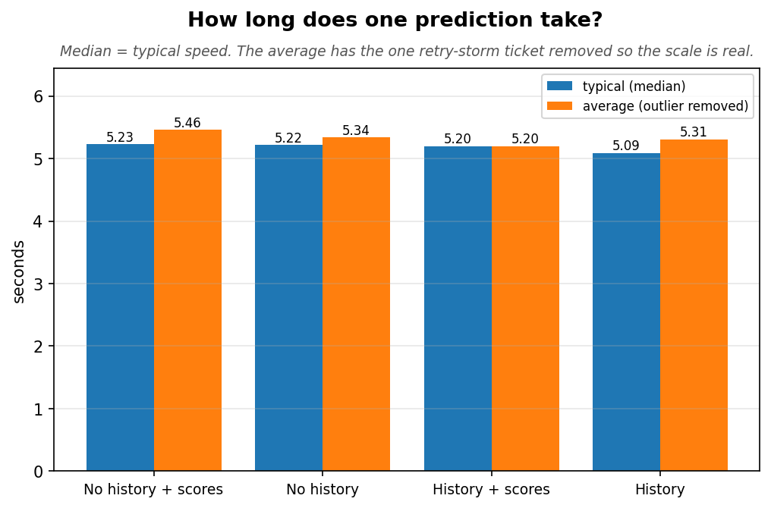
Approach | P | R | F1 | Easy R | Hard R | Backed | Lift | Typical
No history + scores | 15% | 60% | 0.24 | 77% | 57% | 61% | +0.08 | 5.2s
No history | 15% | 59% | 0.24 | 68% | 56% | 59% | +0.05 | 5.2s
History + scores | 19% | 75% | 0.30 | 86% | 72% | 79% | +0.32 | 5.2s
History | 18% | 73% | 0.29 | 84% | 69% | 76% | +0.31 | 5.1s

Chapter 2 — Prompt engineering (History, no scores)

What each approach means
Approach | What we showed the model
Current prompt | The proven evidence prompt — strict 'verify each pick, don't over-trust precedent'.
Trust prompt | Clear fits first, then fill the requested count with precedent-backed streams instead of padding.
Recall prompt | Precedent as a primary signal + push completeness on multi-workflow ideas.

Verdict
- The Recall prompt wins: recall 0.726 → 0.776 and hard-ticket recall 0.692 → 0.744, while the judge-precision guardrail held (0.478 → 0.470) — so the extra picks are genuinely relevant, not padding. It also captured more precedent (backed 0.76 → 0.83) and relied on it more (lift 0.31 → 0.41).
- Trust helped too but less on hard tickets, dropped judge precision more, and ran slower. The detailed change-log below explains exactly which wording moved which number.

What changed in each prompt, and which number it moved
We compared three instruction sheets for the same setup (History + no scores). Only the prompt
wording changed; the tickets, candidates, and evidence shown to the model were identical.

Current → Trust
The current prompt is cautious about precedent: it says "Treat them as PRECEDENT, not as answers",
"Do NOT pick a value stream solely because a past ticket used it", and in its fit test "exclude it
— even if a past ticket used it." When it ran short of the requested count, the leftover slots were
padded with arbitrary catalogue streams.
The Trust prompt replaced that padding with a two-tier rule: Tier 1 = the streams that
clearly fit; Tier 2 = fill the remaining slots with streams the most-similar past tickets were
tagged with, never random padding.
Effect: recall 0.726 → 0.770 and precedent backed 0.76 → 0.81 — precedent that used to be
wasted on padding now lands on real answers. Easy-ticket recall jumped to 0.94. Cost: judge
precision slipped (0.478 → 0.457) and it ran slower — treating precedent as a blunt count-filler
pulled in a few weak picks.

Trust → Recall
Two wording changes. (1) Precedent moved from a fallback filler to a primary inclusion signal:
"PRECEDENT IS A PRIMARY SIGNAL … INCLUDE a precedent-backed stream unless it clearly cannot apply",
with an explicit priority order (process fit → precedent → upstream/downstream reach). (2) An
explicit completeness instruction for multi-workflow ideas: "An idea rarely touches only one
workflow … find ALL of them … under-selecting is the most common mistake."
Effect: hard-ticket recall 0.718 → 0.744 (the completeness push made the model enumerate the
upstream/downstream streams that multi-VS tickets need), precedent backed 0.81 → 0.83 and lift
0.34 → 0.41 (precedent first-class, not padding), and judge precision recovered to 0.470 — picks
were now justified by reasoning or a named precedent rather than dumped to fill the count.

In short
Trust stopped wasting slots on random padding (lifted overall + easy recall). Recall then
made precedent first-class and forced multi-workflow completeness (lifted the hard cohort and
restored precision). Each change targeted a measured weak spot, and the judge-precision guardrail
confirms the gains are real picks, not count-padding.

Precision, Recall, F1
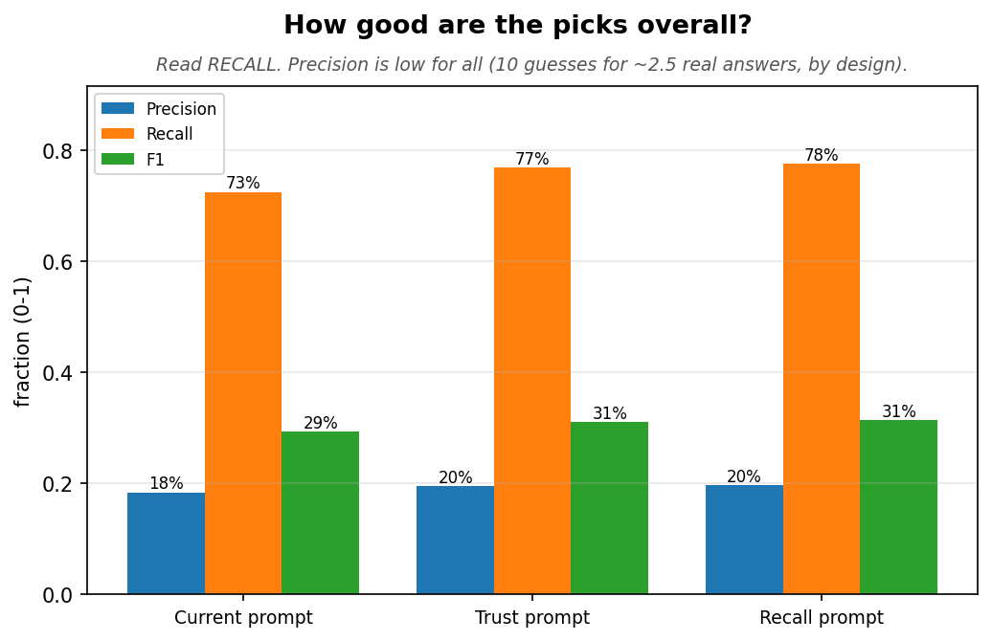

Easy vs hard tickets
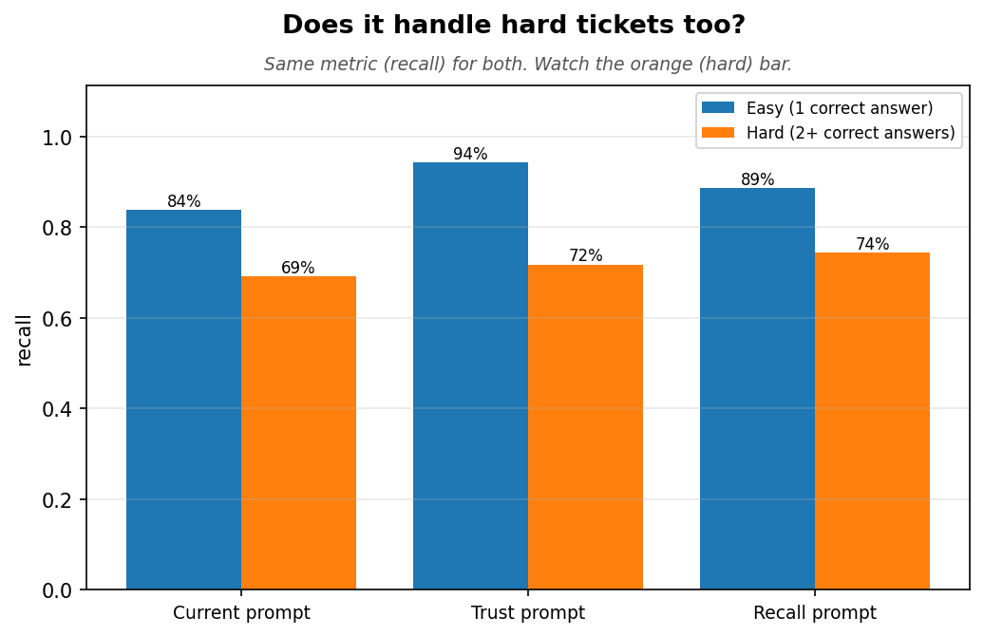
Approach | Easy n | Easy R | Hard n | Hard R
Current prompt | 35 | 84% | 25 | 69%
Trust prompt | 35 | 94% | 25 | 72%
Recall prompt | 35 | 89% | 25 | 74%

Were the right answers shown to the model?

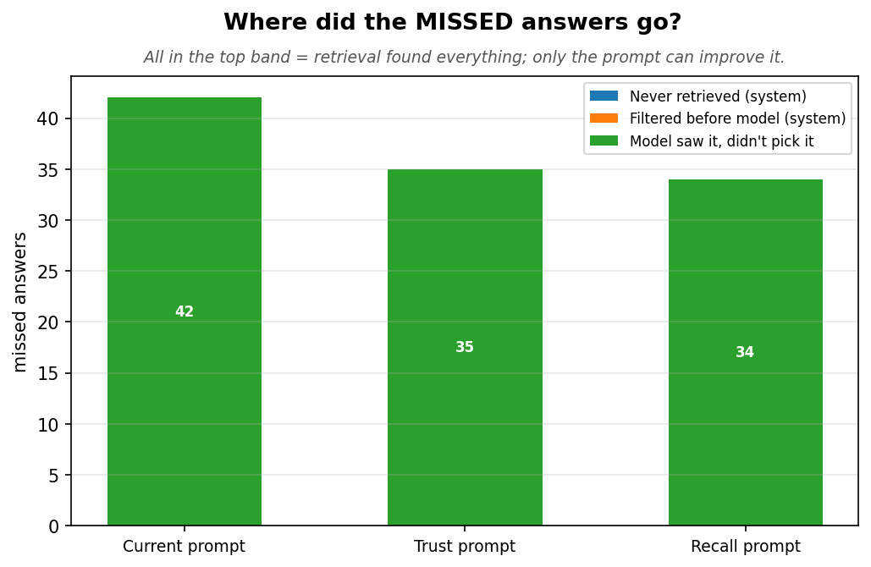

Precedent: backed vs lift
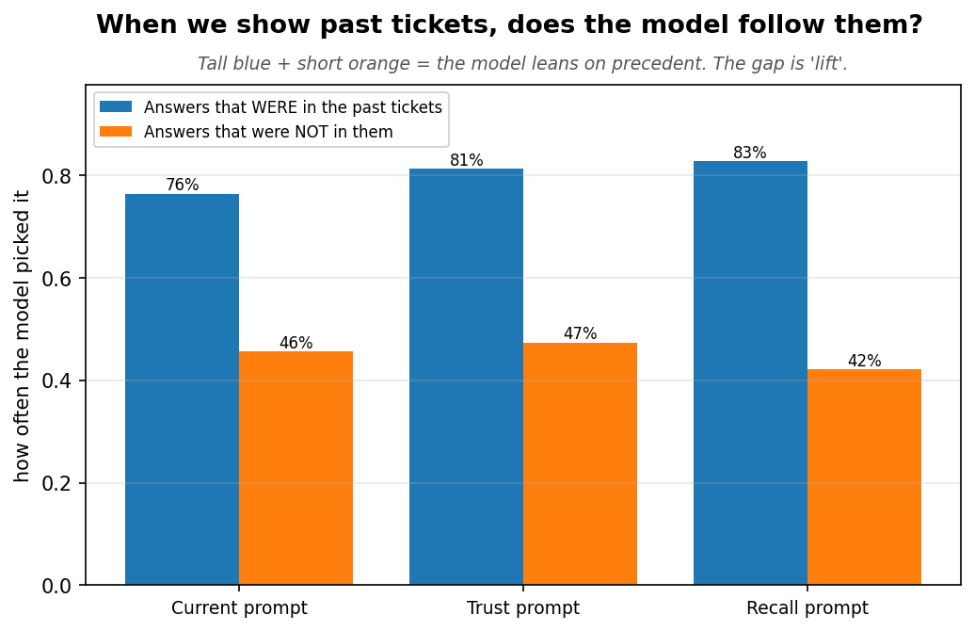
Approach | Precedent backed | Precedent lift
Current prompt | 76% | +0.31
Trust prompt | 81% | +0.34
Recall prompt | 83% | +0.41

Latency
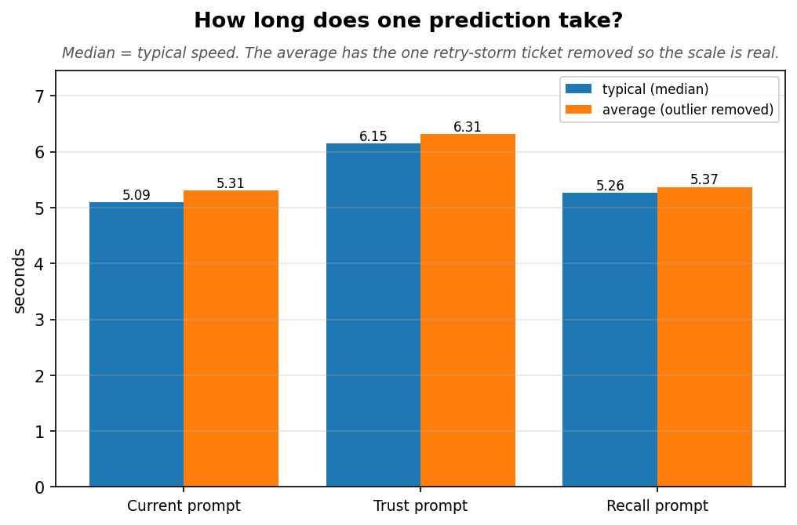
Approach | P | R | F1 | Easy R | Hard R | Backed | Lift | Typical
Current prompt | 18% | 73% | 0.29 | 84% | 69% | 76% | +0.31 | 5.1s
Trust prompt | 20% | 77% | 0.31 | 94% | 72% | 81% | +0.34 | 6.2s
Recall prompt | 20% | 78% | 0.31 | 89% | 74% | 83% | +0.41 | 5.3s

Chapter 3 — Historic-K: how many past tickets to show

What each approach means
Approach | What we showed the model
Recall K=6 | Recall prompt, 6 similar past tickets shown as evidence.
Recall K=8 | Recall prompt, 8 similar past tickets.
Recall K=10 | Recall prompt, 10 similar past tickets.

Verdict
- 6 → 8 gives a small real gain (recall +0.02, hard recall +0.025). 8 → 10 is dilution, not gain: recall and hard-recall are flat, but the precedent ceiling rises while the model captures LESS of it (backed 0.838 → 0.827), lift falls (0.401 → 0.366), and judge precision keeps eroding.
- Decision: keep historic-K = 6. The +0.02 at K=8 is within noise and not worth the added prompt length and the dilution that grows at K=10.

Historic-K — how many past tickets to show (Recall prompt fixed)
We held the winning Recall prompt fixed and varied only the number of similar past tickets shown
as precedent evidence: 6, 8, 10.
- 6 → 8: a small real gain — recall 0.776 → 0.796 and hard-ticket recall 0.744 → 0.769, and
the model captured a little more precedent (backed 0.827 → 0.838). No latency or precision cost.
- 8 → 10: dilution, not gain. Recall, F1 and hard-recall are flat (0.796 / 0.322 / 0.769), but
the precedent *ceiling* rises (more GT surfaced, 0.892 → 0.913) while the model captures less
of it (backed 0.838 → 0.827), lift falls (0.401 → 0.366), and judge precision keeps eroding
(0.460 → 0.450). The two extra tickets are less-similar analogs that add noise the model doesn't use.
Decision: keep historic-K = 6. K=8's +0.020 recall is within run-to-run noise (these are single
runs) and not a major gain; it is not worth the added prompt length and the dilution that grows at
K=10. The `--historic-k` flag stays for future re-tests; the config default `historical_fetch_k`
remains 6.

Precision, Recall, F1
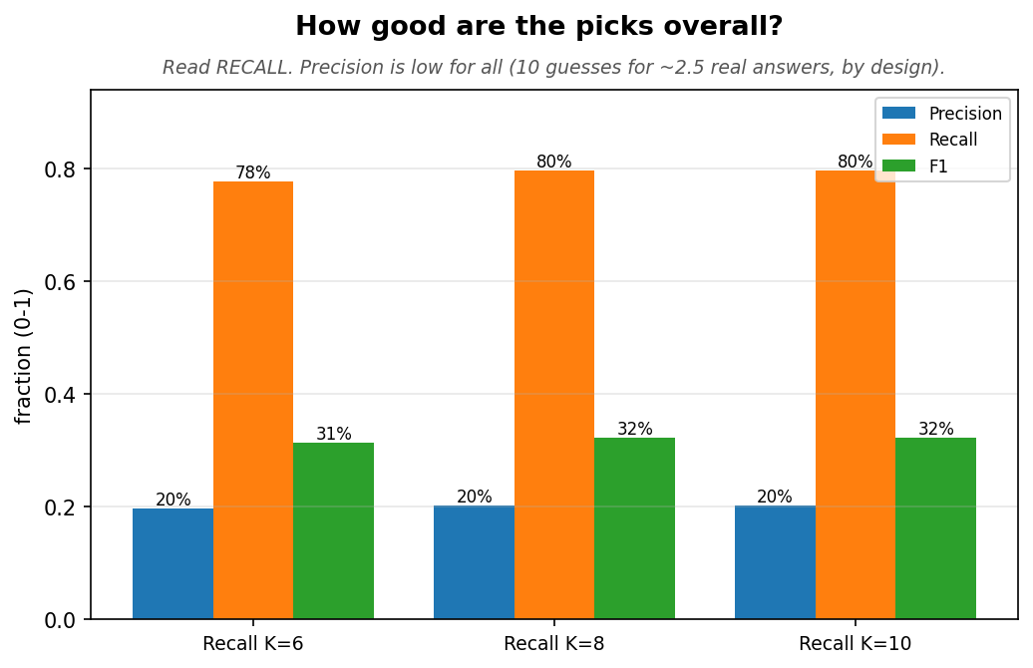

Easy vs hard tickets
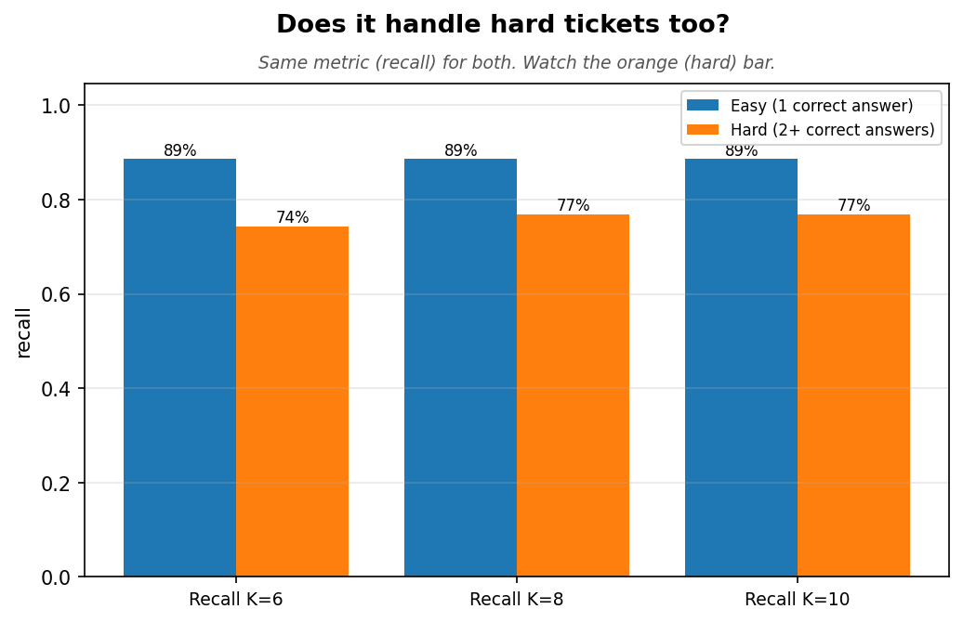
Approach | Easy n | Easy R | Hard n | Hard R
Recall K=6 | 35 | 89% | 25 | 74%
Recall K=8 | 35 | 89% | 25 | 77%
Recall K=10 | 35 | 89% | 25 | 77%

Were the right answers shown to the model?

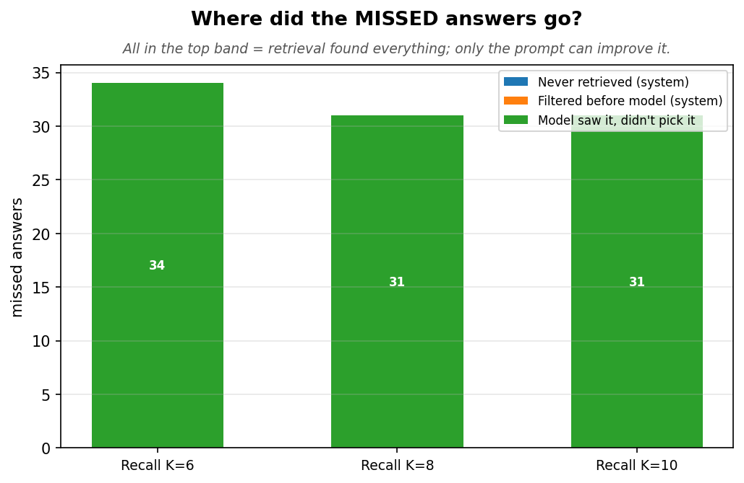

Precedent: backed vs lift
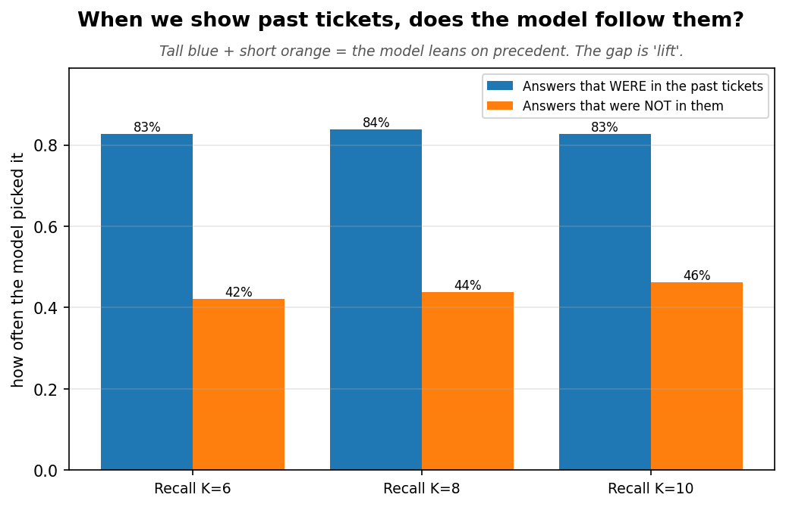
Approach | Precedent backed | Precedent lift
Recall K=6 | 83% | +0.41
Recall K=8 | 84% | +0.40
Recall K=10 | 83% | +0.37

Latency
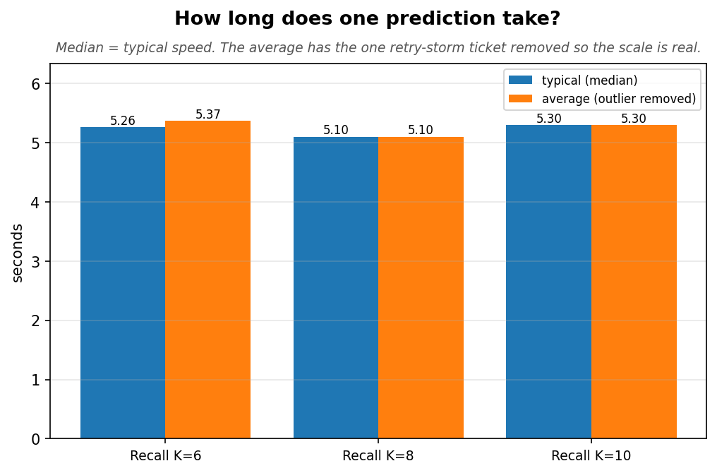
Approach | P | R | F1 | Easy R | Hard R | Backed | Lift | Typical
Recall K=6 | 20% | 78% | 0.31 | 89% | 74% | 83% | +0.41 | 5.3s
Recall K=8 | 20% | 80% | 0.32 | 89% | 77% | 84% | +0.40 | 5.1s
Recall K=10 | 20% | 80% | 0.32 | 89% | 77% | 83% | +0.37 | 5.3s

What the metrics mean
Term | Plain meaning
Recall | Of the correct Value Streams, the fraction we found. Higher is better.
Precision | Of our guesses, the fraction correct. Low by design (10 guesses, ~2.5 real).
F1 | Balance of precision and recall. Higher is better.
Easy / Hard ticket | Easy = one correct stream; Hard = two or more. Tracked apart so a win isn't just the easy cases.
Precedent backed | Of the correct answers that were in the shown past tickets, the fraction the model picked. How much of the offered precedent it used.
Precedent lift | (pick-rate on answers IN the past tickets) - (pick-rate on answers NOT in them). Whether the precedent is what's causing the pick.
Ceiling | Fraction of correct answers on the candidate list at all (~100%, the full catalogue is shown).
Where misses go | Never retrieved / filtered before the model / model saw it and dropped it. The last is the model's choice, not the system's.

