VS Selection — Mode Comparison
Modes: all50, evidence. Each metric is the mean across that mode's repeat runs.

Verdict
- Winner: 'evidence' - best recall (0.743) and F1 (0.301).
- It lifts recall +0.168 over 'all50' (0.575 -> 0.743) - about 29% relative.
- Single-VS recall (easy half): 0.676 -> 0.848; multi-VS F1 (hard half): 0.347 -> 0.454 - it lifts BOTH, so the gain is real, not easy-case bias.
- Historic boost in 'evidence': GT shown in the evidence is picked 0.787 of the time vs 0.439 when it isn't (+0.348) - the model is genuinely using the precedent.
- Headroom: the historic lane SURFACES 0.887 of GT but the model only CAPTURES 0.787 - ~0.10 of the signal is in the evidence yet not picked. A more trusting prompt (or more historic tickets) could capture it.
- Precision is count-capped (predicting 10 vs ~2.5 GT) - read recall/F1, not precision.

1. Selection quality (P / R / F1)
Precision is count-capped (predicting 10 when avg GT is ~2.5), so READ RECALL and F1, not precision. Best F1: 'evidence' (0.301). Best recall: 'evidence' (0.743).
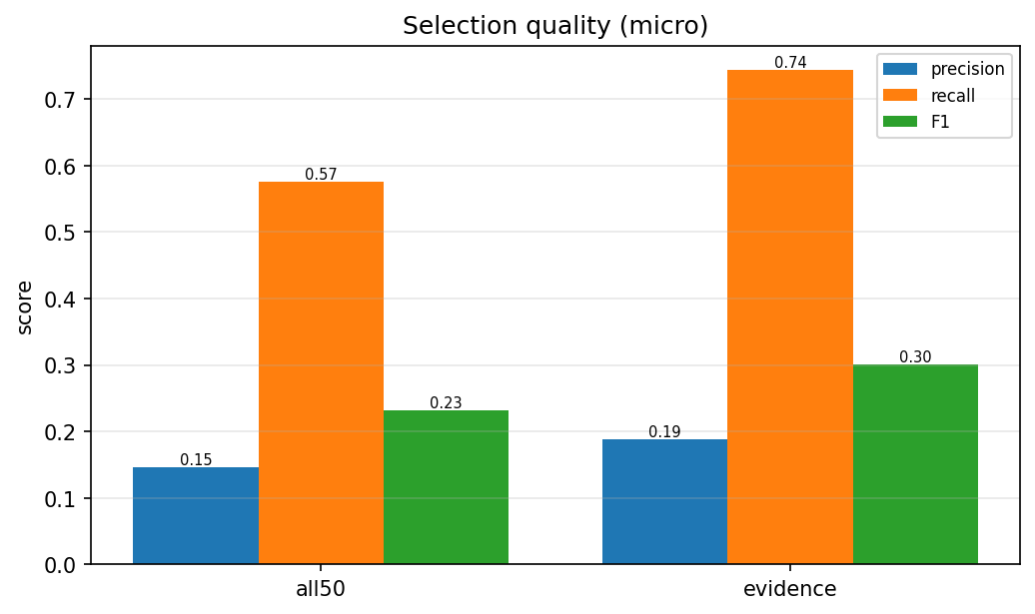

2. Single-VS vs Multi-VS
Single-VS tickets (one obvious answer) are the easy half - watch recall. Multi-VS is the hard half. A mode that lifts BOTH is genuinely better, not just easy-case-biased.
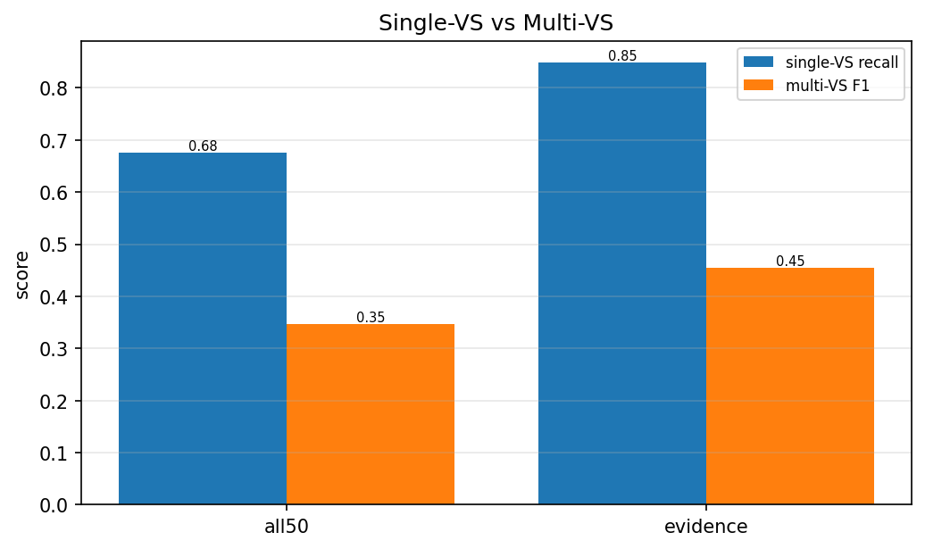

3. Retrieval recall - the ceiling
Did retrieval put the GT in front of the LLM? Selection recall cannot exceed review-pool recall. VS lane R@10 = semantic-ranking quality (low = embedding ranks GT poorly). Historic lane R = what precedent surfaces. Pool R = the ceiling the LLM sees.
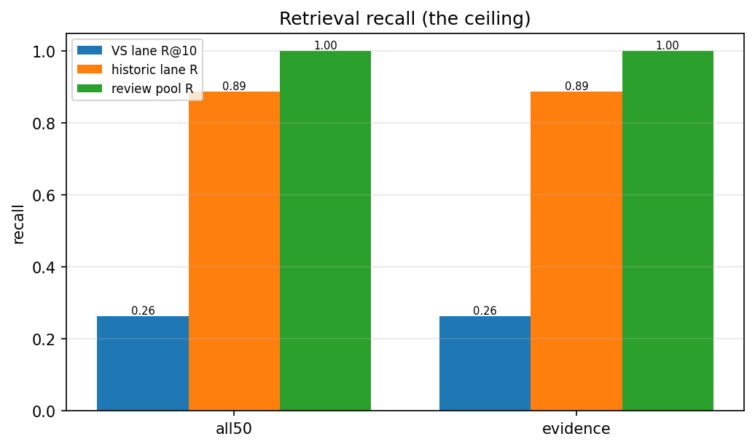

4. Historic boost
Recall on GT that appeared in the historic evidence vs GT that didn't. A big gap means the model is USING the precedent: GT shown in similar past tickets gets picked far more.
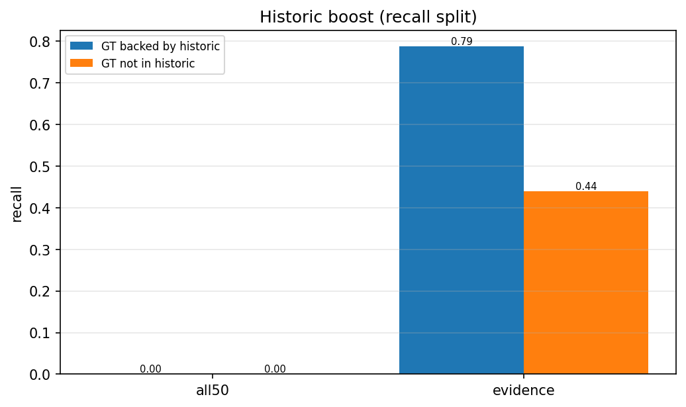

5. Latency
Per-prediction latency (excludes the eval-only judge calls). The richer modes (more candidates/evidence) cost a little more time per ticket.
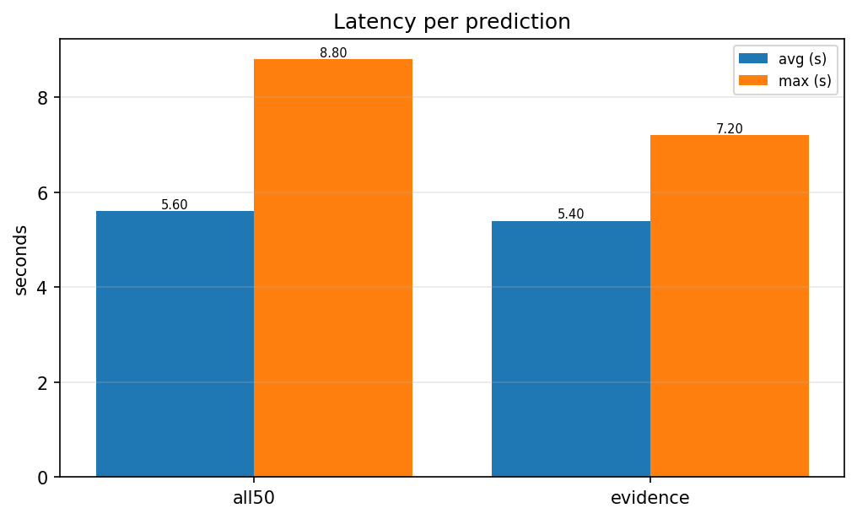

Summary table
mode | P | R | F1 | single-R | multi-F1 | hist boost
all50 | 0.146 | 0.575 | 0.232 | 0.676 | 0.347 | -
evidence | 0.188 | 0.743 | 0.301 | 0.848 | 0.454 | +0.348

