VS Selection — Mode Comparison
Modes: all50_semantic, all50_noscore, evidence_semantic, evidence_noscore. Each metric is the mean across that mode's repeat runs.

Verdict
- Winner: 'evidence_semantic' - best recall (0.743) and F1 (0.301).
- It lifts recall +0.168 over 'all50_semantic' (0.575 -> 0.743) - about 29% relative.
- Single-VS recall (easy half): 0.676 -> 0.848; multi-VS F1 (hard half): 0.347 -> 0.454 - it lifts BOTH, so the gain is real, not easy-case bias.
- Historic boost in 'evidence_semantic': GT shown in the evidence is picked 0.787 of the time vs 0.439 when it isn't (+0.348) - the model is genuinely using the precedent.
- Headroom: the historic lane SURFACES 0.887 of GT but the model only CAPTURES 0.787 - ~0.10 of the signal is in the evidence yet not picked. A more trusting prompt (or more historic tickets) could capture it.
- Precision is count-capped (predicting 10 vs ~2.5 GT) - read recall/F1, not precision.

Axis comparison (isolated deltas)
Each axis holds everything else fixed and changes ONE thing, so the delta is attributable. Δ = B - A; arrow points at the better side for that metric (recall/F1/lift: higher is better; dropped GT and latency: lower is better).

plain->historic (no-scores): all50_noscore → evidence_noscore
metric | all50_noscore | evidence_noscore | Δ (B-A) | better
micro R | 0.588 | 0.726 | +0.138 | → evidence_noscore
micro F1 | 0.237 | 0.294 | +0.056 | → evidence_noscore
single-VS R | 0.676 | 0.838 | +0.162 | → evidence_noscore
multi-VS F1 | 0.358 | 0.441 | +0.083 | → evidence_noscore
historic lift | 0.050 | 0.308 | +0.258 | → evidence_noscore
LLM-dropped GT | 63 | 42 | -21.000 | → evidence_noscore
median latency (s) | 5.200 | 5.100 | -0.100 | → evidence_noscore

plain->historic (semantic): all50_semantic → evidence_semantic
metric | all50_semantic | evidence_semantic | Δ (B-A) | better
micro R | 0.575 | 0.743 | +0.168 | → evidence_semantic
micro F1 | 0.232 | 0.301 | +0.069 | → evidence_semantic
single-VS R | 0.676 | 0.848 | +0.172 | → evidence_semantic
multi-VS F1 | 0.347 | 0.454 | +0.107 | → evidence_semantic
historic lift | 0.000 | 0.348 | +0.348 | → evidence_semantic
LLM-dropped GT | n/a | n/a | n/a | —
median latency (s) | n/a | n/a | n/a | —

semantic->no-scores (evidence): evidence_semantic → evidence_noscore
metric | evidence_semantic | evidence_noscore | Δ (B-A) | better
micro R | 0.743 | 0.726 | -0.017 | → evidence_semantic
micro F1 | 0.301 | 0.294 | -0.007 | → evidence_semantic
single-VS R | 0.848 | 0.838 | -0.010 | → evidence_semantic
multi-VS F1 | 0.454 | 0.441 | -0.013 | → evidence_semantic
historic lift | 0.348 | 0.308 | -0.040 | → evidence_semantic
LLM-dropped GT | n/a | 42 | n/a | —
median latency (s) | n/a | 5.100 | n/a | —

semantic->no-scores (all50): all50_semantic → all50_noscore
metric | all50_semantic | all50_noscore | Δ (B-A) | better
micro R | 0.575 | 0.588 | +0.013 | → all50_noscore
micro F1 | 0.232 | 0.237 | +0.005 | → all50_noscore
single-VS R | 0.676 | 0.676 | +0.000 | → all50_noscore
multi-VS F1 | 0.347 | 0.358 | +0.011 | → all50_noscore
historic lift | 0.000 | 0.050 | +0.050 | → all50_noscore
LLM-dropped GT | n/a | 63 | n/a | —
median latency (s) | n/a | 5.200 | n/a | —

1. Selection quality (P / R / F1)
Precision is count-capped (predicting 10 when avg GT is ~2.5), so READ RECALL and F1, not precision. Best F1: 'evidence_semantic' (0.301). Best recall: 'evidence_semantic' (0.743).
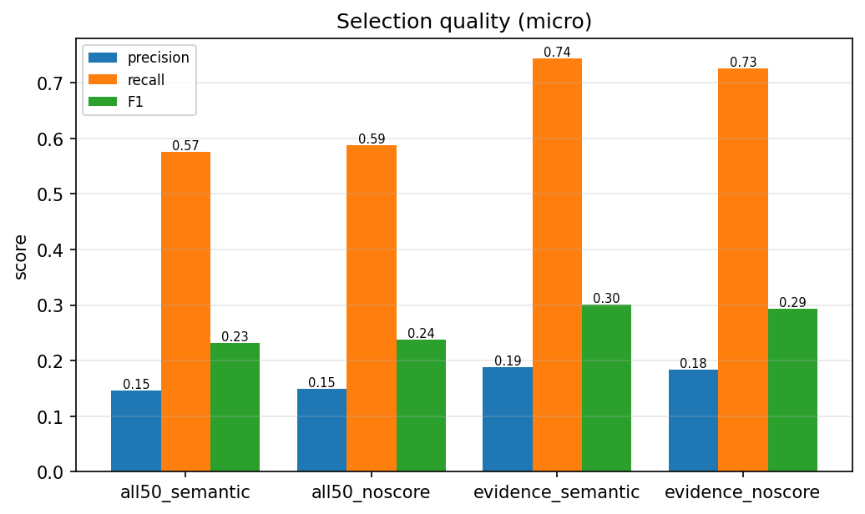

2. Single-VS vs Multi-VS
Single-VS tickets (one obvious answer) are the easy half - watch recall. Multi-VS is the hard half. A mode that lifts BOTH is genuinely better, not just easy-case-biased.
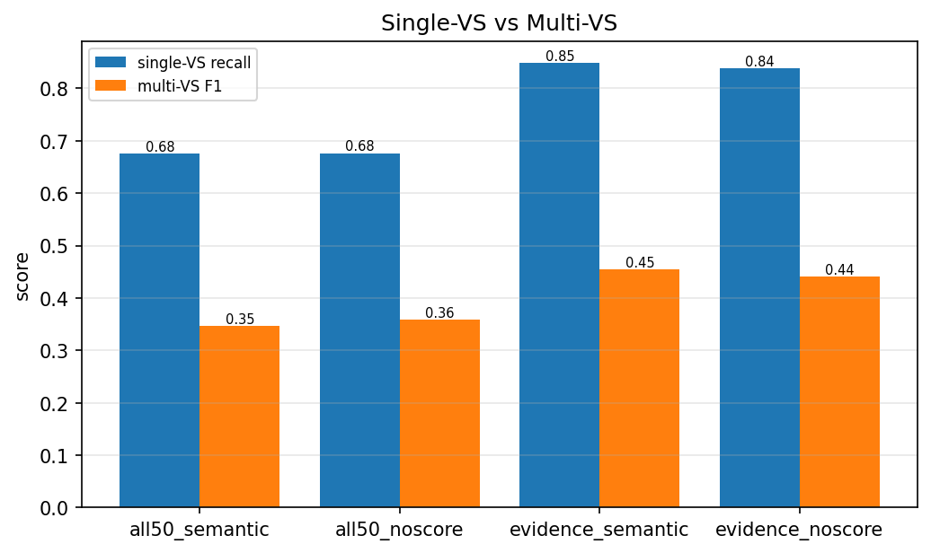

3. Retrieval recall - the ceiling
Did retrieval put the GT in front of the LLM? Selection recall cannot exceed review-pool recall. VS lane R@10 = semantic-ranking quality (low = embedding ranks GT poorly). Historic lane R = what precedent surfaces. Pool R = the ceiling the LLM sees.
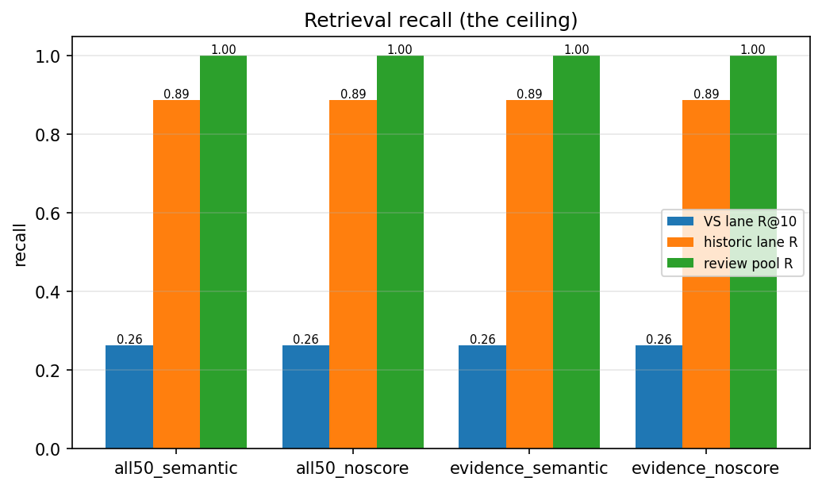

4. Historic boost
Recall on GT that appeared in the historic evidence vs GT that didn't. A big gap means the model is USING the precedent: GT shown in similar past tickets gets picked far more.
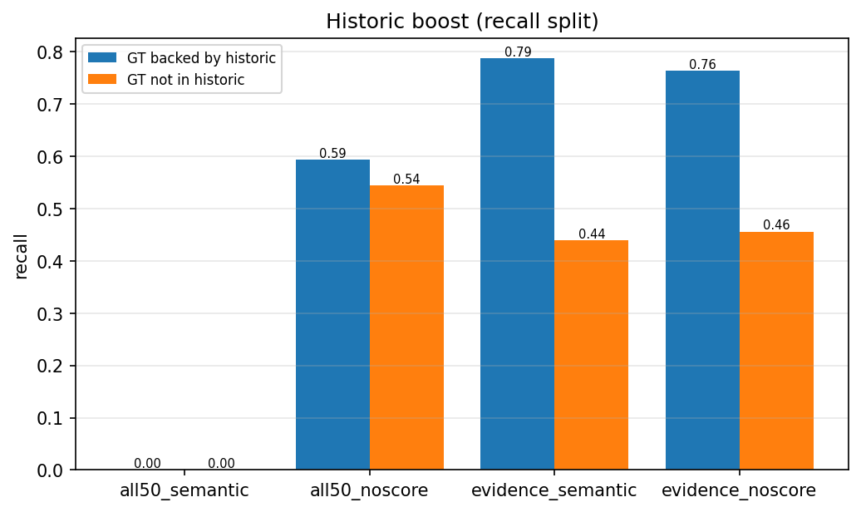

5. Latency
Per-prediction latency (excludes the eval-only judge calls). The richer modes (more candidates/evidence) cost a little more time per ticket.
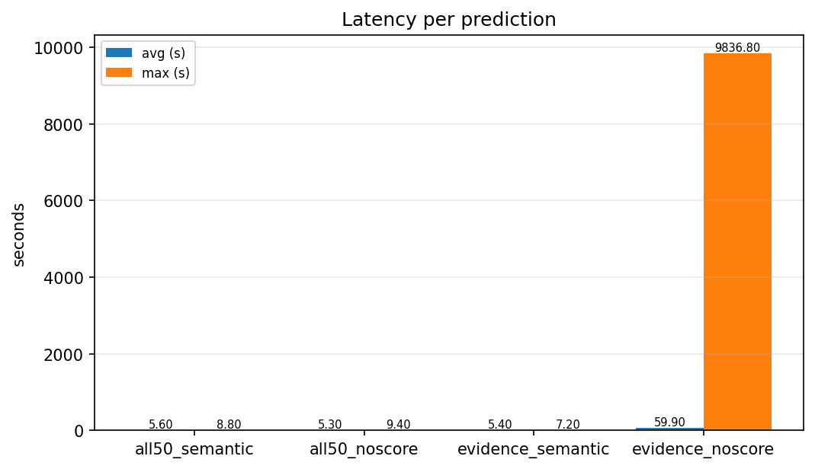

Summary table
mode | P | R | F1 | single-R | multi-F1 | hist boost
all50_semantic | 0.146 | 0.575 | 0.232 | 0.676 | 0.347 | -
all50_noscore | 0.149 | 0.588 | 0.237 | 0.676 | 0.358 | +0.050
evidence_semantic | 0.188 | 0.743 | 0.301 | 0.848 | 0.454 | +0.348
evidence_noscore | 0.184 | 0.726 | 0.294 | 0.838 | 0.441 | +0.308

