Value Stream Historical RAG Pipeline
This document explains the full value-stream RAG flow end to end: retrieval, historical FAISS support, merge, LLM selection, finalization, limits, offsets, scoring formulas, and the reason behind the current heuristic math.
The short version: the pipeline does not ask the LLM to classify from scratch. It first builds a bounded candidate set from semantic retrieval and historical ticket retrieval, merges those signals by value-stream name, protects recall-heavy lanes, then asks the LLM to choose from real candidates only.

Key Files
Area | File
Streaming API route | `src/vs_app/api/routes/rag.py`
Non-streaming and batch pipeline | `src/vs_app/modules/rag/pipeline.py`
Semantic VS retrieval | `src/vs_app/modules/rag/retrieval/semantic_retriever.py`
Historical FAISS retrieval | `src/vs_app/modules/rag/retrieval/historical_retriever.py`
Candidate merge and ranking | `src/vs_app/modules/rag/augmentation/candidate_merger.py`
Prompt context construction | `src/vs_app/modules/rag/augmentation/prompt_context.py`
LLM finalizer and rescue | `src/vs_app/modules/rag/augmentation/finalizer.py`
LLM output sanitizer | `src/vs_app/modules/rag/ranking/reranker.py`
Direct selection prompt | `prompt_yaml/selection.yaml`
Historical gap prompt | `prompt_yaml/historical_gap_selection.yaml`
Batch eval script | `scripts/evaluate_rag_batch.py`

One Picture
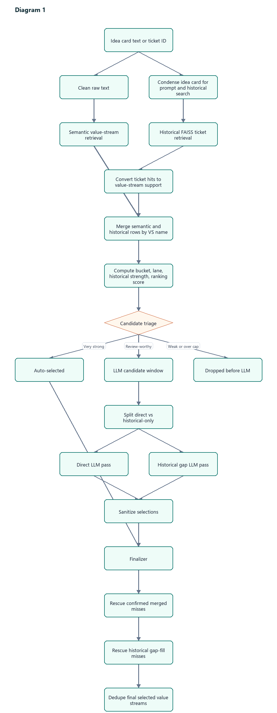

Request Inputs
The UI calls either:
- `POST /rag/value-streams/stream`
- `POST /rag/value-streams`
Important inputs:
Input | Meaning
`ticket_id` | Jira/idea-card ID such as `IDMT-19761`. Used for display, source-ticket exclusion, and ground-truth comparison.
`idea_card_text` | Uploaded or extracted idea-card text. This becomes the query.
`top_k_value_streams` | Semantic VS retrieval size from the UI.
`top_k_historical` | Historical RAG candidate slider from the UI.
`exclude_source_ticket_from_historical` | Leave-one-out toggle. When on, the current ticket is removed from historical FAISS hits.
`use_llm_finalizer` | Whether final selection should use LLM review.
When uploaded text and a selected ticket ID both exist, the text is the query, but the ticket ID still controls source exclusion and comparison.

Step 1: Query Preparation
The pipeline prepares two query forms:
Query | Source | Used For
`cleaned_query` | `clean_ppt_text(query)` | Semantic VS retrieval
`query_for_prompt` | `condense_idea_card(query, max_chars=3500)` | Historical FAISS retrieval and LLM prompts
The non-streaming path runs condensation and semantic retrieval in parallel:
with ThreadPoolExecutor(max_workers=2):
condense_idea_card(...)
retrieve_semantic_candidates(...)
Why this exists:
- Semantic retrieval benefits from cleaned but still rich text.
- LLM prompts and historical retrieval work better with a condensed business summary.
- Parallelism hides part of the condensation latency.

Step 2: Retrieval Limits
The UI sends a requested candidate count. In the code this arrives as `fetch_count`. Before the pipeline calls any retriever, that one number is turned into three separate limits:
top_k = min(max(12, fetch_count), 50)
max_llm_candidates = min(max(top_k + 15, 40), 50)
historical_max_ticket_hits = min(max(12, fetch_count), 40)
These three values are used in different places:
Value | Used By | What It Controls
`top_k` | `retrieve_semantic_candidates(..., top_k=top_k)` | How many direct semantic value-stream candidates come back from the value-stream index.
`historical_max_ticket_hits` | `retrieve_historical_support(..., max_ticket_hits=historical_max_ticket_hits)` | How many similar historical tickets are kept from FAISS before they are converted into value-stream support.
`max_llm_candidates` | `merge_candidate_sources(..., max_llm_candidates=max_llm_candidates)` | How many merged value-stream candidates are allowed to reach the final LLM review step.
The important distinction:
top_k controls semantic value streams.
historical_max_ticket_hits controls historical tickets.
max_llm_candidates controls merged value-stream rows after semantic and historical evidence are combined.
So `max_llm_candidates = 45` does not mean 45 tickets are retrieved. It means that after semantic value streams and historical ticket-derived value streams are merged, up to 45 unique value-stream candidates can be sent to the LLM.

Why Minimum 12
`12` prevents tiny candidate windows from starving the LLM. Many real tickets have more than a handful of plausible value streams, and early experiments showed that low windows caused recall misses before the LLM had a chance.

Why Maximum 50
There are only about 50 possible predefined value streams in the taxonomy. Asking for more than 50 semantic value-stream rows does not add new labels. It mostly adds duplicate/noisy work.

Why `top_k + 15`
Semantic retrieval and historical retrieval are merged later. A ticket may ask for 30 value streams from the UI, but after historical candidates are merged in, useful cross-confirmed rows can land below rank 30. The `+15` offset gives the merged list headroom so candidates found by both semantic and historical signals are not cut too early.

Why Minimum LLM Window 40
For broad tickets, the final candidate list can easily contain:
- 20 to 30 confirmed candidates,
- 10 to 15 historical-only candidates,
- a few semantic-only candidates.
An LLM window below 40 repeatedly caused `DROPPED BEFORE LLM / llm_candidate_cap` misses in the UI.

Why Historical Ticket Hits Cap 40
Historical FAISS retrieves prior tickets, not value streams. More tickets means more labels, more broad support, and more prompt noise. `40` is enough to find repeated patterns while limiting broad-ticket contamination.

Limit Examples
UI fetch count | Semantic `top_k` | Historical hits | LLM candidate cap
5 | 12 | 12 | 40
12 | 12 | 12 | 40
20 | 20 | 20 | 40
30 | 30 | 30 | 45
40 | 40 | 40 | 50
50 | 50 | 40 | 50
75 | 50 | 40 | 50
Example with `fetch_count = 30`:
top_k = 30
historical_max_ticket_hits = 30
max_llm_candidates = 45
The run does this:
- Retrieve up to 30 semantic value-stream candidates from the value-stream index.
- Retrieve up to 30 historical FAISS ticket hits.
- Convert those historical tickets into value-stream support rows.
- Merge semantic and historical value-stream rows by name.
- Allow up to 45 merged value-stream rows into the LLM candidate window.

Step 3: Semantic Value-Stream Retrieval
Semantic retrieval searches the value-stream index directly from the current idea card.
Typical candidate fields:
{
"entity_id": "VS-123",
"entity_name": "Establish Product Offering",
"description": "The gathering of market attributes...",
"semantic_score": 1.72
}
This is direct evidence. It answers:
Which value streams does the current idea card itself look like?
Semantic retrieval does not know historical ticket patterns.

Step 4: Historical FAISS Retrieval
Historical FAISS searches prior idea-card summaries. It returns similar tickets, not value streams directly.
Each hit carries metadata:
{
"ticket_id": "IDMT-8199",
"best_score": 0.696,
"title": "...",
"summary_preview": "...",
"direct_vs_names": ["Resolve Request-Inquiry"],
"implied_vs_names": ["Manage Member Care"],
"label_source": "jira_issuelinks"
}
This is precedent evidence. It answers:
When prior tickets looked like this one, which value streams were attached?

Source Ticket Exclusion
The UI toggle `Exclude source ticket` removes the current ticket from historical FAISS hits.
This matters for testing. If `IDMT-19761` searches the historical index and the same `IDMT-19761` is allowed, the pipeline can see its own labels. That inflates recall and hides whether the system generalizes.
When exclusions are active:
exclusion_backfill = len(excluded_ticket_ids)
fetch_k = max_ticket_hits + exclusion_backfill
In normal UI testing there is usually exactly one excluded ticket: the selected source ticket.
So with one excluded ticket:
len(excluded_ticket_ids) = 1
exclusion_backfill = 1
fetch_k = max_ticket_hits + 1
That means the pipeline asks FAISS for one extra raw result, then filters out the source ticket, then keeps only the requested number of non-excluded hits.

Without Source-Ticket Exclusion
If `fetch_count = 30`:
historical_max_ticket_hits = min(max(12, 30), 40) = 30
excluded_ticket_ids = []
exclusion_backfill = 0
fetch_k = 30
Flow:
Ask FAISS for 30 raw ticket hits
Keep up to 30 ticket hits
Convert those 30 tickets into value-stream support
If the source ticket is the top FAISS result, it stays in those 30 hits.

With Source-Ticket Exclusion
If `fetch_count = 30` and the selected ticket is `IDMT-19761`:
historical_max_ticket_hits = 30
excluded_ticket_ids = ["IDMT-19761"]
exclusion_backfill = 1
fetch_k = 30 + 1 = 31
Flow:
Ask FAISS for 31 raw ticket hits
Drop any hit whose ticket_id is IDMT-19761
Keep the first 30 non-excluded ticket hits
Convert those 30 tickets into value-stream support
So the backfill does not increase the final number of historical ticket hits. It only increases the temporary FAISS request size by the number of excluded tickets so the pipeline can still end with about 30 usable non-source hits after removing the source ticket.

Why Backfill Exists
If the self-ticket is removed, the FAISS result list now has a hole. Backfill fetches extra neighbors so the pipeline can still return the requested number of non-excluded historical tickets.

Why `len(excluded_ticket_ids)`
For normal UI use, only one ticket is excluded and the historical index is built from summaries, so a ticket should appear at most once. Asking for one extra result is enough to replace that one removed source ticket.
For batch or future multi-ticket exclusions, the extra request size scales one-for-one with the number of removed IDs.

Step 5: Convert FAISS Hits To Value-Stream Support
Historical retrieval turns ticket-level hits into value-stream-level support.
Important: direct vs implied is already decided during ingestion.
The FAISS summary index stores that result as metadata on each summary document. At RAG time, the historical retriever does not re-classify direct vs implied. It reads the stored metadata and aggregates it.
In the current generated data, the value-stream labels are expected to come from Jira issue links and already include direct/implied splits:
{
"ticket_id": "IDMT-8199",
"summary_preview": "...",
"direct_vs_names": ["Resolve Request-Inquiry"],
"implied_vs_names": ["Manage Member Care"],
"label_source": "jira_issuelinks"
}
So the normal path is simple:
Ingestion resolves Jira issue-link labels.
Ingestion writes direct_vs_names and implied_vs_names into FAISS summary metadata.
Historical RAG reads those stored fields from FAISS hits.
Historical RAG aggregates them into value-stream support rows.
More specifically, ingestion resolves value-stream issue links like this:
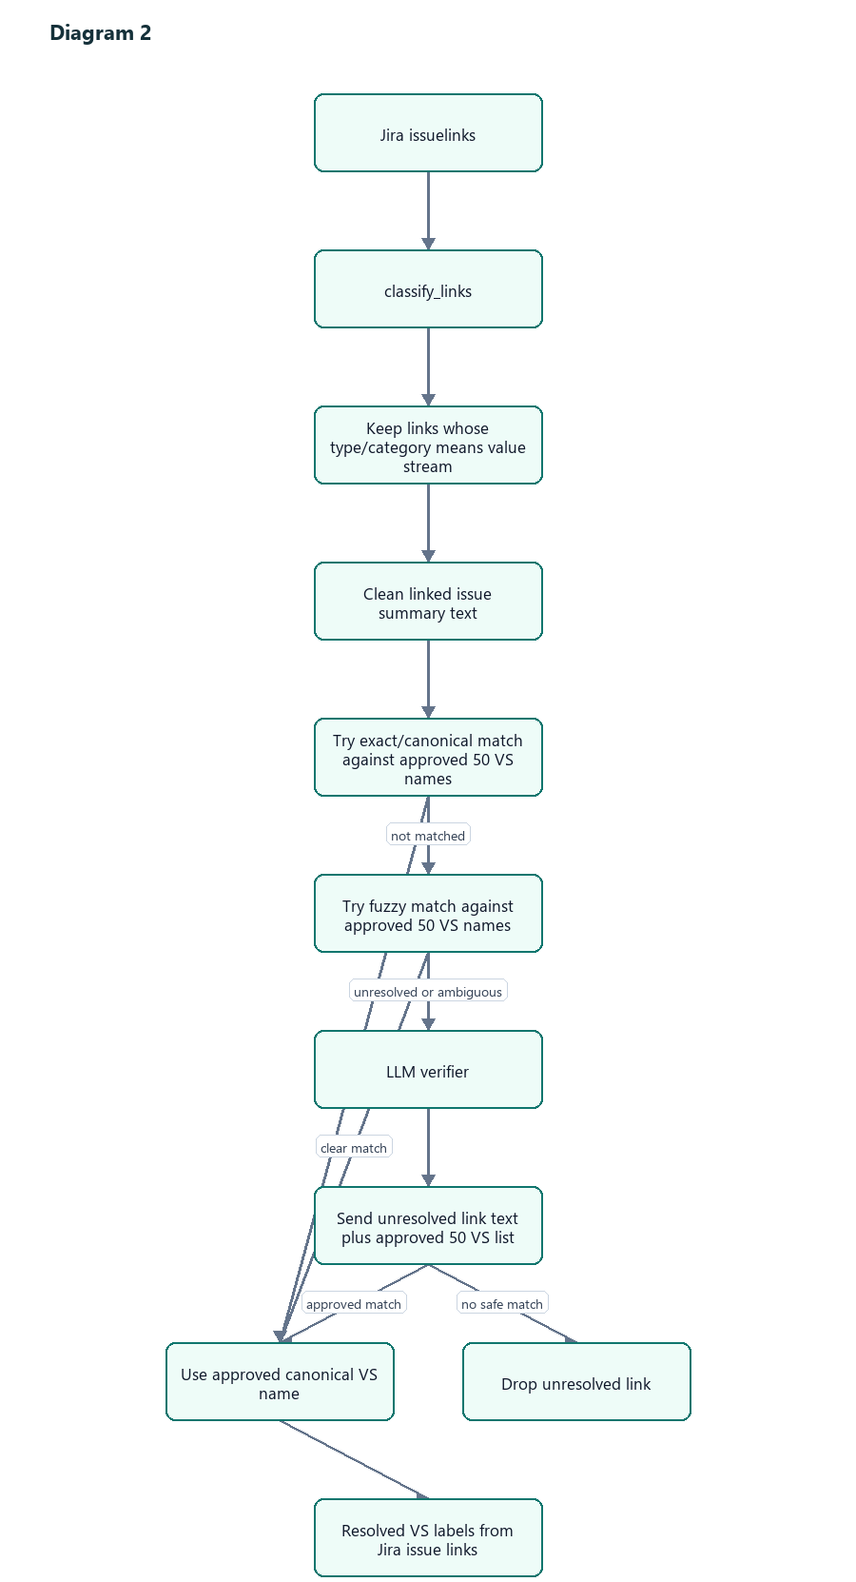
The LLM verifier is not asked to infer all value streams from the whole ticket. It only receives the unresolved Jira issue-link text and the approved value-stream list, then tries to map that linked issue text to one of the approved names.
After the names are resolved, a separate ingestion step classifies each resolved value stream as:
direct
implied
That classifier receives:
raw/consolidated ticket text
+ the resolved value-stream labels attached/fetched from the ticket
and asks the LLM to mark each supplied label as direct or implied. This step is classification of known labels, not discovery of new labels.
That direct/implied classification is what later becomes:
direct_vs_names
implied_vs_names
in the FAISS summary metadata.

What Happens If There Are No VS Issue Links
There is no theme fallback in the current contract.
Tickets should be ingested/evaluated only after verifying they have value-stream issue links. If a ticket has no resolvable VS issue links, ingestion leaves it unlabeled instead of trying to infer labels from themes.
File: `src/vs_app/modules/ingestion/value_stream_labels/value_stream_mapping.py`
No value-stream issue links
-> no value_stream_names
-> no value_stream_ids
-> do not create theme-derived labels

Direct/Implied Classifier Requirement
File: `src/vs_app/modules/ingestion/summary/llm_summary_extractor.py`
After ingestion has a list of resolved value-stream labels, it asks the LLM to classify those labels as direct or implied.
If the LLM is unavailable, the ticket text is empty, or the LLM does not return a classification for a supplied label, ingestion does not silently default that label to direct or implied.
No direct/implied classification
-> no direct_vs_names / implied_vs_names for that label
-> the label does not contribute historical VS support later
This keeps bad or incomplete ingestion visible instead of hiding it behind a fallback.
For each historical ticket hit during RAG:
- Prefer `direct_vs_names`.
- Add `implied_vs_names` that are not already direct.
There is no RAG-time fallback from `value_stream_names` or `value_stream_labels` into direct/implied support. For the current index, the required fields are `direct_vs_names`, `implied_vs_names`, and `label_source = jira_issuelinks`.
So when this document says "historical support is direct" or "historical support is implied", that is not a new decision made by the RAG query. It is the direct/implied label that was already stored during FAISS ingestion.

Per-Ticket Weight
Each historical ticket gets total weight `1.0`, split across its value streams:
per_ticket_weight = 1.0 / number_of_streams_on_ticket
Why:
- A ticket tagged with 2 streams should give each stream meaningful support.
- A ticket tagged with 12 streams should not give every stream the same power as a narrow direct ticket.
- This prevents broad tickets from overpowering the merge simply because they list many labels.
Example:
Historical Ticket | Streams On Ticket | Weight Per Stream
`IDMT-1` | 2 | 0.500
`IDMT-2` | 5 | 0.200
`IDMT-3` | 10 | 0.100
Support fields created per value stream:
Field | Meaning
`support_count` | Raw count of support observations.
`direct_count` | Count of direct support observations.
`implied_count` | Count of implied support observations.
`weighted_support_count` | Sum of per-ticket weights.
`weighted_direct_count` | Weighted direct support.
`weighted_implied_count` | Weighted implied support.
`best_support_score` | Highest FAISS score among supporting tickets.
`avg_support_score` | Average FAISS score across observations.
`supporting_ticket_ids` | Historical tickets behind this stream.
`historical_reasons` | Short snippets used for prompts and UI reasoning.

Step 6: Merge Semantic And Historical Sources
The merger joins semantic candidates and historical support rows by normalized value-stream name:
" Resolve Request-Inquiry " -> "resolve request-inquiry"
If both sources contain the same stream, one merged row is created.
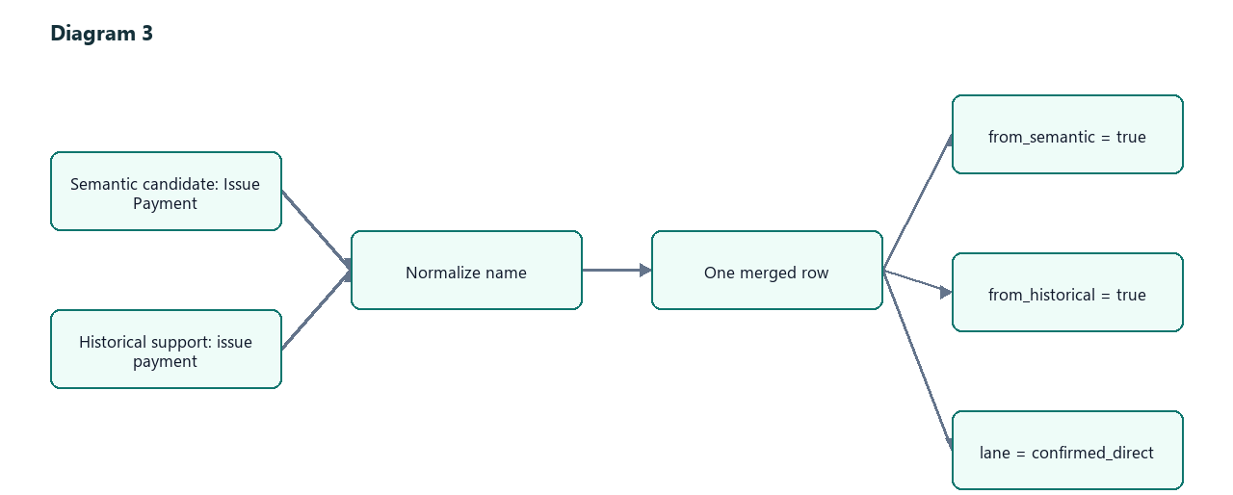
Buckets:
Bucket | Meaning
`semantic_plus_historical` | Both semantic and historical found the stream.
`semantic_only` | Only semantic retrieval found it.
`historical_only` | Only historical support found it.
Lanes:
Lane | Bucket Pattern | Meaning
`confirmed_direct` | semantic plus historical | Safest lane. Two independent signals agree.
`semantic_direct` | semantic only | Direct current-card evidence, no historical support.
`historical_recall` | historical only | Precedent-only candidate. Useful for recall, noisier.
`weak_noise` | neither | Defensive fallback.

Step 7: Historical Strength Formula
Every merged row gets a historical strength:
historical_strength =
best_support_score
+ 0.18 * weighted_direct_count
+ 0.06 * weighted_implied_count
+ label_source_adjustment

What Each Term Means
Term | Meaning
`best_support_score` | Peak similarity from FAISS. This is the base historical relevance signal.
`0.18 * weighted_direct_count` | Direct historical labels are strong evidence, but should not dominate semantic similarity.
`0.06 * weighted_implied_count` | Implied labels help, but are weaker than direct labels.
`label_source_adjustment` | Small boost when the historical labels came from Jira issue links. In current data this is normally `+0.06` for historical rows.

Why Direct Is `0.18`
Direct support means a historical ticket explicitly mapped to the value stream. It should move the candidate meaningfully upward.
But it should not overpower FAISS similarity. If each direct weighted count added `1.0`, then one broad or mislabeled ticket could dominate the ranking. `0.18` is intentionally modest:
5 weighted direct support points = +0.90
1 weighted direct support point = +0.18
That makes repeated explicit evidence matter, while a single direct label only nudges the score.

Why Implied Is `0.06`
Implied support is useful but fuzzier. It comes from the ingestion-time direct/implied classifier when the supplied Jira value-stream label is related to the ticket but not the primary directly changed stream.
The formula makes direct support exactly 3x implied support:
0.18 / 0.06 = 3
This encodes the current judgment:
One direct support signal is worth about three implied support signals.

Why Source Adjustment Is Small
if "jira_issuelinks" in sources:
+0.06
else:
0.00
This offset should break ties, not rewrite the ranking.
`jira_issuelinks` is explicit business metadata from Jira relationships, so it gets a small boost. Since the current generated data is expected to use Jira issue links, this usually acts as a small historical-evidence confidence bump, not as a choice between multiple active data sources.
The number is smaller than direct/implied support because source quality should influence confidence, not become the main evidence.

Example Historical Strength
Assume:
best_support_score = 0.690
weighted_direct_count = 2.0
weighted_implied_count = 1.5
label_source_adjustment = +0.06
Then:
historical_strength
= 0.690 + 0.18*2.0 + 0.06*1.5 + 0.06
= 0.690 + 0.360 + 0.090 + 0.060
= 1.200
Interpretation: the historical lane sees this as much stronger than a one-off FAISS hit because there is repeated direct and implied support.

Step 8: Ranking Score Formula
Merged candidates get a ranking score:
if semantic and historical:
ranking_score = semantic_score + 0.25 * historical_strength
elif semantic only:
ranking_score = semantic_score
else:
ranking_score = 0.70 * historical_strength

Why Confirmed Uses `semantic + 0.25 * historical`
For confirmed candidates, semantic retrieval is still the primary signal. The current card should drive classification.
Historical support is a confirmation boost. `0.25` means:
Historical strength can move the row up, but it does not replace direct semantic fit.
Example:
semantic_score = 1.45
historical_strength = 1.20
ranking_score = 1.45 + 0.25*1.20 = 1.75
The row becomes stronger than semantic-only candidates around `1.45`, because two independent signals agree.

Why Historical-Only Uses `0.70 * historical_strength`
Historical-only candidates need to compete for recall, but they should not outrank strong semantic candidates too easily.
`0.70` lets strong repeated precedent enter the LLM window, while keeping direct evidence above precedent-only evidence most of the time.
Example:
historical_strength = 1.20
ranking_score = 0.70*1.20 = 0.84
That is enough to be considered in the historical lane, but not enough to dominate confirmed direct rows.

Step 9: Auto-Selection
Some candidates skip the LLM when evidence is very strong.

Confirmed Direct Auto-Select
from_semantic = true
from_historical = true
semantic_score >= 1.50
best_support_score >= 0.70
support_count >= 4
Why:
- Semantic score is high.
- Historical similarity is high.
- Support appears at least 4 times.
This is the safest auto-select path.

Historical-Only Auto-Select: Direct Consensus
from_semantic = false
direct_count >= 4
support_count >= 6
best_support_score >= 0.78
avg_support_score >= 0.65
weighted_support_count >= 2.0
Why so strict:
- There is no semantic direct hit.
- Historical-only rows can be noisy.
- We require repeated direct evidence, high peak similarity, good average similarity, and concentrated support.

Historical-Only Auto-Select: Heavy Implied Consensus
support_count >= 8
best_support_score >= 0.75
avg_support_score >= 0.65
weighted_support_count >= 2.5
This catches repeated implied patterns, but only when the evidence is very dense.

Step 10: LLM Admission
Rows that are not auto-selected can still go to the LLM.
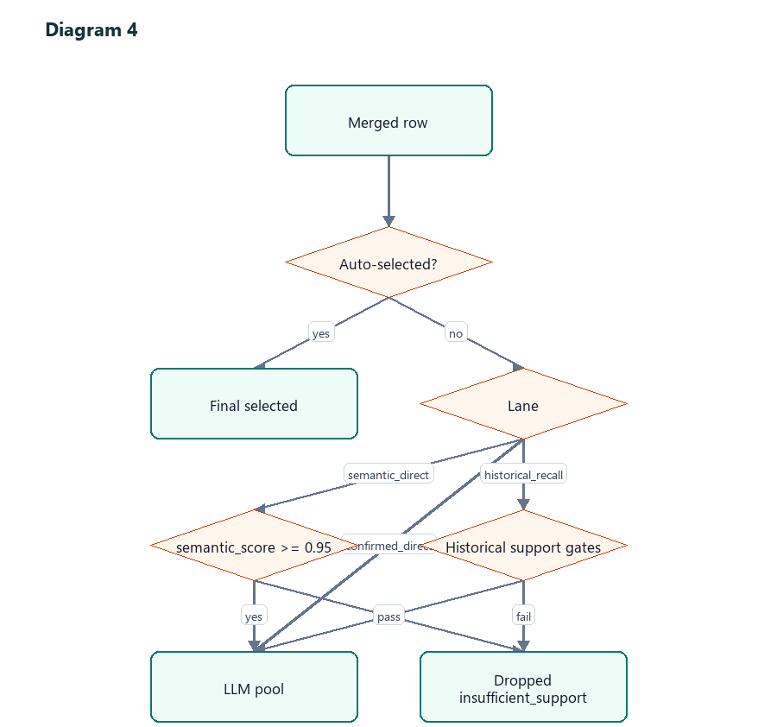

Semantic Direct Gate
semantic_score >= 0.95
This is intentionally permissive. Semantic-only rows are direct evidence from the current ticket, so they deserve LLM review if they are at least plausible.

Historical Recall Gates
Historical-only rows pass if any pattern is true:
direct_count >= 2 and best_support_score >= 0.55
or:
support_count >= 3
best_support_score >= 0.70
avg_support_score >= 0.58
or:
implied_count >= 5
best_support_score >= 0.72
avg_support_score >= 0.60
or leave-one-out moderate repeated support:
support_count >= 5
best_support_score >= 0.60
avg_support_score >= 0.55
(direct_count >= 1 or implied_count >= 5)
or broad repeated support:
support_count >= 8
best_support_score >= 0.60
avg_support_score >= 0.52
or weighted evidence gate:
support_count >= 2
weighted_support_count >= max(1.0, support_count * 0.4)
or final low-score evidence gate:
best_support_score >= 0.45
weighted_support_count >= 0.5
Why multiple gates:
- Some true positives are direct but few.
- Some are implied but repeated.
- Some lose their strongest hit when source-ticket exclusion is on.
- Weighted support protects against broad tickets.

Step 11: LLM Candidate Lane Quotas
The LLM window is bounded, usually 40 to 50 candidates. Within the cap, lanes are protected:
confirmed = min(max(1, ceil(total * 0.55)), 32)
historical = min(max(1, ceil(total * 0.30)), 18)
semantic = remaining
For `total = 50`:
confirmed_direct: 28
historical_recall: 15
semantic_direct: 7

Why 55 Percent Confirmed
Confirmed candidates are the safest: semantic and historical agree. The screenshots showed many misses where confirmed candidates were found but cut before the LLM. Giving this lane 55 percent protects those rows.

Why 30 Percent Historical
Historical-only candidates are the recall engine. They catch downstream or precedent-supported streams that semantic retrieval missed. But they are noisier, so they get a meaningful but smaller protected slice.

Why Semantic Gets Remainder
Semantic-only candidates are useful, but if a stream is semantic-only and not historically supported, it is either:
- a direct current-card match with no historical precedent, or
- a plausible but isolated match.
The remainder keeps semantic-only candidates visible without letting them crowd out confirmed and historical recall lanes.

Overflow
After protected slices are filled, leftover room is filled by priority:
confirmed_direct weight = 3
historical_recall weight = 2
semantic_direct weight = 1
This preserves the same trust order.

Step 12: LLM Prompt Split
The finalizer splits LLM candidates:
if lane == "historical_recall" or historical-only:
historical_gap_candidates.append(row)
else:
direct_candidates.append(row)
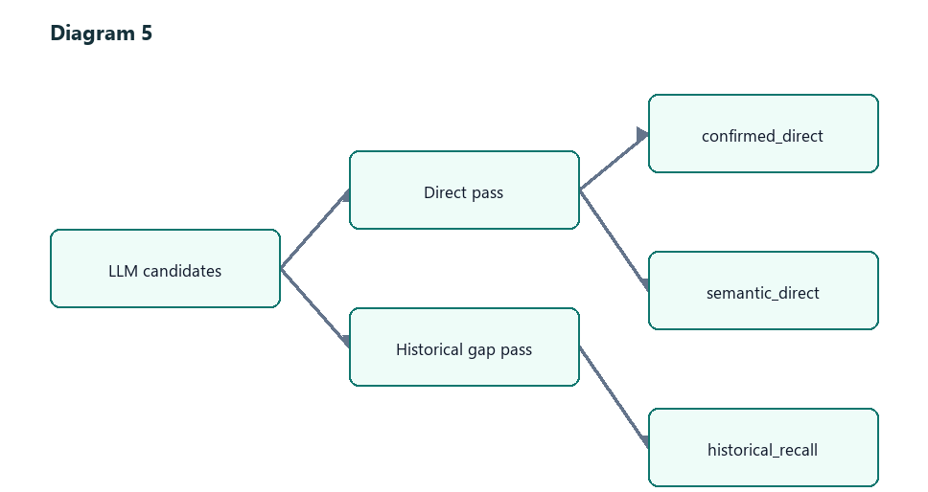
Why split:
- Direct candidates should be judged against the current idea card.
- Historical-only candidates need precedent context and stricter handling.
- The two prompts can run in parallel.

Step 13: Direct LLM Pass
Direct pass settings:
min_select = 4
max_select = min(22, max(12, ceil(candidate_count * 0.65)))

Why Minimum 4
Most idea cards touch multiple value streams. A nonzero minimum nudges the model away from under-selecting when there are plausible direct candidates.

Why Maximum 22
Some tickets have many labels, but the taxonomy has only about 50 total value streams. `22` gives broad tickets enough room without letting the LLM select nearly everything.

Why `0.65`
The LLM should not select every candidate. It should select a majority only when many candidates are plausible. `65%` is recall-friendly but still leaves room to reject weak candidates.
Example:
Direct Candidates | Formula | Max Select
8 | max(12, ceil(8*0.65)) | 12
20 | ceil(20*0.65) | 13
30 | ceil(30*0.65) | 20
40 | min(22, ceil(40*0.65)) | 22

Step 14: Historical Gap LLM Pass
Historical gap pass settings:
min_select = 0
max_select = 12
Why:
- Historical-only candidates can be true misses, but they can also be analog noise.
- `min_select = 0` allows the model to reject all historical-only rows.
- `max_select = 12` caps the blast radius from precedent-only evidence.

Step 15: LLM Sanitization
After each LLM pass, `sanitize_selected()` verifies that selected rows exist in the candidate list.
It removes:
- hallucinated value-stream names,
- renamed candidates,
- extra labels not in the prompt,
- malformed rows.
This is why the LLM cannot invent a new value stream. It can only choose from candidates produced by retrieval and merge.

Step 16: Finalizer
The finalizer combines:
auto-selected
+ sanitized direct LLM selections
+ sanitized historical gap LLM selections
+ confirmed-merged rescue
+ historical gap-fill rescue
Then it dedupes by lowercased `entity_name`.
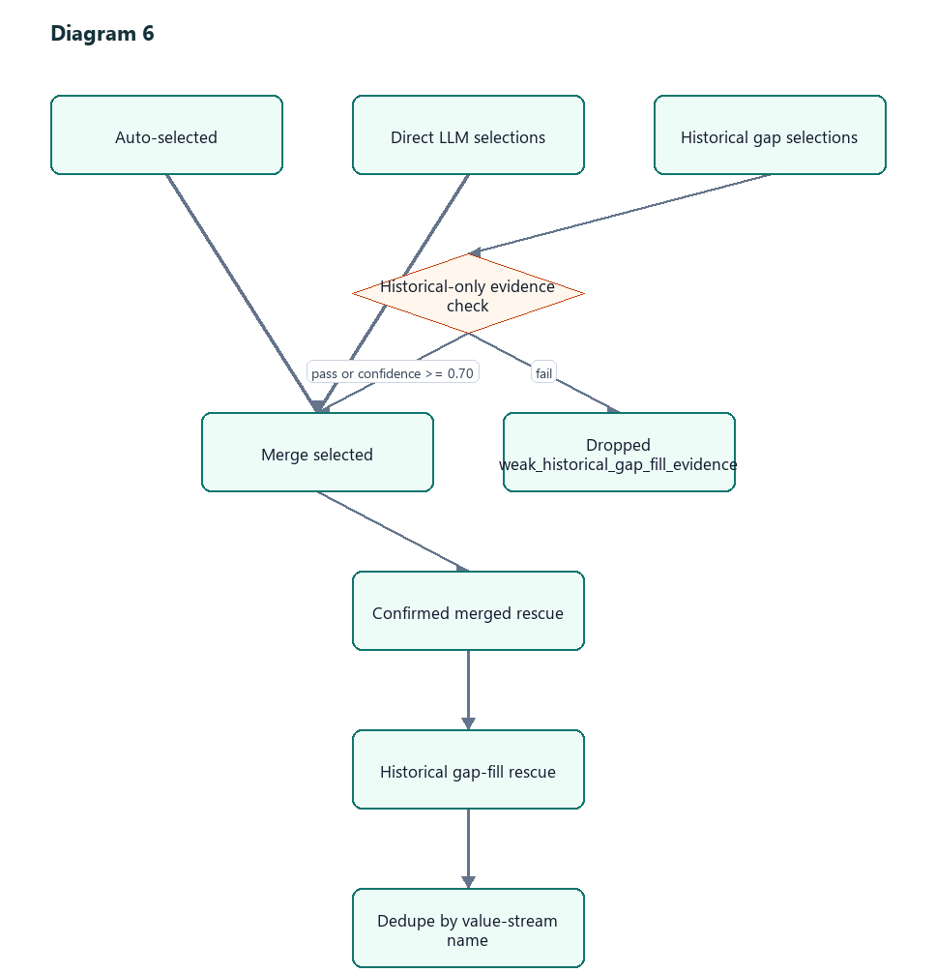

Historical-Only Selection Filter
Historical-only LLM selections are dropped if:
candidate is historical_gap_fill
and not _passes_gap_fill_evidence(candidate)
and LLM confidence < 0.70
Why:
- The historical gap prompt is useful for recall.
- But historical-only selections are the easiest place to create false positives.
- A confident LLM selection can override the evidence filter at `0.70`.
Direct LLM selections are trusted after sanitizer validation. This is the current recall-first behavior because ground-truth labels can be incomplete.

Confirmed-Merged Rescue
Confirmed merged rescue adds back strong `confirmed_direct` rows the LLM skipped.
Budget:
_CONFIRMED_MERGED_RESCUE_BUDGET = 12
Gate:
weighted_support_count >= 0.75
and one of:
support_count >= 5
semantic_score >= 1.20
best_support_score >= 0.60
or:
support_count >= 5
semantic_score >= 1.00
or:
support_count >= 3
semantic_score >= 1.35
best_support_score >= 0.65
Why:
- Confirmed rows are relatively trustworthy because semantic and historical signals agree.
- The LLM can under-select when candidate lists are crowded.
- Rescue protects recall without opening historical-only floodgates.

Historical Gap-Fill Rescue
Historical gap-fill rescue adds back historical-only rows that evidence says are coherent even if the LLM skipped them.
Budget:
_HISTORICAL_GAP_FILL_BUDGET = 4
Why only 4:
- Historical-only candidates are valuable for recall.
- They are also the highest false-positive risk.
- A small budget lets the pipeline recover strong misses without adding too many broad adjacent streams.
Evidence patterns that pass include:
single-ticket dense direct:
ticket_count == 1
direct_count >= 4
support_count >= 4
best_score >= 0.62
avg_score >= 0.56
weighted_support >= 0.75
moderate repeated direct:
support_count >= 5
direct_count >= 3
best_score >= 0.62
avg_score >= 0.56
weighted_support >= 0.60
moderate repeated implied:
support_count >= 8
implied_count >= 5
best_score >= 0.60
avg_score >= 0.55
weighted_support >= 0.60
strong multi-ticket:
support_count >= 3
ticket_count >= 2
best_score >= 0.70
avg_score >= 0.58
weighted_support >= 0.75
(direct_count >= 1 or implied_count >= 3)
lower multi-ticket repeated:
support_count >= 5
ticket_count >= 2
best_score >= 0.64
avg_score >= 0.56
weighted_support >= 0.75
(direct_count >= 1 or implied_count >= 3)

Example Run
Assume:
Ticket: IDMT-19761
Fetch count: 30
Exclude source ticket: on
Limits:
top_k = 30
historical_max_ticket_hits = 30
max_llm_candidates = min(max(30 + 15, 40), 50) = 45

Input Idea
The idea card describes a broad health/member/product initiative. Ground truth may contain:
Establish Product Offering
Configure, Price, and Quote
Manage Leads and Opportunities
Order to Cash for Group Coverage
Onboard Partner
Perform Engagement
Resolve Request-Inquiry
Manage Invoice and Payment Receipt
Issue Payment
Discover Business Insights
Manage Member Care
Manage Utilization Management Program

Semantic Retrieval Finds
Rank | Value Stream | Semantic Score
1 | Establish Product Offering | 1.72
2 | Perform Engagement | 1.46
3 | Configure, Price, and Quote | 1.44
4 | Discover Business Insights | 1.43
5 | Manage Member Care | 1.25

Historical FAISS Finds Similar Tickets
Ticket | Similarity | Direct Labels | Implied Labels
`IDMT-8199` | 0.696 | Resolve Request-Inquiry, Manage Member Care | Discover Business Insights
`IDMT-31170` | 0.672 | Establish Provider Network | Issue Payment, Reconcile Account
`IDMT-12167` | 0.636 | Establish Product Offering, Configure, Price, and Quote | Order to Cash for Group Coverage

Historical Support Aggregates
Value Stream | Support | Direct | Implied | Best | Weighted
Resolve Request-Inquiry | 14 | 5 | 9 | 0.696 | 1.8
Manage Member Care | 8 | 4 | 4 | 0.696 | 1.2
Issue Payment | 8 | 0 | 8 | 0.672 | 0.9
Order to Cash for Group Coverage | 5 | 2 | 3 | 0.636 | 0.8

Merge Creates Lanes
Value Stream | Semantic? | Historical? | Lane
Establish Product Offering | yes | yes | `confirmed_direct`
Configure, Price, and Quote | yes | yes | `confirmed_direct`
Discover Business Insights | yes | yes | `confirmed_direct`
Manage Member Care | yes | yes | `confirmed_direct`
Issue Payment | no or weak | yes | `historical_recall`
Perform Engagement | yes | no | `semantic_direct`

Candidate Window
The merged list may contain 39 to 45 candidates. Lane quotas protect the important groups:
confirmed_direct: about 25
historical_recall: about 14
semantic_direct: remaining

LLM Split
Direct LLM:
confirmed_direct + semantic_direct
Historical gap LLM:
historical_recall

Final Output
Final selected streams can come from:
Stream | Possible Selection Source
Establish Product Offering | direct LLM or auto-select
Configure, Price, and Quote | direct LLM
Discover Business Insights | direct LLM or confirmed rescue
Issue Payment | historical gap LLM or historical rescue
Manage Member Care | direct LLM or confirmed rescue
Resolve Request-Inquiry | historical gap LLM or rescue

UI Tab Reading
Tab | Meaning
`Selection` | Final selected value streams after all selection and rescue.
`Comparison` | Final selected streams compared with ground truth.
`LLM Passes` | Direct and historical LLM outputs before final rescue.
`VS Candidates` | Semantic retrieval candidates only.
`Historic` | Historical value-stream support from FAISS hits.
`FAISS Hits` | Raw historical ticket neighbors.
`Merged` | Most important debug tab. Shows combined candidates, lanes, status, and drop reasons.

Common Debug Patterns

`DROPPED BEFORE LLM / INSUFFICIENT SUPPORT`
The candidate failed admission gates. Check:
- `support_count`
- `direct_count`
- `implied_count`
- `best_support_score`
- `avg_support_score`
- `weighted_support_count`

`DROPPED BEFORE LLM / LLM CANDIDATE CAP`
The candidate was eligible but lost the bounded LLM window. This is usually a cap or lane quota issue.

`SENT TO LLM` But Missing From Selection
The LLM did not select it, or historical-only evidence filtering dropped it. For confirmed rows, rescue may add it back if evidence passes.

Many False Positives
Inspect whether they are:
- `semantic_direct` selected by direct LLM,
- `historical_recall` selected with high confidence,
- confirmed rescue rows,
- historical gap-fill rescue rows.
The tuning knob depends on the source.

Batch Evaluation Notes
The batch evaluator writes one headline precision/recall/F1 using pooled counts across evaluated tickets.
By default it skips tickets with fewer than 2 ground-truth value streams:
--min-ground-truth-streams 2
Why:
- The audit showed many tickets with 0 or 1 truth streams.
- Single-label tickets distort precision when the model predicts plausible additional streams.
- If truth labels are incomplete, a single-label ticket can make good recall behavior look bad.
To include those tickets:
py -3 scripts\evaluate_rag_batch.py --limit 100 --concurrency 4 --min-ground-truth-streams 1
Default eval:
py -3 scripts\evaluate_rag_batch.py --limit 100 --concurrency 4

Why The Math Is Heuristic
The numeric weights are not learned model coefficients. They are practical heuristics chosen to encode business trust:
- Current-card semantic fit is the strongest direct signal.
- Historical explicit labels are stronger than historical implied labels.
- Repeated historical evidence matters more than one broad ticket.
- Cross-confirmed rows should be protected for recall.
- Historical-only rows should be allowed in, but with caps and evidence gates.
- Source quality should nudge scores, not dominate them.
The constants are deliberately small where they are offsets:
- `+0.06` source boost is a tie-breaker.
- `0.18` direct support is meaningful but not dominant.
- `0.06` implied support is useful but weak.
- `0.25` historical boost on confirmed rows keeps semantic score primary.
- `0.70` historical-only rank scale lets strong precedent compete without beating direct evidence too easily.
Think of the formulas as ranking policy, not probability. They are meant to order candidates well enough that the LLM sees the right rows and the finalizer can recover strong misses.

Current Bias
The current pipeline is recall-first.
That means:
- More candidates reach the LLM.
- Direct LLM selections are trusted after sanitizer validation.
- Confirmed merged rescue has a larger budget.
- Historical-only rescue stays small because it is the noisiest lane.
This matches the current testing reality: ground truth can be incomplete or imperfect, so missing plausible value streams is worse than carrying some extra false positives during analysis.

