Home

Slide 1

Slide title:

Skin solutions,  
Customised for you

Button text: Book a consult

Slide 2

Slide title:

Picked by experts,  
Packed with actives

Button text: Shop products

Slide 3

Slide title:

Fayshell. The future of facials is (nearly) here!

Button text: Shop pre-sale

Heading 2

Title: We swear…

Body text: To take the fluff out of facials and customise skincare just for you.

Heading 3

Title: Facials for you (coming soon) *(DELETE)*

Body text:

Treatment menus are so passé.  
(Try it the Fayshell way?)

Button text: Shop pre-sale

Heading 4

Title: Professional Products

Body text: Active ingredients. Real results.

Begin with a cleanser

"Correct with serums"

"Seal with a moisturiser"

"Protect with SPF

Can we copy layout of Heyday here?

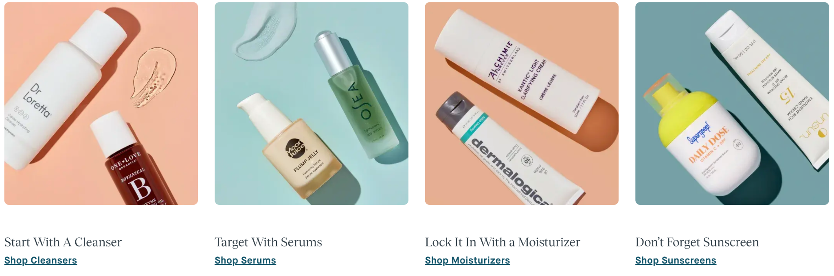

Heading 5

Title: Free expert advice

Body text:

No two skins are the same, sis, so why should your skincare routine be? Book your private consult now for custom skin advice and targeted solutions.

Button text: Speak to an expert

Heading 6

Title: Have skin in the game

Body text:

*Let us keep you up to date with expert advice and exclusive offers*

Heading 7

Title: #FayshellSkin

How it works

3 Column structure

Column 1 title:

Column 1 body text:

Column 2 title:

Column 2 body text:

Column 3 title:

Column 3 body text:

About us section of “how it works” - about the founders

Short title: Something else

Title: Our Mission

Body text:

FAQ section

Question 1

Answer 1

* Add as many questions as you like

Email subscribe

Title: Get on the list

Body text:

Gifts

Title: Gifts

Body text: Is there a greater gift than the gift of great skin? (Spoiler alert: no)

Box 1

Title: In store gift cards

Body text (when you click on card)

Whether it's a facial, top beauty products or a session of LED magic, Fayshell gift cards are the gift that keeps on giving. Our facials range from $189-269

Box 2

Title: Online gift cards

Body text (when you click on card)

A couple wise women (aka the Fayshell founders) once said ‘you can never have too many serums’, and they were right. Hook your friend up with an online gift card (perrrfect for a Fayshell.com.au shopping spree.)

Box 3:

Title: Gift ideas

Body text (when you click on card)

Stuck for a gift idea? we've got you covered. Browse the crowd favs

Skin Advice

Heading 1

Title: Personalised advice. That's a promise.

Body text:

Bestie, we know there’s h-e-a-p-s of skin advice out there (🆘), so we're here to help. Think of us as your tightly coiled spring, ready to jump into action at first sign of a breakout!

All you have to do is book a free consultation and let our skin experts do the rest. Check out how it works below

Body text: Book a free consult

Title: How it works

4 columns structure

Column 1 title: Book in a 15 minute consultation with our experts

Column 2 title: Fill out our form, so we can get to know your skin

Column 3 title: Chat to a Fayshell expert via zoom

Column 4 title: Voila! Receive your personalised skin advice

LED Lounge

Heading 1

Title: LED Lounge

Body text: Let me introduce you to your new BFF in skin

4 columns structure

Column 1 title: 15 MIN HEAVEN!

Column 2 title:

Column 3 title:

Column 4 title:

Heading 2

Title: Treatment Overview.

Body text:

Heading 3

Title: Treats

Heading 4

Title: Suitable For

Heading 5

Title: Costs

Memberships

Heading 1

Short title: Our Membership

Title: Monthly Facials, Daily Radiance

Body text:

Heading 2

Short title: Get The Glow Only Members Know

Title: Our memberships

Body text: Built around your skin cells’ monthly renewal cycle, our membership includes a customized facial, plus member pricing on proven products to maintain the glow at home.

3 columns structure

Column 1 title: Facials

Column 1 price:

Column 1 features:

Column 2 title:

Column 2 price:

Column 2 features:

Column 3 title:

Column 3 price:

Column 3 features:

Heading 2 Chat with a host to sign up the next time you’re in our shop.

Heading 3: Got Membership Q's? We’ve Got A's

Contact Us

Title: Contact us

Body text: Minimalist styling is not about creating a cold, hard, empty white box of a home. It is about using simple and natural forms,

and taking away layers without losing the aesthetic appeal of the space.

Replace the below with details of your choice. You can have address, email and phone. We recommend an minimum of 2 pieces of contact info (minimum is email and phone)

01

STORE NEWYORK

123 SKY TOWER, WEST 21TH STREET, SUITE 721, NY

+844 123 456 789

sale@yourcompany.com

Map: please send us an address or we can hide this.

Shipping and returns

Please specify your shipping pricing - is it flat rate AU wide or state by state?

$8AU wide for normal

$12 for Express

Also, you will need an officially policy for shipping and returns (answering things like what happens if the customer’s item doesn’t arrive, and if/how you accept returns).

### Returns policy

### We offer exchanges (subject to stock availability) or refunds of products for change of mind where we determine (at our absolute discretion):

#### you have provided the proof of purchase and you purchased the products within 14 days prior to the request for an exchange or refund;

#### the products are in their original condition and have not been opened, used, worn, damaged, tampered with, washed, altered, connected, installed or attempted to be connected or installed;

#### the products are in their original undamaged packaging with all product tags still intact;

#### the products are not sale items, custom-made, special buy products or gift vouchers; and

#### a return and exchanges form has been completed.

### We will not cover the costs of delivery or re-delivery for a change of mind return. You must cover these yourself.

### You may have rights under the Australian Consumer Law (see below) in addition to this clause.

# Australian Consumer Law

### Nothing in these Terms attempts to modify or exclude the conditions, warranties and undertakings, and other legal rights, under the Australian Consumer Law. In Australia, our goods come with guarantees which cannot be excluded under the Australian Consumer Law. You are entitled to a replacement or refund for a major failure and compensation for any other reasonably foreseeable loss or damage. You are also entitled to have the goods repaired or replaced if the goods fail to be of acceptable quality and the failure does not amount to a major failure. Any and all other warranties or conditions which are not guaranteed by the Australian Consumer Law are expressly excluded where permitted, except to the extent such warranties and conditions are fully expressed in these Terms.

### Where you return products to us to seek an Australian Consumer Law remedy, you will need to cover any associated costs (for example delivery costs) of you returning the products to us.

### Where your claim is a valid claim under the Australian Consumer Law, we will refund your return delivery costs and, depending on the failure, either dispatch a new or repaired replacement product or refund you the Price of the relevant product. Please contact us for further information.