* End Portals
  + End Portal Frame are now craft able using the recipe 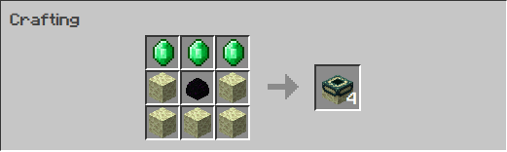
  + End Portal Frames are now breakable with a netherite pickaxe
* Compasses
  + Compasses have the abbility to change where they are pointing by right clicking, mods include
    - Point to bed
    - Point to world spawn
    - Point to player
    - Point to location (Command)
* Chat
  + Custom colors chat by using chat codes
    - #0 Black
    - #1 Dark Blue
    - #2 Dark Green
    - #3 Dark Aqua
    - #4 Dark Red
    - #5 Dark Purple
    - #6 Gold
    - #7 Gray
    - #8 Dark Gray
    - #9 Blue
    - #a Green
    - #b Aqua
    - #c Red
    - #d Light Purple
    - #e Yellow
    - #f White
    - #l Bold
    - #m Strikethrough
    - #n Underline
    - #o Italic
    - #r Reset
  + Names can also be set using the command /setname
* Wandering trader
  + Added a notification of when the wondering trader arrives
  + Added new types of wandering traders
    - Color Trader
      * Trades various dyes
    - Horse Tack Trader
      * Horse armor
      * Saddles
      * Leads
* Mending
  + Tools can now be mended by crouching and holding right click allowing the user to use their stored exp to repair the held item
* Flowers
  + All flowers can be interacted with bonemeal producing more flowers similar to the tall flowers previously
* Ender Dragon
  + Killing the ender dragon more than once will produce another egg
* Crafting Recipes

