Cross-Layer Video Delivery over Open OFDM-ISAC: Measuring Container Fragility and Outer-Code Sufficiency
Jiarui Ye (叶嘉锐)
Shanghai Maritime University (上海海事大学)
Shanghai, China
Abstract
Real-time video delivery over integrated sensing and communication (ISAC) links faces a qualitatively different challenge from file transfer: residual bit errors that survive forward error correction propagate through inter-frame prediction and are amplified by the encapsulation layer before the decoder ever sees them. This paper presents the first systematic measurement of these two amplification mechanisms on a live OFDM-ISAC platform. Using OpenISAC with USRP N320 and B210 software-defined radios over an indoor over-the-air link, we (i) conduct a Pareto scan of four Reed-Solomon outer codes and show that the LDPC(1008,504) residual error rate is below 5×10⁻¹⁰, making the lightest RS(255,223) configuration both necessary and sufficient — recovering 8.4% payload throughput over the deployed heavier code with zero steady-state block failures; and (ii) model and directly measure the MPEG transport stream container amplification factor γ, deriving γ ≈ 7 from a Markov-chain header-exposure model and measuring γ = 4 to 500 across three decoder stacks. Replacing MPEG-TS with bare H.264 Annex B and tuning queue depths to non-blocking minima yielded 250 ms ± 0.5 ms end-to-end latency — of which the ISAC radio contributes only ≈3 ms — with zero-error payload delivery and 2.5× throughput headroom. These results reveal that on a strongly coded ISAC link, the container and decoder layer dominates video quality far more than the outer FEC code.
Keywords: ISAC, OFDM, video transmission, MPEG-TS, Reed-Solomon, LDPC, cross-layer design, software-defined radio
I. Introduction
Integrated sensing and communication (ISAC) is a key enabler for 6G networks, sharing waveforms, hardware, and spectrum between data transmission and environmental radar sensing [1]–[3]. Open platforms such as OpenISAC [4] now allow complete physical-layer experimentation over the air, making live ISAC links accessible to the research community with commodity USRP hardware.
Real-time video is among the most demanding payloads an ISAC link can carry. Unlike file transfer — where ARQ repairs residual FEC errors silently — inter-frame codecs such as H.264/AVC propagate damage across an entire group of pictures (GOP) from a single corrupted macroblock [5]. The video service therefore couples the sparse error statistics of a strongly coded OFDM physical layer to design decisions at the container, decoder, and buffer layers that existing ISAC experimental studies leave unexamined: prior work targets sensing estimation accuracy or raw link throughput [4],[6], not a running media service.
This paper closes that gap with three contributions, all derived from controlled over-the-air experiments without new hardware:
- RS outer-code Pareto analysis. We show empirically that the LDPC(1008,504) inner code’s residual BER on a QPSK indoor link is below 5×10⁻¹⁰, that all four tested RS(255,K) configurations achieve zero steady-state failures, and that the lightest (RS(255,223), 14.3% redundancy) is therefore Pareto-optimal, recovering 8.4% payload throughput over the deployed RS(255,191).
- MPEG-TS container fragility: model and measurement. We derive a Markov-chain model of TS parser behavior under residual errors, predicting a header-exposure amplification factor γ ≈ 7, and measure γ = 4–500 empirically across three decoder stacks. This is, to our knowledge, the first measurement of γ on a live ISAC platform.
- Latency optimization. We identify and eliminate a positive-feedback latency accumulation loop; the resulting service pins at 250 ms ± 0.5 ms end-to-end, with ≈80% attributed to the H.264 decoder and only ≈3 ms to the ISAC radio.
These results support a least-sufficient protection design rule: on a strongly coded ISAC link, outer FEC redundancy should be sized to the measured residual, and the budget freed by that reduction reinvested at the container and decoder layer, where protection is genuinely scarce.
II. System Description
A. Platform
All experiments use OpenISAC [4], an open-source C++ OFDM-ISAC platform on USRP hardware. The base station (BS) uses a NI USRP N320 (dual-channel, 200 MHz FPGA, GPSDO-disciplined clock) connected over SFP+ 10 GbE; the user equipment (UE) uses a NI USRP B210 (AD9361 front end, USB 3.0). Both sides use log-periodic antennas (6–8 dBi). OpenISAC’s resource model supports explicit payload and sensing_pilot resource-block types within each OFDM frame, allowing communication and sensing to share the waveform with configurable resource separation; both functions run concurrently in all experiments.
Video pipeline: camera → x264 encoder → UDP :50000 → ISAC modulator (N320) ··· air ··· ISAC demodulator (B210) → UDP :50001 → H.264 decoder → display.
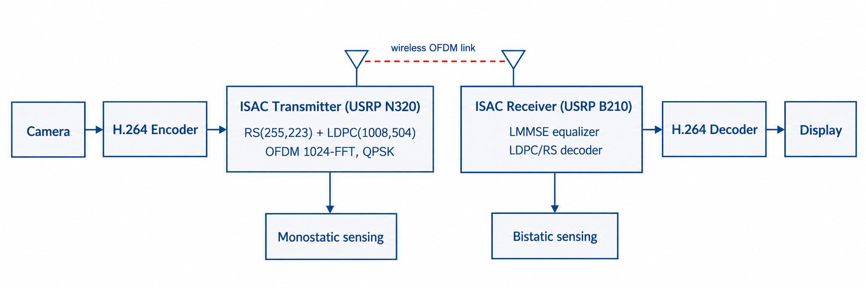
Fig. 1. System topology: real-time H.264 video service on the OpenISAC OFDM-ISAC platform with concurrent sensing.
B. OFDM Waveform
The frame uses FFT size N = 1024, cyclic prefix G = 128 (2.56 μs, 12.5% overhead), 100 symbols per frame, and a 50 MHz sampling rate, giving a frame duration of 2.304 ms (≈434 frames/s) and a subcarrier spacing of 48.828 kHz. Symbol 1 carries a Zadoff–Chu synchronization sequence (root u = 29). Eight uniformly spaced pilot subcarriers support LMMSE channel estimation, CFO/SFO tracking, and zero-forcing equalization; reducing from 16 to 8 pilots released 792 additional resource elements per frame with no measurable channel estimation degradation.
C. Concatenated Coding Chain
Transmit chain: UDP payload → RS(255,K) outer code → LDPC(1008,504) inner code → scrambler → 21×48 block interleaver → QPSK → OFDM. The RS outer code operates over GF(2⁸), correcting t = (255−K)/2 byte errors per codeword. The LDPC inner code (rate 1/2) uses the AFF3CT library [7] with BP horizontal-layered normalized min-sum decoding (6 iterations, early termination). The video operating point is 640×480@20 fps, 1200 kbps, GOP 30, encoded by x264 (ultrafast preset).
III. Reed-Solomon Outer-Code Pareto Analysis
A. Motivation and Experiment Design
A finite-iteration LDPC decoder exhibits an error floor: at high SNR, occasional codewords fail with a small number of residual bytes. Sizing the outer code against this residual is classical practice [8], but the required protection strength is an empirical question on a specific link. We swept four RS(255,K) configurations spanning a 3× range of redundancy (Table I), each compiled into both radios and tested with a fixed-pattern load (1024-byte packets) at injection rates from 500 to 4000 kbps in 10 s intervals, with a concurrent H.264 stream for subjective quality assessment.

Table I. RS Outer-Code Configurations Under Test.
Configuration | K | Parity | t | Redundancy
RS(255,223) | 223 | 32 | 16 | 14.3%
RS(255,207) | 207 | 48 | 24 | 23.2%
RS(255,191) | 191 | 64 | 32 | 33.5%
RS(255,179) | 179 | 76 | 38 | 42.5%

B. Results
Every configuration, including the lightest, recorded zero decoding failures in steady state (success counter > 20,000 packets). The only failures across the entire campaign occurred during the frame-synchronization transient (first ∼1,000 packets) and appeared in all four configurations, confirming they are synchronization artifacts rather than channel-induced residuals. Over 10⁶ RS codewords decoded without a single steady-state correction event, the LDPC residual byte-error rate is bounded at below 1/(255 × 8 × 10⁶) ≈ 5×10⁻¹⁰ under indoor SNR conditions.
C. Pareto Consequence
Given equal steady-state reliability, RS(255,223) dominates all others on throughput. The code-rate ratio 223/191 − 1 = 16.8%; accounting for the 2-byte length prefix in 1024-byte payloads, the effective payload-throughput gain over the deployed RS(255,191) is 8.4%. On this link the outer code acts only as a transient synchronization guard, not an active corrector in steady state, meaning video quality in sustained operation is determined entirely by layers above the FEC stack.
IV. MPEG-TS Container Fragility
A. Markov-Chain Amplification Model
H.264 over IP is conventionally encapsulated in MPEG-TS [9], designed for broadcast channels with rare, bounded errors. Let the post-LDPC byte-error probability be p. A TS packet is 188 bytes; its critical header fields (0x47 sync byte, PID, continuity counter, PES start code) total m₀ = 7 critical bytes per packet. In practice, 7 TS packets are bundled per UDP datagram (1316 bytes), so a corrupted sub-packet destroys the synchronization of the whole bundle; the effective critical byte count per bundle is m ≈ 28. A bare H.264 Annex B stream resynchronizes on any 4-byte start code, giving m_raw = 4. The static header-exposure amplification factor is therefore γ₀ = 28/4 = 7.
The static model understates the dynamic amplification because TS recovery is itself fragile. Modelling the TS parser as a Markov chain with states {SEARCH, TENTATIVE(k), LOCKED}, with K_lock = 3 (VLC/ffmpeg default), the mean residence in SEARCH after a single sync loss is E[T_Search] ≈ 188 / (1 − 3×188p) bytes. At p = 10⁻³ this is ≈700 bytes (≈3.7 TS packets) before re-locking. False lock on payload bytes containing 0x47 (natural frequency 1/256) can extend loss bursts to seconds — the mechanism behind the TS discontinuity stalls observed with VLC.
B. Measurement Protocol and Results
We measured γ empirically by disabling the RS outer code entirely, raising post-LDPC residuals to a measurable level while the LDPC inner code still operates. Three transport stacks were tested: MPEG-TS + VLC (VDPAU hardware path), MPEG-TS + ffplay (software, external clock), and bare H.264 Annex B + GStreamer (avdec_h264, output-corrupt=true).

Table II. Measured Container Amplification Factors (RS outer code disabled).
Transport stack | γ (measured) | Dominant mechanism
MPEG-TS + VLC | ≈500× | sync-search + buffer deadlock
MPEG-TS + ffplay | ≈150× | bounded sync search
Bare H.264 + GStreamer | ≈4× | start-code exposure only

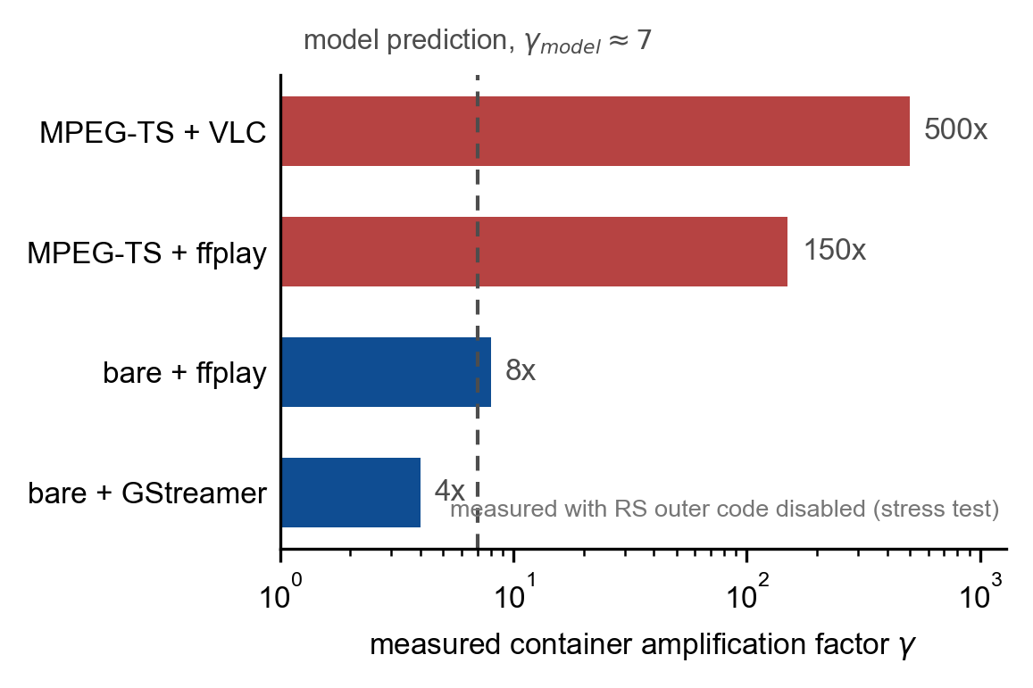
Fig. 3. Measured container amplification factor γ (log scale). Dashed line: model prediction γ₀ ≈ 7. MPEG-TS stacks exceed the prediction; bare-stream stacks fall below it.
MPEG-TS + VLC produced 0% usable playback (persistent frozen frames from PCR-clock deadlock); MPEG-TS + ffplay ≈30%; bare H.264 + GStreamer ≈95%, with the raw TS packet failure rate at 99.5%. The measured range (4×–500×) brackets the static header-exposure prediction (7×): fault-tolerant decoders suppress the static exposure, while state-machine pathologies amplify it. With the outer code re-enabled, the same ordering persisted.
C. Design Consequence
On an ISAC link with a strong inner code and a minimal outer code, MPEG-TS should be replaced by bare H.264 Annex B, and the decoder must be selected for fault tolerance (silent skip on damage, no PCR-clock coupling). GStreamer’s avdec_h264 with output-corrupt=true meets both requirements and produced stable playback across all tested conditions.
V. Latency Optimization
A. Positive-Feedback Latency Loop
The initial deployment used default queue depths of 32 frames at four pipeline stages. At 434 frames/s each queue contributes up to ≈74 ms worst-case queuing delay. When the H.264 decoder stalled, the UDP receive buffer filled, the demodulator’s downstream send blocked, the LDPC decode thread back-pressured, and the synchronization queue grew further — a positive-feedback loop. Queue depths were reduced to the minimum sustaining continuous operation (16, 8, 4, 8 at the four stages) and all blocking enqueues replaced by try_push semantics that drop on overflow, converting unbounded latency growth into bounded, visible frame loss.
B. Measured Latency
The five-minute stopwatch trace (millisecond timer filmed at camera and display; 30 fps capture, ≈33 ms resolution) shows 250.3 ± 0.5 ms steady-state latency with no accumulation trend. Occasional deviations correspond to the decoder’s internal reference-frame pool reset, a receiver software behavior, not a link effect.

Table III. End-to-End Latency Decomposition.
Component | Contribution (ms)
H.264 decoder + GStreamer pipeline | ≈200 (∼80%)
Buffering (all queues combined) | ≈27
x264 encode | ≈10
FEC decode (RS + LDPC) | ≈5
OFDM framing | 2.3
ISAC radio link | ≈3
Localhost UDP | <5
Total | ≈250

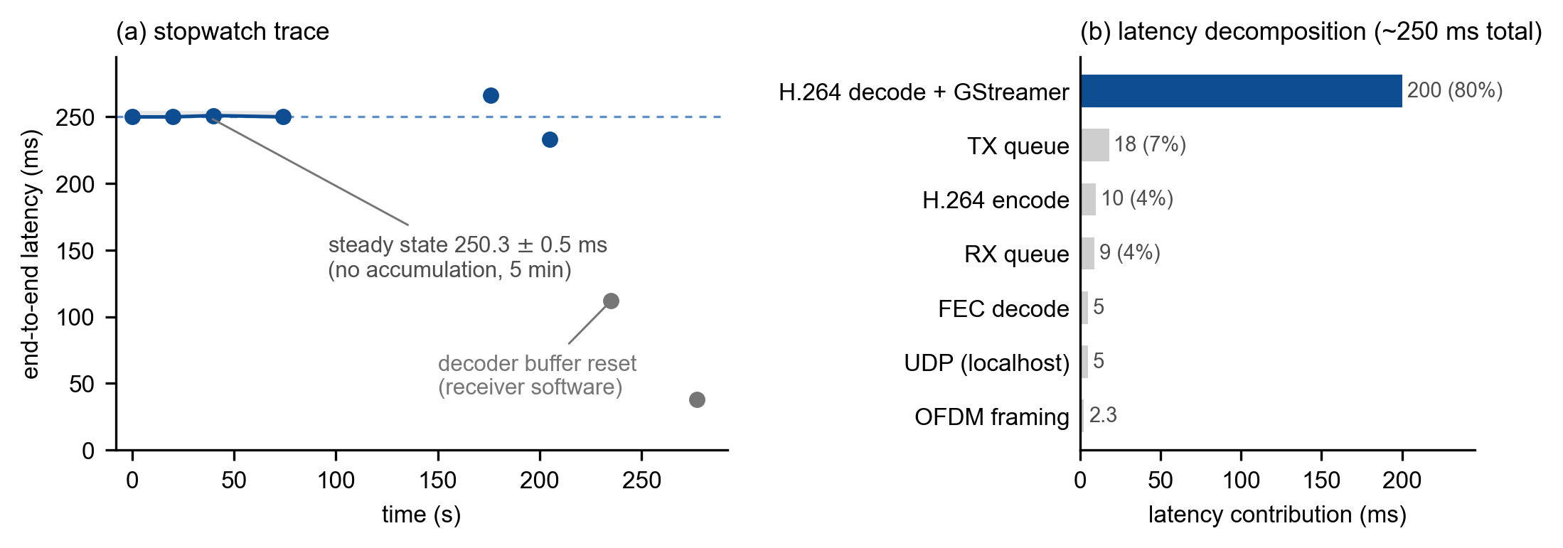
Fig. 2. (a) Five-minute end-to-end latency trace (steady state 250.3 ± 0.5 ms). (b) Latency decomposition: H.264 decoder owns ≈80% of the 250 ms total; ISAC radio contributes ≈3 ms.
The ISAC radio contributes ≈3 ms. Further latency reduction on this platform requires targeting the decoder path, not the radio.
VI. Discussion
A. Least-Sufficient Protection
Below the container, protection is already more than sufficient: a 5×10⁻¹⁰ LDPC residual means the outer code never fires in steady state, and the lightest configuration dominates on throughput. At and above the container, protection is the scarcest resource: a default container choice multiplies effective failure exposure by 7× (modeled) to 500× (measured). The engineering rule is therefore: add protection where it is scarcest — container and decoder — and keep it minimal where residuals are already sparse — the outer FEC. With the outer code removed entirely, bare-stream + fault-tolerant decoder retained ≈95% usable playback while TS-based stacks failed completely.
B. Boundary Conditions
All results are bounded to: a single indoor line-of-sight link (≈5 m, QPSK, B210 receive platform), 640×480@20 fps H.264, and one LDPC configuration (rate 1/2, 6 iterations). The γ measurements derive from a disabled-outer-code stress regime; absolute γ values are regime-specific, though the ordering is preserved in normal operation. The 16QAM modulation was compute-bound (CPU 105% on B210) rather than channel-bound, identifying a platform ceiling rather than a waveform result. Future work includes adaptive outer-code switching driven by SNR, physical-layer-assisted error concealment, and measured hardware upgrade results.
VII. Conclusion
On the OpenISAC platform carrying live H.264 video over the air, delivered video quality is decided above the channel code. The LDPC inner code’s residual BER is below 5×10⁻¹⁰, making the lightest Reed-Solomon outer code (14.3% redundancy) both sufficient and Pareto-optimal, recovering 8.4% payload throughput over the deployed heavier code. MPEG-TS encapsulation amplifies the same physical error stream by 7× (Markov-chain model) to 500× (measured worst-case decoder); replacing MPEG-TS with bare H.264 Annex B, selecting a fault-tolerant decoder, and shrinking queues to non-blocking minima yields 250 ms ± 0.5 ms end-to-end latency — with the radio contributing ≈3 ms — and zero-error payload delivery at 2.5× video headroom. These results support a least-sufficient-protection design rule: size the outer code to the measured residual, and reinvest the freed redundancy budget at the container and decoder layer.
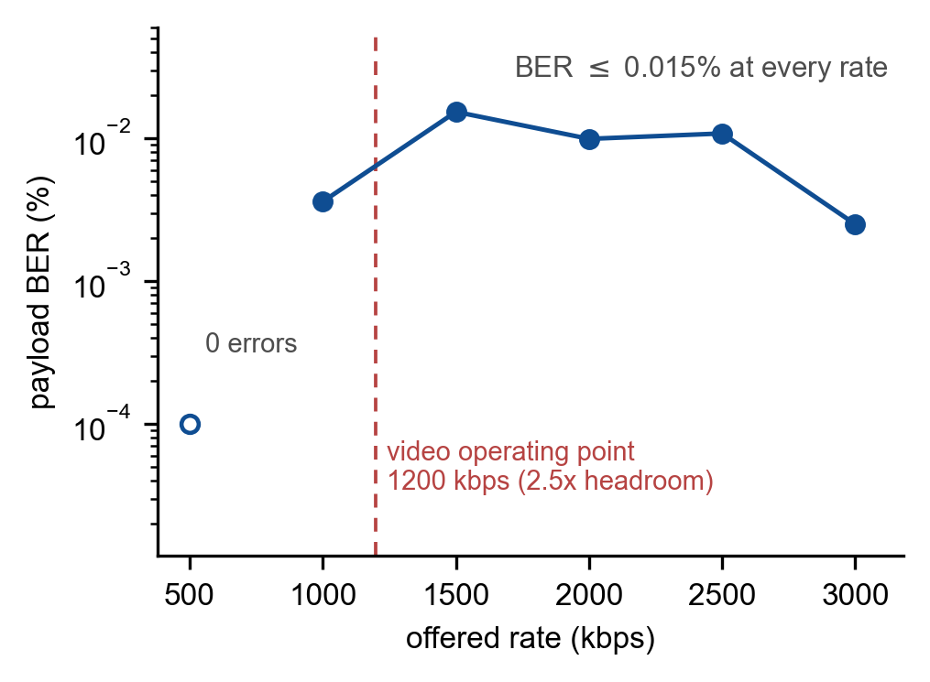
Fig. 5. Payload BER vs. offered rate under RS(255,223). BER ≤0.015% at every tested rate; non-monotonic behaviour reflects pipeline occupancy. Open marker: zero errors at 500 kbps.
References
[1] ITU-R, "Framework and overall objectives of the future development of IMT for 2030 and beyond," Rec. ITU-R M.2160-0, Nov. 2023.
[2] F. Liu, Y. Cui, C. Masouros, J. Xu, T. X. Han, Y. C. Eldar, and S. Buzzi, "Integrated sensing and communications: Toward dual-functional wireless networks for 6G and beyond," IEEE J. Sel. Areas Commun., vol. 40, no. 6, pp. 1728-1767, Jun. 2022. doi:10.1109/JSAC.2022.3156632
[3] Z. Wei et al., "Integrated sensing and communication signals toward 5G-A and 6G: A survey," IEEE Internet Things J., early access, 2023. arXiv:2301.03857.
[4] Z. Zhou, C. Zhang, X. Xu, and Y. Zeng, "OpenISAC: An open-source real-time experimentation platform for OFDM-ISAC with over-the-air synchronization," arXiv:2601.03535, Jan. 2026.
[5] T. Wiegand, G. J. Sullivan, G. Bjontegaard, and A. Luthra, "Overview of the H.264/AVC video coding standard," IEEE Trans. Circuits Syst. Video Technol., vol. 13, no. 7, pp. 560-576, Jul. 2003. doi:10.1109/TCSVT.2003.815165
[6] D. Brunner et al., "Bistatic OFDM-based ISAC with over-the-air synchronization: System concept and performance analysis," in Proc. IEEE ICC, 2024. arXiv:2405.04962.
[7] A. Cassagne et al., "AFF3CT: A fast forward error correction toolbox!" SoftwareX, vol. 10, p. 100345, 2019. doi:10.1016/j.softx.2019.100345
[8] S. Lin and D. J. Costello, Error Control Coding, 2nd ed. Upper Saddle River, NJ: Prentice Hall, 2004.
[9] ISO/IEC 13818-1:2022, Information technology -- Generic coding of moving pictures and associated audio information: Systems (MPEG-TS), 2022.

