Jeremiah Martin

Tuesday, May 17, 2022

Disc Net

Introduction

1. Introduction
   1. Disc Net allows for customers to browse all types of discs from many manufacturers. Customers can easily make accounts and place orders, and even make refund claims and chat with vendors. The intent of Disc Net is to streamline online disc purchases.
2. Inception
   1. In this inception we will identify the scope and scale of the intended product. While defining the needs and requirements. We will rely heavily on collaboration and feedback directly from the clients. To be effective we will cover the following:
      1. Identifying the client
      2. Icebreaking
      3. Identifying the stakeholders
      4. Identifying the viewpoints of the stakeholders
3. Identifying the client
   1. The main client is Disc Net owners and creators. As the owners of the business they have the most claim to the final project. Consumers and disc manufacturers are secondary clients.
4. Icebreaking
   1. With the intention of breaking down walls between the client and engineers to maximize communication we included this icebreaker. It is vital that the stakeholders are comfortable and able to communicate their fears, requests and ideas in an open and direct way without fear of dismissal. Through open communication we can push this project to its best.
5. Identifying the stakeholders
   1. Stakeholders are those entities that have a vested interest in the development of Disc Net. They are the groups or persons that will be effected by the end product and have a wide range of views depending on their role or interaction with the end product. Our market research indicates that the following are stakeholders:
      1. Disc net owners
      2. Customers
      3. Disc manufacturers
6. Identifying the viewpoint of the stakeholders
   1. Stakeholders have different needs depending on viewpoint and how they will interact with Disc Net. It is critical to identify each stakeholder viewpoint and the unique expectations. By identifying their individual viewpoints, we can determine the best way to meet their needs.
      1. Disc Net owners
         1. Security
         2. Easy to use, simple UI
         3. Strong products page
      2. Customers
         1. Easy to use UI
         2. Products are easy to view
         3. Secure checkout
         4. Save checkout information
      3. Disc manufacturers
         1. Uploading product is easy
         2. Making changes to products
         3. Approve refunds
7. Conclusion
   1. The intent of Disc Net will be to help customers easily purchase disc online, and interface with the vendors if needed. Allowing vendors and manufacturers to easily upload products and edit products. All hosted securely via Disc Net with ability for admins to make changes and manage the site.

ELICITATION

1. Introduction
   1. The intention of elicitation is to combine the retail and disc knowledge with the technical knowledge of the development team. We will derive clear requirements from the information and feedback from the stakeholders and return to them working software that meets their requirements.
2. Elicitation direction
   1. During this phase we aim to define the requirements and needs of the client. Through collaboration we can combine the viewpoints with known needs and create our requirements. During the elicitation phase we will identify the following:
      1. Quality Function Deployment
      2. Elicitation requirements
      3. Use cases
      4. Activity diagrams
3. Quality Function Deployment
   1. Quality function deployment (QFD) is the process of turning the needs and viewpoints into specific technical software requirements. That the software engineers use to design and implement into the software.
4. Elicitation requirements
   1. Normal requirements
      1. These requirements are derived directly from the clients and their needs. Normal requirements are the bare minimum and must be included in the final product.
         1. Login/ registration
         2. Types of users
         3. Products can have title, description, image, price, discounts
         4. Add/edit/ delete products
         5. Product filtering
         6. Add items to cart
         7. Users checkout
         8. View past orders
         9. Users create reviews
         10. Users create returns
         11. Chat
   2. Expected requirements
      1. Expected requirements are not specifically stated by the clients but are standard or inferred to make the software work well.
         1. Secure login
         2. Automatic inventory adjustment
         3. Venders can only edit their products
         4. Admins can edit all products
         5. Calculate cart total
   3. Exciting requirements
      1. Exciting requirements are not required but would add to the software and greatly increase the satisfaction of the client. These will be completed if time and budget allow.
         1. Saving checkout information
         2. Multiple images per product
         3. Advanced filter
         4. Discount total calculated

Scenario based modeling

1. Introduction
   1. Disc Net is an e-commerce page dedicated to helping customers easily order disc as well as supporting disc manufacturers. Customers can create accounts, add items to their cart, place orders, view order status, view past orders, request a refund, or chat with vendors. The following use cases will show the relationship between elements within the system and how they interact with each other.
   2. **Primary actors**: Customers and Vendors/admins are the primary actors and users. In most cases they have access to different features but both actors are need in the use case. In the use cases and activity diagrams they will be labeled directly if necessary, otherwise they will be referred to as “user”
   3. **Secondary actors**:Secondary actors provide Disc Net with the support and resources needed for some features to operate properly. The secondary actors will be labeled directly and are as follows. Outside system and supporting equipment IE: printers, scanners. In some use cases a customers or vendors/admins can be a secondary actor as well.
2. Use cases
   1. Level 0

Primary actors: Users

Secondary actors: Secure Database

Description: Shows the base level interaction between the user system and Database.

* 1. Level 1

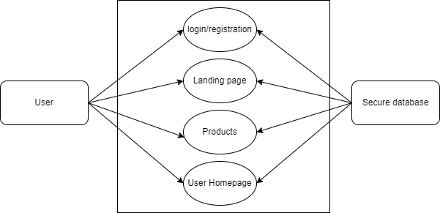

Primary actors: Users

Secondary actors: Secure Database

Description: Shows the features that are first available to the user.

* 1. Level 2

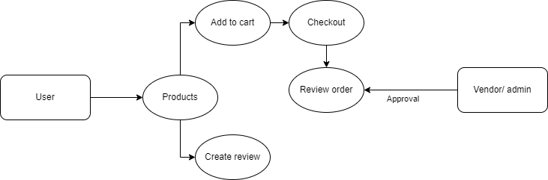

Primary actors: Users

Secondary actors: Vendor / admin

Description: Once the user is login they can navigate to the products page to, add items to their cart or create a review.

* 1. Level 3

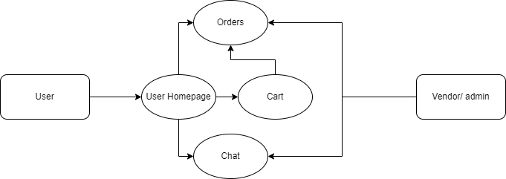

Primary actors: Users

Secondary actors: Vendor / admin

Description: From the user homepage they are able to navigate to view past orders, their cart or the chat feature.

* 1. Level 4

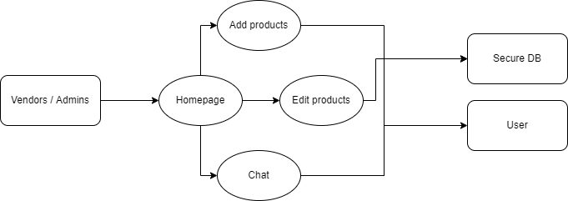

Primary actors: Vendors / admins

Secondary actors: Database, users

Description: From the Vendor/ admin homepage, they are able to create new products, edit existing products and interface with the chat.

* 1. Level 5

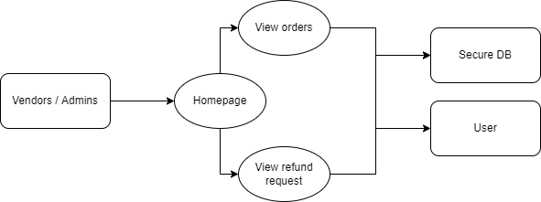

Primary actors: Vendors / admins

Secondary actors: Database, users

Description: From the Vendor/ admin homepage, they must approve orders and they are able to view refund request and appropriately respond.