**Review of basic linguistics**

**Consonants + Vowels**

1) A consonant is produced when the airstream is_____by a part of the vocal tract, while vowels are sounds that are produced with no_____of the airstream.

2) Label the drawing according to the place of articulation.

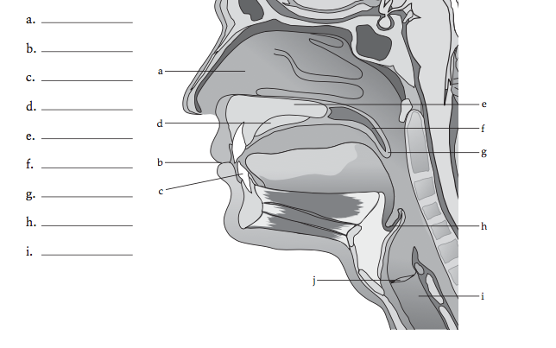

3) Complete the following chart by writing the phonetic symbols in the appropriate boxes.

4) Fill in the boxes for English vowels

5) Reverse the transcription into regular English orthography.

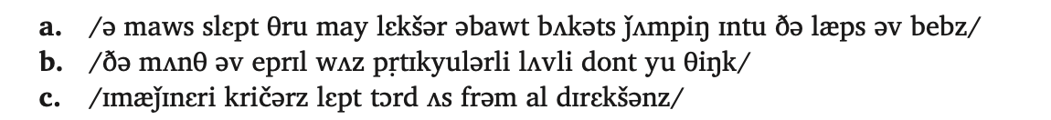

6) Explain the concepts of phoneme and allophone, with illustrative examples.

7) Describe the following phonological processes, with illustrative examples

Cluster reduction (initial or final)

Deletion (weak syllable deletion, etc)

Palatalization

Fronting

* Velar fronting
* Palatal fronting

Assimilation (harmony)

Insertion

Lenition (sonorization)

Stop 🡪 voiced stop 🡪 fricative 🡪 glide/liquid 🡪 deletion

Devoicing