Shawn S Hillyer

1/3/2016

CS 261 – 400

Assignment 0: Introduction and IDE Setup

# Introduction

My name is Shawn Hillyer. I’m an Oregon State University alumn with a degree in Business Management. When I decided to research ways to get into the computer science career field, OSU was a natural fit. Since I work full time and am married with a child (she’s about 1.5 now, so less than a year old when I decided to enroll), being able to take all of my classes online was important to me.

I’ve been a PC user since I was about 4 or so, and a lot of my computer use was to play games. When I was young, it was Math Blaster and Spell-a-Saurus. Later on, any Star Wars game I could find. And for the last 15 years or so, I was playing just about any MMO that came on the market because I loved the social component. Of course, Star Wars: The Old Republic was a great combination of my two favorite game types. I still play games, but I’ve had to sacrifice a LOT of my game time (99% of it, I think!) to focus on my daughter and school. I also have started playing the piano again, and have played the guitar, saxophone, flute, and harmonica quite a bit as well.

Right now I’m really interested in how the web is transforming how applications are developed. I’m interested to see how the internet of things is going to drive a lot more data. I’m also excited to see how cloud computing (software as a service, particularly) is going to play into all of this. It seems like we’re going to see a shift where a lot of software is being hosted on the cloud and dished up to our hardware. Already, you can rent and use a development environment from the cloud and never have to even install your own linux kernel.

So, right now, I see myself doing something involved with web development, apps, internet of things, or even big data. I prefer working with high level languages and constructs that allow me to get things done quickly, versus the low level work involved in assembly language. At any rate, I really enjoy the process of creating and designing something, implementing it, and seeing it come alive. It’s thoroughly rewarding. But I also love being a leader and would love to move up to a more senior role as I get further into my career and find a niche in the industry.

Overall, I’m very excited to be finally getting a degree in computer science. When I was first going to college, for some reason I dismissed it despite all of my experience building my own PC’s and even some experience programming and using HTML to build web sites in my teen years. I thought I’d never want to have some desk job, that I wasn’t amazing at math (I’m solid, but it’s not the easiest topic for me), and I didn’t think I would be good at problem-solving.

I think if I had a chance to speak with real programmers and people in various industries before I decided on my major, I might have been more likely to pursue my passion instead of going for what I thought was a safe choice. I know I’m already thinking about how I’m going to make sure my daughter is given a lot more effort from me to help her find what she’s passionate about and definitely get her interested in science and mathematics in general.

# Environment Setup

I have setup a few environments over time, but will be using Visual Studio for most of my work this term, so I’ll show screenshots of my successful use of the 2013 IDE here. The first two screenshots are of the code screen and the program in the debug terminal window:

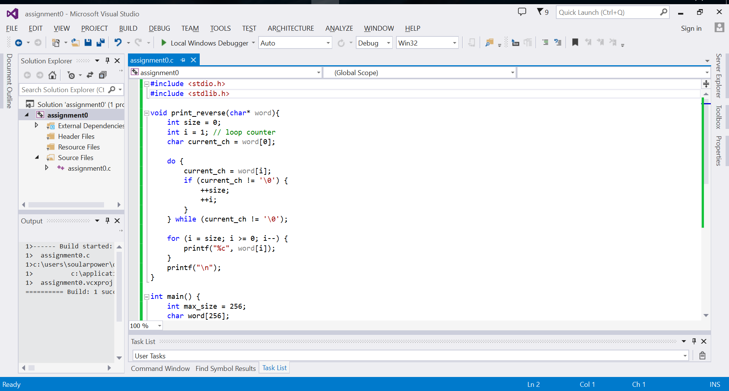

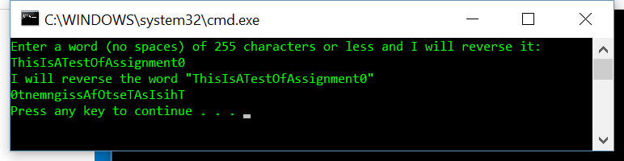

Next I’ll show successful compiling on FLIP. Normally I’d use a makefile but for a single source file, I won’t go through the trouble. I have tested a few more complex programs on FLIP including multiple source files and headers already during the winter break.

