Worksheet 22: Constructing a Bag using a Linked List

In Preparation: Read Chapter 8 to learn more about the Bag data abstraction. If you have not done so already, complete Worksheets 17 and 18 to learn about the basic features of the linked list.

In this lesson we continue developing the LinkedList data structure started in Worksheet 19. In the earlier worksheet you implemented operations to add and remove values from either the front or the back of the container. Recall that this implementation used a sentinel at both ends and double links. Because we want to quickly determine the number of elements in the collection, the implementation also maintained an integer data field named count, similar to the count field in the dynamic array bag.

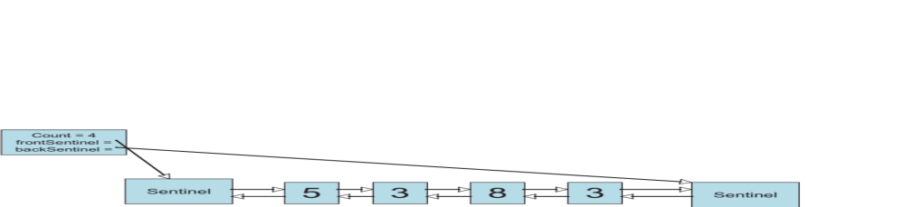

Also recall that adding or removing elements is a problem that you have already solved. Adding a new value at either end was implemented using a more general internal function, termed addLink:

void _addLink (struct LinkedList * lst, struct dLink * lnk, TYPE e);

Similarly removing a value, from either the front or the back, used the following function:

void _removeLink (struct linkedList * lst, struct dLink * lnk);

To create a bag we need three operations: add, contains, and remove. The add operation can simply add the new value to the front, and so is easy to write. The method contains must use a loop to cycle over the chain of links. Each element is tested against the argument, using the EQ (equal to) macro. If any are equal, then the Boolean value true is returned. Otherwise, if the loop terminates without finding any matching element, the value False is returned.

The remove method uses a similar loop. However, this time, if a matching value is found, then the method removeLink is invoked. The method then terminates, without examining the rest of the collection.

Complete the implementation of the ListBag based on these ideas:

struct dLink {
TYPE value;
struct dLink * next;
struct dLink * prev;
};

struct linkedList {
struct dLink * frontSentinel;
struct dLink * backSentinel;
int size;
};

/* the following functions were written in earlier lessons */
void linkedlistInit (struct linkedList *lst);
void linkedListFree (struct linkedList *lst);
void _addLink (struct linkedList * lst, struct dLink * lnk, TYPE e);
void _removeLink (struct linkedList * lst, struct dLink * lnk);

void linkedListAdd (struct linkedList * lst, TYPE e)
{ _addLink(lst, lst->frontSentinel->next, e); }

/* you must write the following */

int linkedListContains (struct linkedList *lst, TYPE e) {
assert(lst != NULL);

struct dlink* iter = frontSentinel.next;

// iterate through the list until value is found or iterator points to the back sentinel
while (iter != backSentinel) {
if (iter.value == e) {
return 1; // true
}
}

// if reach end of list and do not see value in any node, does not contain
return 0; // false}

void linkedListRemove (struct linkedList *lst, TYPE e) {
assert(lst != NULL);

struct dlink* iter = frontSentinel.next;

// iterate through the list until value is found or iterator points to the back sentinel
while (iter != backSentinel) {
if (iter.value == e) {
// Remove the node
_removeLink(lst, iter);
}
}

// If doesn't exist, silently fail
}

- What were the algorithmic complexities of the methods addLink and removeLink that you wrote back in linked list for Deque?

If they meant worksheet 19, the addLink and removeLink function signatures were never provided.

Anyway, adding/removing a link using _addlink or _removeLink with a specific value just takes O(1) time (constant) because it's just doing a constant number of steps (several variable assignments) using the arguments provided, regardless of the size of the data we're working on.

I do not think this is what the question really wants to know though...

To actually *iterate* and get to the node that we want to add or remove takes O(N) time in a linked list. Once we have it, it just takes O(1) time to do the actual removal.

So I think the answer is O(N), which is kind of the standard worst-case running time of any normal linked list that goes through all its contents searching for something (either a value or a location to insert/add a node, for example).

- Given your answer to the previous question, what are the algorithmic complexities of the three principle Bag operations?

For an unordered linked list bag:

add - O(1). Just put it in the first or last node position every time.
contains - O(n). Have to iterate through every element in the worst case. Best case would be O(1).
remove - O(n). Same as above, we might have to search every value in the worst case. Best case would be O(1).

