WINDOWS SERVER
ACTIVE DIRECTORY LAB
Technical Project Write-Up
Two-VM enterprise-style environment for identity, policy, access control, and departmental file services
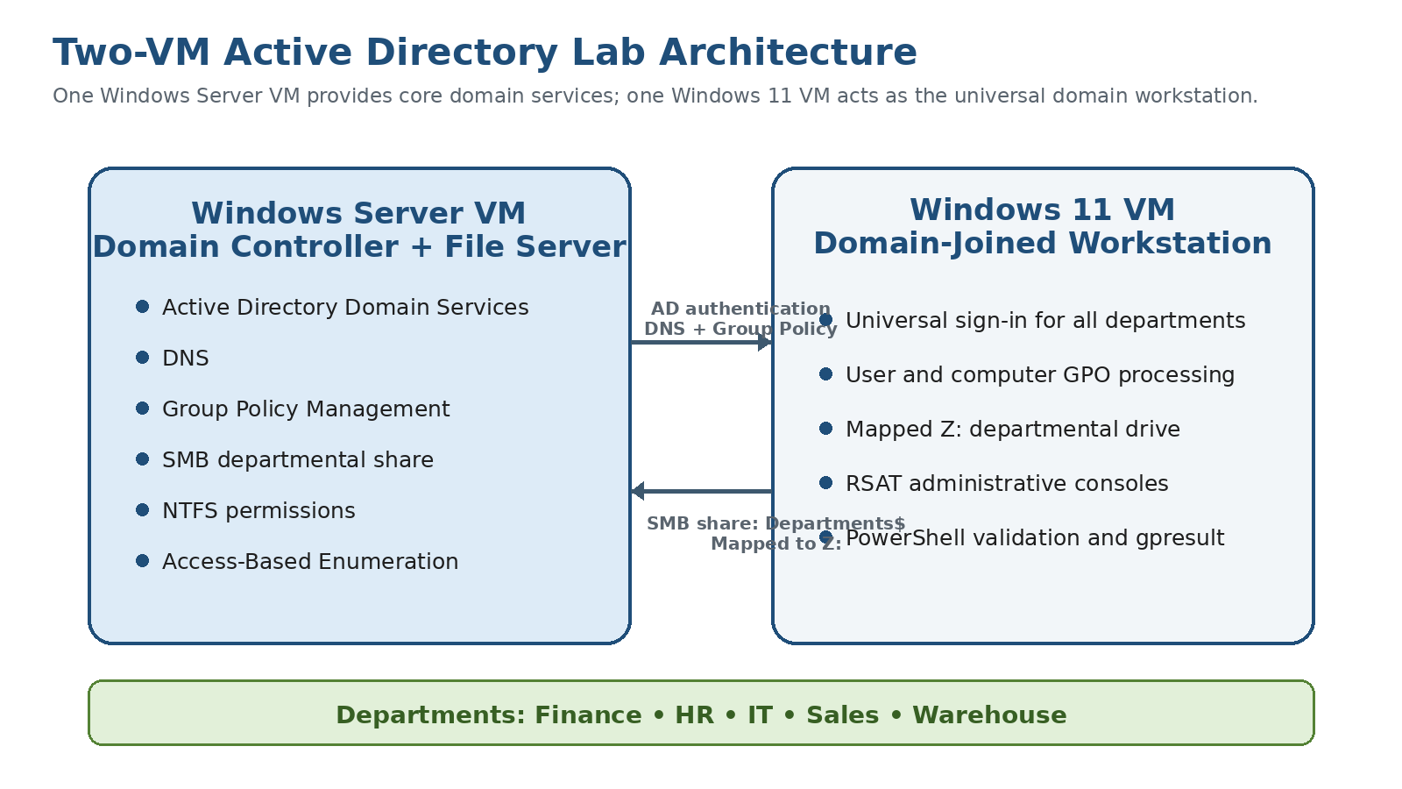
Prepared by Nicholas Sugrim
Self-Directed Lab • July 2026

Executive Summary
This project is a two-virtual-machine Windows domain designed to demonstrate the core identity, access, policy, and troubleshooting tasks commonly found in entry-level systems administration and IT support environments. One Windows Server virtual machine provides Active Directory Domain Services, DNS, Group Policy administration, and departmental SMB file storage. A Windows 11 workstation is joined to the domain and acts as a universal endpoint where users from Finance, HR, IT, Sales, and Warehouse can sign in and receive the correct policies and resources.
The environment uses organizational units to separate users, computers, role groups, and resource groups. Access is assigned through an AGDLP-style model: users are placed in Global role groups, the role groups are nested into Domain Local resource groups, and the Domain Local groups receive NTFS permissions. This design allows Sales users to read Warehouse inventory reports without receiving permission to modify the source files.
Group Policy is divided by purpose so that domain account policies, workstation security, workstation auditing, mapped drives, and department-specific user settings can be tested independently. A delegated IT support role was also configured to perform routine account tasks and review policy configuration without receiving local administrator or Domain Admin rights.
Category | Implementation
Project type | Self-directed Windows Server and Active Directory lab
Virtual machines | 1 Windows Server VM and 1 Windows 11 VM
Domain | ADLab.Domain
Departments | Finance, HR, IT, Sales, and Warehouse
Core services | AD DS, DNS, Group Policy, SMB file sharing, NTFS permissions
Administration tools | ADUC, GPMC, RSAT, Event Viewer, Computer Management, PowerShell

Contents
1. Project Goals and Design Constraints
2. Lab Architecture
3. Active Directory and OU Design
4. Identity, Security Groups, and RBAC
5. Departmental File Services
6. Group Policy Architecture
7. Department-Specific User Policies
8. Delegated IT Support Administration
9. RSAT and Administrative Tooling
10. Validation and Testing
11. PowerShell Reporting
12. Results, Skills Demonstrated, and Future Improvements
Appendix A. GPO Configuration Matrix
Appendix B. Validation Test Matrix

1. Project Goals and Design Constraints
The primary objective was to build a portfolio-ready Active Directory environment that demonstrates practical administration rather than a simple domain-join exercise. The lab was intentionally limited to two virtual machines: one Windows Server domain controller that also hosts departmental file services, and one Windows 11 workstation that supports sign-in for users from every department.
The design goals were:
- Create a clean OU structure for users, computers, security groups, disabled accounts, and departmental identities.
- Use role-based access control instead of assigning permissions directly to individual users.
- Apply both computer and user Group Policies to a shared workstation.
- Map a common Z: drive while allowing Access-Based Enumeration and NTFS permissions to control what each user sees.
- Demonstrate cross-department access, including Sales read-only access to Warehouse inventory reports.
- Delegate routine account administration without granting broad administrative privileges.
- Produce repeatable validation evidence through graphical consoles and PowerShell reporting.
Production note: combining the domain controller and file server is acceptable for this constrained lab, but a production design would normally separate those roles and deploy at least two domain controllers for redundancy.

2. Lab Architecture
Figure 1. Two-VM Active Directory lab architecture.
Component | Responsibilities
Windows Server VM | Domain controller, AD DS, DNS, Group Policy Management, SMB departmental share, NTFS permissions, and Access-Based Enumeration.
Windows 11 VM | Domain-joined universal workstation, user and computer policy processing, mapped-drive testing, RSAT consoles, Event Viewer, and PowerShell validation.
Department share | The server-local Z:\ volume is shared as Departments$ and mapped to Z: on the workstation. The share root contains Finance, HR, IT, Sales, and Warehouse.

3. Active Directory and OU Design
The domain uses a dedicated Lab OU to keep project objects separate from default Active Directory containers. Computers, groups, and users are separated so that policy linking, delegation, and administration remain easy to understand and troubleshoot. The workstation computer object is placed in the workstation OU so that baseline and auditing policies apply to the machine, while departmental users remain in their individual user OUs and receive identity-specific settings on the same endpoint.
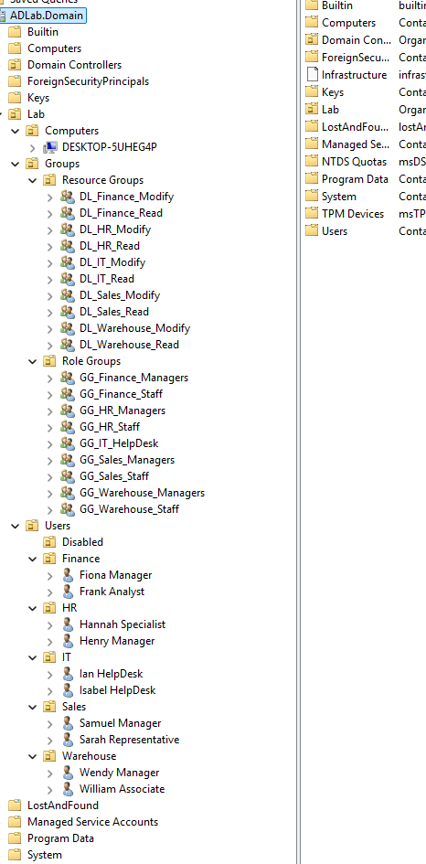
Figure 2. Active Directory OU hierarchy used by the lab.
OU / Container | Purpose
Lab\Computers\Server | Contains the Windows Server computer object.
Lab\Computers\Workstation | Contains the domain-joined Windows workstation and receives computer GPOs.
Lab\Groups\Role Groups | Stores Global security groups that describe department or job role.
Lab\Groups\Resource Groups | Stores Domain Local security groups associated with resource permissions.
Lab\Users\Departments | Parent OU for Finance, HR, IT, Sales, and Warehouse user accounts.
Lab\Users\Disabled | Controlled location for inactive or terminated accounts.

This structure supports clear separation between user policy and computer policy. User GPOs are linked to departmental OUs, while workstation security and auditing GPOs are linked to the workstation computer OU. Loopback processing is not required because the correct user settings follow the user account and the correct computer settings follow the workstation object.

4. Identity, Security Groups, and RBAC
The lab uses an AGDLP-style access model. Accounts are placed in Global groups representing their business role. Those role groups are nested into Domain Local groups representing a permission on a specific folder. NTFS permissions are assigned to the Domain Local groups, not directly to users.
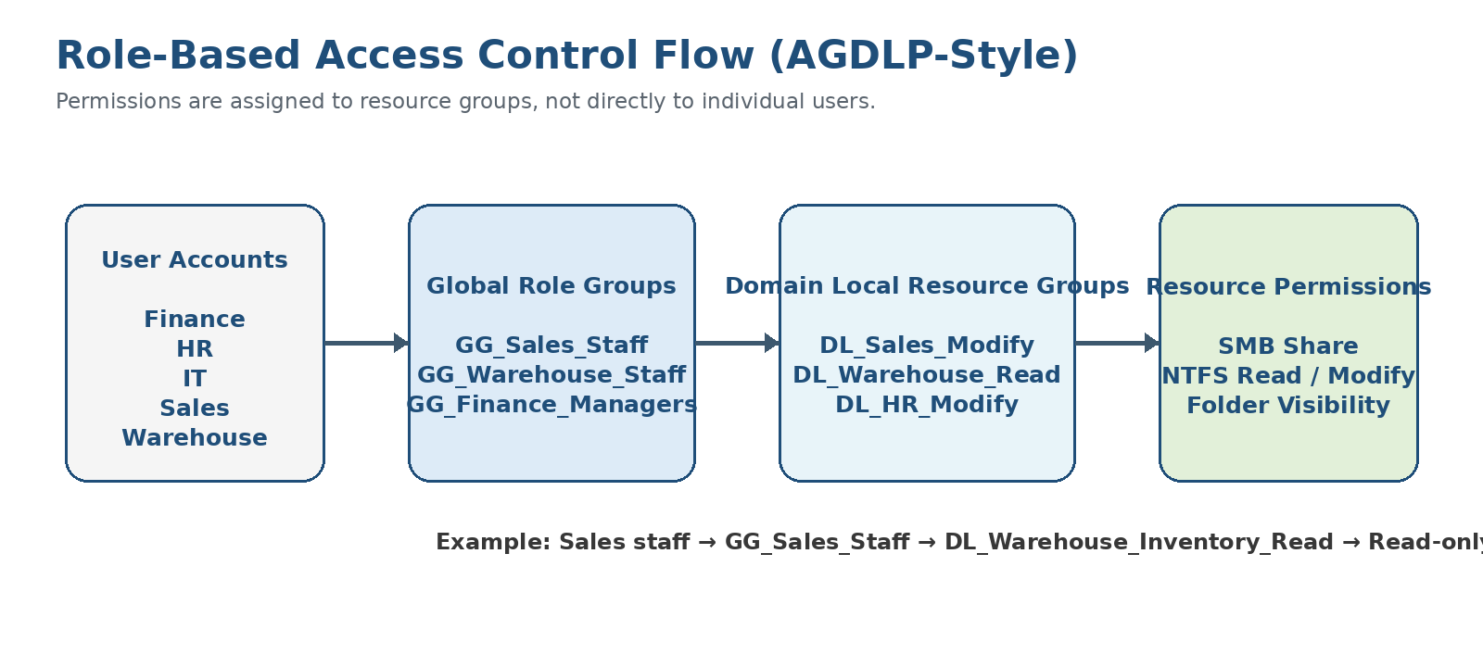
Figure 3. Role-based permission flow from users to resources.
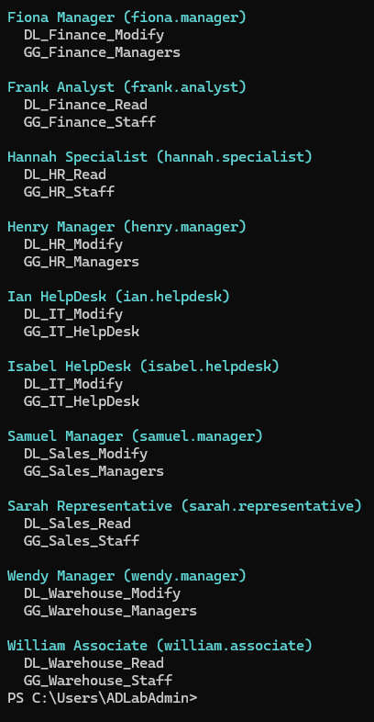
Figure 4. Example user membership in a departmental Global security group.
Group type | Example | Purpose
Global role group | GG_Sales_Staff | Collects users who perform the same departmental role.
Global manager group | GG_Finance_Managers | Identifies managers for targeted shortcuts and management-folder access.
Domain Local Modify group | DL_Sales_Modify | Receives Modify permission on the Sales department resource.
Domain Local Read group | DL_Warehouse_Inventory_Read | Receives Read and Execute permission on Warehouse inventory reports.

Cross-department example: Sales users belong to GG_Sales_Staff. That Global group is nested into DL_Warehouse_Inventory_Read, which receives Read and Execute permission on the Warehouse inventory-report folder. Warehouse staff remain members of a separate Modify resource group, allowing them to create, edit, and delete reports while Sales can only view or copy them.

5. Departmental File Services
The server-local data drive is organized directly beneath Z:\ with one top-level folder for each department. The root of the volume is shared as Departments$, so the workstation mapping presents the same directory structure as Z:\Finance, Z:\HR, Z:\IT, Z:\Sales, and Z:\Warehouse.
Server path | Workstation path | Intended access
Z:\Finance | Z:\Finance | Finance staff; manager subfolder restricted to Finance managers.
Z:\HR | Z:\HR | HR staff; employee records and management resources protected from other departments.
Z:\IT | Z:\IT | IT documentation, scripts, and software repository.
Z:\Sales | Z:\Sales | Sales staff with Modify rights; management resources restricted to Sales managers.
Z:\Warehouse | Z:\Warehouse | Warehouse staff with Modify rights; inventory reports readable by Sales.

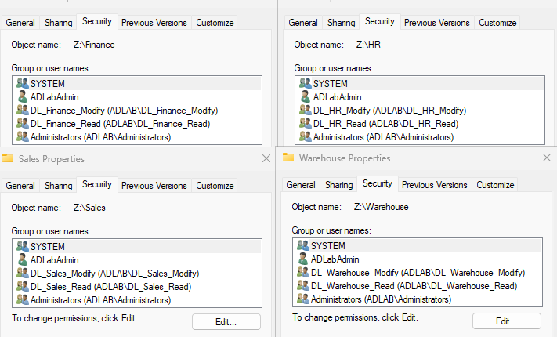
Figure 5. NTFS access assigned to Domain Local resource groups.
Share permissions provide the ability to connect to the SMB share, while NTFS permissions provide the detailed authorization. Access-Based Enumeration is enabled so users do not see folders for which they lack access. Broad principals such as Everyone or Domain Users are not granted Modify access to departmental content.
The lab includes realistic fictional files for each department, including inventory reports, finance workbooks, HR forms, sales quotes, IT documentation, and validation scripts. This makes permission testing visible and repeatable rather than relying on empty folders.

6. Group Policy Architecture
Group Policy is separated by function. Domain account policies remain at the domain level, computer security and auditing policies are linked to the workstation OU, the common mapped-drive policy is linked to the parent user hierarchy, and each department receives a dedicated user policy.
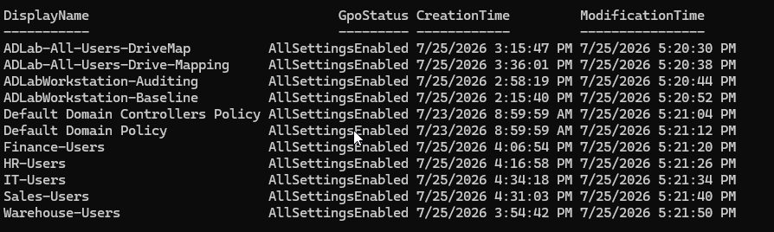
Figure 6. Group Policy inventory for the domain, workstation, drive mapping, and departments.

6.1 Common Department Drive Mapping
Setting | Configuration
Policy path | User Configuration > Preferences > Windows Settings > Drive Maps
Action | Update
Location | \\<domain-controller>\Departments$
Drive letter | Z:
Label | Department Files
Options | Reconnect enabled; remove the mapping when the item no longer applies.
Scope | Parent Lab user hierarchy so all departmental users inherit the mapping.

Every user receives the same root mapping. Department visibility and access level are controlled by Access-Based Enumeration and NTFS permissions rather than by creating a different drive letter for each department. One duplicate drive-map GPO was retained temporarily during troubleshooting; the intended final configuration uses one authoritative Z: mapping to avoid duplicate preference processing.

6.2 Workstation Security Baseline
Policy setting | Configured value
Interactive logon: Do not display last signed-in user | Enabled
Interactive logon: Machine inactivity limit | 900 seconds
Interactive logon message title | ADLab Authorized Access
Interactive logon message text | Authorized-use and activity-monitoring notice
Accounts: Guest account status | Disabled
UAC: Run administrators in Admin Approval Mode | Enabled
UAC: Switch to secure desktop when prompting | Enabled
Microsoft Defender Antivirus | Real-time protection, behavior monitoring, downloaded-file scanning, and program-activity monitoring enabled
Windows Defender Firewall | Domain, Private, and Public profiles enabled; inbound blocked and outbound allowed by default
Firewall logging | Dropped-packet logging enabled; 16,384 KB maximum log size
Automatic Updates | Automatic download and scheduled installation configured

6.3 Workstation Auditing
Audit area | Configured events
Advanced audit policy override | Enabled so subcategory settings override legacy audit categories.
Logon and Logoff | Logon success/failure, logoff success, account lockout failure, and special logon success.
Account Management | User-account, security-group, and computer-account management success/failure.
Detailed Tracking | Process creation success with command-line data included in process events.
Object Access | File-share success/failure, detailed file-share failure, and removable-storage success/failure.
PowerShell logging | Script Block Logging enabled; Module Logging enabled for all modules.

6.4 Domain Password and Lockout Policy
Setting | Value
Password history | 10 passwords remembered
Maximum password age | 90 days
Minimum password age | 1 day
Minimum password length | 12 characters
Password complexity | Enabled
Reversible encryption | Disabled
Account lockout threshold | 5 invalid attempts
Lockout duration | 15 minutes
Reset lockout counter | 15 minutes

The Default Domain Controllers Policy remains linked to the Domain Controllers OU for controller-specific settings and is kept separate from workstation and departmental configuration.

7. Department-Specific User Policies
Each department receives a user GPO linked to its OU. Group Policy Preferences create shortcuts to relevant resources, while user-side Personalization settings enforce department-appropriate inactivity controls. Manager shortcuts use item-level targeting, but NTFS permissions remain the authoritative security boundary.
GPO | Shortcuts and resources | Security / personalization
Finance-Users | Finance Files (Z:\Finance); Financial Reports; manager shortcut targeted to GG_Finance_Managers. | Screen saver enabled; password required on resume; 300-second timeout; users cannot change screen saver.
HR-Users | HR Files (Z:\HR); Employee Records; manager shortcut targeted to GG_HR_Managers. | Screen saver enabled; password required on resume; 300-second timeout; users cannot change screen saver.
Sales-Users | Sales Files; Customer Quotes; Warehouse Inventory - Read Only; manager shortcut targeted to GG_Sales_Managers. | Screen saver enabled; password required on resume; 900-second timeout.
Warehouse-Users | Warehouse Files; Inventory Reports; manager shortcut targeted to GG_Warehouse_Managers. | Screen saver enabled; password required on resume; 900-second timeout.
IT-Users | IT Documentation, IT Scripts, IT Software, ADUC, GPMC, Event Viewer, and Computer Management. | Provides centralized tools and resources without granting additional permissions by itself.

8. Delegated IT Support Administration
A least-privilege IT support role was created through a Global security group. The account uses RSAT from the domain workstation and receives delegated rights over normal departmental users, while privileged accounts remain outside the delegated OU scope.
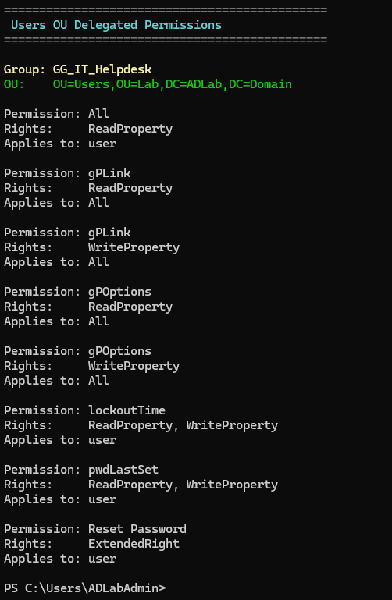
Figure 7. Delegation of Control applied to the IT support security group.
Allowed task | Implementation
View normal user accounts | Read all user information delegated on the departmental user hierarchy.
Reset passwords | Reset user passwords and force password change at next logon delegated through ADUC.
Unlock accounts | User-account unlock permission delegated for normal departmental identities.
Edit approved user fields | Description, office, phone, mobile, address, title, department, and company.
Review Group Policy | Read-only permissions on GPOs; optional Group Policy Results access for troubleshooting.

The delegated role is intentionally not a member of Domain Admins, Account Operators, Group Policy Creator Owners, or the workstation local Administrators group. It cannot create or delete users, change group membership, edit or link GPOs, reset privileged administrator passwords, or automatically access sensitive HR and Finance files.

9. RSAT and Administrative Tooling
Remote Server Administration Tools were installed on the Windows workstation so routine administration and troubleshooting could be performed without interactive administration of the domain controller. Installing RSAT provides the consoles but does not grant permissions; Active Directory delegation and GPO permissions determine what each account can do.
RSAT feature / shortcut | Purpose
Active Directory Domain Services and LDS Tools | ADUC, Active Directory Administrative Center, and directory-management components.
Group Policy Management Tools | View GPO settings, links, and Group Policy Results.
DNS Server Tools | Inspect DNS zones and records during name-resolution troubleshooting.
Server Manager | View server roles and management status from the workstation.
Event Viewer | Review System, Application, Security, and GroupPolicy Operational logs.
Computer Management | Review local services, devices, shared folders, and workstation state.
IT Documentation / Scripts / Software | Shortcuts to centralized IT resources on Z:\IT.

10. Validation and Testing
The configuration was tested from the domain workstation using separate user identities. Group membership changes were followed by a complete sign-out and sign-in so the user security token contained the updated memberships.
- Verified that the workstation receives baseline and auditing GPOs after its computer object is placed in the workstation OU.
- Confirmed that all departmental users receive the Z: mapping and only see folders authorized through NTFS permissions and Access-Based Enumeration.
- Confirmed that Finance, HR, IT, Sales, and Warehouse access is granted through role-group and resource-group nesting rather than direct user permissions.
- Verified that Sales can read Warehouse inventory reports but cannot create, edit, or delete files in the protected folder.
- Verified that manager-only shortcuts appear only for the corresponding manager Global groups.
- Confirmed that department-specific screen-lock settings and shortcuts change according to the user who signs into the shared workstation.
- Confirmed that the delegated IT support account can reset and unlock normal users but cannot edit GPOs or administer privileged identities.
- Reviewed applied user and computer policy through Group Policy Results and HTML reports generated by gpresult.

11. PowerShell Reporting and Evidence
Although the environment was configured primarily through graphical tools, PowerShell was used to inventory and validate the finished design. These commands produce reproducible evidence that can be included in a portfolio or used during troubleshooting.
# Active Directory structure and identities
Get-ADOrganizationalUnit -Filter *
Get-ADUser -Filter * -Properties Department,Title,Enabled
Get-ADGroup -Filter *
Get-ADGroupMember 'DL_Warehouse_Inventory_Read'
Get-ADPrincipalGroupMembership 'it.helpdesk'
# Group Policy and workstation results
Get-GPO -All
gpresult /h C:\Temp\GPO-Results.html /f
# File services and access
Get-SmbShare
Get-SmbShareAccess -Name 'Departments$'
Get-SmbMapping
Get-Acl 'Z:\Warehouse\Inventory Reports'

Recommended portfolio outputs include the OU inventory, GPO inventory, key group-nesting reports, mapped-drive status, SMB-share configuration, NTFS access-control entries, the workstation local Administrators membership, and a gpresult HTML report for at least one department user.

12. Results, Skills Demonstrated, and Future Improvements
The completed environment represents a compact departmental Windows domain. One workstation can serve users from five departments while applying different shortcuts, inactivity controls, and resource permissions according to the signed-in identity. Centralized policy and role-based permissions make the configuration easier to audit and maintain than direct per-user assignments.
Skills demonstrated:
- Active Directory Domain Services and DNS
- OU design and computer-object placement
- Global and Domain Local security groups
- AGDLP-style RBAC and least privilege
- SMB shares, Access-Based Enumeration, and NTFS permissions
- User and computer Group Policy processing
- Group Policy Preferences and item-level targeting
- Password and account-lockout policy
- Windows Defender, Firewall, auditing, and PowerShell logging
- RSAT, delegated administration, and Group Policy Results
- PowerShell inventory and validation
Future improvements for a production-style expansion:
- Add a second domain controller for redundancy and DNS resilience.
- Separate the file-server role from the domain controller.
- Deploy Windows LAPS for local administrator password management.
- Add centralized backups and test restoration procedures.
- Introduce DHCP, patch-management, and software-deployment services.
- Forward security and PowerShell logs to a centralized monitoring platform.

Appendix A. GPO Configuration Matrix
GPO | Scope | Primary purpose
Default Domain Policy | Domain root | Password history, age, length, complexity, and account lockout controls.
Default Domain Controllers Policy | Domain Controllers OU | Controller-specific default security assignments.
ADLabWorkstation-Baseline | Workstation computer OU | Interactive logon, inactivity lock, UAC, Defender, Firewall, and Updates.
ADLabWorkstation-Auditing | Workstation computer OU | Authentication, account-management, process, file-share, removable-storage, and PowerShell logging.
ADLab-All-Users-DriveMap | Parent user hierarchy | Maps Departments$ to Z: for all departmental users.
Finance-Users | Finance OU | Finance shortcuts and five-minute protected screen saver.
HR-Users | HR OU | HR shortcuts and five-minute protected screen saver.
Sales-Users | Sales OU | Sales resources, read-only Warehouse inventory shortcut, and 15-minute protected screen saver.
Warehouse-Users | Warehouse OU | Warehouse resources and 15-minute protected screen saver.
IT-Users | IT OU | IT resources and administrative-console shortcuts.

Appendix B. Validation Test Matrix
Test identity | Expected outcome | Result to capture
Warehouse staff | Modify Warehouse resources and inventory reports. | Create, edit, and delete a test file.
Sales staff | Modify Sales resources; read Warehouse inventory reports. | Open report successfully; modification or deletion denied.
Finance staff | Access Finance resources; no access to HR resources. | Visible Finance folder and denied HR path.
HR staff | Access HR resources; no access to Finance or Sales. | Visible HR folder and denied unauthorized paths.
Department manager | Receive the department management shortcut and folder access. | Shortcut visible only after manager group membership.
IT support account | Reset/unlock normal users and read GPOs. | Successful user task; GPO edit unavailable or denied.
Privileged administrator | Perform domain and GPO administration. | Used only for administrative changes, not routine sign-in.

End of Project Write-Up

