Reflection 1:
1. A socket is a pair consisting of an IP address and a port. It is used to give applications access to the network and to send data.
2. AF_INET is an IPv4 address
3. SOCK_STREAM is a TCP socket

TCP Server/Client:
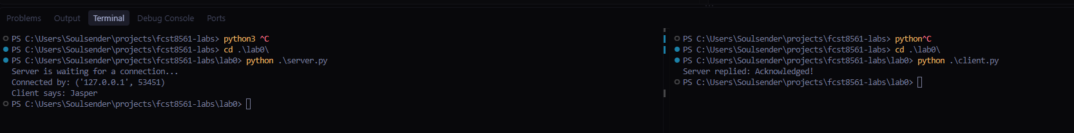
Reflection 2:
1. The host was example.com
2. The port was 80 as
3. This is the port for HTTP
4. The server sent back a 200 status HTTP header, as well as html for example.com

HTTP Client:
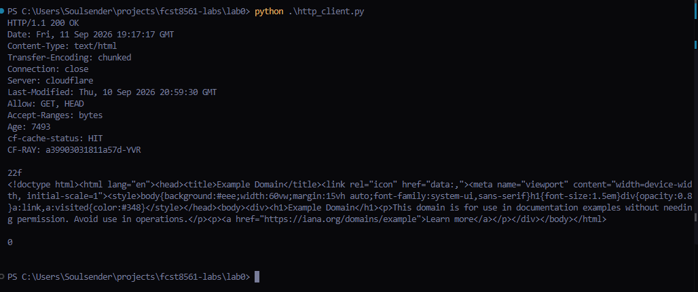
SocketIO:
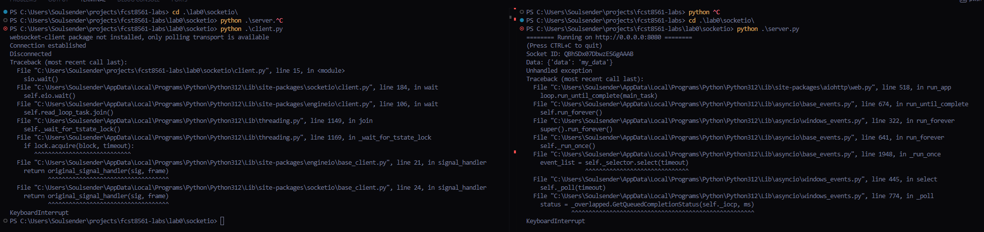
Reflection 3:
1. If a server accepts any requests, this could be used to create a DDoS attack by a threat actor
2. The messages are not encrypted
3. Yes
4. To prevent things like remote code injections, SQL injections, etc.
5. To prove a user is who they say they are
6. Encrypt the message and provide a way to authenticate such as a password

Source code at: https://github.com/Soulsender/fcst8561-labs

