Part 7:
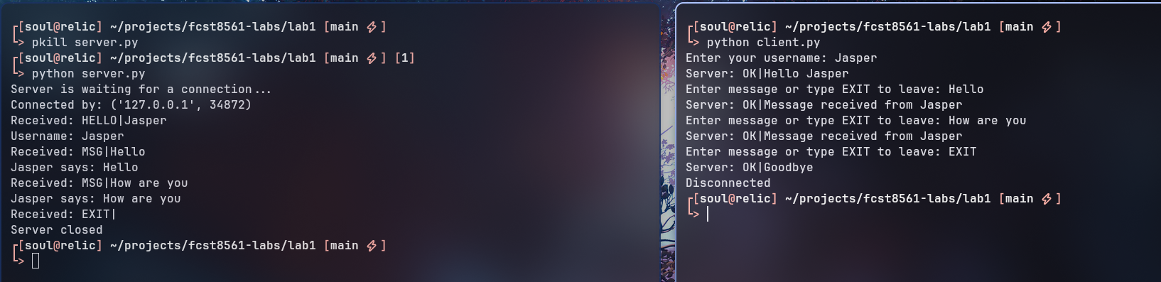

Part 8: Robustness
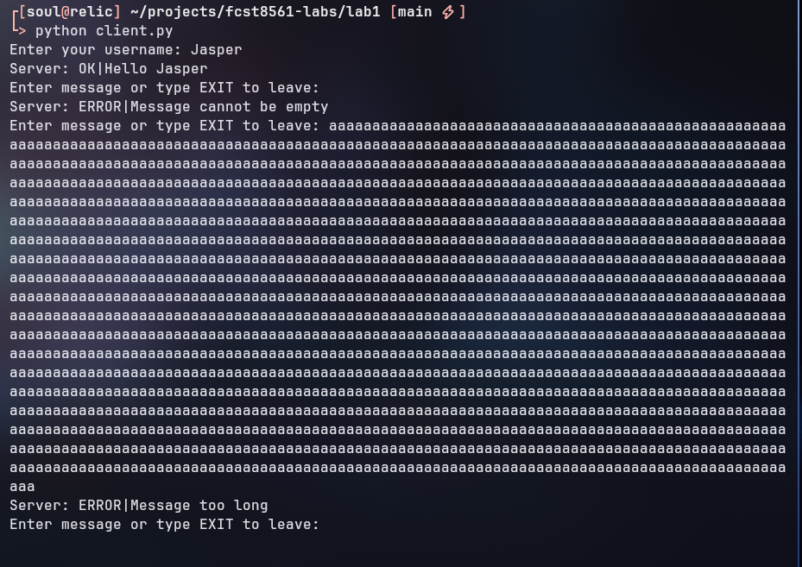
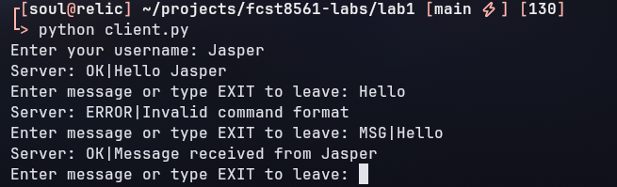
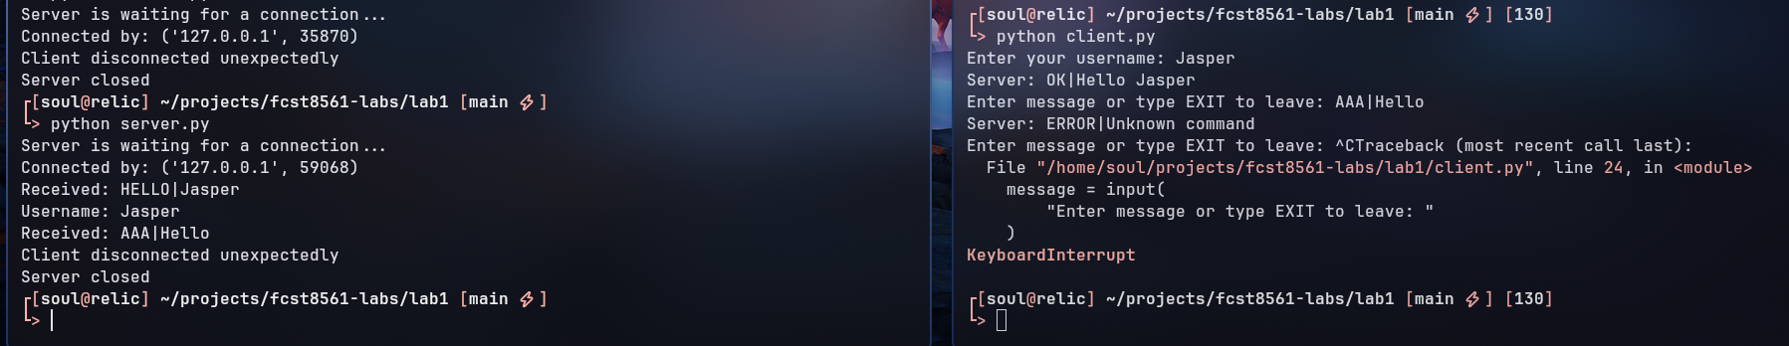

Part 10:
1. What happens if the server crashes while the client is connected?
Connection is broken with error “broken pipe”.
2. How could the server be extended to handle multiple clients?
Using asyncronous functions and non-blocking code.
3. Why can `recv(1024)` split messages unexpectedly?
Messages over 1024 bytes will get cut off as the socket buffer is only expecting to receive 1024 bytes or less.
4. Why does TCP reliability not mean the application is secure?
TCP does not make an application secure. TCP implements no kind of encryption mechanism on it’s own.
5. What new attack surfaces are created by adding usernames and protocol commands?
Potentially another user could pretend to be one user and use commands they may not be supposed to use.
6. How could a malicious client abuse the protocol?
Crashing the server by sending too many bytes, injecting code through the MSG command, sniffing unecrypted data travelling from another user, etc.
7. How would you add authentication?
I would first add encryption to the connection, then create a secure SQLite database of usernames and password hashes that a user would have to authenticate against.
8. How would you add encryption?
I would do the same thing as SSH and add pulbic/private RSA key exchange.
9. What validation is performed in your implementation?
Each message from the client is split by the pipe “|”. Anything before the pipe is a command, and anything after is further parameters.
10. What additional mitigations would be needed for a real deployment?
Add encryption, add authentication, fix security issues.

Part 11:
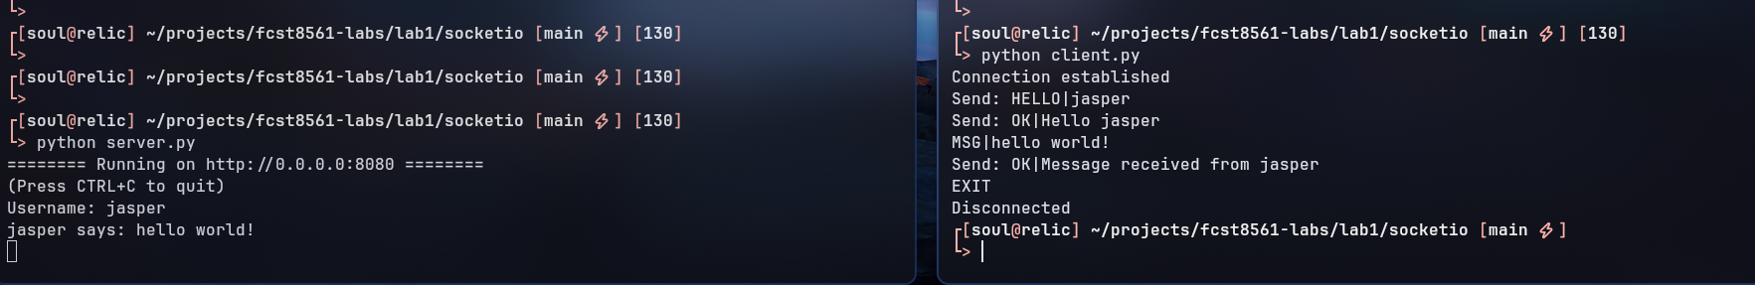
https://github.com/Soulsender/fcst8561-labs

